**Анализ на конкуренцията**

**Конкуренти:**

* <https://www.freshdirect.com/>
* <https://www.thefruitcompany.com/>
* <https://webportal.fruitguys.com/>
* <https://www.berries.com/>
* <https://www.farmfreshtoyou.com/>

**Анализ (<https://www.freshdirect.com)>**

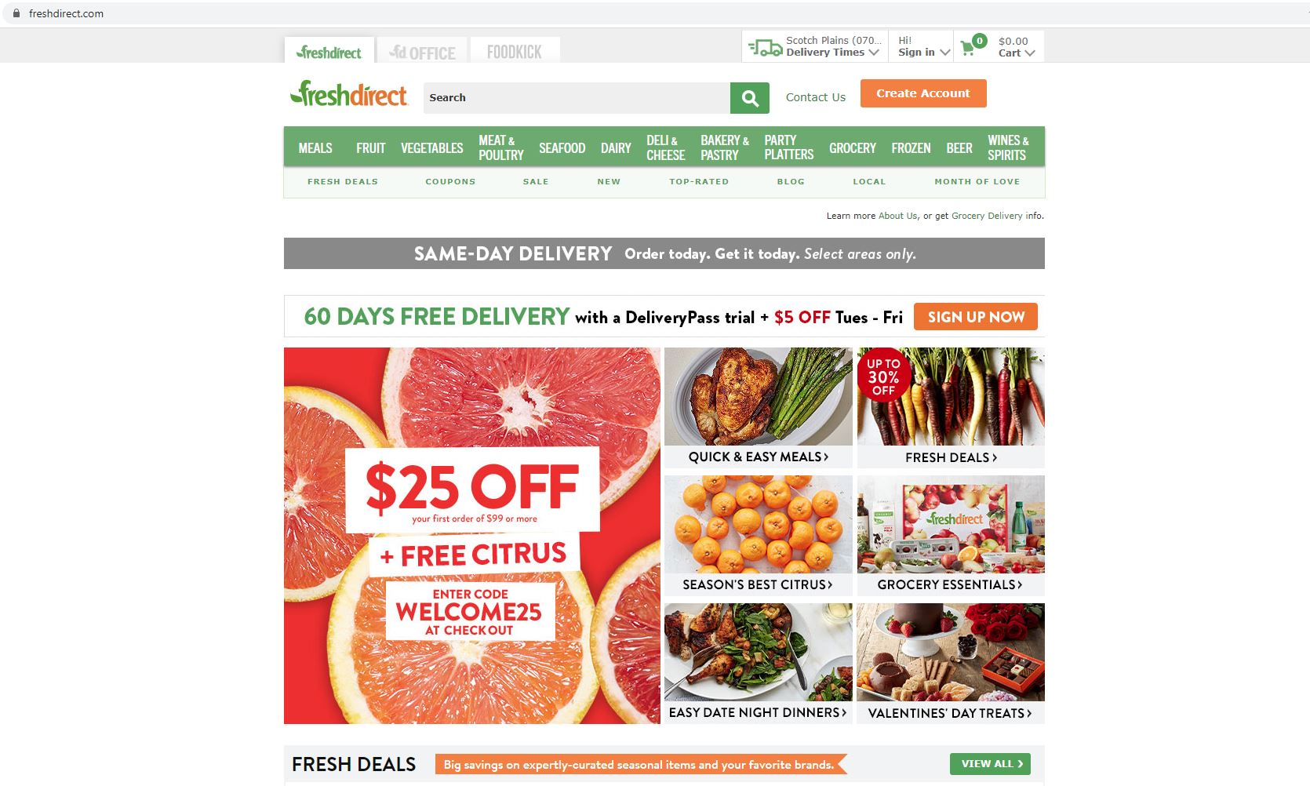

1. **Трафик**

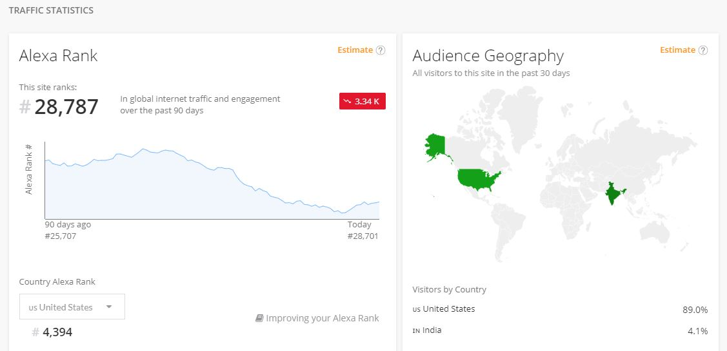

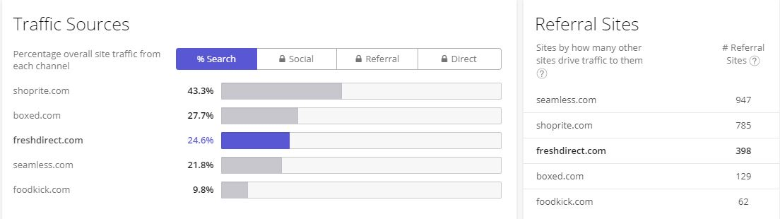

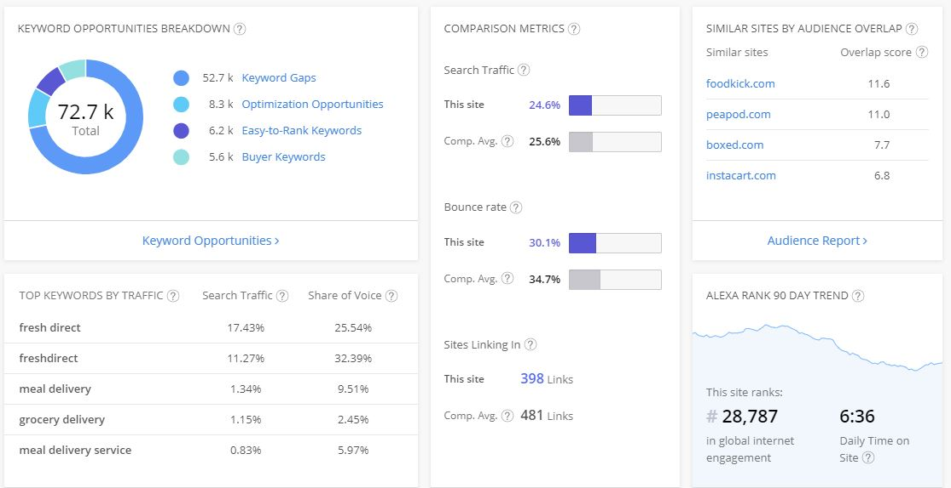

1. **Сравнение на мета данни и ключови думи**

<https://georgievbg6.github.io/> -

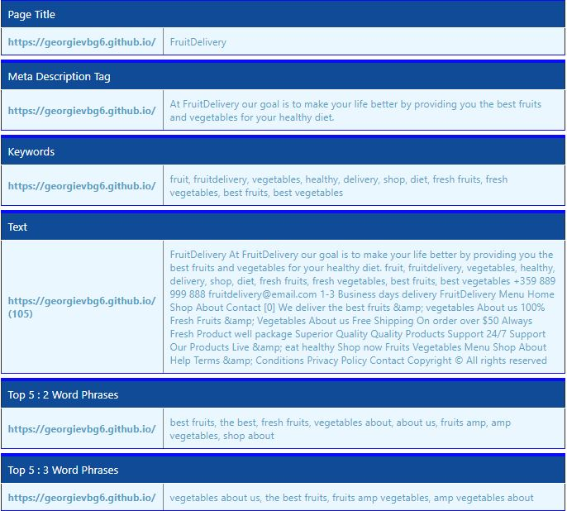

* <https://www.freshdirect.com/> - Compares the page titles, meta information, and common phrases occuring on different pages!

1. **История на промените**

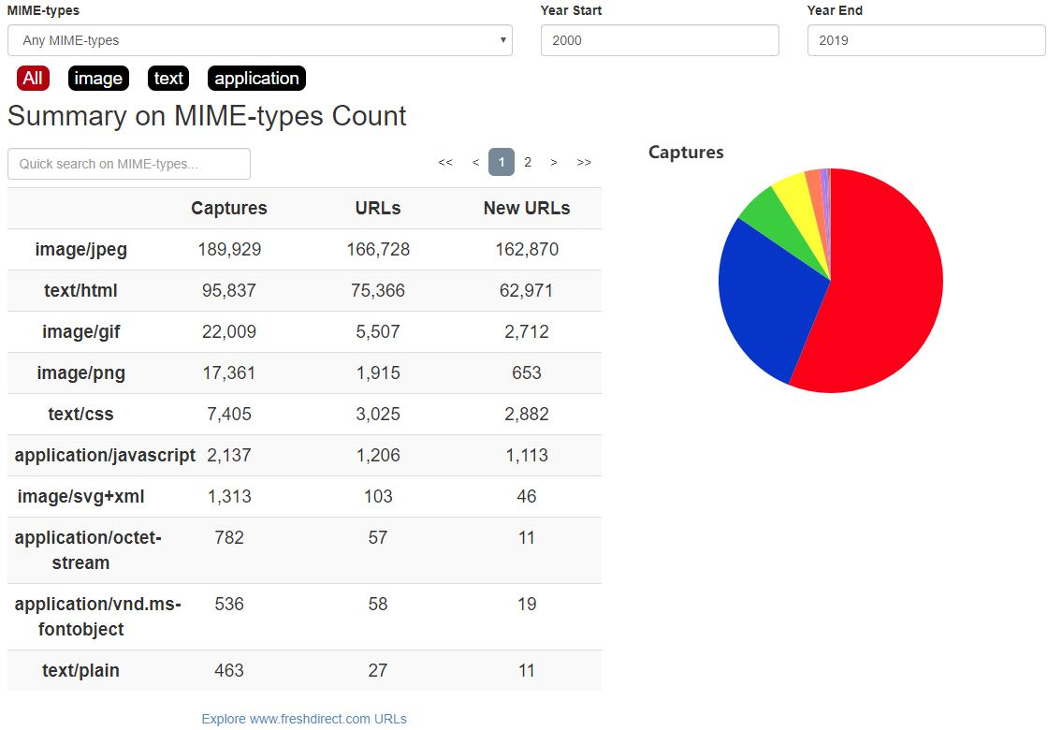

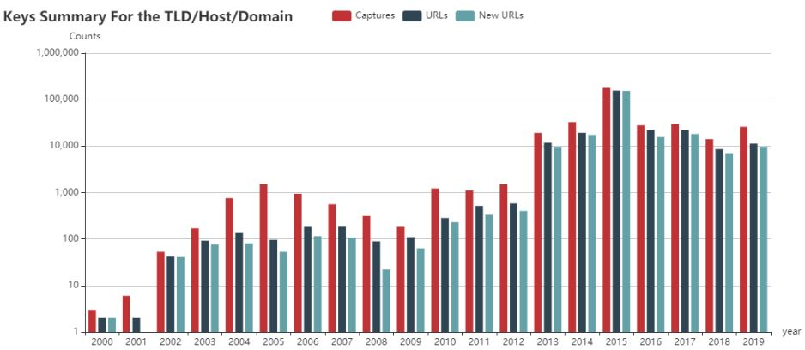

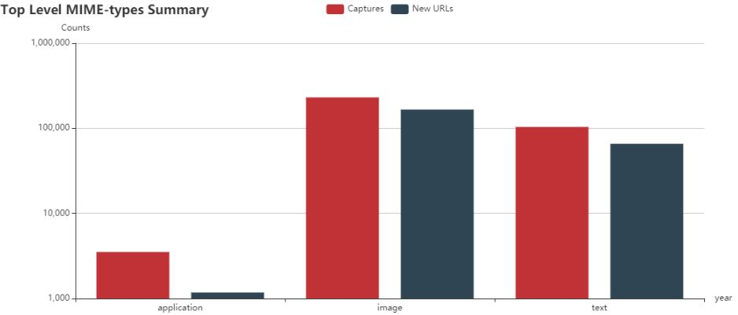

1. **WhoIs**

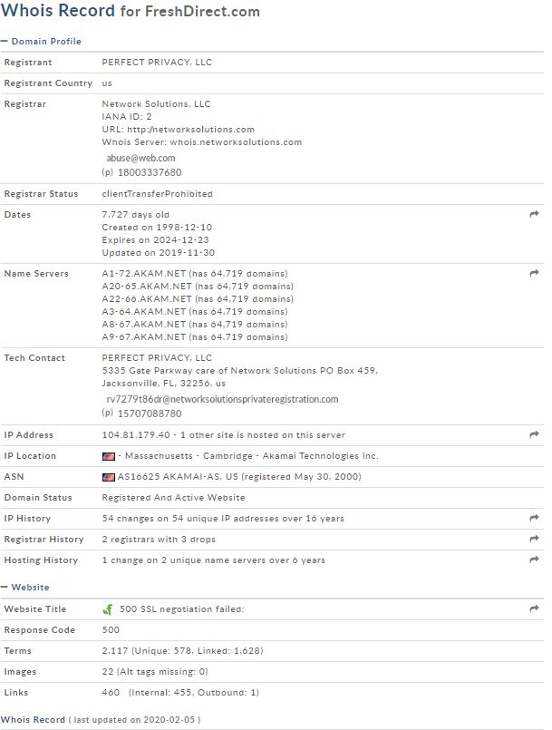

1. **Статистики за ключови думи и AdWords**

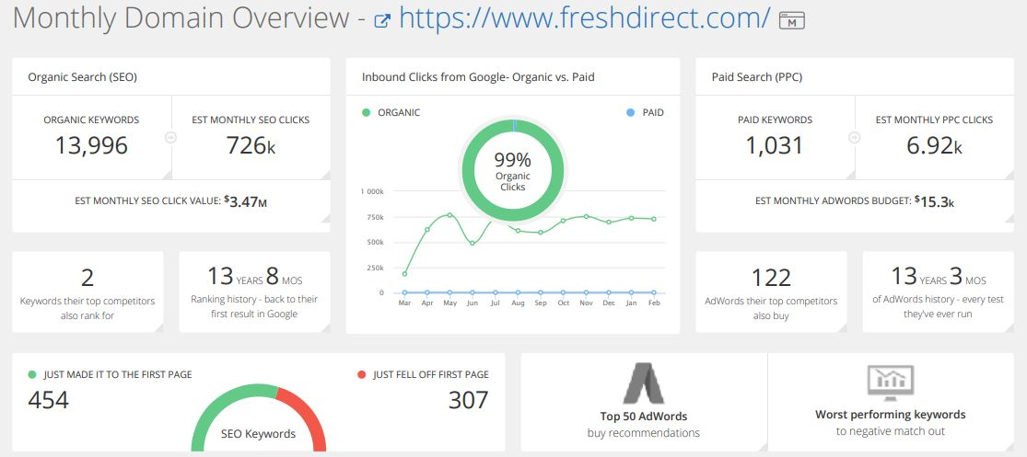

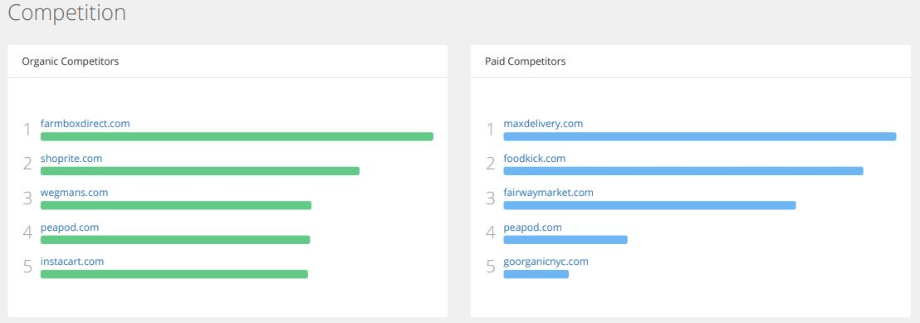

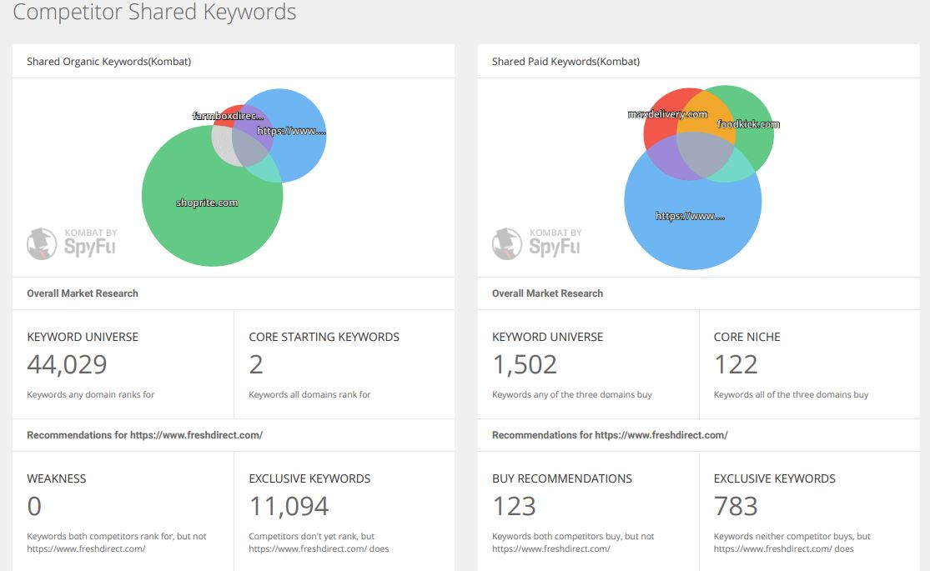

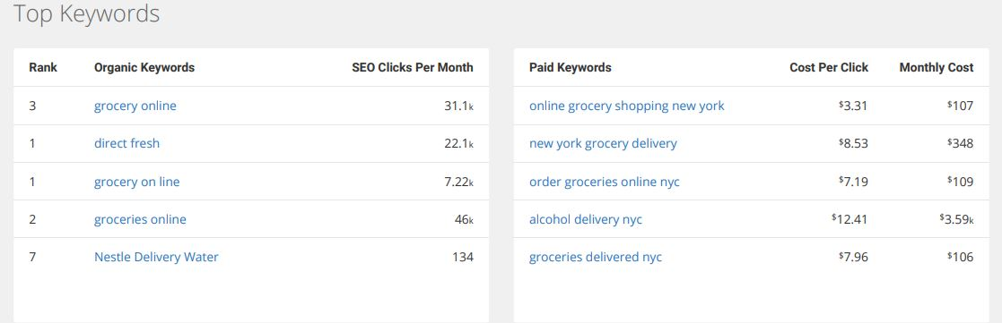

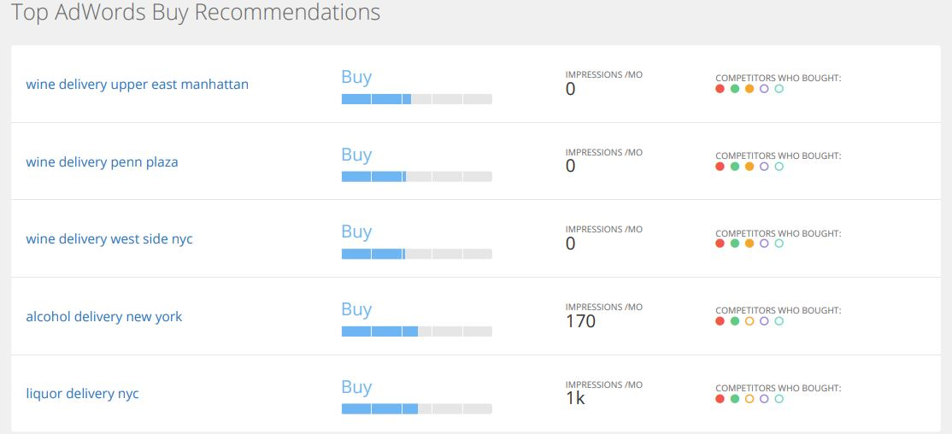

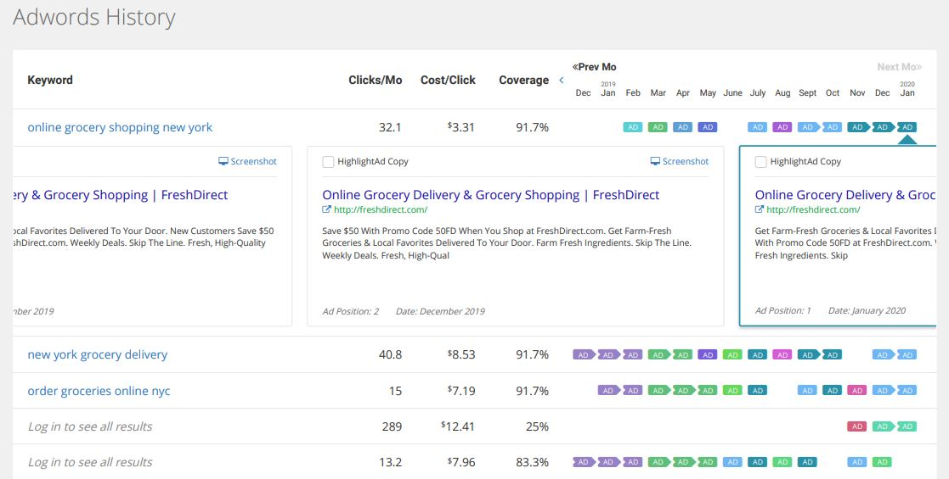

1. **Сравнение на уникално съдържание**

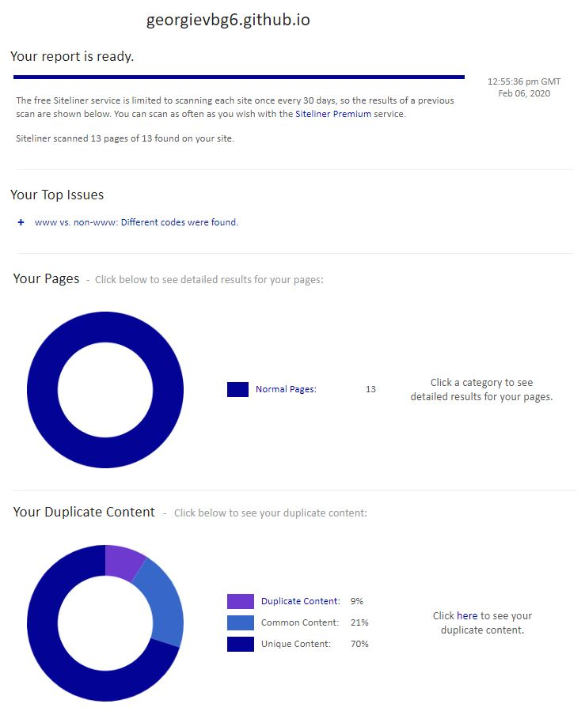

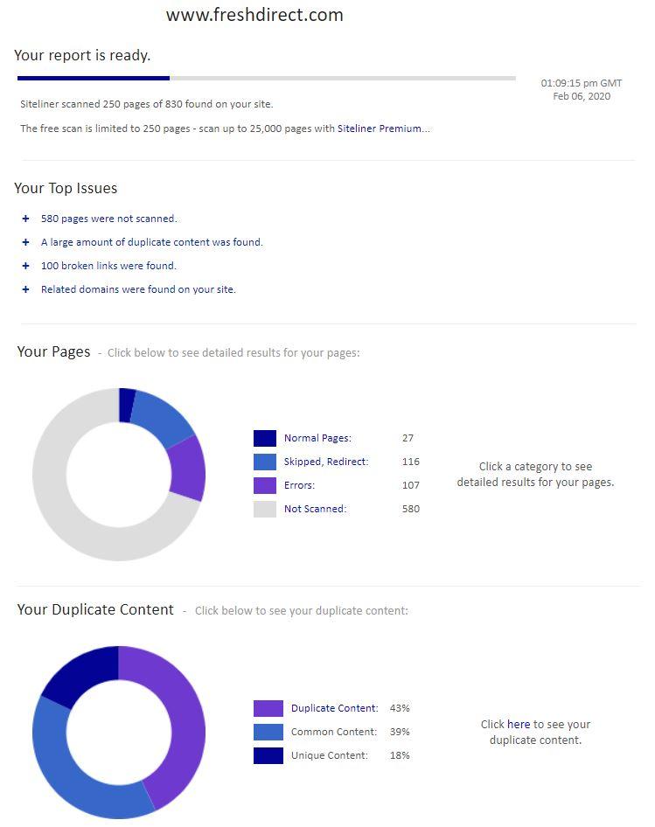

<https://georgievbg6.github.io/> -

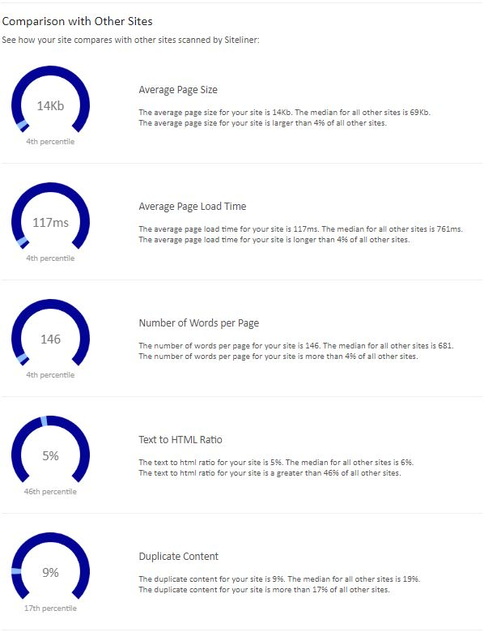

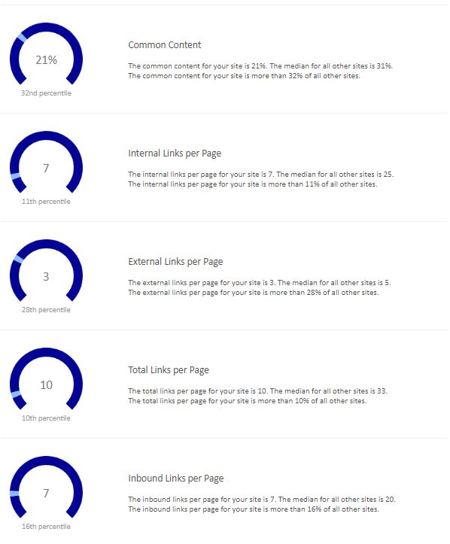

<https://www.freshdirect.com/> -

