Usability Inspection

1. Schneiderman and Plaisant
I used Schneiderman and Plaisant’s (2010) heuristics for the inspection of Google Maps’s mobile user interface. I did not use Nielsen’s list because for the past 23 years technology has grown rapidly and so have people’s expectations of it. Nowadays, it is assumed that applications always work, their usage is intuitive and no one reads documentation. ^{[1]} Schneiderman and Plaisant’s rules cut out the less relevant “error recovery” and “documentation” in favour of “universal usability”. Today, computing devices are widely available and it is very important for applications to cater for users of all backgrounds.
I would also like to note that Google Maps has had a usability inspection based on Nielsen’s heuristics in 2005.^{[3]} Since then, the company has improved their product in many aspects.

2. Device details
For my inspection, I used a LG G4 Android phone and the mobile app version of Google Maps. The device has: Android version – 6.0 (Marshmallow); chipset - Qualcomm MSM8992 Snapdragon 808. Six cores - four 1.4GHz Cortex-A53 and two 1.8GHz Cortex-A57; 3 GB RAM; A-GPS, GLONASS.

3. System exploration

Description and summary
I completed the evaluation by first going through all the parts of the Google Maps application and taking notes on issues that I found. After that, I associated those issues with the different heuristics by Schneiderman and Plaisant. Next, I looked up different papers on the topic of “digital maps usage” (and similar), in order to gain a better grounding. Finally, I evaluated the whole app again, this time with my personas, the heuristics, and the studies in mind.
Heuristic | #Problems | Issue IDs
Strive for consistency | 2 | Issue 1, Issue 2,
Cater to universal usability | 1 | Issue 3,
Offer informative feedback | 6 | Issue 1, Issue 4, Issue 5, Issue 6, Issue 7, Issue 8,
Design dialogues to yield closure | 0
Prevent errors | 1 | Issue 8,
Permit easy reversal of actions | 2 | Issue 9, Issue 10,
Support internal locus of control | 5 | Issue 2, Issue 4, Issue 7, Issue 8, Issue 11,
Reduce short-term memory loss | 2 | Issue 2, Issue 9

Evaluation
Google Maps is a popular digital map software. Despite a couple of issues, the system strives for consistency with other digital and physical maps users might be familiar with. Most users will quickly get used to the interface but the application still has a way to go in terms of universal usability. The most common interactions are well thought out, end with a noticeable change (e.g. pan the map or bring up a list), and provide sufficient feedback. Error prevention happens somewhat subtly. Typos and addresses are auto-corrected, Street View does not have a thumbnail image and it does not react when there is no caption available to render. Google Maps does not feature an “undo” feature which takes away from the aesthetic beauty of reversing actions. For the most part, the UI provides control to the user over the software. Google Maps deserves a high score in terms of reducing short-term memory load. It keeps track of recent searches and does not require the user to remember any specific commands. It can also keep track of favourite places, thereby reducing long-term memory load as well.
Issue 1 – Lack of “Legend”. Google Maps applies colours to some buildings and areas but it does never state what each colour means. You might see yellow and pink buildings but there is no ‘standard legend’ to provide meaning. The colours are explained in this forum post by a Google Maps Community Manager.
Issue 2 – Same features do not share the same names. When the application loads up, at the bottom line the user can see a few map layer options - “Explore”, “Driving”, and “Transit”. The triple dots pull up three more options, of which only “Bicycling” is relatively close to the others. Moreover, the same options are available through the ‘triple layer icon’ in the top right of the screen. This just makes it confusing, especially with one of those layers having a different name (“Driving” is the same as “Traffic”).
Issue 3 – Visually impaired. Vihaan uses his phone’s “TalkBack” functionality and the vocal navigation to use Google Maps. It is much better than paper maps but his experience with the system is still limited by the fact that some icons and button are too small for his impaired sight. Colourblind people also run into limitations. See this.
Issue 4 – Prioritizing map elements. Often when zooming in/out on the map, some icons and details on the map will appear and disappear. There is no priority order specified for what gets shown and what – not. The user is not given any control over that.
Issue 5 – Distance measuring. When measuring distance (from a pin put on the map), once the distance reaches 0.1 mi, the distance in feet is no longer available. Essentially, the precision is reduced.
Issue 6 – Greyed out timeline. In “Timeline” mode, there is no indication as to why some sections are greyed out on the map. The blue lines are the ones the user has walked through but the grey ones are left to their imagination.
Issue 7 – Confusing touch interactions. In Street View mode, touch responses are often counter-intuitive, and in some cases the view repositions on its own, without displaying any message to the user.
Issue 8 – Pin restriction. When viewing a tagged location (such as home, work, or a custom tag), the user is not allowed to place pins on the map. No reasoning is provided for this behaviour and no error is shown.
Issue 9 – Lack of undo. In my opinion, this is a major flaw in the software. There is no way to undo any tap the user has made. Tapping a point of interest removes the current (unsaved) pin and there’s no way to get it back. Accidentally closing a route causes the application to completely forget it. If the user has prepared a long trip and then pushes the ‘X’ button at the top right, the route is closed, all untagged points of the path are forgotten and there is no ‘undo’.
Issue 10 – Lack of redo. The “measure distance” mode has a ‘remove last point’ arrow, which resemble undo but it does not have a matching redo. Once a dot has been removed, it’s gone for good.
Issue 11 – Blocked full screen. When looking at a route between two points, the interface does not let the user enter full screen mode. The details of the route take up more than 40% of the screen and multiple routes are hard to compare.

4. Appendix (screen shots)
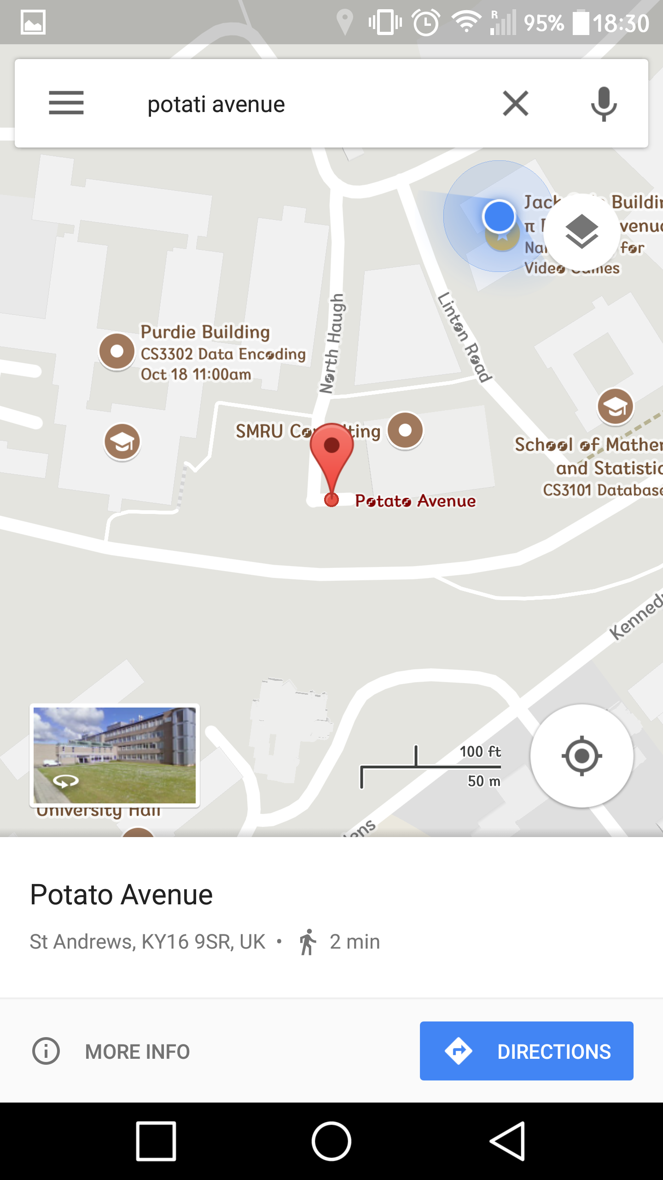
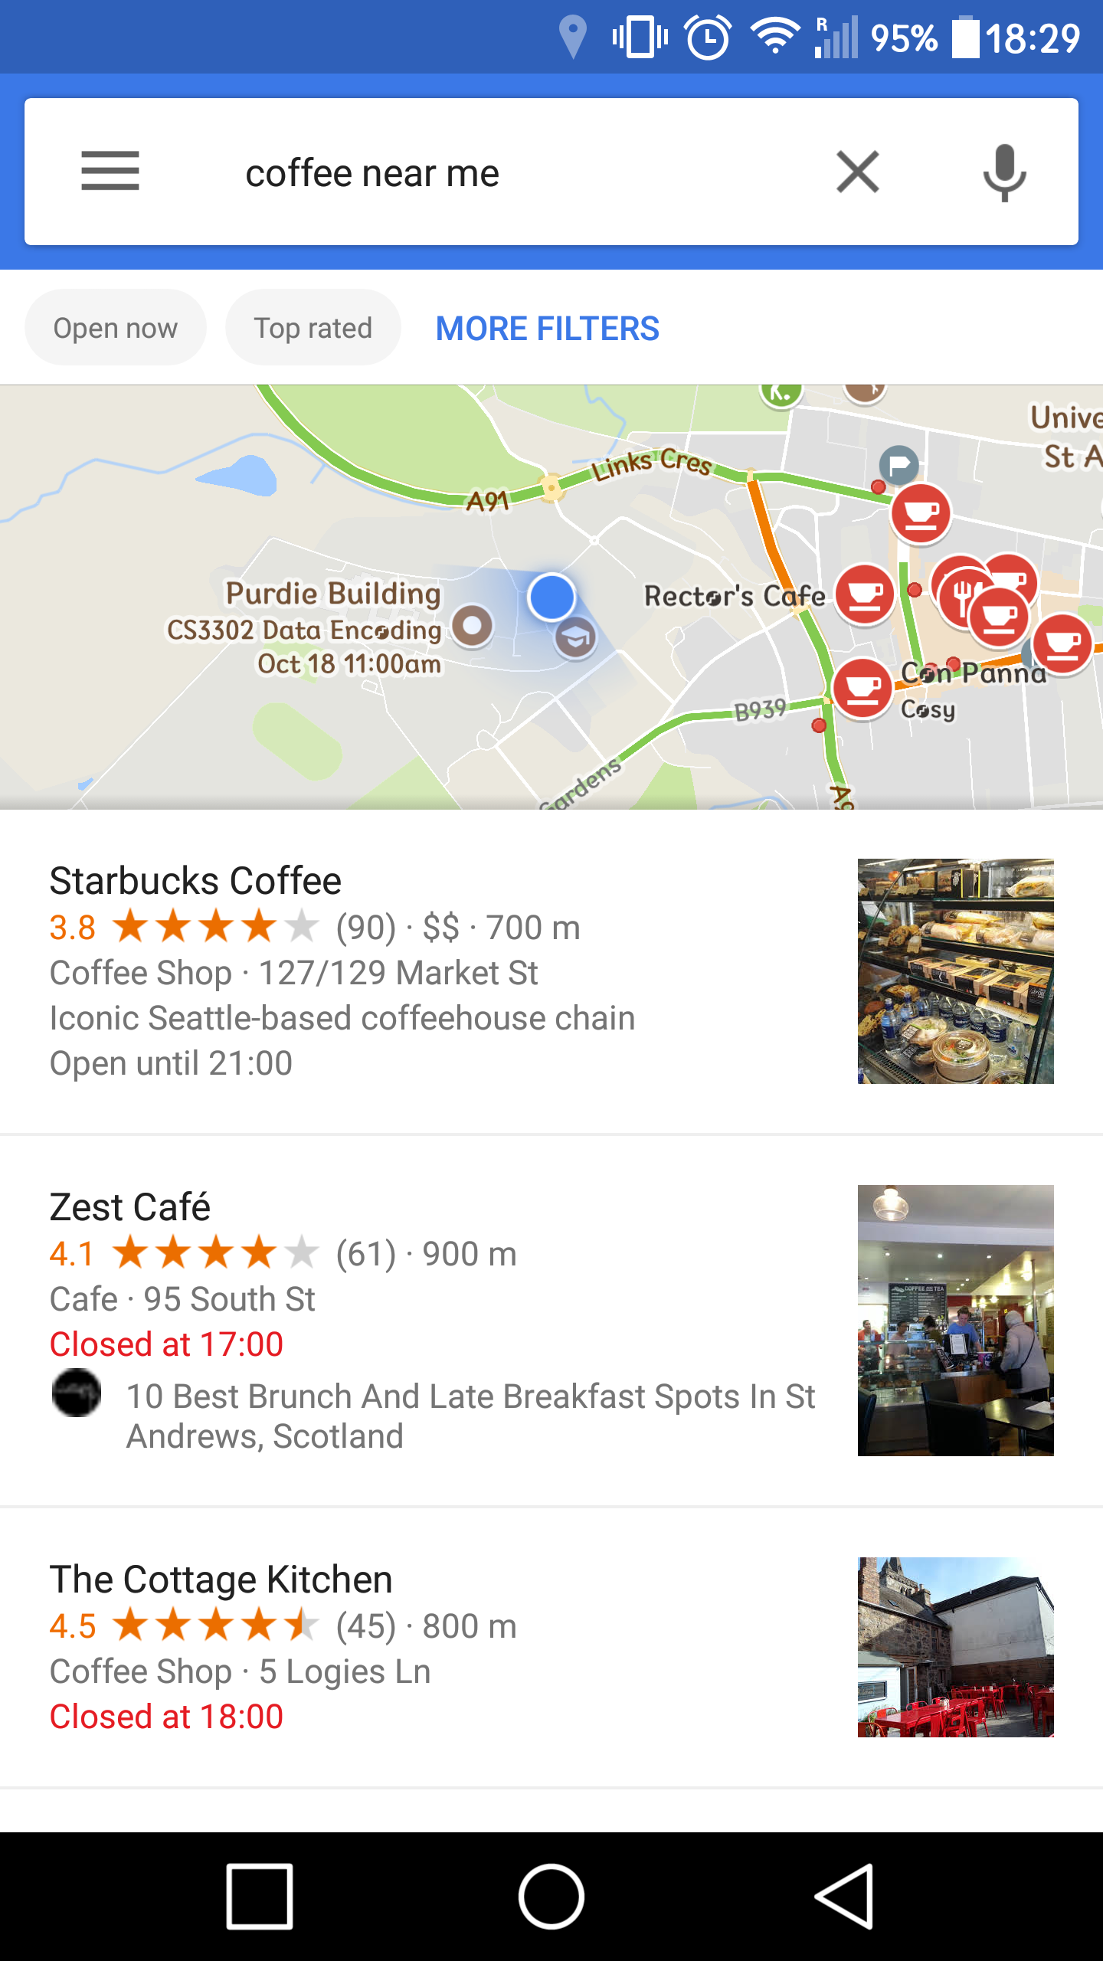
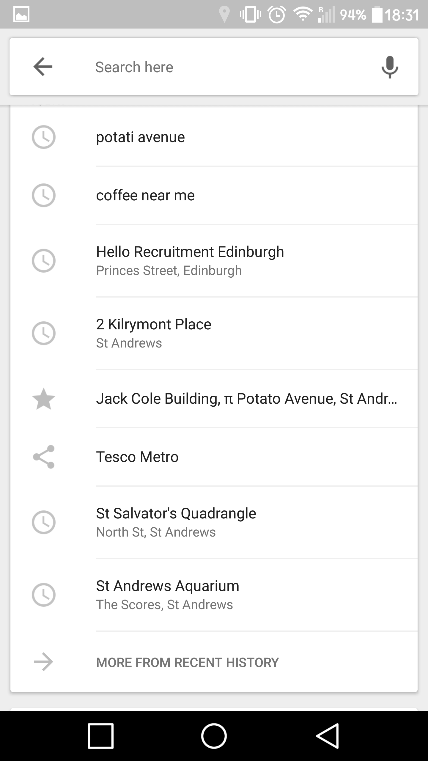
Auto Corrected Search Results Search Results

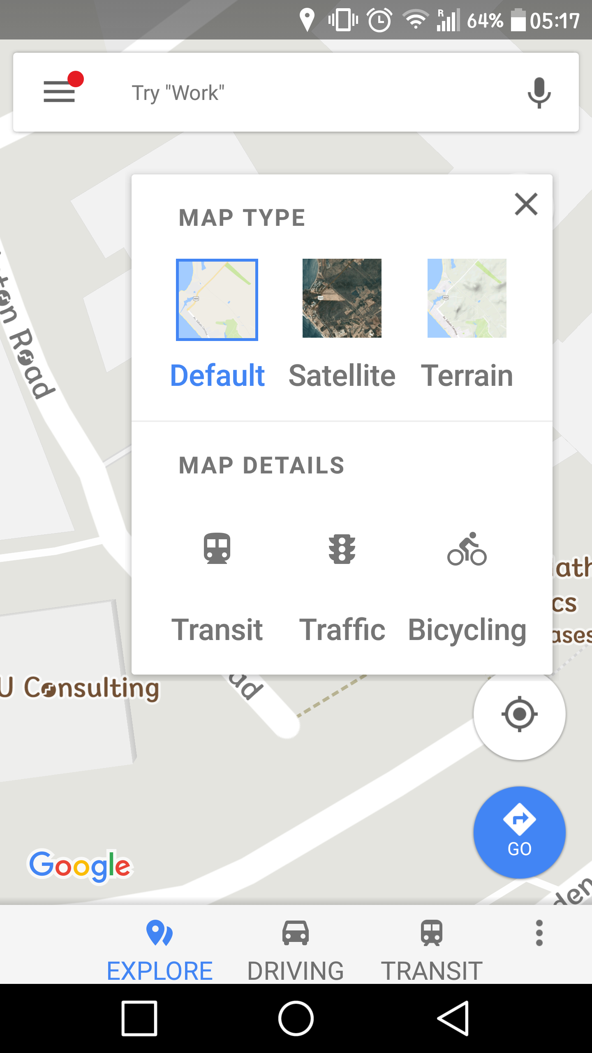
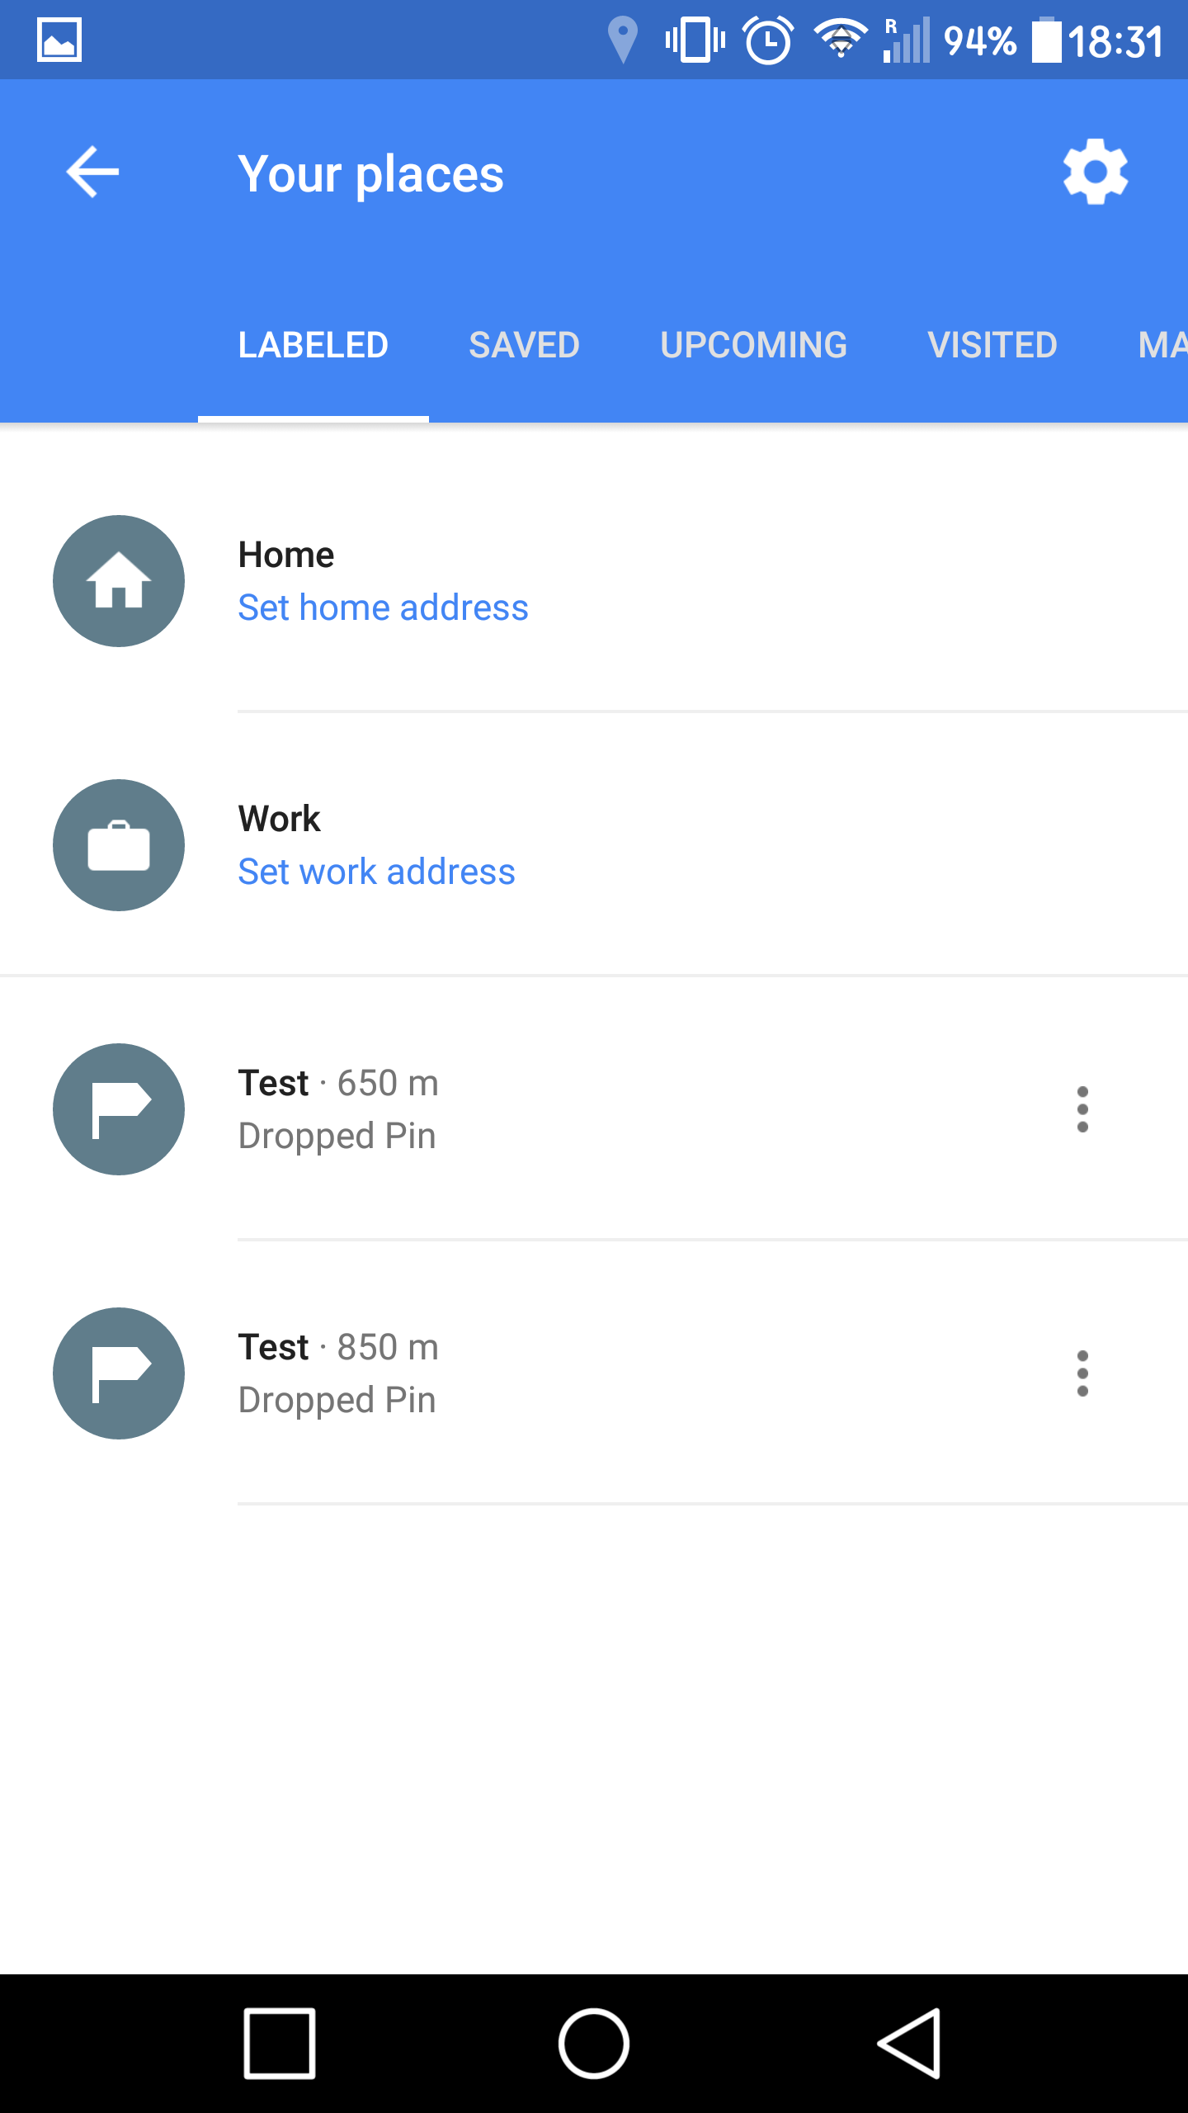
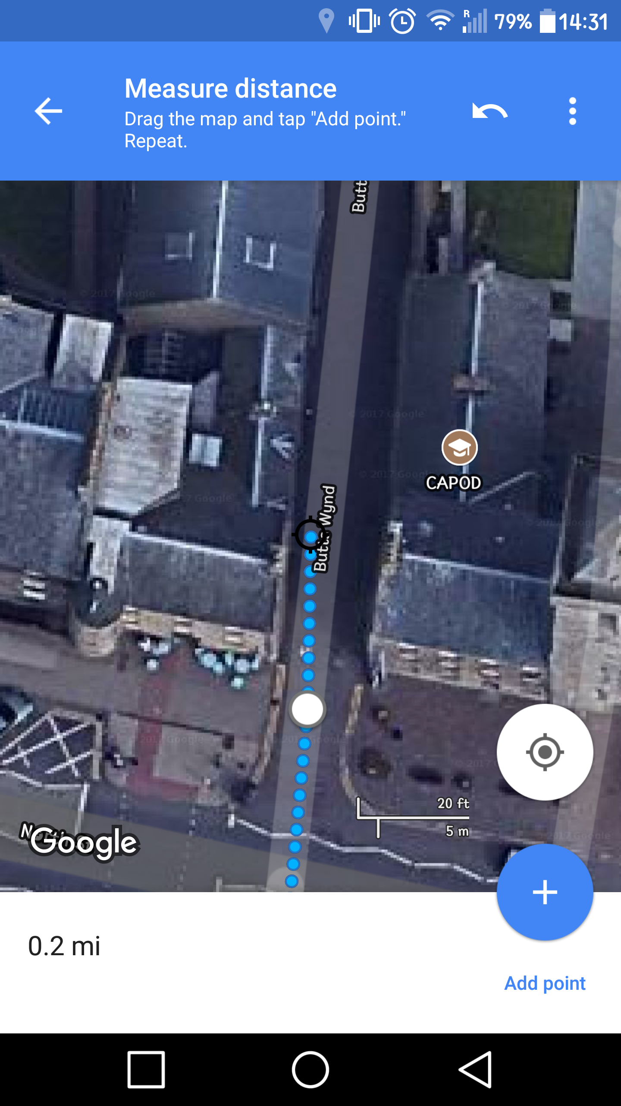
Same Functionality Saved Places Point and Distance
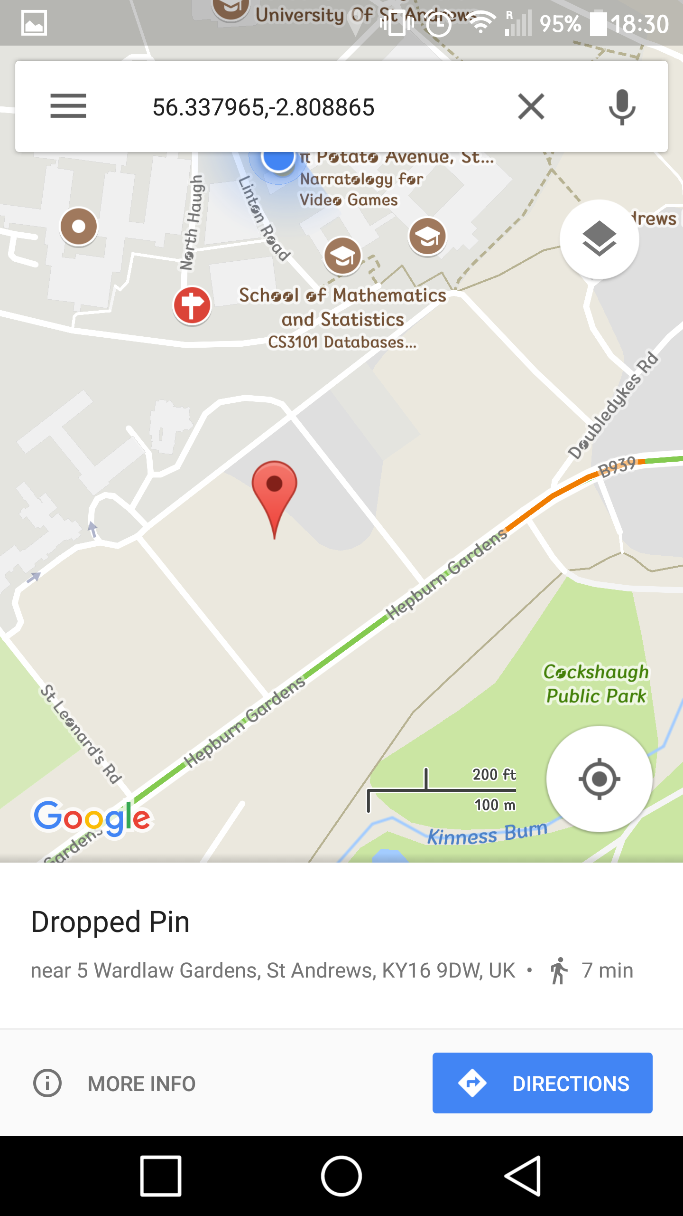
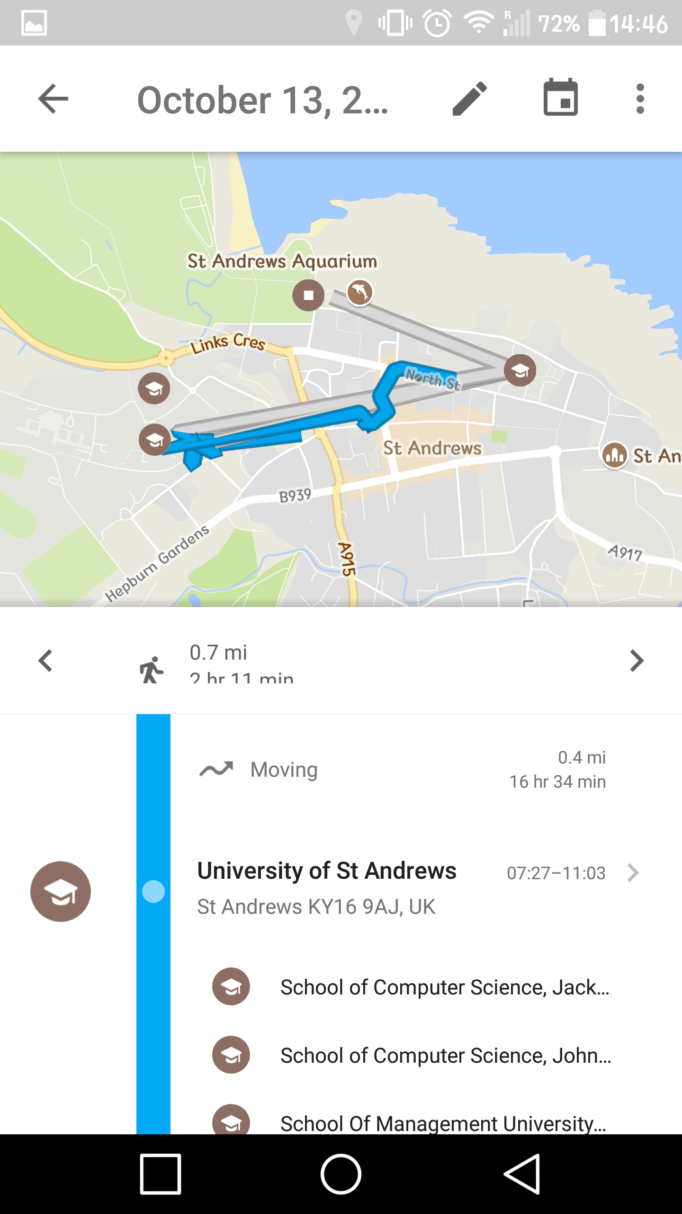
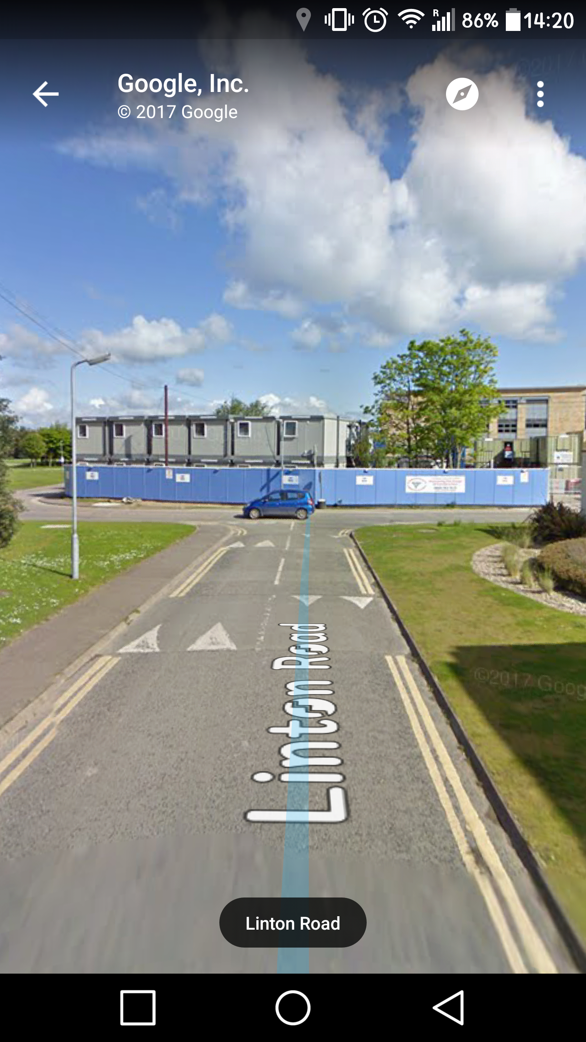
No Street View Grey Path in History Counter-Intuitive

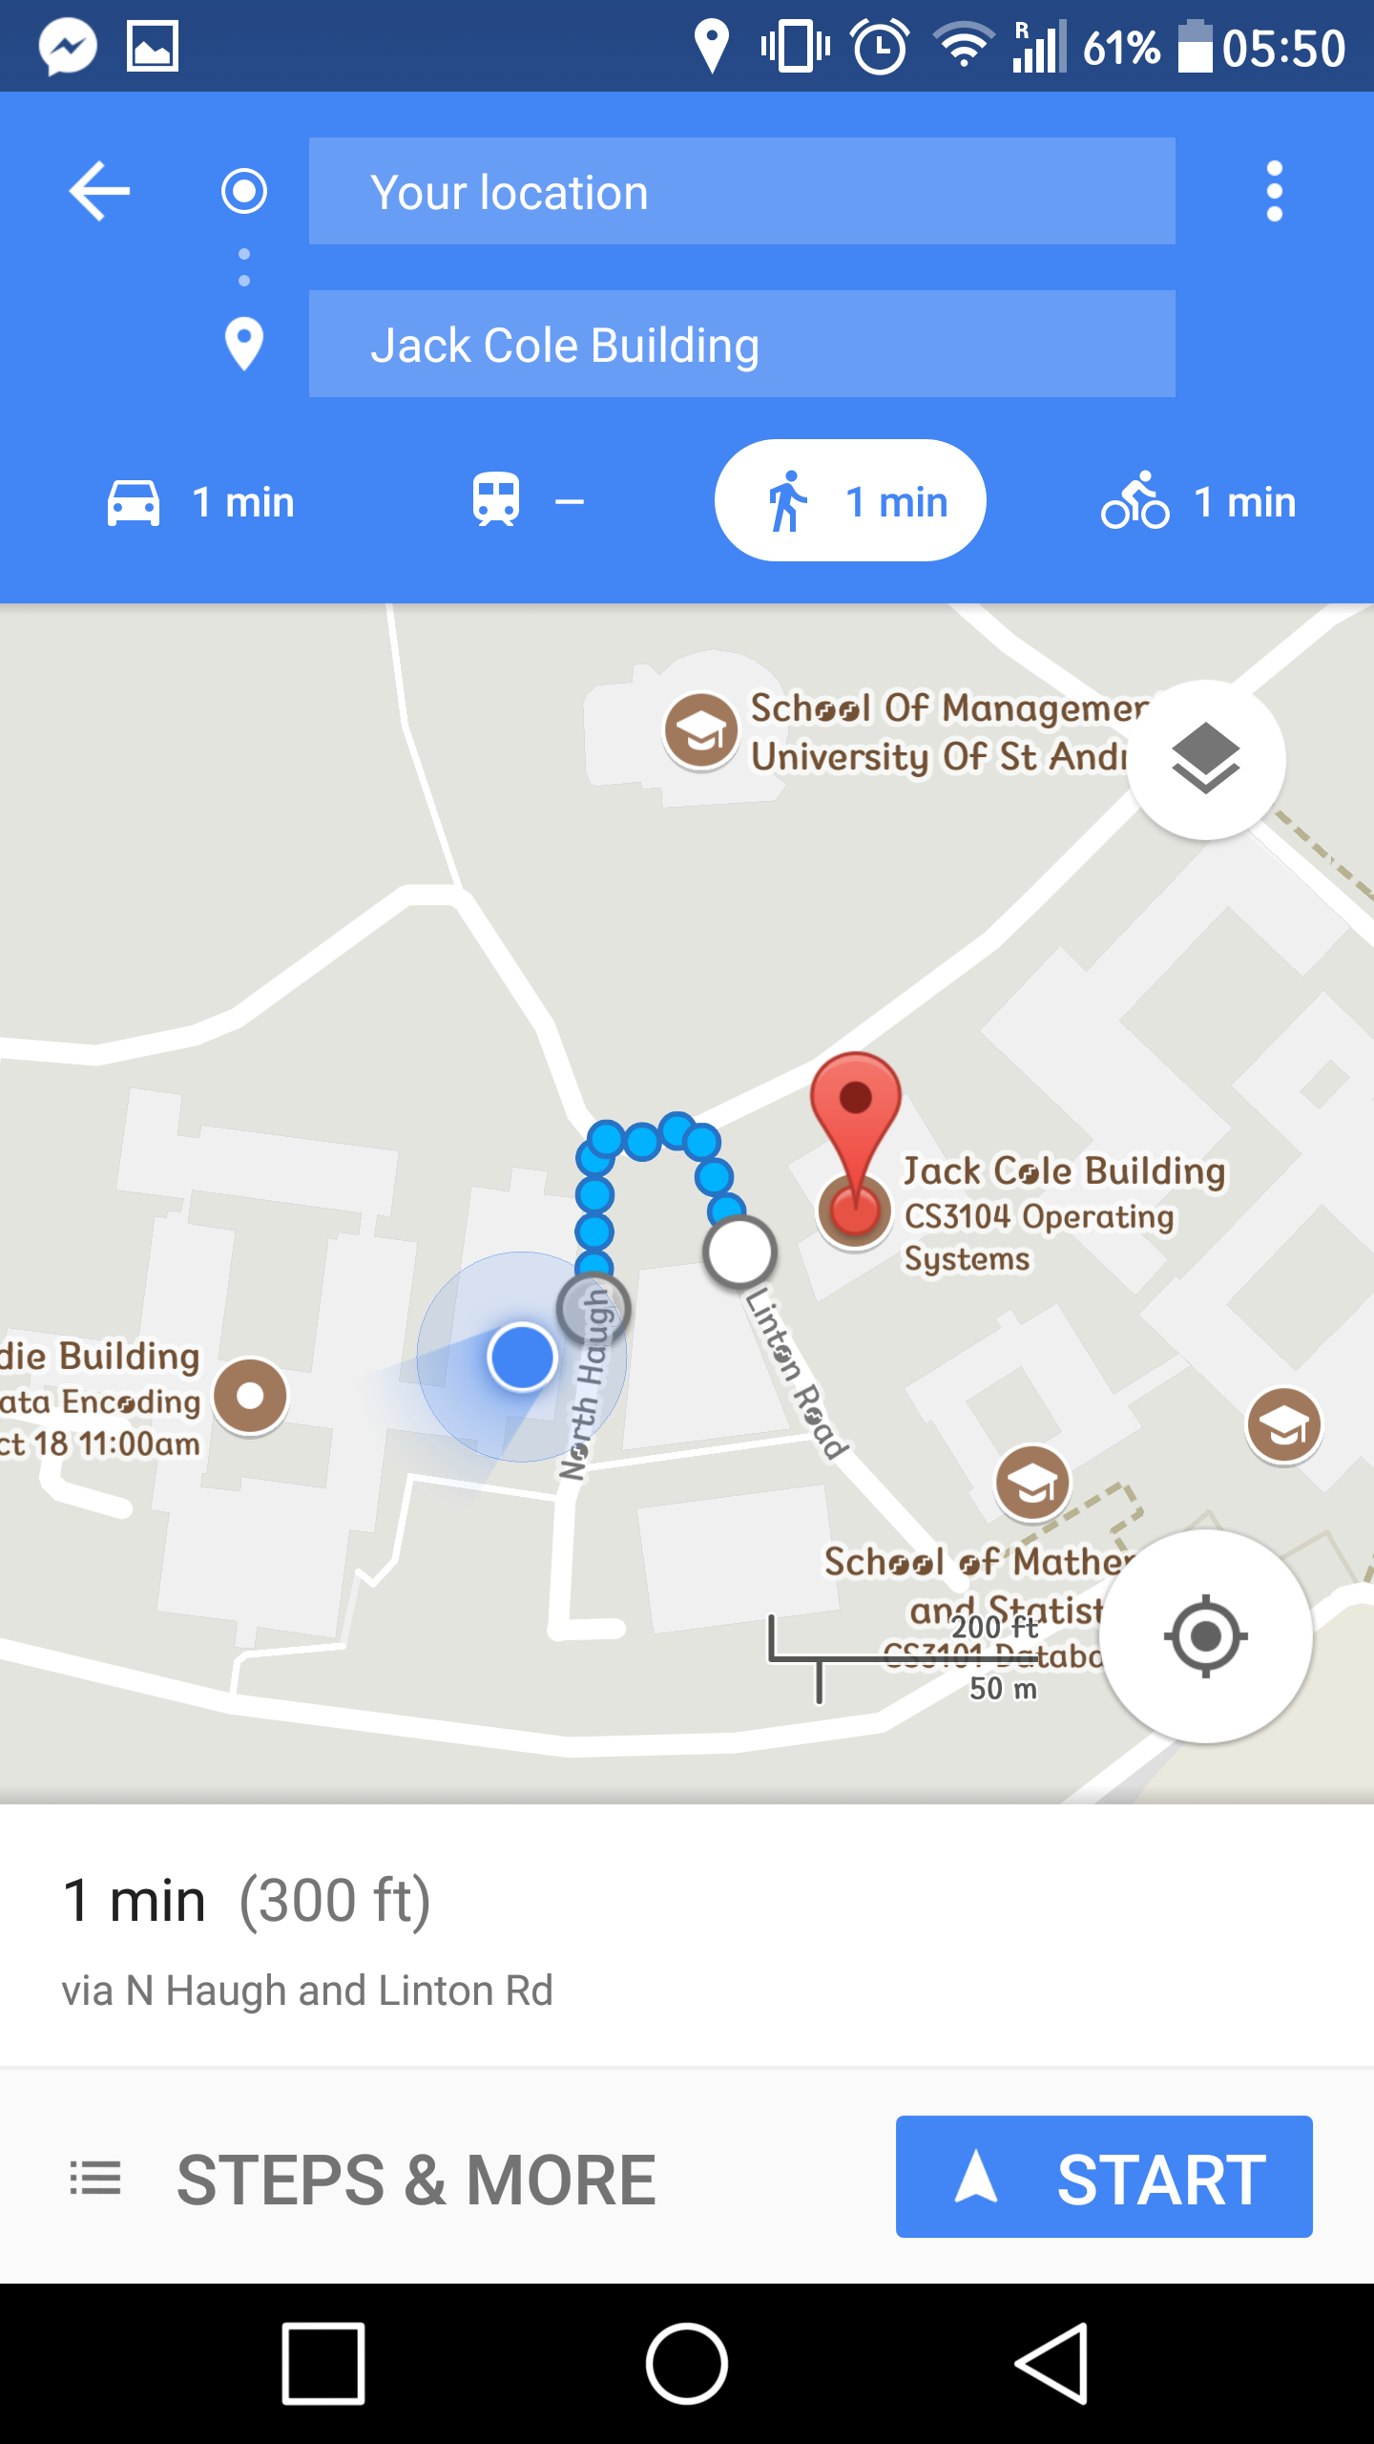
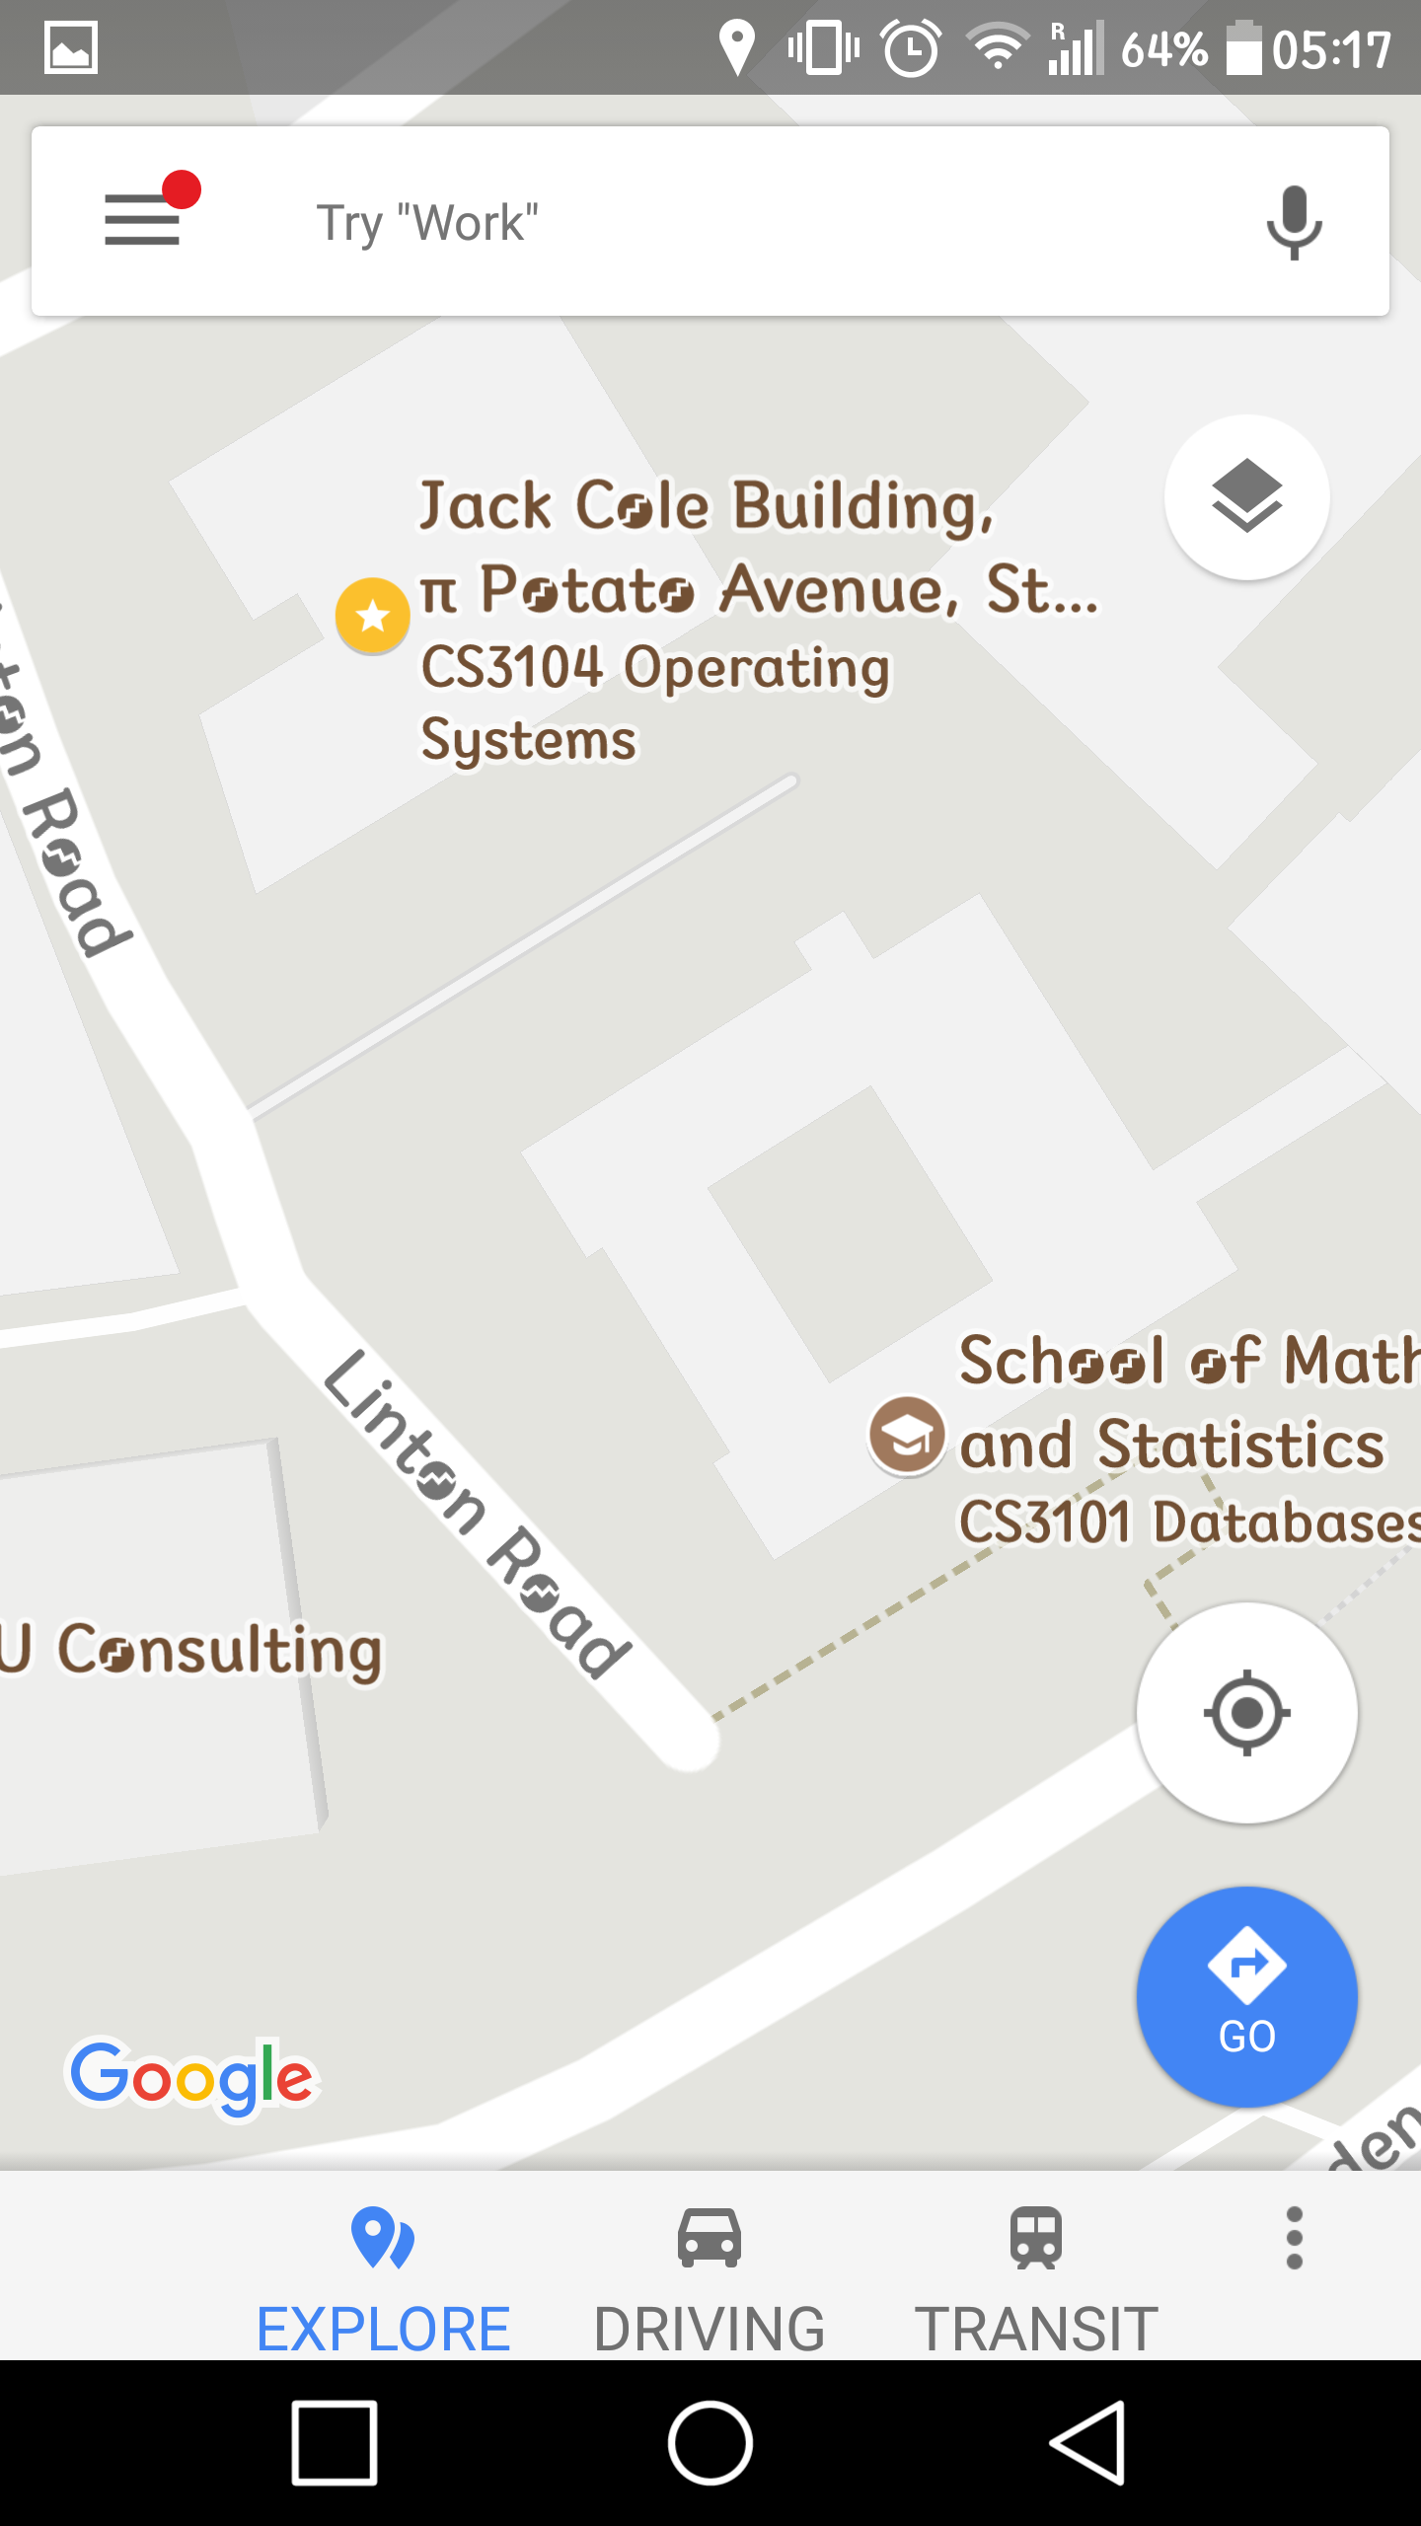
Zoom Disabled What gets shown?

References:
[1] David G. Novick, Karen Ward (2006). Why don’t people read the manual?
http://digitalcommons.utep.edu/cgi/viewcontent.cgi?article=1010&context=cs_papers
[2] Marc Rettig (1991). Nobody reads documentation
https://dl.acm.org/citation.cfm?id=105788&CFID=987104295&CFTOKEN=61989172
[3] Robert Murphy, Cassy Rowe (2005). Google Maps Comparison Study
http://rc-murphy.com/portfolio/usability/google_maps.pdf
[4] AJ Polanco, “Google Maps” for Desktop/Mobile – A Heuristic Evaluation Report
https://www.scribd.com/document/275169301/Google-Maps-Heuristic-Evaluation

