Scenario of Use

Desired functionality
This study shows that people are looking for a grid feature in digital map software. Such a grid will give the user a rough estimate of distance just by looking at the UI. Currently that can only be achieved by setting points for either a route or the “Measure Distance” mode. However, neither of those two methods can be used to compare distances or view the lengths of streets.

Sample Solution
A “Ruler Grid Overlay” feature could add a lot to Google Maps. There could be a switchable overlay grid that puts lines over the streets and shows their lengths instead of names. The feature will be usable in two ways: “Lengths Only” and “Distance from Point”. The former will only display the street lengths. The latter will use a starting point (either user location or dropped pin) and add up the lengths of the streets to show the distances to different intersections. Pressing a number (the length of a street) will highlight the line on the map that is being measured. A pop-up menu will provide the option to put “line breaks” and measure the line in parts.
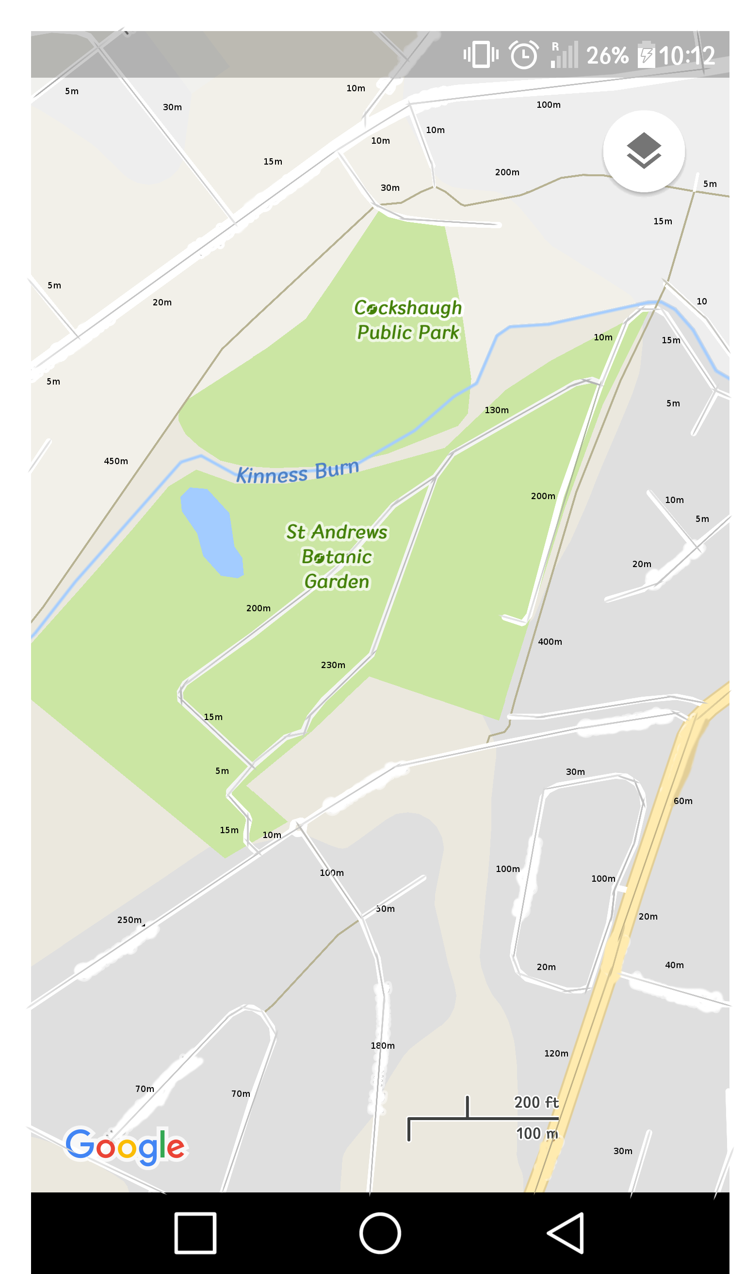
numbers in example are rough estimates
they can be exact point to point distances

Reference
[1] A.-M. Nivala, S. Brewster, L.T. Sarjakoski¹. Usability Problems of Web Map Sites
http://www.dcs.gla.ac.uk/~stephen/papers/Nivala_etal_ICC07.pdf

