Reasoning with Uncertainty
Bayesian Networks

Overview
The assignment asks to model two Bayesian Networks and then implement the merging algorithm Feng et al (2013) as described in the lectures. I have completed both parts of the assignment. The networks reflect my interpretation of the problem specification, as required by the practical. The merging algorithm is separated from the code that constructs the networks and can be applied to any two Bayesian Networks.

Running

XML Model
The two xml models bn1.xml and bn2.xml can be viewed in the AISpace tool referred in the practical specification. A copy of the tool is not supplied with this submission but it can be obtained from http://www.aispace.org/downloads.shtml under “Belief and Decision Networks”.
With the Java jar file, execute java -jar bayes.jar. Then select File > Load from File, navigate to the submission folder and open the XML.

Merging Algorithm
A Java jar file is provided to run the algorithm.
Execute java -jar prob.jar <network creator class>. The expected argument is the name of the class that creates the networks to be merged. There are four accepted arguments: Practical, Example, Simple, and Corner. The program is case-insensitive, any argument is converted to lower case and its first letter to upper case.
Running the program with Practical as the argument, creates and merges the networks defined in the submitted XML files. (Command: java -jar prob.jar practical)
Running the program with Example as the argument, creates and merges the networks defined in the XML files from studres. (Command: java -jar prob.jar example)
Running the program with Simple as the argument, creates and merges two small networks that were used for a simple test case. (Command: java -jar prob.jar simple)
Running the program with Corner as the argument, creates and merges two small networks that were used for a corner case. (Command: java -jar prob.jar corner)

Interpretation
As stated during the lectures, the practical specification was vague in terms of describing the fictional scenario. The following is one interpretation and imagining of the policies and systems inside CNX.
CNX has several systems that each determine how likely is it that a part of the network is under attack. The outputs of those systems are combined in an alert system. The chance for an alert to be triggered increases with the number of systems that report high likelihoods of attacks.
The assignment asks to consider possibilities of attacks in a single moment in time, without inspecting how the situation may evolve. The following subsections detail how each part of the system operates and what that means in a single moment.

Phishing Detection
The Phishing Detection System (PDS) inspects the contents of emails and determines whether or not an email is an attempt at phishing. Emails are divided into two categories – Personal and Business. Since the environment is a company network, it assumed that most (90%) emails are Business and few (10%) are Personal. It is also assumed that phishing attempts are more likely to be disguised as personal emails because few employees would have access to CNX’s bank account(s).
Thus, PDS catches nearly all phishing attempts in Personal emails and most phishing attempts in Business emails. For each email category, PDS has a 3% chance to incorrectly classify the email (that is, mark a phishing email as non-phishing or a non-phishing email as phishing).
In a single moment in time, the system reports whether it detected phishing based on the most recently received email was a phishing attempt.

Network Protection
A firewall is present to protect the network from various malicious software. If maintenance is planned, there is a 5% chance that the firewall is turned off. Furthermore, the Network Protection System (NPS) has access to an up-to-date list of possible attacks and can predict how well protected the network is against them. The maintenance information is out of date 2% of the time. That is assumed to mean that CNX security officers believe that they have performed maintenance to protect the network against new threats but that has not actually happened. In that case, NPS is more likely to report that the network is vulnerable.
In a single moment in time, the system reports whether the network is protected based on the firewall status (on/off) and whether or not maintenance information is up to date in that specific moment.

Distributed Denial of Service
CNX is located in a place where there are 100 days of holidays and political events in 360 days. It is assumed that 360 is rounded down from the normal length of an year. It is also assumed that holidays and political events combined make up 100 days. That leaves 260 work days. It is assumed that Distributed Denial of Service attacks (DDoS) are uncommon on workdays (1% chance) and intensified on non-work days (10% chance).
In a single moment in time, the system reports whether the chance for a DDoS is high based on the type of day (work or holiday/political event).

Logging
A logging system monitors activity on the network and records only anomalous activities. Activities are considered to be any client-generated traffic. Since the system has a bad fault tolerance, there is a 30% chance that a normal activity will be logged and 30% chance that an anomalous activity will be missed. It is assumed that most (90%) activities are normal.
In a single moment in time, the system reports whether or not it logged the most recent activity.

Alert Triggering
The Alert system takes in the reports of the previously described systems. An alert is triggered if there is need for one of the security officers to inspect the system. In other words, the situation is critical. It is assumed that each part of the network can defend itself well. The chance of an alert increases with the number of systems that report danger in their areas. Thus, a coordinated attack on multiple parts of the system (for example DDoS and Phishing at once) has a greater chance of producing an alert.
Each system has a value associated with it. These values have a sum total of 100. When determining the chance for an alert, the current sum total is multiplied by 80% to account for the probability of raising an alert in any situation.

SQL Injection
The practical asks to augment the Bayesian Network derived from the five factors above. For this purpose the risk of SQL injection has been introduced into the system. Because such attempts are fairly easy to detect (searching for keywords and characters), the system is given a high chance of catching them (90%).
Similar to previous factors, in a single moment in time, it reports whether SQL Injection has been detected based on the most recent database query. When determining the alert, the values for the other factors are reduced, so that with this value, the sum total is still 100.

Models
The two Bayesian Networks produced for this assignment are referred to as models, so as to differentiate from the company network. The first one BN1 is detailed in the following subsection. The second one BN2 adds two more events and those are described in the second subsection. For the most part, anything that applies to BN1 also applies to BN2.

BN1
The model is constructed with a top-to-bottom flow. Events higher up in the model influence those below them and no event influences an event above it. Each factor from the interpretation is represented by a branch. Each branch contains all events needed to model its respective factor and appropriate relations between them. The alert system is represented by a single event Alert which accounts for the 80% probability of triggering an alert. All branches lead to Alert.

Phishing Detection
The Phishing Detection branch tells Alert whether or not Phishing has been detected. The Phishing node represents whether or not the email received is actually an attempt at Phishing. It is assumed that phishing does not happen that often, so it’s given 20% chance being true. The Email node represents the type of the content of the received email (Personal or Business). As previously stated, it is assumed that 90% of all emails are business related.
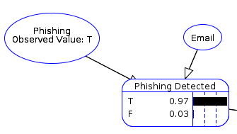
Finally, the Phishing Detection System itself is represented with the node Phishing Detected. It is affected by Phishing and Email. Its Conditional Probability Table (CPT) is empirically derived. They are set so that the chance of catching a Personal Phishing email is higher than the chance of catching a Business Phishing email because Business emails more often involve transactions. Furthermore, the error is always 3%.
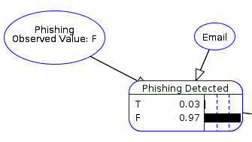

Network Protection
This branch tells Alert whether or not the network is protected. The Maintenance node says whether or not maintenance is currently happening. It has been assigned an arbitrary probability of 20%. It directly affects Firewall, the node that says whether or not the firewall of the network is currently on. The 2% chance of having outdated maintenance information is represented by Maintenance Info Outdated which directly affects Network Protected. The latter node is also affected by Firewall. Network Protected determines if the network is protected in the current moment. It represents the aforementioned NPS.

DDoS
This branch models the intensification of DDoS attacks during holidays and political events. It tells Alert whether there is a high chance of a DDoS attack in the given day. It has two events – Work Day which influences DDoS Chance. Work Day has a 72% chance of being true because 260 days out of 360 are ‘work day’s, and that ratio is roughly 72/100.

Logging
This branch is as simple as the DDoS one. It tells Alert whether the last activity has been logged. It has two events. Activity represents the type of the last activity (Normal or Anomalous) and it influences Logged. The latter event models the logging system’s error in determining which activities should be logged.

Alert
This single node models the alert system. The following values are assigned to each branch. Phishing Detected - 20 if true; Network Protected – 40 if false; DDoS Chance – 30 if high; Logged – 10 if true. For each permutation, the sum of the values is multiplied by 80% to obtain the chance of an alert. The values represent a threat level associated with each factor. Logged is given a low value because it is not very reliable. DDoS attacks are threatening but not unmanageable. If the network is not protected against Malware, however, then the situation can be quite dangerous.

BN2
This model adds a new branch and changes the values for the Alert node.

SQL Inject
This branch tells Alert whether or not an SQL injection has been attempted. It is made up of 2 nodes. SQL Inject represents whether or not a query was indeed an injection attempt. It has been given 20% probability due to its low chance of success. It influences SQL Inject Detected which models the SQL Injection Detection system.

Alert
Alert works in much the same way, except it’s probability table has doubled in size due to the presence of a new parent SQL Inject Detected. The values for all factors have been changed. Phishing Detected - 15 if true; Network Protected – 35 if false; DDoS Chance – 30 if high; Logged – 5 if true, SQL Inject Detected – 15 if true. SQL injection is fairly easy to protect against. It is more concerning than an anomalous activity and less concerning than the potential for a DDoS.

Queries
As required, three queries have been designed and tested on BN1 and BN2. Below are their descriptions and the evaluation results. It should first be noted that, when no events are observed, the overall probability of an alert is 7% for BN1 and 15% for BN2.
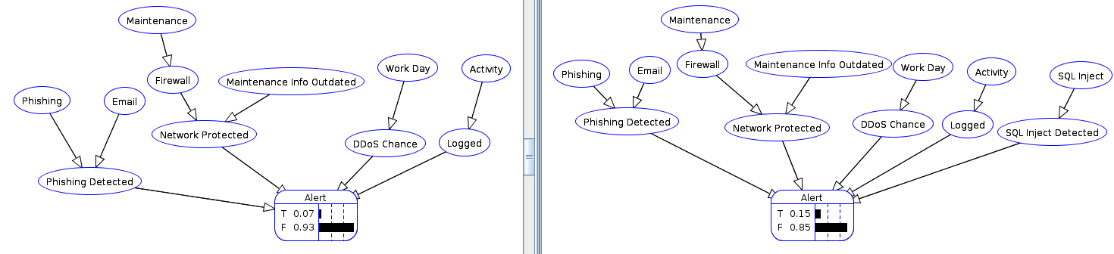
Note: In all images, BN1 is on the left and BN2 is on the right.

Predictive
The chosen predictive query is “Given that a Phishing email has been send, how likely is it that an Alert will be triggered?”. Formally, the probability P(Alert|Phishing) is inspected.
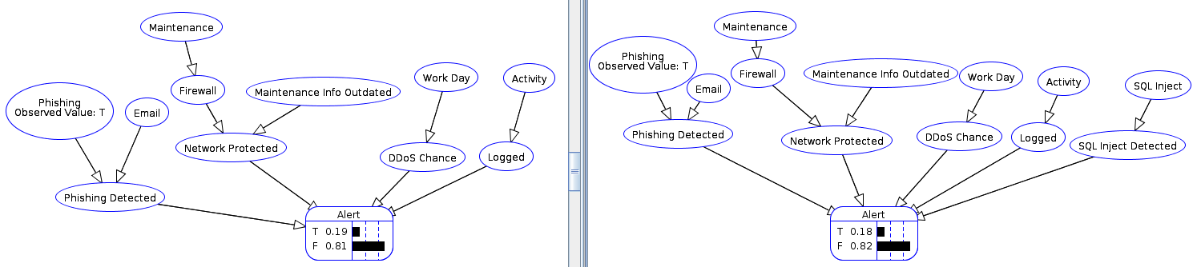
This shows that in BN1, P(Alert|Phishing) is 19%, and in BN2, P(Alert|Phishing) is 18%. The latter probability is slightly lower due to the lower threat level of Phishing (20 in BN1, 15 in BN2). The higher threat level in BN1 is also the reason why the probability of Alert jumped almost three times (from 7% to 19%).

Diagnostic
The chosen diagnostic query is “Given that an Alert has happened, how likely is it that the maintenance information is out of date?”. Formally, the probability P(Maintenance Info Outdated|Alert) is inspected.
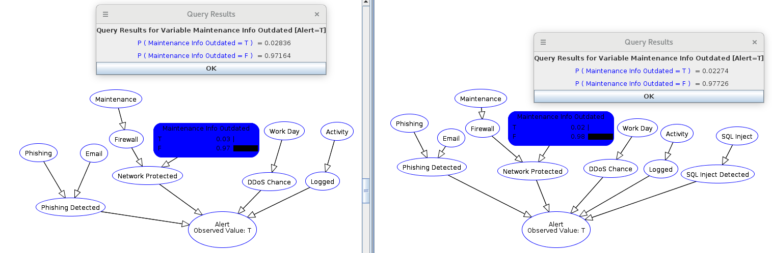
The original probability of the maintenance information being outdated is 2 percent and Alert alone has low effect on that. The image shows the slight increase in both BN1 and BN2 (BN1 puts more weight on Network Protection then BN2 does, so it’s near 3%). This is because Alert could be triggered by other factors and increasing a starting chance of 2% is very difficult.
However, let’s assume than an investigation proves that Phishing has not been detected, the firewall is turned on, the chance for a DDoS is low, that no activity has been logged, and that no SQL Injection has been detected. The probabilities are then:
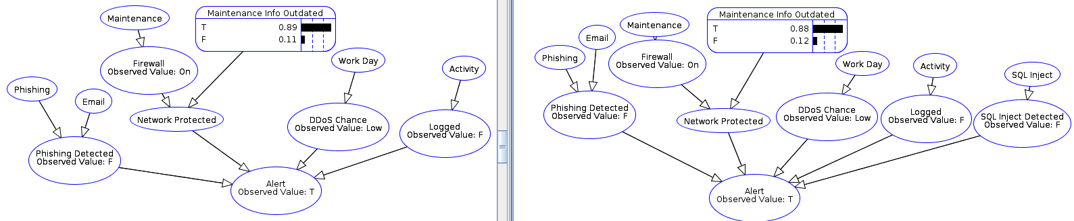
By the process of elimination, a security officer at CNX can now tell that outdated maintenance information is the most likely cause for an alert. (This query type is intercausal. It was added for demonstrative purposes.)

Profiling
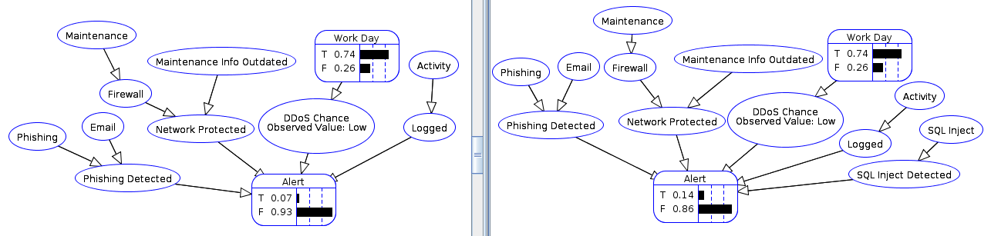
The chosen profiling query is based on DDoS Chance. It’s effects on Alert and on Work Day have been examined. The formal definitions of the probabilities are
P(Alert|DDoS Chance=High), P(Alert|DDoS Chance=Low),
P(Work Day|DDoS Chance=High), P(Work Day|DDoS Chance=Low).
Having a low chance of DDoS increases the chance of the current day being a work day. In both models, the probability changes by the same amount because the Work Day is the same and has the same conditional independences. The chance for an alert is slightly changed because low DDoS chance does not give information about the other factors that contribute to the triggering of an alert.
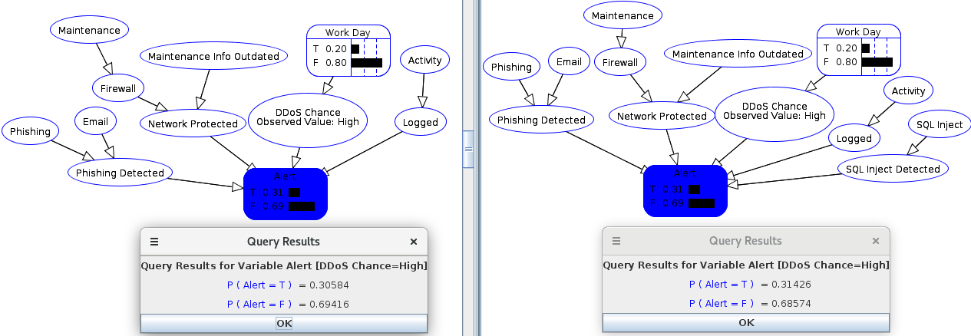
When the chance of DDoS is high, the events in both models change to relatively the same values. Naturally, the probabilities in Work Day are adjusted to account for the fact that DDoS is more likely on holidays and political events. The probability of an Alert becomes about 31% in both BN1 and BN2 because the weight of DDoS in both models is 30.
Overall, the models make a good representation of the fictional company’s network. CNX is in a fictional world with 360 days, so some probabilities are unrealistic. The probability of Phishing being true 20% of the time would mean that every 5th email is a phishing attempt. These values were purposefully exaggerated, so that the effects of observations are more visible. The realistic amount 1 in 131 emails^{[1]} may cause floating point precision loss when calculating very small values.

Merging Algorithm
The Feng et al algorithm has been implemented in Java. The Encog library has been used and, specifically, the bayesian package. It provides data structures for Bayesian Networks, events in those networks, and tables for the CPTs.
The class files in the packages main and networks have been written for this assignment. The util package contains a class reused from previous assignments.

Design
The implementation closely follows the steps of the algorithm as presented in the lectures. There is, however, one major distinction. When constructing the merged network BNT, first all necessary dependencies are added (from all steps), and then all CPTs. The reason behind this is that an instance of BayesianNetwork has to be ‘finalized’ before the tables can be edited. However, once an instance has been finalized, it cannot have new events or dependencies added.

Private Instances
The algorithm is implemented in the Merger class. It can be accessed with the static method merge. Internally, an instance of the class is created and that instance stores references to the original BNs, the new BNT, and the sets of ‘internal’ and ‘external’ nodes, and those that are outside the intersection. The merge method then calls methods on the Merger instance that execute the steps of the algorithm.
This way of accessing the merging functionality can easily be made thread-safe. Any thread can execute the static method merge but each call creates new instances of Merger, so the steps can be interleaved without affecting other executions.
In terms of usage, it is syntactically better to make a static call Merger.merge(bn1, bn2), rather than new Merger(bn1, bn2).merge().

Algorithm Steps
The steps of the algorithm have been implemented in several instance methods. The following steps have been omitted from implementation. Step 0 – the sets of events can be accessed by calling getEvents() on one of the Bns, and the getParents() method is implemented in the library. Step 1 – it simply looks into what the algorithm’s goals; Step 5 – the dependencies are easily accessible by calling getParents() on an event; Step 8 – it simply summarizes the progress achieved so far.
Steps 2 and 3 are implemented in two methods that determine the intersection set Z and then sort all the events into ‘internal’, ‘external’, and ‘outside’ sets. At this point, BNT has all the events. The next method calls add the dependencies between the events.
Step 4 is implemented in two methods. One copies the dependencies of nodes outside the intersection, while the other copies their CPTs. Again, those happen separately because the structure of BNT needs to be finalized before CPTs are edited.
Steps 6 and 7 are implemented in two methods. One iterates all internal nodes (step 6) and applies the DELETE RULE to each one (step 7) to determine which dependencies to copy into BNT. The other method iterates all internal nodes (step 6) and applies the DELETE RULE to each one (step 7) to determine which CPTs to copy into BNT.
Step 9 is implemented in one method which copies all dependencies that external nodes have. Step 10 is implemented in three methods. One iterates the external nodes, a second method recursively generates all possible permutations of values for the parents, and the third fills in the probabilities in one line of the CPT, given a permutation by the previous method. This is further detailed in the next subsection.
It should be noted that most method print output to the screen to show the progress through the steps of the algorithm.

CPT merging
When implementing the merging of CPTs for external nodes, the following issue was considered. What happens if an external event A has a parent B which is in the intersection? For example, event A has parents B and C in BN1, but in BN2 A has parents B and D. It is external, so the two CPTs have to be merged. However, simply multiplying the number of parents in each BN would mean that in BNT A will have 4 parents (2 by 2) whereas in fact, it only has three parents (B, C, D).
The following approach was taken. Given a mapping of values for the parents in BNT, create two more mappings, one for each of the original BNs. The new mappings comply with the given one, such that if parent X is true in the given mapping, it is also true in the mapping for BN1(if present there), and in the mapping for BN2(if present there). The same applies if parent X is false in the given mapping, it is also false in the new mappings. The two new mappings can then be used to access the correct probabilities in the two original CPTs. After that the standard rule p1+p2-p1*p2 can be applied. It is applied for both when the event is true and when the event false. The two resulting values are then normalized and added to the new CPT in BNT.
In terms of implementation, one method mergeLine() implements the approach described above. Another method recursePerumations() recursively creates all possible mappings for parents in BNT, and a third method mergeCPTs() iterates the external nodes and calls recursePermutations() to fill in the CPTs.
The aforementioned ‘mappings’ are implemented as arrays because the library accepts integer arrays as arguments. The implementation is not very efficient because it needs to search for the index of a parent event given its label (not an object reference). The parents are stored in a list structure, so after finding the index, that list has to be accessed with it. The index is needed, so that the value of the parent can be put in the correct index in the arguments array. So, there is a list access via index (a library method which likely has linear time complexity), which is inside a loop through all parents (linear time) in a BN, which is inside a loop through all parents in BNT (linear time). This is cubic time complexity in total. And it happens at the bottom of a recursive method, so further multiply by 2^{n}, where n is the number of parents in BNT.
Luckily, most events have less than four parents, so, in practice, this computation is not that expensive.

Sample Networks and Testing
The system has been tested multiple times with several input Bayesian Networks. The library method BIFUtil.readBIF() was throwing exceptions when called with the networks ‘bn1.xml’ and ‘bn2.xml’. Supposedly, that’s because those two files were manually edited and spaces were added.
An abstract class Creator was written that provides two methods to create Bayesian Networks. There are four implementing classes – Practical, Example, Simple, Corner. The Prob class contains the main method that is executed when the program is run. It parses a command line argument and uses reflection to find the class which is to be used to create the Bayesian Networks.
The output of running the program is as follows. First, the two Bayesian Networks are printed. Each network is displayed as a set of CPTs. Where events have dependencies, the parents are listed under the name of the event. They are ordered in the same way as the arguments in each row.
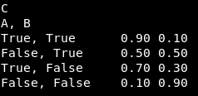
In this case, the CPT is for C, with parents A and B. In the second line, A is false and B is true.

After displaying the two Bayesian Networks, the merging algorithm takes place. Each major method outputs its progress to the screen. After the sets of nodes are filled, they are printed to the console. Finally, the merged BNT is printed in the same way as before.
The image on the following page demonstrates the full output of the implemented system.

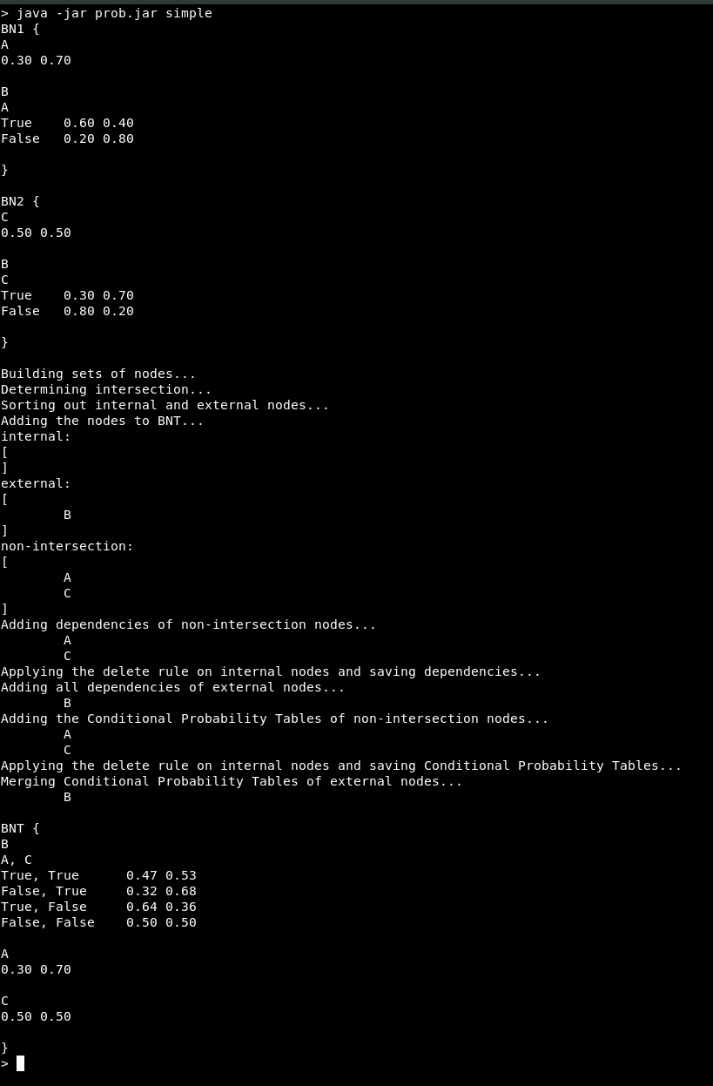
To demonstrate that the system works with the Bayesian Networks developed in part 1 of this assignment:
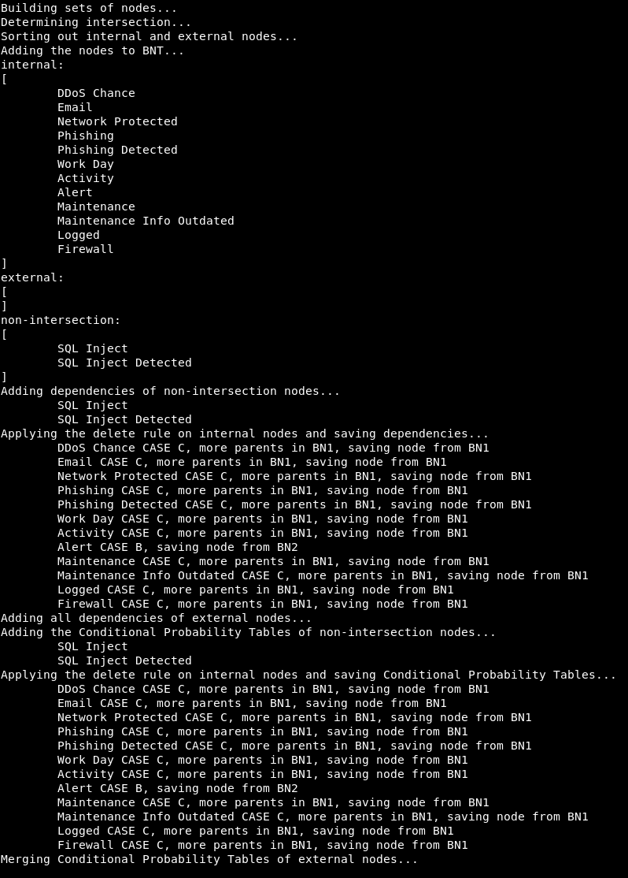
There are no external nodes because all nodes in BN1 are present in BN2, so they are the intersection, and thus, all of their parents in BN1 are in the intersection (making them internal).

To test the aforementioned corner case of external nodes with parents appearing in both BN1 and BN2, the following networks have been created:
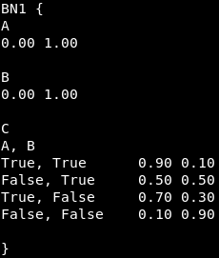
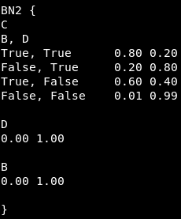

Node C has parents A, B, and D. Parent B appears in both BNs. This is the output of merging them:
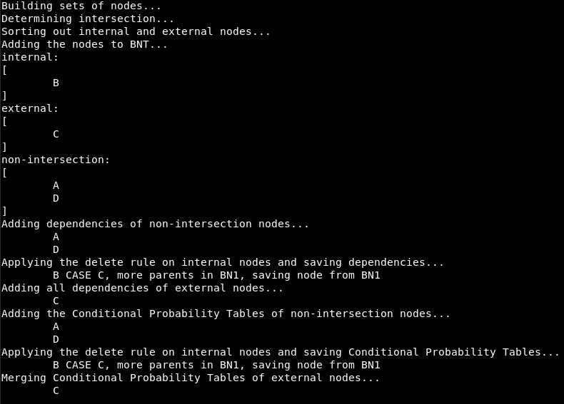
And the resulting BNT is:
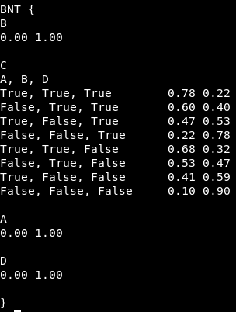
The two tables for C have been correctly merged. The tables for A, B, and D have the default values assigned by the Encog library.

Evaluation
Overall, the system achieves all the basic requirements of the practical. The algorithm works as expected and produces correct results. The Bayesian Networks are easily visible and the result can be verified on paper. The system suffers from an inefficient implementation of step 10 of the Feng et al algorithm. It has a time complexity of 2^{n}.n³. The exponential part cannot be removed because all permutations have to be iterated. The cubic part might be reducible to a square but it would be a minor optimization in the context of an exponent.
The manual creation of Bayesian Networks via classes is not ideal but works well. A general parser for Bayesian Networks from XML files would be a valuable extension.

Literature Review
Bayesian Networks are widely used in various fields. This^{[2]} blog post lists some common applications. The most popular ones are semantic search (to reduce search space for queries), and spam filter (to probabilistically distinguish between normal emails and spam).
However, there are more interesting applications that have been researched. [3] looks into different factor that contribute to the risk of nuclear waste disposal. The models derived have a structure similar to the one in BN1 of this assignment. Multiple factors flow down into a final event. The factors have weights associated with them to help evaluate the risk. As the goal of the paper is to produce an realistically accurate network, a large section of it focuses on quantifying the relations between events. The models are complex, as the events can assume values from a wide domain.
Another paper [4] looks into the application of Bayesian Network in a problem much closer to the field of computer science – Object-Oriented Software Maintainability. The models presented form relations between the structures of classes, and the usage of objects in other classes. The results are estimates of how easy it would be to introduce different changes into the code.

Total number of words before Bibliography: 4241.

Bibliography
[1] Must-Know Phishing Statistics 2017
Jonathan Crowe
https://blog.barkly.com/phishing-statistics-2017
[2] Top 10 Real-World Bayesian Networks Applications
Dataflair team
https://data-flair.training/blogs/bayesian-network-applications/
[3] Application of Bayesian network to the probabilistic risk assessment of nuclear waste disposal
Chang-Ju Lee, Kun Jai Lee
https://doi.org/10.1016/j.ress.2005.03.011
[4] An application of Bayesian network for predicting object-oriented software maintainability
C. van Koten, A.R. Gray
https://doi.org/10.1016/j.infsof.2005.03.002

