# ASP.NET MVC Exam (June 2015) – Sport System

Design and implement a **Web based sport system** to bet for matches, played by teams. Use C#, ASP.NET MVC, Entity Framework and SQL Server. Implement the front-end with HTML, CSS, Bootstrap, JavaScript and AJAX.

## Data Model

* The system holds **teams**, **players**, **matches**, **comments**, **users**, **bets** and **votes**.
* **Teams** have **name**, **nick name** (optional), **web site** (optional), **date founded** (optional) and a set of **players**.
* Players have **name**, **date of birth**, **height**, and may be part of some **team** or be **unemployed**.
* Teams play **matches**. Each **match** has **home team**, **away team**, **date and time** and might have a set of **comments**.
* **Comments** have **content** (text), **date and time** and **owner user** (author).
* Users have **username**, **email** and **password** (encrypted, not plain text). Users hold also a set of **bets** and a set of **comments** for the matches.
* **Users** can **bet** some money for the home or away team for existing **match**, e.g. user "peter" can bet $20 for Manchester and $30 for Chelsea in the "Manchester – Chelsea" match.
* **Users** can **vote** for a **team** (give +1) one or several times.

## Functionality

* **Anonymous** **users** can **register** user account by email and password.
* **Anonymous** **users** can **login** by email and password.
* **Logged-in users** can **logout**.
* **Anonymous users** can **view the home page**, holding the **top 3 matches** (having most bets) and **best 3 teams** (most voted).
* **Anonymous users** can **view** **all matches** (ordered by date, with paging).
* **Logged-in users** can **view team details** (information about the team and its players).
* **Logged-in users** can **vote for a team** (no more than once).
* **Logged-in users** can **view match details** (home team, away team, date and comments).
* **Logged-in users** can **add comments for given match**.
* **Logged-in users** can **bet for the home or away team**.
* **Logged-in users** can **create a new team** and assign players to the new team.
* All forms should implement **data validation**. Use client-side validation with AJAX and server-side validation.
* Display a **notification message** after each successful operation that changes the database.

## Design the Database

Design **entity classes** and create a **database** to hold the **teams**, **players**, **matches**, **comments**, **users**, **bets** and **votes** with Entity Framework **code first**. Put your data layer in separate Visual Studio project (class library).

The data layer should be implemented with some abstraction:

* You can use repository pattern and unit of work.
* You can use repositories and data service layer with database queries.
* You can use only data services layer on the top of the EF context.

10 score

Use **automatic migrations**. At application start-up, **fill the following sample data** in the database:

**Teams**

|  |  |  |  |
| --- | --- | --- | --- |
| **Name** | **Web Site** | **Date Founded** | **Nickname** |
| Manchester United F.C. | http://www.manutd.com | 1-Jun-1878 | The Red Devils |
| Real Madrid | http://www.realmadrid.com | 6-Mar-1902 | The Whites |
| FC Barcelona | http://www.fcbarcelona.com | 12-Nov-1899 | Barca |
| Bayern Munich | http://www.fcbayern.de | 13-Feb-1900 | The Bavarians |
| Manchester City | http://www.mcfc.com | 1-May-1880 | The Citizens |
| Chelsea | https://www.chelseafc.com | 10-Mar-1905 | The Pensioners |
| Arsenal | http://www.arsenal.com | 1-Sep-1886 | The Gunners |

**Matches**

|  |  |  |
| --- | --- | --- |
| **Home Team** | **Away Team** | **Match Date** |
| Real Madrid | Manchester United F.C. | 2015-Jun-13 |
| Bayern Munich | Manchester United F.C. | 2015-Jun-14 |
| FC Barcelona | Manchester City | 2015-Jun-15 |
| Chelsea | FC Barcelona | 2015-Jun-16 |
| Real Madrid | Manchester City | 2015-Jun-17 |
| Manchester United F.C. | Chelsea | 2015-Jun-18 |
| Arsenal | Bayern Munich | 2015-Jun-12 |
| Chelsea | Real Madrid | 2015-Jun-11 |
| Chelsea | Manchester City | 2015-Jun-10 |
| Chelsea | Arsenal | 2015-Jun-19 |
| Arsenal | FC Barcelona | 2015-Jun-20 |

**Players**

|  |  |  |  |
| --- | --- | --- | --- |
| **Name** | **Birth Date** | **Height** | **Team** |
| Alexis Sanchez | 1982-01-03 | 1.65 | FC Barcelona |
| Arjen Robben | 1982-01-03 | 1.65 | Real Madrid |
| Franck Ribery | 1982-01-03 | 1.65 | Manchester United F.C. |
| Wayne Rooney | 1982-01-03 | 1.65 | Manchester United F.C. |
| Lionel Messi | 1982-01-13 | 1.65 | *(NULL)* |
| Theo Walcott | 1983-02-17 | 1.75 | *(NULL)* |
| Cristiano Ronaldo | 1984-03-16 | 1.85 | *(NULL)* |
| Aaron Lennon | 1985-04-15 | 1.95 | *(NULL)* |
| Gareth Bale | 1986-05-14 | 1.90 | *(NULL)* |
| Antonio Valencia | 1987-05-23 | 1.82 | *(NULL)* |
| Robin van Persie | 1988-06-13 | 1.84 | *(NULL)* |
| Ronaldinho | 1989-07-30 | 1.87 | *(NULL)* |

**Users**

|  |  |
| --- | --- |
| **Username** | **Password** |
| alex@usa.net | 12qw!@QW |
| tanya@gmail.com | P@ssW0RD!123 |

**Comments**

|  |  |  |  |
| --- | --- | --- | --- |
| **Match** | **Comments** | | |
| Bayern Munich - Manchester United F.C. | 1 | The best match this summer! | alex@usa.net |
| 2 | The good football this evening. | tanya@gmail.com |
| FC Barcelona - Manchester City | 1 | Barca! | tanya@gmail.com |
| Real Madrid - Manchester City | 1 | Real forever! | alex@usa.net |
| 2 | Real, real, real | alex@usa.net |
| 3 | Real again :) | alex@usa.net |
| Chelsea - Real Madrid | 1 | Chelsea champion! | tanya@gmail.com |

**Bets**

|  |  |  |  |
| --- | --- | --- | --- |
| **Match** | **Home Bet** | **Away Bet** | **User** |
| Chelsea - FC Barcelona | 30.00 | 0.00 | alex@usa.net |
| Chelsea - FC Barcelona | 0.00 | 50.00 | alex@usa.net |
| Chelsea - FC Barcelona | 0.00 | 120.00 | alex@usa.net |
| FC Barcelona - Manchester City | 120.00 | 0.00 | alex@usa.net |
| Bayern Munich - Manchester United F.C. | 500.00 | 0.00 | alex@usa.net |
| Bayern Munich - Manchester United F.C. | 50.00 | 0.00 | tanya@gmail.com |
| Bayern Munich - Manchester United F.C. | 0.00 | 20.00 | tanya@gmail.com |
| Chelsea - FC Barcelona | 0.00 | 220.00 | tanya@gmail.com |

**Votes**

|  |  |
| --- | --- |
| **Team** | **Vote User** |
| Bayern Munich | tanya@gmail.com |
| Real Madrid | tanya@gmail.com |
| Bayern Munich | alex@usa.net |

20 score

## Implement Home Page, Users, Login and Logout

Implement user **registration**, **login** and **logout**.

* **User registration** should create a new user account and display "**User registered**" **notification message**. In case of error, display an error message. **Validate** the registration form. **Allow simple passwords** (e.g. "123").
* **User registration form** should have **email**, **password** and **confirm password** fields (mandatory).

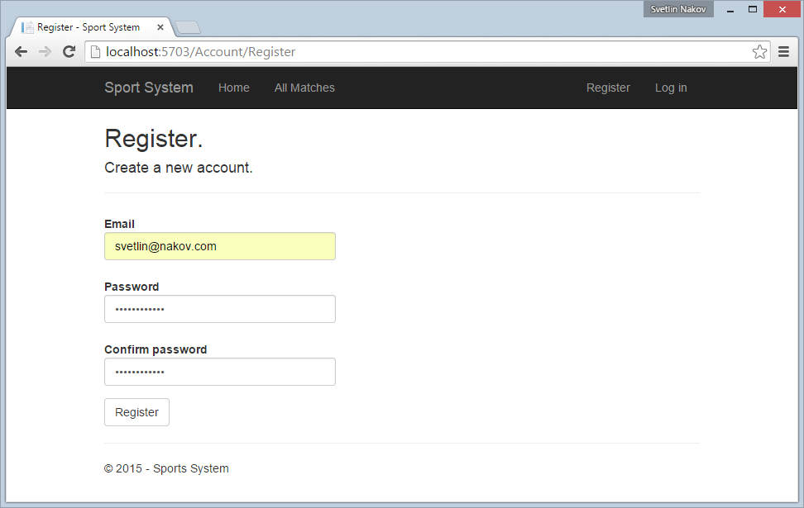

8 score

* **User login** should login an existing user by **email** and **password**. After login, display user's home page. In case of problem, display an error message. **Validate** the login form. **Allow simple passwords** (e.g. "123").

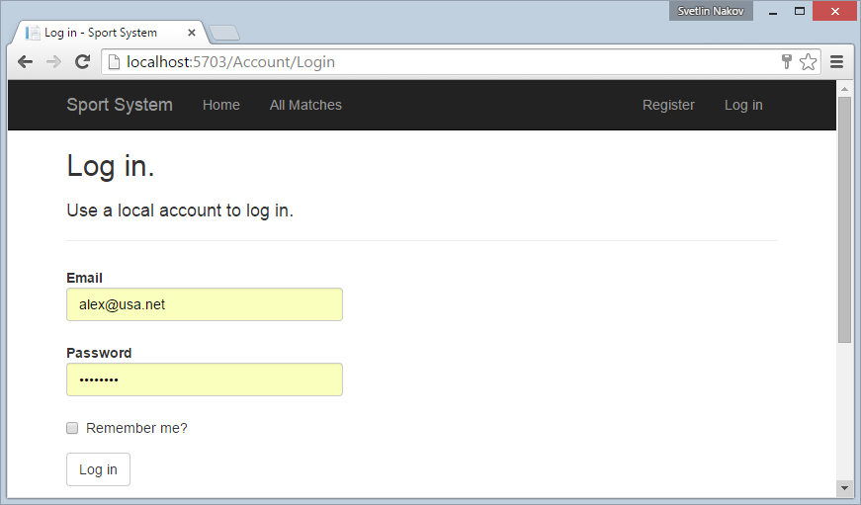

4 score

* **Prevent anonymous access** to the pages that require login (e.g. view bookmarks details page or create bookmark page). Prevent the non-administrator users from accessing the administrator page.

3 score

* **User logout** should invalidate user's session and redirect to the application home page.

2 score

## Implement the Home Page

Anonymous users can view the **home page**.

* Display at the home page the **top 3 matches** (having most bets) and **best 3 teams** (most voted).

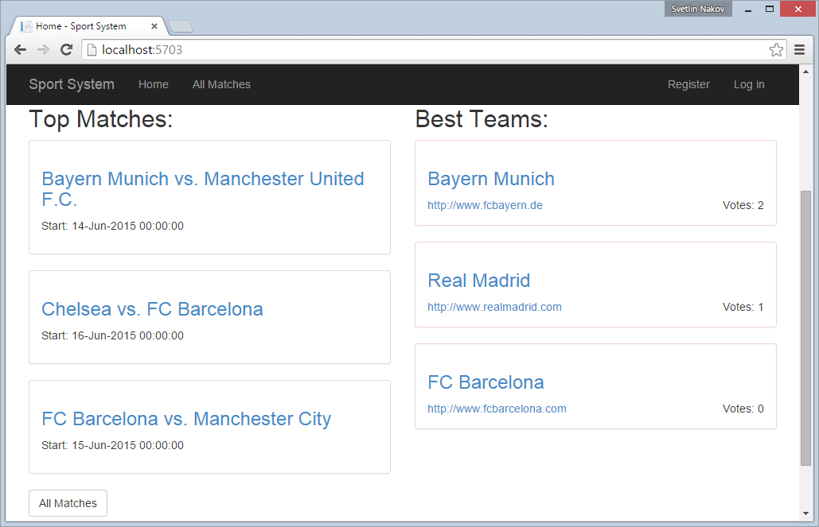

5 score

## Implement the View All Matches Page

Anonymous users can **view all matches**.

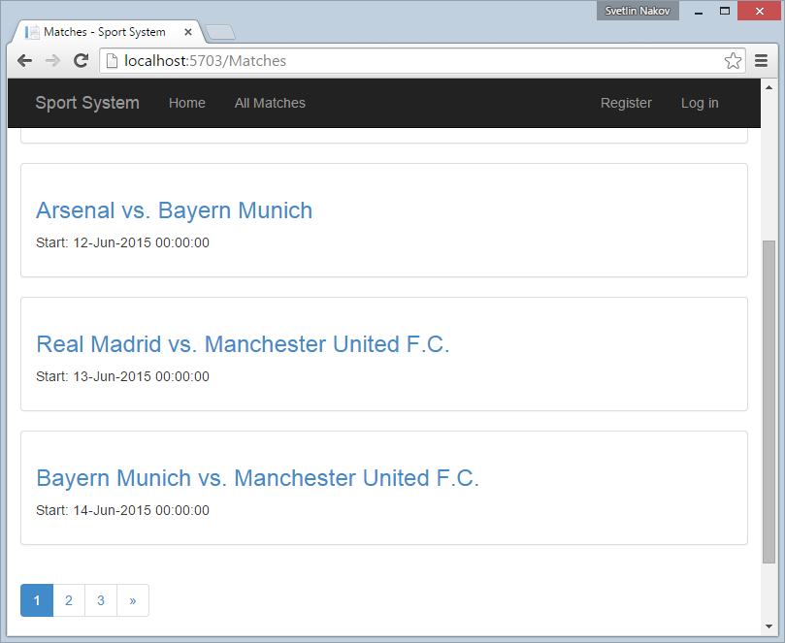

* Display the matches, ordered by date.

5 score

* Implement paging.

5 score

## Implement the View Team Details

Logged-in users can view team details (information about the team and its players).

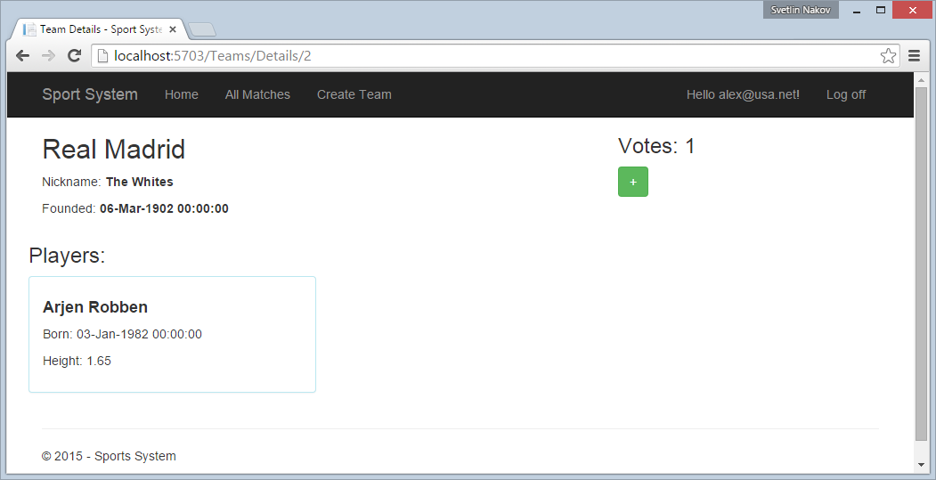

5 score

## Implement the Voting for a Team

Logged-in users can **vote for a team** (no more than once).

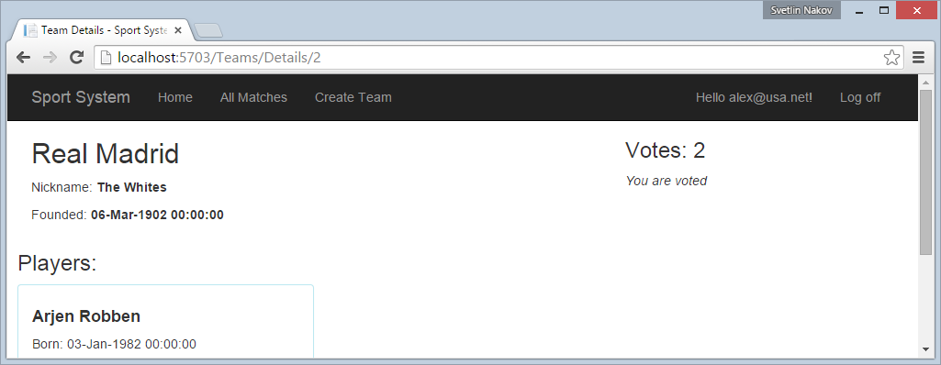

5 score

## Implement the Voting for a Team

Logged-in users can **vote for a team** (no more than once).



5 score

## Implement the View Match Details

Logged-in users can **view match details** (home team, away team, date and comments).

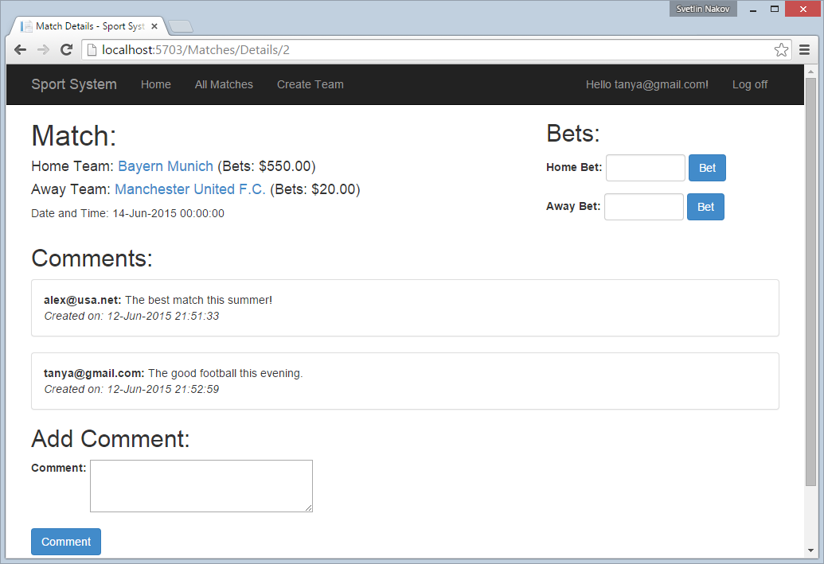

5 score

## Implement the Add Comments for Match

Logged-in users can **add comments** for given match.

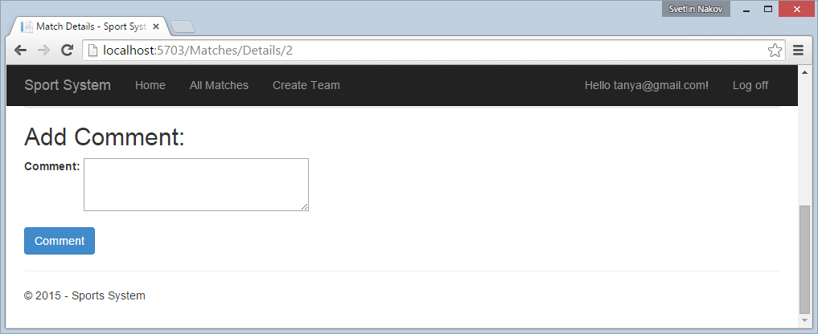

5 score

## Implement the Bet for a Team in a Match

Logged-in users can **bet for the home or away team**.

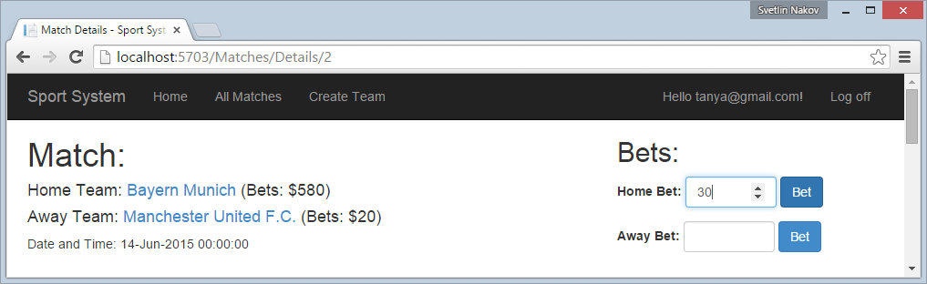

5 score

## Implement the Create New Team

Logged-in users can **create a new team** and **assign players** to the new team.

* **Create a new team** by filling its details.

5 score

* **Add players** when creating a team. Implement client-side functionality to add more player dropdowns dynamically.

5 score

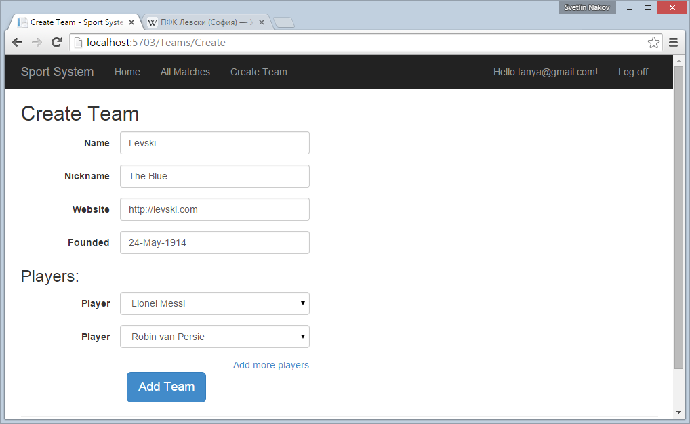

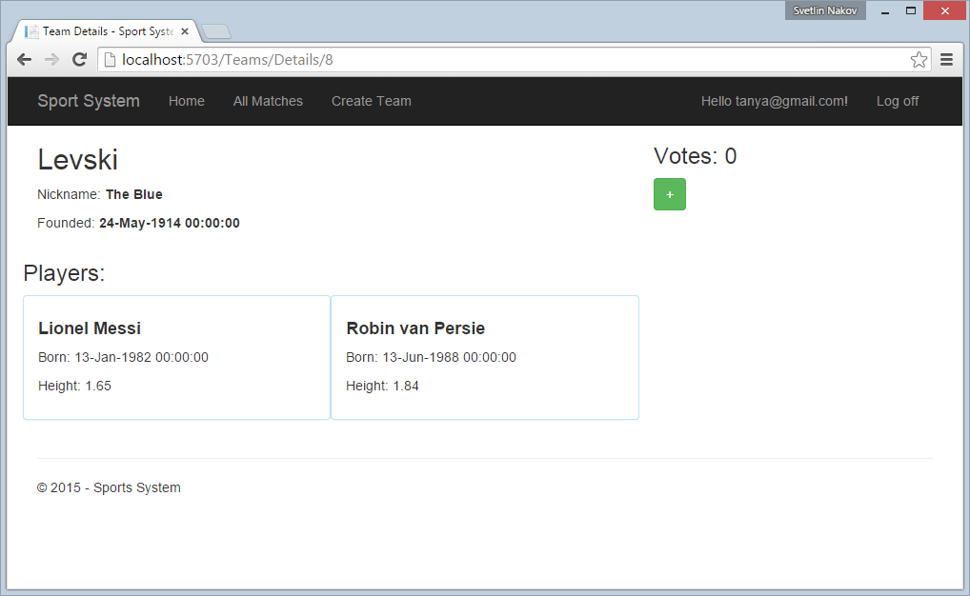

## Project Infrastructure Bonus

Bonus points code quality / good application structure / additional effort.

* Bonus points for implementing **separate data layer**.
* Bonus points for using **dependency inversion**.
* Bonus points for using **AutoMapper**.
* Bonus points for using **services** for different jobs.

5 score