***soft_eng 2024 - colors gia papei website***

***before***

* **kokkino 🡪 #61051b**
* **light kokkino 🡪 #790621**
* **ble 🡪 #001c33**

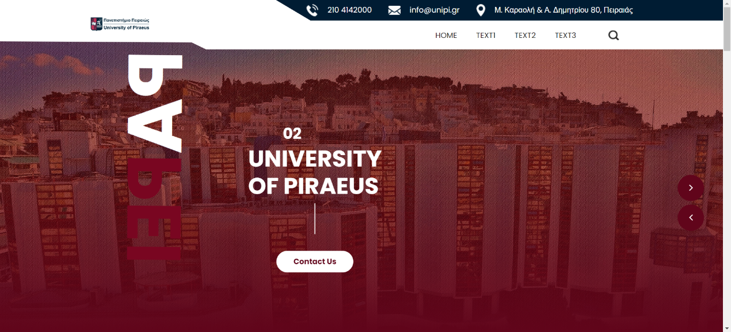

***xrwmata me vash to official unipi***

* **kokkino 🡪 #9d2235**
* **light kokkino 🡪 #a72538**
* **ble 🡪 #222c54**

