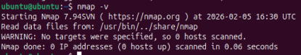
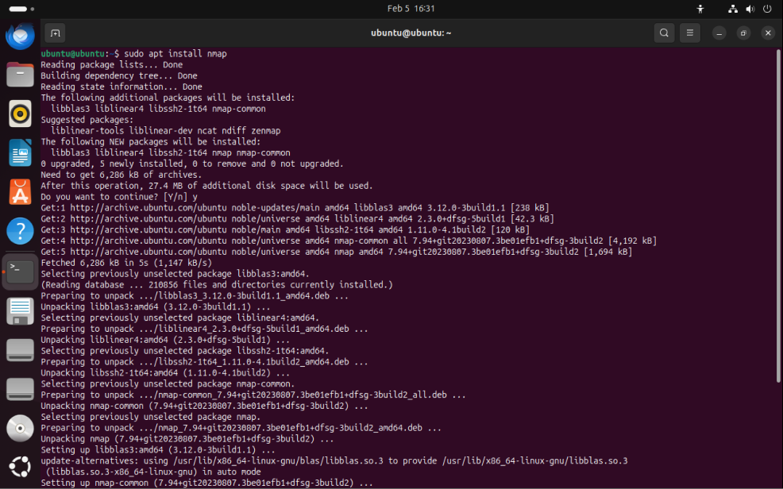
- $ sudo apt install nmap
- $ nmap –v

-$ nmap 192.168.1.7
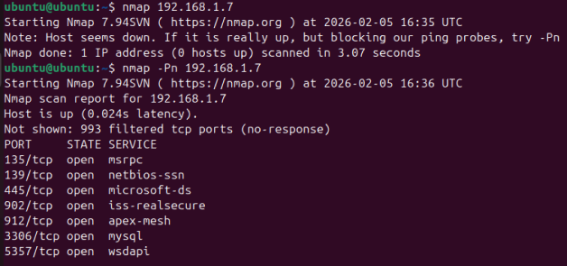
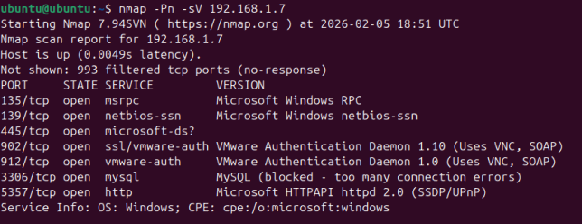
- $ nmap –Pn 192.168.1.7-10
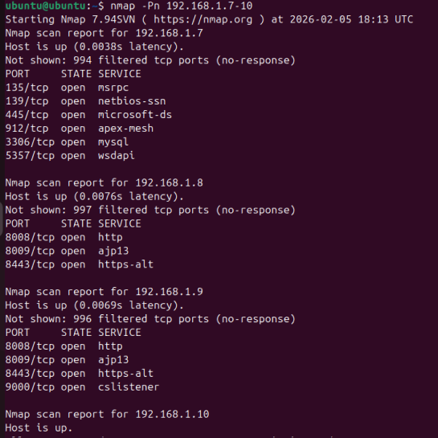
- $ nmap –Pn –sV 192.168.1.7
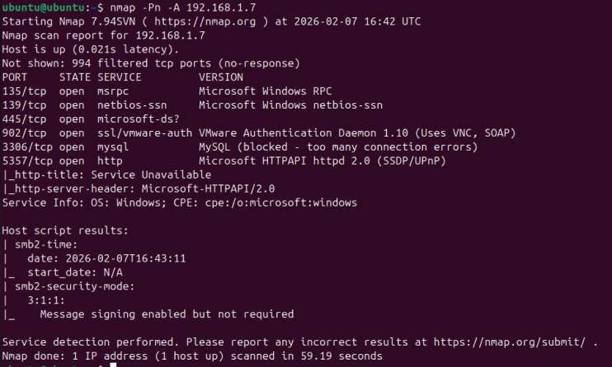
-$ nmap –Pn –A 192.168.1.7

