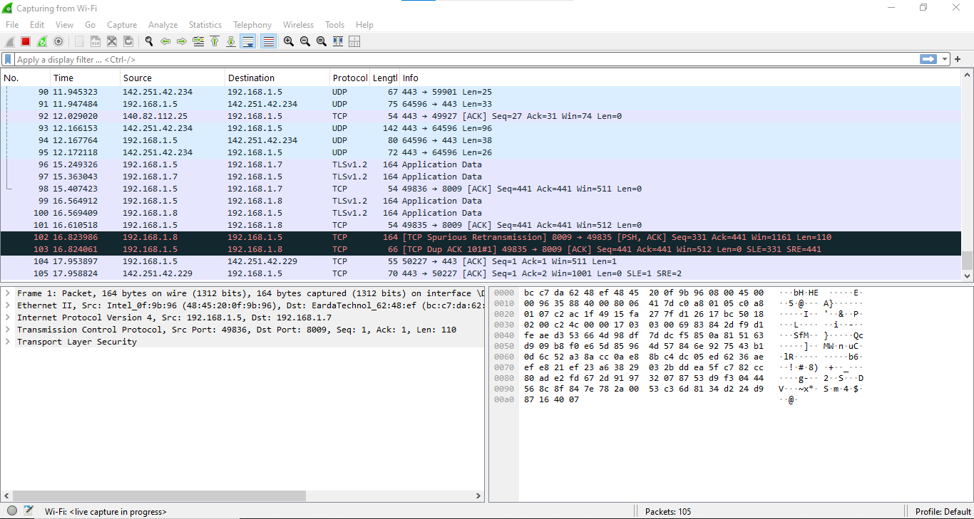
Capturing Wi-Fi network in WireShark

