Google Ads API — Design Document
Piano Tuning KC — Basic Access Application

Company Information
Company Name | Piano Tuning KC
Company Website | https://pianotuningkc.com
Google Ads Customer ID | 790-110-2348

Business Model
Piano Tuning KC is a local piano tuning service operating in the Kansas City metropolitan area. We operate a single website (https://pianotuningkc.com) which serves as our primary online presence for booking piano tuning appointments. We only advertise for our own business and do not manage ads for any other companies or clients.

Tool Access / Use
Our tool is an internal-only reporting and automation system used exclusively by the business owner and a technical consultant to:
- View and analyze ad performance — A lightweight internal dashboard that displays campaign metrics (clicks, impressions, conversions, cost, CPC, CTR) across configurable date ranges. This dashboard is accessible only to authorized internal users and is not publicly accessible.
- Generate performance reports — The tool can export ad performance summaries for internal review. These reports are used solely for internal business decisions (budget allocation, keyword optimization, seasonal planning). Reports are not shared with any external agencies or third parties.
- Automated campaign monitoring — A scheduled script runs periodically to pull the latest campaign metrics and flag significant changes in performance (e.g., cost-per-conversion exceeding a threshold, conversion rate drops, budget pacing issues). Alerts are sent to the business owner via internal notification.
No external parties will have access to the tool. It is hosted locally and used only by internal personnel.

Tool Design

Data Flow Architecture
Google Ads API (GAQL queries)
↓
Python Script (google-ads library)
↓
Local SQLite Database (metrics cache)
↓
Internal Dashboard (HTML/JS, localhost)
↓
Business Owner views reports

How It Works
1. Data Collection: A Python script using the official google-ads Python client library makes read-only API calls using Google Ads Query Language (GAQL) to retrieve campaign, ad group, keyword, and search term performance data.
2. Data Storage: Retrieved metrics are stored in a local SQLite database to enable historical trend analysis and reduce redundant API calls. The database is stored locally and is not accessible externally.
3. Dashboard Display: A simple internal web dashboard (served on localhost) reads from the local database to display account-level summary metrics, campaign-level performance comparisons, keyword performance data, and date range filtering.
4. Automated Monitoring: A scheduled script runs every 4 hours during business hours to pull the latest performance metrics, compare against historical baselines, and log any significant performance changes.

Data Retention
- Metrics data is retained locally for up to 12 months for trend analysis.
- No personally identifiable information (PII) is collected or stored.
- Only aggregate performance metrics are retrieved from the API.

API Services Called
We will use read-only access to the following API resources:
API Resource | Purpose | Operations
GoogleAdsService | Execute GAQL queries to pull performance reports | Search, SearchStream
Customer | Retrieve account-level settings and summary metrics | Read only
Campaign | Pull campaign names, statuses, budgets, bid strategies | Read only
AdGroup | View ad group structure and performance | Read only
AdGroupAd | Review ad copy and ad-level performance metrics | Read only
AdGroupCriterion | Analyze keyword performance, match types, Quality Score | Read only
SearchTermView | Review actual search queries that triggered ads | Read only
GeoTargetConstant | Understand geographic targeting settings | Read only

We do NOT modify, create, or delete any campaigns, ads, or keywords via the API. All campaign management is done through the Google Ads web interface. The API is used exclusively for reporting and analysis.

Example GAQL Queries
Campaign Performance Report:
SELECT
campaign.name,
campaign.status,
campaign_budget.amount_micros,
metrics.impressions,
metrics.clicks,
metrics.cost_micros,
metrics.conversions,
metrics.average_cpc,
metrics.ctr
FROM campaign
WHERE segments.date DURING LAST_30_DAYS
ORDER BY metrics.cost_micros DESC

Keyword Performance Report:
SELECT
ad_group_criterion.keyword.text,
ad_group_criterion.keyword.match_type,
metrics.impressions,
metrics.clicks,
metrics.cost_micros,
metrics.conversions,
metrics.average_cpc
FROM keyword_view
WHERE segments.date DURING LAST_30_DAYS
AND metrics.impressions > 0
ORDER BY metrics.cost_micros DESC

Search Terms Report:
SELECT
search_term_view.search_term,
metrics.impressions,
metrics.clicks,
metrics.cost_micros,
metrics.conversions
FROM search_term_view
WHERE segments.date DURING LAST_30_DAYS
ORDER BY metrics.impressions DESC

Tool Mockup
The dashboard is an internal-only tool served on localhost. Below is a mockup of the reporting interface:
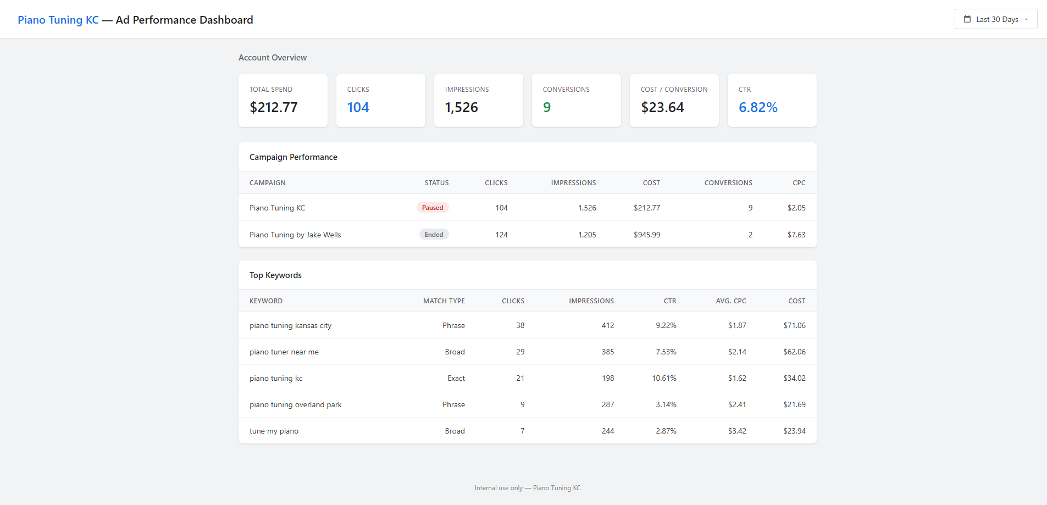

Dashboard Features:
- Account Overview — Summary cards showing total spend, clicks, impressions, conversions, cost/conversion, and CTR for the selected date range.
- Campaign Performance — Table comparing all campaigns with status indicators, click/impression/cost/conversion metrics.
- Top Keywords — Table showing keyword-level performance including match type, CTR, average CPC, and total cost.
- Date Range Selector — Dropdown to switch between Last 7 Days, Last 30 Days, Last 90 Days, and All Time views.
The tool is not externally accessible. It runs locally on the business owner's machine and is used solely for internal reporting and analysis.

Rate Limiting and Responsible Use
- API calls are made periodically (every 4 hours during business hours), not in real-time.
- Results are cached locally to minimize redundant API requests.
- We anticipate fewer than 50 API requests per day.
- We will respect all rate limits and quotas defined by the Google Ads API Terms of Service.

Contact Information
Business Owner | Jake Wells
Email | jake@pianotuningkc.com
Phone | (913) 725-8124
Website | https://pianotuningkc.com

