**Full title here**

First Author1, Second Author2 and Third Author1

1Affiliation one

2Affiliation two

## Summary

One paragraph summary here.

**Keywords**: keyword 1, keyword 2, keyword 3, keyword 4, keyword 5

## Introduction

Introduction to your brilliant abstract here!

We recommend that your expanded abstract be approximately 4 pages. This is not a hard limit. Longer and shorter abstracts will be accepted.

For submission, please use the naming convention LastName2023-3DEM7.pdf and email your final abstract to: 3delectromagnetics@gmail.com. If you have a preference for a poster or talk, please indicate this in your email.

We look forward to welcoming you to Vancouver in November!

## Methods

3DEM-6 was held in Berkeley, CA in 2017. Figure 1 shows the fine group of people who participated.

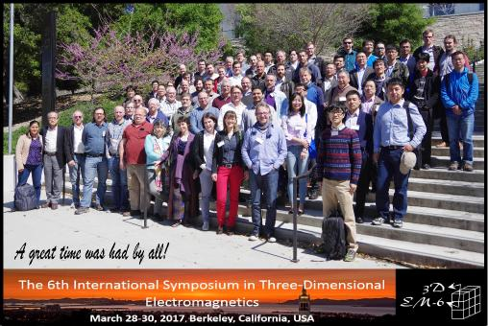

**Figure 1:** Participants of the 3DEM-6 symposium in Berkeley, CA.

**Subsection**

Here, we have Maxwell’s equation.

$∇×\vec{e}+\frac{∂\vec{b}}{∂t}=0$

$∇×\vec{h}+\frac{∂\vec{d}}{∂t}=\vec{j}$ (1)

For more details, see Ward & Hohmann (1988).

**Discussion**

Tables can also be included.

**Table 1:** Caption for my table.

|  |  |
| --- | --- |
| Column 1 | Column 2 |
| a | b |
| c | d |

**Conclusion**

**Acknowledgments**

If you have any large figures or tables that span multiple columns, they can be included here.

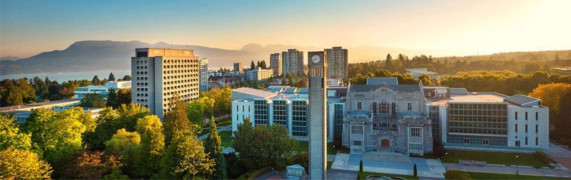

**Figure 2:** An image of the UBC campus from https://www.ubc.ca/our-campuses/.

**References**

Ward, S. H., and Hohmann, G. W. (1988). Electromagnetic Theory for Geophysical Applications. In *Electromagnetic Methods in Applied Geophysics, Volume 1, Theory*. Society of Exploration Geophysicists, 130-311.