# Lab 9: Electromagnetics Part II – Apparent conductivity + Expo Site

## Name:__________________ ID:_____________________

TA: Thibaut Astic (thibaut.astic@gmail.com)

Due: Nov. 26th 2018

## Overview

In the first part of the lab, we introduce the concept of apparent conductivity for EM measurements and further explore how the apparent conductivity can be computed with the layered structures.

Then in the second portion of the lab, we examine data sets obtained at the old Expo site in the False Creek area of Vancouver. The site has a fairly complex industrial history, and was set to be remediated and turned into a public space. Before any remediation could take place, the site needed to be characterized. You will be examining geophysical data collected over this site. To detect anomalous conductive or resistive targets, we first treat frequency domain EM data collected with the EM-31 instrument. We will interpret the measured EM data sets and characterize the subsurface of the site. To increase reliability we also study gradient magnetics data to obtain information about the magnetic susceptibility subsurface. By integrating these two geophysical data sets we better characterize isolated targets embedded in this region.

Read the background information from the Expo site characterization report ([https://gpg.geosci.xyz/content/electromagnetics/electromagnetic_interpretation.htm](https://gpg.geosci.xyz/content/electromagnetics/electromagnetic_interpretation.html)l) and use it to answer questions regarding the EM-31 and magnetic gradient surveys.

**Notation:** In the GPG and in this app we are attempting to keep a consistent notation to help you keep track of the configuration of the source and receiver.

* HCP: Horizontal coplanar system. The associated dipoles are perpendicular to the plane of the loops and are therefore in the vertical direction. The response function associated with this is $ϕ_{V}$.
* VCP: Vertical coplanar system. The associated dipoles are perpendicular to the plane of the loops and are therefore in the horizontal direction. The response function associated with this is $ϕ_{H}$.

## Apparent conductivity

**Q1.** Considering a horizontal coplanar (HCP) configuration of EM system (e.g. EM-31), imaginary part of the measured data, Hs/Hp, can be written as

$$Im( \frac{Hs}{Hp} )≈\left(\frac{ωμ_{0}σs^{2}}{4}\right)×100 [\%], when δ≫s$$

* $δ$: skin depth ( $=500\sqrt{\frac{1}{σf}}$) [m]
* $s$: source and receiver separation [m]
* $ω=2πf$: angular frequency [rad/s]

**a.** By using the above equation derive a formula that you can compute apparent conductivity, $σ_{a}$

**b.** Suppose with the EM-31 you have measured EM data:

* In-phase Hs/Hp: 2.6%
* Quadrature Hs/Hp: 1.15%

Compute the apparent conductivity using the equation that you derived in the above question.

**Q2.** Use the response function app to answer the following questions. You can click [here](https://mybinder.org/v2/gh/geoscixyz/gpgLabs/master?filepath=Notebooks%2FEM_EM31.ipynb) to open the app.

The apparent conductivity is equal to the “integral” of the true conductivity and a response function ( $ϕ_{V}$ or $ϕ_{H}$; depending upon how the instrument is oriented). Become familiar with this concept by adjusting the parameters $h_{1}, σ_{1}, σ_{2}$ and change the boom configuration and see how this affects the apparent conductivity.

**a.** Set the parameters to the following: $σ_{1}=0.01, { σ}_{2}=0.01, h_{1}=0.5, h_{boom}=0$. What is the apparent conductivity for each of the configuration (HCP and VCP)? Note description of the horizontal coplanar (HCP) and vertical coplanar (VCP) is shown in [GPG](https://gpg.geosci.xyz/content/electromagnetics/electromagnetic_survey.html#cumulative-response-functions).

**b.** Next, set $σ_{1}=0.1$, and keep $σ_{2}=0.01, h_{1}=0.5, h_{boom}=0.$ What is the apparent conductivity for each of the boom configurations (HCP and VCP)?

**c.** Now set $σ_{1}=0.01$, $σ_{2}=0.1, and keep h_{1}=0.5, h_{boom}=0$. What is the apparent conductivity for each of the boom configurations (HCP and VCP)??

**d.** Set $σ_{1}=0.01$, $σ_{2}=0.1$ and increase $h_{1}$ to 1.5. What are the apparent conductivities for each of the boom configurations (HCP and VCP)?

**e.** For the above examples, we observe that the HCP and VCP configurations give different apparent conductivities. How do you explain this?

**f.** Using the response function diagrams, and the answers above, which boom configuration has greater depth of penetration? Which is more sensitive to near-surface layers?

**Q3.** Using the [app](https://mybinder.org/v2/gh/geoscixyz/gpgLabs/master?filepath=Notebooks%2FEM_EM31.ipynb), answer following questions.

**a.** Set $σ_{1}=0.1, { σ}_{2}=0.1$, $h_{1}=$ 0.5. Now raise the boom height, $h_{boom}$. First, look at the HCP configuration. How does the apparent conductivity change?

|  |  |
| --- | --- |
| $$h_{boom}$$ | $$σ_{a}$$ |
| 0 |  |
| .5 |  |
| 1.0 |  |
| 2.0 |  |
| 3.0 |  |

**b.** Set $σ_{1}=0.01, { σ}_{2}=0.1$, $h_{1}=$ 0.5. Now raise the boom height, $h_{boom}$. Look at the VCP configuration. How does the apparent conductivity change?

|  |  |
| --- | --- |
| $$h_{boom}$$ | $$σ_{a}$$ |
| 0 |  |
| .5 |  |
| 1.0 |  |
| 2.0 |  |
| 3.0 |  |

## Expo Site EM-31 data maps

EM-31 data are measured on a 2m-spacing grid with the boom about 1 m above the surface. At each station, in-phase and quadrature components of Hs/Hp (%) are recorded for EW and NS boom orientations, resulting in four maps as shown below.

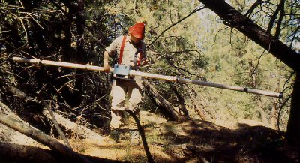

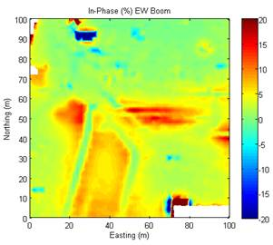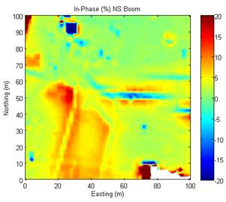

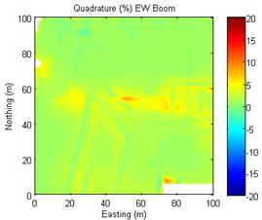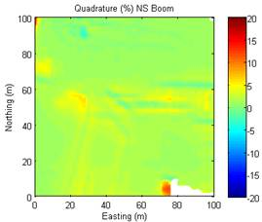

The quadrature data are then converted to apparent conductivity maps. Apparent conductivity can be a good representation of the ground conductivity if the earth is uniform and the Tx-Rx separation is much less than the skin depth (s << $δ$).

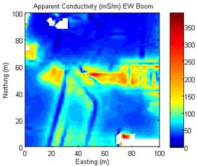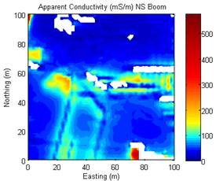

**Q4.** The EM-31 is often used to measure the Earth's conductivity. Look at the apparent conductivity maps using both EW and NS boom orientations (error readings and negative readings are plotted as white) and answer the following questions.

**a.** What are the maximum and background conductivities for each map? Calculate the skin depths for the maximum and background conductivities for each map.

**b.** Based upon this criterion, do you think the inferred ground conductivity at the location with maximum apparent conductivity is reliable? Why or why not?

**c.** The apparent conductivity values computed using the EM-31 data are based on the assumption that the earth is a uniform half-space. Based on the apparent conductivity maps, where are the regions that might satisfy this assumption?

**d.** There are some areas with negative apparent conductivities, which are not realistic. Why could this happen? Hint: think about how an apparent conductivity is calculated and the sign convention of EM-31 data; recall the 3-loop model diagram.

**Q5.** Oil/hydrocarbon-bearing strata are usually more electrically resistive than their hosts. Oil was found to have contaminated the water table in the North-West section of the map at (20E, 80N). Knowing that oil is present in the region near (20E, 80N), draw a contour line on the apparent conductivity map (either EW or NS boom) that might indicate an approximate extent of the hydrocarbon contamination.

**Q6.** Note that there is considerable linear structure in the maps. Now let’s examine the E-W trending feature at Northing = 50m.

**a.** From the data spreadsheet (download “em-31.xls” from the course website), extract the in-phase and quadrature data along a N-S profile recorded at Easting = 70 for both of the boom orientations. For the NS boom orientation data, make a line plot of the data for the in-phase and quadrature. Then perform the same exercise for the EW boom orientation. Use different colors and line styles to distinguish the four plots. Adjust the scale and range of the x-axis and y-axis so we focus on the anomaly near Northing = 50 m. Attach your plots below.

**b.** Compare the amplitudes of in-phase and quadrature data at each location. What information about the conductivity of the target near Northing = 50 can be inferred?

**c.** What is the major difference between the anomalies observed with EW and NS boom orientations near Northing = 50?

**d.** By looking at the in-phase maps, what type of object do you think could explain the observed data? Support your answer with evidence based on conductivity and shape of the anomaly.

**e**. Look at the linear features striking NNE in the bottom left hand portion of the in-phase maps. Describe the difference of these anomalies in the EW boom map and in the NS boom maps and provide an explanation.

**f.** On the in-phase data map, circle those places (at least four) that you suspect could have buried metal conductors. Annotate with your interpretation of what they could be based on the available a prior information.

High magnetic gradients will be observed when there are magnetic objects close to the surface. From your background reading about the site, there could be many of these. Iron, rebar, pipes, drums and buried locomotives are conductive and magnetically permeable. Thus, the EM-31 and the magnetic gradient results can provide complementary information. Use the vertical magnetic gradient map below to answer the following questions.

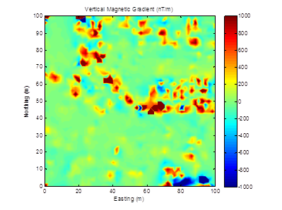

**Q7.** Briefly describe what the vertical magnetic gradient is. How is it acquired? What is it sensitive to and why? And what benefits does it provide over total field data?

**Q8.** How does the use of both magnetic gradient and EM-31 data help in the identification of iron targets? How would the two responses from an iron target differ from that produced by a copper target?

**Q9.** What inferences could you make about the NNE linear features (in the south-west quadrant of the plots) when you compare the EM and the magnetic plots?