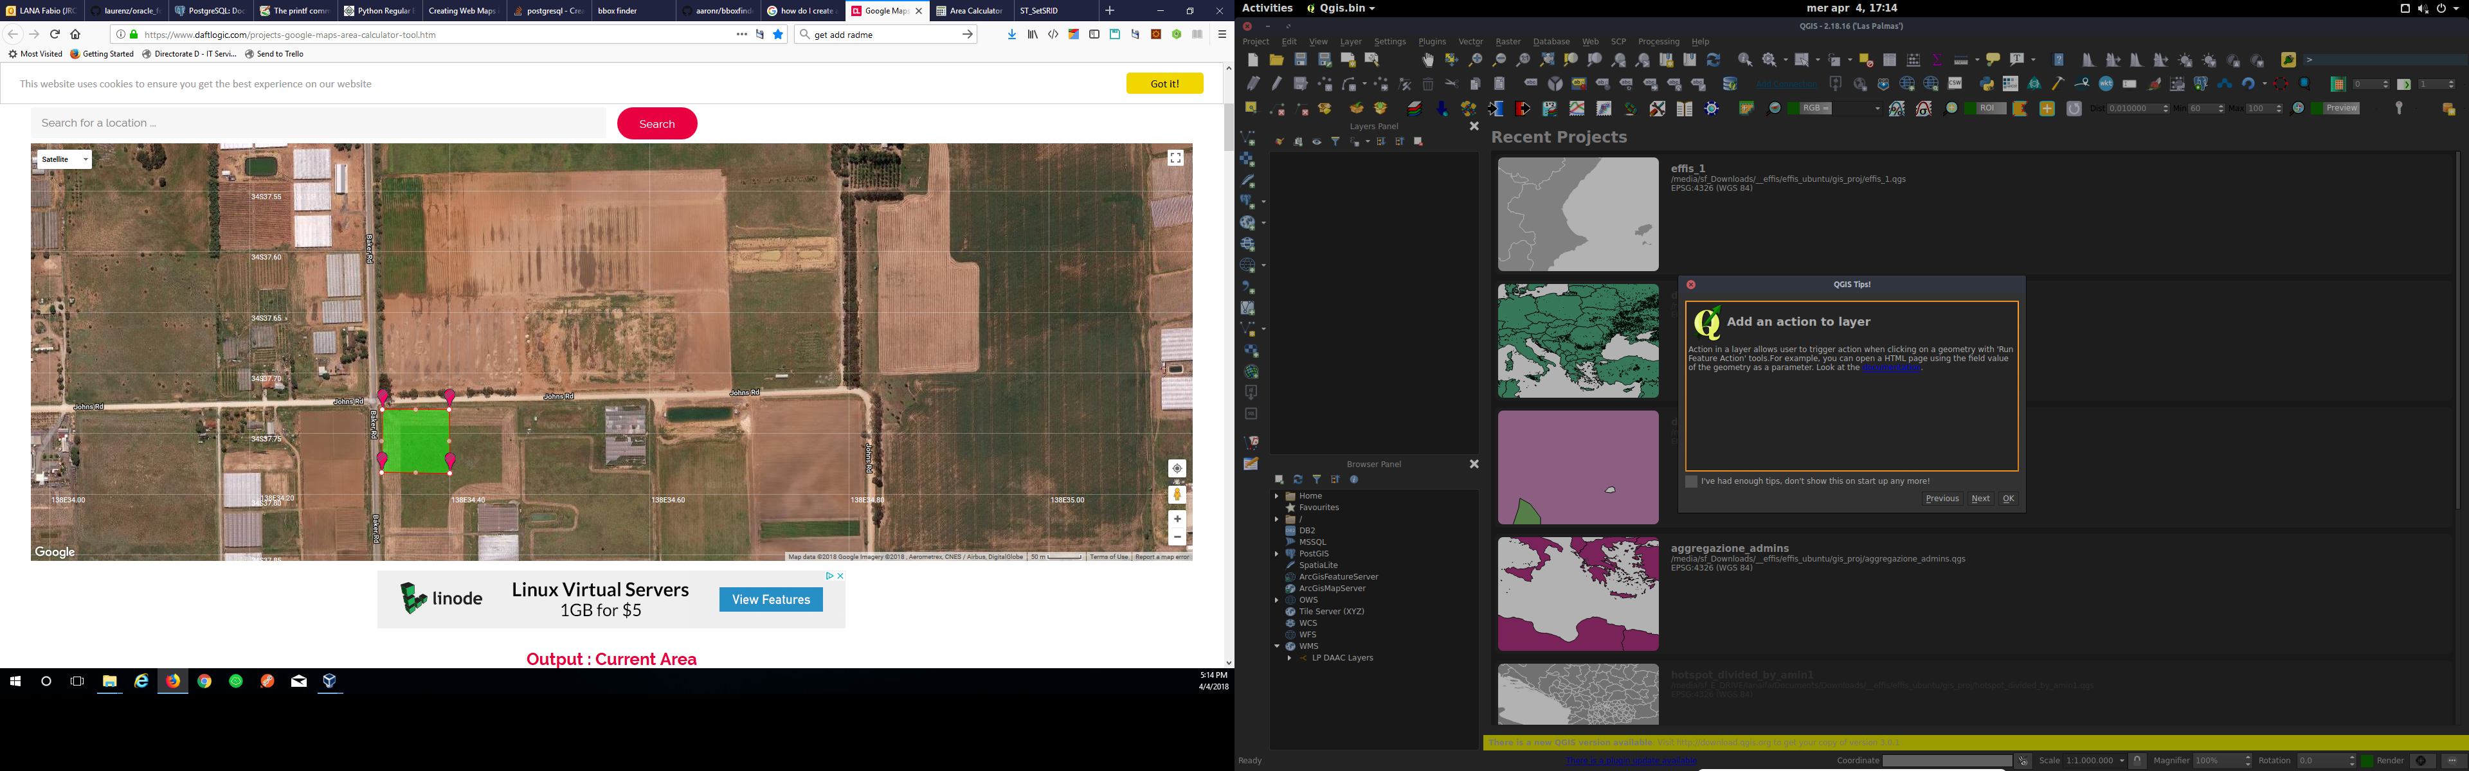

**Output : Current Area**

9980.58 m² | 0.01 km² | 2.47 acres | 1.00 hectares | 107430.09 feet² | 0.00 square miles | 0.00 square nautical miles

**Current Perimeter**

400.490m OR 1313.945feet

**Coordinates**

-34.62884156415669,138.5722189852088

-34.62884156415669,138.573334784159

-34.629719968121805,138.57334551299505

-34.62970672592002,138.5722082563727