When launching the plugin *Build_Radial_City*, the following window opens

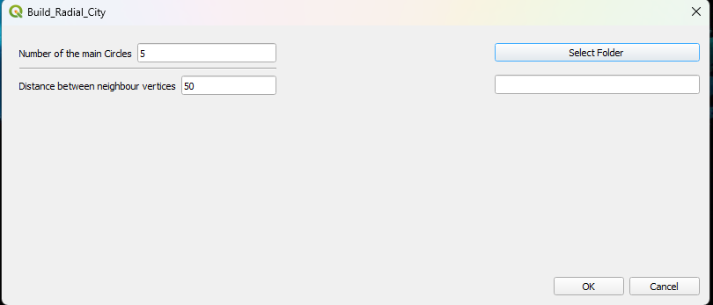

1. You can modify the values the text field “Number of main circles” and “Distance between neighbour vertices”.
2. If you click on the "Select Folder" button, it will open a window for selecting a directory to save the resulting layer files. The path of the selected directory will appear in the text field below the button.