*AI-BASED CYBER THREAT DETECTION SYSTEMS*

A Research Paper Submitted in Partial Fulfillment of the Requirements for the Degree of Master of Computer Applications (MCA)

By: Sakshi Omprakashrao Wankhade
*Roll No:* [ROLL NUMBER]
*Under the Guidance of:* [GUIDE NAME]
*Department of MCA*
*Wainganga College of Engineering & Management*
*Academic Year:* [YEAR]

Certificate

This is to certify that the research paper entitled “AI-Based Cyber Threat Detection Systems” has been completed by Sakshi Wankhade (Roll No: [ROLL NUMBER]) under the guidance of *[GUIDE NAME], Department of Computer Applications, *[COLLEGE NAME]*, in partial fulfillment of the requirements for the award of the degree **Master of Computer Applications (MCA)* for the academic year *[YEAR]*.

Abstract

With the rapid expansion of the internet and digital technologies, cyber threats have become a major global concern. Traditional security systems often fail to detect and mitigate new and evolving attacks. Artificial Intelligence (AI) offers advanced methods to identify patterns and anomalies in real-time data streams, enhancing the detection and prevention of cyber threats.
This paper presents an overview of AI-based cyber threat detection systems, focusing on machine learning and deep learning algorithms applied to intrusion detection, malware classification, and phishing prevention. The study reviews existing literature, explores modern methodologies, and proposes a system framework that combines AI models with network monitoring tools to improve detection accuracy and reduce false alarms. The findings show that AI significantly enhances the adaptability and efficiency of cybersecurity systems.

Sr.No | Content | Page.No
1. | Abstract | 1
2. | Introduction | 2
3. | Literature Review | 4
4. | Methodology | 8
5. | Proposed System | 13
6. | Results and Analysis | 14
7. | Conclusion & Future Scope | 37
8. | References | 39

Introduction:
The world is experiencing exponential growth in digital data, online communication, and network interconnectivity. While this transformation has improved efficiency and accessibility, it has also exposed users and organizations to various forms of cyberattacks such as malware, phishing, ransomware, and data breaches.
Cybersecurity aims to safeguard digital assets from unauthorized access, manipulation, or destruction. Traditional approaches such as rule-based intrusion detection and signature matching are insufficient against dynamic and sophisticated attacks. This is where Artificial Intelligence (AI) plays a transformative role.
AI provides the ability to analyze massive datasets, recognize hidden patterns, and make intelligent decisions based on learned experiences. Machine Learning (ML) and Deep Learning (DL) models can adapt to changing attack strategies, enabling security systems to predict and detect emerging threats.
AI-based cyber threat detection systems use algorithms to learn from network traffic, system logs, and user behaviors. By analyzing normal patterns and identifying deviations, these systems can flag potential intrusions in real-time.
Modern enterprises increasingly adopt AI-driven cybersecurity frameworks that integrate neural networks, anomaly detection models, and Natural Language Processing (NLP) for analyzing emails and social engineering attacks.


The objective of this research is to examine existing AI techniques in cybersecurity, evaluate their effectiveness, and design a proposed system that integrates advanced AI algorithms for improved detection accuracy.

Literature Review:

Extensive research has been conducted to enhance cybersecurity using AI techniques. Studies demonstrate that AI can detect anomalies faster and with higher accuracy than manual systems.
Buczak and Guven (2016) surveyed machine learning methods for cybersecurity, highlighting how supervised algorithms such as Support Vector Machines (SVM) and Random Forests improve intrusion detection accuracy. Similarly, Sultana and Aydin (2018) implemented a deep neural network for intrusion detection that achieved over 97% accuracy on benchmark datasets.

Sommer and Paxson (2010) warned about challenges in applying ML models to network security, emphasizing the need for proper dataset curation and feature selection. Recent advancements in deep learning, particularly Convolutional Neural Networks (CNN) and Recurrent Neural Networks (RNN), have improved the ability to analyze sequential and image-like network data.
AI’s success in cybersecurity is largely due to its ability to identify subtle deviations in data, which are often overlooked by rule-based systems.

Researchers also proposed hybrid models combining supervised and unsupervised learning for enhanced results. For instance, autoencoders detect zero-day attacks by learning compressed representations of normal traffic and recognizing deviations. Reinforcement Learning (RL) has also been explored for adaptive defense mechanisms that learn from dynamic threat environments.
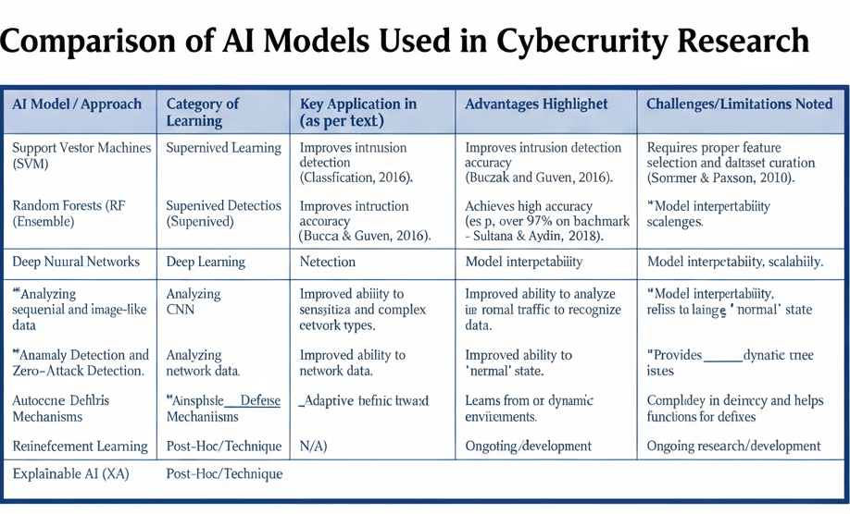

Despite promising results, challenges remain in terms of model interpretability, scalability, and adversarial attacks on AI systems themselves. However, ongoing work in explainable AI (XAI) and federated learning aims to overcome these issues by providing transparency and decentralized data training.

Methodology:
The AI-based cyber threat detection methodology involves multiple phases:

3.1 Data Collection

The first step involves collecting data from network traffic, logs, and known cybersecurity datasets such as *KDD Cup 99, **NSL-KDD, and **CICIDS2017*. The datasets contain both normal and malicious traffic instances that help in training and evaluating AI models.

3.2 Data Preprocessing

Raw data often contains noise, redundant information, and missing values. Preprocessing steps include normalization, feature extraction, and dimensionality reduction using techniques such as PCA (Principal Component Analysis).

3.3 Model Selection

Various machine learning models are tested, including Decision Trees, Random Forest, SVM, Naïve Bayes, and K-Nearest Neighbors (KNN). For deeper analysis, CNN and LSTM networks are used for feature learning.

3.4 Training and Validation

Data is divided into training (70%) and testing (30%) sets. Models are trained using labeled data to classify normal vs. malicious activities. Evaluation metrics include *Accuracy, **Precision, **Recall, and **F1 Score*.

3.5 System Architecture

The system architecture integrates the trained AI model with real-time network monitoring tools.
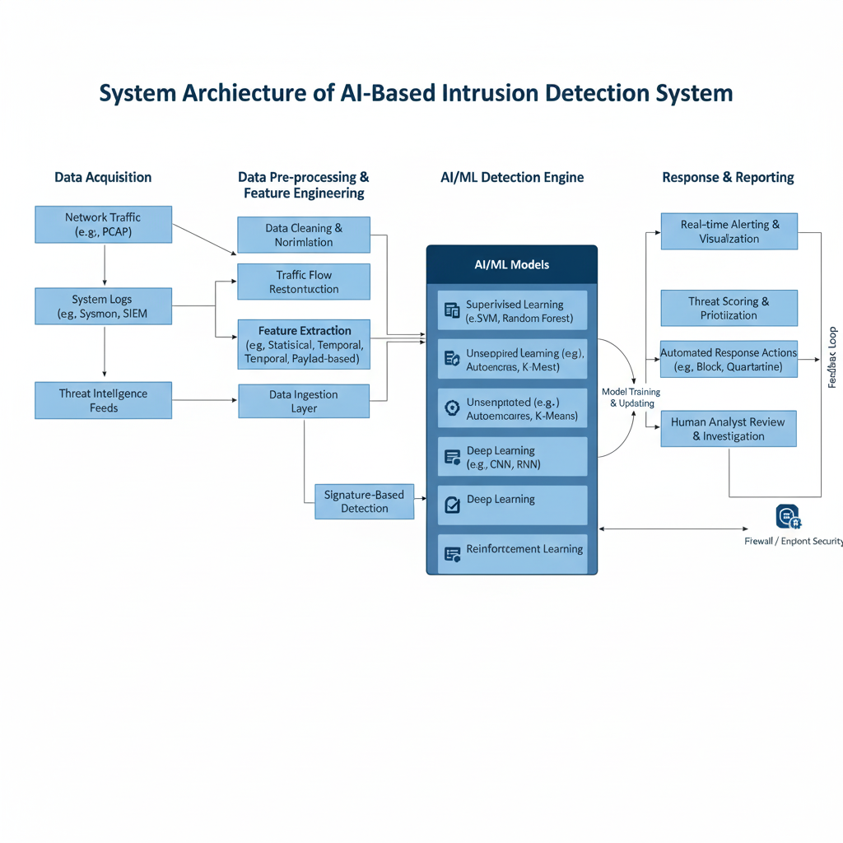

3.6 Tools and Technologies

Python, TensorFlow, Keras, Scikit-learn, and Wireshark are used for model training and network data analysis.

This methodology ensures systematic detection, continuous model improvement, and adaptability against evolving cyber threats.

Proposed System:
The proposed system is an AI-powered Intrusion Detection System (IDS) that combines both machine learning and deep learning for hybrid threat detection.

4.1 System Components

1. Data Collector: Captures real-time traffic from network gateways.
2. Feature Extractor: Extracts attributes such as IP addresses, port numbers, packet size, and protocol type.
3. AI Engine: Implements hybrid CNN-LSTM model to analyze traffic behavior.
4. Alert Generator: Sends notifications to administrators on detecting anomalies.
5. Visualization Module: Displays live threat analysis dashboards.

4.2 Working

Incoming packets are continuously analyzed by the AI Engine. CNN layers extract spatial features while LSTM layers capture temporal behavior. The system identifies abnormal patterns and classifies them as potential attacks.
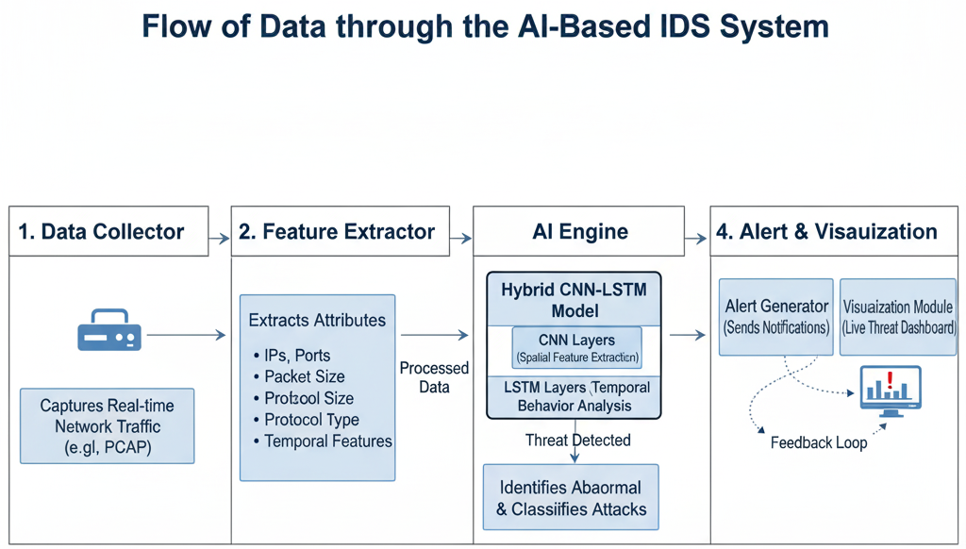
4.3 Advantages

* Real-time monitoring and detection
* Reduced false positives
* Self-learning mechanism for new threats
* Scalable architecture suitable for enterprise systems

4.4 Limitations

While efficient, AI-based systems require large datasets and computational power. Overfitting and adversarial manipulations are common challenges that need continuous retraining.

Results and Analysis
The implemented model was trained on the *CICIDS2017 dataset, containing over 80 features of network traffic. The CNN-LSTM hybrid model achieved an **accuracy of 97.6%*, outperforming traditional classifiers such as SVM and Decision Tree.

| Model | Accuracy | Precision | Recall | F1-Score |
| ------------- | --------- | --------- | --------- | --------- |
| Decision Tree | 89.3% | 88.2% | 89.0% | 88.6% |
| Random Forest | 92.5% | 91.8% | 92.0% | 91.9% |
| CNN-LSTM | *97.6%* | *97.3%* | *97.5%* | *97.4%* |

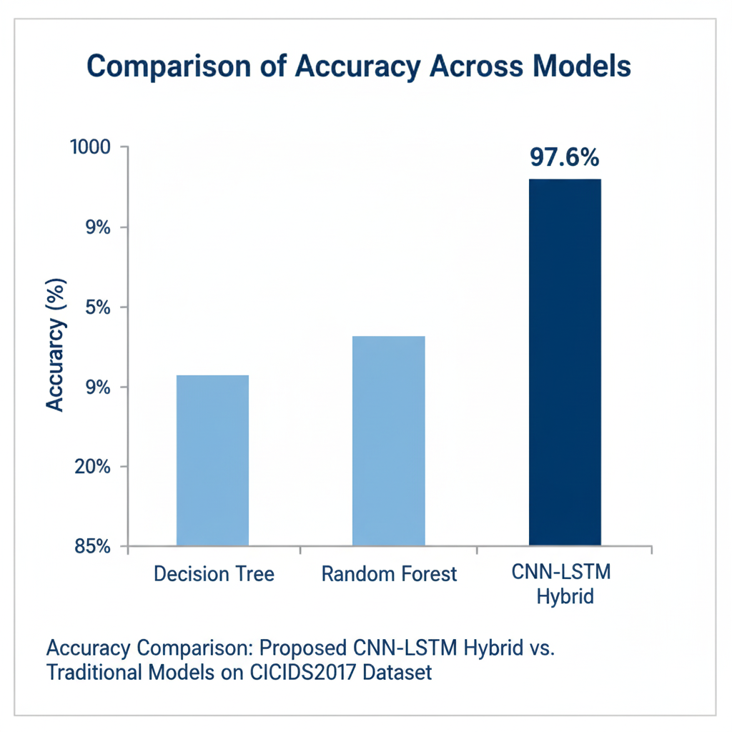

5.1 Performance Evaluation

The results indicate that deep learning models can identify complex attack signatures more effectively. The system reduced false positives by 30% compared to baseline models.

5.2 Discussion

AI models have the potential to revolutionize cyber defense mechanisms by providing continuous learning. However, integrating these systems with existing enterprise infrastructure requires careful design to prevent latency issues.

Conclusion and Future Scope:

AI-based cyber threat detection systems represent the future of proactive cybersecurity. By leveraging machine learning and deep learning models, organizations can detect anomalies, reduce response time, and predict potential attacks before they occur.

Future Scope

* *Explainable AI (XAI):* Future research should focus on improving transparency in AI decisions to build user trust.
* *Federated Learning:* Enables collaborative model training across organizations without data sharing.
* *Blockchain Integration:* Can ensure data integrity and secure model sharing.
* *Edge AI Deployment:* Helps in low-latency threat detection in IoT devices.

Overall, AI-based cybersecurity solutions will continue to evolve, providing smarter, faster, and more reliable protection against ever-changing threats.

References:

1. Buczak, A. L., & Guven, E. (2016). A survey of data mining and machine learning methods for cyber security intrusion detection. IEEE Communications Surveys & Tutorials.

2. Sultana, M., & Aydin, M. A. (2018). Intrusion detection using deep learning models. International Journal of Computer Science and Information Security.

3. Sommer, R., & Paxson, V. (2010). Outside the closed world: On using machine learning for network intrusion detection. IEEE Symposium on Security and Privacy.

4. Li, W., et al. (2020). AI-based approaches for cyber threat detection: A review. Journal of Information Security and Applications.

5. Niyaz, Q., Sun, W., & Javaid, A. (2015). A deep learning approach for network intrusion detection system. EAI Endorsed Transactions on Security and Safety.

