Building GDAL 1.4.2 for Windows using Visual Studio

V. 1.0



Daniele Romagnoli
Dott. Ing. Simone Giannecchini

1. Introduction
This simple guide will provide you some instructions about how to build GDAL 1.4.2 with support for the following formats:
- MrSID (v 6.0.7)
- ECW (v 3.3)
- Kakadu (v. 5.2.6)
- HDF4 (v. 4.2r1)

2. Preliminary steps
In order to add support for the listed formats, you need to achieve some preliminary steps for each format.

2.1 - ECW
Download the Image Compression SDK (source code) from ER Mapper site at this address:
http://www.ermapper.com (You need to be registered in order to download it).
From the main site, select the menu “products & downloads” -> “Image Compression SDK” from the Desktop section. Download the Image Compression SDK Source Code 3.3 file and extract this somewhere on your hard disk, as an instance on C:\ExternalLibraries\libecwj2-3.3.
Be sure you have Microsoft Windows® Server 2003 R2 Platform SDK installed.
If not yet installed, download it from this location:
http://www.microsoft.com/downloads/details.aspx?FamilyID=484269e2-3b89-47e3-8eb7-1f2be6d7123a&DisplayLang=en
Then, open the ready-to-use libecwj2_win32_net_shared.vcproj Visual Studio Project available in C:\ExternalLibraries\libecwj2-3.3\Source\NCSBuildQmake.
You will be asked to create a new solution. Select a location where to create the solution and, when done, change the solution properties (right click on the solution -> Properties).
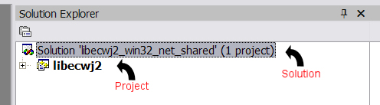
Select “Configuration Properties” and switch the Configuration value from “Debug” to “Release”.
Finally, select the libecwj2 project in your solution explorer and change its properties as follow:
Configuration Properties -> C/C++ -> General -> Additional Include Directories:
add an entry referring the include subfolder of the Microsoft Windows® Server 2003 R2 Platform SDK (As an instance: “C:\ProgramFiles\Microsoft Platform SDK for Windows Server 2003 R2\Include”).
Then, you are ready to build your solution.

2.2 - MrSID
As a first requirement, you need the LizardTech Decoding Software Development Kit (DSDK).
You can download it free of charge from this site:
http://developer.lizardtech.com (You need to be registered in order to download it).
After logged in, select “Download” -> “Software Development Kits” -> “Download SDK's”.
Select the proper version of SDK to be download.
When your download is completed, unzip the DSDK somewhere on your hard disk, as an instance, on C:\ExternalLibraries\MrSid

2.3 - KAKADU
The visual studio solution for kakadu building allows to build a shared debug DLL.
We need to change some settings to build a shared Release DLL.
Otherwise, sometimes, memory allocations errors occurs since some libs use MSVCRT71D and some others MSVCR71.
First step is open the proper ready-to-use Visual Studio Solution of kakadu coresys (located in kakadu\VERSION\coresys) and change the coresys configuration properties by changing the option C/C++->Code Generation -> RunTime Library from /MDd to /MD.
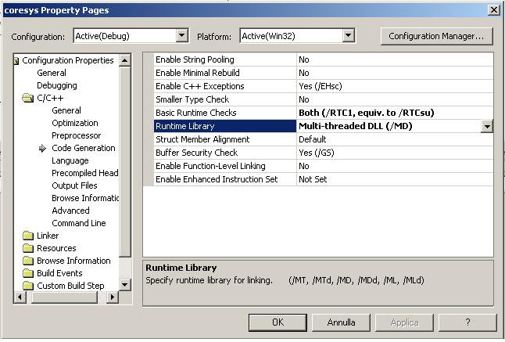
Then, you are ready to build your solution.
After you done this, open the Kakadu apps solution (located in kakadu\VERSION\apps). Change the Code Generation runtime library of each project from /MDd to /MD and build them.
Then, copy the produced .obj files in the kakadu\VERSION\apps\make folder. The required .obj and the location from where to get them are listed in the following table.
File | Originating location
args.obj | \v5_generated\v_compress\debug
2.obj | \v5_generated\v_compress\debug
mj2.obj | \v5_generated\v_compress\debug
image_in.obj | \v5_generated\compress\debug
palette.obj | \v5_generated\compress\debug
roi_sources.obj | \v5_generated\compress\debug
kdu_tiff.obj | \v5_generated\compress\debug
jpx.obj | \v5_generated\compress\debug
kdu_stripe_decompressor.obj | \v5_generated\buffer_expand\debug
image_out.obj | \v5_generated\expand\debug

2.4 - HDF4
As a first requirement, you need to download the binary distribution of HDF4 release from this site:
http://hdf.ncsa.uiuc.edu/release4/obtain.html
Scroll this page until you find the link to the binary distribution file for Windows.
When your download is completed, unzip the binary somewhere on your hard disk, as an instance, on C:\ExternalLibraries\HDF4
Then, enter in the release subfolder and create a libpath folder where you need to copy 4 *.lib files contained in release\lib and release\dll subfolders. They are: hd421.lib, hd421m.lib, hm421.lib, hm421m.lib
This could seem a strange workaround but it avoid errors when building GDAL against HDF4.
It is finally worth to point out that HDF4 leverages on some external libs: JPEG, ZLIB, SZIP. Be sure you have them. http://hdf.ncsa.uiuc.edu/release4/obtain.html also contains 3 links where to download the required libraries. For each library, you need to select the “Pre-Compiled Binaries” link and select the proper version (for Windows).

3. Configuring GDAL
Firstly, you need to download GDAL 1.4.2 from OSGeo SVN at this location: https://svn.osgeo.org/gdal/tags/1.4.2/gdal
You may use Tortoise SVN (available at: http://tortoisesvn.net/downloads) to download it.
Then, you need to apply the patch available at this location:
https://imageio-ext.dev.java.net/svn/imageio-ext/trunk/patches/1.4.2GDAL.patch
This patch contains several changes for:
- Kakadu support: Multithreading added; More Kakadu options supported. Makefile modified
- Java bindings: improved data access (read Dataset at once instead of read RasterBands at once; PixelSpace, LineSpace and BandSpace parameters now are allowed)
To apply the patch, supposing you already downloaded Tortoise SVN, you need to select the GDAL folder on your hard-disk, then right-button's click on it with your mouse and select TortoiseSVN ->Apply patch... At this point, you need to specify the previously downloaded 1.4.2GDAL.patch file and apply.

Finally, you need to modify your GDAL\NMAKE.opt as explained in the following sections.

3.1 - KAKADU SETTINGS
Find the KAKADU Setting properties by looking for the following line:
# Uncommment if you have Kakadu 4.0 or newer

Supposing your KAKADU library has been placed in C:\ExternalLibraries\kakadu, edit the next line, like this:
KAKDIR = C:\ExternalLibraries\kakadu\v5_2_6-90032L

Be sure the proper version subfolder is set. (In this case: v5_2_6-90032L).
To enable kakadu support we need to change only another property. Go ahead in the NMAKE.OPT and look for the following line:
# Any extra libraries needed on this platform?
Then, edit the ADD_LIBS variable by adding the kakadu lib, like this:
ADD_LIBS = C:\ExternalLibraries\kakadu\lib\kdu_v52D.lib

3.2 - MrSID SETTINGS
Find the MrSID Setting properties by looking for the following line:
#Uncomment the following for MrSID support
Supposing your MrSID library has been placed in C:\ExternalLibraries\MrSid, edit the next lines, like this
MRSID_DIR = C:\ExternalLibraries\MrSid
MRSID_INCLUDE = -I$(MRSID_DIR)\include\base -I$(MRSID_DIR)\include\support \
-I$(MRSID_DIR)\include\metadata \
-I$(MRSID_DIR)\include\mrsid_readers \
-I$(MRSID_DIR)\include\j2k_readers
MRSID_LIB = $(MRSID_DIR)\lib\Release_md\lti_dsdk_dll.lib advapi32.lib user32.lib

3.3 - ECW SETTINGS
Find the ECW Setting properties by looking for the following line:
# Uncomment the following and update to enable ECW support.
Supposing your ECW library has been placed in C:\ExternalLibraries\libecwj2-3.3, edit the next 2 lines, like this:
ECWDIR = E:\work\libecwj2-3.3
ECWLIB = $(ECWDIR)\lib\libecwj2.lib

3.4 - HDF4 SETTINGS
Find the HDF4 Setting properties by looking for the following line:
# Uncomment the following and update to enable NCSA HDF Release 4 support.
Supposing your HDF4 library has been placed in C:\ExternalLibraries\HDF4, edit the next 2 lines, like this:
HDF4_DIR = c:\ExternalLibraries\HDF4\release
HDF4_LIB = /LIBPATH:$(HDF4_DIR)\libpath

4. Building GDAL
Now, you are ready to build GDAL. Open Visual Studio Command Prompt, and enter in your GDAL home folder. At this point, you are ready to start the build process by running the following command:
nmake /f makefile.vc
When the build is terminated, you need to generate JAVA bindings.

5. Generating Java Bindings

5.1 - Requirements
Be sure you have properly downloaded SWIG, the Simplified Wrapper and Interface Generator which allow to produce JAVA bindings for GDAL. You can download it from: http://www.swig.org/
You also need ANT which will be used in order to build a JAR containing all JAVA classes generated by SWIG. You can download it from: http://ant.apache.org/

5.2 - Variable settings
Be sure your GDAL\NMAKE.opt has the SWIG variable, properly set. Check this variable by finding the following lines:
# Set the location of your SWIG installation
!IFNDEF SWIG
SWIG = C:\Programs\swig\swigwin-1.3.29\swig.exe
!ENDIF

Be sure SWIG variable refer to the proper swig.exe path.
Then, check your GDAL\SWIG\JAVA\java.opt is properly configured. (Basically, you need to check the JAVA_HOME and ANT_HOME variables)

5.3 - Running SWIG
Now, you are ready to generate java bindings. From the Command Line, enter in your GDAL\SWIG folder and run nmake /f makefile.vc java
This command will automatically generate wrappers and bindings.

6. Final Settings
At this point, you should have:
- some external DLLs (Kakadu: kdu_v52D.dll, ECW: libecwj2.dll, MrSID: lti_dsdk_dll.dll, HDF4: hd421m.dll, hm421m.dll)
- a GDAL DLL (gdal14.dll)
- 4 JNI DLL (gdalconstjni.dll, gdaljni.dll, ogrjni.dll, osrjni.dll)
- a jar file (gdal.jar)
You need to place all these DLLs in the folder where your application will look for libraries. A typical location where to place them is your JAVA_HOME/JRE/BIN if you are using JDK's JRE, or JAVA_HOME/BIN if you are using JRE.
Finally, gdal.jar needs to be used as dependency of your projects using GDAL Libraries and related java bindings.

As an instance, if you are using Visual Studio .Net 2003, open the coresys_2003.sln solution file.

