SWAN plugin - Summarizing report.



Eng. Simone Giannecchini
Daniele Romagnoli
This documentation describes some topics related to the GeoSolutions ImageIO Extension SWAN plugin.

Actually, the document is proposed in a basic form but it will further improved.

The main sections of this report will illustrate the structure of a typical SWAN output file, the Plugin capabilities as well as the SWAN header produced to describe SWAN output file properties.

SWAN OUTPUT FILES
A SWAN generated output file may contain data for both a single output quantity (as an instance, HSIGN quantity) and a set of output quantities (as an instance, the same file should contain data for HSIGN, DIR, TDIR, PER,… quantities).

For each quantity, depending on the tau parameter (representing the number of required forecasts), SWAN will generate data for several forecasts.

When N output quantities are written within the same file, data are organized in this way:

- 1ST forecast – 1ST quantity data
- 1ST forecast – 2ND quantity data
- 1ST forecast – 3RD quantity data
- …………………………………
- 1ST forecast – N^{TH} quantity data
- 2ND forecast – 1ST quantity data
- 2ND forecast – 2ND quantity data
- 2ND forecast – 3RD quantity data
- …………………………………
- 2ST forecast – N^{TH} quantity data
- …………………………………
- Last forecast – 1ST quantity data
- Last forecast – 2ND quantity data
- Last forecast – 3RD quantity data
- …………………………………
- Last forecast – N^{TH} quantity data

The SWAN output plugin is able to read raster data from both types of output files (containing single quantity or multiple quantities).

To access and read a specific raster contained in the source file, you need to specify a proper imageIndex when using SwanImageReader.read(int imageIndex) method. (It is worth to point out that such method will also be called by JAI when you performs an ImageRead operation. In this case, you should specify a proper ImageReadParam setting the imageChoice parameter).

If source file contains data for a single SWAN output quantity, imageIndex refers to a specific forecast (as an instance, imageIndex=0 refers to the first forecast, imageIndex=1, to the second one and so on).
If source file contains data for several SWAN output quantities, imageIndex refers to a specific forecast of a specific quantity, following a simple logic:

Let be nDatasets the number of quantities contained in the file.
Let be requiredQuantity the index (zero based) of the output quantity you want to access.
Let be requiredForecast the index (zero based) of the required forecast.

Then, imageIndex = (requiredForecast * nDatasets) + requiredQuantity

You can retrieve a proper imageIndex necessary to access a specific forecast of a specific quantity, using the auxiliary method
SwanImageReader.getImageIndexFromTauAndDatasets(int requiredForecast, int requiredQuantity).

OUTPUT DATA FORMAT
Let us provide a brief description about the format of the output values.
Each value is stored in the file as a sequence of M chars, each one having the following structure:

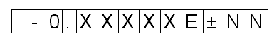

- The 1ST char is always a “space”
- The 2ND char may be a “space” or a “minus sign” (“-“).
- The 3RD char is always a zero (“0”).
- The 4TH char is always a “dot sign” (“.”).
- Then, there are D chars representing the decimal digits. (D is in the range [1-9])
- After them, there is always a “E” char.
- After the “E” char there may be only a “plus sign” (“+”) or a “minus sign” (“-“), representing the exponent sign.
- Finally, there are always 2 chars, representing the exponent power.

By this way, each value may be calculated as 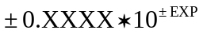
The first space should be considered as a part of the value representation. By this way, the values of the same raster row are consecutive and no white spaces divide them.
Each data row contains C consecutive values and it terminates with a new line sequence.
Finally each forecast of each quantity contains R data rows.

When preparing read operations, we may specify source subsampling factors as well as source region refining.
The exact knowledge of number of chars for each value, number of rows, number of columns, number of taus and number of output quantities, allows the SWAN plugin to fast skip chars related to unrequired data values.

All of the considerations contained in these chapters are valid if the SWAN commands used to produce output files follow a simple set of rules which will be introduced in the Appendix A.

SWAN HEADER
A SWAN output file is always accompanied by a SWAN header file (.swh) containing information about the data stored in the output file. Prior to start with the read operation the plugin checks if the header file contains all the required information.

Figure 1 shows the XML schema describing information available in the SWAN header file.

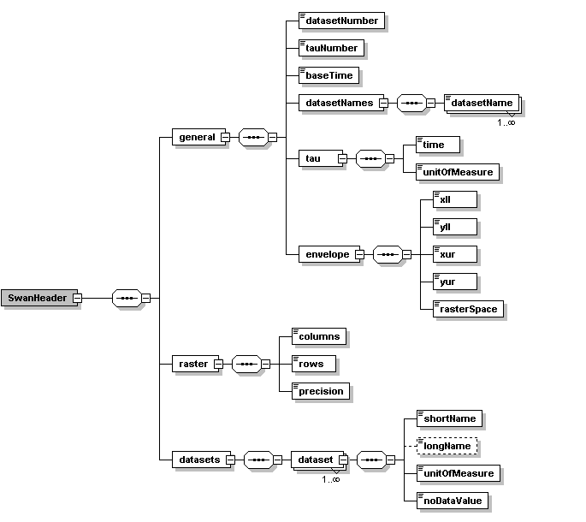

Figure 1.

The “general” element provides information about the general properties of the output file such as:
- the number of SWAN output quantities stored (identified by datasetNumber)
- the number of forecasts contained within the file (identified by the tauNumber)
- the baseTime (expressed as a ISO 8601 formatted string)
- the tau (expressed by 2 elements: a “time” quantity and a unit of measure for the time)
- the envelope (containing grid lower-left and upper-right coordinates as well as the rasterSpace type which describes if these coordinates are related to the corner of the pixel cell or its center).

The “raster” element provides information about the properties of the output data values grid. More precisely:
- the number of columns
- the number of rows
- the decimal precision, representing the number of D decimal digits, introduced in the previous chapter.

Finally, the “datasets” element contains a list of “dataset”s elements providing information which is strictly related to a specific SWAN output quantity, such as:
- the short name of the quantity (like, as an instance, HSIGN)
- the long name of the quantity (a kind of description)
- its unit of measure
- the value representing invalid data (as an instance, a typical value should be –9999).

The SWAN plugin is able to provide, any information contained in the Header file, as metadata.
In compliance with the ImageIO metadata definitions we should distinguish between two types of metadata:
- stream metadata: which is used to report information related the whole data source we are referring.
- image metadata: which is used to report information about a single image.

In such a context, the SWAN plugin may retrieve Stream Metadata as well as Image Metadata (for a specific imageIndex, in compliance with the previously explained rule).
By referring at the schema of Figure 1, Stream Metadata provide information related to “general” and “raster” elements.
Image metadata provide information related to “raster” element as well as “envelope” sub-element and a specific “dataset” element.
Metadata are provided as a well formed IIOMetadataNode. You should take a look on the available SWAN plugin code to get more information about how metedata is structured.

It is worth to point out that, for the same ouput grid, the envelope, the number of data rows and data columns as well as the number of decimal digits, are always the same indipendently of the specific output quantity, and these information are provided as stream metadata. However this information will be also repeated within the image metadata.

FUTURE IMPROVEMENTS
- Data rescaling when all values differ for a very little quantity. (flat visualization)
- Adding support for more unit of measure.

APPENDIX A - SWAN commands.
The description provided in the previous chapters, relying SWAN output files structure, are valid only under a specific SWAN commands setting.

--- Extend this section ---

The number of D chars used to represent the decimal digits of the value is contained in the SWAN header, which will be introduced in the next section.
C is the number of COLUMNS of the data raster. Its value is known and it is contained in the SWAN header, which will be introduced in the next section.
The SWAN plugin take care of understanding if the new line is a sequence of /CR /LF chars or a simple /CR char (linux style).
R is the number of ROWS of the data raster. Its value is known and it is contained in the SWAN header, which will be introduced in the next section.

