**ni_find_nearest_nodeB_to_nodeA_using_nn** – this function finds the closest node of nodeset B to each node in nodeset A. The resulting output table will contain all the attributes of the nodes of nodeset A, as well as:

* Geometry of each node of nodeset A
* PR Key of each node of nodeset A
* Geometry of closest node of nodeset B, to node of nodeset A
* PR Key of closest node of nodeset B, to node of nodeset A
* A straight line between node of nodeset A, and the closest node to it from nodeset B
* The straight line distance between node of nodeset A, and the closest node of nodeset B

**Parameters:**

1) nodeset_A_table_name: string – table name of node set A

2) nodeset_A_prkey: string – unique key of node set A

3) nodeset_A_geometry_column_name: string – column name containing point geometry of nodeset A

4) nodeset_B_table_name: string – table name of node set B

5) nodeset_B_prkey: string – unique key of node set B

6) nodeset_B_geometry_column_name: string – column name containing point geometry of nodeset B

7) output_table_name: string – name of the resulting output table

8) add_to_geometry_columns: boolean – indicates whether you wish the output table to be added to the geometry_columns table, once it has been created.

**e.g. SELECT * FROM ni_find_nearest_nodeB_to_nodeA(‘nodeset_A’, ‘gid’, ‘geom’, ‘nodeset_B’, ‘gid’, ‘geom’, ‘closest_nodeB_to_each_nodeA’, false);**

**SELECT * FROM ni_find_nearest_nodeB_to_nodeA('OS_WaterPumpingStations', 'gid', 'geom', 'OS_ElectricitySubStations', 'gid', 'geom', 'closest_substation_to_each_pumping_station', false)f( node_A_geom geometry, node_A_id integer, node_B_geom geometry, node_B_id integer, node_AB_line geometry, st_distance numeric, gid integer, oid_ varchar (254), objectid numeric(10,0), unique_ref numeric(10,0), "name" varchar(254), easting numeric, northing numeric, county varchar(254), postcode varchar(254), geom geometry);**

**Figure.1** illustrates running this operation for the water pumping stations and electricity sub stations in the UK:

The blue dots are the water pumping stations and the yellow dots are the closest electricity sub station to each water pumping station. The red line denotes to which pumping station each sub station is providing power.

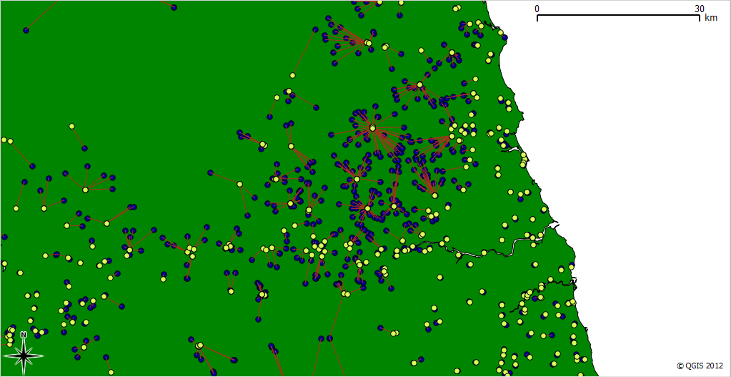

Figure.1 – calculating closest substation to each water pumping station