**ni_data_proc_connect_hanging_edges_to_nodes_in_search** – this function connects edges “ends” to each node that are within a specified search distance of each node.

**Parameters:**

1) Edge_table_name: string e.g. data_national_grid_gas_pipeline_feeder

2) Edge_Geometry table geometry column name: string e.g. geom.

3) Edge table primary key: string e.g. gid

4) Node_table_name: string e.g. data_national_grid_gas_site_centroids

5) Node table geometry column name: string e.g. geom.

6) Node table primary key: string e.g. gid

7) Output table name: string e.g. conct_pipeline_feeder_edge_gas_site_centroid_edge_end_pt

8) Boolean indicating whether the output table should be added to the geometry_columns table: true/false

9) Search distance in (m): double, float, numeric – used to determine whether the distance between a hanging edge and a node is valid, and will result in a join i.e. distances greater than the search distance will result in no additional connection, whereas distances less than the search distance will result in a new connection

e.g.

**SELECT * FROM ni_data_proc_connect_hanging_edges_to_nodes_in_search ('data_national_grid_gas_pipeline_feeder','geom', 'gid', 'data_national_grid_gas_site_centroids','geom', 'gid', 'conct_pipeline_feeder_edge_gas_site_centroid_edge_end_pt', false, 1000) f(gid integer, objectid numeric, inspecti_1 varchar(254), subtypecd numeric(10,0), primaryind numeric(10, 0), gavprimary numeric(10, 0), pipe_name varchar(255), ng_owned varchar(2), geom geometry, connection_point_geom geometry, additional_geom geometry, additional_combined_geom geometry, start_point_distance numeric(10,0), end_point_distance numeric(10,0)) ORDER BY start_point_distance ASC;**

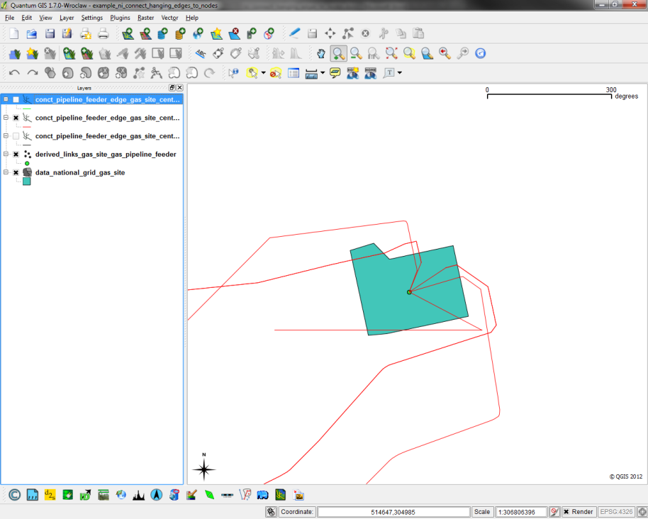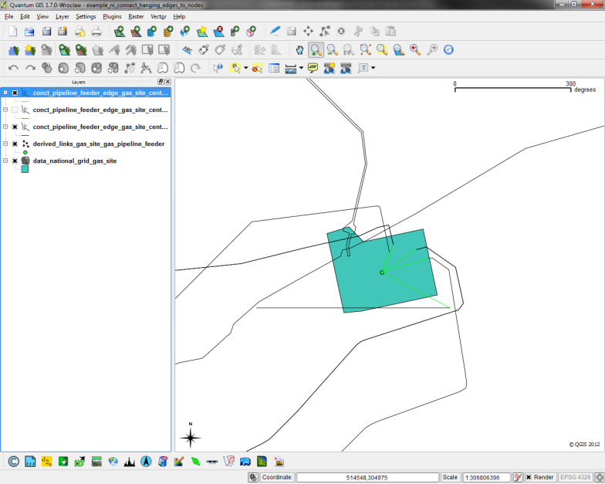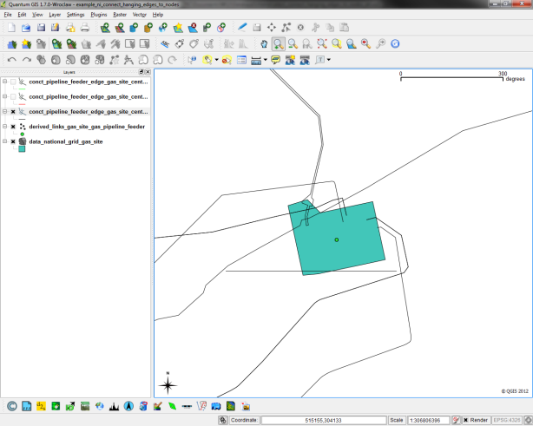

**Figure.1** – Edge ends are not joined to the appropriate node (black, tl). Run the tool **ni_data_proc_connect_hanging_edges_to_nodes_in_search** to auto-generate the appropriate additional edge geometry (green tr), based on the afore-mentioned supplied parameters. The red connections denote the combination of the old geometry + the newly derived geometry (bl).

This table would be output with _join appended to the input output table name (parameter 7). Secondly a table with _unique appended to the input output table name (parameter 7) is also written to the schema that contains the original geometry replaced with the newly derived geometry.