**ni_find_junctions** – this function attempts to identify the likely point locations of junctions along a network, based solely on the intersection count of edges with nodes. The function works by calculating the start and end points of each edge element (linestring) and then for each edge end point created, an intersection count against the number of edges is calculated, and any edge end points with an intersection count of not equal to 1 is considered to be a “*junction*”.

Parameters:

1. Input Line / Edge Table Name
2. Input Line / Edge Table Name split by all vertices in 1.
3. Unique key for 1.
4. Output junction table name
5. Value to assign to all points identified as junctions e.g. ‘Railway junction’

e.g. SELECT * FROM ni_find_junctions(‘os_meridian_rail_ln’, ‘os_meridian_rail_ln_split_vertices’, ‘gid’, ‘os_meridian_rail_junctions’, ‘JUNCTION’)

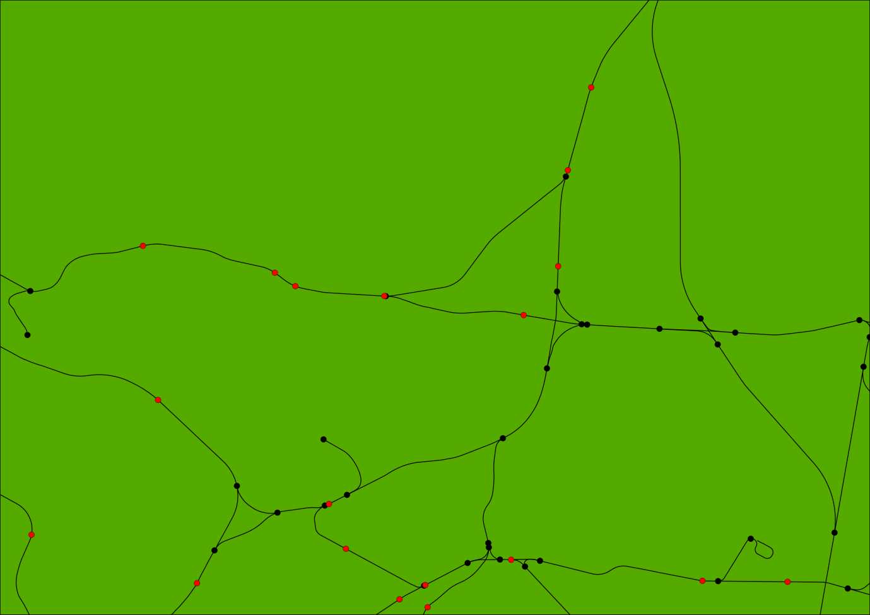

Figure - Junctions (black) identified from raw Ordnance Survey Meridian 2 rail shapefile