**Assignment 1**

Q1.0

By opening the createFilterBank file, a total of 4 filters were observed.

1. LoG filter – Laplacian filter
2. Gaussian filter
3. Dx filter
4. Dy filter

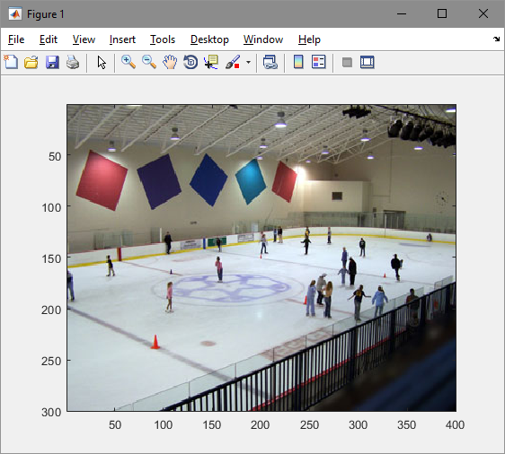Q1.1

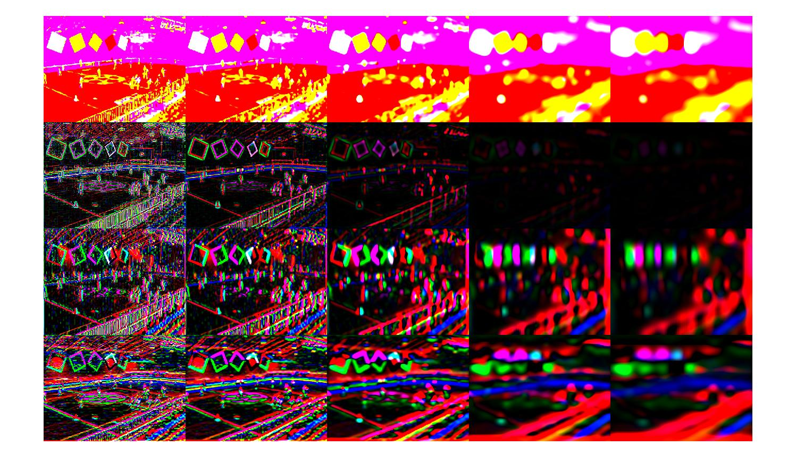

Q1.3

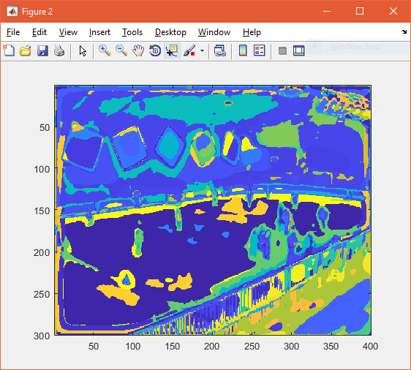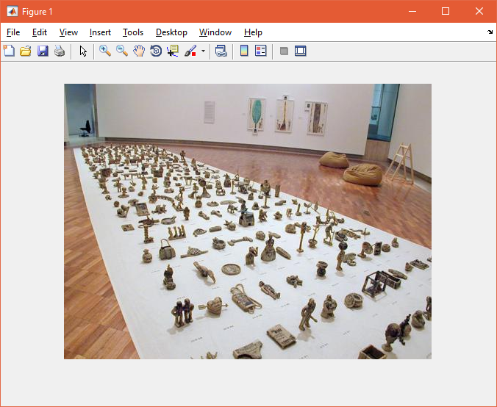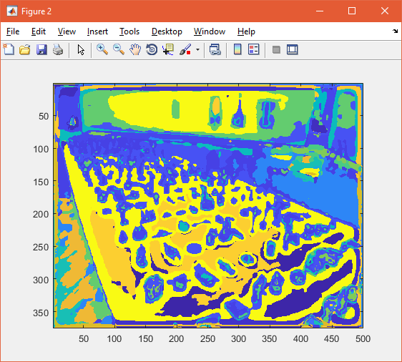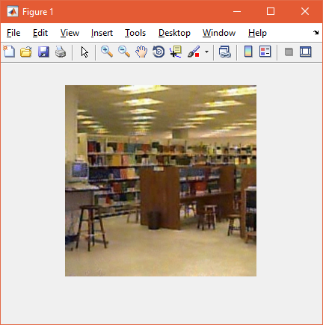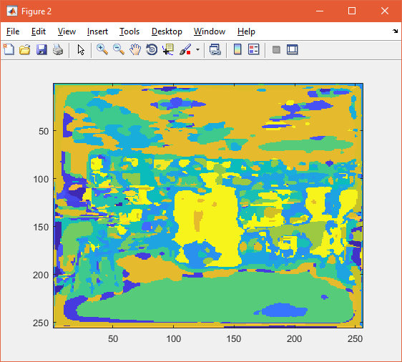

Q2.5

Accuracy = 12.5%

Confusion Matrix = 20 0 0 0 0 0 0 0

20 0 0 0 0 0 0 0

20 0 0 0 0 0 0 0

20 0 0 0 0 0 0 0

20 0 0 0 0 0 0 0

20 0 0 0 0 0 0 0

20 0 0 0 0 0 0 0

20 0 0 0 0 0 0 0