CS321-P2-Abreu-Calciu-Hayes-Tang

**System Overview**

Our application, SnapBuy, is a mobile app that allows users to take a picture of any product they desire and search for a website to buy it from. The app would recognize the general category for which the product belongs in (ex. a pair of Jordans belongs under “shoes”) and find a place online where you can buy other products under the same category.

**Requirements**

a)

Functional Requirements (Ordered from highest priority to lowest priority)

1. Take a Picture: 2 Days

* Users must submit an image or video for AWS Rekognition to analyse. This functional requirement supports that stage.

2. Image Analysis: 2 Weeks

* Images and videos submitted by the user must be analysed by AWS Rekognition, and generated keywords must be collected.

3. Web Search: 2 Days

* Keywords generated by AWS Rekognition must be used in conjunction with web search API to retrieve shopping-related links.

4. Website Redirection: 2 Days

* Users must be able to view the retrieved links, select a link, and have the default browser automatically open and create a new tab that opens the corresponding webpage.

Stretch Goals :

5. Search Refinement/Filtering: 1 Week

* Users may desire to customize the web search stage and add filters.

6. List Sort: 1 Day

* Users may wish to have different views of links displayed via various sorts after the web search stage.

7. Tips Page: 2 Days

* A help screen with tutorial information, FAQs, and other useful information.

Non-functional Requirements

1. Ease of Use

a. Subjective Measurement Criteria

i. 1-10 scale of user comfort with UI and flow

b. Objective Measurement Criteria

i. A new user shall be able to take a picture and submit it for image analysis in at most three (3) seconds, not including the amount of time required to take the picture. Additionally, a new user shall be able to select a suggested link in at most three (3) seconds.

2. Short Search and Result Generation Time

a. Objective Measurement Criteria

i. If a search (searches consist of Image Analysis and Web Search) for a

product yields a result in five (5) seconds or less, a low search time has been achieved

3. Permissions Requirements

a. The app will require, at a minimum, access to the device’s camera in order to take pictures or videos

b. Accomplishment of stretch goals will additionally require access to device storage in order to save pictures and videos

b) The “Tips Page” functional requirement was added, as were estimated development periods for each functional requirement.

**System Architecture**

a) We plan to apply the Data flow architectural pattern to our system. The output of each element is the input of the following element. The first element is a button option to take a picture. Clicking the button is then the input for spawning the camera permission. Answering no brings the user back to the main screen and answering yes opens the camera. The picture taken is the input for the Rekognition API. The keywords output from the Rekognition API are then input into the web search. The web search results are the input for the product results screen.

This architectural pattern reflects our non-functional requirements. The pattern leads to ease of use, as the application is linear and the user is always led to the next step.. There is also an option within the architecture for handling the user not giving camera permission. Finally, the result generation is right after the picture is to be taken in the data flow architecture, leading to a short result time.

b) 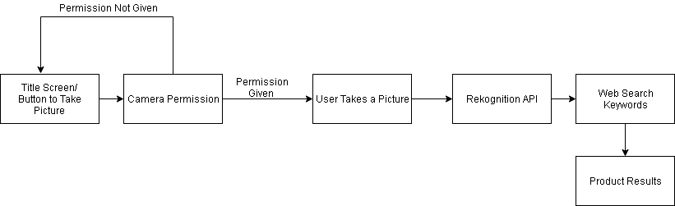

**User Experience**

The overall goal of achieving a good user experience requires time efficiency and convenience. With the system architecture in mind, designing the user’s experience will follow a fast flow of actions. The user should feel that with each button press, they are taking a step in achieving their goal. With that, each step should be quick on the backend as well in order to match the user’s expectation of the flow from the frontend perspective. A necessary step in the user’s experience is granting the app camera permissions. Without this, the user’s experience of the app is essentially non-existent as the app will only function on the title screen.

**Team Retrospective**

a) We have made steady progress in terms of team meetings and team coordination. We also work on the deliverables together and turn them on it time.

b) We are still trying to get to the same level in terms of our work environment setup and skills. We are also having trouble using the AWS Rekognition with Android Studio

c) We have been looking at tutorials and learning from Adrian about version control technologies. In terms of the AWS Rekognition, we are going our separate ways in trying to figure out how to use it. We discuss about any new discoveries every time we meet.

**Contributions**

* Mike managed the work for this deliverable.
* The work was allocated based on the approximate words needed to complete each section

and the amount of brain power needed. We talked with each other to confirm certain aspects and details of the parts before writing it down.

George - “System Overview”, Team Retrospection

Morgan - User Experience

Adrian - Requirements, Contributions

Mike - System Architectures