CS321-P3-Abreu-Calciu-Hayes-Tang

**System Overview**

Our application, SnapBuy, is a mobile app that allows users to take a picture of any product they desire and search for a website to buy it from. The app would recognize the general category for which the product belongs in (ex. a pair of Jordans belongs under “shoes”) and find a place online where you can buy other products under the same category.

**Technology**

1. Android Studio: This is the main environment we will be using to develop our app.

AWS Rekognition API: Amazon’s Rekognition API is a vital component to our project as it will handle generating keywords based on the picture a user will take.

Git (Bitbucket): We will be using git for our VCS with Bitbucket as our frontend

Android Device (Camera/Permissions): The app is being developed solely for android devices. As such, accessing the camera and checking permissions will need to be handled in the context of our users being on an Android device.

1. The system architecture remains unchanged.

**Class Diagrams**

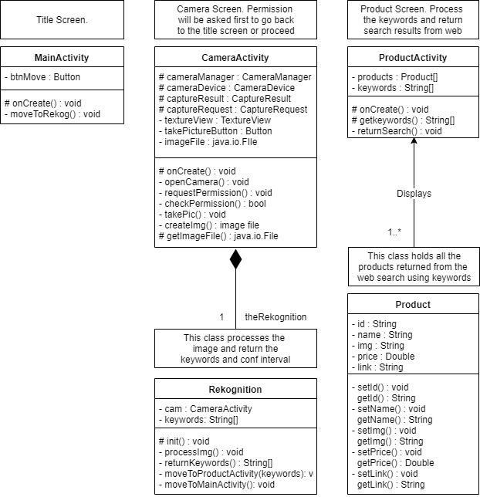

**Dynamic Analysis Diagrams**

Diagram 1: Shows the user opening the app and following the full process to receive search results

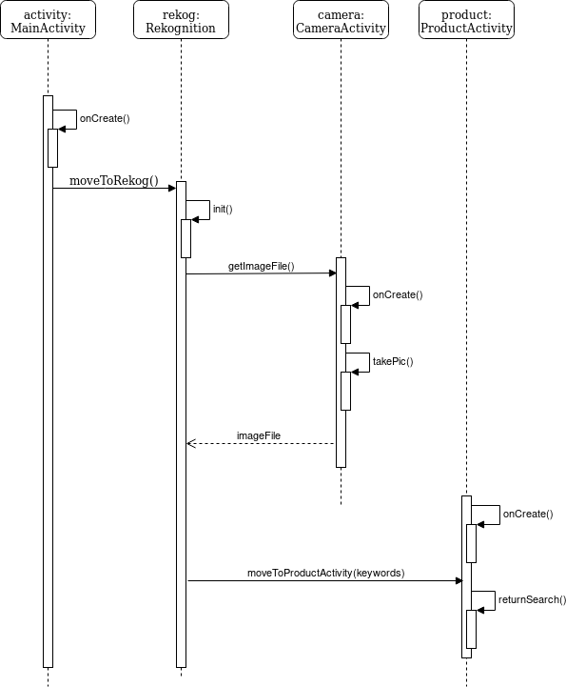

Diagram 2: Shows user returning to the main screen after taking a picture

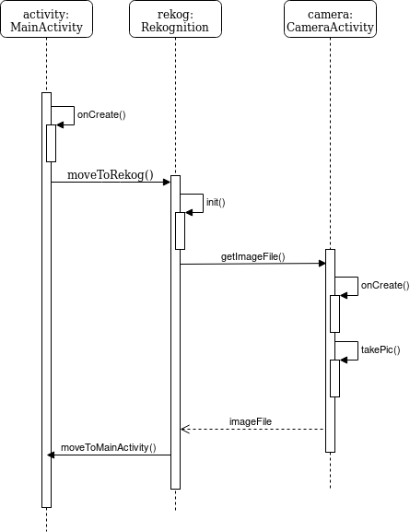

**User Experience**

The overall goal of achieving a good user experience requires time efficiency and convenience. With the system architecture in mind, designing the user’s experience will follow a fast flow of actions. The user should feel that with each button press, they are taking a step in achieving their goal. With that, each step should be quick on the backend as well in order to match the user’s expectation of the flow from the frontend perspective. A necessary step in the user’s experience is granting the app camera permissions. Without this, the user’s experience of the app is essentially non-existent as the app will only function on the title screen.

**Team Retrospective**

a) The team is staying consistent in terms of progress and coordination. All team members put forth a reasonable amount of effort to complete the needed components in a timely manner. We have also shown effort in learning about parts of the project we may have less experience with.

b) Now that we have been discussing implementation, there has been a discussion about how certain components will work together. The confusion here began with talking about the diagrams required for this deliverable.

c) We have addressed this issue by discussing each member’s idea and what it would look like during implementation, specifically within Android. While we are still discussing exactly what implementation will look like in terms of class communication, we have all come to an understanding of each of our options.

**Contributions**

* Morgan managed the work for this deliverable.
* While each member was in charge of a particular part of the deliverable, all team members assisted in completing the assignment. Specifically, all team members assisted in completing the class diagrams and sequence diagrams

George - System Overview, Class Diagram

Morgan - User Experience, Team Retrospective, Contributions, Technology

Adrian - Dynamic Analysis Diagram

Mike - Dynamic Analysis Diagram