SFC WEB API

System Requirements

# Design Principles

* 1. Design around **resources**
  2. Focuses on **business entities**
  3. Separate URIs for individual resource
  4. **Stateless** request model
  5. Use **HATEOAS** approach (navigation links, related resources)
  6. URIs **should** be based on nouns not verbs
  7. Design the API as an **abstraction of the data items (DB)**
  8. A resource **does not have** to be based on a single data item (table)
  9. Provide through the API the relationship between data items
  10. Create a consistent naming convention
  11. Follow the URIs pattern :
      + - * ./resources (get all items for this resource)
          * ./resources/item (get one single item)
  12. Keep the URIs **as simple as possible** :
      + - * ./resources/item/nested_resoucers (recommended nested resources)
  13. The more requests, the bigger the server load
  14. Combine related information into a bigger resource (Extraneous Fetching Anti-pattern)

# Anti-Design Principles

* 1. Do not create API **mirroring the database**
  2. Do not create **complex nested resources** URIs :
     + - * ./resources/item/resources/item/resources/…
  3. Do not create APIs that exposes a large number of small resources (**Chatty I/O Anti-pattern**)
  4. Avoid client to send multiple requests to get all the desired data
  5. Do not return to the client data that was not required
  6. Do not return to the client very-large objects (**Extraneous Fetching Anti-pattern**)
  7. Be careful with pseudo-resources and query-string parameters

# Scenarios (use-cases)

* 1. **Tracking Station**
     1. Login into station
     + Validate login and password
     + Validate the rights to login into the station
     + Retrieve the last logged record (station_location)
     1. Change the station
     + Validate the rights to login into the station
     + Validate login and password
     + Update the login record (station_location)
     1. Scan the unit
     + Validate the unit route
     + Validate the unit state (lock, fail, etc)
     + Update the unit state
     + Update the unit route
     + Update the unit log
     + Update the work order
  2. **Fail Station**
     1. Login into station
     + Validate login and password
     + Validate the rights to login into the station
     + Retrieve the last logged record (station_location)
     1. Change the station
     + Validate the rights to login into the station
     + Validate login and password
     + Update the login record (station_location)
     1. Scan the unit
     + Validate the unit route
     + Validate the unit state (lock, fail, etc)
     + Update the unit state
     + Update the unit route
     + Update the unit log
     + Update the work order
     1. Fail the unit
     + Validate the unit route
     + Validate the unit state (lock, fail, etc)
     + Update the unit state (fail status)
     + Update the unit route
     + Update the unit log
     + Update the work order
  3. **Assembly Station**
     1. Login into station
     + Validate login and password
     + Validate the rights to login into the station
     + Retrieve the last logged record (station_location)
     + Retrieve the scan list (wo_parts)
     1. Change the station
     + Validate the rights to login into the station
     + Validate login and password
     + Update the login record (station_location)
     + Retrieve the scan list (wo_parts)
     1. Scan the unit
     + Validate the unit route
     + Validate the unit state (lock, fail, etc)
     + Update the unit state (fail status)
     + Update the unit route
     + Update the unit log
     + Update the work order
     + Retrieve the scan list (wo_parts)
     1. Scan the parts
     + Validate work order parts rules
     + Assembly parts into unit
     + Update parts status

# API Resources

* 1. Users
  2. Stations
  3. WorkOrders
  4. Wips
  5. Parts

# API Resources Actions

* 1. Users
  2. Login
  3. Logout
  4. Change station
  5. Check rights
  6. Change password
  7. WorkOrders
  8. Get scan list (by product, process, etc)
  9. Validate parts (part number, eee-code, etc…)
  10. Wips
  11. Scan serial number
  12. Check state (active, lock, failed, etc…)
  13. Assembly parts (collection)
  14. Parts
  15. Scan serial number
  16. Assembly part (single part into a unit)
  17. Get assembled parts

# API Reference

| RESOURCE | GET | POST | PUT | DELETE |
| --- | --- | --- | --- | --- |
| /users | Get all users | Create a new user | Bulk update users | Delete all users |
| /users?filter | Get users with filter | n/a | n/a | Delete users with filter |
| /users/{id} | Get the user detail | n/a | Update the user detail | Delete the user |
| /users/{id}?action=login | n/a | Login the user | n/a | n/a |
| /users/{id}?action=logout | n/a | Logout the user | n/a | n/a |
| /users/{id}?action=rights | Get user rights | Check user rights | n/a | n/a |
| /stations | Get all stations | Create new station | Bulk update stations | Delete all stations |
| /stations?filter | Get stations with filter | n/a | n/a | Delete stations with the filter |
| /stations/{id} | Get the station detail | n/a | Update the station detail | Delete the station |
| /workorders | Get all WOs | Create new WO | Bulk update WOs | Delete all WOs |
| /workorders?filter | Get WOs with filter | n/a | n/a | Delete WOs with filter |
| /workorders/{id} | Get WO detail | n/a | Update WO detail | Delete WO |
| /workorders/{id}/wips | Get all WIPs for the WO | n/a | Bulk update WIPs for the WO | Delete all WIPs for the WO |
| /workorders/{id}/wips?filter | Get WIPs for the WO with filter | n/a | n/a | Delete WIPs for the WO with filter |
| /workorders/{id}/parts | Get all PARTs for the WO | Add part for the WO | Bulk update PARTs for the WO | Delete all PARTs for the WO |
| /workorders/{id}/parts?filter | Get PARTs for the WO with filter | n/a | n/a | Delete PARTs for the WO with filter |
| /workorders/{id}/routes | Get ROUTE for the WO | n/a | Update ROUTE for the WO | Remove ROUTE for the WO |
| /workorders/{id}/routes?filter | Get ROUTE for the WO with filter | n/a | Update ROUTE for the WO with filter | Remove ROUTE for the WO with filter |
| /wips | Get all WIPs | n/a | Bulk update WIPs | Delete all WIPs |
| /wips?filter | Get WIPs with filter | n/a | Update WIPs with filter | Delete WIPs with filter |
| /wips/{id} | Get WIP detail | n/a | Update WIP detail | Delete WIP |
| /wips/{id}?action=check | n/a | Check WIP status | n/a | n/a |
| /wips/{id}?action=scan | n/a | Scan WIP for PASS or FAIL | n/a | n/a |
| /wips/{id}?action=history | Get WIP history (wip_log) | n/a | n/a | n/a |
| /wips/{id}/workorders | Get WO for the WIP | n/a | Update WO for the WIP | n/a |
| /wips/{id}/parts | Get all PARTs for the WIP | Add PARTs for the WIP | Update PARTs for the WIP | Delete PARTs for the WIP |
| /wips/{id}/parts?filter | Get PARTs for the WIP using filter |  |  | Delete PARTs for the WIP using filter |
| /wips/{id}/routes | Get ROUTE for the WIP | n/a | Update ROUTE for the WIP | n/a |
| /wips/{id}/routes?filter | Get ROUTE for the WIP with filter | n/a | Update ROUTE for the WIP with filter | n/a |
| /parts | Get all PARTs | Create new PART | Bulk update PARTs | Delete all PARTs |
| /parts?filter | Get PARTs with filter | n/a | Update PARTs with filter | Delete PARTs with filter |
| /parts/{id} | Get PART detail | n/a | Update PART detail | Delete PART |
| /parts/{id}?action=scan | n/a | Scan the PART | n/a | n/a |
| /parts/{id}/wips | Get WIP for the PART | Add WIP for the PART | Update WIP for the PART | Delete WIP for the PART |
| /parts/{id}/wips?filter | Get WIP for the PART with filter | Add WIP for the PART with filter | Update WIP for the PART with filter | Delete WIP for the PART with filter |

# API Sequence Diagram

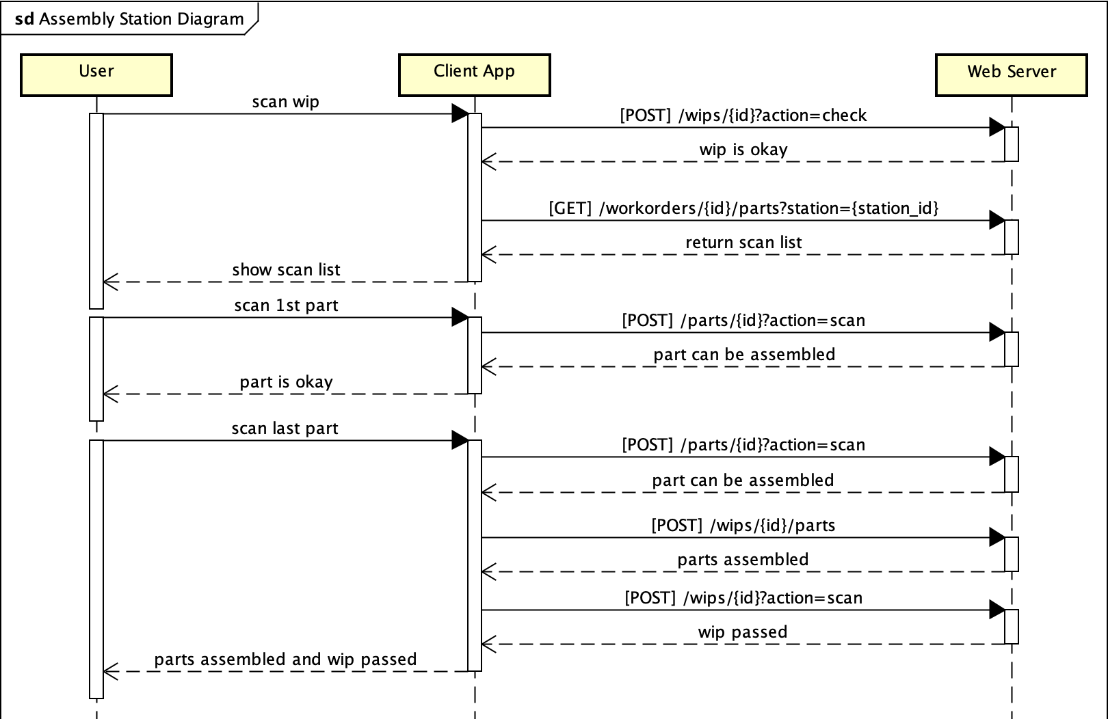

# Business Logic Sequence Diagram

# 