Exploring Science, Technology, Engineering, and Mathematics (STEM) With MathPiper
by Ted Kosan

Copyright © 2010 by Ted Kosan

This work is licensed under the Creative Commons Attribution-ShareAlike 3.0 License. To view a copy of this license, visit http://creativecommons.org/licenses/by-sa/3.0/

Table of Contents
1 Preface 8
1.1 Dedication 8
1.2 Acknowledgments 8
1.3 Website And Support Email List 8
1.4 Recommended Weekly Sequence When Teaching A Class With This Book 8
2 Introduction 9
2.1 Patterns And STEM 9
3 Patterns And Pattern Spaces 10
3.1 Exploring A Permutation Pattern Space 10
3.1.1 Generating Permutation Patterns With PermutationsList() 10
3.1.2 The Permutations() Function And The Enormous Pattern Spaces It Can Work With 14
3.2 Tools For Moving Through A Pattern Space 16
3.2.1 Walking Through A Pattern Space With Pencil And Paper 16
3.2.2 Flying A Spacecraft Through A Pattern Space With A Loop Based Program 17
3.2.2.1 A Pattern Space Can Quickly Become Too Vast For Even A Computer "Spacecraft" To Traverse 18
3.2.3 Hyperspace Jumping Through A Pattern Space With Mathematical Formulas And Theorems 20
3.2.3.1 Beginning The Search For An Integer Summing Jump Point 20
3.2.3.2 Switching To Mathematical Notation 23
3.2.4 Formulas And Theorems Are Like Hyperspace Jump Points 27
3.2.5 The Greek Letter Sigma () Is Used In Mathematical Notation To Represent The Sum Operation 28
3.2.5.1 Summing Without Applying An Operation 28
3.2.5.2 Applying An Operation While Summing 29
3.2.6 Mathematical Notation Was Designed To Relay Complex Ideas With A Minimum Amount Of Writing (Or Typing!) 30
3.2.6.1 Knowing How To Program Makes Learning Mathematics Easier 30
3.2.6.2 Using Juxtaposition Notation For Multiplication Instead Of The * Operator In Mathematical Notation 30
3.3 Exercises 31
3.3.1 Exercise 1 31
3.3.2 Exercise 2 32
3.3.3 Exercise 3 32
3.3.4 Exercise 4 32
3.3.5 Exercise 5 34
3.3.6 Exercise 6 35
4 Number System Patterns (Some Have Big Gaps, Some Have Small Gaps or No Gaps) 36
4.1 Number Systems Which Have Big Gaps 36
4.1.1 - The Natural (Or Counting) Numbers 36
4.1.2 The Integers (Natural Numbers Plus Their Negative Counterparts) 37
4.1.3 The Big Gaps Which Exist Between Natural Numbers And Integers 38
4.1.3.1 Zooming Into The Area Between The Integers 0 And 1 38
4.1.4 Natural Numbers And Integers Are Used When Counting Things; Discrete Mathematics 39
4.2 The Rational Numbers, A Number System Which Has Small Gaps 40
4.2.1 The Rational Number System Contains Equivalents To All The Integers 40
4.2.2 Zooming Into The Area Between The Rational Numbers 0/1 And 1/1 41
4.2.3 Going Beyond One Level In The Zoom (All Rational Numbers Have An Infinite Number Of Rational Numbers Between Them) 42
4.2.4 Irrational Numbers 43
4.3 The Real Numbers And Decimal Representations 43
4.3.1 Obtaining Decimal Representations Of Real Numbers With N() 44
4.3.2 Obtaining Decimal Representations Of Rational Numbers With N() 45
4.3.3 Obtaining Rational Representations Of Decimal Numbers 47
4.3.4 Zooming Into The Area Between The Real Numbers 0.0 And 1.0 47
4.3.5 Going Beyond One Level In The Zoom (All Real Numbers Have An Infinite Number Of Real Numbers Between Them) 48
4.3.6 Rational Numbers And Real Numbers Are Used When Measuring Things; Continuous Mathematics 49
4.3.7 Imaginary Numbers And Complex Numbers Will Be Covered Later 49
4.3.8 Using the Random() Function To Generate Random Numbers Which Are Decimals 49
4.4 Exercises 49
4.4.1 Exercise 1 50
4.4.2 Exercise 2 51
4.4.3 Exercise 3 51
4.4.4 Exercise 4 51
4.4.5 Exercise 5 51
4.4.6 Exercise 6 51
4.4.7 Exercise 7 52
4.4.8 Exercise 8 52
4.4.9 Exercise 9 52
4.4.10 Exercise 10 52
4.4.11 Exercise 11 52
5 The Modeling And Simulation Of Systems 54
6 Counting Based Simulations Which Use Probability 55
6.1 Rules Related To Probability 56
6.2 The Three Kinds Of Probabilities 57
6.2.1 Subjective Probability 57
6.2.2 Theoretical Probability 57
6.2.2.1 Calculating The Probability That A Single Die Will Come Up 5 When Rolled Using Theory 58
6.2.3 Empirical Probability 60
6.2.3.1 Determining The Probability That A Single Die Will Come Up 5 When Rolled Using Simulation; The Law Of Large Numbers 60
6.2.4 Histograms 63
6.2.4.1 Plain Histogram With No Title 64
6.2.4.2 Adding A Title To A Histogram And The Options Operator (->) 65
6.2.4.3 Histogram With Configured Bins 65
6.2.4.4 Histogram With Two 1's 66
6.2.4.5 Histogram With Three 5's 67
6.2.4.6 Histogram With Axes Labels And Data Series Titles 68
6.2.5 A Histogram Which Shows The Result Of Rolling A Single Simulated Die 1000 Times 69
6.2.6 A Histogram Which Shows The Result Of Rolling Two Simulated Dice 1000 Times 70
6.3 Exercises 71
6.3.1 Exercise 1 72
6.3.2 Exercise 2 72
6.3.3 Exercise 3 72
6.3.4 Exercise 4 72
6.3.5 Exercise 5 72
6.3.6 Exercise 6 73
6.3.7 Exercise 7 73
6.3.8 Exercise 8 73
6.3.9 Exercise 9 73
7 Monte Carlo Simulations 74
7.1 The Three Doors Game 76
7.2 In A Room Full Of People, What Is The Probability That At Least Two Will Have The Same Birthday? 77
7.3 What Is The Probability Of A Family With Four Children Having Exactly Three Boys? 80
7.4 What Is The Probability Of Having Three Or More Hits In Five Basketball Free throws? 82
7.5 Shooting At A Target 84
7.6 Two Stacks Of 10 Pennies 86
7.7 Vending Machine Simulation 88
7.8 Card Game Simulations 91
7.8.1 The Probability Of Obtaining A Hand With Two Of A Kind In Cards 92
7.8.2 The Probability Of Obtaining Two Pairs Vs. Three Of A Kind In Cards 93
7.8.3 Modeling A Deck Of Cards 94
7.9 A Random Walk Simulation 95
7.10 Exercises 97
7.10.1 Exercise 1 98
7.10.2 Exercise 2 98
7.10.3 Exercise 3 98
7.10.4 Exercise 4 98
7.10.5 Exercise 5 98
7.10.6 Exercise 6 99
8 The AskUser(), TellUser(), and ToAtom() Functions 100
8.1 AskUser() 100
8.2 TellUser() 101
8.3 Using AskUser() and TellUser() Together In a Repeat() Loop 101
8.4 Exercises 102
8.4.1 Exercise 1 102
8.4.2 Exercise 2 103
9 Mathematical Formulas, The Solve() Function, Mathematical Functions, And Static Plotting 104
9.1 Applied Mathematics And Formulas 104
9.2 Rearranging Formulas With The == Operator And The Solve() Function 105
9.3 Turning A Formula Into An Explicit Function; Independent And Dependent Variables 107
9.4 The Domain And Range Of A Function 108
9.5 Plotting A Function (Obtaining A Graphic "Map" Of A Function's Pattern Space) 109
9.5.1 Generating 11 Points With A ForEach Loop And Plotting Them With ScatterPlot() 110
9.5.2 Analyzing The Plotted Points With Cross Hairs And Mouse Pointer Hovering 112
9.5.3 Generating 11 Points With Table() And Plotting Them With ScatterPlot() 112
9.5.4 Generating More Accurate Plots With Table() And ScatterPlot() 114
9.5.5 Generating Points With Plot2D But Not Plotting Them 116
9.5.6 Plotting A Function With Plot2D() 117
9.5.7 Calculating The Rate Of Change Of The Function f(t) = 55t; Rise Over Run; Slope 119
9.5.7.1 Calculating The Slope Using Two Adjacent Points 120
9.5.7.2 Calculating The Slope Using Two Points Which Are Not Adjacent 121
9.5.7.3 Using Randomly Selected Points To Calculate The Slope 122
9.6 Exercises 125
9.6.1 Exercise 1 125
9.6.2 Exercise 2 126
9.6.3 Exercise 3 126
9.6.4 Exercise 4 126
10 Introduction To The GeoGebra Plugin; Dynamic Equations; Simple Linear Simulations 127
10.1 An Overview Of The GeoGebra GUI 127
10.2 Adding Points To The Drawing Pad 129
10.3 Adding Lines To The Drawing Pad 131
10.4 Plotting Functions On The Drawing Pad 132
10.4.1 Adjusting The Scale Of The Range Axis 134
10.5 Plotting A Line Which Has A Slope Of 55 135
10.6 Plotting Functions Of Lines Which Have Negative Slopes 136
10.7 Dynamically Changing The Slope Of A Line 137
10.7.1 A Better Looking GeoGebra Slope Simulation 138
10.8 The %geogebra Fold 139
10.8.1 Entering A Function Into GeoGebra In Order To Dynamically Change It 140
10.9 The GeoGebraPoint() Function 141
10.9.1 Plotting 5 Random Points On The Drawing Pad 141
10.9.2 Simulating A Ball Falling At A Constant Rate 142
10.9.2.1 Adding A Line To The Simulation And Tracing It 142
10.9.3 Moving A Point At A Specified Slope 144
10.9.4 Simulating A Random Walk 145
10.9.5 A Simple Bouncing Ball Simulation 146
10.10 The GeoGebraPlot() Function 148
10.11 Exercises 149
10.11.1 Exercise 1 149
10.11.2 Exercise 2 150
10.11.3 Exercise 3 150
10.11.4 Exercise 4 151
10.11.5 Exercise 5 151
10.11.6 Exercise 6 151
10.11.7 Exercise 7 151
10.11.8 Exercise 8 152
11 Calculating And Simulating The Throwing Of A Ball Into The Air With Gravity 153
11.1 Analysis Of Throwing A Ball Into The Air With Gravity 154
11.2 Showing Only The Ball 154
11.3 Ball + Plot Of The Distance vs. Time Function 156
11.4 Ball + Plot Of The Distance Vs. Time Function + Slope 157
11.5 Plotting Velocity Vs. Time 157
11.5.1 Velocity Vs. Time Indicated By Tracing The Velocity Point 158
11.5.2 Velocity Vs. Time Indicated By Tracing The Velocity Point And Showing The Velocity Vs. Time Function 159
11.5.3 Showing Only The Distance Vs. Time And Velocity Vs. Time Functions 159
11.6 A Little Bit Of Calculus 160
11.7 Finding The Velocity Vs. Time Function From The Distance Vs. Time Function Using Differentiation From Calculus 162
11.8 Finding The Distance Vs. Time Function From The Velocity Vs. Time Function Using Integration From Calculus 164
11.9 Calculating When The Ball Is On The Ground 166
11.10 Calculating When The Ball Has Reached The Highest Point In Its Path 167
11.11 Simulation Of Dropping A Ball With Gravity 168
11.11.1 How The Code y := y + v * dt Works 169
11.11.2 How The Code v := v + g * dt Works 171
11.12 Throwing A Ball Vertically Into The Air With Gravity 171
11.13 Throwing A Ball Horizontally With Gravity 172
11.14 Exercises 173
11.14.1 Exercise 1 174
11.14.2 Exercise 2 174
11.14.3 Exercise 3 174
11.14.4 Exercise 4 174
11.14.5 Exercise 5 175
11.14.6 Exercise 6 175

Preface

Dedication
This book is dedicated to Steve Yegge and his blog entries "Math Every Day" (http://steve.yegge.googlepages.com/math-every-day) and "Math For Programmers" (http://steve-yegge.blogspot.com/2006/03/math-for-programmers.html).

Acknowledgments

Website And Support Email List
The website for MathPiper and MathPiperIDE is http://mathpiper.org.
The support email list for this book is called mathpiper-user@googlegroups.com and you can subscribe to it at http://groups.google.com/group/mathpiper-user

Recommended Weekly Sequence When Teaching A Class With This Book
- Week 7: Sections 1-3.
- Week 8: Section 4
- Week 9: Sections 5-6
- Week 10: Section 7
- Week 11: Sections 8-9
- Week 12: Exam
- Week 13: Section 10
- Week 14: Section 11
- Week 15: TBD
- Week 16: Exam

Introduction
In the book Introduction To Programming With MathPiper, the basic parts of MathPiperIDE were covered along with the fundamentals of MathPiper programming. This book shows how to use these skills to explore the exciting areas of Science, Engineering, Technology, and Mathematics which are collectively referred to as the STEM disciplines. It uses an intuitive approach to describing these areas which is based on the concept of patterns. While the ideas that are discussed are not presented with the mathematical rigor that they typically are, it is hoped that this intuitive approach will provide an additional path to understanding which complements the rigorous approach.

Patterns And STEM
Before you continue working through this book, I recommend that you download and view the mathpiper_presentation which can be found in the Documentation page of the MathPiper website at the following URL:
http://www.mathpiper.org/documentation-1

This presentation provides an introduction to the concept of patterns upon which this book is based.

Patterns And Pattern Spaces

Exploring A Permutation Pattern Space
A pattern is anything which has aspects which repeat in a predictable manner and here are some examples of them:
- All plants and animals are made of patterns of cells.
- Cells and minerals are built with patterns of molecules and atoms.
- Atoms are patterns of protons, neutrons, and electrons.
- Music consists of sound patterns.
- Weather moves in weather patterns.
- Objects that are dropped fall according to a specific pattern.
- Objects that are thrown follow a specific pattern.
- Words are composed of letter patterns.

Generating Permutation Patterns With PermutationsList()
A good place to begin our study of patterns is with permutation patterns. Imagine that a certain family has three children named Bill, Mary, and Tom and that they are going to the store in the family car. Bill, Mary, and Tom will be sitting in the back seat. How many different ways can they be seated? This can be shown using the PermutationsList() function, which takes a list as an argument and returns another list that has all of the patterns that can be generated from it:

In> PermutationsList({Bill,Mary,Tom})
Result: {{Bill,Mary,Tom},{Bill,Tom,Mary},{Tom,Bill,Mary},{Mary,Bill,Tom},{Mary,Tom,Bill},{Tom,Mary,Bill}}

All of the different ways in which Bill, Mary, and Tom can be seated is an example of a permutation pattern and with this type of pattern, the order of its elements is taken into account. In mathematics, this kind of permutation is categorized under combinatorics and it is defined to be:
"Possible arrangements of a set of objects in which the order of the arrangement makes a difference. Example: Determine all the different ways five books can be arranged in order on a shelf." schools.look4.net.nz/maths/maths_glossary/p

Instead of using permutations of names, let's use permutations that can be formed by letters of the English alphabet because they take up less space when printed. We will start with 2 letters and work up from there. How many different patterns can be formed by the letters a and b?:

In> PermutationsList({a,b})
Result: {{a,b},{b,a}}

It looks like two patterns. What about 3 letters?:

In> PermutationsList({a,b,c})
Result: {{a,b,c},{a,c,b},{c,a,b},{b,a,c},{b,c,a},{c,b,a}}

The total number of patterns is 6. The following two examples show the number of permutation patterns that can be generated with 4 and 5 letters:

In> PermutationsList({a,b,c,d})
Result: {{a,b,c,d},{a,b,d,c},{a,d,b,c},{d,a,b,c},{a,c,b,d},{a,c,d,b},{a,d,c,b},{d,a,c,b},{c,a,b,d},{c,a,d,b},{c,d,a,b},{d,c,a,b},{b,a,c,d},{b,a,d,c},{b,d,a,c},{d,b,a,c},{b,c,a,d},{b,c,d,a},{b,d,c,a},{d,b,c,a},{c,b,a,d},{c,b,d,a},{c,d,b,a},{d,c,b,a}}

In> PermutationsList({a,b,c,d,e})
Result: {{a,b,c,d,e},{a,b,c,e,d},{a,b,e,c,d},{a,e,b,c,d},{e,a,b,c,d},{a,b,d,c,e},{a,b,d,e,c},{a,b,e,d,c},{a,e,b,d,c},{e,a,b,d,c},{a,d,b,c,e},{a,d,b,e,c},{a,d,e,b,c},{a,e,d,b,c},{e,a,d,b,c},{d,a,b,c,e},{d,a,b,e,c},{d,a,e,b,c},{d,e,a,b,c},{e,d,a,b,c},{a,c,b,d,e},{a,c,b,e,d},{a,c,e,b,d},{a,e,c,b,d},{e,a,c,b,d},{a,c,d,b,e},{a,c,d,e,b},{a,c,e,d,b},{a,e,c,d,b},{e,a,c,d,b},{a,d,c,b,e},{a,d,c,e,b},{a,d,e,c,b},{a,e,d,c,b},{e,a,d,c,b},{d,a,c,b,e},{d,a,c,e,b},{d,a,e,c,b},{d,e,a,c,b},{e,d,a,c,b},{c,a,b,d,e},{c,a,b,e,d},{c,a,e,b,d},{c,e,a,b,d},{e,c,a,b,d},{c,a,d,b,e},{c,a,d,e,b},{c,a,e,d,b},{c,e,a,d,b},{e,c,a,d,b},{c,d,a,b,e},{c,d,a,e,b},{c,d,e,a,b},{c,e,d,a,b},{e,c,d,a,b},{d,c,a,b,e},{d,c,a,e,b},{d,c,e,a,b},{d,e,c,a,b},{e,d,c,a,b},{b,a,c,d,e},{b,a,c,e,d},{b,a,e,c,d},{b,e,a,c,d},{e,b,a,c,d},{b,a,d,c,e},{b,a,d,e,c},{b,a,e,d,c},{b,e,a,d,c},{e,b,a,d,c},{b,d,a,c,e},{b,d,a,e,c},{b,d,e,a,c},{b,e,d,a,c},{e,b,d,a,c},{d,b,a,c,e},{d,b,a,e,c},{d,b,e,a,c},{d,e,b,a,c},{e,d,b,a,c},{b,c,a,d,e},{b,c,a,e,d},{b,c,e,a,d},{b,e,c,a,d},{e,b,c,a,d},{b,c,d,a,e},{b,c,d,e,a},{b,c,e,d,a},{b,e,c,d,a},{e,b,c,d,a},{b,d,c,a,e},{b,d,c,e,a},{b,d,e,c,a},{b,e,d,c,a},{e,b,d,c,a},{d,b,c,a,e},{d,b,c,e,a},{d,b,e,c,a},{d,e,b,c,a},{e,d,b,c,a},{c,b,a,d,e},{c,b,a,e,d},{c,b,e,a,d},{c,e,b,a,d},{e,c,b,a,d},{c,b,d,a,e},{c,b,d,e,a},{c,b,e,d,a},{c,e,b,d,a},{e,c,b,d,a},{c,d,b,a,e},{c,d,b,e,a},{c,d,e,b,a},{c,e,d,b,a},{e,c,d,b,a},{d,c,b,a,e},{d,c,b,e,a},{d,c,e,b,a},{d,e,c,b,a},{e,d,c,b,a}}

As you can see, for each letter that is added to the input list, the number of patterns that are generated increases significantly. Use MathPiperIDE right now to experiment with generating permutation patterns.

(Also, the TableForm() function can be used to view the contents of a list vertically if desired):

In> TableForm(PermutationsList({a,b,c}))
Result: True
Side Effects:
{a,b,c}
{a,c,b}
{c,a,b}
{b,a,c}
{b,c,a}
{c,b,a}

As you experimented with generating permutation patterns of letters in MathPiper, did you see how a small number of symbols (letters) which are arranged using a given set of rules can generate numerous thousands of patterns? In this book, a set of symbols along with rules for manipulating them is called a pattern system and the patterns that are generated by the system are called its pattern space.
If we wanted to determine the number of permutation patterns (or pattern space size) that could be generated by 2 letters, 5 letters, or even 8 letters, we could do this by having PermutationsList() generate the patterns for us and then we could count them using a loop. Here is a program which does this:

%mathpiper,title=""

patterns := PermutationsList({a,b,c,d,e,f,g,h});

numberOfPatterns := 0;

ForEach(pattern, patterns)
[
numberOfPatterns++;
];

NewLine(2);

Echo("Number of patterns: ", numberOfPatterns);

%/mathpiper

%output,preserve="false"
Result: True

Side Effects:
Number of patterns: 40320
. %/output

We can also count the number of patterns with less code by letting the Length() function do the looping for us:

%mathpiper,title=""

patterns := PermutationsList({a,b,c,d,e,f,g,h});

Length(patterns);

%/mathpiper

%output,preserve="false"
Result: 40320
. %/output

However, I am purposely using While loops in these examples to emphasize the fact that a loop is being used to count the patterns .
How long did it take the While loop based program to arrive at its answer? Here is a version of the program with timing code added to it which answers this question:

%mathpiper,title=""

patternGenerationTime := Time() patterns := PermutationsList({a,b,c,d,e,f,g,h});

numberOfPatterns := 0;

countingTime := Time() ForEach(pattern, patterns)
[
numberOfPatterns++;
];

NewLine(2);

Echo("Number of patterns: ", numberOfPatterns);

Echo("Pattern generation time: ", patternGenerationTime, "seconds.");

Echo("Counting time: ", countingTime, "seconds.");

Echo("Total Time: ", patternGenerationTime + countingTime, "seconds.");

%/mathpiper

%output,preserve="false"
Result: True

Side Effects:
Number of patterns: 40320
Pattern generation time: 2.004516503 seconds.
Counting time: 0.531656747 seconds.
Total Time: 2.536173250 seconds.
. %/output

Unfortunately, you will find that if you increase the number of letters to permute to 9 or higher, the pattern space that is generated becomes too large for the computer to handle. But what if we wanted to know how many patterns could be generated by 15, 20, or more letters? Is there a way to determine this? The answer is yes, by using the Permutations() function.

The Permutations() Function And The Enormous Pattern Spaces It Can Work With
The Permutations() function is able to determine the number of permutation patterns that can be generated with a given number of symbols. There are two versions of the Permutations() function but we are only using the following one for now:

Permutations(number_of_symbols)

The number_of_symbols parameter is an integer and it is used to indicate the total number of symbols that are to be worked with. Here are some examples which calculate the number of permutation patterns that can be generated with 1, 2, 3, 4, 5, 6, 7, 8, 9, 10, 15, 20, and 40 symbols (along with the times needed to make the calculations):

In> EchoTime() Permutations(1)
Result: 1
Side Effects:
0.000727397 seconds taken.

In> EchoTime() Permutations(2)
Result: 2
Side Effects:
0.000958431 seconds taken.

In> EchoTime() Permutations(3)
Result: 6
Side Effects:
0.000793467 seconds taken.

In> EchoTime() Permutations(4)
Result: 24
Side Effects:
0.000828178 seconds taken.

In> EchoTime() Permutations(5)
Result: 120
Side Effects:
0.000806806 seconds taken.

In> EchoTime() Permutations(6)
Result: 720
Side Effects:
0.000925119 seconds taken.

In> EchoTime() Permutations(7)
Result: 5040
Side Effects:
0.000907727 seconds taken.

In> EchoTime() Permutations(8)
Result: 40320
Side Effects:
0.000967442 seconds taken.

In> EchoTime() Permutations(9)
Result: 362880
Side Effects:
0.000965765 seconds taken.

In> EchoTime() Permutations(10)
Result: 3628800
Side Effects:
0.000993493 seconds taken.

In> EchoTime() Permutations(15)
Result: 1307674368000
Side Effects:
0.001352337 seconds taken.

In> EchoTime() Permutations(20)
Result: 2432902008176640000
Side Effects:
0.001340743 seconds taken.

In> EchoTime() Permutations(40)
Result: 815915283247897734345611269596115894272000000000
Side Effects:
0.001955836 seconds taken.

These examples contain two shocking surprises! The first surprise is how large the pattern spaces become for a relatively small number of symbols. Who would have thought that 40 symbols can generate 815915283247897734345611269596115894272000000000 different patterns!?
The second surprise is how quickly the size of even the largest pattern space in the example can be calculated. Even the enormous permutation pattern space for 40 symbols only took aboutof a second (or 2 milliseconds) to calculate!
If it took our looping program around 2.5 seconds to determine the pattern space that 8 symbols generate, how can the Permutations() function calculate the size of the 40 symbol pattern space in around 2 milliseconds?!
There is definitely something almost magical going on here because somehow the Permutations() function is able to move through a pattern space way way faster than our looping program can. The question is, how is it able to do this? The next section explains this by discussing the different tools that can be used to move through a pattern space.

Tools For Moving Through A Pattern Space
Pattern spaces are present everywhere in the universe, from the microscopic level of atoms, molecules, and cells up through the macroscopic level of solar systems, galaxies, and super galaxies. The astonishing thing is that most of these diverse patterns are similar to each other in ways which enable humans to work with them using a single set of tools. If you know how to work with patterns using these tools, the universe (and everything in it) is yours to explore...
A common thing that needs to be done with a pattern space is to move through it. For example, here is a familiar patten space which consists of the numbers from 1 to 100:

In> integersList := 1 .. 100
Result: {1,2,3,4,5,6,7,8,9,10,11,12,13,14,15,16,17,18,19,20,21,22,23,24,25,26,27,28,29,30,31,32,33,34,35,36,37,38,39,40,41,42,43,44,45,46,47,48,49,50,51,52,53,54,55,56,57,58,59,60,61,62,63,64,65,66,67,68,69,70,71,72,73,74,75,76,77,78,79,80,81,82,83,84,85,86,87,88,89,90,91,92,93,94,95,96,97,98,99,100}

In this section, we will use this pattern as an example because in some ways it is simpler than a permutation pattern.

Walking Through A Pattern Space With Pencil And Paper
An operation we may want to perform on these numbers is to find their sum. One way to do this is to write the numbers on a piece of paper and then add them together using a pencil. Here is the list shown in a form which is similar to what it might look like on a piece of paper:

In> PrintList(integersList," + ");
Result: "1 + 2 + 3 + 4 + 5 + 6 + 7 + 8 + 9 + 10 + 11 + 12 + 13 + 14 + 15 + 16 + 17 + 18 + 19 + 20 + 21 + 22 + 23 + 24 + 25 + 26 + 27 + 28 + 29 + 30 + 31 + 32 + 33 + 34 + 35 + 36 + 37 + 38 + 39 + 40 + 41 + 42 + 43 + 44 + 45 + 46 + 47 + 48 + 49 + 50 + 51 + 52 + 53 + 54 + 55 + 56 + 57 + 58 + 59 + 60 + 61 + 62 + 63 + 64 + 65 + 66 + 67 + 68 + 69 + 70 + 71 + 72 + 73 + 74 + 75 + 76 + 77 + 78 + 79 + 80 + 81 + 82 + 83 + 84 + 85 + 86 + 87 + 88 + 89 + 90 + 91 + 92 + 93 + 94 + 95 + 96 + 97 + 98 + 99 + 100"

A typical person doing the adding would need to slowly move through this pattern space, visiting each number in turn in order to add it to an accumulating sum. The complete process will take perhaps 10 minutes and when a human manually moves through a pattern space like this, it can be thought of as walking through it.

Flying A Spacecraft Through A Pattern Space With A Loop Based Program
A computer program is able to find the sum of these numbers significantly faster than a human can because the program is able to move through a pattern space much quicker than a human. The following program moves through this pattern space very quickly using a While loop, visiting each number in turn and adding it to an accumulating sum:

%mathpiper,title=""

sum := 0;

index := 1;

runTime := Time() While(index <= 100)
[
sum := sum + index;

index++;
];

Echo("Sum: ", sum);

Echo("Run time: ", runTime);

%/mathpiper

%output,preserve="false"
Result: True

Side Effects:
Sum: 5050
Run time: 0.006013
. %/output

The program took aboutof a second (or 6 milliseconds) to find the sum of the numbers between 1 and 100 inclusive. How much faster is this than a typical human can do it by hand? Let's calculate it:

In> N((10 /*minutes*/ * 60 /*seconds per minute*/ )/runTime /*seconds*/);
Result: 99833.61065

About 100,000 times faster!
This program shows that one of the reasons that computers are so powerful is that they can move through pattern spaces at very high rates of speed. Moving through a pattern space with a computer can be thought of as flying a spacecraft through it and a significant part of this book is devoted to showing how a computer's speed can be used to do amazing things with patterns. However, before you become too taken with this enormous amount of power, you should know how easily a computer can be brought to it's knees.

A Pattern Space Can Quickly Become Too Vast For Even A Computer "Spacecraft" To Traverse
Calculating the sum of the integers between 1 and 100 with a While loop did not take that long, but how long would it take if the highest number in the sum was 1000, 10000, 100000, etc.? Let's find out.
The following code consists of two parts which have been placed into separate folds. The first part is the declaration of a function called sumNums() which calculates the sum of the integers between 1 and a passed in integer. The second part is a program which passes increasingly larger integers to sumNums() and then prints the sums and how long it took to calculate them.
In order to run this code in MathPiperIDE, you must first execute the sumNums() definition fold (but only once) to create the sumNums() function. Then, you can execute the second fold as many times as you need to in order to experiment with it.

%mathpiper,title=""

sumOfIntegers(highestInteger) :=
[
Local(sum, index);

sum := 0;

index := 1;

While(index <= highestInteger)
[
sum := sum + index;

index++;
];

sum;
];

%/mathpiper

%mathpiper,title=""

ForEach(highNumber, {100,1000,10000,100000,1000000})
[
runTime := Time() sum := sumOfIntegers(highNumber);

Echo("High number: ", highNumber);

Echo("Sum: ", sum);

Echo("Run time: ", runTime, "seconds.");

NewLine();
];

%/mathpiper

%output,preserve="false"
Result: True

Side Effects:
High number: 100
Sum: 5050
Run time: 0.007535663 seconds.

High number: 1000
Sum: 500500
Run time: 0.07409049 seconds.

High number: 10000
Sum: 50005000
Run time: 0.412270142 seconds.

High number: 100000
Sum: 5000050000
Run time: 3.609522366 seconds.

High number: 1000000
Sum: 500000500000
Run time: 35.263227167 seconds.
. %/output
As you can see, the number that is being summed to is made 10 times larger, the time it takes to calculate the sum becomes about 10 times longer. Just like with the loop-based permutation counting program, it won't take too many additional digits before the generated pattern space is too large for this loop-based program to move through. Even though both of these loop-based programs move through their respective pattern spaces with a speed that is analogous to a spacecraft's, they also both become overwhelmed when the pattern spaces become too large.
At this point you may be wondering if there is a "magical" method for quickly calculating the sums of enormous sequences of integers that is analogous to the one that the Permutations() function used to quickly calculate the size of enormous permutation pattern spaces.
The answer is yes! And as Darth Vader might say:
Don't be too proud of this computational terror you've constructed. The ability to speed through a pattern space is insignificant next to the power of... mathematics!

Hyperspace Jumping Through A Pattern Space With Mathematical Formulas And Theorems
At this point you should have a fairly good grasp of how fundamental computer programming works and how a loop-based program can quickly move through a pattern space in order to perform a calculation. The process mostly consists of doing some simple operations over and over again at a high rate of speed.
The techniques we are going to discuss next work very differently than this. Instead of moving through a pattern space in a linear fashion, they jump from one part of a pattern space to another almost instantly. The hard part is locating a jump point which will take you where you want to go. After you have located a jump point, you just make the jump and you are there!

Beginning The Search For An Integer Summing Jump Point
George Pólya was a mathematician who developed a set of principles for solving problems. One of the ways he devised for solving a difficult problem is to first solve a simpler problem which is similar to it and then use what you learned to solve the more difficult problem.
In our case we want to locate a jump point which will allow us to navigate to the location in the integer pattern space which contains the integer which is the sum of a given sequence of integers. This is a difficult problem to solve generally for all possible sequences of integers so we will begin by solving the simpler problem of finding the sum of the integers 1-10.
It is said that the mathematician Karl Friedrich Gauss discovered this jump point while he was in elementary school. Evidently his math teacher use to occupy the class with calculating the sums of sequences of integers so he could do other things. Gauss was able to use this jump point to calculate the sums within seconds to the great astonishment of his teacher (http://en.wikipedia.org/wiki/Carl_Friedrich_Gauss). How did Gauss discover this jump point? By carefully studying patterns that are present in sequences of integers.
Let's start looking for the pattern he found by making a list of the numbers 1-10 in forward order, a second list of the numbers 1-10 in reverse order, and then placing them on top of each other like this:

Study these two rows of numbers for a while. What you are looking for are (surprise!) patterns that are contained in the numbers. Do you see any?
One way you can look at these numbers is as a set of columns and this can be more easily seen by drawing a rectangle around each column:

There are a number of operations that can be done to the numbers in these columns but perhaps the easiest one is to simply add them together:

After you have added all of the numbers in the columns together you can see that something astonishing has happened. All of the columns add to 11! Do you think this pattern will work for sequences of integers other than 1-10? Let's use MathPiper to find out. First, remember that 1 .. 10 produces a list of integers from 1 to 10 and 10 .. 1 produces a list of integers from 10 to 1 (also remember, spaces need to be placed on either side of the .. operator):

In> 1 .. 10
Result: {1,2,3,4,5,6,7,8,9,10}

In> 10 .. 1
Result: {10,9,8,7,6,5,4,3,2,1}

Also, if two lists are added together, their individual elements are added and the sums are returned as a list:

In> {1,2,3} + {1,1,1}
Result: {2,3,4}

Now, we will start with 1-10 to make sure we did the above calculation correctly:

In> (1 .. 10) + (10 .. 1)
Result: {11,11,11,11,11,11,11,11,11,11}

Yes, we did the calculation correctly. Now, let's try some other sequences of numbers:

In> (1 .. 2) + (2 .. 1)
Result: {3,3}

In> (1 .. 3) + (3 .. 1)
Result: {4,4,4}

In> (1 .. 4) + (4 .. 1)
Result: {5,5,5,5}

In> (1 .. 5) + (5 .. 1)
Result: {6,6,6,6,6}

In> (1 .. 6) + (6 .. 1)
Result: {7,7,7,7,7,7}

In> (1 .. 7) + (7 .. 1)
Result: {8,8,8,8,8,8,8}

In> (1 .. 8) + (8 .. 1)
Result: {9,9,9,9,9,9,9,9}

In> (1 .. 9) + (9 .. 1)
Result: {10,10,10,10,10,10,10,10,10}

In> (1 .. 15) + (15 .. 1)
Result: {16,16,16,16,16,16,16,16,16,16,16,16,16,16,16}

In> (1 .. 20) + (20 .. 1)
Result: {21,21,21,21,21,21,21,21,21,21,21,21,21,21,21,21,21,21,21,21}

It works with other sequences of integers too! But where do we go from here? If you study these examples you should become aware of yet another pattern. Whatever the highest number is in a given sequence, the number that each column adds to is one higher than it. For example, if the highest number is 2, the sum of each column is 2+1 = 3. If the highest number is 7, the sum of each column is 7+1=8, and so on.

Switching To Mathematical Notation
However, instead of using the phrase "and so on" to indicate that this pattern will work for any sequence of integers from 1 to a given number, a better way is to express this idea is with mathematical notation.
What is mathematical notation? Elementary algebra is written using a subset of mathematical notation so if you have done any elementary algebra, you have already used some mathematical notation. Elementary algebra uses numerals like 1,2,3 to represent numbers, letter symbols like a,b,c to represent variables, and various other symbols like +,-,*,/ to represent different operations. More advanced mathematical notation uses interesting looking symbols likeand(in addition to the elementary algebra operation symbols) to represent operations. In this book, we will mostly be using mathematical notation at the elementary algebra level and then use more advanced mathematical notation only periodically (to delight you!).
Something you may not know about elementary algebra is that, in a way, it is also a programming language. However, it is a special type of "programming" language because it was specifically designed to work with patterns. If you are finding that you are starting to like the patterns stuff we have been doing, you are going to discover that you will absolutely love algebra once you understand what it is capable of doing.
If you were never very good at algebra, don't worry because all of the programming knowledge you have gained up to this point should help you understand what algebra is and how it works. For example, variables in algebra are very similar to variables in computer programming so if you understand how programming variables work, this should give you a good feel for how algebra variables work too.
Now, let's see how the patterns we noticed in the above examples can be expressed in mathematical notation. Each sequence of integers we will be interested in working with will have a different number of integers in it and the largest integer will be equal to the total number of integers in the sequence. For example, the list {1,2,3} has 3 integers in it and the largest integer is 3. The list {1,2,3,4,5} has 5 integers in it and the largest integer is 5, etc.
Since this value varies for different sequences, it makes sense to represent it with a variable. Let's use the variablewithstanding for the number of values in the sequence. In the following diagram you can see thatis equivalent to the number of columns we have identified:

And the next diagram shows that each column sums to (n+1):

Now that the number of columns and the value that each column sums to have been converted into mathematical notation, what can be done with this information? Let's experiment with it. What value would we get if we multiplied n and (n+1) together like this?:

(1)

For a sequence that had 10 integers in it,would equal 10 and thereforewould becomewhich equals 110:

In> 10*(10 + 1)
Result: 110

What relationship does 110 have to the sum of the numbers 1-10? Let's calculate the actual sum using our sumOfIntegers() function:

In> sumOfIntegers(10)
Result: 55

The number 110 is twice the size of 55 and, if you think about it, this makes sense becauserepresents the sum of two sequences of integers from 1-10 instead of just one. Sinceis always going to give us a result that is twice as large as the one we desire, all we need to do is to cut it in half. We can do this by dividing it by 2 and here is the adjusted mathematical expression:

(2)

The following example shows the new expression being tested withand checked with our sumOfIntegers() function:

In> (10*(10 + 1))/2
Result: 55

In> sumOfIntegers(10)
Result: 55

The new expression works with 10, but does it work with other values? Let's see:

In> (100*(100 + 1))/2
Result: 5050

In> sumOfIntegers(100)
Result: 5050

In> (1000*(1000 + 1))/2
Result: 500500

In> sumOfIntegers(1000)
Result: 500500

It seems to work! But now we need to determine if using this algebraic expression is really faster than the looping approach we have been using. In other words, is it a jump point? In order to test it we will put the expression into a function called fastSumOfIntegers() and then use the same timing code we used earlier to test sumOfIntegers():

%mathpiper,title=""

fastSumOfIntegers(n) := (n*(n + 1))/2;

%/mathpiper

%mathpiper,title=""

ForEach(highNumber, {100,1000,10000,100000,1000000,10000000,100000000,1000000000})
[
runTime := Time() sum := fastSumOfIntegers(highNumber);

Echo("High number: ", highNumber);

Echo("Sum: ", sum);

Echo("Run time: ", runTime, "seconds.");

NewLine();
];

%/mathpiper

%output,preserve="false"
Result: True

Side Effects:
High number: 100
Sum: 5050
Run time: 0.004019436 seconds.

High number: 1000
Sum: 500500
Run time: 0.004275194 seconds.

High number: 10000
Sum: 50005000
Run time: 0.003729804 seconds.

High number: 100000
Sum: 5000050000
Run time: 0.003852794 seconds.

High number: 1000000
Sum: 500000500000
Run time: 0.005721676 seconds.

High number: 10000000
Sum: 50000005000000
Run time: 0.005777341 seconds.

High number: 100000000
Sum: 5000000050000000
Run time: 0.005822806 seconds.

High number: 1000000000
Sum: 500000000500000000
Run time: 0.005872953 seconds.
. %/output
As the timed results of this program indicate, the mathematical expressiondefinitely appears to behave like a hyperspace jump point for jumping through the integers pattern spaces! This is an exciting discovery and it should lead you to wonder if there are more pattern space jump points sprinkled throughout the universe of pattern spaces.

Formulas And Theorems Are Like Hyperspace Jump Points
As it turns out, pattern space jump points are present in all kinds of pattern spaces. You have seen for yourself how powerful a pattern space jump point can be. In fact, they are so important that there is a group of people who spend most of their time searching for new pattern space jump points and using existing ones. These people are called mathematicians and what we have been referring to as jump points they call formulas and theorems.
Many people have the impression that the life of a mathematician is extremely boring. Hopefully our discussion has shown you that discovering a jump point in a pattern space and then using it is actually exciting and that mathematicians have had us all fooled! When a mathematician does math, it looks like they are just sitting there not doing much of anything at all. But what they are actually doing is locating pattern space jump points and using them to navigate to useful and exotic places deep within pattern space, just like what Han and Chewie do in physical space.
From this point on we are going to be using the words formula and theorem when referring to pattern space jump points. However, instead of providing formal definitions for these words, we going to continue to use the intuitive descriptions that we have developed for them.

The Greek Letter Sigma () Is Used In Mathematical Notation To Represent The Sum Operation

Summing Without Applying An Operation
Earlier it was mentioned that mathematical notation is like a programming language and a good example of this is how it uses the Greek letter Sigma () to represent the operation of summing. As you recall, the MathPiper Sum() function is used to determine the sum of the values in a list:

In> Sum(1 .. 3)
Result: 6

The equivalent to this code in mathematical notation is as follows:

(3)

In this notation, x is a variable which is initialized to 1 and it is set to all the integer values in the sequence between 1 and the integer at the top of the sigma symbol, which is 3. As x is moved through the sequence of integers, the sum of all these integers is accumulated and when the end of the sequence is reached, the accumulated sum is returned as a result. Here is a version of expression (3) which shows the accumulating steps and the result:

(4)

Finally, the following program is also equivalent to this notation but, unlike the first code example, it shows the details of the summing logic:

%mathpiper,title=""

sum := 0;

x := 1;

While(x <= 3)
[
sum := sum + x;

x++;
];

sum;

%/mathpiper

%output,preserve="false"
Result: 6
. %/output

Applying An Operation While Summing
An operation can also be applied to the variable during the summing operation. For example, the following version of the notation shows x being multiplied by 2, the intermediate values that are calculated, and the sum of the values which is the result:

(5)

Finally, the following code shows what summing while applying an operation looks like as a program. It is the same as the previous program, except that x is now being multiplied by 2 each time through the loop:

%mathpiper,title=""

sum := 0;

x := 1;

While(x <= 3)
[
sum := sum + 2*x;

x++;
];

sum;

%/mathpiper

%output,preserve="false"
Result: 12
. %/output

Mathematical Notation Was Designed To Relay Complex Ideas With A Minimum Amount Of Writing (Or Typing!)
In the previous section you may have noticed that the mathematical notation of the summing operation was significantly shorter than its expanded program equivalents. Mathematical notation evolved slowly over hundreds of years and it was specifically designed to relay complex ideas with a minimum amount of writing (or typing!). The notation is often described as being "dense" because a little bit of it is capable of representing enormous amounts of information.
For a person who already knows mathematical notation, its high density is wonderful because it allows complex ideas to be communicated and manipulated with relatively little effort. However, for people who are just starting to learn mathematical notation, its density makes it challenging to learn.

Knowing How To Program Makes Learning Mathematics Easier
The nice thing about knowing how to program before learning mathematics (beyond the level of arithmetic) is that programs can be used to explain what a given section of mathematical notation is doing in an expanded form. This technique was used in the sigma notation section and it will continue to be used throughout the rest of the book.

Using Juxtaposition Notation For Multiplication Instead Of The * Operator In Mathematical Notation
One way that mathematical notation increases its density is by using juxtaposition instead of the * operator for multiplication. Juxtaposition simply means to place two things next to each other and in certain parts of mathematical notation, placing two symbols next to each other indicates that they should be multiplied. For example,

(6)

can be written without the * symbol like this:

(7)

Using juxtaposition to indicate multiplication allows us to write formula (2) which we developed earlier for quickly summing sequences of integers from 1 to n as follows:

(8)

And here is how expression (5) which used sigma notation that included a multiplication operation can be written:

(9)

In mathematical notation, juxtaposition is used to indicate multiplication much more often than * is and so the juxtaposition form will be the one used in the rest of this book.

Exercises
For the following exercises, create a new MathPiperIDE worksheet file called book_2_section_3_exercises_<your first name>_<your last name>.mpw. (Note: there are no spaces in this file name). For example, John Smith's worksheet would be called:
book_2_section_3_exercises_john_smith.mpw.
After this worksheet has been created, place your answer for each exercise that requires a fold into its own fold in this worksheet. Place a title attribute in the start tag of each fold which indicates the exercise the fold contains the solution to. The folds you create should look similar to this one:

%mathpiper,title="Exercise 1"

//Sample fold.

%/mathpiper

If an exercise uses the MathPiper console instead of a fold, copy the work you did in the console into the worksheet so it can be saved.

Exercise 1
The following code creates a permutation pattern space which contains two legitimate sentences and these sentences have been marked with an 'X':

In> TableForm(PermutationsList({Bill,ate,a,carrot}))
Result: True
Side Effects:
{Bill,ate,a,carrot} X
{Bill,ate,carrot,a}
{Bill,carrot,ate,a}
{carrot,Bill,ate,a}
{Bill,a,ate,carrot}
{Bill,a,carrot,ate}
{Bill,carrot,a,ate}
{carrot,Bill,a,ate}
{a,Bill,ate,carrot}
{a,Bill,carrot,ate}
{a,carrot,Bill,ate}
{carrot,a,Bill,ate}
{ate,Bill,a,carrot}
{ate,Bill,carrot,a}
{ate,carrot,Bill,a}
{carrot,ate,Bill,a}
{ate,a,Bill,carrot}
{ate,a,carrot,Bill}
{ate,carrot,a,Bill}
{carrot,ate,a,Bill}
{a,ate,Bill,carrot}
{a,ate,carrot,Bill}
{a,carrot,ate,Bill} X
{carrot,a,ate,Bill}

Use the PermutationList() function to create a permutation pattern space which contains more than two legitimate sentences.

Exercise 2
Give the MathPiper code that will calculate how many ways 30 books can be arranged on a bookshelf.

Exercise 3
a) Create a loop-based function called productOfIntegers(highestInteger) which takes a positive integer as its input and returns the product of 1 through this integer. For example, calling productOfIntegers(3) would calculate 1*2*3. Calling productOfIntegers(4) would calculate 1*2*3*4, etc.

b) The larger the integer that is sent to this function, the longer it will take to run. What is the smallest integer that still causes this function to take over 5 seconds to run?

Exercise 4
Create a program which will solve this riddle using only nested Repeat() loops and the addition operator:

As I was going to St. Ives
I met a man with seven wives
Each wife had seven sacks
Each sack had seven cats
Each cat had seven kits
Kits, cats, sacks, wives
How many were going to St Ives?

Assume that the man and his wives are also going to St. Ives.

Here is an example program to help you get started:

%mathpiper

kits := 0;

cats := 0;

Repeat(7) //cats.
[

Repeat(7) //kits.
[
kits++;
];

cats++;
];

Echo("Cats: ", cats);
Echo("Kits: ", kits);

%/mathpiper

%output,preserve="false"
Result: True

Side Effects:
Cats: 7
Kits: 49
. %/output

In order to help you visualize the riddle, here is a program which places the kits, cats, sacks, and wifes into a list:

%mathpiper,title=""

cat := FillList(kit,7);

sack := FillList(cat,7);

wife := FillList(sack,7);

man := FillList(wife,7);

%/mathpiper

And this program prints the list in an easy to read format:

%mathpiper

ForEach(wife, man)
[
Echo("Wife");

ForEach(sack, wife)
[
Echo(" Sack");

ForEach(cat, sack)
[
Echo(" Cat");

Space(12);

ForEach(kit, cat)
[
Write(kit,,);

];
NewLine();

];

];

];

%/mathpiper

Exercise 5
Give a mathematical expression which will solve the riddle from exercise 4.

Exercise 6
Create a program that is the equivalent of the following expression:

Number System Patterns (Some Have Big Gaps, Some Have Small Gaps or No Gaps)
The natural number pattern space (or natural number system) was among the first patterns that humans developed and its study was the beginning of mathematics. Over time things in the physical world were discovered which could not be expressed with the natural number system and then a more comprehensive number system was developed by extending it. This more comprehensive number system eventually also needed to be extended and this lead to a series of number systems being developed by this process of extension.
In this section, the most commonly used number systems are described. These number systems are classified into 1) those which have big gaps and 2) those which have small gaps or no gaps. As you might have guessed, the earlier number systems are the ones that have gaps in them and these are the ones that will be discussed first.

Number Systems Which Have Big Gaps

- The Natural (Or Counting) Numbers
The natural number system was the first number system that was developed and the types of problems it was designed to solve were those which involved counting things. For this reason, the natural numbers are also called the counting numbers. An example of an early need to count things is that of a shepherd who needed to determine how many sheep left a pen in the morning to graze so he could determine if any sheep were missing when they were put back into the pen at night. Other early examples which involved the need to count things are easy to imagine so there is no need to list further ones here.
The original version of the natural number system started with the number 1. Later, when the number 0 was invented, it was added to the natural number system and this version of the system is often referred to as the whole numbers. In this book we will us the version of the natural number system which starts with 0.
The first number in the natural number system is 0, the next number in the system is 1, the next one after that is 2, and so on to infinity. The way that one moves from any given natural number to the next larger one is by simply adding 1 to it. In mathematical notation,is the symbol which is used to represent the natural numbers and it stands for the word "Natural". Thesymbol is used to indicate "to infinity". Expression (10) shows how the natural numbers are defined using mathematical notation:

(10)

We can't actually show all the numbers from 1 to infinity because there is not enough matter in the universe to write them all on. However, a quote that comes to mind here is:

“Money can't buy you happiness, but it can buy you a yacht big enough to pull up right alongside it.” David Lee Roth

While we can't show all of the numbers from 1 to infinity, with MathPiper we can show more of them that you could count in a lifetime! Here is a list of the natural numbers from 0 to 200:

In> Echo(0 .. 200)
Result: True
Side Effects:
0 1 2 3 4 5 6 7 8 9 10 11 12 13 14 15 16 17 18 19 20 21 22 23 24 25 26 27 28 29 30 31 32 33 34 35 36 37 38 39 40 41 42 43 44 45 46 47 48 49 50 51 52 53 54 55 56 57 58 59 60 61 62 63 64 65 66 67 68 69 70 71 72 73 74 75 76 77 78 79 80 81 82 83 84 85 86 87 88 89 90 91 92 93 94 95 96 97 98 99 100 101 102 103 104 105 106 107 108 109 110 111 112 113 114 115 116 117 118 119 120 121 122 123 124 125 126 127 128 129 130 131 132 133 134 135 136 137 138 139 140 141 142 143 144 145 146 147 148 149 150 151 152 153 154 155 156 157 158 159 160 161 162 163 164 165 166 167 168 169 170 171 172 173 174 175 176 177 178 179 180 181 182 183 184 185 186 187 188 189 190 191 192 193 194 195 196 197 198 199 200

Feel free to use MathPiper to view more natural numbers than this, but don't be surprised if your computer runs out of memory and crashes if you try to display too many of them!

The Integers (Natural Numbers Plus Their Negative Counterparts)
The natural numbers are very useful, but people eventually encountered the need to work with counting-related ideas that the natural number system could not represent. For example, if a person has a total of 0 dollars and they borrow 5 dollars from someone, how much money do they have now? They have less than 0 dollars and negative numbers were invented to represent concepts like this. The notation for a negative number consists of placing a minus sign (-) in front of the positive number which has the same magnitude as it and therefore the person can be said to have -5 dollars.
When the natural number system was extended to include negative numbers, a new number system was created which was called the integer number system. In mathematical notation,is the symbol which is used to represent the integers and it stands for the German word "Zahlen" which means "numbers". Expression (11) shows how the natural numbers are defined using mathematical notation:

(11)

Notice thatis used to represent negative infinity as well as positive infinity.
Finally, here is a list of the integers from -100 to +100:

In> Echo(-100 .. 100)
Result: True
Side Effects:
-100 -99 -98 -97 -96 -95 -94 -93 -92 -91 -90 -89 -88 -87 -86 -85 -84 -83 -82 -81 -80 -79 -78 -77 -76 -75 -74 -73 -72 -71 -70 -69 -68 -67 -66 -65 -64 -63 -62 -61 -60 -59 -58 -57 -56 -55 -54 -53 -52 -51 -50 -49 -48 -47 -46 -45 -44 -43 -42 -41 -40 -39 -38 -37 -36 -35 -34 -33 -32 -31 -30 -29 -28 -27 -26 -25 -24 -23 -22 -21 -20 -19 -18 -17 -16 -15 -14 -13 -12 -11 -10 -9 -8 -7 -6 -5 -4 -3 -2 -1 0 1 2 3 4 5 6 7 8 9 10 11 12 13 14 15 16 17 18 19 20 21 22 23 24 25 26 27 28 29 30 31 32 33 34 35 36 37 38 39 40 41 42 43 44 45 46 47 48 49 50 51 52 53 54 55 56 57 58 59 60 61 62 63 64 65 66 67 68 69 70 71 72 73 74 75 76 77 78 79 80 81 82 83 84 85 86 87 88 89 90 91 92 93 94 95 96 97 98 99 100

The Big Gaps Which Exist Between Natural Numbers And Integers

Zooming Into The Area Between The Integers 0 And 1
Now that we have discussed the natural numbers and integers, let's take a look at what lies between all of the numbers in these systems. We will do this by listing the integers near 0 and then zooming in towards the space that exists between 0 and 1:

Zoom

Zoom

Zoom

As you can see, there is absolutely nothing between these numbers except big gaps. This means neither natural numbers nor integers can be used to represent parts of things. For example, if someone took an apple, cut it in half and then gave you one of the halves, there would be no way to represent this half with either of these number systems. Furthermore, if you are at a given number in these systems and you want to move to the next number, you do this by "jumping" over the gap that exists between them.

Natural Numbers And Integers Are Used When Counting Things; Discrete Mathematics
You might think that natural numbers and integers are not very powerful because they can only represent whole objects. However, these numbers are extremely powerful because they are the numbers which are used when counting things and there are an enormous number of things in the universe that can be counted. For example, the permutation patterns we studied earlier are categorized as being part of discrete mathematics.
The area of mathematics which deals with these two number systems is called discrete mathematics (sometimes it is also referred to as finite mathematics, especially in the area of business). Here is a definition for the word discrete:
Separate; distinct; individual; Something that can be perceived individually and not as connected to, or part of something else; en.wiktionary.org/wiki/discrete
You can see that the word discrete fits the concept of numbers separated by gaps fairly well.
Discrete mathematics and ways that it can be used will be discussed later in the book, but for now let's turn our attention to kinds of numbers which have small gaps or no gaps in them.

The Rational Numbers, A Number System Which Has Small Gaps
If an apple were cut it into 2 equals pieces with a knife, how can each piece be represented with numbers? One way this can be done is to use two integers and come up with a way to relate them which can be used to represent things which are not whole. Half an apple can be thought of as 1 apple which was cut into 2 pieces and the given apple half is one of the pieces. Expressions (12), (13), and (14) are three equivalent notations which represent this concept:

or | (12)

or | (13)

or | (14)

This system can also be used to represent 1 apple cut into 3 pieces, 1 apple cut into 4 pieces , 2 apples cut into 3 pieces , 5 apples cut into 7 pieces , etc. This system is called the rational numbers system because it consists of integers which are configured as a ratio. In mathematical notation, the rational numbers are represented by the symboland it stands for the word "Quotients".

The Rational Number System Contains Equivalents To All The Integers
Rational numbers are good at representing parts of things, but they contain equivalents to the integers too. This means that rational numbers can represent anything integers can represent. For example, the rational number equivalent to the integer 0 is, the equivalent of 1 is, the equivalent of 2 is, and so on.

Zooming Into The Area Between The Rational Numbers 0/1 And 1/1
When we zoomed into the area between the integers 0 and 1, all we found was an empty gap. Let's use the NumberLinePrintZoom() function to zoom into the area between the rational numbers 0/1 and 1/1 to see what is there. The calling format for NumberLinePrintZoom() is as follows:

NumberLinePrintZoom(low_number, high_number, divisions, depth)

The argument "low_number" indicates the lowest number in the zoom range, "high_number" indicates the highest number in the range, and "divisions" indicates how many parts to divide the range into ("depth" will be covered in a moment). In the following code, the area between 0/1 and 1/1 is zoomed into and this area is divided into 8 divisions:
In> NumberLinePrintZoom(0/1,1/1,8,1)
Result: True
Side Effects:
0 1/8 1/4 3/8 1/2 5/8 3/4 7/8 1

First, notice that MathPiper converted 0/1 and 1/1 into their integer equivalents. MathPiper will automatically convert any rational number into its integer equivalent if one exists. Now, look at the area between 0/1 and 1/1. Instead of there being a gap between these rational numbers, we find that there are more rational numbers! Also notice that all of these rational numbers are in lowest terms because MathPiper automatically converts all rational numbers to lowest terms.
The following examples show the area between 0/1 and 1/1 being divided into 10 divisions, 20 divisions, and 50 divisions:

In> NumberLinePrintZoom(0/1,1/1,10,1)
Result: True
Side Effects:
0 1/10 1/5 3/10 2/5 1/2 3/5 7/10 4/5 9/10 1

In> NumberLinePrintZoom(0/1,1/1,20,1)
Result: True
Side Effects:
0 1/20 1/10 3/20 1/5 1/4 3/10 7/20 2/5 9/20 1/2 11/20 3/5 13/20 7/10 3/4 4/5 17/20 9/10 19/20 1

In> NumberLinePrintZoom(0/1,1/1,50,1)
Result: True
Side Effects:
0 1/50 1/25 3/50 2/25 1/10 3/25 7/50 4/25 9/50 1/5 11/50 6/25 13/50 7/25 3/10 8/25 17/50 9/25 19/50 2/5 21/50 11/25 23/50 12/25 1/2 13/25 27/50 14/25 29/50 3/5 31/50 16/25 33/50 17/25 7/10 18/25 37/50 19/25 39/50 4/5 41/50 21/25 43/50 22/25 9/10 23/25 47/50 24/25 49/50

You will find that as you increase the number of divisions that the area between 0/1 and 1/1 is divided into, more and more rational numbers will appear to mark the boundaries of the divisions. What this indicates is that there are an infinite number of rational numbers between 0/1 and 1/1. You can continue zooming into this area forever and never run out of rational numbers.

Going Beyond One Level In The Zoom (All Rational Numbers Have An Infinite Number Of Rational Numbers Between Them)
Not only do 0/1 and 1/1 have an infinite number of rational numbers between them, all rational number have an infinite number of rational numbers between them. One way the NumberLinePrintZoom() function can be used to show this is by sending it different values for "low_value" and "high_value":

In> NumberLinePrintZoom(1/10,2/10,10,1)
Result: True
Side Effects:
1/10 11/100 3/25 13/100 7/50 3/20 4/25 17/100 9/50 19/100 1/5

However, if the NumberLinePrintZoom() function's "depth" argument is set to a value which is greater than 1, the function will continue the zooming process to the number of levels specified by "depth". For example, the following code zooms into the area between 0/1 and 1/1 and then continues on to zoom into the area between 3/8 and 1/2 because "depth" is set to 2:

In> NumberLinePrintZoom(0/1,1/1,8,2)
Result: True
Side Effects:
0 1/8 1/4 3/8 1/2 5/8 3/4 7/8 1
|
----------------------------------------------------------------
3/8 25/64 13/32 27/64 7/16 29/64 15/32 31/64 1/2

The | character is used to indicate which pair of rational numbers have been chosen for further division How did the function choose the space between 3/8 and 1/2 as the one it was going to zoom into? It was chosen randomly and if the function is executed again, a different pair of rational numbers will probably be chosen:

In> NumberLinePrintZoom(0/1,1/1,8,2)
Result: True
Side Effects:
0 1/8 1/4 3/8 1/2 5/8 3/4 7/8 1
|
---------------------------------------------------------------
7/8 57/64 29/32 59/64 15/16 61/64 31/32 63/64 1

Finally, here is the area between 0/1 and 1/1 being divided into 8 divisions and zoomed to a depth of 4:

In> NumberLinePrintZoom(0/1,1/1,8,4)
Result: True
Side Effects:
0 1/8 1/4 3/8 1/2 5/8 3/4 7/8 1
|
----------------------------------------------------------------
1/2 33/64 17/32 35/64 9/16 37/64 19/32 39/64 5/8
|
--------------------------------------------------------------------------------
1/2 257/512 129/256 259/512 65/128 261/512 131/256 263/512 33/64
|
--------------------------------------------------------------------------------------------------
263/512 2105/4096 1053/2048 2107/4096 527/1024 2109/4096 1055/2048 2111/4096 33/64

Irrational Numbers
Since there are an infinite number of rational numbers between any two given rational numbers, one might think that rational numbers are able to represent everything that can be represented by numbers. The ancient Greeks believed this until a Greek mathematician named Hippasus discovered thatcould not be represented by a whole number nor a rational number. According to one legend, Greek mathematicians became so upset when they learned that the rational number system was inadequate for representing everything in the universe that they threw Hippasus into the sea!
Eventually mathematicians discovered that there were numerous numbers likewhich could not be represented with rational numbers and they named these new numbers irrational (not rational) numbers. The discovery of this new kind of number meant that the rational number system had small gaps in it and therefore yet another number system was needed which could fill the gaps.

The Real Numbers And Decimal Representations
The real number system consists of all the rational numbers and all the irrational numbers and this system is able to represent most things in the universe that can be represented by numbers. Because of this, the areas of science and engineering rely heavily on the real numbers and most physical constants and variables are represented with them. In mathematical notation, the real numbers are represented by the symbolwhich stands for the word "Real".
Computers are unable to work with real numbers directly because many of them have extremely long representations which would not fit into a computer's finite memory space. Instead, most computers work with real numbers using approximate decimal representations which have a limited number of decimals. However, computer algebra systems like MathPiper can also represent real numbers symbolically. For example MathPiper represents the real number which is the square root of 2 () with Sqrt(2).
Computer algebra systems represent real numbers symbolically whenever possible because these systems are designed to perform calculations as precisely as possible. This emphasis on precision is also why computer algebra systems work with rational numbers by default. However, these systems usually provide a way to obtain either 1) exact decimal representations of rational numbers (if they exist) or 2) approximate decimal representations of rational numbers and symbolically represented real numbers to as many decimals of precision as the user specifies (within the limits of the computer's memory).

Obtaining Decimal Representations Of Real Numbers With N()
In MathPiper, the N() function is used to obtain decimal representations of rational numbers and symbolically represented real numbers to a specified number of significant decimals (or precision). Here are the two calling formats for the N() function:

N(expression)
N(expression, precision)

The argument "expression" is any MathPiper expression and "precision" specifies how many significant digits the decimal approximation of the expression that N() returns contains. If no precision is specified, the system default precision of 10 significant digits is used. Let's begin our exploration of the the N() function by using it to obtain various decimal approximations of. First, here is what Sqrt(2) returns without using the N() function:

In> Sqrt(2)
Result: Sqrt(2)

Since Sqrt(2) is how MathPiper symbolically represents, it simply returned it as the result because this is the most precise representation it has for. Now, let's use N() to obtain a decimal approximate ofto 1, 2, 3, 5, 10, 20, 50, and 100 significant digits of precision:

In> N(Sqrt(2), 1)
Result: 1

In> N(Sqrt(2), 2)
Result: 1.4

In> N(Sqrt(2), 3)
Result: 1.41

In> N(Sqrt(2), 5)
Result: 1.4142

In> N(Sqrt(2), 10)
Result: 1.414213562

In> N(Sqrt(2), 20)
Result: 1.4142135623730950488

In> N(Sqrt(2), 50)
Result: 1.4142135623730950488016887242096980785696718753769

In> N(Sqrt(2), 100)
Result: 1.414213562373095048801688724209698078569671875376948073176679737990732478462107038850387534327641573

These examples are performing what is called a decimal expansion on the number. If a number has an infinite number of decimals likedoes, it is said to have an infinite decimal expansion and it is also said to have infinite precision. However, a computer is only capable of approximating infinite precision numbers to a given precision.
Also notice that the decimal approximate of this irrational number does not have any pattern of repeated digits. All irrational numbers have this property.
If no precision is specified, N() will return a decimal approximate to 10 significant digits of precision because this is MathPiper's default precision:

In> N(Sqrt(2))
Result: 1.414213562

Obtaining Decimal Representations Of Rational Numbers With N()
The N() function can also be used to obtain decimal representations of rational numbers. However, unlike symbolically represented real numbers such as Sqrt(2) (which are always represented approximately by N()), the decimal representations of rational numbers can either be exact or approximate. Here are some examples of rational numbers that can be represented by decimals exactly:

In> N(1/2)
Result: 0.5

In> N(1/4)
Result: 0.25

In> N(3/8)
Result: 0.375

In> N(5/16)
Result: 0.3125

Notice that even though the system is configured to use 10 digits of precision by default, less digits than this are needed to represent these rational numbers. The above exact decimal representations are called finite decimal fractions and they have finite decimal expansions.
The following rational numbers cannot be represented exactly by decimals so they are represented approximately to a specified precision:

In> N(1/3, 50)
Result: 0.33333333333333333333333333333333333333333333333333

In> N(1/9, 50)
Result: 0.11111111111111111111111111111111111111111111111111

In> N(1/27, 50)
Result: 0.037037037037037037037037037037037037037037037037037

In> N(1/11, 50)
Result: 0.090909090909090909090909090909090909090909090909091

In> N(1/81, 53)
Result: 0.012345679012345679012345679012345679012345679012346789

Each of these rational numbers have an infinite decimal expansion just likedoes, but notice that these decimal expansions contain repeating digits where the decimal expansion fordid not contain repeating digits. Here are two repeating digit rules for rational and irrational numbers:
1) Any rational number that cannot be represented with a finite decimal fraction has an infinite decimal expansion which contains repeating digits.
2) Irrational numbers like, on the other hand, have infinite decimal expansions which do not contain repeating digits.

Obtaining Rational Representations Of Decimal Numbers
If you have a decimal number and you would like to have a rational number representation of it, the Rationalize() function can be used to obtain one. For example, Rationalize() can obtain the equivalent rational numbers for finite decimal fractions:

In> Rationalize(0.5)
Result: 1/2

In> Rationalize(0.25)
Result: 1/4

In> Rationalize(0.375)
Result: 3/8

In> Rationalize(0.3125)
Result: 5/16

However, for numbers which are not finite decimal fractions, only rational numbers which approximate them can be obtained:

In> Rationalize(0.33333333333333333333333333333333333333333333333333)
Result: 1666666667/5000000000

In> Rationalize(0.11111111111111111111111111111111111111111111111111)
Result: 138888889/1250000000

In> Rationalize(0.037037037037037037037037037037037037037037037037037)
Result: 740740741/20000000000

In> Rationalize(0.090909090909090909090909090909090909090909090909091)
Result: 2272727273/25000000000

In> Rationalize(0.012345679012345679012345679012345679012345679012346789)
Result: 617283951/50000000000

Zooming Into The Area Between The Real Numbers 0.0 And 1.0
When we zoomed into the area between the rational numbers 0/0 and 1/1, we found that the further we zoomed, the more rational numbers we found. Let's use the NumberLinePrintZoom() function to zoom into the area between the real numbers 0.0 and 1.0 to see what is there.

In> NumberLinePrintZoom(0.0,1.0,8,1)
Result: True
Side Effects:
0.0 0.125 0.250 0.375 0.500 0.625 0.750 0.875 1.000

The following examples show the area between 0.0 and 1.0 being divided into 10 divisions, 20 divisions, and 50 divisions:

In> NumberLinePrintZoom(0.0,1.0,10,1)
Result: True
Side Effects:
0.0 0.1 0.2 0.3 0.4 0.5 0.6 0.7 0.8 0.9 1.0

In> NumberLinePrintZoom(0.0,1.0,20,1)
Result: True
Side Effects:
0.0 0.05 0.10 0.15 0.20 0.25 0.30 0.35 0.40 0.45 0.50 0.55 0.60 0.65 0.70 0.75 0.80 0.85 0.90 0.95 1.00

In> NumberLinePrintZoom(0.0,1.0,50,1)
Result: True
Side Effects:
0.0 0.02 0.04 0.06 0.08 0.10 0.12 0.14 0.16 0.18 0.20 0.22 0.24 0.26 0.28 0.30 0.32 0.34 0.36 0.38 0.40 0.42 0.44 0.46 0.48 0.50 0.52 0.54 0.56 0.58 0.60 0.62 0.64 0.66 0.68 0.70 0.72 0.74 0.76 0.78 0.80 0.82 0.84 0.86 0.88 0.90 0.92 0.94 0.96 0.98 1.00

You will find that as you increase the number of divisions that the area between 0.0 and 1.0 is divided into, more real numbers will appear to mark the boundaries of the divisions. What this indicates is that there are an infinite number of real numbers between 0.0 and 1.0. You can continue zooming into this area forever and never run out of real numbers.

Going Beyond One Level In The Zoom (All Real Numbers Have An Infinite Number Of Real Numbers Between Them)
Not only do 0.0 and 1.0 have an infinite number of rational numbers between them, all real number have an infinite number of real numbers between them. Again, the way the NumberLinePrintZoom() function can be used to show this is by sending it different values for "low_value" and "high_value":

In> NumberLinePrintZoom(.1,.2,10,1)
Result: True
Side Effects:
.1 0.11 0.12 0.13 0.14 0.15 0.16 0.17 0.18 0.19 0.20

Here is the area between 0.0 and 1.0 being divided into 8 divisions and zoomed to a depth of 4:

In> N(NumberLinePrintZoom(0.0,1.0,8,4),6)
Result: True
Side Effects:
0.0 0.125 0.250 0.375 0.500 0.625 0.750 0.875 1.000
|
---------------------------------------------------------------------------------------------
0.500 0.515625 0.531250 0.546875 0.562500 0.578125 0.593750 0.609375 0.625000
|
------------------------------------------------------------------------------------------------
0.546875 0.548828 0.550781 0.552734 0.554687 0.556640 0.558593 0.560546 0.562499
|
------------------------------------------------------------------------------------------------
0.558593 0.558837 0.559081 0.559325 0.559569 0.559813 0.560057 0.560301 0.560545

The precision has been set to 6 in this example so that the output would fit on the page without wrapping. When you experiment with this example in MathPiperIDE, you can either remove the N() function or set it to a higher precision.

Rational Numbers And Real Numbers Are Used When Measuring Things; Continuous Mathematics
While integers are used when counting things, rational numbers, or the decimal representation of a real numbers, are used to measure things. Types of measurements include length, width, thickness, weight, time, temperature, color, etc. Instead of having empty gaps, quantities like these are continuous which means that between one measurement and another there are an infinite number of measurements. Rational numbers and real numbers are well suited for representing measured quantities because the infinite number of rational numbers or real numbers between any two measurements can be used to represent the infinite amount of "stuff" which exists between two parts of something.
The area of mathematics which deals with continuous quantities is called continuous mathematics and we will be discussing continuous mathematics later in the book.

Imaginary Numbers And Complex Numbers Will Be Covered Later
Real numbers are capable of representing most things that can be represented by numbers, but not all things. Imaginary numbers and complex numbers were invented to represent things that real numbers could not represent. However, they will not be discussed in this book.

Using the Random() Function To Generate Random Numbers Which Are Decimals
IN DEVELOPMENT

Exercises
For the following exercises, create a new MathPiperIDE worksheet file called book_2_section_4_exercises_<your first name>_<your last name>.mpw. (Note: there are no spaces in this file name). For example, John Smith's worksheet would be called:
book_2_section_4_exercises_john_smith.mpw.
After this worksheet has been created, place your answer for each exercise that requires a fold into its own fold in this worksheet. Place a title attribute in the start tag of each fold which indicates the exercise the fold contains the solution to. The folds you create should look similar to this one:

%mathpiper,title="Exercise 1"

//Sample fold.

%/mathpiper

If an exercise uses the MathPiper console instead of a fold, copy the work you did in the console into the worksheet so it can be saved but do not put it in a fold.

Exercise 1
The following code uses integers for counting. How many times does the Echo() function in this code get called when the code is executed?

%mathpiper,title="Counting."

outerMostLoopCounter := 0;

While(outerMostLoopCounter <= 5)
[
middleLoopCounter := 0;

While(middleLoopCounter <= 7)
[
innerMostLoopCounter := 0;

While(innerMostLoopCounter <= 3)
[
//How many times does this Echo() function get called?
Echo(outerMostLoopCounter,,,middleLoopCounter,,,innerMostLoopCounter);

innerMostLoopCounter++;
];

middleLoopCounter++;
];

outerMostLoopCounter++;
];

%/mathpiper

Exercise 2
Give the code that will zoom into the area between two rational numbers which interest you.

Exercise 3
Give the code that will zoom into the area between two real numbers which interest you.

Exercise 4
Give the code that uses a single Echo function inside of a single While loop to print the following numbers:

1,5/4,3/2,7/4,2,9/4,5/2,11/4,3,13/4,7/2,15/4,4,17/4,9/2,19/4,5,21/4,11/2,23/4,6,25/4,13/2,27/4,7,29/4,15/2,31/4

(Hint: Index variables can be incremented with rational numbers:

In> index := 1/2
Result: 1/2

In> index := index + 1/8
Result: 5/8

)

Exercise 5
Give the code that uses a single Echo function inside of a single While loop to print the following numbers:

1,1.25,1.50,1.75,2.00,2.25,2.50,2.75,3.00,3.25,3.50,3.75,4.00,4.25,4.50,4.75,5.00,5.25,5.50,5.75,6.00,6.25,6.50,6.75,7.00,7.25,7.50,7.75,

(Hint: Index variables can be incremented with decimal numbers:

In> index := .5
Result: .5

In> index := index + .125
Result: 0.625

)

Exercise 6
Create a function called randomRational() which works similarly to the single argument version of RandomInteger() but returns rational numbers instead of integers. (Hint: The function Random() may be useful for this exercise.)

Exercise 7
Create a function called randomDecimal() which works similarly to the single argument version of RandomInteger() but returns decimal numbers instead of integers. (Hint: The function Random() may be useful for this exercise.)

Exercise 8
Create a function that takes a positive integer as an argument. Have it return a list that contains a mix of 10 random integers, random rational numbers, and random decimal numbers that are between 1 and the passed-in integer.

Exercise 9
Create a function which accepts a rational number as an argument. If the number is an improper fraction, return it as a mixed number in the form "a + b/c" as a string. If it is not an improper fraction, return it as-is. (Hint: Numbers can be converted into strings using the ToString function and strings can be combined to make larger strings using the colon operator:

In> a := 3
Result: 3

In> b := 5/6
Result: 5/6

In> ToString(a):"+":ToString(Numerator(b)):"/":ToString(Denominator(b))
Result: "3+5/6"

)

Exercise 10
Create a function which takes one number as an argument and then returns "The number is an integer." if the argument is an integer, "The number is a rational number." if the argument is a rational number, and "The number is a decimal number." if the number is a decimal number. (Hint: Some of the predicate functions may be useful for this exercise.)

Exercise 11
Create a function ask() that simulates a 20 answer Magic 8 Ball (http://en.wikipedia.org/wiki/Magic_8-Ball). The function should accept a single string as an argument and it should randomly select one of the following replies and return it:

As I see it, yes.
It is certain.
It is decidedly so.
Most likely.
Outlook good.
Signs point to yes.
Without a doubt.
Yes.
Yes - definitely.
You may rely on it.
Reply hazy, try again.
Ask again later.
Better not tell you now.
Cannot predict now.
Concentrate and ask again.
Don't count on it.
My reply is no.
My sources say no.
Outlook not so good.
Very doubtful.

The Modeling And Simulation Of Systems
In this book, we are going to use the following definitions for system, model, and simulation:
System A system exists and operates in time and space. A system is understood to be an entity which maintains its existence through the interaction of its parts.
Model A model is a simplified representation of a system at some particular point in time or space intended to promote understanding of the real system. Whether a model is a good model or not depends on the extent to which it promotes understanding. Since all models are simplifications of reality there is always a trade-off as to what level of detail is included in the model. If too little detail is included in the model one runs the risk of missing relevant interactions and the resultant model does not promote understanding. If too much detail is included in the model the model may become overly complicated and actually preclude the development of understanding. One simply cannot develop all models in the context of the entire universe.
Simulation A simulation is the manipulation of a model in such a way that it operates on time or space to compress it, thus enabling one to perceive the interactions that would not otherwise be apparent because of their separation in time or space. A simulation generally refers to a computerized version of the model which is run over time to study the implications of the defined interactions. Simulations are generally iterative in there development. One develops a model, simulates it, learns from the simulation, revises the model, and continues the iterations until an adequate level of understanding is developed.
Modeling and Simulation is a discipline for developing a level of understanding of the interaction of the parts of a system, and of the system as a whole. The level of understanding which may be developed via this discipline is seldom achievable via any other discipline.
Gene Bellinger http://www.systems-thinking.org/modsim/modsim.htm

In the next couple of sections we are going to use integers to model counting-oriented (or discrete) systems. After that, we will use rational and real numbers to model measurement-oriented (or continuous) systems.

Counting Based Simulations Which Use Probability
In a previous section integers and the RandomInteger() function were used to simulate the flipping of a coin and the rolling of dice. Both of these simulations were counting based (or discrete) simulations because flipping coins and rolling dice can only be counted, not measured. This section begins where those simulations left off and then builds upon the techniques they used to create more sophisticated discrete simulations.
Before we can experiment with discrete simulations, we first need to discuss the concept of probability. Probability is the likelihood of a particular event occurring and a probability is represented by a decimal number between 0 and 1. An equivalent way to represent probabilities is with chance notation which consists of a probability that has been multiplied by 100 followed by a % sign. As an example, the following program produces a table which contains 10 probabilities and their respective chances:

%mathpiper

Repeat(10)
[
probability := N(Random(),2);

percent := N(Rationalize(probability * 100));

WriteString("Probability of " : ToString(probability) :
" = " : ToString(percent) : "% chance");

NewLine();
];

%/mathpiper

%output,preserve="false"
Result: 10

Side Effects:
Probability of 0.67 = 67% chance
Probability of 0.64 = 64% chance
Probability of 0.51 = 51% chance
Probability of 0.84 = 84% chance
Probability of 0.60 = 60% chance
Probability of 0.45 = 45% chance
Probability of 0.85 = 85% chance
Probability of 0.18 = 18% chance
Probability of 0.26 = 26% chance
Probability of 0.31 = 31% chance
. %/output
Situations where probabilities are used are easy to find, especially since they are associated with almost all parts of a person's life. For example, on a given day the weather forecast might predict a 50% chance of rain, you might have a 5% chance of dropping food on your shirt, and you may have a 10% chance of hearing a joke that makes you laugh so hard that it bring tears to your eyes.
Before we can model and simulate probabilities, we need to cover the following definitions which are related to it:
- Fact - a piece of information about circumstances that exist or events that have occurred. ( http://wordnetweb.princeton.edu/perl/webwn ). An example is information that indicates which side of a die is currently facing up.
- Data - a collection of facts from which conclusions can be drawn. ( http://wordnetweb.princeton.edu/perl/webwn ). An example is which sides are currently facing up on two dice.
- Experiment - measuring or observing a system to collect data on it. An example is rolling two dice.
- Outcome - the result of a given experiment. An example is rolling a 3 and a 4 on a pair of dice.
- Sample space - all of the possible outcomes of a given experiment. For the experiment of rolling two dice, the sample space is {2,3,4,5,6,7,8,9,10,11,12}.
- Event - a collection of one or more possible outcomes of an experiment that are of interest in a given situation. One example is rolling two dice and having their sum equal 7. Another example is rolling a single die and obtaining a number that is.
Now that these definitions have been presented, the next step is to discuss some rules related to probability.

Rules Related To Probability
- A probability consists of a quantitative representation of the likelihood of a particular event.
- Probability is represented with a real number between 0 and 1 (or 0% chance and 100% chance) inclusive.
- A probability of 0 means that the event will not occur.
- Rare events have probabilities which are close to 0.
- A probability of 1 means that the event will definitely occur.
- Common events have probabilities which are close to 1.
- The sum of all the probabilities for the mutually exclusive events in a given sample space must equal 1 (mutually exclusive means that only one of the events can occur at a time.)

The Three Kinds Of Probabilities

Subjective Probability
Subjective probability consists of a person using only their judgment to determine the likelihood of a given event occurring. This kind of probability is used when data related to an event does not exist and it would be impossible or too expensive to collect. Here are some examples where subjective probability may be used:
- The probability that the next time you visit the supermarket the floors would have just been waxed (perhaps .05 or 5% chance).
- The probability that the next time you visit a restaurant that has a buffet, the container which holds your favorite food is empty when you go to fill your plate (perhaps .3 or 30% chance).
- The probability that the next time you order a pop or soda at a restaurant it does not have enough carbonation in it (perhaps .15 or 15% chance).
- The probability that the next time you start to drift off to sleep, you suddenly feel like you are falling which causes you to wake up abruptly (perhaps .02 or 2% chance).

Theoretical Probability
Theoretical (or classical) probability is used when 1) the total number of possible outcomes of a given experiment is known 2) each of these outcomes are equally likely to occur and 3) the number of possible outcomes in which a given event (let's call it event A) can occur is known.
We will use the following notation for representing the probabilityof eventoccurring:

(15)

The probability of eventoccurring can be calculated using the following formula:

(16)

Calculating The Probability That A Single Die Will Come Up 5 When Rolled Using Theory
An example where classical probability can be used is the rolling of a die. The experiment consists of rolling the die and event A is the outcome of the die coming up 5. The possible outcomes in the experiment are {1,2,3,4,5,6} and the total number of these outcomes is 6. The possible number of ways that the number 5 can come up on a single die is 1. The probability that the die will come up 5 can be calculated as follows:

(17)

The number 5 has a probability ofor .167 of coming up on any given roll. Actually, since all six sides of a die have an equal probability of coming up on a given roll, they all have a probability of. Remember the probability rule which states that all the probabilities of the mutually exclusive events in a sample space must equal 1? Let's see if the rule holds for a single die if the events of interest are the 6 ways the die can come up when rolled:

In> 1/6 + 1/6 + 1/6 + 1/6 + 1/6 + 1/6
Result: 1

Yes, it does! Now, let's say that event B is a single die coming up less than 3 when rolled. What is the probability for this event? The possible outcomes for event B are {1,2} and their total number is 2. Therefore the calculation is

(18)

These single die examples of using theoretical probability are very simple, but theoretical probability can be used with more complex problems like determining the probability of obtaining a certain combination of cards from a well-shuffled deck or the probability of winning a lottery.

Why is this kind of probability called theoretical probability? In order to determine this, one must first understand what theory is and here is a definition for it:

Theory - A theory, in the general sense of the word, is an analytic structure designed to explain a set of observations. ( http://en.wikipedia.org/wiki/Theory )

This definition indicates that theory is based on an analytic structure and that this structure is designed to explain a set of observations. But what does "analytic structure" mean? Here is a definition for the word analytic:

Analytic - using or subjected to a methodology using algebra and calculus. ( wordnetweb.princeton.edu/perl/webwn )

What these definitions are indicating is that theory is based upon algebraic and calculus-related structures which contain pattern-related information about something of interest that has been observed. For those people who don't know what calculus is yet (which includes many people who are likely to be reading this book), when we refer to an analytic structure, you can think algebraic structure. An algebraic structure has a specific meaning in mathematics but instead of using the precise mathematical meaning, we can use an intuitive pattern space based meaning for now.
Theory can be thought of as 1) a pattern space which is arranged in such a way that it models something of interest that has been observed and 2) one or more formulas which can be used to navigate this pattern space. Analytic structures typically have enormous pattern spaces and formulas are used to navigate to areas of interest in this pattern space.
Since theoretical probability is based on theory, it also has an enormous pattern space and this pattern space is navigated by formula (16). The theoretical probability pattern space and formula can be used to model anything in the universe which matches its structure. If you have the theory related to something, you already have a significant amount of information about it and this information can be used to make predictions about how the something will behave under various conditions. The amazing thing is that all of these predictions can be done without having to work directly with the something of interest at all. The predictions can be done on paper, or on a computer!
This section showed how theoretical probability can be used to predict what will happen when a single die is rolled and it also mentioned how it can be used to predict what will happen in situations like obtaining cards from a deck or playing a lottery. At this point you may be wondering how the theory for theoretical probability developed in the first place? This theory was developed by: observing games of chance, discovering a pattern space which modeled how these games worked, and then creating formulas which could be used to navigate this pattern space.
However, as stated at the beginning of this section, theoretical probability can only be used if 1) the total number of possible outcomes of a given experiment is known 2) each of these outcomes are equally likely to occur and 3) the number of possible outcomes in which a given event can occur is known. If all these criteria cannot be met, then theoretical probability cannot be used. This does not mean that it is impossible to determine probabilities for something if these criteria cannot be met and the next section discusses how the probabilities can be obtained using another technique.

Empirical Probability
Empirical Probability is used when 1) the total number of possible outcomes in an experiment's sample space is unknown and 2) the number of possible outcomes in which an event can occur in the experiment is also unknown. This sounds complicated but it is actually fairly simple. Let's start with a definition for the word "empirical":

Empirical - derived from experiment and observation rather than theory. ( http://wordnetweb.princeton.edu/perl/webwn )

Empirical just means to perform some experiments and observe what happens instead of using theory to calculate what should happen.
With empirical probability, the probability of event A occurring can be calculated using the following formula:

(19)

In the physical world, performing experiments, observing the outcomes, and recording these outcomes can be tedious. However, this process can also be simulated with a computer program and usually much easier, cheaper, and faster than it can be done physically.

Determining The Probability That A Single Die Will Come Up 5 When Rolled Using Simulation; The Law Of Large Numbers
In the section on theoretical probability, we used theory to calculate that the probability that a 5 will come up when a single die is rolled isor .167. Let's now use empirical probability and a simulation of rolling a die to see if the simulation and theory agree. The event we are looking for is a 5 being rolled. The following code simulates the rolling of a single die 10 times, counts the number of 5's that came up (which is the frequency with which our "5" event occurred), and then calculates the probability of this event using (19), the empirical probability formula:

In> dieRollsList := RandomIntegerList(10,1,6)
Result: {2,6,5,1,1,4,4,1,2,4}

In> numberOfFives := Count(dieRollsList,5)
Result: 1

In> N(numberOfFives/10)
Result: 0.1

In this case, the frequency with which the 5's were observed was 1 and the total number of rolls was 10. The empirical probability was therefore 0.1. This is close to the probability of .167 which we calculated using theory, but it does not match it exactly. Let's see what happens if the number of rolls is increased to 100:

In> dieRollsList := RandomIntegerList(100,1,6)
Result: {4,2,4,1,2,1,3,6,4,3,1,1,5,6,2,5,1,4,1,1,1,2,6,3,3,2,5,5,4,6,2,6,5,6,1,2,5,3,4,2,6,3,4,2,4,1,2,6,3,1,1,4,2,6,4,4,3,1,2,5,3,1,6,6,1,6,6,4,2,1,5,4,2,3,2,5,6,3,6,4,1,1,6,5,3,4,5,1,2,1,5,6,4,6,2,5,2,6,4,6}

In> numberOfFives := Count(dieRollsList,5)
Result: 13

In> N(numberOfFives/100)
Result: 0.13

This time the empirical probability of 0.13 is closer to the theoretical probability of .167. It seems that increasing the number of times the experiment is run moves the empirical probability closer to the theoretical probability. Let's see if this is true by going one step further and increasing the number of rolls to 1000:

In> dieRollsList := RandomIntegerList(1000,1,6)
Result: {2,1,3,5,5,1,5,3,5,4,4,6,6,6,6,2,6,2,6,5,4,2,1,1,4,5,5,1,2,2,2,4,1,5,1,6,5,4,4,6,3,5,1,6,6,3,3,5,2,2,2,2,6,5,3,4,6,5,3,5,2,2,3,6,5,5,5,2,6,6,3,4,6,6,1,3,4,5,6,4,5,1,3,1,2,3,1,5,2,2,5,4,2,6,2,2,6,3,3,3,3,6,2,6,3,1,5,6,2,1,6,3,4,3,1,6,2,4,3,6,4,6,5,5,6,1,5,5,4,3,4,4,3,6,2,4,1,6,3,4,6,4,6,1,6,6,3,2,6,5,6,6,4,3,1,2,1,6,4,4,1,5,4,4,3,6,1,2,6,3,1,4,3,5,6,1,6,2,2,3,2,2,4,4,6,6,2,5,1,3,3,2,1,3,2,6,1,4,2,6,3,2,5,3,4,1,1,2,4,3,5,3,6,6,3,5,5,5,1,3,3,6,5,6,3,5,1,2,6,5,2,2,2,4,5,3,6,5,2,4,1,1,5,4,5,1,2,1,4,1,1,5,2,4,5,1,3,3,2,2,2,2,6,3,6,2,6,2,4,4,6,1,4,2,1,6,5,4,4,5,1,1,1,3,4,5,3,1,5,6,6,5,1,1,4,6,2,5,6,2,5,1,5,4,1,6,6,2,3,1,6,4,2,3,4,6,6,6,4,4,1,4,6,4,1,3,1,2,3,4,5,1,3,6,5,1,4,1,6,2,4,4,3,5,4,2,1,5,2,3,1,1,5,4,6,5,1,1,5,2,6,4,4,4,3,4,1,6,2,6,4,1,3,5,1,4,5,2,6,5,5,6,2,3,2,2,3,1,4,4,2,3,5,5,4,2,1,3,4,1,6,4,5,4,2,4,5,6,5,6,3,5,5,5,2,6,3,2,6,4,6,5,4,4,1,4,5,1,6,5,1,6,4,2,2,6,4,1,1,3,5,1,2,4,2,4,3,5,3,6,3,4,1,1,1,3,2,2,1,6,3,5,1,5,3,2,3,1,5,2,4,6,4,1,3,6,1,3,5,4,4,1,6,1,1,6,4,5,1,3,2,4,6,2,5,6,1,6,6,3,6,2,3,2,1,6,2,1,5,4,4,2,6,1,2,2,4,4,4,5,4,3,4,1,6,3,3,5,3,6,3,2,4,3,5,5,3,2,2,5,1,2,5,6,1,6,5,4,2,3,4,1,2,1,3,4,3,3,5,1,6,2,3,5,1,4,4,5,2,1,4,1,6,1,3,4,6,6,1,1,3,2,1,1,5,6,6,1,3,2,5,1,5,6,3,2,2,4,3,1,3,2,2,3,6,2,6,1,5,3,2,4,1,3,6,5,2,6,5,5,5,2,6,4,1,2,2,2,1,2,5,1,1,6,1,5,3,3,2,5,6,1,3,2,3,5,3,1,6,3,6,1,6,4,4,2,6,2,6,3,1,3,2,5,5,5,4,3,4,6,1,6,4,5,2,5,2,5,6,4,3,4,5,6,2,5,1,5,5,1,2,1,6,3,5,5,2,4,2,6,4,6,6,5,2,4,4,5,1,3,2,2,5,1,5,1,6,1,2,1,4,2,5,6,4,5,2,5,4,6,3,3,1,3,3,4,1,5,5,5,3,2,4,5,2,2,1,5,2,1,6,5,1,6,5,5,2,1,4,6,3,2,1,3,1,5,5,5,2,1,1,3,3,5,2,3,3,5,4,3,3,2,6,1,1,4,4,3,1,3,3,6,3,6,2,4,4,3,5,5,2,1,3,5,1,2,1,4,2,6,6,4,5,2,3,6,1,6,6,3,3,6,6,6,3,4,3,2,2,4,4,2,2,6,1,4,4,1,1,6,6,4,1,1,2,5,6,3,2,2,4,5,6,5,4,1,1,1,1,2,6,5,4,5,1,6,3,4,1,2,5,6,6,3,1,4,2,3,3,3,6,2,4,3,6,5,2,3,1,3,4,2,5,3,4,6,3,3,1,1,4,1,3,3,1,3,3,4,6,2,4,3,4,3,6,3,4,5,5,1,1,5,2,1,2,2,3,2,1,6,2,6,1,4,4,1,4,1,6,6,1,4,3,3,3,5,1,6,5,5,6,3,5,1,5,4,1,5,4,6,3,6,3,1,6,1,1,4,6,5,4,5,2,6,3,6,5,6,6,5,3,1,6,5,4,6,6,3,4,5,6,4,3,1,1,6,4,6,6,6}

In> numberOfFives := Count(dieRollsList,5)
Result: 164

In> N(numberOfFives/1000)
Result: 0.164

This time the empirical probability of 0.164 is very close to the theoretical probability of .167. There is a law called the law of large numbers which states that the greater the number of times an experiment is run, the closer the empirical probability of the process (or simulation) will become to the analogous theoretical probability. If we wanted to increase the number of rolls in our simulation beyond 1000 to see if this is true, it would be best to use a program in a fold instead of the MathPiper console so that the the rolls are not displayed. Here is a program that rolls a simulated die 10,000 times:

%mathpiper,title=""

totalNumberOfRolls := 10000;

dieRollsList := RandomIntegerList(totalNumberOfRolls,1,6);

numberOfFives := Count(dieRollsList,5);

N(numberOfFives/totalNumberOfRolls);

%/mathpiper

%output,preserve="false"
Result: 0.1696
. %/output

And this program rolls the simulated die 100,000 times:

%mathpiper,title=""

totalNumberOfRolls := 100000;

dieRollsList := RandomIntegerList(totalNumberOfRolls,1,6);

numberOfFives := Count(dieRollsList,5);

N(numberOfFives/totalNumberOfRolls);

%/mathpiper

%output,preserve="false"
Result: 0.16691
. %/output
The law of large numbers does indeed appear to be true!

Histograms
The numeric results that simulations usually produce are very useful, but these raw numbers are often difficult for humans to interpret. Thankfully, graphic tools exist which enable numeric information to be viewed graphically and one of these tools is the histogram. Here is a description for what a histogram is:

In statistics, a histogram is a graphical display of tabulated frequencies, shown as bars. It shows what proportion of cases fall into each of several categories: it is a form of data binning. The categories are usually specified as non-overlapping intervals of some variable. The categories (bars) must be adjacent. The intervals (or bands, or bins) are generally of the same size. ( http://en.wikipedia.org/wiki/Histogram ).

MathPiper has a function called Histogram() which is capable of converting numerical data into a graphic histogram and then displaying it in the JFreeChart plugin. In this book, graphics which display summaries of numeric data will be referred to as charts. The following sections show how to use the Histogram() function.

Plain Histogram With No Title
The Histogram() function accepts one or more arguments and the first argument is always a list which contains numbers. These numbers are counted by the Histogram() function and then placed into bins. The bins are represented by rectangular bars. The following code shows the numbers 1,2,3,4,5,6 being passed to Histogram():

%mathpiper,title="Plain Histogram No Title"

Histogram({1,2,3,4,5,6});

%/mathpiper

%output,preserve="false"
Result: org.jfree.chart.ChartPanel
. %/output

And here is the chart that is produced:

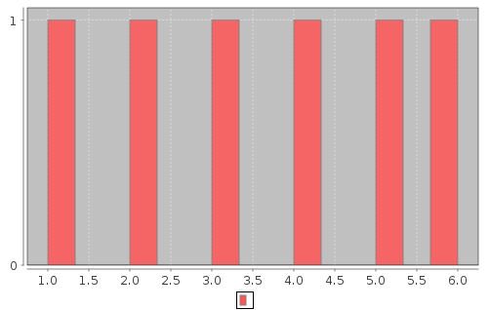
This is a plain histogram without a title and it shows that each of the numbers 1-6 occurred in the list one time. Unfortunately, it is difficult to determine what information the histogram is trying to relay because it does not contain any explanatory text. Also, the bars are not uniformly placed, but we will take care of that in a moment. The first improvement that will be made to this chart is to add a title.

Adding A Title To A Histogram And The Options Operator (->)
A title can be added to a histogram by passing a title option to the Histogram() function as the following code shows:

%mathpiper,title="Plain Histogram With Title"

Histogram({1,2,3,4,5,6}, title -> "Plain Histogram With Title");

%/mathpiper

%output,preserve="false"
Result: org.jfree.chart.ChartPanel
. %/output

Options are passed to functions by using the -> operator. The -> operator is an infix operator which means that its first argument is to its immediate left and its second argument is to its immediate right. The operator's first argument is the name of the option that will be set and the second argument is the value that the option will be set to. In this example, the title option is being set to the string value "Plain Histogram With Title" and here is the result:

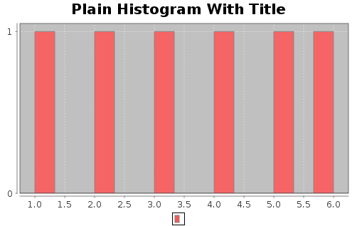
The addition of a title for the histogram is an improvement, but the bars are still not uniform so we will fix them next.

Histogram With Configured Bins
The binMinimum, binMaximum, and numberOfBins options are used to configure the Histogram() function's bins. In the following code, binMinimum is set to .5 which indicates that the left side of the leftmost bar will be at .5 on the X axis. Next, binMaximum is set to 6.5 which indicates that the right side of the rightmost bar will be at 6.5 on the X axis. Finally, numberOfBins is set to 6 since we want 6 bins to match the 6 different number values that can be placed into the list.

%mathpiper,title="Histogram With Configured Bins"

Histogram({1,2,3,4,5,6},
title -> "Histogram With Configured Bins",
binMinimum -> .5,
binMaximum -> 6.5,
numberOfBins -> 6,);

%/mathpiper

%output,preserve="false"
Result: org.jfree.chart.ChartPanel
. %/output

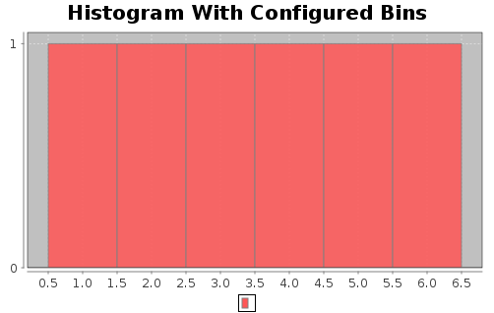
The bins in the chart which this code displays are now uniformly placed and centered on the number they represent. For example, the first bin is centered on 1.0, the second bin is centered on 2.0, and so on. However, it is still not completely clear what information this histogram is relaying and therefore in the next section we will see what happens when an additional number is added to the list.

Histogram With Two 1's
In this example, an additional 1 has been placed into the list:

%mathpiper,title="Histogram With Two 1's"

Histogram({1,1,2,3,4,5,6}, title -> "Histogram With Two 1's", binMinimum -> .5, binMaximum -> 6.5, numberOfBins -> 6,);

%/mathpiper

%output,preserve="false"
Result: org.jfree.chart.ChartPanel
. %/output
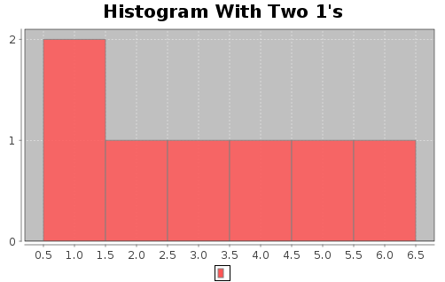
Notice that the height of the 1.0 bin is now set to 2 which indicates the list has two 1's in it. All the other bins have a height of 1 which indicates that there are only one of each of these numbers in the list. Now let's see what happens when two additional 5's are added to the list

Histogram With Three 5's
The list in the code in this section has had two additional 5's added to it for a total of three 5's:

%mathpiper,title="Histogram With Three 5's"

Histogram({1,1,2,3,4,5,5,5,6}, title -> "Histogram With Three 5's", binMinimum -> .5, binMaximum -> 6.5, numberOfBins -> 6,);

%/mathpiper

%output,preserve="false"
Result: org.jfree.chart.ChartPanel
. %/output

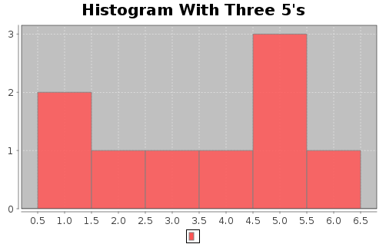
By now you should be able to see that the hight of a histogram's bars indicates how frequently each number occurs in the list that is passed to it. If you now go back an reread the description for a histogram, it should make more sense to you. This histogram is reasonably informative, but it can be improved by adding labels to the X and Y axes and also a title for the data. This is done in the next section.

Histogram With Axes Labels And Data Series Titles
The code in this section uses the xAxisLabel, yAxisLabel, and seriesTitle options to add additional explanatory text to the histogram:

%mathpiper,title="Histogram With Axes Labels And Data Series Title"

Histogram({1,1,2,3,4,5,5,5,6}, title -> "Histogram With Axes Labels And Data Series Title", binMinimum -> .5, binMaximum -> 6.5, numberOfBins -> 6, xAxisLabel -> "Number", yAxisLabel -> "Frequency", seriesTitle ->"Data");

%/mathpiper

%output,preserve="false"
Result: org.jfree.chart.ChartPanel
. %/output

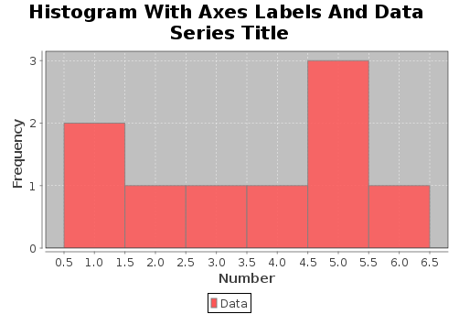
The X axis has been labeled "Number" because it represents the various numbers in the given list and the Y axis has been labeled "Frequency" because it indicates how frequently each number in the list occurs. The series of numbers in the list has been given the simple title "Data" to show how the data can be labeled. The Histogram() function has more capabilities than what has been show here, but the capabilities that have been covered are sufficient for displaying the results of simple simulations.

A Histogram Which Shows The Result Of Rolling A Single Simulated Die 1000 Times
Now that you know how to use the Histogram() function, let's use it to display the data from a simulation which rolls a single die 1000 times:

%mathpiper,title="Rolls Of A Single Die"

numberOfRolls := 1000;

dieRollsList := RandomIntegerList(numberOfRolls,1,6);

Histogram(dieRollsList, binMinimum -> .5, binMaximum -> 6.5, numberOfBins -> 6, title -> "Single Die Rolls", xAxisLabel -> "Number Rolled", yAxisLabel -> "Frequency", seriesTitle -> ToString(numberOfRolls) : " Rolls");

%/mathpiper

%output,preserve="false"
Result: org.jfree.chart.ChartPanel
. %/output

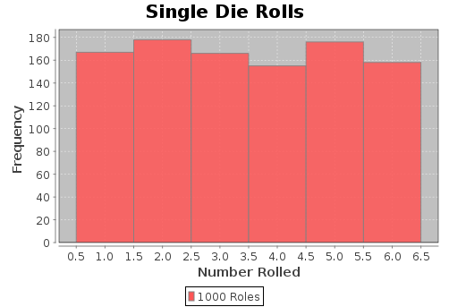
This histogram shows that each number on the simulated die has about the same probability of landing face up as the other numbers on the die. The kind of probability that a simulation like this produces is empirical probability. As discussed earlier, if the number of rolls in the simulation were increased, the simulation's observed empirical probability would become closer to the theoretical probability for this kind of experiment.

A Histogram Which Shows The Result Of Rolling Two Simulated Dice 1000 Times
The program in this section simulates the rolling of two dice 1000 times. Each time the two dice are rolled, their sum is calculated and then appended to the list which is bound to the variable dieRollsList. After the simulation is complete, a histogram of the sum data which was accumulated in dieRollsList is displayed:

%mathpiper,title="Rolls Two Dice"

numberOfRolls := 1000;

dieRollsList := {};

Repeat(numberOfRolls)
[
die1 := RandomInteger(6);

die2 := RandomInteger(6);

dieRollsList := Append(dieRollsList, die1 + die2);
];

Histogram(dieRollsList,
binMinimum -> 1.5,
binMaximum -> 12.5,
numberOfBins -> 11,
title -> "Rolling Two Dice",
xAxisLabel -> "Sum Rolled",
yAxisLabel -> "Frequency",
seriesTitle -> ToString(numberOfRolls) : " Rolls"
);

%/mathpiper

%output,preserve="false"
Result: org.jfree.chart.ChartPanel
. %/output

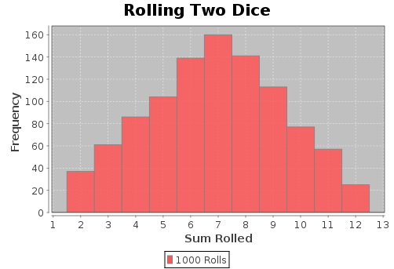
The results of the simulation show that sums in the middle of the range between 2 and 12 inclusive occur more often than the sums near either end of the range.

Exercises
For the following exercises, create a new MathPiperIDE worksheet file called book_2_section_6_exercises_<your first name>_<your last name>.mpw. (Note: there are no spaces in this file name). For example, John Smith's worksheet would be called:
book_2_section_6_exercises_john_smith.mpw.
After this worksheet has been created, place your answer for each exercise that requires a fold into its own fold in this worksheet. Place a title attribute in the start tag of each fold which indicates the exercise the fold contains the solution to. The folds you create should look similar to this one:

%mathpiper,title="Exercise 1"

//Sample fold.

%/mathpiper

If an exercise uses the MathPiper console instead of a fold, copy the work you did in the console into the worksheet so it can be saved.

Exercise 1
Use an empirical probability simulation to determine the probability of rolling an 8 with a pair of dice.

Exercise 2
Write a program which will determine the number of different ways that each of the sums 2-12 can come up when rolling two dice. (Hint: A ForEach-based nested loop can be used to cycle through all the possible outcomes that can occur when a pair of dice are rolled.)

Exercise 3
Write a program that uses theoretical probability to determine the probability of rolling an 8 with a pair of dice. (Hint: Search for "rolling two dice" on the Internet for more information on how theoretical probability can be applied to this "rolling two dice" problem.)

Exercise 4
Use an empirical probability simulation to determine the probability of rolling an 8 or a 9 with a pair of dice.

Exercise 5
Write a program that uses theoretical probability to determine the probability of rolling an 8 or a 9 with a pair of dice.

Exercise 6
Write a program that calculates how many times more likely you are to roll a 7 with a pair of dice than a 2, 3, 4, 5, and 6. For example, a 7 is x times more likely to be rolled than a 3. (Hint: Use the data that was generated by the program in Exercise 2 for this program.)

Exercise 7
Use an empirical probability simulation to determine the sums that are most likely to come up when rolling three dice.

Exercise 8
Write a program which will determine the number of different ways that each of the sums 3-18 can come up when rolling three dice.

Exercise 9
Use an empirical probability simulation to determine the sums that are most likely to come up when rolling a 6 sided die, a 12 sided die, and a 20 sided die together.

Monte Carlo Simulations
Monte Carlo is a district in the sovereign city-state of Monaco and it is located on the north central coast of the Mediterranean sea. It contains a number of casinos and people from all over the world travel there to gamble. Why is this district associated with simulations? The answer can be found in the history of the Manhattan Project which was the project that was created during World War II to develop the atomic bomb. The following passage discusses how the name Monte Carlo became associated with simulations:
Physicists at Los Alamos Scientific Laboratory were investigating radiation shielding and the distance that neutrons would likely travel through various materials. Despite having most of the necessary data, such as the average distance a neutron would travel in a substance before it collided with an atomic nucleus or how much energy the neutron was likely to give off following a collision, the problem could not be solved with theoretical calculations. John von Neumann and Stanislaw Ulam suggested that the problem be solved by modeling the experiment on a computer using chance. Being secret, their work required a code name. Von Neumann chose the name "Monte Carlo". The name is a reference to the Monte Carlo Casino in Monaco where Ulam's uncle would borrow money to gamble.[4][5][6] ...
Monte Carlo methods were central to the simulations required for the Manhattan Project, though were severely limited by the computational tools at the time. Therefore, it was only after electronic computers were first built (from 1945 on) that Monte Carlo methods began to be studied in depth. In the 1950s they were used at Los Alamos for early work relating to the development of the hydrogen bomb, and became popularized in the fields of physics, physical chemistry, and operations research. The Rand Corporation and the U.S. Air Force were two of the major organizations responsible for funding and disseminating information on Monte Carlo methods during this time, and they began to find a wide application in many different fields.
Uses of Monte Carlo methods require large amounts of random numbers, and it was their use that spurred the development of pseudorandom number generators, which were far quicker to use than the tables of random numbers which had been previously used for statistical sampling. (http://en.wikipedia.org/wiki/Monte_Carlo).
This passage indicates that the problem the scientists were working on were so complex that they "...could not be solved with theoretical calculations." Instead, they solved the problem using chance-based simulations which were driven by pseudorandom number generators (which are similar to the pseudorandom number generators which are in Mathpiper).
In this section we explore a type of Monte Carlo simulation which is based on the approach to resampling statistics which can be found on this website:
http://www.resample.com.
One of the main philosophies of this approach is that Monte Carlo simulations can not only be used to solve complex problems, they can also be used to solve the whole range of problems from simple ones up through complex ones. The most compelling reason to use this approach is that determining which theory to apply to a given problem (no matter how simple) is usually difficult and error prone. Julian Simon, the author of the book Resampling: The New Statistics, explains this philosophy as follows:
In the standard approach the student learns to choose and solve a formula. Doing the algebra and arithmetic is quick and easy. The difficulty is in choosing the correct formula. Unless you are a professional mathematician, it may take you quite a while to arrive at the correct formula—considerable hard thinking, and perhaps some digging in textbooks. More important than the labor, however, is that you may come up with the wrong formula, and hence obtain the wrong answer. Most students who have had a standard course in probability and statistics are quick to tell you that it is not easy to find the correct formula, even immediately after finishing a course (or several courses) on the subject. After leaving school, it is harder still to choose the right formula. Even many people who have taught statistics at the university level (including this writer) must look at a book to get the correct formula for a problem (...), and then we are not always sure of the right answer. This is the grave disadvantage of the standard approach.
Once we get rid of the formulas and tables, we can see that statistics is a matter of clear thinking, not fancy mathematics. Then we can get down to the business of learning how to do that clear statistical thinking, and putting it to work for you. The study of probability is purely mathematics (though not necessarily formulas) and technique. But statistics has to do with meaning. For example, what is the meaning of data showing an association just discovered between a type of behavior and a disease? Of differences in the pay of men and women in your firm? Issues of causation, acceptability of control, design of experiments cannot be reduced to technique. This is “philosophy” in the fullest sense. Probability and statistics calculations are just one input. Resampling simulation enables us to get past issues of mathematical technique and focus on the crucial statistical elements of statistical problems.
This book is available for free on the http://www.resample.com website and I recommend that you read it if you yourself becoming attracted to this practical approach to statistics.
In this section we will be exploring resampling-based Monte Carlo simulations using MathPiper. Hopefully you will find this problem solving technique so easy to use that after you have finished the section you will begin using this technique to solve your own problems.

The Three Doors Game
Suppose you are on a TV game show where the host shows you three closed doors and says "Behind one of these doors is a prize and the area behind the other two doors is empty." The host then tells to you pick which door you think the prize is behind and if your pick is correct, you can have the prize. You pick a door, but the host does not open it yet. At least one of the doors you didn't pick is empty and the host (who knows which door leads to the prize) opens the empty door.
Now comes the fun part! There are two unopened doors remaining (the one you picked and one which you did not pick) and the host then asks you if you would like to switch your pick to the second door. What should you do? Do you have a higher chance of winning if you 1) stay with the original door you picked or 2) switch to the other door? Or 3) do you have the same chance of winning regardless of which door you pick?
This is a very difficult problem to solve correctly by reason alone, but it is easy to solve with a simulation. Think about this problem for a little bit, record somewhere what you think the solution is, and then run the following simulation to see if you are correct:

%mathpiper,title="Three doors simulation."

numberOfTrials := 1000;

firstPickList := {};

secondPickList := {};

Repeat(numberOfTrials)
[
doorsList := Shuffle({EMPTY, PRIZE, EMPTY});

//The contestant always picks door 1 as their first pick.
firstPick := doorsList[1];

/*
If door 2 is empty, the second pick is the 3rd door else
the second pick is the 2nd door. In a real game the contestant
may or may not make a second pick, but in this simulation
we always make the second pick in order to see what it is.
*/
If(doorsList[2] = EMPTY,
secondPick := doorsList[3],
secondPick := doorsList[2]);

//Save all of the first pick results in a list.
firstPickList := Append(firstPickList, firstPick);

//Save all of the second pick results in a list.
secondPickList := Append(secondPickList, secondPick);
];

firstPickWins := Count(firstPickList,PRIZE);

secondPickWins := Count(secondPickList,PRIZE);

Echo("The number of times the first door picked contained a prize: ",
firstPickWins, "/ ", numberOfTrials);
Echo("The probability of winning for always staying with the first pick: ",
N(firstPickWins/numberOfTrials) );
NewLine();

Echo("The number of times the second door picked contained a prize: ",
secondPickWins, "/ ", numberOfTrials);
Echo("The probability of winning for always changing the pick: ",
N(secondPickWins/numberOfTrials) );

%/mathpiper
The function Shuffle() in this program takes a list and randomly shuffles its contents:

In> Shuffle({a,b,c,d})
Result: {d,c,a,b}

The comments that are in the rest of the program should be sufficient for explaining how it works. This program provides a good example of how simulations can be used to solve problems that are difficult to solve just by thinking about them.

In A Room Full Of People, What Is The Probability That At Least Two Will Have The Same Birthday?
There will often be times in your life when you will find yourself in a room full of people and examples include classrooms, theaters, restaurants, and meetings. When you find yourself in a situation like this, perhaps you will begin wondering what these people may have in common with each other. One thing that people may have in common is a birthday and the following program determines what the probability is that two or more people in a room of 20 will have the same birthday:

%mathpiper,title="Same birthday simulation."

birthdayMatchCounter := 0;

numberOfPeople := 20;

numberOfTrials := 40;

Repeat(numberOfTrials)
[
//Create a random birthday for each simulated person in the room.
birthdaysList := RandomIntegerList(numberOfPeople, 1, 365);

//Print the birthdays for this room of simulated people (comment
//this line out for a large number of trials).
Write(birthdaysList);

/*
Index through all of the days in a year and for each day scan
the birthdays list to see if two people in the list have this
day as their birthday. If there is a match, increment
birthdayMathCounter.
*/
ForEach(day, 1 .. 365)
[
If(Count(birthdaysList,day) >= 2,
[
birthdayMatchCounter++;

WriteString(" - Match on ");
Write(day);

Break();
]);
];

NewLine();

];

NewLine();
Echo("The number of trials is: ", numberOfTrials);
Echo("The number of people in the room is: ", numberOfPeople);
Echo("The number of matches is: ",
birthdayMatchCounter, "/ ", numberOfTrials);
Echo("The probability of having a birthday match: ",
N(birthdayMatchCounter/numberOfTrials) );

%/mathpiper

%output,preserve="false"
Result: True

Side Effects:
{323,362,99,208,102,237,116,199,25,174,23,160,312,351,72,205,40,114,110,212}
{166,313,124,334,75,187,102,348,64,363,106,78,238,187,360,245,177,194,34,163} - Match on 187
{79,148,15,5,81,173,315,50,272,140,319,262,305,95,209,269,14,170,55,179}
{320,219,45,102,350,163,166,286,271,201,234,99,295,39,77,302,243,314,10,308}
{343,251,320,322,351,204,281,57,228,213,134,286,187,285,2,13,62,116,266,258}
{189,315,293,322,105,274,28,69,175,244,269,297,260,192,281,146,166,70,250,24}
{22,295,307,248,194,135,322,234,350,80,249,108,214,69,85,75,148,22,352,172} - Match on 22
{98,4,310,87,142,282,301,242,90,58,319,156,275,238,109,30,253,276,192,118}
{115,290,360,171,14,297,147,86,84,120,365,39,347,204,15,137,227,313,47,42}
{213,10,262,96,156,67,101,348,27,328,186,135,195,95,50,75,101,212,216,8} - Match on 101
{51,149,48,218,275,200,289,197,132,283,211,101,9,336,146,238,43,15,46,120}
{22,113,82,46,86,143,160,203,5,328,325,247,300,261,43,183,80,284,145,42}
{321,28,323,262,161,194,336,272,62,152,5,107,127,27,320,2,124,190,2,228} - Match on 2
{101,269,77,139,103,83,191,161,75,222,354,198,276,323,208,29,4,39,34,272}
{89,27,333,1,347,302,173,176,32,202,281,211,148,230,97,137,306,177,269,37}
{321,352,156,120,323,322,355,22,87,169,197,339,114,121,224,246,70,285,310,34}
{10,347,172,238,19,245,214,349,43,216,347,83,263,120,185,14,174,113,86,156} - Match on 347
{337,357,255,229,241,28,261,214,258,254,235,159,8,268,242,52,67,189,190,180}
{22,77,62,232,190,275,274,111,16,355,118,365,69,214,298,86,323,275,231,29} - Match on 275
{162,331,112,63,91,181,261,146,26,142,80,151,335,209,79,70,141,309,191,299}
{155,89,3,246,172,290,351,78,327,136,216,204,243,110,38,11,70,140,293,310}
{112,27,238,75,95,170,264,305,268,286,362,124,277,18,319,144,187,242,1,30}
{334,185,230,180,345,123,42,289,239,39,336,354,290,332,219,154,352,90,49,206}
{107,109,51,248,184,324,117,64,136,299,230,155,174,105,220,148,61,11,83,112}
{274,345,318,112,272,295,239,247,80,302,258,158,38,252,280,264,156,296,203,35}
{154,165,125,324,156,150,61,324,195,351,53,178,329,268,100,171,251,88,82,236} - Match on 324
{194,251,186,208,192,299,175,151,224,161,221,106,125,115,165,64,339,52,294,219}
{202,99,140,114,309,319,202,44,168,86,193,27,261,316,156,58,83,40,256,275} - Match on 202
{167,349,111,351,48,263,29,24,164,108,292,92,19,242,98,296,233,119,349,365} - Match on 349
{79,143,217,277,328,354,56,163,67,200,242,296,242,37,109,135,35,198,61,141} - Match on 242
{284,96,94,228,60,149,344,31,232,225,195,328,153,317,97,207,191,58,71,270}
{251,248,151,262,90,67,18,309,312,82,169,14,4,360,32,205,124,122,131,108}
{189,304,56,245,308,139,73,155,124,61,318,153,127,226,296,243,199,25,304,282} - Match on 304
{126,279,193,356,204,355,7,351,123,303,102,245,98,227,181,88,213,78,316,118}
{153,102,115,333,29,14,192,333,74,70,266,221,295,266,270,81,51,110,215,291} - Match on 266
{86,312,104,180,70,73,18,214,14,78,198,114,50,129,173,262,41,63,15,282}
{62,199,234,311,294,88,102,314,288,219,55,34,151,337,279,41,328,124,43,276}
{336,288,118,186,67,292,37,146,361,299,240,229,264,249,100,34,76,363,55,13}
{314,24,315,343,211,42,335,343,115,139,301,312,95,331,41,33,206,220,281,211} - Match on 211
{207,125,175,336,160,265,57,352,71,86,61,349,2,169,258,181,268,27,279,165}

The number of trials is: 40
The number of people in the room is: 20
The number of matches is: 13 / 40
The probability of having a birthday match: 0.325
. %/output
Of the 40 groups of 20 people this program simulated, 13 of the groups had at least 2 people who had the same birthday. In the data output for these simulations, "Match on xxx" is printed after a group that has a match with "xxx" being the day of the year that the match occurred on. The matched birthdays have also been highlighted in red to make them easier to locate. The simulation indicates that the probability of at least 2 people in a room of 20 having the same birthday is .325.

What Is The Probability Of A Family With Four Children Having Exactly Three Boys?
Being a parent is an enormous responsibility and making the decisions which are related to children are among the more important decisions that a person will make in their life. The ability to help with the analysis of important decisions is one of the main uses of computer simulations and this includes situations related to children. For example, if two people have decided they wanted to have four children, they may wonder what the probability is that exactly three of them will be boys. The following simulation is designed to answer this question.
This simulation uses a function called RandomPickWeighted() which randomly returns items from a list. Each item has a probability associated with it which determines its chance of being chosen. The probabilities of all the items in the list must sum to 1.

%mathpiper,title="Three boys simulation"

numberOfTrials := 40;

numberOfChildren := 4;

numberOfBoys := 3;

threeBoysCounter := 0;

girlProbability := 49/100;

boyProbability := 51/100;

Repeat(numberOfTrials)
[
//Create a random list of simulated children.
childrenList := Table(RandomPickWeighted(
{{GIRL,girlProbability}, {BOY,boyProbability}}),
var,1,numberOfChildren,1);
//Print the list of simulated children (comment
//this line out for a large number of trials).
Write(childrenList);

/*
If the list contains 3 boys, increment the three
boys counter.
*/
If(Count(childrenList, BOY) = numberOfBoys,
[
threeBoysCounter++;

WriteString(" - ");
Write(numberOfBoys);
WriteString(" boys.");
]);

NewLine();
];

NewLine();
Echo("The number of trials is: ", numberOfTrials);
Echo("The number of children is: ", numberOfChildren);
Echo("The number of trials which have 3 boys: ",
threeBoysCounter, "/ ", numberOfTrials);
Echo("The probability of having 3 boys: ",
N(threeBoysCounter/numberOfTrials) );

%/mathpiper

%output,preserve="false"
Result: True

Side Effects:
{GIRL,GIRL,BOY,GIRL}
{GIRL,BOY,GIRL,GIRL}
{GIRL,GIRL,BOY,GIRL}
{GIRL,GIRL,BOY,BOY}
{GIRL,BOY,BOY,BOY} - 3 boys.
{GIRL,GIRL,BOY,GIRL}
{BOY,BOY,BOY,BOY}
{GIRL,BOY,GIRL,GIRL}
{GIRL,BOY,GIRL,BOY}
{GIRL,BOY,BOY,GIRL}
{BOY,BOY,BOY,GIRL} - 3 boys.
{GIRL,GIRL,GIRL,BOY}
{BOY,BOY,GIRL,BOY} - 3 boys.
{GIRL,GIRL,BOY,BOY}
{GIRL,BOY,BOY,BOY} - 3 boys.
{GIRL,GIRL,BOY,BOY}
{GIRL,GIRL,GIRL,BOY}
{BOY,GIRL,BOY,BOY} - 3 boys.
{GIRL,GIRL,BOY,GIRL}
{GIRL,BOY,BOY,BOY} - 3 boys.
{BOY,GIRL,BOY,GIRL}
{GIRL,GIRL,GIRL,BOY}
{BOY,GIRL,GIRL,GIRL}
{GIRL,BOY,BOY,GIRL}
{GIRL,BOY,GIRL,GIRL}
{GIRL,GIRL,BOY,BOY}
{BOY,GIRL,GIRL,BOY}
{BOY,BOY,GIRL,GIRL}
{BOY,BOY,BOY,GIRL} - 3 boys.
{GIRL,GIRL,BOY,GIRL}
{GIRL,BOY,GIRL,GIRL}
{GIRL,GIRL,BOY,BOY}
{BOY,BOY,BOY,GIRL} - 3 boys.
{GIRL,BOY,GIRL,BOY}
{BOY,BOY,GIRL,GIRL}
{BOY,BOY,BOY,GIRL} - 3 boys.
{GIRL,GIRL,BOY,GIRL}
{GIRL,BOY,GIRL,GIRL}
{BOY,GIRL,BOY,GIRL}
{GIRL,GIRL,BOY,BOY}

The number of trials is: 40
The number of children is: 4
The number of trials which have 3 boys: 9 / 40
The probability of having 3 boys: 0.225
. %/output

The first thing to notice in this program is that the probability of having a boy is slightly higher than the probability for having a girl. This information was obtained through observations that have been conducted over a long period of time. As for the data, the program generated 40 simulated sets of four children and 9 of these sets contained exactly three boys. It was determined that the probability of having exactly three boys with four children is .225.

What Is The Probability Of Having Three Or More Hits In Five Basketball Free throws?
Sports are often a fertile area for statistical analysis and examples of this include batting averages in baseball, receiving yards in football, and free throws in basketball. The following simulation determines what the probability is for a given basketball player who normally hits 30% of their shots to have three or more hits in five free throws:

%mathpiper,title="Five basketball free throws."

numberOfTrials := 40;

//A success is defined as 3 or more hits.
successesCounter := 0;

numberOfThrows := 5;

hitProbability := .30;

missProbability := .70;

Repeat(numberOfTrials)
[
sampleList := Table(RandomPickWeighted(
{{HIT,hitProbability}, {MISS,missProbability}}),
var,1,numberOfThrows,1);
//Print the list of simulated throws (comment
//this line out for a large number of trials).
Write(sampleList);

/*
If the list contains 3 or more hits, increment the
success counter.
*/
If(Count(sampleList,HIT) >= 3,
[
successesCounter++;

WriteString(" - ");
WriteString(" success.");
]);

NewLine();
];

NewLine();
Echo("The number of trials is: ", numberOfTrials);
Echo("The number of throws is: ", numberOfThrows);
Echo("The number of trials which have 3 or more hits: ",
successesCounter, "/ ", numberOfTrials);
Echo("The probability of having 3 or more hits: ",
N(successesCounter/numberOfTrials) );

%/mathpiper

%output,preserve="false"
Result: True

Side Effects:
{HIT,MISS,HIT,HIT,HIT} - success.
{HIT,MISS,MISS,HIT,MISS}
{MISS,MISS,MISS,MISS,HIT}
{MISS,MISS,MISS,HIT,HIT}
{MISS,HIT,MISS,MISS,HIT}
{MISS,MISS,MISS,HIT,MISS}
{MISS,HIT,MISS,HIT,MISS}
{MISS,HIT,HIT,MISS,MISS}
{MISS,MISS,MISS,MISS,MISS}
{MISS,HIT,MISS,MISS,MISS}
{HIT,MISS,MISS,MISS,MISS}
{HIT,HIT,HIT,HIT,MISS} - success.
{MISS,MISS,MISS,MISS,HIT}
{MISS,MISS,MISS,MISS,MISS}
{MISS,MISS,MISS,MISS,HIT}
{MISS,MISS,MISS,MISS,HIT}
{MISS,MISS,MISS,MISS,MISS}
{HIT,MISS,MISS,HIT,MISS}
{MISS,MISS,MISS,HIT,MISS}
{MISS,MISS,MISS,MISS,HIT}
{MISS,HIT,MISS,HIT,MISS}
{MISS,HIT,MISS,MISS,MISS}
{HIT,MISS,MISS,HIT,HIT} - success.
{MISS,HIT,MISS,MISS,MISS}
{MISS,HIT,MISS,MISS,MISS}
{MISS,MISS,MISS,MISS,MISS}
{MISS,MISS,MISS,MISS,HIT}
{MISS,HIT,MISS,HIT,HIT} - success.
{HIT,MISS,MISS,MISS,HIT}
{MISS,HIT,MISS,MISS,MISS}
{HIT,MISS,MISS,HIT,HIT} - success.
{MISS,HIT,MISS,MISS,HIT}
{HIT,MISS,HIT,MISS,MISS}
{HIT,MISS,MISS,MISS,MISS}
{MISS,MISS,MISS,HIT,HIT}
{HIT,HIT,MISS,HIT,MISS} - success.
{MISS,HIT,MISS,MISS,HIT}
{MISS,MISS,HIT,MISS,MISS}
{MISS,MISS,MISS,MISS,MISS}
{MISS,MISS,MISS,MISS,HIT}

The number of trials is: 40
The number of throws is: 5
The number of trials which have 3 or more hits: 6 / 40
The probability of having 3 or more hits: 0.15
. %/output
This program generated 40 simulated sets of five free throws. Six of the 40 sets contained three or more hits which means that the probability of this player having three hits out of five free throws is .15.

Shooting At A Target
Target shooting is a sport which is practiced across the world and it is so popular that there are a number of Olympic events which are based upon it. The following program simulates shooting at a target which consists of a black bullseye and one white ring around the bullseye. A shot can hit in the black, hit in the white, or miss the target completely. We are interested in determining the probability that out of five shots, exactly one will be in the black and three will be in the white:

%mathpiper,title="Shooting at a target."

numberOfTrials := 40;

numberOfShots := 5;

successCounter := 0;

Repeat(numberOfTrials)
[
sampleList := Table(RandomPickWeighted(
{{BLACK,15/100}, {WHITE,55/100}, {MISS,30/100}}),
var,1,numberOfShots,1);
//Print the list of simulated throws (comment
//this line out for a large number of trials).
Write(sampleList);

/*
If the list contains 1 hit in the black and 3 hits
in the white, increment the successCounter.
*/
If(Count(sampleList,BLACK)= 1 And Count(sampleList,WHITE) = 3,
[
successCounter++;

WriteString(" - ");
WriteString(" success.");
]);

NewLine();

];

NewLine();
Echo("The number of trials is: ", numberOfTrials);
Echo("The number of shots per trial is: ", numberOfShots);
Echo("The number of trials which have 1 black hit and 3 white hits: ",
successCounter, "/ ", numberOfTrials);
Echo("The probability of having 1 black hit and 3 white hits: ",
N(successCounter/numberOfTrials) );

%/mathpiper

%output,preserve="false"
Result: True

Side Effects:
{WHITE,BLACK,WHITE,MISS,BLACK}
{WHITE,BLACK,WHITE,WHITE,MISS} - success.
{MISS,WHITE,MISS,WHITE,WHITE}
{MISS,BLACK,MISS,MISS,WHITE}
{WHITE,MISS,MISS,MISS,WHITE}
{WHITE,WHITE,WHITE,WHITE,WHITE}
{WHITE,WHITE,WHITE,MISS,BLACK} - success.
{WHITE,WHITE,BLACK,BLACK,MISS}
{MISS,WHITE,BLACK,BLACK,WHITE}
{MISS,MISS,WHITE,WHITE,WHITE}
{WHITE,MISS,MISS,MISS,WHITE}
{BLACK,BLACK,BLACK,BLACK,WHITE}
{MISS,MISS,WHITE,MISS,BLACK}
{MISS,WHITE,WHITE,BLACK,WHITE} - success.
{MISS,MISS,MISS,WHITE,BLACK}
{WHITE,WHITE,WHITE,WHITE,WHITE}
{MISS,WHITE,WHITE,WHITE,MISS}
{WHITE,WHITE,WHITE,BLACK,WHITE}
{WHITE,WHITE,MISS,WHITE,WHITE}
{MISS,WHITE,WHITE,BLACK,BLACK}
{WHITE,BLACK,WHITE,WHITE,BLACK}
{WHITE,WHITE,WHITE,MISS,WHITE}
{WHITE,WHITE,WHITE,WHITE,MISS}
{WHITE,WHITE,MISS,MISS,BLACK}
{WHITE,MISS,WHITE,BLACK,WHITE} - success.
{WHITE,WHITE,WHITE,WHITE,MISS}
{WHITE,MISS,BLACK,WHITE,WHITE} - success.
{BLACK,WHITE,WHITE,MISS,MISS}
{BLACK,WHITE,WHITE,WHITE,WHITE}
{MISS,BLACK,MISS,MISS,MISS}
{MISS,WHITE,MISS,BLACK,MISS}
{WHITE,WHITE,MISS,WHITE,MISS}
{WHITE,MISS,WHITE,BLACK,MISS}
{BLACK,BLACK,WHITE,MISS,WHITE}
{WHITE,BLACK,WHITE,MISS,WHITE} - success
{MISS,MISS,MISS,MISS,MISS}
{WHITE,BLACK,MISS,MISS,WHITE}
{MISS,MISS,WHITE,WHITE,MISS}
{MISS,WHITE,WHITE,WHITE,WHITE}
{MISS,WHITE,MISS,MISS,MISS}

The number of trials is: 40
The number of shots per trial is: 5
The number of trials which have 1 black hit and 3 white hits: 6 / 40
The probability of having 1 black hit and 3 white hits: 0.15
. %/output
This program generated 40 simulated sets of five shots. Six of the 40 sets contained one hit in the black and three hits in the white which results in a probability of .15 for this combination.

Two Stacks Of 10 Pennies
Two friends (let's call them Bill and Mary), two stacks of 10 pennies, and one coin for flipping are the ingredients for the next simulation. Imagine that the friends are sitting across from each other at a table and that each of them has a stack of 10 pennies in front of them. Bill picks up the flipping coin and flips it. If the coin lands heads up, Bill takes a penny from Mary's stack and places on his own. However, if the coin lands tails up, Mary takes a coin from Bill's stack and places it on her stack. The flipping and coin moving continue until either Bill or Mary have an empty stack or 50 flips have been made. The following program simulates this scenario:

%mathpiper,title="Two stacks of pennies."

numberOfTrials := 20;

emptyStackCounter := 0;

Repeat(numberOfTrials)
[
//Create two stacks of 10 pennies.
stack1 := 10; stack2 := 10;

maxFlips := 50;

emptyMessage := "";

/*
Flip a coin (let's say it's a quarter) up to maxFlips times. If
it comes up heads remove a penny from stack 2 and places it on
stack 1. If it comes up tails, remove a penny from stack 1 and
place it on stack 2. If either stack reaches 0 before maxFlips
have been flipped, break out of the loop.
*/
numberOfFlips := Repeat(maxFlips)
[
flip := RandomPickWeighted({{HEAD,1/2},{TAIL,1/2}});

If(flip = HEAD, [stack1++; stack2--;],
[stack1--; stack2++;] );

If(stack1 = 0 Or stack2 = 0,
[emptyStackCounter++; emptyMessage := " - Empty"; Break();] );
];

//Print the state of the stacks after each flip (comment
//this line out for a large number of trials).
Echo("Stack 1: ", PadLeft(stack1,2),
" Stack 2: ", PadLeft(stack2,2),
" Number of flips: ", PadLeft(numberOfFlips,3), emptyMessage);
];

NewLine();
Echo("The number of trials is: ", numberOfTrials);
Echo("The maximum flips per trial: ", maxFlips);
Echo("The number of trials which resulted in an empty stack: ",
emptyStackCounter, "/ ", numberOfTrials);
Echo("The probability of having an empty stack: ",
N(emptyStackCounter/numberOfTrials) );

%/mathpiper

%output,preserve="false"
Result: True

Side Effects:
Stack 1: 14 Stack 2: 06 Number of flips: 050
Stack 1: 08 Stack 2: 12 Number of flips: 050
Stack 1: 20 Stack 2: 00 Number of flips: 037 - Empty
Stack 1: 20 Stack 2: 00 Number of flips: 023 - Empty
Stack 1: 10 Stack 2: 10 Number of flips: 050
Stack 1: 04 Stack 2: 16 Number of flips: 050
Stack 1: 02 Stack 2: 18 Number of flips: 050
Stack 1: 02 Stack 2: 18 Number of flips: 050
Stack 1: 04 Stack 2: 16 Number of flips: 050
Stack 1: 06 Stack 2: 14 Number of flips: 050
Stack 1: 20 Stack 2: 00 Number of flips: 035 - Empty
Stack 1: 14 Stack 2: 06 Number of flips: 050
Stack 1: 00 Stack 2: 20 Number of flips: 031 - Empty
Stack 1: 12 Stack 2: 08 Number of flips: 050
Stack 1: 08 Stack 2: 12 Number of flips: 050
Stack 1: 00 Stack 2: 20 Number of flips: 023 - Empty
Stack 1: 04 Stack 2: 16 Number of flips: 050
Stack 1: 04 Stack 2: 16 Number of flips: 050
Stack 1: 08 Stack 2: 12 Number of flips: 050
Stack 1: 08 Stack 2: 12 Number of flips: 050

The number of trials is: 20
The maximum flips per trial: 50
The number of trials which resulted in an empty stack: 5 / 20
The probability of having an empty stack: 0.25
. %/output
In this simulation, 20 trials were conducted each of which flipped a simulated coin up to 50 times. If one of the two stacks became empty during a given trial, the word "Empty" was printed next to it along with how many flips it took to empty the stack. As can been seen in the results, five trials resulted in an empty stack which translates into a probability of .25 for this occurring.

Vending Machine Simulation
The stacks of pennies example which was used in the previous section may have appeared to be pointless, but actually there are numerous situations in the physical world which are similar to it. For example, did you ever wonder how the people who restock vending machines know when to restock them? Customers purchasing items from a machine are analogous to pennies being removed from a stack and the vendor restocking a machine is analogous to pennies being added to a stack.
The initial configuration of the following program determines how many days it takes a vending machine to become empty without being restocked. As an option, a line of code can be uncommented which will enable periodically stocking the machine to be added to the simulation.

%mathpiper,title="Pop vending machine."

daysToEmptyList := {};

numberOfTrials := 10;

daysBetweenRestocking := 3;

machineCanCapacity := 50;

Repeat(numberOfTrials)
[
//Fill the machine to capacity before starting the trial.
cansInMachine := machineCanCapacity;

daysToEmptyCounter := 0;

Echo("New Trial");

//Run the simulation in an infinite loop until the machine is empty.
Repeat()
[
//Simulate a 24 hour period.
Repeat(24)
[
//Determine the number of cans which were purchased during this hour.
numberOfCansPurchasedThisHour := RandomPickWeighted({
{0,60/100},
{1,20/100},
{2,15/100},
{3,05/100}});

cansInMachine := cansInMachine - numberOfCansPurchasedThisHour;

//If the machine has become empty, end the 24 hour simulation.
If(cansInMachine <= 0, [cansInMachine := 0; Break();]);
];

Echo("Day: " ,
PadLeft(daysToEmptyCounter,2),
" Cans in machine: ",
PadLeft(cansInMachine,2));

//If the machine has become empty, end this trial.
If(cansInMachine = 0, Break());

/*
Uncomment the following line to enable restocking.
*/
/*
If(Modulo(daysToEmptyCounter,daysBetweenRestocking) = 0,
cansInMachine := machineCanCapacity);
*/

daysToEmptyCounter++;
];

NewLine();

//Save the days to empty data in a list for later analysis.
daysToEmptyList := Append(daysToEmptyList, daysToEmptyCounter);

];

Echo("Days to empty data: ", daysToEmptyList);

Echo("Mean days to empty: ", N(Mean(daysToEmptyList)));

%/mathpiper

%output,preserve="false"
Result: True

Side Effects:
New Trial
Day: 00 Cans in machine: 40
Day: 01 Cans in machine: 25
Day: 02 Cans in machine: 12
Day: 03 Cans in machine: 00

New Trial
Day: 00 Cans in machine: 43
Day: 01 Cans in machine: 32
Day: 02 Cans in machine: 21
Day: 03 Cans in machine: 04
Day: 04 Cans in machine: 00

New Trial
Day: 00 Cans in machine: 38
Day: 01 Cans in machine: 28
Day: 02 Cans in machine: 12
Day: 03 Cans in machine: 00

New Trial
Day: 00 Cans in machine: 31
Day: 01 Cans in machine: 15
Day: 02 Cans in machine: 01
Day: 03 Cans in machine: 00

New Trial
Day: 00 Cans in machine: 36
Day: 01 Cans in machine: 09
Day: 02 Cans in machine: 00

New Trial
Day: 00 Cans in machine: 33
Day: 01 Cans in machine: 08
Day: 02 Cans in machine: 00

New Trial
Day: 00 Cans in machine: 35
Day: 01 Cans in machine: 15
Day: 02 Cans in machine: 00

New Trial
Day: 00 Cans in machine: 35
Day: 01 Cans in machine: 20
Day: 02 Cans in machine: 00

New Trial
Day: 00 Cans in machine: 30
Day: 01 Cans in machine: 14
Day: 02 Cans in machine: 05
Day: 03 Cans in machine: 00

New Trial
Day: 00 Cans in machine: 27
Day: 01 Cans in machine: 15
Day: 02 Cans in machine: 00

Days to empty data: {3,4,3,3,2,2,2,2,3,2}
Mean days to empty: 2.6
. %/output

This simulation conducted 10 trials and the number of days it took to empty the vending machine in each trial was placed into daysToEmptyList. A more informative view of the data in this list can be obtained by sending it to the Histogram() function:

In> Histogram(daysToEmptyList, title -> "Days Until Empty", xAxisLabel -> "Days", yAxisLabel -> "Count", seriesTitle -> "Day Data")
Result: org.jfree.chart.ChartPanel
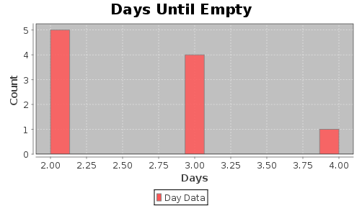

Card Game Simulations
The following two card game simulations involve a shuffled deck and a "hand" taken from the deck which contains 5 cards. The simulations use a function called ShuffledDeckNoSuits() which simulates a shuffled deck of 52 cards with a list of numbers between 1 and 52 inclusive which have been placed into a random order:

In> ShuffledDeckNoSuits()
Result: {3,3,3,10,11,2,8,1,8,4,11,5,5,13,13,10,3,8,6,7,2,12,6,9,4,9,8,2,12,1,7,12,4,9,11,13,2,13,10,7,6,7,11,4,10,6,5,1,5,1,9,12}

The first simulation determines the probability of obtaining a hand with two of a kind and the second simulation determines the probability of obtaining two pairs vs. three of a kind.

The Probability Of Obtaining A Hand With Two Of A Kind In Cards

%mathpiper,title="Cards: two of a kind."

pairsCount := 0;

numberOfTrials := 40;

Repeat(numberOfTrials)
[
deck := ShuffledDeckNoSuits();

hand := Take(deck,5);

Write(hand);

handPairCount := 0;

ForEach(card, 1 .. 13)
[
If(Count(hand,card) = 2, handPairCount++);
];

If(handPairCount = 1, [pairsCount++; WriteString(" - pair");]);

NewLine();
];

NewLine();
Echo("Number of trials: ", numberOfTrials);
Echo("Probability of receiving a single pair: ",
N(pairsCount/numberOfTrials) );

%/mathpiper

%output,preserve="false"
Result: True

Side Effects:
{5,1,7,8,6}
{11,7,12,4,6}
{12,4,3,1,12} - pair
{9,13,6,3,7}
{5,8,9,10,8} - pair
{1,5,6,13,8}
{13,6,9,2,11}
{13,3,12,13,2} - pair
{4,1,3,12,1} - pair
{5,1,1,3,8} - pair
{2,1,8,10,8} - pair
{12,10,11,6,13}
{10,8,3,6,7}
{6,7,10,8,3}
{5,1,9,2,4}
{12,9,11,8,10}
{12,9,6,3,6} - pair
{11,4,8,5,7}
{1,13,7,3,7} - pair
{1,3,2,6,10}
{3,13,12,10,11}
{8,6,4,2,4} - pair
{1,9,5,13,7}
{10,12,1,1,9} - pair
{3,1,13,11,5}
{13,13,1,2,6} - pair
{10,1,3,10,11} - pair
{13,5,11,8,5} - pair
{4,7,2,13,1}
{6,11,2,1,11} - pair
{1,11,12,9,10}
{1,13,12,4,5}
{4,5,13,1,11}
{8,8,7,13,5} - pair
{10,9,3,11,4}
{8,1,11,13,3}
{11,1,3,7,11} - pair
{4,10,9,9,11} - pair
{4,13,4,1,8} - pair
{2,12,11,12,7} - pair

Number of trials: 40
Probability of receiving a single pair: 0.475
. %/output

The Probability Of Obtaining Two Pairs Vs. Three Of A Kind In Cards

%mathpiper,title="Cards: two pairs vs. three of a kind."

pairsCount := 0;

threeOfAKindCount := 0;

numberOfTrials := 1000;

Repeat(numberOfTrials)
[
deck := ShuffledDeckNoSuits();

hand := Take(deck, 5);

//Echo(hand);

handPairCount := 0;

handThreeOfAKindCount := 0;

ForEach(card, 1 .. 13)
[
If(Count(hand, card) = 2, handPairCount++);

If(Count(hand, card) = 3, handThreeOfAKindCount++);
];

If(handPairCount = 2, pairsCount++);

If(handThreeOfAKindCount = 1, threeOfAKindCount++);
];

Echo("Probability of two pairs: ", N(pairsCount/numberOfTrials) );
Echo("Probability of three of a kind: ",
N(threeOfAKindCount/numberOfTrials) );

%/mathpiper

%output,preserve="false"
Result: True

Side Effects:
Probability of two pairs: 0.071
Probability of three of a kind: 0.025
. %/output

Modeling A Deck Of Cards
The following program can be used to model a deck of cards. You may find it useful for making your own card-related simulations:

%mathpiper,title=""

deck := {};

cardNames := Concat(2 .. 10, {J,Q,K,A});

suitNames := {CLUB,DIAMOND,HEART,SPADE};

ForEach(card,cardNames)
[
ForEach(suit,suitNames)
[
unboundSymbol := ToAtom(ToString(card) : "'" : ToString(suit));

deck := Append(deck, unboundSymbol);
];
];

shuffledDeck := Shuffle(deck);

%/mathpiper

A Random Walk Simulation
The following simulation places a person at location (0,0) on a Cartesian coordinate system and then has the person take 12 steps. However, each step is taken in a random direction with the possible directions being:
North (0,1)
South (0,-1)
East (1,0)
West (-1,0)
A target position has also been identified in the simulation and the simulation keeps track of whether or not the person reaches the target position during any given trial:

%mathpiper,title="Random walk."

targetPosition := {2,1};

successCount := 0;

numberOfTrials := 40;

numberOfSteps := 12;

Repeat(numberOfTrials)
[
currentPosition := {0,0};

walkPath := {};

Repeat(numberOfSteps)
[
step:= RandomPickWeighted({
{ {1,0}, 1/4},
{ {-1,0}, 1/4},
{ {0,1}, 1/4},
{ {0,-1}, 1/4}});

currentPosition := currentPosition + step;

walkPath := Append(walkPath, currentPosition);
];

Write(walkPath);

If(Contains(walkPath, targetPosition),
[successCount++; WriteString(" - Success");]);

NewLine();
];

NewLine();
Echo("Number of trials: ", numberOfTrials);
Echo("The last walk path: ", walkPath);
Echo("Number of successes: ", successCount);
Echo("Probability of a success: ", N(successCount/numberOfTrials));

%/mathpiper

%output,preserve="false"
Result: True

Side Effects:
{{0,1},{0,0},{0,-1},{-1,-1},{-1,0},{-1,-1},{-2,-1},{-1,-1},{0,-1},{1,-1},{2,-1},{3,-1}}
{{0,-1},{0,-2},{-1,-2},{-1,-1},{-1,-2},{-1,-1},{-1,0},{-1,1},{-1,0},{-1,1},{-2,1},{-2,0}}
{{1,0},{0,0},{-1,0},{-2,0},{-2,-1},{-3,-1},{-3,0},{-2,0},{-2,-1},{-3,-1},{-2,-1},{-3,-1}}
{{1,0},{1,1},{1,0},{0,0},{0,1},{0,2},{-1,2},{-1,1},{0,1},{-1,1},{0,1},{0,0}}
{{0,-1},{0,-2},{0,-1},{1,-1},{0,-1},{1,-1},{2,-1},{3,-1},{3,0},{3,1},{2,1},{2,2}} - Success
{{1,0},{1,1},{1,0},{2,0},{2,1},{3,1},{4,1},{4,0},{4,-1},{4,-2},{4,-3},{4,-4}} - Success
{{0,1},{0,2},{-1,2},{-1,3},{-1,4},{-1,3},{0,3},{1,3},{1,4},{0,4},{0,3},{-1,3}}
{{1,0},{2,0},{1,0},{2,0},{2,1},{1,1},{0,1},{0,2},{1,2},{1,1},{0,1},{-1,1}} - Success
{{1,0},{2,0},{2,1},{2,2},{1,2},{1,1},{2,1},{3,1},{2,1},{2,2},{2,3},{1,3}} - Success
{{-1,0},{-2,0},{-2,-1},{-1,-1},{-2,-1},{-1,-1},{-2,-1},{-1,-1},{-1,0},{-1,1},{-1,0},{-2,0}}
{{0,-1},{0,-2},{-1,-2},{-1,-1},{-1,-2},{-1,-3},{-1,-4},{-1,-5},{-1,-4},{-1,-5},{-1,-4},{0,-4}}
{{1,0},{1,1},{0,1},{-1,1},{-1,0},{-1,1},{-1,2},{-1,3},{-1,2},{-1,1},{-2,1},{-2,0}}
{{0,-1},{0,-2},{-1,-2},{-1,-3},{-1,-2},{0,-2},{-1,-2},{-1,-1},{-2,-1},{-2,0},{-2,1},{-3,1}}
{{1,0},{1,1},{1,0},{1,-1},{2,-1},{3,-1},{3,0},{3,1},{3,0},{3,1},{2,1},{3,1}} - Success
{{1,0},{1,1},{0,1},{0,0},{0,1},{0,0},{0,1},{0,0},{1,0},{0,0},{-1,0},{-2,0}}
{{0,1},{-1,1},{0,1},{0,2},{1,2},{1,3},{2,3},{2,4},{2,3},{2,2},{1,2},{2,2}}
{{-1,0},{-1,-1},{-1,-2},{-2,-2},{-2,-1},{-2,-2},{-2,-3},{-3,-3},{-3,-2},{-2,-2},{-3,-2},{-4,-2}}
{{0,1},{0,2},{-1,2},{-1,3},{-2,3},{-1,3},{0,3},{1,3},{1,2},{1,3},{2,3},{2,4}}
{{1,0},{2,0},{2,1},{1,1},{2,1},{2,0},{2,-1},{2,0},{1,0},{2,0},{2,1},{2,0}} - Success
{{0,1},{0,2},{-1,2},{-1,1},{0,1},{-1,1},{-2,1},{-2,0},{-2,1},{-1,1},{0,1},{-1,1}}
{{1,0},{1,1},{2,1},{3,1},{2,1},{2,2},{2,1},{3,1},{4,1},{5,1},{4,1},{5,1}} - Success
{{0,1},{0,0},{0,-1},{-1,-1},{-2,-1},{-2,0},{-2,-1},{-2,-2},{-2,-3},{-1,-3},{-2,-3},{-2,-4}}
{{0,1},{0,2},{0,1},{0,0},{0,-1},{0,-2},{0,-3},{0,-2},{1,-2},{2,-2},{2,-1},{2,-2}}
{{0,-1},{-1,-1},{-1,0},{-1,-1},{0,-1},{-1,-1},{-1,-2},{-2,-2},{-3,-2},{-3,-1},{-3,-2},{-4,-2}}
{{0,1},{0,2},{-1,2},{0,2},{-1,2},{-1,3},{-1,2},{-2,2},{-2,3},{-3,3},{-3,4},{-3,3}}
{{0,1},{0,2},{0,3},{1,3},{1,2},{1,1},{2,1},{2,2},{3,2},{3,1},{2,1},{3,1}} - Success
{{0,-1},{0,-2},{1,-2},{1,-3},{2,-3},{2,-2},{2,-1},{2,0},{2,1},{3,1},{3,2},{3,1}} - Success
{{-1,0},{-2,0},{-3,0},{-3,1},{-3,2},{-4,2},{-4,3},{-4,2},{-3,2},{-3,3},{-4,3},{-5,3}}
{{0,1},{-1,1},{0,1},{-1,1},{-1,2},{-1,3},{0,3},{0,2},{1,2},{0,2},{0,1},{1,1}}
{{-1,0},{0,0},{-1,0},{-2,0},{-2,1},{-2,2},{-3,2},{-2,2},{-1,2},{0,2},{1,2},{1,3}}
{{0,1},{0,0},{-1,0},{-2,0},{-3,0},{-4,0},{-4,-1},{-5,-1},{-6,-1},{-6,-2},{-5,-2},{-4,-2}}
{{0,-1},{-1,-1},{-1,0},{-1,1},{0,1},{1,1},{1,2},{0,2},{0,3},{0,4},{-1,4},{0,4}}
{{0,-1},{0,0},{-1,0},{-1,-1},{0,-1},{1,-1},{0,-1},{0,-2},{1,-2},{1,-1},{0,-1},{1,-1}}
{{-1,0},{-1,1},{-1,0},{-1,1},{0,1},{1,1},{2,1},{2,2},{2,3},{2,2},{2,3},{1,3}} - Success
{{-1,0},{-1,-1},{-1,-2},{0,-2},{1,-2},{2,-2},{1,-2},{2,-2},{2,-3},{3,-3},{4,-3},{5,-3}}
{{0,-1},{1,-1},{2,-1},{1,-1},{1,0},{2,0},{2,1},{1,1},{1,0},{2,0},{3,0},{3,-1}} - Success
{{0,1},{0,2},{-1,2},{-2,2},{-2,1},{-1,1},{0,1},{0,0},{0,1},{1,1},{1,2},{0,2}}
{{0,1},{0,2},{0,3},{-1,3},{-1,4},{0,4},{1,4},{2,4},{3,4},{4,4},{4,3},{4,2}}
{{1,0},{0,0},{0,-1},{0,-2},{0,-3},{0,-2},{0,-3},{-1,-3},{0,-3},{0,-4},{1,-4},{1,-3}}
{{0,1},{0,2},{0,3},{0,2},{0,3},{1,3},{1,4},{2,4},{1,4},{0,4},{-1,4},{-1,5}}

The last walk path: {{0,1},{0,2},{0,3},{0,2},{0,3},{1,3},{1,4},{2,4},{1,4},{0,4},{-1,4},{-1,5}}
Number of trials: 40
Number of successes: 11
Probability of a success: 0.275
. %/output
The walk produced from a given trial can be plotted in the GeoGebra plugin by first opening the GeoGebra plugin and then executing the following code:

In> walkPath
Result: {{1,0},{2,0},{2,1},{2,0},{3,0},{3,1},{4,1},{4,2},{4,1},{5,1},{4,1},{3,1}}

In> GeoGebraPlot(walkPath, lines -> True)
Result: True

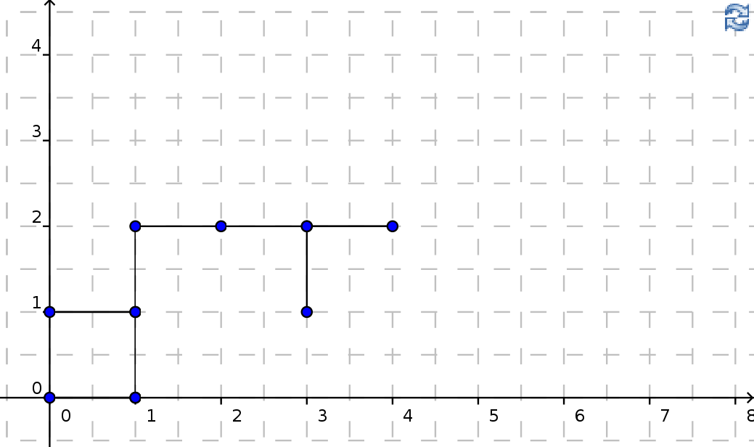
The GeoGebra plugin is covered in a later section so if you would like to know how to clear the GeoGebra drawing pad or how to move it around, look ahead at that section.

Exercises
For the following exercises, create a new MathPiperIDE worksheet file called book_2_section_7_exercises_<your first name>_<your last name>.mpw. (Note: there are no spaces in this file name). For example, John Smith's worksheet would be called:
book_2_section_7_exercises_john_smith.mpw.
After this worksheet has been created, place your answer for each exercise that requires a fold into its own fold in this worksheet. Place a title attribute in the start tag of each fold which indicates the exercise the fold contains the solution to. The folds you create should look similar to this one:

%mathpiper,title="Exercise 1"

//Sample fold.

%/mathpiper

If an exercise uses the MathPiper console instead of a fold, copy the work you did in the console into the worksheet so it can be saved.
For the following exercises, create a Monte Carlo simulation to solve the problem that is presented in each exercise.

Exercise 1
In a room full of 5 people, what is the probability that at least two of them will have the same zodiac sign?

Exercise 2
What is the probability that a family with 6 children will have exactly 2 girls?

Exercise 3
1) Modify the vending machine simulation so that it keeps track of hours until empty instead of days until empty. 2) Plot a histogram of the "hours until empty" data that the program generates. 3) Enable restocking in your program and plot a histogram of the "hours until empty" data that is generated with restocking enabled.

Exercise 4
Bill is an amateur mechanic and he is extremely cheap. Bill has never purchased a new car in his life and instead he owns 3 old cars that he maintains himself. On any given day car A has a 10% chance of being broken , car B has a 12% chance of being broken, and car C has a 15% chance of being broken. 1) What is the probability that on any given day all of Bill's cars are broken? 2) How many days in a year is Bill without a functioning car? (Hint: Have each trial simulate 365 days and during each day determine if each car is BROKEN or RUNNING like this:

carA := RandomPickWeighted({{BROKEN,10/100},{RUNNING,90/100}});
carB := RandomPickWeighted({{BROKEN,12/100},{RUNNING,88/100}});
carC := RandomPickWeighted({{BROKEN,15/100},{RUNNING,85/100}});

Exercise 5
Come up with a problem in an area you are interested in that can be solved with a Monte Carlo simulation and then create a simulation to solve it.

Exercise 6
Modify the random walk simulation to create a histogram which shows the maximum distances the walker moved from location (0,0) over X number of trials. Note, the maximum distance can occur during any of the steps the walker takes, not just the last step. (Hint: Research the distance formula.)

The AskUser(), TellUser(), and ToAtom() Functions
MathPiperIDE worksheet folds and the MathPiper console are designed to enable a user to directly enter and edit input and view it without having to use special input and output oriented functions. However, sometimes it is useful to use functions to obtain input from the user and output information to the user and MathPiper() has the AskUser() and TellUser() functions for this purpose.

AskUser()
The AskUser() function obtains information from the user and here is its calling format:

AskUser(message)

The "message" argument is a string that contains instructions for what kind of input the user should enter. When the AskUser() function is called, a graphic dialog window is displayed which contains the message string and a text field into which the user can enter input. The dialog window looks like this:

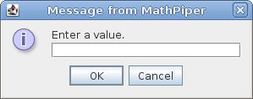
After entering the input, the user presses the "OK" button, or the <Enter> key on the keyboard, and the input which was entered into the text field is returned by the function. For example, the following code asks the user to enter a value and then this value is assigned to inputValue:

In> inputValue := AskUser("Enter a value.")
Result: "42"

In> inputValue
Result: "42"

When the dialog window was displayed, the number 42 was entered and the number was returned by the function as the string "42". If you want to treat the input value as a number instead of a string, the ToAtom() function can be used to do this:

In> ToAtom("42")
Result: 42

The ToAtom() function can also be used to turn a string into an unbound variable symbol:

In> ToAtom("a")
Result: a

TellUser()
The TellUser() function displays a graphic dialog window which contains output information for the user to view and here is its calling format:

TellUser(message)

The "message" argument is simply a string which contains the output to be displayed to the user. For example, the following code sends the message "Message from the program: 2 + 3 = 5" to the user:

In> TellUser("Message from the program: 2 + 3 = " : ToString(2 + 3) )
Result: True

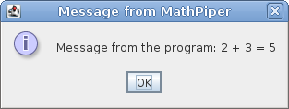

Using AskUser() and TellUser() Together In a Repeat() Loop
The AskUser() and TellUser() functions can be used separately, but they are also often used together inside of a Repeat() loop. The following program is an infinite loop which repeatedly asks the user to enter an integer and then it tells the user which integer was entered:

%mathpiper,title=""

Repeat()
[
time := Time() inputValue := AskUser("Enter an integer (or q to quit).");

If(inputValue = "q" Or inputValue = "Q", Break() );

integerValue := ToAtom(inputValue);

If(Not IsInteger(integerValue),
[TellUser("You must enter an integer."); Continue();]);

TellUser("The integer you entered is " : ToString(integerValue) : "." : Nl() :
"It took you " : ToString(RoundTo(time,3)) : " seconds to enter the number." );
];

%/mathpiper
If the user enters a lower case q or upper case Q, the program stops looping by executing a Break() function. If the user presses the "cancel" button in the input dialog window, the program will also stop looping. If the user enters input that is not an integer, the program will tell the user that they must enter an integer.
If the user enters an integer, the program tells the user which integer they entered and it also tells them how long it took to enter it.

Exercises
For the following exercises, create a new MathPiperIDE worksheet file called book_2_section_8_exercises_<your first name>_<your last name>.mpw. (Note: there are no spaces in this file name). For example, John Smith's worksheet would be called:
book_2_section_8_exercises_john_smith.mpw.
After this worksheet has been created, place your answer for each exercise that requires a fold into its own fold in this worksheet. Place a title attribute in the start tag of each fold which indicates the exercise the fold contains the solution to. The folds you create should look similar to this one:

%mathpiper,title="Exercise 1"

//Sample fold.

%/mathpiper

If an exercise uses the MathPiper console instead of a fold, copy the work you did in the console into the worksheet so it can be saved.
For the following exercises, use the AskUser() and TellUser() functions in an infinite Repeat() loop.

Exercise 1
Create a program which generates a random integer between 1 and 5. Ask the user to guess the number and keep track of how many attempts it takes to guess it. After each attempt, tell the user if they guessed correctly or not and ask them if they would like to guess again. If they enter "y", allow them to guess again and if they enter "n", end the program. If the user guesses the number, display how many tries it took them to guess it.

Exercise 2
Create a program which quizzes the user on simple addition facts in a way which is similar to how flash cards are used. Generate the addition problems randomly and keep track of how many problems the user answered correctly or missed. If the user answers a problem correctly, move to the next problem and if they miss a problem, give them the correct answer before moving on to the next problem. The program should give the user 10 problems to solve and then display the summary of their results.

Mathematical Formulas, The Solve() Function, Mathematical Functions, And Static Plotting

Applied Mathematics And Formulas
In this book we are exploring the areas of science, technology, engineering, and mathematics and therefore the branch of mathematics we are focusing on is applied mathematics. Here is a definition for applied mathematics:
Applied Mathematics - Mathematics used to solve problems in other sciences such as physics, engineering or electronics, as opposed to pure mathematics. http://en.wiktionary.org/wiki/applied_mathematics
The applied mathematics which is used in science, technology, and engineering is full of formulas and a significant part of the work that scientists, technologists, and engineers do consists of working with these formulas. For example, one of the most used formulas in physics is

or

In this formula, d, v, and t are all variables which means that the values they represent can vary. In an earlier section we discussed how a mathematical formula can be thought of as a jump point which can be used to navigate through a pattern space. Most formula "jump points" are expressed as equations and the equals sign (=) can be thought of as a hyperspace tube through which the jump takes place. This idea is shown in the following diagram:

Let's put this formula into MathPiper and use it to make a jump. The following program deals with a car which has been traveling at a speed of 55 miles-per-hour for 1 hour. The program uses the above formula to "navigate" (calculate) to the location in pattern space which holds the number that represents the distance the car traveled during this hour:

%mathpiper,title=""

v := 55.0; //Miles per hour.

t := 1.0; //Hour.

d := v*t;

Echo("The speed of the car is ", v, "miles per hour.");
Echo("The amount of time the car has been traveling at this speed is ", t, "hour.");
Echo("Therefore, the distance traveled is ", d, "miles.");

%/mathpiper

%output,preserve="false"
Result: True

Side Effects:
The speed of the car is 55.0 miles per hour.
The amount of time the car has been traveling at this speed is 1.0 hour.
Therefore, the distance traveled is 55.00 miles.
. %/output
As indicated in the diagram, all values on the right side of the = sign must be known before the "jump" can take place and in this program the value 55.0 is assigned to the variable v and the value 1.0 is assigned to the variable t. Executing the program causes it to jump to the location in pattern space which holds the number 55. This means that the car traveled 55 miles during 1 hour of traveling at 55 miles-per-hour.
Notice that the values that are used in this program are real numbers. Most calculations which are made with science and engineering formulas are done with real numbers. The reason for this is that most phenomenon in the physical universe are continuous and therefore science and engineering formulas need to use continuous variables to represent these phenomenon.

Rearranging Formulas With The == Operator And The Solve() Function
In the previous section, the formulawas used with the known values of speed and time to "navigate" to a location in pattern space which represented a distance. However, what if we are currently at the location of the distance pattern and we want to navigate to the location of the speed or the time pattern? An amazing property of formulas is that they can be rearranged to "jump" from any set of variables in the formula to any given variable in the formula.
The process of reconfiguring a formula so that it jumps to a desired location in pattern space is called solving the formula for a given variable. All computer algebra systems are able to solve formulas for a given variable and in MathPiper, the Solve() function is used for this. Here is the calling format for the Solve() function:

Solve(equation, variable)

The first argument to Solve() is a symbolic equation and the second argument is the unbound variable in the equation that is to be solved for. This unbound variable represents the destination in pattern space one wants to jump to. In MathPiper, the == "equals" operator is used to symbolically define an equation and in the following example, Solve() is used to solve the formulafor v (Note: make sure the variables in the equation are unbound):

In> Unbind(d,v,t)
Result: True

In> Solve(d == v*t, v)
Result: {v==d/t}

Notice how the formulais expressed as d == v*t in text form using the == operator. The result that is returned by Solve() is a symbolic equation which is also in text form and in this case it is v==d/t . The result is returned in a list because sometimes equations have more than one solution and all of these solutions are returned in the result list. Of course, a human could have easily solved this equation using the laws of algebra, but the Solve() function can also solve equations much larger than this one considerably quicker than a human can.
The following example shows the formulabeing solved for t. The result is assigned to the variable solutionsList and then the solution is obtained from this list and assigned to the variable solution:

In> solutionsList := Solve(d == v*t, t)
Result: {t==d/v}

In> solution := solutionsList[1];
Result: t==d/v
Finally, Solve() is used to solvefor the variable d and the result is the originalform of the equation which we started with:

In> Solve(solution, d)
Result: {d==t*v}

Turning A Formula Into An Explicit Function; Independent And Dependent Variables
Earlier we wrote a program which used the formulato calculate how far a car which was moving at a speed of 55 miles-per-hour had traveled after traveling for 1 hour. However, what if we wanted to calculate how far the car will travel during any time greater than or equal to 0 hours? The program we wrote could be made to do this by manually changing the value which is being assigned to t and then rerunning it, but a better approach is to turninto an executable mathematical function. Here is a definition of a mathematical function:
In traditional calculus, a function is defined as a relation between two terms called variables because their values vary. Call the terms, for example, x and y. If every value of x is associated with exactly one value of y, then y is said to be a function of x. It is customary to use x for what is called the "independent variable," and y for what is called the "dependent variable" because its value depends on the value of x.[1] Therefore, y = x2 means that y, the dependent variable, is the square of x, the independent variable.[1][2]
The most common way to denote a "function" is to replace y, the dependent variable, by f(x), where f is the first letter of the word "function." Thus, y = f(x) = x2 means that y, a dependent variable, a function of x, is the square of x. Also, in this form, the expression is called an "explicit" function of x, contrasted with x2 − y = 0, which is called an "implicit" function. http://en.wikipedia.org/wiki/Dependent_and_independent_variables
Turning our formula into an executable explicit function is easy and here is how it is done:

In> f(t) := 55*t
Result: True

In English this function reads "f of t equals 55 times t." Since we are currently only interested in using this function when the speed of the car is 55 miles-per-hour, we simply use the constant 55 in place of the variable v. In this function, t is the independent variable and d (which is now represented by f(t)) is the dependent variable. Now that this function has been defined, it can be used to calculate how far the car will travel for various times:

In> f(1)
Result: 55

In> f(2)
Result: 110

In> f(5)
Result: 275

In> f(2.3)
Result: 126.5

In> f(7.75)
Result: 426.25

The Table() function can be used with f(t) to obtain a list which has multiple distances in it:

In> Table(f(t),t,1,10,1)
Result: {55,110,165,220,275,330,385,440,495,550}

If an unbound symbolic variable is passed to this function instead of a numeric value, the expression that the function uses to perform the calculation is returned:

In> f(t)
Result: 55*t

In> f(x)
Result: 55*x

The Domain And Range Of A Function
A function has a set of values that can be sent to it (called its domain) and a respective set of values that it can return (called its range). Here are definitions for the domain and range of a function:
The domain of a function is the complete set of possible values of the independent variable in the function. The range of a function is the complete set of all possible resulting values of the dependent variable of a function, after we have substituted the values in the domain. http://www.intmath.com/Functions-and-graphs/2a_Domain-and-range.php
In the following program, a list of domain values which consists of the integers 0-10 inclusive is created and then these values are sent (each in turn) to the functionfor evaluation. The results of each evaluation are placed into a range values list and then the function, the domain list, and the range list are printed.

%mathpiper,title=""

f(t) := 55*t;

domainList := 0 .. 10;

rangeList := {};

ForEach(domainValue, domainList)
[
rangeList := Append(rangeList, f(domainValue));
];

Echo("The function is: f(t) = ", f(t));
Echo("Some of the function's domain values are: ", domainList);
Echo("Some of the function's range values are: ", rangeList);

%/mathpiper

%output,preserve="false"
Result: True

Side Effects:
The function f(t) = 55*t
Some of the function's domain values are: {0,1,2,3,4,5,6,7,8,9,10}
Some of the function's range values are:
{0,55,110,165,220,275,330,385,440,495,550}
. %/output
It is usually impossible to work with all the values in a function's domain and range because the amount of values is too large. Therefore, most programs that use executable mathematical functions only use a small subset of the function's domain and range values like this program does.
In this program, the list of numerical distances which are calculated and then placed into rangeList can be thought of as representing jump point destination locations in theformula's pattern space. Having these values in a list is more convenient than working with them separately, but it is still somewhat difficult to visualize what the relationship is between the range and domain values when they are viewed in this textual format. What would be nice to have is something like a graphical map of a function's pattern space, similar to a road map or perhaps a hyperspace jump point map. Luckily, tools for obtaining graphical "maps" like this are available and some of them are covered in the next section.

Plotting A Function (Obtaining A Graphic "Map" Of A Function's Pattern Space)
Plotting a function means to take a sequence of a function's domain values, pair them with their respective range values, and then show each pair as a graphic point on a two dimensional graphical background. Each point's domain value/range value pair is called its coordinates and these coordinates determine where a given point is located on the plot. In mathematical notation, the coordinates of a point are often placed inside of parentheses like this:
(domain_value, range_value)
For example, here are the coordinates of the points which were generated by the program in the previous section:
(0,0)
(1,55)
(2,110)
(3,165)
(4,220)
(5,275)
(6,330)
(7,385)
(8,440)
(9,495)
(10,550)
These points, together with the background they are drawn on, can be thought of as being a map of the function's pattern space. The following sections show various ways to plot the function f(t) = 55*t.

Generating 11 Points With A ForEach Loop And Plotting Them With ScatterPlot()
In the following program, a list of 11 domain values (0-10) called domainList is created and then a ForEach loop is used to send each of these domain values in turn to the functionfor evaluation. The resulting range values are placed into a list called rangeList. The contents of domainList and rangeList are printed and then sent to a function called ScatterPlot() for plotting in the JFreeChart plugin (the plot is shown below the program):

%mathpiper,title="ForEach() based program."

f(t) := 55*t;

domainList := 0 .. 10;

rangeList := {};

ForEach(domainValue, domainList)
[
rangeList := Append(rangeList, f(domainValue));
];

Echo("The function is: f(t) = ", f(t));
Echo("The domain values: ", domainList);
Echo("The range values: ", rangeList);

ScatterPlot({domainList, rangeList},
title -> "Plot Of Function f(t) = 55*t",
xAxisLabel -> "Domain: Hours",
yAxisLabel -> "Range: Miles Traveled",
series1Title -> ToString(Length(domainList)):" plotted points");

%/mathpiper

%output,preserve="false"
Result: org.jfree.chart.ChartPanel

Side Effects:
The function f(t) = 55*t
The domain values: {0,1,2,3,4,5,6,7,8,9,10}
The range values: {0,55,110,165,220,275,330,385,440,495,550}
. %/output
In this program, ScatterPlot() takes a list as its first argument. The list contains a domain list and its matching range list and these two lists must have the same number of elements in them or an error message will be printed. Notice that the ScatterPlot() function accepts the same options that the Histogram() function does.
Here is the plot the program produces:

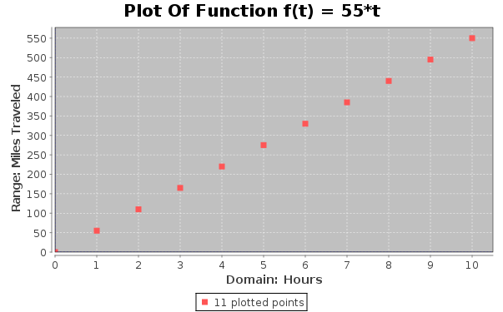
In this plot, the Domain axis runs horizontally along the bottom of the plot and the Range axis runs vertically along the left side of the plot. Each domain/range pair of values is represented as a red point. The domain value for each of these points can be found by locating the number which is directly below it on Domain axis and the range value can be found by finding the number which is directly to its left on the Range axis.

Analyzing The Plotted Points With Cross Hairs And Mouse Pointer Hovering
It is sometimes difficult to precisely determine the domain and range values for a point on a plot and therefore tools are available to help with this. If you select any one of the points in the plot from the previous section by clicking on it with your mouse pointer, blue cross hairs will appear which look like this:
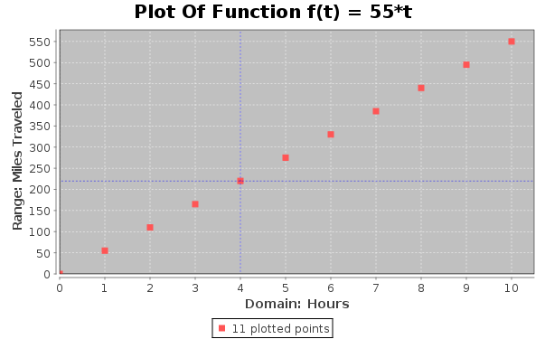
The blue cross hairs make it easier to determine the domain and range values for any given point. If you would like to know the exact domain and range values for a given point, simply place your mouse pointer over the point and let it sit there for a few seconds without clicking it or moving it. This is called "hovering" and when the mouse pointer is made to hover over a point, a small message will be displayed which contains the exact domain and range values for the point.

Generating 11 Points With Table() And Plotting Them With ScatterPlot()
The previous program shows how to use a ForEach loop to generate points with a function, but a more convenient way to do this is with the Table() function. The following program generates the same data and plot that the ForEach() based program did, except it uses a Table() function call to generate the domain list and another Table() function call to generate the range list:

%mathpiper,title="Table() based program."

f(t) := 55*t;

beginValue := 0;

endValue := 10;

stepAmount := 1;

domainList := Table(x,x,beginValue,endValue,stepAmount);

rangeList := Table(f(t),t,beginValue,endValue,stepAmount);

Echo("The function is: f(t) = ", f(t));
Echo("The domain values: ", domainList);
Echo("The range values: ", rangeList);

ScatterPlot({domainList,rangeList},
title -> "Plot Of Function f(t) = 55*t",
xAxisLabel -> "Domain: Hours",
yAxisLabel -> "Range: Miles Traveled",
series1Title -> ToString(Length(domainList)):" plotted points");

%/mathpiper

%output,preserve="false"
Result: org.jfree.chart.ChartPanel

Side Effects:
The function f(t) = 55*t
The domain values: {0,1,2,3,4,5,6,7,8,9,10}
The range values: {0,55,110,165,220,275,330,385,440,495,550}
. %/output
Here is the plot that this program generates. It is identical to the plot that was generated by the ForEach based code:

Notice that this program uses a variable called stepAmount to specify the numerical distance between the domain axis values of the points that are generated. As can be seen in this plot, a stepAmount value of 1 produces a fairly large space between the points. The stepAmount variable is used in the following sections to specify increasingly smaller distances between the domain axis values of the points until the visual space which is between them is eliminated.

Generating More Accurate Plots With Table() And ScatterPlot()
The plots of the functionin the previous sections were a good start, but the space between the points was somewhat large. If our goal is to create a map of a function's pattern space, then a plot which has its points closer together would be a more useful map. The following plot contains 21 points instead of 11 and it was generated with the Table() based program by setting the variable stepAmount to .5:

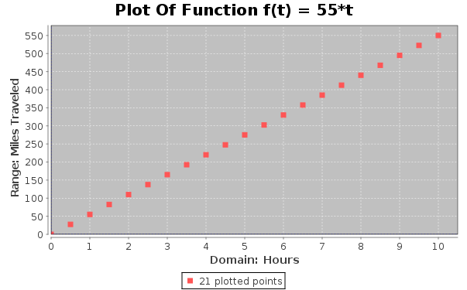
This plot is better, but there are still fairly large spaces between the points. Let's decrease the spaces between the points further by setting stepAmount to .25:

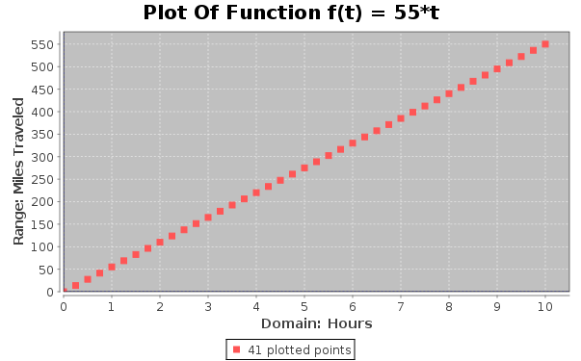
This plot has 41 points and the spaces between the points have almost disappeared. Setting stepAmount to .1 produces 101 points and the plot that is produced does not have any visual space between the points:

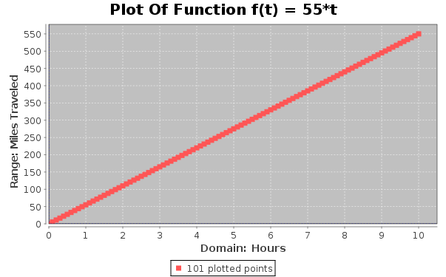
Even though there are an infinite number of points that could be plotted for a function, this plot shows that only enough of them need to be plotted so that there are no visible spaces between the points. All plotting functions use this principle when plotting.

Generating Points With Plot2D But Not Plotting Them
The ScatterPlot() based programs in the previous sections were fairly good for creating plots, but there are other plotting functions in MathPiper which can plot mathematical functions with less code needed to be typed. One of these functions is Plot2D() and here is an example of Plot2D() being used to print (domain,range) points for the function:

%mathpiper,title=""

f(t) := 55*t;

Plot2D(f(t), 0:10, output -> data);

%/mathpiper

%output,preserve="false"
Result: {{{0,0},{0.4166666668,22.91666667},{0.8333333335,45.83333334},{1.250000001,68.75000006},{1.666666667,91.66666669},{2.083333334,114.5833334},{2.500000001,137.5000001},{2.916666668,160.4166667},{3.333333334,183.3333334},{3.750000001,206.2500001},{4.166666668,229.1666667},{4.583333335,252.0833334},{5.000000001,275.0000001},{5.41666667,297.9166669},{5.833333335,320.8333334},{6.25000000,343.7500000},{6.666666668,366.6666667},{7.083333335,389.5833334},{7.500000002,412.5000001},{7.91666667,435.4166669},{8.333333335,458.3333334},{8.75000000,481.2500000},{9.166666669,504.1666668},{9.583333335,527.0833334},{10.00000000,550.0000000}}}
. %/output
The first argument to Plot2D() is the function to be plotted and the second argument specifies the span of domain values to plot over. The value to the left of the colon indicates the smallest domain value in the plot and the value to the right of the colon specifies the largest domain value in the plot. Therefore, 0:10 means the plot starts at 0 in the domain and plots up through 10.
Notice that unlike the ScatterPlot() based programs (which used separate lists for the domain and range values) Plot2D() places each domain value and its respective range value into a sublist. For example, the domain and range value for the first point after {0,0} is {0.4166666668,22.91666667}. Also notice that the domain values are not integers, but rather they are real numbers which have been selected because they will produce a plot with no gaps visible between the points.
Finally, the option output has been set to data to have Plot2D() print its points instead of graphically plotting them.

Plotting A Function With Plot2D()
The following program uses Plot2D() to display a graphical plot of the function:

%mathpiper,title=""

f(t) := 55*t;

Plot2D(f(t),0:10);

%/mathpiper

%output,preserve="false"
Result: org.jfree.chart.ChartPanel
. %/output

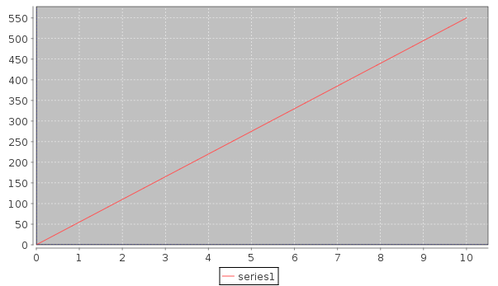
This is a good looking plot, but it would be more informative if it had a title and labels for the domain axis, the range axis, and the data. Here is a program that adds this information:

%mathpiper,title=""

f(t) := 55 * t;

Plot2D(f(t),0:10,
title -> "Plot Of Function f(t) = 55*t",
xAxisLabel -> "Domain: Hours",
yAxisLabel -> "Range: Miles Traveled",
series1Title -> "Enough plotted points to display a solid line");

%/mathpiper

%output,preserve="false"
Result: org.jfree.chart.ChartPanel
. %/output

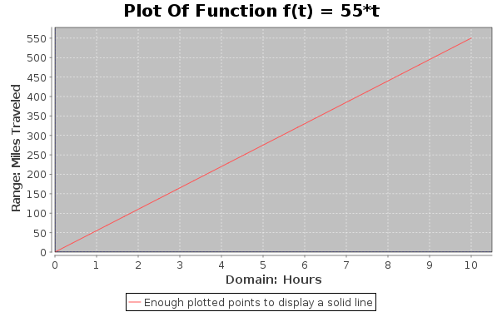

Calculating The Rate Of Change Of The Function f(t) = 55t; Rise Over Run; Slope
The plots of the functionwe have been working with enable a person to determine how far a car that is moving at a speed of 55 miles-per-hour has traveled during a given amount of time. This can be done by selecting an hour on the domain axis, locating the point on the line which is directly above this hour value, and then finding the miles value which is to the left of this point on the range axis. The blue cross hairs are useful when doing this.
If you will recall, the functionwas developed from the formula. Also, the domain axis of the plot indicates the time values that the independent variable t can be set to and the range axis indicates the distance values that the dependent variable d can have. But what about the speed variable v (which we set to 55)? Where is it represented in the plots?
In order to understand where speed is represented in the plot, one must first understand what speed means. The speed of a moving object is the rate at which the distance covered by the object changes with time. In the case of this car, the rate at which it is covering distance is 55 miles every hour or 55 miles-per-hour or.
On a plot, the speed of a moving object is represented by the steepness of the plotted distance vs. time line and this steepness is referred to as the slope of the line. Just to be clear:

Speed
=
The rate of change of distance
=
The steepness of a distance vs. time line
=
The slope of this line

The following plot shows how the slope of a line can be determined by performing a simple calculation on two of the points on the line.

Calculating The Slope Using Two Adjacent Points
The following plot shows the slope of the line being calculated using two adjacent points:

In this plot, the points (5, 275) and (6, 330) are used to calculate the slope of the line. First, the amount the domain value changed between the two points is determined by calculating the difference between the domain values of the two points. This domain value difference is called the run and in this case the calculation is 6 - 5 = 1. Then, the amount the range value changed between the two points is determined by calculating the difference between the range values of the two points. This range value difference is called the rise and here the calculation is 330 - 275 = 55. Finally, the slope is determined by dividing the rise value by the run value and this division is often referred to as calculating "rise over run." Here is the calculation:

This calculation on two adjacent points indicates that the slope of the line is 55, but would the same slope be arrived at if the rise over run calculation was performed on two points which are not adjacent? Let's find out.

Calculating The Slope Using Two Points Which Are Not Adjacent
The following plot shows the slope of the line being calculated with two points that are not adjacent:

In this plot, the points (5, 275) and (7, 385) are used to calculate the slope of the line. The domain axis run between the two points is 2 and the range axis rise between the two points is 110. Here is the calculation of the slope of the line:

Even when two points which are not adjacent are used to calculate the slope, it is still determined to be 55! Does this mean that a slope of 55 would be arrived at if any two points on the line were used to make the calculation? Let's explore this idea with a program.

Using Randomly Selected Points To Calculate The Slope
The following program calculates 11 points on the line which is defined by. Eight pairs of points are then randomly chosen from the 11 and then the rise-over-run slope calculation is performed on them:

%mathpiper,title=""

f(t) := 55*t;

beginValue := 0;

endValue := 10;

stepAmount := 1;

//Create the points list and print it.
pointsList := Table({t,f(t)},t,beginValue,endValue,stepAmount);

Echo("The ",ToString(Length(pointsList))," points in the plot:");

TableForm(pointsList);

NewLine();

/*
In this loop, 8 unique pairs of points are randomly selected from
pointsList and each of these pairs is used to calculate the slope
of the line they are on.
*/
Repeat(8)
[
//Randomly select two unique points from pointsList.
randomIndex1 := 0;

randomIndex2 := 0;

While(randomIndex1 = randomIndex2)
[
randomIndex1 := RandomInteger(Length(pointsList));

randomIndex2 := RandomInteger(Length(pointsList));
];

point1 := pointsList[randomIndex1];

point2 := pointsList[randomIndex2];

//Make sure that the point with the smallest domain value is placed in point1.
If(point1[1] > point2[1], [tmp := point1; point1 := point2; point2 := tmp;]);

Echo("Point1: ", point1);
Echo("Point2: ", point2);

rise := point2[2] - point1[2];

run := point2[1] - point1[1];

Echo("Rise = Point2y - Point1y = " :
ToString(point2[2]):" - ":
ToString(point1[2]) :" = ", rise);
Echo("Run = Point2x - Point1x = " :
ToString(point2[1]):" - ":
ToString(point1[1]) :" = ", run);
Echo("Slope = rise/run = ":
ToString(rise) :"/":
ToString(run): " = ***":
ToString(rise/run):"***");

NewLine();
];

%/mathpiper

%output,preserve="false"
Result: 8

Side Effects:
The 11 points in the plot:
{0,0}
{1,55}
{2,110}
{3,165}
{4,220}
{5,275}
{6,330}
{7,385}
{8,440}
{9,495}
{10,550}

Point1: {8,440}
Point2: {10,550}
Rise = Point2y - Point1y = 550 - 440 = 110
Run = Point2x - Point1x = 10 - 8 = 2
Slope = rise/run = 110/2 = ***55***

Point1: {4,220}
Point2: {8,440}
Rise = Point2y - Point1y = 440 - 220 = 220
Run = Point2x - Point1x = 8 - 4 = 4
Slope = rise/run = 220/4 = ***55***

Point1: {6,330}
Point2: {10,550}
Rise = Point2y - Point1y = 550 - 330 = 220
Run = Point2x - Point1x = 10 - 6 = 4
Slope = rise/run = 220/4 = ***55***

Point1: {2,110}
Point2: {4,220}
Rise = Point2y - Point1y = 220 - 110 = 110
Run = Point2x - Point1x = 4 - 2 = 2
Slope = rise/run = 110/2 = ***55***

Point1: {0,0}
Point2: {2,110}
Rise = Point2y - Point1y = 110 - 0 = 110
Run = Point2x - Point1x = 2 - 0 = 2
Slope = rise/run = 110/2 = ***55***

Point1: {9,495}
Point2: {10,550}
Rise = Point2y - Point1y = 550 - 495 = 55
Run = Point2x - Point1x = 10 - 9 = 1
Slope = rise/run = 55/1 = ***55***

Point1: {3,165}
Point2: {8,440}
Rise = Point2y - Point1y = 440 - 165 = 275
Run = Point2x - Point1x = 8 - 3 = 5
Slope = rise/run = 275/5 = ***55***

Point1: {7,385}
Point2: {10,550}
Rise = Point2y - Point1y = 550 - 385 = 165
Run = Point2x - Point1x = 10 - 7 = 3
Slope = rise/run = 165/3 = ***55***
. %/output
Notice that no matter which pair of points is selected, the slope which is calculated using the points is always 55! Something interesting is going on here and what it is will be explored in the next section.

Exercises
For the following exercises, create a new MathPiperIDE worksheet file called book_2_section_9_exercises_<your first name>_<your last name>.mpw. (Note: there are no spaces in this file name). For example, John Smith's worksheet would be called:
book_2_section_9_exercises_john_smith.mpw.
After this worksheet has been created, place your answer for each exercise that requires a fold into its own fold in this worksheet. Place a title attribute in the start tag of each fold which indicates the exercise the fold contains the solution to. The folds you create should look similar to this one:

%mathpiper,title="Exercise 1"

//Sample fold.

%/mathpiper

If an exercise uses the MathPiper console instead of a fold, copy the work you did in the console into the worksheet so it can be saved.

Exercise 1
Solve the following equations using the Solve() function (remember to use == instead of = and also that multiplication needs to be indicated with a * character):

1) Solve -20 = -4 x - 6 x for x.
2) Solve 8 x - 2 = -9 + 7 x for x.
3) Solve y = m x + b for m.
4) Solve 5 h - 14 = 8 h + 4 for h.
5) Solve v = i r for i.
6) Solve (x+6)/2-(3*x+36)/4==4 for x.
7) Solve -18 - 6k = 6(1 + 3k) for k.
8) Solve 2(4 x - 3) - 8 = 4 + 2 x for x.
9) Solve -(1 + 7 x) - 6(-7 - x) = 36 for x.
10) Solve 23a - 22 = -4(1 - 6a) for a.
11) Solve (36-4*x)/(x^2-9)-(2+3*x)/(3-x)==(3*x-2)/(x+3) for x.
12) Solve a + 5 = -5a + 5 for a.
13) Solve h - 1 = 5 h + 3 h - 8 for h.
14) Solve v = a t for a.
15) Solve 12 = -4(-6 x - 3) for x.
16) Solve 2/(x-3)-3/(x+3)==12/(x^2-9) for x.
17) Solve 5n + 34 = -2(1 - 7n) for n.
18) Solve d = 1/2 a t^2 for a.
19) Solve d = 1/2 a t^2 for t.
20) Solve -5(1 - 5 x) + 5(-8 x - 2) = -4 x - 8 x for x.

Exercise 2
Create an executable mathematical function called f(d) which implements t = d/v and uses 55 for v.

Exercise 3
a) Plot f(d) from d=0 to d=500 using ScatterPlot(). Plot the points so that there is a small gap between them. (Hint: ScatterPlot() cannot take rational numbers)
b) Use the plot to determine the time values for the following distances:
75, 150, 225, 400, 475.
Record these time values in your worksheet.

Exercise 4
a) Plot f(d) from d=0 to d=500 using Plot2D().
b) Use the plot to determine the time values for the following distances:
77, 153, 226, 423, 492.
Record these time values in your worksheet.

Introduction To The GeoGebra Plugin; Dynamic Equations; Simple Linear Simulations
In the previous section, various techniques were shown for generating plots of functions. However, these plots were static which means that we could not change the value of the function's parameters using the GUI and have it replotted as the change was happening. This section discusses the GeoGebra plugin which enables the user to interact with mathematical objects such as functions, points, lines, triangles, circles, etc. dynamically with the GUI. In this section we will only be covering enough of GeoGebra to allow us to interact with functions. If you would like to learn more about GeoGebra, visit the project's website at http://geogebra.org.

An Overview Of The GeoGebra GUI
If you open the GeoGebra plugin by clicking on the tab which is at the right side of the MathPiperIDE application, the following window will appear:

The GeoGebra GUI contains the following areas:
- Drawing Pad - This is where graphic representations of mathematical objects are displayed. The drawing area is a two dimensional Cartesian coordinate system. Right clicking on the drawing pad will display a popup menu which can be used to configure the pad. Configurations include showing/hiding a grid and changing the scale of the axes.
- Toolbar Buttons - Each button performs an action such as adding points to the drawing area and drawing a line through two points. When a button is selected, a blue square is drawn around it. Each button has multiple modes it can be set to and these modes are accessed by clicking on the small inverted triangle which is at the lower right corner of each button.
- Independent (Free) And Dependent Object Lists - As mathematical objects are created, they are listed here. Any mathematical object in this area can be configured by right clicking on it. Also, these mathematical objects can be hidden and unhidden by clicking on the small circle that is shown to the left of each object.
- Input Text Field - This text field enables GeoGebra commands to be entered one at a time.
- Domain Axis - The horizontal axis which is on the bottom of the drawing pad. It is also referred to as the x axis.
- Range Axis - The vertical axis which is on the left side of the drawing pad. It is also referred to as the y axis.
- Undo, Redo, And Reset Buttons - The undo and redo buttons simply undo and redo actions which have been performed in GeoGebra. The reset button erases all entered work.
- Object Select/Move Button - When this button is selected, the mouse pointer can be used to select mathematical objects in the drawing pad and move them if desired.

- Drawing Pad Move/Zoom Button - This button enables the drawing pad to be moved in any direction. It also has modes which enable the drawing pad to be zoomed into and out of.
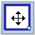
- Drawing Pad Move/Zoom Button Modes - The following image shows that when the small inverted triangle which is at the lower right corner of the button is clicked, a popup menu is displayed which allows the button modes to be set.
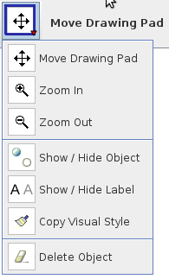

Adding Points To The Drawing Pad
Now that you know a little bit about how to use the GeoGebra GUI, let's use it to add some points and lines to the drawing pad. If you type (2,3) into the input text field like this:

and then press the <Enter> button on your keyboard, a blue point will be plotted at location (2,3) on the drawing pad:

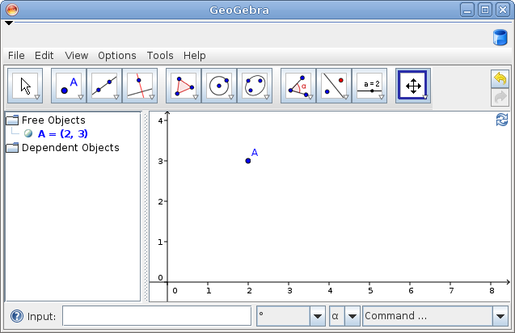
Notice that the point was automatically given the label "A" and it was also placed into the independent/free objects list. Now, add some more points to the drawing pad using both the input text field and the "New Point" button (Note: when the "point" button is selected, clicking on the drawing pad will place a point at that position):
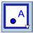

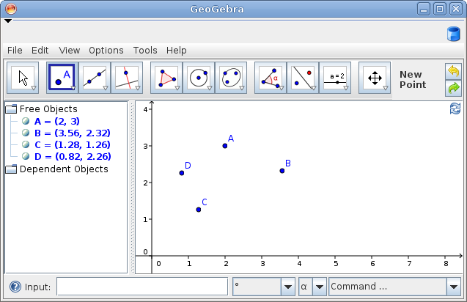

Adding Lines To The Drawing Pad
Now that there are some points on the drawing pad, select the "Line through Two Points" button:
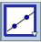
After the button has been selected, start clicking on pairs of points on the drawing pad and a line will be drawn through each pair that has been clicked:
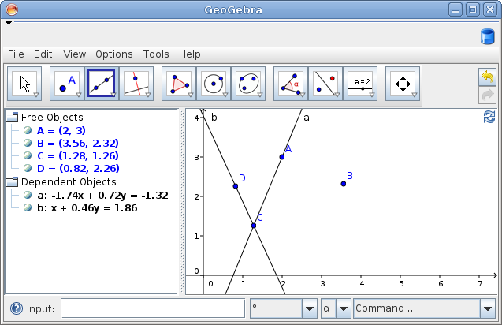
Notice that each line is automatically labeled with a lower case letter starting with "a". Also notice that these lines are listed in the "Dependent Objects" list.
These objects can be moved with the "Move" tool by selecting and dragging them.
(Note: clear the drawing pad by selecting File->New before moving on to the next section.)

Plotting Functions On The Drawing Pad
Functions can be plotted on the drawing pad by entering them into the Input text field. For example, if x is entered in the text field like this:

Input: x

A line labeled f(x) will be plotted on the drawing pad which is identical to the red line in the following diagram. You could have entered f(x) = x instead of just x and the result would have been the same. However, since just x was entered, GeoGebra automatically named the function f(x).
Now, enter the following two functions:

Input: 2x

Input: .5x

This caused two more lines to be plotted on the drawing area, with the first one being labeled g(x) and the second one being labeled h(x). When GeoGebra automatically names functions, it starts with f(x) and then moves on to g(x), h(x), etc. Also notice that 2*x was entered as 2x and .5*x was entered as .5x. GeoGebra understands traditional mathematics notation and therefore using the * multiplication symbol is optional.
The following diagram shows all three plots: (Note: I have made each of the lines in this plot a separate color so that they can be identified easier. If you would like to change the color of your lines, right clicking on them will bring up a dialog window which will allow you to do so. Also, the drawing area grid has been turned on in this diagram. This can be done by right clicking on the drawing grid and then selecting the 'grid' option.)

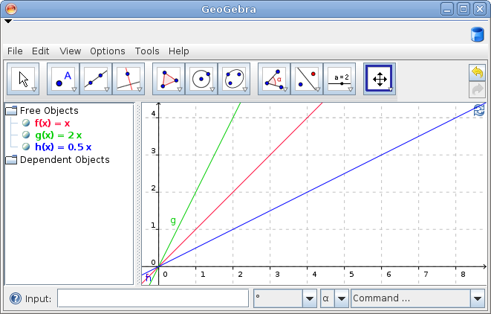
In the above diagram notice that the slope of the line f(x) = x is 1 (because x really means 1x), the slope of the line g(x) = 2x is 2, and the slope of the line h(x) = .5x is .5.
If the function 15x is added to the plot, it will be drawn steeper than 2x because its slope is greater. In the following diagram, the line which is plotted for 15x is drawn in purple:

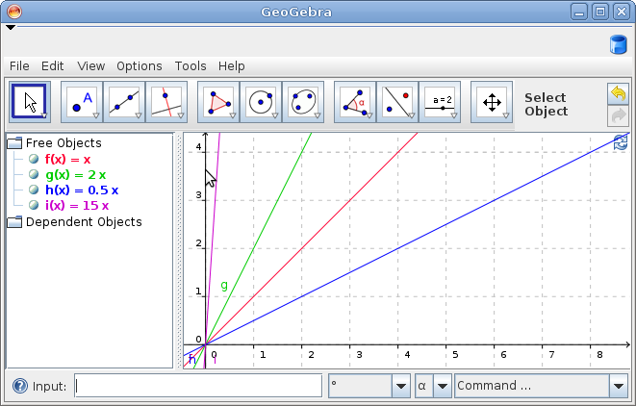

Adjusting The Scale Of The Range Axis
Unfortunately, if we wanted to plot functions whose lines have slopes that are greater than 15, it would be difficult to do because there is not very much room for them. However, more room can be added by changing the scale of the domain axis. In order to do this, place your cursor on the domain axis as shown in the above diagram and then 1) hold down the <shift> key on your keyboard 2) press the left mouse button on your mouse, and 3) drag the domain axis down toward the bottom of the screen. The domain axis will then be dynamically scaled to suite your viewing needs (Note: the range axis can be scaled in the same manner. Also note that the <shift> key must be pressed before the left mouse button.)
The following diagram shows the drawing pad after the range axis has been scaled:

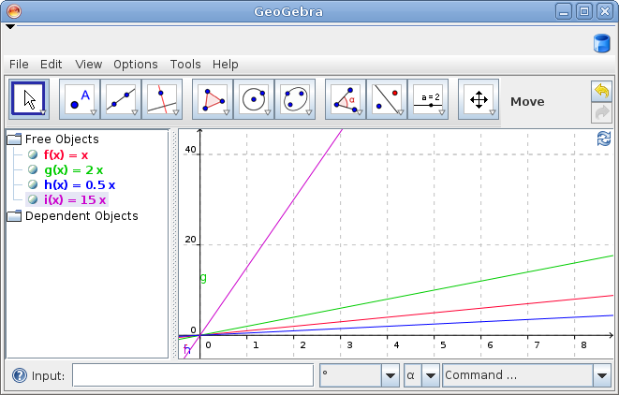

Plotting A Line Which Has A Slope Of 55
Now that the range axis has been scaled in order to create room for lines with greater slopes, we can plot the distance function. However, instead of naming the function f(t), we will let GeoGebra automatically select a name. Also, GeoGebra always uses x as the variable for the domain axis so instead of using t, we will need to use x. This is how to enter the function:

Input: 55x

And here is the plot that is generated (the color of the line plotted for 55x is cyan):
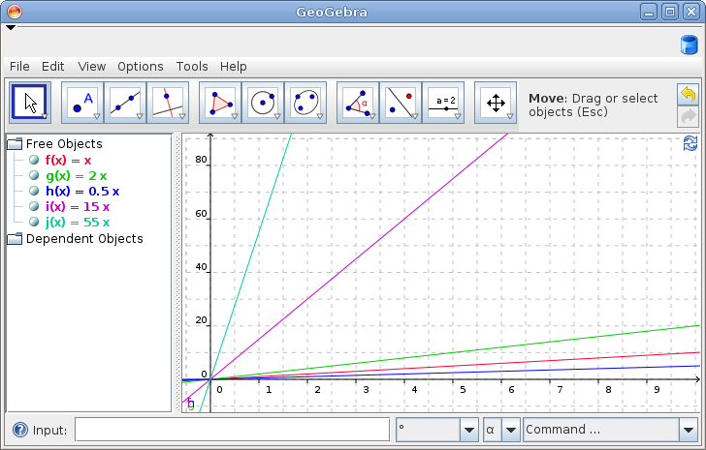

Plotting Functions Of Lines Which Have Negative Slopes
In addition to plotting functions of lines which have positive slopes, one can also plot functions of lines which have negative slopes as is shown in the following diagram.

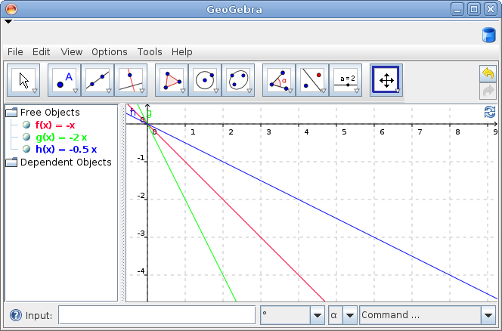
(Note: clear the drawing pad before moving on to the next section.)

Dynamically Changing The Slope Of A Line
Plotting functions statically in GeoGebra is useful and informative, but GeoGebra is also capable of plotting functions dynamically while the user causes parts of the function definition to change with a GUI slider. For example, instead of plotting 55x with a constant value for 55, we can use a variable in place of 55 and then have the user change the variable with a GUI slider.
Let's try this. Make sure you have a blank drawing pad and then enter the following text into the Input text field:

The equation speed = 5 will be placed in the Free Object list and the function f(x) = 5 x will be placed in the Dependent Objects list. Do you notice the small circle which is to the immediate left of the speed = 5 equation? Click on it with the mouse in order to enable it and then observe that this causes a GUI slider for the speed variable to be placed into the drawing pad. (Note: each item in both the Free Objects list and the Dependent Objects list has a small ball on its left side which can be be used to display or hide its analogous graphic representation on the drawing pad.)
After the slider for the speed variable has been enabled, it can be used to dynamically change the value of the speed variable by placing the mouse pointer on the slider's ball and dragging it to the left and to the right. As the slider changes the value of the speed variable, the dependent object which uses the speed variable (in this case f(x) = 5 x) changes with it. In this case, since the speed variable represents the slope of the line that is being plotted, the line's slope changes as speed is changed. This is shown in the following diagram.

A Better Looking GeoGebra Slope Simulation
The slope.mpw file contains a better looking version of the above slope simulation. This file is in the examples/books/exploring_stem_with_mathpiper directory in your mathpiperide folder.
The code for this simulation is contained inside of a %geogebra_xml fold and if you execute this fold, the slope simulation which is shown in the following diagram will be loaded into GeoGebra:

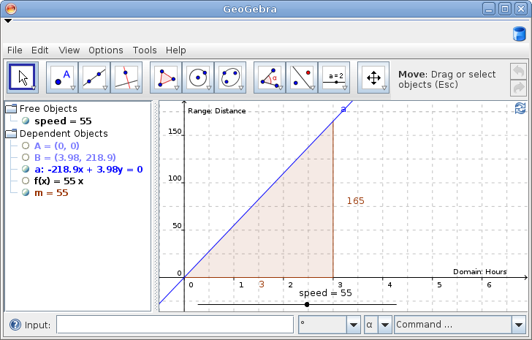
Notice that this simulation has a wider speed slider and a shaded slope indicator. A slider can be widened by right clicking on it and changing its properties. A slope indicator can be added to a line by selecting the small inverted triangle which is at the lower left corner of the angle button and then selecting the Slope menu item. The slope indicator shows the rise and run values for each slope the line is set to.

The %geogebra Fold
A %geogebra fold in a MathPiperIDE worksheet can also be used to execute GeoGebra commands (Note: this is different than a %geogebra_xml fold). For example, the following %geogebra fold plots the points (2,3), (1,4), and (1.5,2) on the drawing pad along with the function y = 2x:

%geogebra

(2,3)
(1,4)
(1.5,2)

2 x

%/geogebra
Using a fold to enter GeoGebra commands is convenient because more than one command can be entered at a time. However, if the fold is executed more than one time, multiple copies of the same mathematical objects are added to the drawing area. The way to prevent this is to add a clear="true" option to the %geogebra fold's header like this:

%geogebra,clear="true"

(2,3)
(1,4)
(1.5,2)

2 x

%/geogebra
The clear="true" option causes the GeoGebra drawing pad to be cleared each time the %geogebra fold is executed.

Entering A Function Into GeoGebra In Order To Dynamically Change It
The following fold enters the same f(x) = speed*x function into GeoGebra that we entered earlier:

%geogebra,clear="true"

speed = 1

f(x) = speed*x

%/geogebra
After this fold has been executed, the ball which is next to the speed variable in the Free Objects list will need to be selected in order to view the slider for this variable.

The GeoGebraPoint() Function
MathPiper is also able to interact directly with GeoGebra using the GeoGebraPoint() function. These two functions are covered in the following sections. (Note: the GeoGebra plugin needs to have been opened at least once after MathPiperIDE has been launched before this function will work.)
The GeoGebraPoint() function plots a point on the GeoGebra drawing pad and its calling format is as follows:

GeoGebraPoint(label, xCoordinate, yCoordinate)

The argument "label" is a string and it indicates what the label of the point should be . The arguments "xCoordinate" and "yCoordinate" specify the point's coordinates. For example, the following line of code will plot a point labeled "A" on the drawing pad at location 2,3:

In> GeoGebraPoint("A",2,3)
Result: java.lang.Boolean

Plotting 5 Random Points On The Drawing Pad
The following program uses RandomInteger() and GeoGebraPoint() to plot 5 random points on the GeoGebra drawing pad:

%mathpiper,title=""

index := 1;

While(index <= 5)
[
x := RandomInteger(8);

y := RandomInteger(8);

GeoGebraPoint("A":ToString(index), x, y);

index++;
];

%/mathpiper
Notice that in this program the variable index is turned into a string with the ToString() function and then concatenated with the string "A" using the : operator. This is done in order to produce a sequence of unique labels such as A1, A2, A3, etc.

Simulating A Ball Falling At A Constant Rate
The following program uses a While loop to simulate the dropping of a ball from a height of 4 units and a delay inside of the loop to regulate the rate at which the ball drops:

%mathpiper,title="Ball falling at a constant rate."
y := 4;

While( y >= 0)
[
GeoGebraPoint("BALL",1,y);

y := y - .1;

/*
The following code creates a delay which waits a
specified number of milliseconds before continuing.
*/

Delay(40);

];

%/mathpiper
In this program, y is initialized to 4 and then .1 is subtracted from it each time through the loop. The program will keep looping until y reaches a height of 0 and then it will stop.
At the bottom of the While loop is a call to the Delay() function which waits 40 milliseconds before returning. One millisecond is 1/1000 of a second or 0.001 seconds. Therefore, 40 milliseconds is 40/1000 of a second or 0.04 seconds. This delay slows down how fast the While() loop loops.

Adding A Line To The Simulation And Tracing It
After the ball drop program has finished running, the ball should be sitting on the "ground" at a y position of 0 like this:

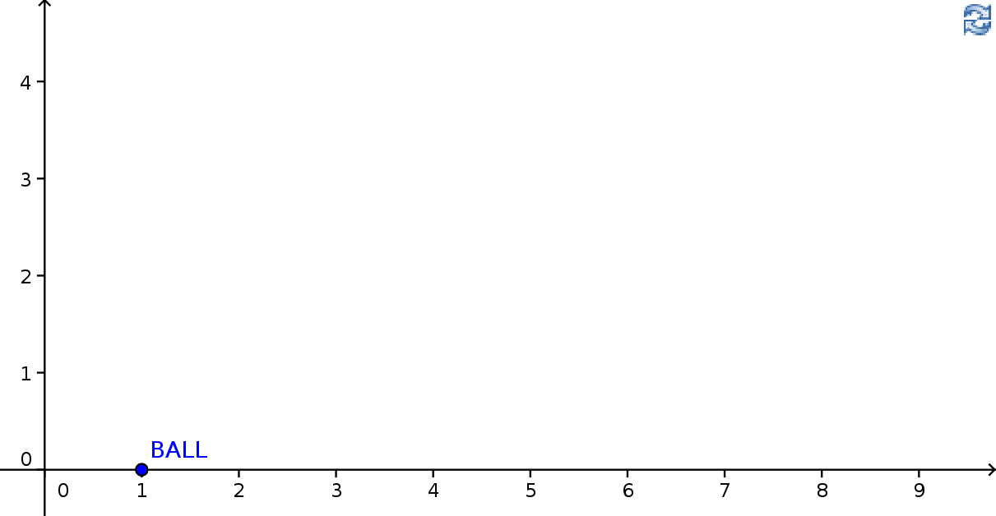
Now, add another point to the drawing area and place it on the drawing pad near where the point "A" is in the diagram below:

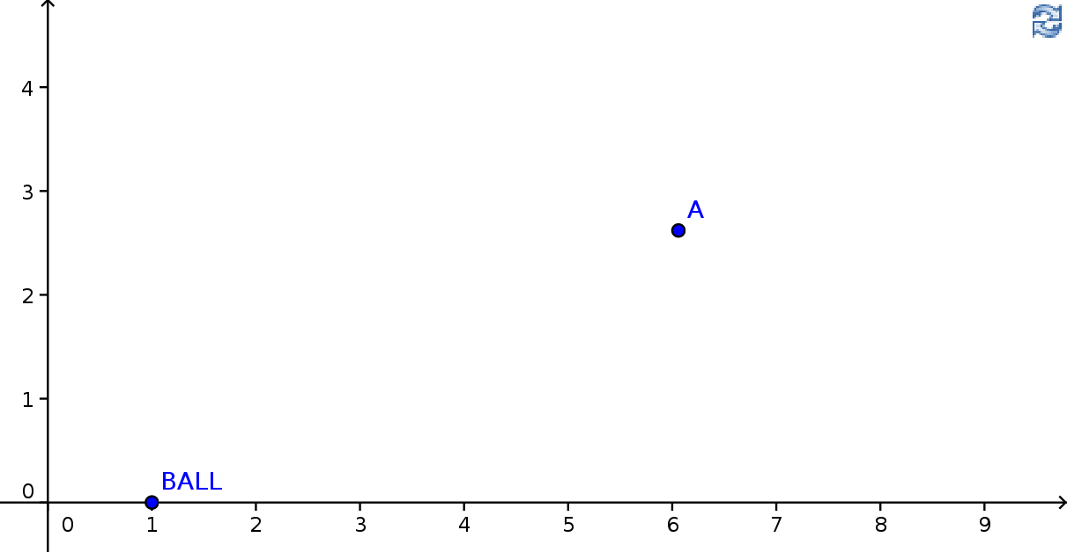
Your next step is to add a segment between these two points and this can be done using the "Segment between Two Points" tool which can be found in the button which is to the right of the "New Point" button. Here is what your drawing pad should look like after this is done:

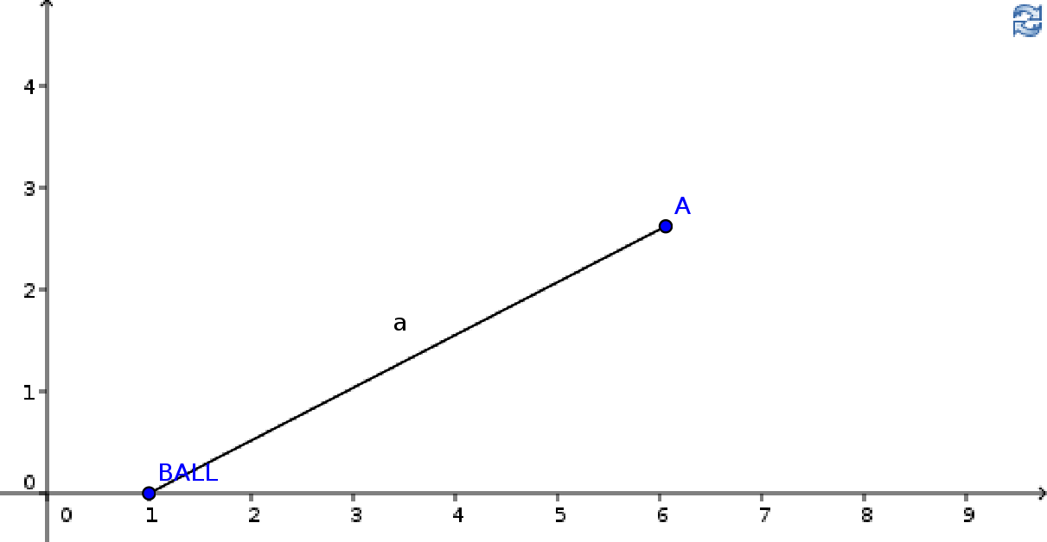
Execute the ball drop program a few times to see what happens with the segment when the ball is dropped.
Finally, right click on the line segment and enable the "Trace On" menu item. When you execute the program now, this is what should be displayed on your drawing pad:

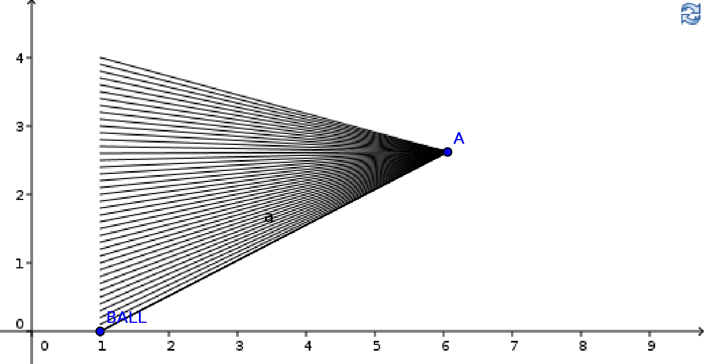
Tracing simply leaves a trailing image behind an object that is moved on the drawing pad and it can be enabled or disabled for any object by simply right clicking on it. In this case, besides creating a nice looking pattern, the interesting thing to notice about these lines is that their left ends are evenly spaced from each other. This indicates that the ball is indeed dropping at a constant rate. Later, we will study a program that simulates dropping a ball on the surface of the Earth and the lines which that program produces are not evenly spaced due to the ball being accelerated by gravity. (Note: go under the "View" menu and then select the "Refresh Views" menu item to clear the background traces.)

Moving A Point At A Specified Slope
The following program moves a point from left to right on the drawing pad at a slope of .5:

%mathpiper
x := 0;

slope := .5;

While(x <= 6)
[
y := slope * x + 1;

GeoGebraPoint("BALL",x,y);

x := x + .1;

Delay(40);
];

%/mathpiper
In this program, .1 is added to the variable "x" each time through the loop and the position of "y" is calculated using the values of "x" and the variable "slope".

Simulating A Random Walk
In a previous section we created a program which ran a series of random walk simulations and then determined the probability that the walker would step on a given point during the walk. The following random walk program is similar to the previous one, except it simulates just one random walk of 75 steps and moves a point on the GeoGebra drawing pad to show the current position of the walker:

%mathpiper,title="Random walk with a point."
currentPosition := {0,0};

Repeat(75)
[
step:= RandomPickWeighted({
{ {.1,0}, 25/100},
{ {-.1,0}, 25/100},
{ {0,.1}, 25/100},
{ {0,-.1}, 25/100}});

currentPosition := currentPosition + step;

GeoGebraPoint("A",currentPosition[1],currentPosition[2]);

Delay(100);
];

%/mathpiper
After you have run this program a few times, turn tracing on for point "A" and run it again. A walk pattern should be drawn on your drawing pad which looks similar to this one:
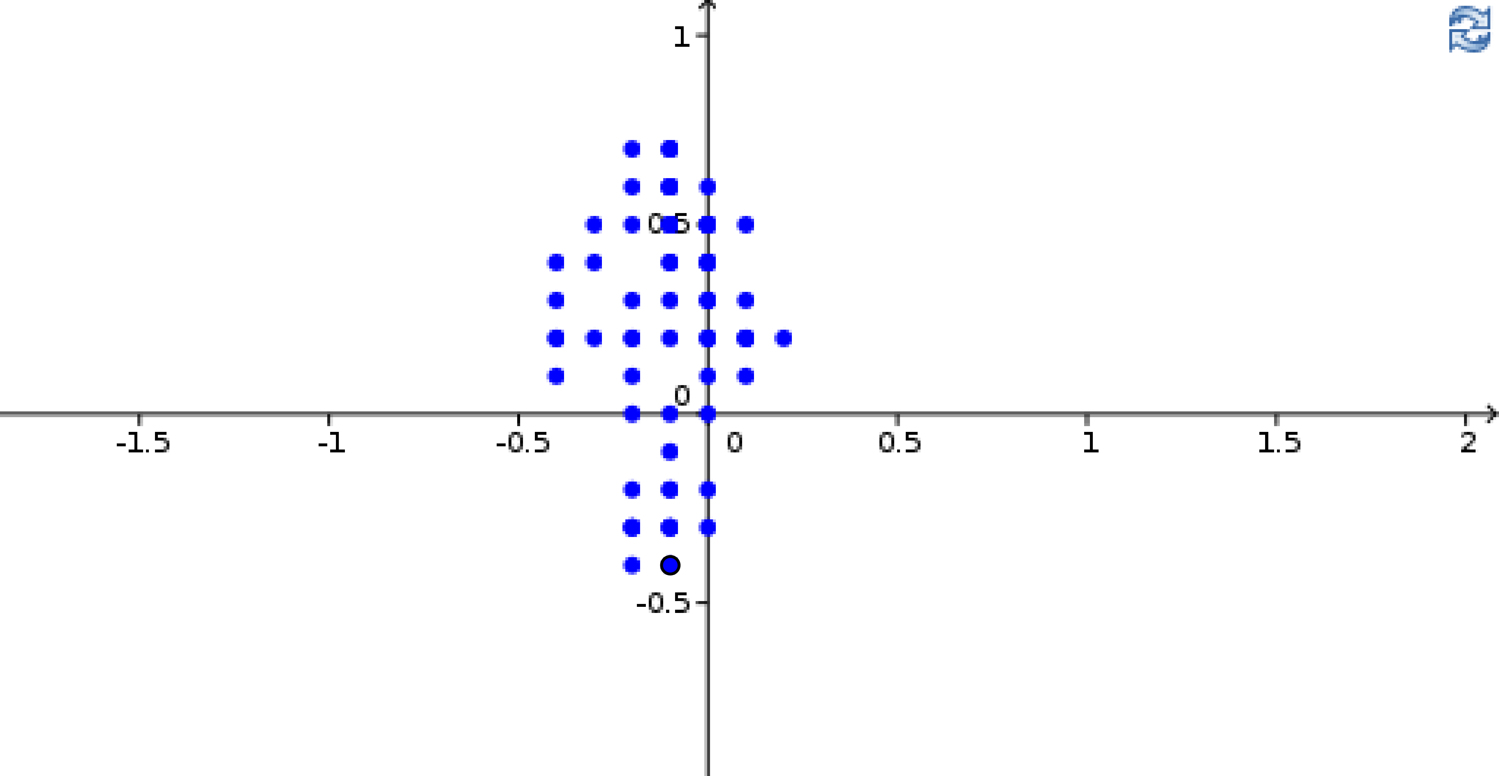

A Simple Bouncing Ball Simulation
In this section, instead of just dropping a ball, we bounce one around inside of a rectangle. Our first step is to draw a rectangle and this can be done using a %geogebra fold. We will be using the X axis as the bottom of the rectangle and the Y axis as its left side so we only need to draw the top and right sides of the rectangle in the fold.:

%geogebra,clear="true"
//Creat the corners of the rectangle.
C1 = (85,0)
C2 = (85,50)
C3 = (0,50)

//Create top and left sides of the rectangle.
Segment[C1,C2]
Segment[C2,C3]

%/geogebra
The Segment[] command in this fold draws a segment between two points. After you have executed this fold, you will need to zoom out of the drawing pad to see it. After zooming out your, drawing pad should look like this:
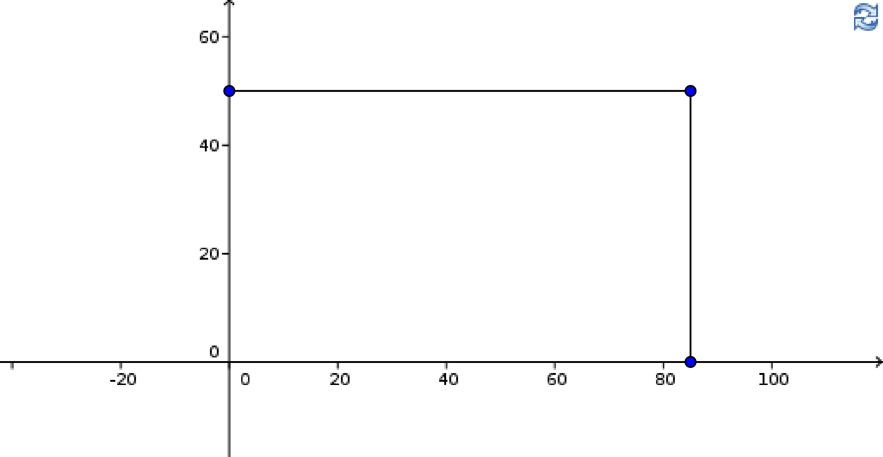
This is the program that bounces a ball around inside of the rectangle:

%mathpiper,title="Bouncing Ball"

x := 27;

y := 9;

xDirection := .5;

yDirection := .5;

Repeat()
[
GeoGebraPoint("A",x,y);

x := x + xDirection;

y := y + yDirection;

If(x = 85 Or x = 0, xDirection := xDirection * -1);

If(y = 50 Or y = 0, yDirection := yDirection * -1);

Delay(10);
];

%/mathpiper
The variables "x" and "y" are used to hold the position of the ball and they are initialized to 27 and 9 so that the ball starts at (27,9) on the drawing pad. Then, an infinite Repeat() loop is entered which moves the ball until the "Halt Calculation" button is pressed in the MathPiper console.
The ball always moves in a diagonal direction and this is done by adding .5 or -.5 to the variables "x" and "y". The following table shows which directions the different combinations of .5 and -.5 produce:

x Change | y Change | Direction
0.5 | 0.5 | Up and to the right.
0.5 | -0.5 | Down and to the right.
-0.5 | 0.5 | Up and to the left.
-0.5 | -0.5 | Down and to the left.

Here is the pattern that is produced when tracing is enabled for the moving point:
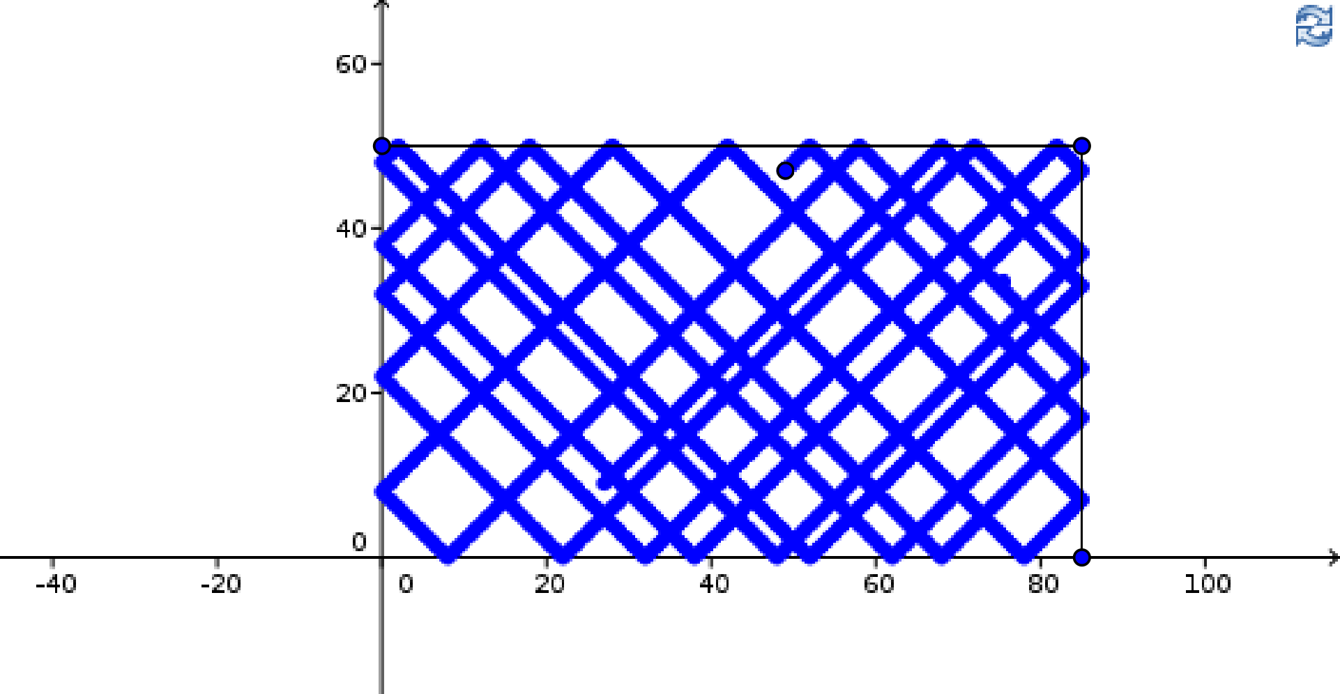

The GeoGebraPlot() Function
The GeoGebraPlot() function takes a function and then plots it in GeoGebra. In the following code, GeoGebraPlot() is used to plot x^2:

In> Unbind(x)
Result: True

In> GeoGebraPlot(x^2)
Result: class java.lang.Boolean
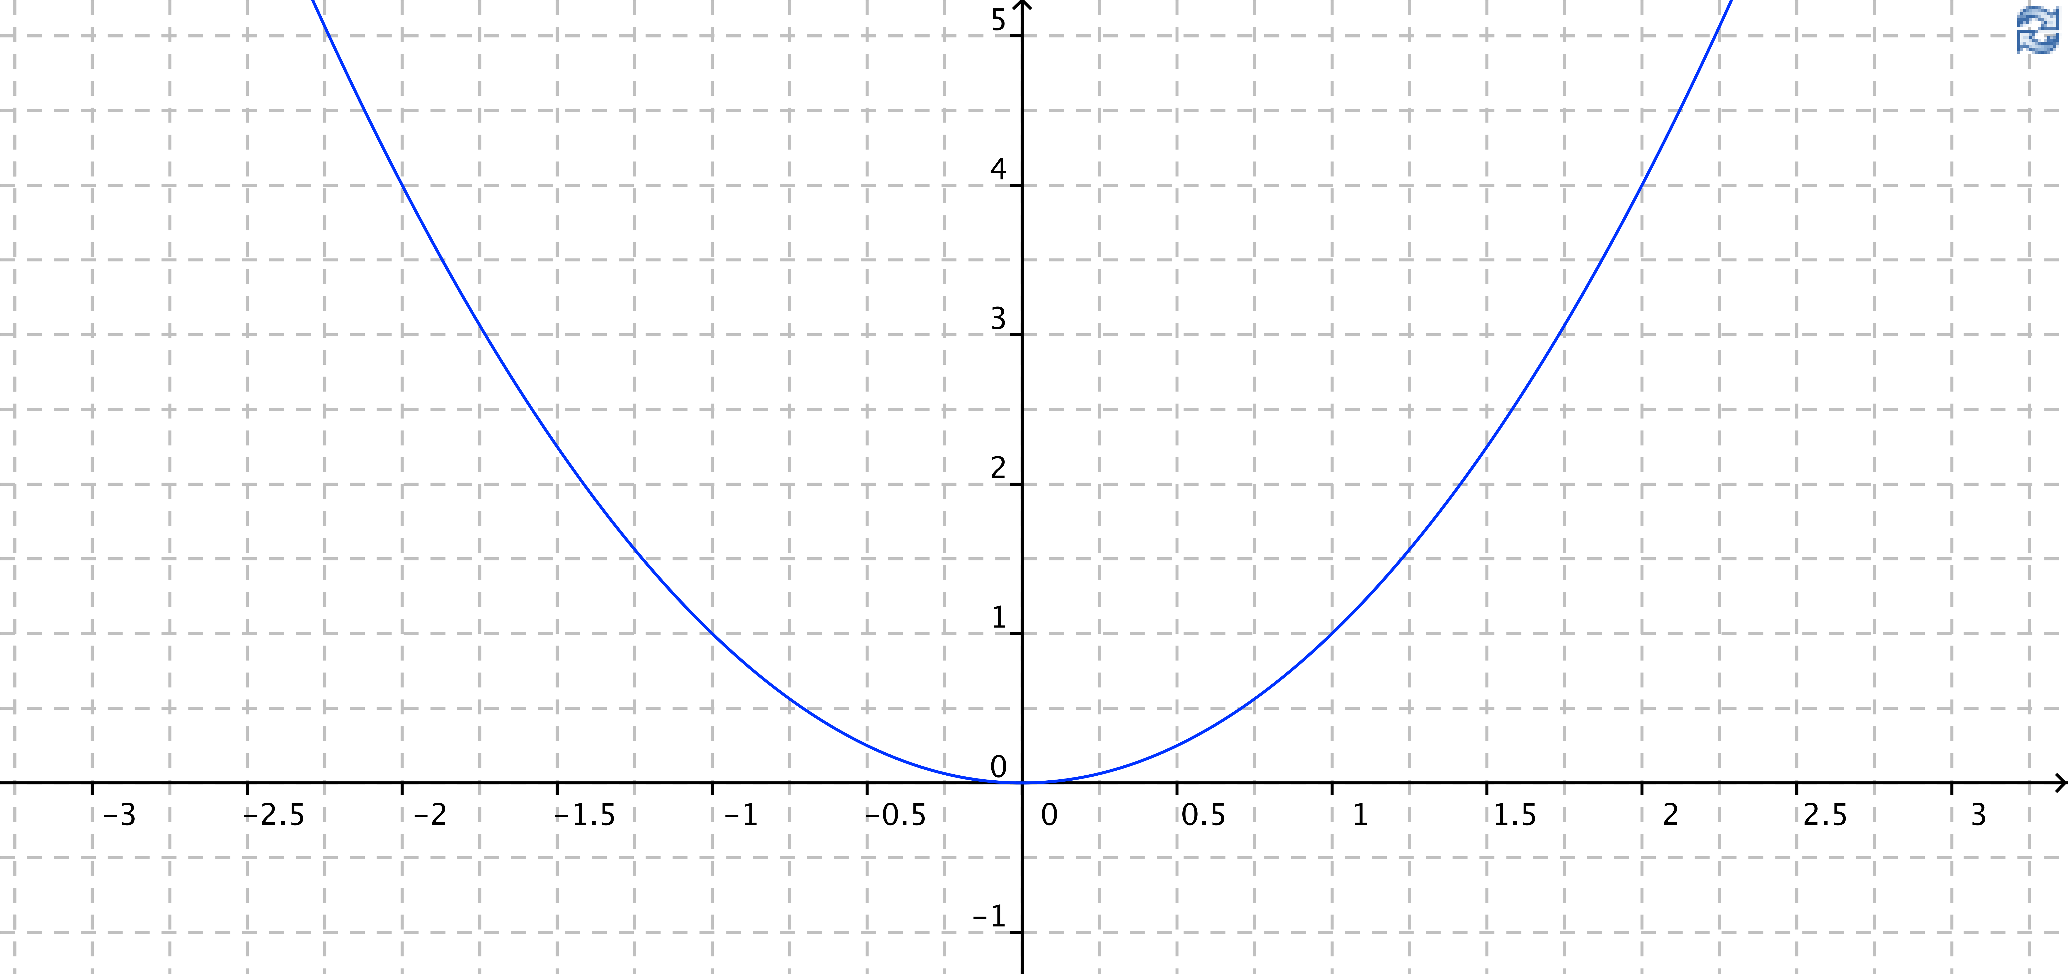
The GeoGebraPlot() function will be used in the next section.

Exercises
For the following exercises, create a new MathPiperIDE worksheet file called book_2_section_10_exercises_<your first name>_<your last name>.mpw. (Note: there are no spaces in this file name). For example, John Smith's worksheet would be called:
book_2_section_10_exercises_john_smith.mpw.
After this worksheet has been created, place your answer for each exercise that requires a fold into its own fold in this worksheet. Place a title attribute in the start tag of each fold which indicates the exercise the fold contains the solution to. The folds you create should look similar to this one:

%mathpiper,title="Exercise 1"

//Sample fold.

%/mathpiper

If an exercise uses the MathPiper console instead of a fold, copy the work you did in the console into the worksheet so it can be saved.

Exercise 1
For this exercise do the following:

a) Create a %geogebra fold.

b) Add code to the fold that will create sliders for the variables m and b.

c) Add code to the fold that will plot the function f(x) = m x + b.

d) Execute the fold and then use the sliders to observe what effect changing these variables has on the function.

e) Give a short description of how each variable in the previous step affected the function when it was changed.

f) Give a short description of what happens when each of these variables is set to 0.

Exercise 2
For this exercise do the following:

a) Create a %geogebra fold.

b) Add code to the fold that will create sliders for the variables a, b, and c. Initialize all of these variables to 1.

c) Add code to the fold that will plot the function f(x) = a x^2 + b x + c.

d) Execute the fold and then use the sliders to observe what effect changing these variables has on the function.

e) Give a short description of how each variable in the previous step affected the function when it was changed.

f) Give a short description of what happens when each of these variables is set to 0.

Exercise 3
For this exercise do the following:

a) Create a %geogebra fold.

b) Add code to the fold that will create sliders for the variables a, b, c, and d.

c) Add code to the fold that will plot the function f(x) = a x^3 + b x^2 + c x + d.

d) Execute the fold and then use the sliders to observe what effect changing these variables has on the function.

e) Give a short description of how each variable in the previous step affected the function when it was changed.

f) Give a short description of what happens when each of these variables is set to 0.

Exercise 4
Use a %geogebra fold to execute GeoGebra commands which will create two sliders labeled "a" and "b" which will move a point around on the screen. If tracing is enabled for the point, an "Etch-a-sketch" effect can be created.

Exercise 5
Modify the ball drop program so that when the ball hits the ground, it rolls to the right 3 units.

Exercise 6
Use the program which moves a point at a slope to produce the following diagram (Note: you will need to add a line between the points and enable tracing manually in GeoGebra):

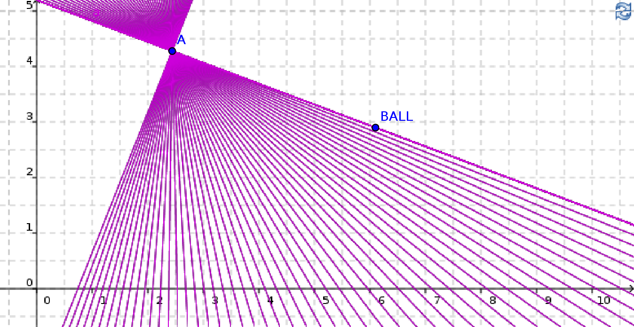

Exercise 7
Create a program which will move a point from left to right along the following path using an approach which is similar to the ball dropping program (Hint: Use the formula y = mx + b to calculate the y coordinate of each point on the line. This equation is in the slope-intercept form with m being the slope and b being the y axis intercept.):

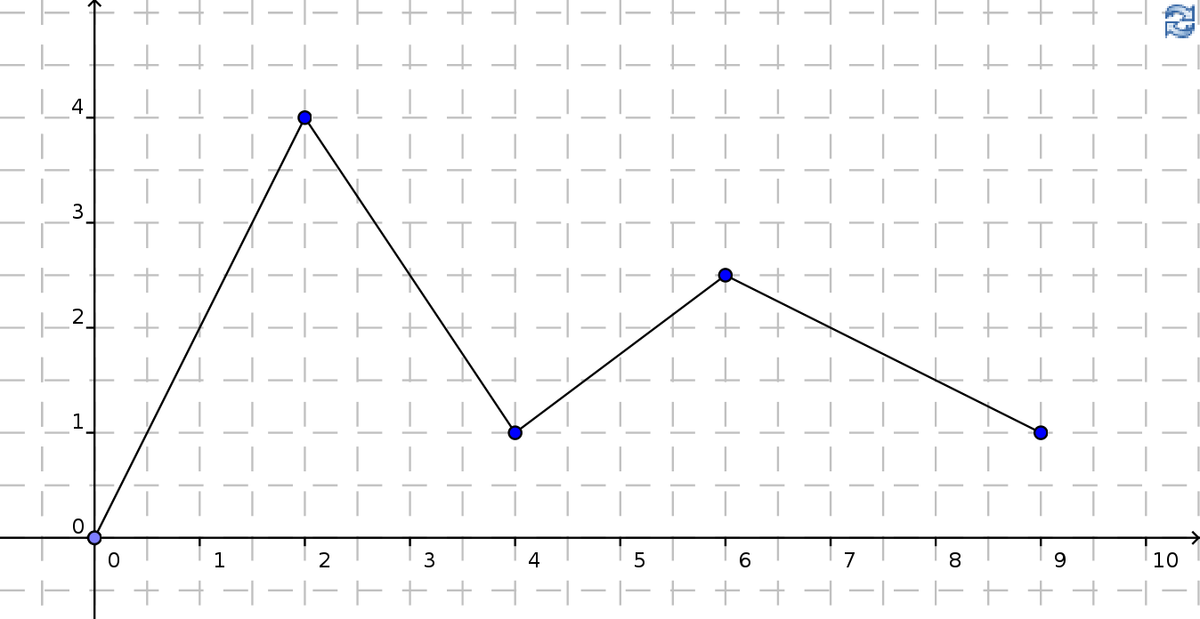

Exercise 8
Create a program which will move a point clockwise around the perimeter of the triangle in this diagram 3 times using an approach which is similar to the ball dropping program:

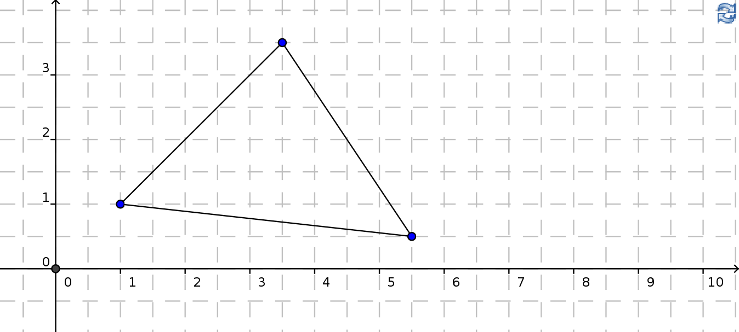

Calculating And Simulating The Throwing Of A Ball Into The Air With Gravity
In the previous section, a simulation was created which dropped a ball at a constant rate and this was done because simulating the dropping of a ball at a constant rate is simple to understand and program. However, real balls do not fall at a constant rate when dropped in gravity fields like the one created by the Earth and in this section we are going to simulate the dropping of a ball on Earth.
Earlier, we discussed what theory was and how it was based upon algebraic and calculus-related structures which contain pattern-related information about something of interest that has been observed. We determined that theory can be thought of as 1) a pattern space which is arranged in such a way that it models something of interest that has been observed and 2) one or more formulas which can be used to navigate this pattern space.
Work on the theory which describes how an object drops in a gravitational field was started by Galileo Galilei as is described in the following passage:

Modern work on gravitational theory began with the work of Galileo Galilei in the late 16th and early 17th centuries. In his famous (though possibly apocryphal)[2] experiment dropping balls from the Tower of Pisa, and later with careful measurements of balls rolling down inclines, Galileo showed that gravitation accelerates all objects at the same rate. This was a major departure from Aristotle's belief that heavier objects are accelerated faster.[3] Galileo correctly postulated air resistance as the reason that lighter objects may fall more slowly in an atmosphere. Galileo's work set the stage for the formulation of Newton's theory of gravity. ( http://en.wikipedia.org/wiki/Gravitation )

The formula which was developed to describe the pattern that an object follows when it is thrown straight up in a gravity field is:

(20)

In this formula, d is distance, v₀ is initial velocity, g is gravity, and t is time. The variable v₀ indicates the velocity of the object at the moment that it leaves the finger tips of the person throwing it. The acceleration of the Earth's gravitational field isand the negative sign indicates that the direction of the acceleration is towards the ground. In the next section we will experiment with this formula inside of GeoGebra in order to better understand how it works. Then, in a later section, we will write small programs which simulate the throwing of a ball into the air on the surface of the Earth.

Analysis Of Throwing A Ball Into The Air With Gravity
In this section we will be using GeoGebra to analyze the pattern a ball follows when it is thrown into the air in the Earth's gravitational field. Your first step is to open the tossing_a_ball_into_the_air.mpw file which is in the examples/books/exploring_stem_with_mathpiper directory in your mathpiperide folder.
This .mpw file contains a %geogebra_xml fold which will load the GeoGebra worksheet into GeoGebra which we will be using in this section.

Showing Only The Ball
After you press <shift><enter> in this fold, your GeoGebra plugin should look like the one in the following diagram:

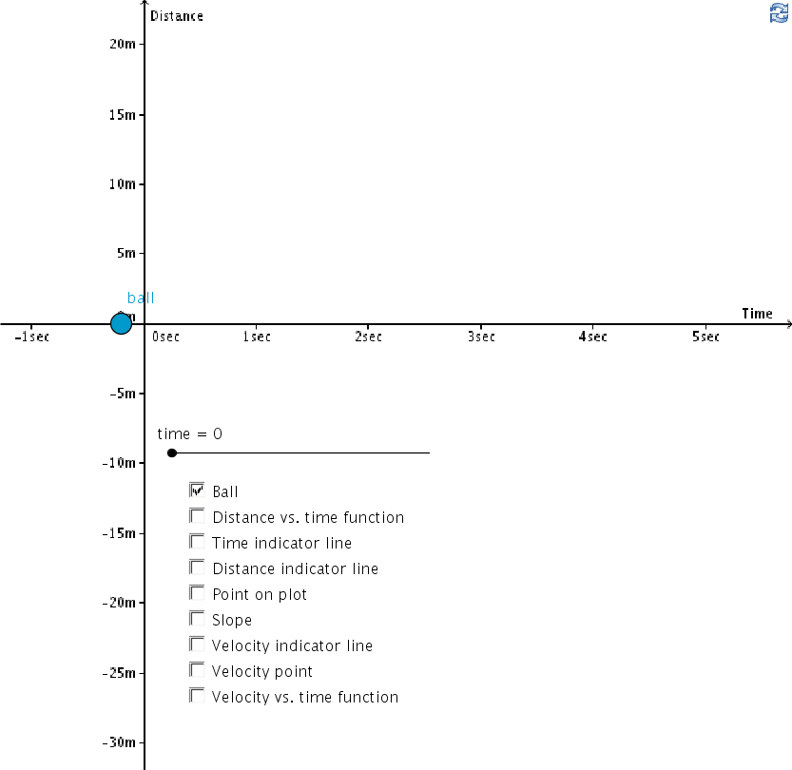

Slide the time slider to the left and right to make the ball move up and down. The Distance axis is in units of meters and it shows how high the ball is at any given time.
If you look at GeoGebra's algebra view, you will see that the formula that GeoGebra is using to determine the distance above the Time axis that the ball will be at any given time is:

(21)

Remember, GeoGebra can only use the variable x for referring to the x axis so x is used here instead of t. The 20 in this formula stands for 20 meters/second and it is the velocity of the ball at the moment it leaves a person's finger tips.

Ball + Plot Of The Distance vs. Time Function
Now that you have made the ball move up and down a few times, your next step is to enable the Distance vs. time function, Time indicator line, Distance indicator line, and Point on plot check boxes. After these check boxes are selected, move the time slider and observe the relationship between the ball and its current position on the distance vs. time plot:
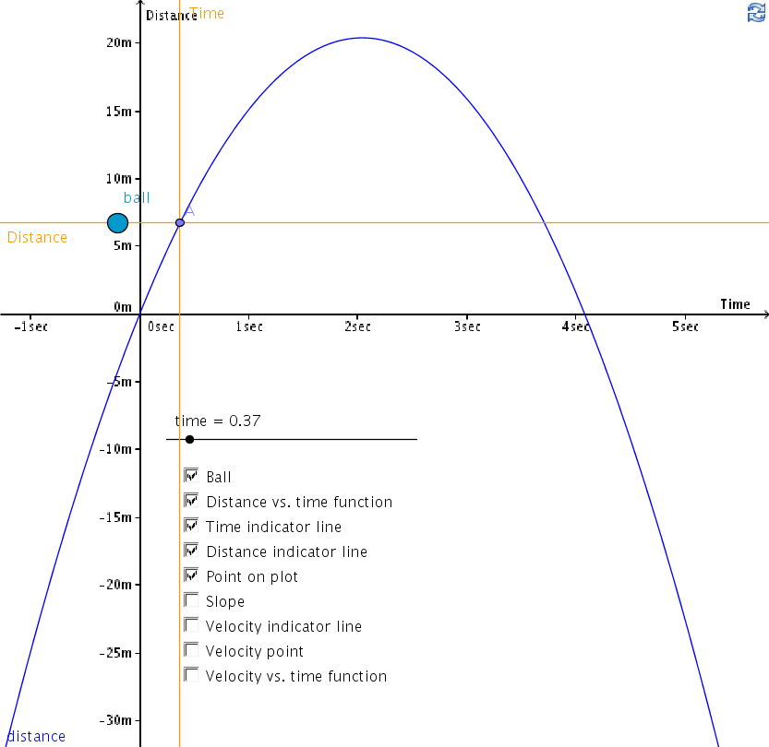
Notice that as the ball rises higher, the rate at which it rises becomes lower until it completely stops near a distance above the ground of 20 meters. The rate of change of distance of the ball is indicated by the slope of the distance vs. time function at point A and this is explored in more detail in the next section.

Ball + Plot Of The Distance Vs. Time Function + Slope
If you select the Slope check box, the slope of the distance vs. time function is shown at point A:
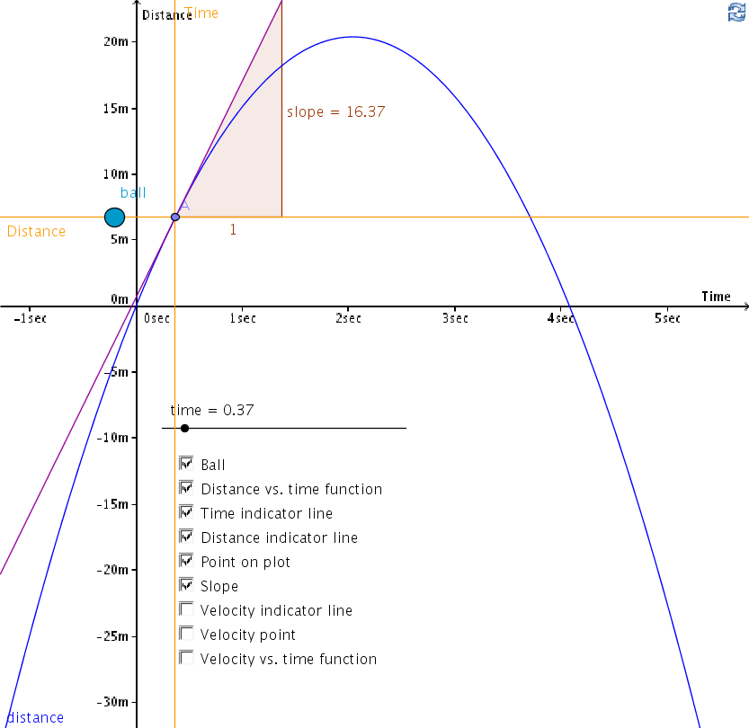
Set your time slider to 0, and then notice that the slope of point A is 20 which indicates that the velocity of the ball when it leaves your fingertips is 20 meters/second. As the ball rises, the slope becomes smaller and smaller which indicates that the velocity of the ball is becoming smaller. The slope and velocity continue to become smaller until they reach 0 at the top of the ball's travel. Then, as the ball starts to fall, its slope becomes negative and continues to decrease which indicates that the velocity is increasing in the direction of the ground.

Plotting Velocity Vs. Time
The diagrams in this section are what we have been leading up to and the concepts they contain are important so I would like you to study them closely to understand the concepts that they are meant to relay.

Velocity Vs. Time Indicated By Tracing The Velocity Point
In the following diagram, the Velocity indicator line and Velocity point check boxes have been enabled and when the time slider is moved, the velocity point B leaves a red trace which indicates the velocity of the ball at any given time:
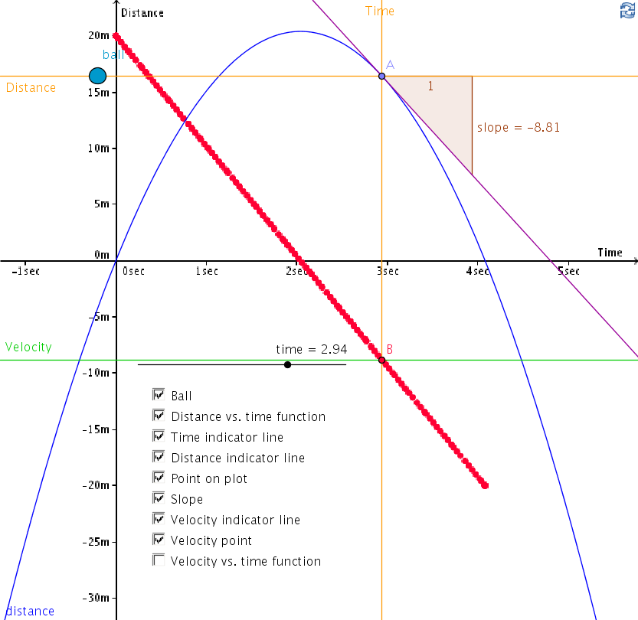

Notice how the value that the green velocity indicator line indicates on the y axis is the same value that is being indicated by the slope of point A. Move the time slider back and forth until you can see that point A is indicating the current distance vs. time relationship and point B is indicating the current velocity vs. time relationship.

Velocity Vs. Time Indicated By Tracing The Velocity Point And Showing The Velocity Vs. Time Function
Enable the Velocity vs. time function check box and observe what happens on the drawing pad:
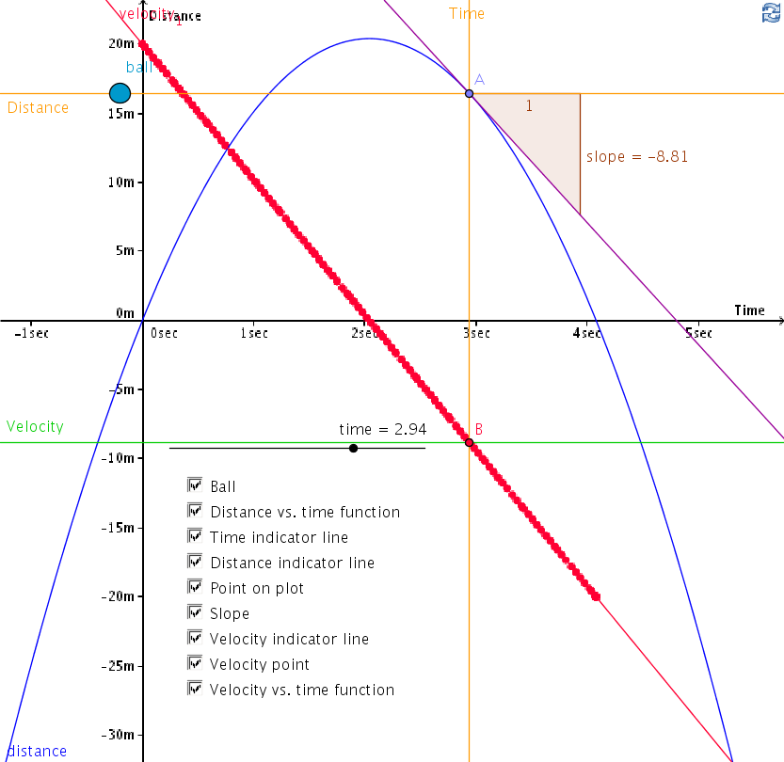

You should notice that a linear red function plot has been added to the drawing pad which coincides with the red traced line that the velocity point B created.

Showing Only The Distance Vs. Time And Velocity Vs. Time Functions
In this section, all of the check boxes have been unchecked except the Distance vs. time function check box and Velocity vs. time function check box:
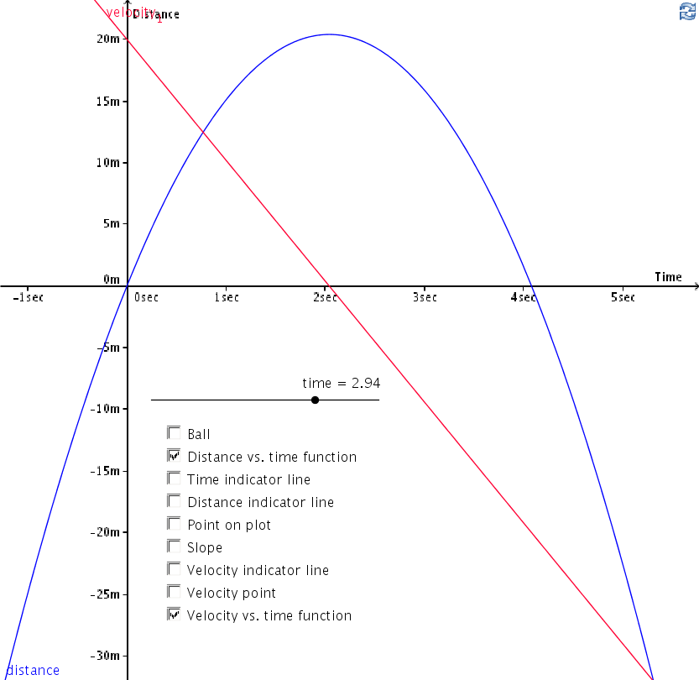

You should be able to see now that the height of the red Velocity vs. time function indicates the rate of change/slope/velocity of the blue Distance vs. time function at any given time.

A Little Bit Of Calculus
Calculus is part of an area of mathematics called mathematical analysis and here is a description for what mathematical analysis is:
In scientific work and in daily affairs, we frequently observe that some two things seem to be related - that any change in the one produces some corresponding change in the other. Often it is important to ascertain precisely how the one will change with the other.
To illustrate: the speed of a locomotive depends in part on the amount of fuel consumed. Just how will the speed vary with the consumption of fuel? The blood-pressure in a healthy person is different at different ages. Just how should the pressure vary with the age? How should the price of corn vary with the size of the crop? Or the cost of a reservoir with the capacity? Or the speed of development of a photograph with the temperature of the developer? And so on.
Mathematical Analysis makes a systematic study of many different modes of variation, discovers exact relations between varying quantities, and devises suitable methods of making any necessary calculations. It has played a leading part in the modern development of the exact sciences and is being used extensively in other fields - the biological and social sciences, psychology and medicine, engineering, and business administration. (Introduction to Mathematical Analysis F. L. Griffin, 1936, pp.1).
In the previous section we saw that there was a relationship between the distance a vertically thrown ball was from the ground and its velocity. Specifically, there was a relationship between its distance vs. time function and its velocity vs. time function. As the ball's distance from the ground increased, its velocity decreased. Then, when the ball began to fall, as its distance from the ground decreased, its velocity increased.
If we knew what one of these functions was, wouldn't it be nice if we could use it to determine what the other one was? Amazingly, this is one of the things that calculus is able to do! Let's use the distance vs. time function we have been working with as an example. The following code shows the distance vs. time function being assigned to f(x) and then plotted in GeoGebra:

In> f(x) := 20*x-9.8*x^2/2
Result: True

In> f(x)
Result: 20*x-(9.8*x^2)/2

In> GeoGebraPlot(f(x))
Result: java.lang.Boolean

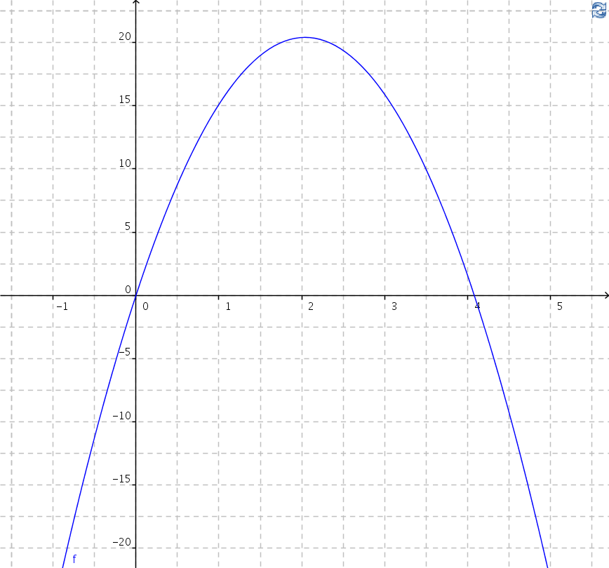
As you can see, this plot matches the plot of the distance vs. time function we have been using.

Finding The Velocity Vs. Time Function From The Distance Vs. Time Function Using Differentiation From Calculus
Calculus is divided into two main parts and the first part is used to find a function which describes the rate of change of a given function. This part of calculus is called differentiation and the function it produces describes the rate of change at any specific point of the given function. This new function is called the derivative of the given function.
We are interested in finding the derivative of our distance vs. time function and the MathPiper function which is used for doing differentiation and creating derivative functions is called Differentiate(). Here is the simplest calling format for the Differentiate() function:

Differentiate(variable) expression

The argument "variable" specifies what variable will be the focus of the differentiation process and "expression" is the function that the derivative function will be produced from. In the following code, the Differentiate() function is used to find the derivative of our distance vs. time function and then this derivative is plotted in GeoGebra in red:

In> Unbind(*)
Result: True

In> g(x) := Differentiate(x) f(x)
Result: True

In> g(x)
Result: 20-(19.6*x)/2

In> GeoGebraPlot(g(x))
Result: java.lang.Boolean

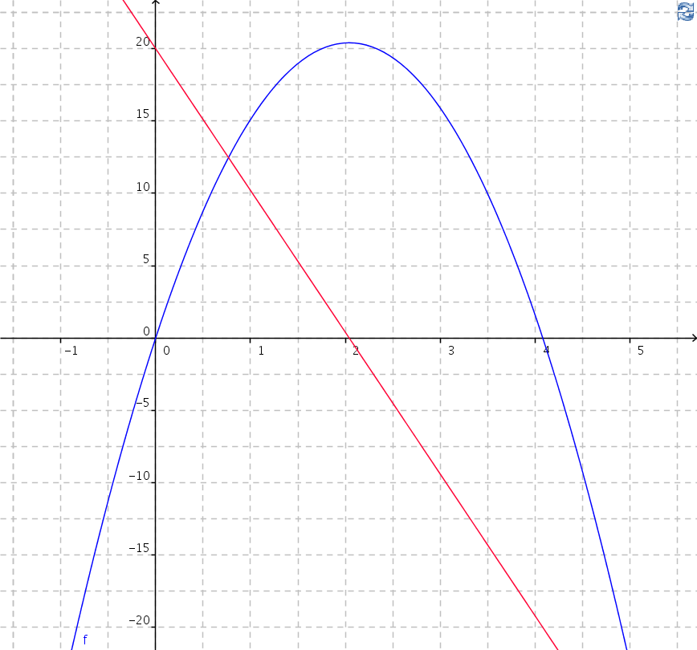

As you can see, the derivative of the distance vs. time function is the velocity vs. time function we have been working with!

Finding The Distance Vs. Time Function From The Velocity Vs. Time Function Using Integration From Calculus
As you may have guessed, the second part of calculus is finding a function if you have a function which describes its rate of change. This part of calculus is called integration and the function it produces is called the indefinite integral of the function.
We are interested in finding the indefinite integral of our velocity vs. time function and the MathPiper function which is used for doing integration and finding indefinite integral functions is called Integrate(). Here is the simplest calling format for the Integrate() function:

Integrate(variable) expression

The argument "variable" specifies what variable will be the focus of the integration process and "expression" is the function that the indefinite integral function will be produced from.
Let's start by assigning our velocity vs. time function to g2(x) and then plotting it in red:

In> g2(x) := 20-(19.6*x)/2
Result: True

In> GeoGebraPlot(g2(x))
Result: java.lang.Boolean

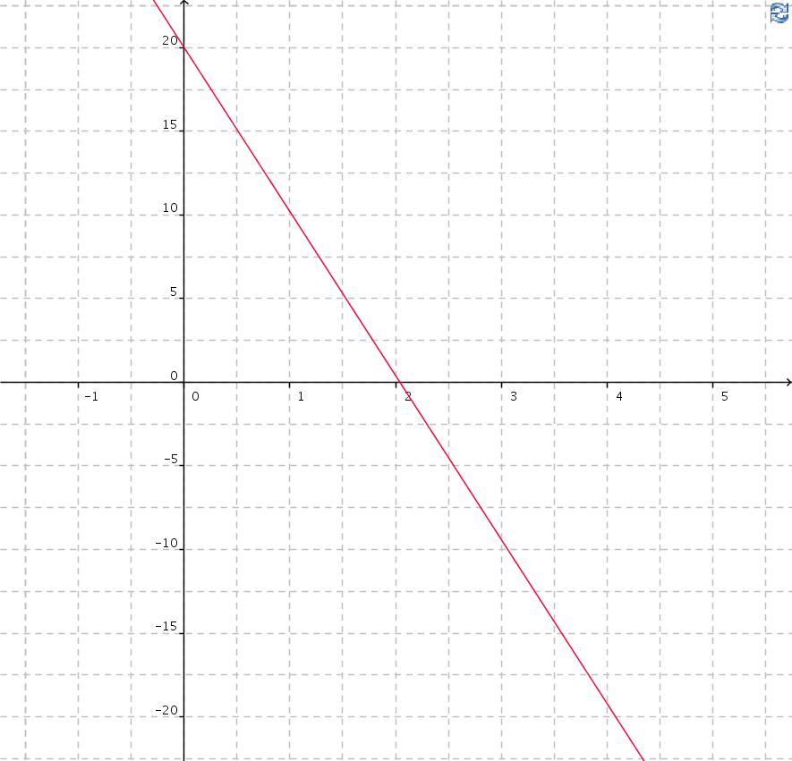
Now, let's use the Integrate() function to find the indefinite integral of our velocity vs. time function and then plot this indefinite integral function in blue:

In> f2(x) := Integrate(x) g2(x)
Result: True

In> f2(x)
Result: 20*x-4.9*x^2

In> GeoGebraPlot(f2(x))
Result: java.lang.Boolean

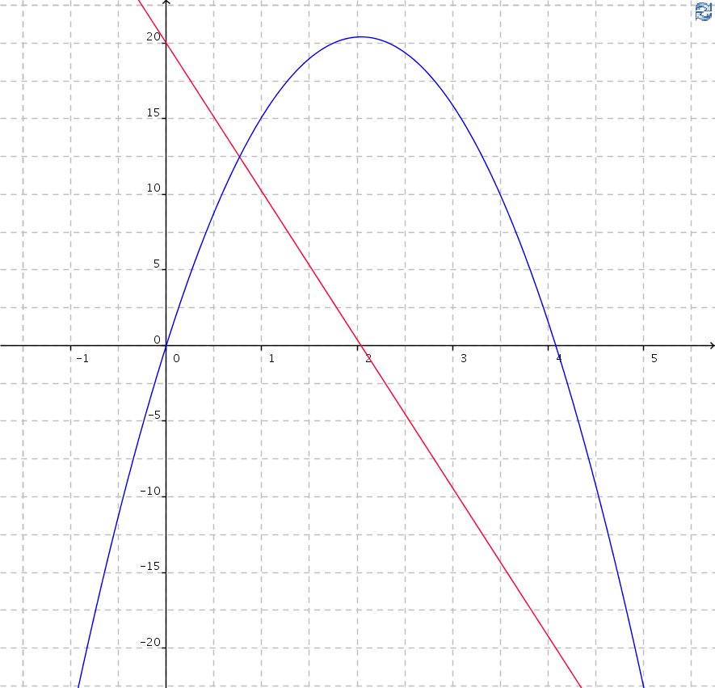
As the diagram shows, the indefinite integral of our velocity vs. time function is indeed our distance vs. time function!

Calculating When The Ball Is On The Ground
If you would like to calculate at what times the ball is on the ground, this can be done by solving the distance vs. time function f(x) := 20*x-9.8*x^2/2 for when f(x) equals 0:

In> f(x) := 20*x-9.8*x^2/2
Result: True

In> (Solve(f(x) == 0, x)
Result: {x==2.040816327-Sqrt(4.164931279),x==Sqrt(4.164931279)+2.040816327}

If you would like to see the solution in decimal form, use the N() function like this:

In> N( Solve(f(x) == 0, x) )
Result: {x==0.00000000000000,x==4.08163265306122}

This result indicates that the ball is on the ground at time = 0 seconds and time = 4.081632653 seconds. If you look at the blue plot of the distance vs. time function in the previous section, you can confirm that this is correct.

Calculating When The Ball Has Reached The Highest Point In Its Path
Calculating when the ball is on the ground was easy if you have the distance vs. time formula, but what if you have the distance vs. time formula and you want to know what the highest point the ball reached when it was tossed into the air? If you study the blue plot of the distance vs. time function, there does not seem to be an easy way to determine this. However, the red velocity vs. time plot becomes 0 (or crosses the x axis) at the same time that the distance vs. time function reaches its highest point. This means that we can derive the velocity vs. time function from the distance vs. time function and then use the Solve function to determine when the velocity vs. time function reaches a y of 0:

In> f(x) := 20*x-9.8*x^2/2
Result: True

In> f(x)
Result: 20*x-(9.8*x^2)/2

In> g(x) := Differentiate(x) f(x) //Derive the velocity vs. time function.
Result: True

In> g(x)
Result: 20-(19.6*x)/2

In> highestPointTimeList := N( Solve( g(x) == 0, x) )
Result: {x==2.04081632653061}

In> highestPointTimeEquation := highestPointTimeList[1]
Result: x==2.04081632653061

Since Solve() returns its results as symbolic equations, we need to use the EquationRight() function to obtain the value which is on the right side of the equation:

In> highestPointTime := EquationRight(highestPointTimeEquation)
Result: 2.04081632653061

Solve() determined that the ball reached its highest point at time = 2.040816327 seconds. In order to find the highest point the ball reached we simply evaluate the distance vs. time function with this time:

In> highestPoint := N( f(highestPointTime) )
Result: 20.40816327

The highest point the ball reached was 20.40816327 meters.

Simulation Of Dropping A Ball With Gravity
Now that you know a little bit about the relationship between the distance a ball travels when it is tossed into the air and its velocity, we can use these concepts to create small programs which simulate the tossing of a ball into the air on Earth.
The following program simulates the dropping of a ball from 20 meters above the ground:

%mathpiper,title="Dropping a ball with gravity."

simulatedTime := 0; //Simulated time in seconds.

dt := 0.01; //Delta t in seconds: the amount time changes in each loop iteration.

x := 1; //Set the horizontal position of the ball 1 meter to the right of 0.

y := 20; //Set the vertical position of the ball to 20 meters above the ground.

v := 0; //Set the initial velocity of the ball to 0 meters/second.

g := -9.8; //Set the acceleration of gravity to -9.8 meters per second^2.

Repeat()
[
GeoGebraPoint("Ball",x,y); //Plot the ball.

y := y + v * dt; //Calculate the new y position of the ball.

If(y <= 0, Break()); //If the ball hit the ground, end the program.

v := v + g * dt; //Calculate the new velocity of the ball.

simulatedTime := simulatedTime + dt; //Move simulated time ahead .01 seconds.

Delay(10); //.01 seconds.
];

Unbind(x);

%/mathpiper
Here is the trace that is produced if a line is connected to the dropping ball:

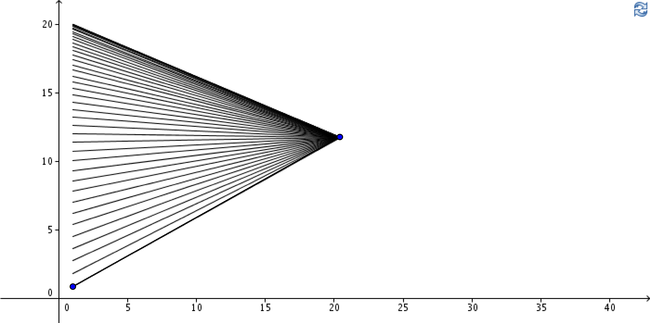
Notice that the spacing between these lines increases as the ball gets closer to the ground. This indicates that the rate that the ball is dropping at increases as it falls.
In this program, simulated time is held in the variable simulatedTime and it is initialized to 0 seconds. The variable dt stands for delta time and it holds how far into the future time will be moved during each iteration of the simulation loop (Note: delta stands for the Greek letterwhich is usually used to indicate a changing quantity in mathematics.) This variable is initialized to .01 which means that time will be moved into the future 1/100 of a second each time through the loop.
The variables x and y hold the position of the ball during the simulation. The variable y is initialized to 20 so that the ball is dropped from a height of 20 meters. The variable v holds the velocity of the ball and it is initialized to 0 because the ball isn't moving just before it is dropped. Finally, the variable g holds the acceleration of gravity on the Earth's surface and it is set to -9.8 meters/second^2. The value is negative to indicated that gravity accelerates objects down towards the ground.

How The Code y := y + v * dt Works
An especially important line of code in the above program is y := y + v * dt which calculates the new position of y for the next time increment dt. In order to understand how this code works, we need to revisit the slope = rise/run calculation. The following diagram shows the slope calculation being made for a rise of .2 and a run of .01:

But in our program we already know the slope of the distance vs. time function at time = 0 is 20 because the velocity of the ball at t = 0 is 20 meters/second. We also know that the run is .01 because this is what dt has been set to. What we need to determine is what the rise is and the formula for calculating this can be obtained by solving the slope = rise/run equation for rise:

In> Solve(slope == rise/run,rise)
Result: {rise==slope*run}

If you look at y := y + v * dt again, you should see that the rise in y is obtained by multiplying the slope at the current time by the run. This line of code calculates how far the height of the ball increases or decreases during the next time increment dt and then adds this value to the ball's current height. This technique is called Euler's (pronounced "oiler") method and more information can be found about it here (http://en.wikipedia.org/wiki/Euler_method).
Euler's method is a numerical method (as opposed to an analytic method) for approximating the value of a function. More exact approximations can be obtained using more sophisticated numerical methods (such as Runge-Kutta), but we are using Euler's method here because it is easy to understand.

How The Code v := v + g * dt Works
During each loop iteration in the simulation we also need to calculate the new velocity for the next time increment. Euler's method is used to make this calculation too, but in this case the rate of change of the velocity is used as the slope which is multiplied by dt. What is the rate of change of velocity? It is acceleration.
Going back to calculus, the rate of change of distance vs. time is velocity vs. time and the rate of change of velocity vs. time is acceleration vs. time. This acceleration can be calculated with MathPiper by starting with the distance vs. time function.
This code specifies the distance vs. time function:

In> f(x) := 20*x-9.8*x^2/2
Result: True

In> f(x)
Result: 20*x-(9.8*x^2)/2

We then take the derivative of this distance vs. time function to obtain the velocity vs. time function:

In> g(x) := Differentiate(x) f(x)
Result: True

In> g(x)
Result: 20-(19.6*x)/2

Finally, we take the derivative of the velocity vs. time function to obtain the acceleration vs. time function:

In> N( Differentiate(x) g(x) )
Result: -9.8

The acceleration vs. time function is a constant -9.8 meters/second^2 and it does not have an x variable because it does not change. This is the value that we initialized g to at the beginning of the program.

Throwing A Ball Vertically Into The Air With Gravity
The following program simulates the throwing of a ball vertically into the air in the Earth's gravitational field:

%mathpiper,title="Tossing a ball into the air with gravity."

simulatedTime := 0; //Simulated time in seconds.

dt := 0.01; //Delta t in seconds: the amount time changes in each loop iteration.

x := 1; //Set the horizontal position of the ball 1 meter to the right of 0.

y := 0; //Set the vertical position of the ball to 20 meters above the ground.

v := 20; //Set the initial velocity of the ball to 0 meters/second.

g := -9.8; //Set the acceleration of gravity to -9.8 meters per second.

Repeat()
[
GeoGebraPoint("Ball",x,y); //Plot the ball.

y := y + v * dt; //Calculate the new y position of the ball.

If(y <= 0, Break()); //If the ball hit the ground, end the program.

v := v + g * dt; //Calculate the new velocity of the ball.

simulatedTime := simulatedTime + dt; //Move simulated time ahead .01 seconds.

Delay(10); //.01 seconds.
];

Unbind(x);

%/mathpiper

This is the same program as the ball dropping program, except y has been initialized to 0 to start the ball on the ground and v has been initialized to 20 to give it a velocity of 20 meters/second at the moment it leaves the tips of the fingers of the person who is tossing it.

Throwing A Ball Horizontally With Gravity
The ball can not only be dropped and thrown into the air, it can also be thrown horizontally. The following program simulates the throwing of a ball horizontally in the Earth's gravitational field:

%mathpiper,title="Throwing a ball horizontally with gravity."

simulatedTime := 0; //Simulated time in seconds.

dt := 0.01; //Delta t in seconds: the amount time changes in each loop iteration.

x := 1; //Set the horizontal position of the ball 1 meter to the right of 0.

y := 0; //Set the vertical position of the ball to 20 meters above the ground.

v := 20; //Set the initial velocity of the ball to 0 meters/second.

g := -9.8; //Set the acceleration of gravity to -9.8 meters per second.

Repeat()
[
GeoGebraPoint("Ball",x,y); //Plot the ball.

y := y + v * dt; //Calculate the new y position of the ball.

x := x + 10*dt; //Move the ball to the right at 10 meters/second.

If(y < 0, Break()); //If the ball hit the ground, end the program.

v := v + g * dt; //Calculate the new velocity of the ball.

simulatedTime := simulatedTime + dt; //Move simulated time ahead .01 seconds.

Delay(10); //.01 seconds.
];

Unbind(x);

%/mathpiper

This program is the same as the ball tossing one, except that the ball has been given a horizontal velocity of 10 meters/second in the line of code v := x + 10*dt. When the ball is thrown, it follows the following path:

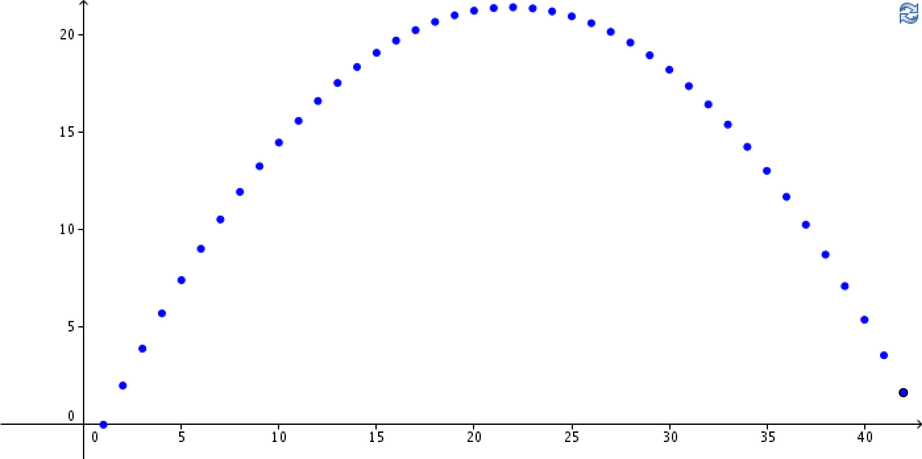

Exercises
For the following exercises, create a new MathPiperIDE worksheet file called book_2_section_11_exercises_<your first name>_<your last name>.mpw. (Note: there are no spaces in this file name). For example, John Smith's worksheet would be called:
book_2_section_11_exercises_john_smith.mpw.
After this worksheet has been created, place your answer for each exercise that requires a fold into its own fold in this worksheet. Place a title attribute in the start tag of each fold which indicates the exercise the fold contains the solution to. The folds you create should look similar to this one:

%mathpiper,title="Exercise 1"

//Sample fold.

%/mathpiper

If an exercise uses the MathPiper console instead of a fold, copy the work you did in the console into the worksheet so it can be saved.
In the falling programs, assume the balls are being tossed and dropped near the surface of the Earth.

Exercise 1
Create a program which will drop a ball from 15 meters and then have it bounce three times before finally settling on the ground. (Hint: when the ball reaches the ground, setting the ball's y position to a small positive value (such as .01) and the ball's velocity to a positive value (such as 4) will make it go back up again.)

Exercise 2
Create a program which will drop a ball from 15 meters and then have it bounce to lower and lower heights until it finally settles on the ground. (Hint: if you set the velocity of the ball to an increasingly smaller value each time it hits the ground, the height it will bounce to will be lower and lower. Adding a "bounce velocity" variable to the program, which can be used to set the ball's velocity for each bounce, is one option. The "bounce velocity" variable can be made smaller after each bounce by multiplying it by a value which is greater than 0 and less than 1. When the ball's bounce velocity has decreased to a specific low value, end the program.)

Exercise 3
Create a program which will drop two balls simultaneously from 15 meters and then have them bounce at lower and lower heights until finally settling on the ground. Each ball should have a different elasticity so that it bounces differently than the other one. Each ball should be given a unique horizontal position. (Hint: use the program from the previous exercise as a starting point.)

Exercise 4
Create a program which will drop 5 balls simultaneously from 15 meters and then have them bounce at lower and lower heights until finally settling on the ground. Each ball should have a randomly generated elasticity so it bounces differently than the other ones. Each ball should be given a unique horizontal position. (Hint: use the program from the previous exercise as a starting point.)

Exercise 5
Create a program that moves a simulated airplane across the drawing pad from left to right (use a point to simulate the plane). Have the plane drop a ball at a location which is around 1/3 of the length of its flight path and have the ball fall as a real ball would until it hits the ground.

Exercise 6
Create a program which will "throw" a ball horizontally from left to right across the drawing pad at a target which is on the ground. Use a point for the target and place the point a random distance from the ball that is being thrown. Use the AskUser() function to ask the user what horizontal and vertical velocity they want to give the ball when it is thrown. Run the program in a loop until the user quits the program.

Notes:
1) Sections 8 and/or 9 need to be expanded a bit to add around 20 minutes of lecture time.
2) Add a section on raw output.
3) Animate ball in section 11.

The idea for this explanation came from http://betterexplained.com
Resampling: The New Statistics Chapter 1 pp.26-27.
Ibid. pp.27.

