Patterns: The Fundamental "Stuff" Out Of Which Everything In The Universe Is Made
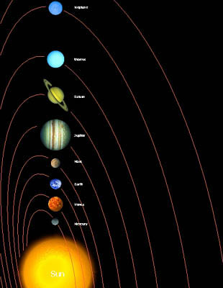


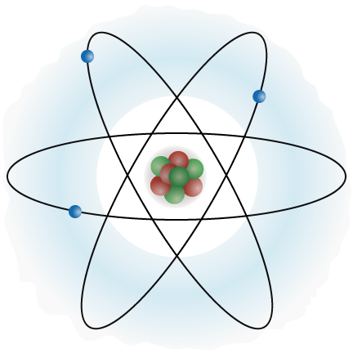

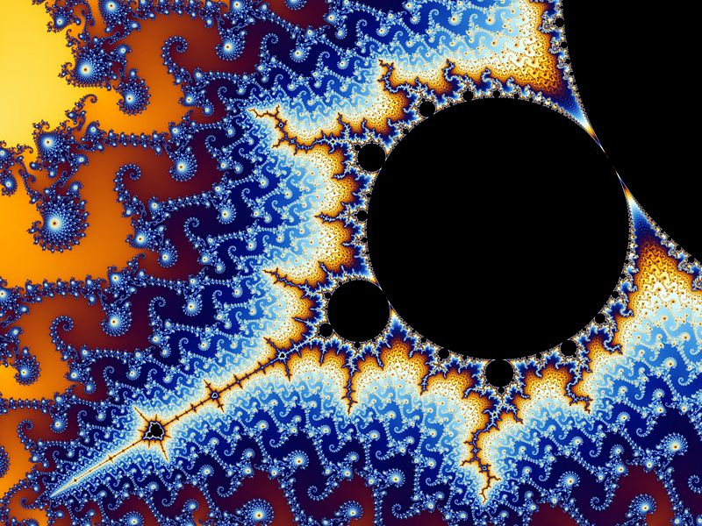




Science: A System For Discovering And Organizing Patterns
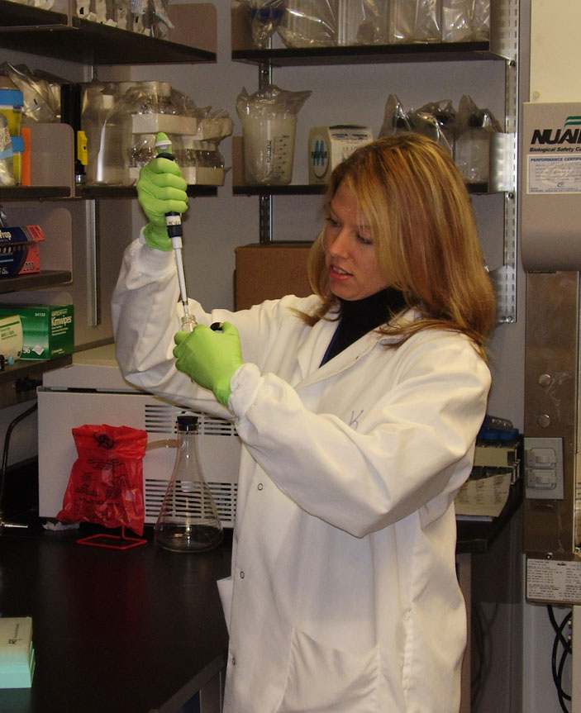

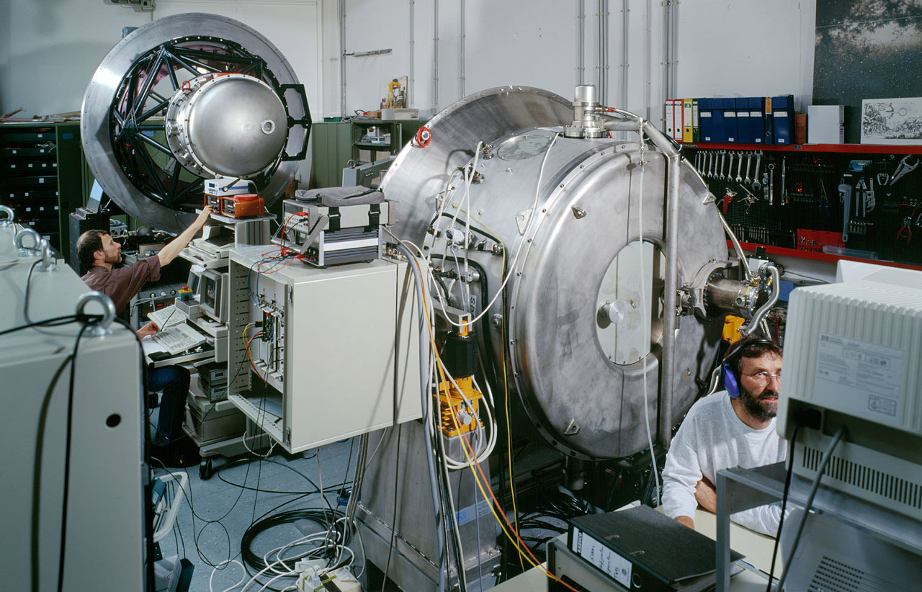

Mathematics: The Language Of Patterns
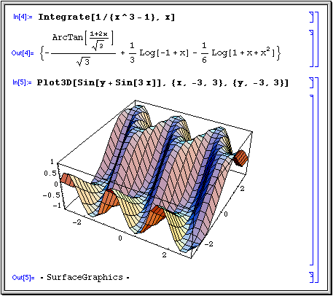
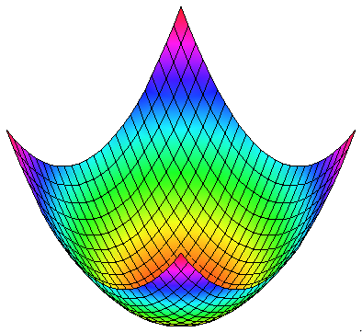
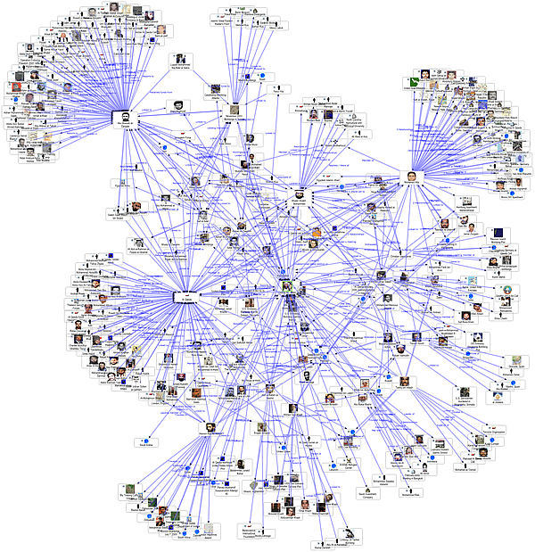

Engineering: Designing Things With Patterns
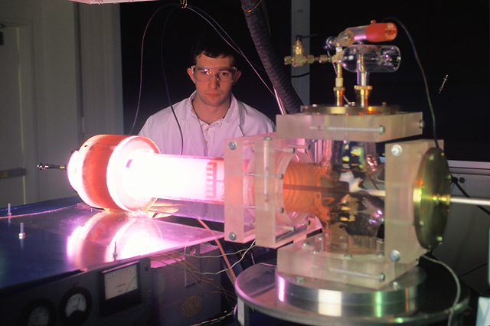
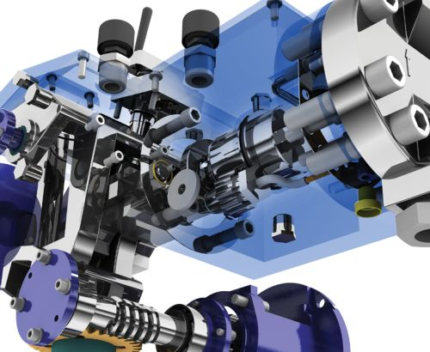
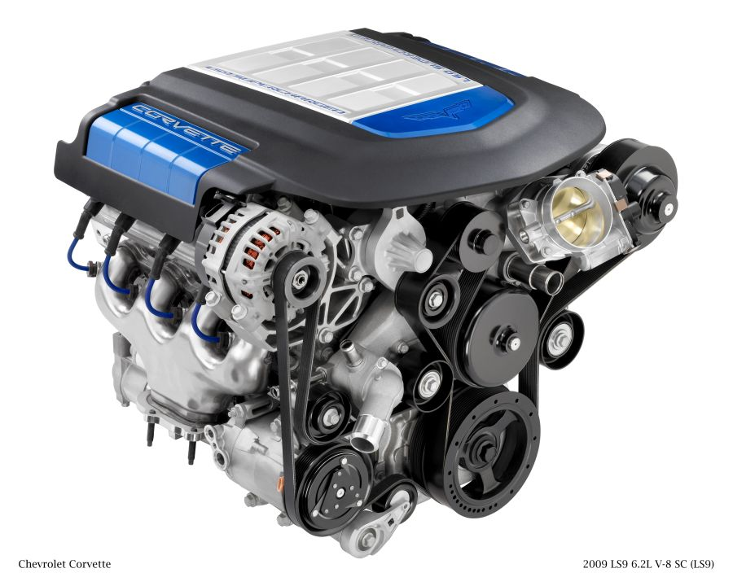
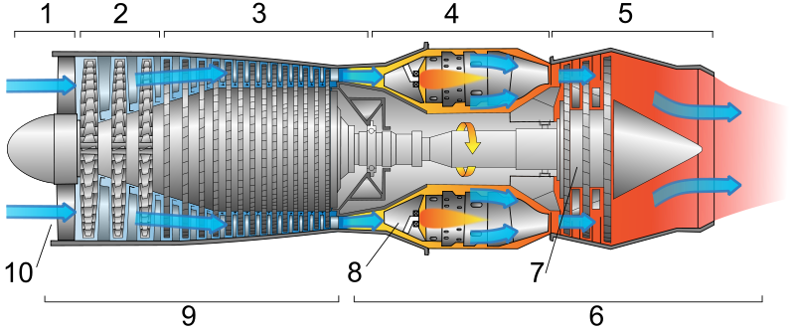
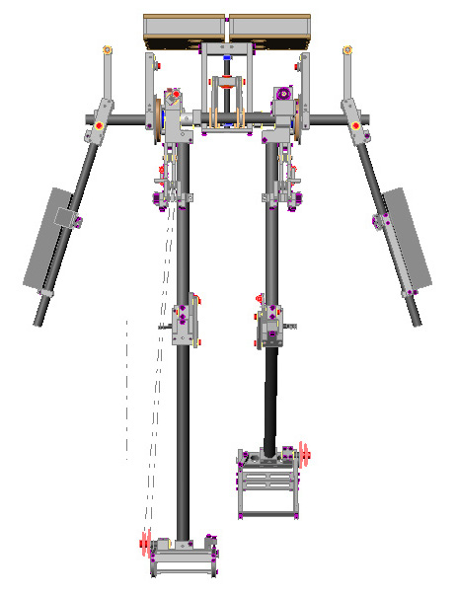

Technology: Making Things With Patterns
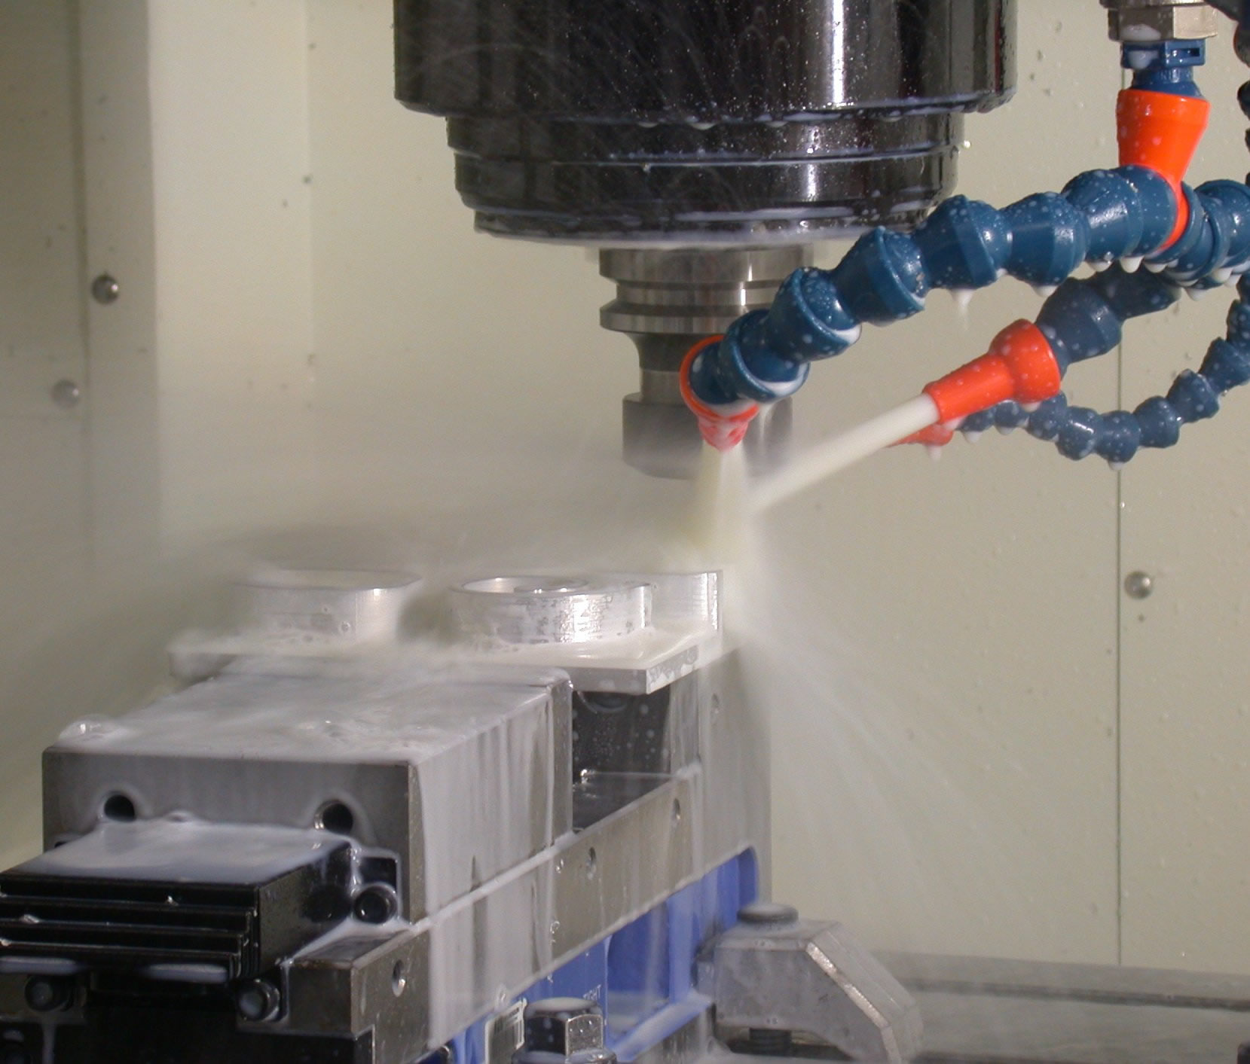
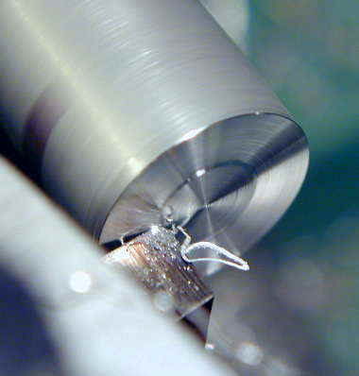

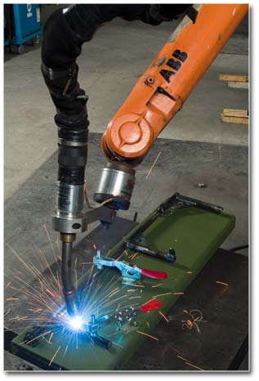
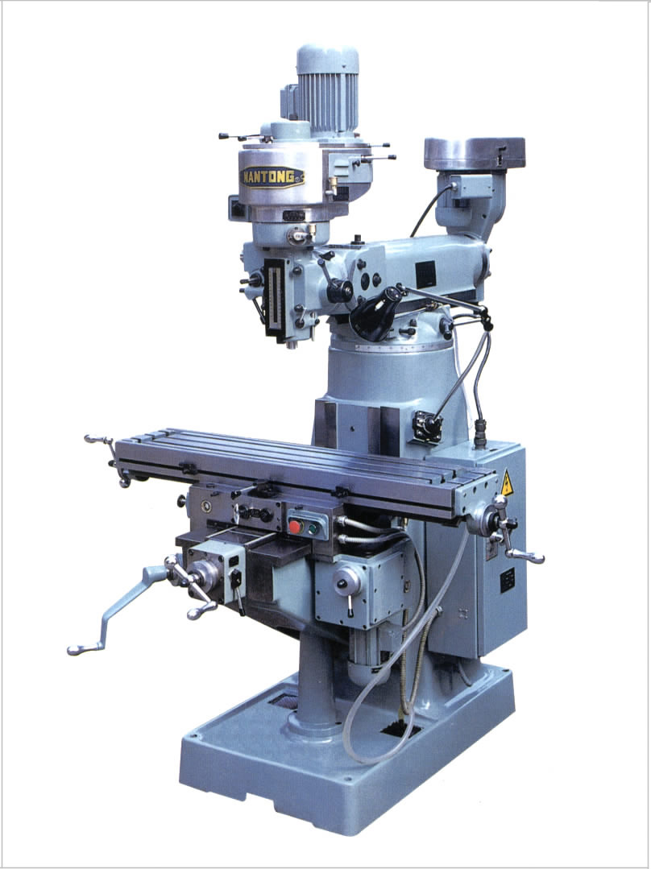

Tools For Analyzing And Manipulating Patterns
This sections contains images which show how the following levels of tools are used to manipulate patterns:

- Pencil marks on paper.
- Hand held calculator.
- Computer programming with loops.
- Computer programming with formulas/theorms.

The higher the level of the tool is, the more powerful it is for manipulating patterns.

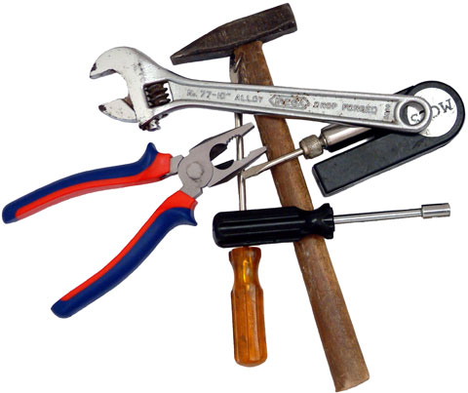

Pencil Marks On Paper = Walking




Hand Held Calculator = Automobile
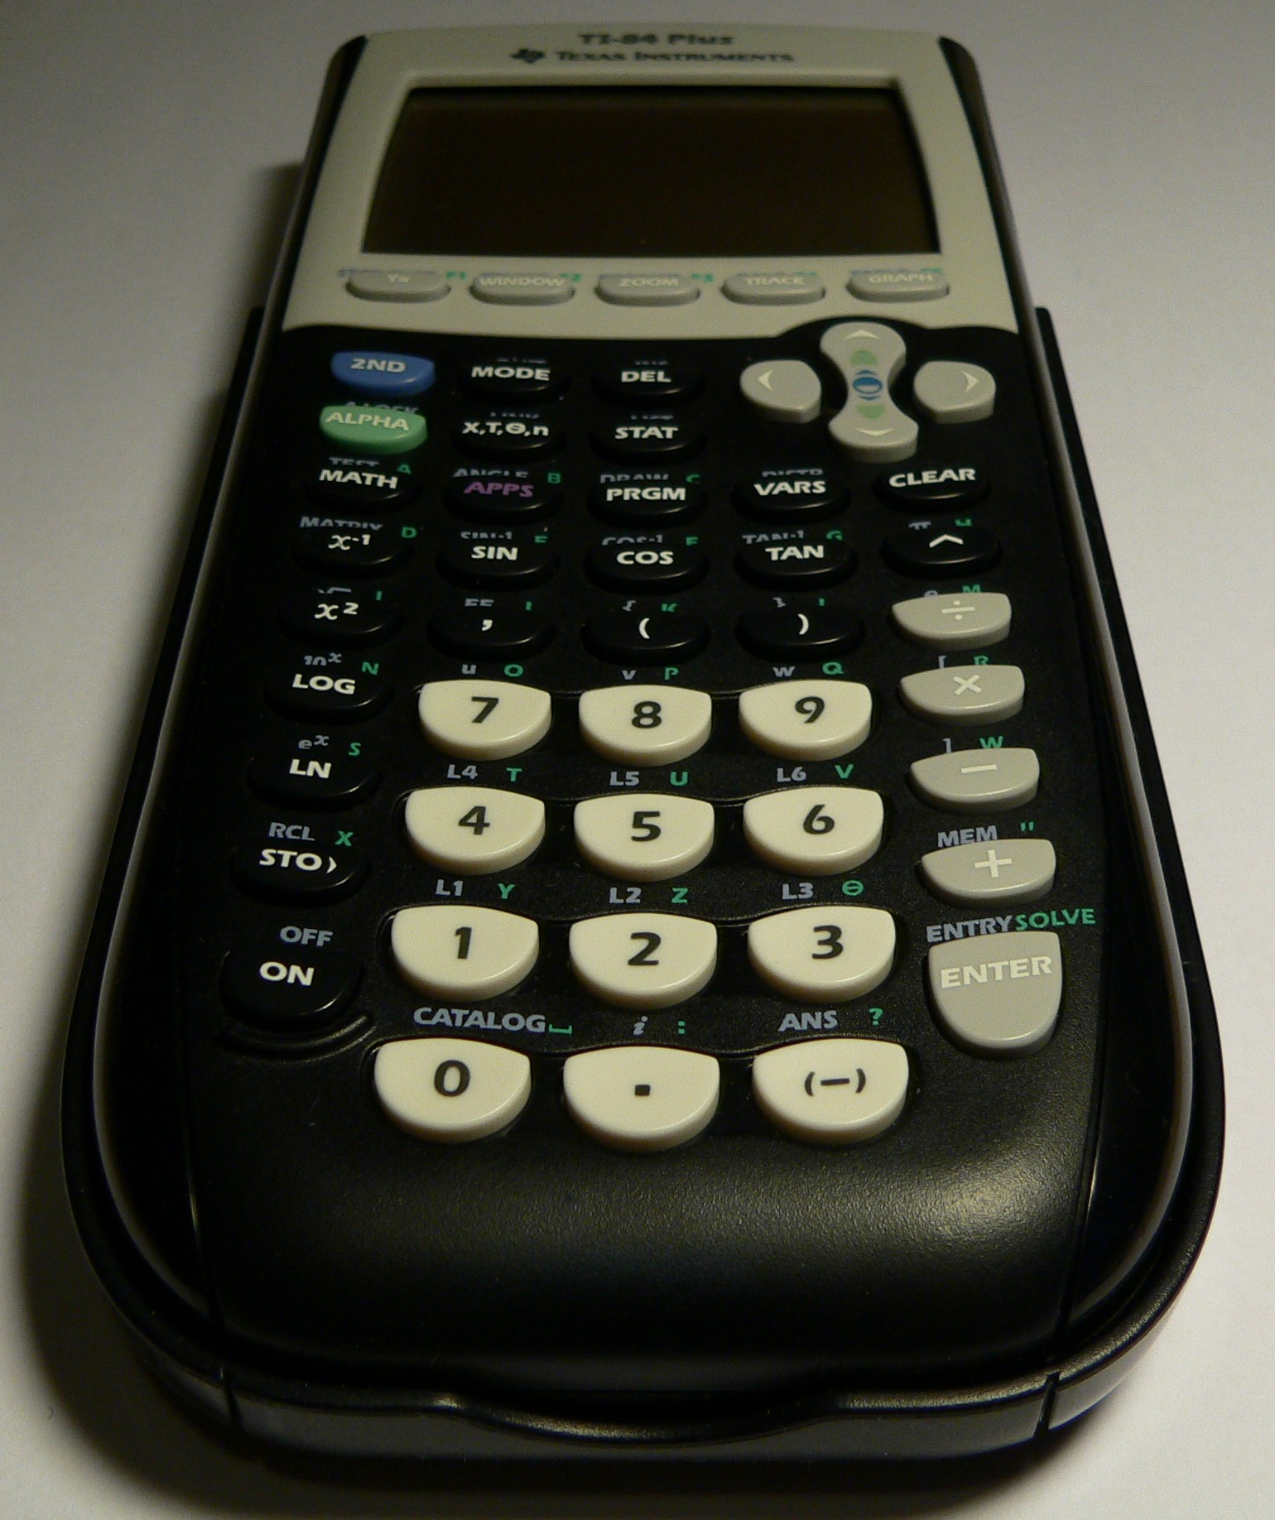



Computer Programming With Loops = Spacecraft
1:%mathpiper
2:
3://Print the odd integers from 1 to 99.
4:
5:x := 1;
6:
7:While(x <= 100)
8:[
9: Write(x);
10: x := x + 2; //Increment x by 2.
11:];
12:
13:%/mathpiper
14:
15: %output,preserve="false"
16: Result: True
17:
18: Side effects:
19: 1 3 5 7 9 11 13 15 17 19 21 23 25 27 29 31 33 35 37 39 41 43
45 47 49 51 53 55 57 59 61 63 65 67 69 71 73 75 77 79 81 83
85 87 89 91 93 95 97 99
20: %/output


Computer Programming With Formulas/Theorems = Spacecraft With Hyperdrive

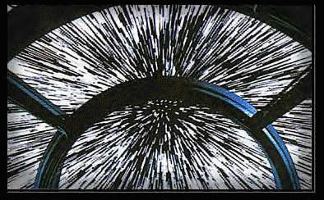

All STEM Areas Are Quickly Becoming Software Based
All the STEM areas are quickly becoming software based and here are some common examples:

If you are interested in having a career in a STEM-related area, one of the most useful skills you can obtain is mathematics-oriented computer programming. The rest of this book shows how mathematics-oriented computer programming can be used to explore the STEM disciplines.

