BPCDG: Breakpoint Climate Data Generator for WEPP
Using Observed Standard Weather Data Sets

Zeleke Gete, Thomas Winter, and Dennis Flanagan

Abstract

To test the overall performance of any new prediction tool, model parameters can be taken directly from observed data sets or generated using different interface mechanisms. This paper presents a relatively simple program, BPCDG (Breakpoint Climate Data Generator), which generates breakpoint climate data using observed standard weather data sets that can then be used as input for the Water Erosion Prediction Project (WEPP) model. Currently the CLIGEN model is used to generate daily climate input data for WEPP. However, CLIGEN itself requires specially formatted monthly statistical weather data as input, which are not readily available in many countries. In the context of this problem, BPCDG has many advantages. First, it allows direct use of observed storm and other daily standard climate data sets. Second, it is easy to apply, and the input files required can be created with any text editor. Third, it doesn’t confront a user with various statistical procedures for preparing input data sets for the model itself. Fourth, the input data can be found in any standard climate station and there is no need for special climate stations, such as the 15-minute precipitation recording stations in the US. The BPCDG model requires four input files that can be created by any text editor or can be updated from existing database systems. Procedures for model operation, input file preparation, and formatting mechanisms are described in this paper. Options for quantifying qualitatively observed data, error checking, and control mechanisms are also provided. The WEPP model was tested at Anjeni Research Unit, Ethiopia, and it performed very well using a climate file generated by BPCDG.

Keywords: Breakpoint climate data, weather data, WEPP, BPCDG, CLIGEN, erosion modeling, runoff, soil loss.

1. Introduction

One of the major constraints of process-based models is the difficulty of obtaining required data sets, both in terms of style and amount. Though this problem is rather universal, it is often serious in many parts of developing countries. With the advent of computer technologies, the new generation models are usually supplied with tools for creating the input files or data sets required by the model. For instance, CLIGEN (Nicks et al., 1995) is a stand-alone program that generates a climate-input file for the WEPP (Flanagan and Nearing, 1995) model, and that has a database of about 7000 stations within the United States. Since WEPP, CLIGEN, and the CLIGEN database were initially developed for application within the United States, obtaining the input files with the required parameters for CLIGEN for locations outside the US can be a serious problem. In many instances, direct use of measured climate data sets might be the best (or only) option, particularly for locations where long-term weather records are not available.

BPCDG, which is a stand-alone program, helps to create breakpoint climate data for WEPP from standard rain gauge data and other daily weather data sets of any meteorological station. The program was designed to use actual measured storm data rather than storm data generated by using different probability functions. Currently CLIGEN is used to generate daily climate data for WEPP, and provides storm intensity input assuming a storm with a single intensity peak and described by a double exponential function. CLIGEN requires long-term monthly statistical weather data parameters for each station, including mean, standard deviation, and skew coefficients of precipitation depth, wet day following a wet day and wet day following a dry day probabilities, mean maximum and minimum air temperatures, solar radiation, and wind speed and direction. Using these monthly statistical parameters, CLIGEN will generate a daily sequence of simulated representative weather for as many years as desired. However, Nicks et al. (1995) show that using generated intensity patterns as an input into WEPP only explained about 90% of the runoff computed using observed intensity patterns, which clearly indicates the advantage of using observed breakpoint storm input data.

Obtaining the required weather data statistics for CLIGEN in the US and other developed countries may not be very difficult. However, obtaining such data sets in many developing countries can be extremely difficult or impossible. For instance, to calculate storm shape, a ‘time to peak’ parameter is required. This parameter can be found easily if there are 15-minute recording stations, which are simply not available in many countries. In light of these problems, BPCDG has several advantages. First, it allows the use of observed storm and other daily climate data sets. Second, it is easy to apply and the input files required can be created with any text editor (details will be given in the following sections). Third, it doesn’t confront the user with various statistical procedures for preparing input data sets for the model itself. Fourth, the input data can be found at any standard climate station, and there is no need for special information, such as from the 15-minute rainfall data recording stations in the US.

WEPP was designed to accept two different kinds of climate input files, standard CLIGEN format (assuming a double-exponential function shaped storm) and breakpoint data. However, in the WEPP Users Summary, Flanagan and Livingston (1995) note that ‘those users wishing to use breakpoint rainfall as input to WEPP will need to create their climate files by hand’. This is not a simple task. Between 2800 and 3000 breakpoint storm data sets and about 2200 other daily values have to be manipulated by hand for each year (an example from our case study area). Besides the time and expense involved, data accuracy must be controlled, which is a problem for such huge data sets. The BPCDG program solves these problems, and the process is now automated. It also provides an option for checking errors in the data set. In many climate stations in developing countries, information especially related to wind direction and speed is not available. BPCDG helps to quantify qualitatively observed wind data using conversion tables. BPCDG is also Y2K compliant; it handles four digit integer values for the year. WEPP was tested using data generated by BPCDG for the Anjeni Research Unit, Gojam, Ethiopia, and it performed very well.

The main purpose of this paper is to focus on generating breakpoint climate input files for WEPP from observed weather data sets in an easy-to-use system. This document provides information about the type of input files required for BPCDG, how to create the input files, how to run the BPCDG model, and how to check errors in the data set. In addition to this, sample-input files, an output file, a sample of intermediate files created for error control purposes, and a summary of outputs from WEPP, using breakpoint climate data generated by BPCDG, are also provided.

2. Description of input files

The BPCDG program requires four input files. The first file (xxyyyyPL.CSV) contains information on the rainfall (storm) pattern. It provides information about day and month of the year, beginning and ending time of the storm, and the intensity of the storm on a specific day. The second file (xxyyyyCS.CSV) contains date, daily minimum and maximum temperatures, and wind velocity and direction at 8 and 18 hours. The third file (xxyyyyCL.DAT) contains Julian day, radiation (monthly or annual), dew point temperature (monthly or annual), and conversion tables for wind velocity and direction. The fourth file (xxyyyyST.DAT) contains the station name, location, elevation, and years of record information. In all file names ‘xx’ is a two-letter code for the station name and ‘yyyy’ indicates the year when climate data were compiled. For instance, AJ1998PL.CSV represents the climate file for Anjeni climate station, for data collected in 1998.

3. Procedures for creating and formatting input files

All input files can be created in any text editor. It is advisable for those users whose files are in Dbase, and/or in any spreadsheet formats, to follow the procedures mentioned below. However, other quick methods may be used, provided that the file formats are kept similar, as described below.

3.1. Rainfall data input file (xxyyyyPL.CSV)

This is the largest input file to BPCDG, and contains rainfall data recorded by a weather station rain gauge and converted into digital format from the automatic rain gauge chart roll. The chart roll can be analyzed to fit certain requirements, but in our case rainfall amounts with equal intensities were considered as one storm, with beginning and ending hours recorded for each interval in the day (see Table 1 and 2). This file can be created by any text editor or spreadsheet, and/or in Dbase. If the file is created in Dbase (which is the usual case), or in any spreadsheet, it is advisable to use the following procedures.

- Open the file in Microsoft EXCEL, remove data columns that are not required, and save it as xxyyyyPL.CSV. This option in EXCEL allows easy manipulation of the data in any text editor without losing any value or function.
- Open this file in any text editor and use the ”replace” function to change characters created during conversion and substitute characters or symbols required by the model format (see Table 1 and Table 2).
- When the format is finished, save the file with the same name and close the file.

If the file was created or has to be created with a text editor, format the file as indicated in Table 2 and save it as xxyyyyPL.CSV.

Please note that it is very important that the final rainfall input data file must have a format similar to that presented in Table 2. It is essential to note that the BPCDG model recognizes every space; leaving an empty space before the numbers or symbols will produce erroneous results. The model recognizes the position of each data set. The symbols in the file, i.e. semicolons and dots, should not be interchanged or replaced by other symbols.

Table 1. An example of the BPCDG rainfall input data file created by Dbase, opened in EXCEL and saved as xxyyyyPL.CSV, when viewed with a text editor.

CONTROLVAR,DATE,START,END,AMOUNT,INTENSITY
Y,16/01/92,19.59,20.06,1.0,8.6
Y,16/01/92,20.06,20.30,0.6,1.5
Y,21/01/92,18.24,18.40,0.2,0.8
Y,22/01/92,17.09,17.18,1.4,9.3
Y,02/02/92,12.42,12.47,0.3,3.6
Y,02/02/92,12.47,12.51,0.8,12.0
Y,02/02/92,12.51,12.55,0.4,6.0
Y,22/02/92,20.21,20.27,0.3,3.0
Y,22/02/92,20.27,20.30,0.1,2.0
Y,06/03/92,19.35,19.39,0.5,7.5
Y,06/03/92,19.48,19.54,0.6,6.0
Y,06/03/92,19.54,19.59,0.1,1.2
Y,06/03/92,19.59,20.05,0.1,1.0

Note: Some of the symbols seen in the table might not appear if EXCEL or another spreadsheet program previously created the file. Values of each column (separated with comma) are control variable, date, beginning time of a storm(h), end time(h), rainfall amount(mm) and intensity(mm·h⁻¹) respectively.

Table 2. An example of the final BPCDG rainfall input data file format, xxyyyyPL.CSV.

CONTROLVAR;DATE;START;END;AMOUNT;INTENSITY
Y;16.01.1992;19.59;20.06;1.0;8.6
Y;16.01.1992;20.06;20.30;0.6;1.5
Y;21.01.1992;18.24;18.40;0.2;0.8
Y;22.01.1992;17.09;17.18;1.4;9.3
Y;02.02.1992;12.42;12.47;0.3;3.6
Y;02.02.1992;12.47;12.51;0.8;12.0
Y;02.02.1992;12.51;12.55;0.4;6.0
Y;22.02.1992;20.21;20.27;0.3;3.0
Y;22.02.1992;20.27;20.30;0.1;2.0
Y;06.03.1992;19.35;19.39;0.5;7.5
Y;06.03.1992;19.48;19.54;0.6;6.0
Y;06.03.1992;19.54;19.59;0.1;1.2
Y;06.03.1992;19.59;20.05;0.1;1.0

Note: Some of the symbols seen in Table 1 are changed, comma (,) with semicolon (;) and slash (/) with dot (.). Values of each column are similar to Table 1 except column separator is changed to semicolon.

3.2. Temperature and wind data input file (xxyyyyCS.CSV)

This file contains daily values for minimum and maximum temperatures and qualitatively observed wind velocity and direction at 8 and 18 hours of the day. The qualitative data sets were preferred for the reason that quantified data sets on wind velocity and direction are scarce in many places. This file can also be created in any text editor, spreadsheet and/or Dbase, similar to the rainfall data input (Section 3.1). If the file was created in Dbase, follow the procedures indicated in section 3.1 above (see also Table 3 and 4). As indicated in Table 4, the first, fifth and sixth columns can be filled with zeros, dashes or characters like ‘Y’, but should not be left empty.

Columns eight and ten, which represent wind direction at 8 and 18 hours respectively, can be left empty if data are not available for that particular day or observation time. However, if all are left empty throughout the year, then the wind velocity column in the output will be occupied by zeroes and it will affect the model output of WEPP. All wind velocity or strength columns (nine and eleven) must be filled with characters, as indicated in Table 4.

Users who have quantified data for wind direction and velocity can replace the values in the final output by hand (the output file, xxyyyy.CLI, can be opened in any text editor). In this case, open the original file in EXCEL before it is saved as xxyyyyCS.CSV, and fill the four columns (8, 9, 10, and 11) with ‘n’ (using copy, block and paste command). Then follow the procedures listed above.

Table 3. An example of the BPCDG temperature and wind input data file created by Dbase, opened in EXCEL and saved as xxyyyyCS.CSV, when viewed with a text editor.

DATE,AIRMIN,AIRMAX,CONTROLVAR(YYY),WINDDIR08,WINDSTR08,WINDDIR18,WIMDSTR18
Y,01/01/92,2,23,Y,Y,Y,,n,w,w
Y,02/01/92,4,25,Y,Y,Y,ne,w,sw,v
Y,03/01/92,3,23,Y,Y,Y,ne,w,wsw,w
Y,04/01/92,4,23,Y,Y,Y,,n,w,w
Y,05/01/92,4,22,Y,Y,Y,,n,sw,v
Y,06/01/92,5,22,Y,Y,Y,,n,w,m
Y,07/01/92,6,22,Y,Y,Y,e,w,wsw,w
Y,08/01/92,7,23,Y,Y,Y,,n,ene,w
Y,09/01/92,7,21,Y,Y,Y,,n,w,w

Note: Some of the symbols seen on the table might not appear if EXCEL or another spreadsheet program previously created the file. Values of each column (separated with comma) are control variable (Y), date, minimum daily temperature(ºC), maximum daily temperature(ºC), control variable (Y,Y,Y), wind direction at 08 hours, wind velocity at 08 hours, and wind direction and velocity at 18 hours of the day respectively

Table 4. An example of the final BPCDG temperature and wind input data file format (xxyyyyCS.CSV).

DATE;AIRMIN;AIRMAX;CONTROLVAR(YYY);WINDDIR08;WINDSTR08;WINDDIR18;WIMDSTR18
-;01.01.1992;2;23;-;-;-;;n;w;w
Y;02.01.1992;4;25;Y;Y;Y;ne;w;sw;v
Y;03.01.1992;3;23;Y;Y;Y;ne;w;wsw;w
Y;04.01.1992;4;23;Y;Y;Y;;n;w;w
Y;05.01.1992;4;22;Y;Y;Y;;n;sw;v
Y;06.01.1992;5;22;Y;Y;Y;;n;w;m
Y;07.01.1992;6;22;Y;Y;Y;e;w;wsw;w
Y;08.01.1992;7;23;Y;Y;Y;;n;ene;w
Y;09.01.1992;7;21;Y;Y;Y;;n;w;w

Notes: It is very important to note the position of each character and symbol. As indicated on the first line, ‘Y’ and other numbers which are not needed by the model can be replaced by a dash (‘-’). This is to indicate possible options. However, this position should not be left empty. Some of the symbols seen in Table 3 are changed, comma (,) with semicolon (;) and slash (/) with dot (.). Values of each column are similar to Table 3 except column separator is changed to semicolon.

3.3. Wind tables, radiation, and dew point temperature data input file (xxyyyyCL.DAT)

This file is divided into four sections. The first two sections contain wind velocity and direction conversion tables, the third and fourth sections contain daily values of radiation and dew point temperature, respectively (see Table 5). The header number for radiation and dew point temperature can be 12 (if monthly values are used), 365 (normal years), or 366 (for leap year).

It is very important that the position of header words (WIND, WINDDIR, RADIATION and DEW POINT T.) and numbers (5, 16, 366) for each section, as well as the format of the file itself be similar to Table 5.
Table 5. An example of the wind tables, radiation, and dew point temperature data input file format, showing the four parts of xxyyyyCL.DAT.

WIND[m/s] 5
n : 0.0
w : 1.5
m : 3.0
s : 6.5
v : 8.0

WINDDIR[o] 16
n : 0
nne: 22.5
ne : 45
ene: 67.5
e : 90
ese: 112.5
se : 135
sse: 157.5
s : 180
ssw: 202.5
sw : 225
wsw: 247.5
w : 270
wnw: 292.5
nw : 315
nnw: 337.5

RADIATION 366 12 for monthly values or 365/366 for daily values
1 : 542.99
2 : 539.66
3 : 532.99
4 : 536.99
5 : 532.99
.

DEW POINT T. 366 12 for monthly values or 365/366 for daily values
1 : 12.1
2 : 11.1
3 : 12.0
4 : 13.6
5 : 13.3
.
Notes: The BPCDG model recognizes the header words (block letters) and numbers (bold numbers), including their position in the line. It is very important to keep the first line and other values in each section in the same position, as indicated in the table below. The horizontal lines in the box are used to separate the sections; they do not belong in the file format. Cursor position for the first digit of header number is 15. Nothing should be added between position 15 and 20 except the numbers. Units for radiation and dew point temperature are Langleys and degrees Centigrade, respectively.

The BPCDG model gives erroneous results or a warning if one of the following is forgotten during leap years: header number 366 and February with 28 days, or header number 365 and February with 29 days. So it is essential to check whether these two values match. The same happens if the header words change position or are not in the format as indicated on Table 5.

The following are the procedures for creating the file.

- It can be created by any text editor and saved as xxyyyyCL.DAT
- If the data are analyzed (radiation and dew point temperature) in EXCEL:
- Create the first two sections in a text editor (wind conversion tables)
- Open the file (which contains radiation and dew point temperature) in EXCEL and copy the values
- Paste the values in their appropriate positions in the file where the first two sections were created in the text editor, format the file as indicated in Table 5, and save it as xxyyyyCL.DAT.

The letters in the wind velocity conversion table are ”n” (none), ”w”(weak), ”m” (moderate), ”s” (strong), and ”v” (very strong), after Hurni (1982). The letters in the wind direction conversion table are universal directions i.e. ”n” (North), ”s” (South), ”e” (East) and ”w” (West).

3.4. Station data input file (xxyyyyST.DAT)

The BPCDG station data input file contains information on the station name, latitude, longitude, elevation, years of record, and observed/simulation year. This information is used directly to create the top header information in the final climate BPCDG output that is used as input to the WEPP model. Format for this file is shown in Table 6. This table can be created by any text editor and has to be saved as xxyyyyST.DAT. The model recognizes the position of header words (block letters) and the first digit of numbers on line one and three in Table 6. For instance, the last number representing years simulated could be 200, but ”2” should keep its position.

Table 6. An example of a station data input file (xxyyyyST.DAT).

STATION NAME Station: Anjeni/Ethiopia
(Latitude, Longitude, Elevation, Observation Years, Beg. Year, Years Simulated)
LOCATION 37.31 10.40 2405 14 1992 1

Note: Lines 2 and 3 shown in the table are only a single line in the normal input file (wrapped). Cursor positions for the first digit of numbers are 11, 20, 32, 41, 50 and 60 respectively.

4. Procedures for model simulation

It is possible to run the BPCDG model in MS-DOS, MS-Windows and Windows NT4 mode. The following are the procedures to be followed:

- The four input files and the executable program code must be in the same directory

- Go to the directory and type ”BPCDG”, then press the return key (in MS-DOS) or highlight BPCDG.EXE and press the return key (in Windows Explorer or Norton Commander). The BPCDG program will start automatically and an interactive window will be displayed.

- You will be asked to give the name of the climate station. You should enter only two letters, consistent with the other input files, i.e. ‘xx’, and press the return key.

- You will again be asked to specify the simulation year. Here, give the four-digit ‘yyyy’ values of the input files and press the return key. The model starts processing the data, and if everything is correct, the process is normally complete in 30 to 40 seconds. Besides the output file, BPCDG creates two intermediate files (xxyyyyPL.CTL and xxyyyyCS.CTL) and one error-indicating file (xxyyyy.ERR). The first two files are used by the model to sort the data, but can also be used by the user to check errors in the data set (see also section 5 below).

- If the BPCDG model detects an error in the data set, it gives a warning message and the process terminates within 10 to 15 seconds. Depending on the error type, the above-mentioned intermediate files may be fully or partially created.

- BPCDG was designed to fit model requirements for WEPP. Existing versions of WEPP do not support more than 50 breakpoints per day. When BPCDG detects more than 50 breakpoints in the xxyyyyPL.CSV file, the model produces a message ‘more than 50 breakpoints detected on day dash’, for instance, 27.08.92. The same warning message will also be left on xxyyyy.ERR file (see Table 10). The model screens the data in their sequential order and gives this warning the moment it encounters the above-mentioned problem. The WEPP climate input file (xxyyyy.CLI) is still created, but the user will need to adjust the input data on the day(s) having more than 50 breakpoints to a maximum of 50.

- If it is necessary to adjust the data into 50 breakpoints, edit the WEPP climate file (xxyyyy.CLI) and merge points having small intensities, especially those with few time gaps. Future enhanced versions of BPCDG may have additional logic that will be able to further process the data and automatically reduce the number of breakpoints to a maximum of 50.

5. The BPCDG output file: style and basic processes (xxyyyy.CLI)

The BPCDG model is designed to produce an output file with a format accepted by WEPP. It checks the data, and as long as there is no rainfall on that particular day, it enters a zero for the number of breakpoints and writes other data in the correct position. When BPCDG encounters a day with rainfall, it first starts sorting out time and cumulative rainfall, using the disaggregation method mentioned in Nicks et al. (1995), then counts the number of breakpoints. If the number of breakpoints are greater than 50, an error message is displayed and also placed in the xxyyyy.ERR file. When the rain stops for a while and then starts again, the cumulative rainfall amount for the first period will be considered as the starting point for the next time gap. For instance, on day 06 03 1992 in Table 7 below, the second storm starts at 19:48 and the model takes the cumulative rainfall amount from the first rainfall event, which was finished at 19:39. When the model finishes sorting the whole data set, it calculates average monthly values and finalizes the process.

Table 7. An example of a portion of a WEPP breakpoint climate file generated by BPCDG.
0.00
1 1 0
Station: Anjeni/Ethiopia
Latitude Longitude Elevation (m) Obs. Years Beginning year Years simulated
37.31 10.40 2405 14 1992 1
Observed monthly ave max temperature (C)
23.3 24.8 25.8 25.1 23.7 21.2 18.7 18.2 19.8 19.8 20.7 22.8
Observed monthly ave min temperature (C)
6.6 7.2 10.0 10.9 11.7 10.9 10.2 10.7 9.3 9.6 7.3 7.3
Observed monthly ave solar radiation (Langleys)
494.5 506.2 523.8 507.8 489.1 415.0 325.3 287.9 401.2 396.5 386.9 441.1
Observed monthly ave rainfall (mm)
2.2 1.9 49.3 123.2 92.0 302.9 279.6 403.9 205.4 215.0 39.0 54.8
day mon year nbrkpt tmax tmin rad w-vel w-dir dew
(mm) (C) (C) (ly/day) m/sec deg (C)
1 1 1992 0 23.00 2.00 543.0 0.75 270.0 12.1
2 1 1992 0 25.00 4.00 539.7 4.75 45.0 11.1
20 1 1992 0 24.00 6.00 518.0 0.75 270.0 12.8
2 2 1992 4 21.00 10.00 570.2 2.25 90.0 13.3
12.42 0.000
12.47 0.300
12.51 1.100
12.55 1.500
3 2 1992 0 24.00 7.00 543.0 0.75 315.0 13.5
6 3 1992 8 26.00 8.00 585.9 4.00 67.5 15.7
19.35 0.000
19.39 0.500
19.48 0.500
19.54 1.100
19.59 1.200
20.05 1.300
20.09 1.400
20.14 1.500
12 3 1992 10 28.00 9.00 419.3 4.00 45.0 15.6

Note: Table does not display all simulation days present in actual WEPP input file. Many days with no rainfall are not displayed.

6. Options for error checking

The model creates three intermediate files to help users identify errors and to allow for easy checking of their data sets. The first two files, xxyyyyCS.CTL (Table 8) and xxyyyyPL.CTL (Table 9), are also used by the BPCDG model itself. If errors are undetected by the model, for instance, the beginning and ending times of the rainfall and its amount can be very easily checked by making use of the control files. The xxyyyy.ERR (Table 10) file is created immediately after simulation starts, and if the model detects an error in the data set, besides the message on the interactive window, it leaves a message in this file about where or in which file the error was detected. BPCDG creates this file even if the simulation task is successful. In this case, the message shows the header numbers used for radiation and dew point temperature (Table 5) to compare with days of the year. It also indicates whether the year is a leap year or not. BPCDG controls the cumulative annual rainfall amount two times, first immediately after it creates xxyyyyPL.CTL file and second, after the output file is created. This message is left to the user as initial control and final control on xxyyyy.ERR file. If these two values are different and incorrect, then the data need to be checked again. A warning message is also left on this file if the model detects more than 50 breakpoints for a particular day (see Table 10)

When the model stops processing due to error conditions, check these files (if they are entirely or partially created). It is also important to check these files even if the data processing is completed successfully. You can delete these files afterwards to save disk space. There might also be a need to change some values in the data set after the simulation process is successfully completed. In this case it is possible to change values on the input files and run the model without deleting the previous output and intermediate files. The model will overwrite them.

Table 8. An example of the control file used to check the rainfall patterns, xxyyyyPL.CTL.

16.01.1992 20.06 20.30 0.6
21.01.1992 18.24 18.40 0.2
22.01.1992 17.09 17.18 1.4
02.02.1992 12.42 12.47 0.3
02.02.1992 12.47 12.51 0.8
02.02.1992 12.51 12.55 0.4
22.02.1992 20.21 20.27 0.3
22.02.1992 20.27 20.30 0.1
06.03.1992 19.35 19.39 0.5
06.03.1992 19.48 19.54 0.6
06.03.1992 19.54 19.59 0.1

Note: Variables in the file by column are date, start time (h) , end time (h), and precipitation depth (mm), respectively.

Table 9. An example of a file used to control other weather data sets, xxyyyyCS.CTL

01.01.1992 2 23 n w w
02.01.1992 4 25 ne w sw v
03.01.1992 3 23 ne w wsw w
04.01.1992 4 23 n w w
05.01.1992 4 22 n sw v
06.01.1992 5 22 n w m
07.01.1992 6 22 e w wsw w
08.01.1992 7 23 n ene w

Note: Variables in the file by columns are date, minimum and maximum air temperatures (ºC), wind direction and velocity at 08 hours, and wind direction and velocity at 18 hours, respectively.

Table 10. An example of the error-controlling file, xxyyyy.ERR.

aj1992cs.csv
The two rows below control the header for Radiation
and Dew point temperature for the days of the year.
366 366
366 366
aj1992pl.csv
Initial control for annual rainfall: 1790.90
More than 50 breakpoints on:28.07.1992
More than 50 breakpoints on:20.08.1992
Final control for annual rainfall : 1790.90

Note: The header numbers for radiation and dew point temperature, number of days in the year, the annual rainfall amount, and warning messages, if any, are indicated after successful data processing. BPCDG controls annual rainfall before it starts data processing, gives a warning message when it encounters errors while processing, and makes a final control of the annual rainfall before it closes the output file.

7. Hardware and set-up requirements

This version of BPCDG (v3.98) is designed to run on IBM and IBM-compatible Personal Computers (PCs) under the MS DOS, Windows 95/98 and Windows NT4 platforms. In order to run the model successfully, your computer needs to have at least an 80386 CPU, along with a math coprocessor and a minimum of 5MB of hard drive free space. It is worth noting that under the Windows NT4 operating system, the interactive window of the current version of BPCDG is automatically closed after data processing is finished and it is hard to read error messages on the screen. In this case, the user is advised to check control files.

The latest version of the BPCDG software can be obtained from the WEPP internet site (http://topsoil.nserl.purdue.edu/weppmain/wepp.html), which currently contains a simple installation file called BPINSTAL.EXE, a self-extracting archive that contains the BPCDG executable program, model documentation and sample input and output files. Create a directory (preferably BPCDG), copy BPINSTAL.EXE to it, then execute the installation program. This will automatically install the BPCDG program and all necessary files. The user must be sure that new data sets to be processed are in the same directory where the executable program is located.

8. Summary of WEPP simulation results

Hillslope applications of the WEPP (v98.4) model were made on a traditionally cropped plot (TP2) in the Anjeni Research Unit, Gojam, Ethiopia. A breakpoint climate input file was prepared using the BPCDG program. The WEPP management input file was prepared based on local conditions. Soil parameters were generated using transfer functions suggested in Flanagan and Nearing (1995) and soil survey database of the area. The time series analysis of runoff curves shows that simulated values fit very well with measured values. After some suspected error data sets were removed, the coefficients of determination (r²) between model-predicted and measured runoff and soil loss on a daily basis were 0.58 and 0.82, respectively. The Nash-Sutcliffe model efficiency is usually preferable to the coefficient of determination to check the predictive capacity of models, (Nash and Sutcliffe, 1970; Risse et al., 1994, 1995; and Baffaut et al., 1998). The model efficiency compares the prediction to the 1:1 line rather than the regression line of the points, and values of model efficiency greater than zero (to a maximum of 1.0) indicate that the model tested performs satisfactorily. In this study the calculated model efficiencies for runoff and soil loss prediction were 0.51 and 0.75 respectively, indicating in general satisfactory predictions by the WEPP model.

WEPP overpredicted runoff to some extent for many storms in this study, especially for smaller events and during the beginning of the rainy season. Runoff for medium and extreme events was slightly underpredicted. Likewise, WEPP slightly overpredicts soil loss for smaller and extreme events. It tends to underpredict soil loss for medium events, (Figures 1 and 2). Similar trends were also observed at other sites (Gete, Z., 1999, forthcoming). Some of the disparities between measured and simulated values may come from two sources. First, measurement procedures and errors in the empirical data sets could exist, as many events had data added based upon unreplicated measurements, and sometimes inflow of runoff into plots occurred during large events. Second, biases in some of the sub-modules in the WEPP model, especially those related to runoff, are expected to be a source of errors. Improving the various transfer functions used to generate input parameters based on local conditions, error screening, and model calibration mechanisms could potentially further improve the performance of the WEPP model. However, these results show that the BPCDG model is a good tool for direct use of observed climate data sets in WEPP in the future.

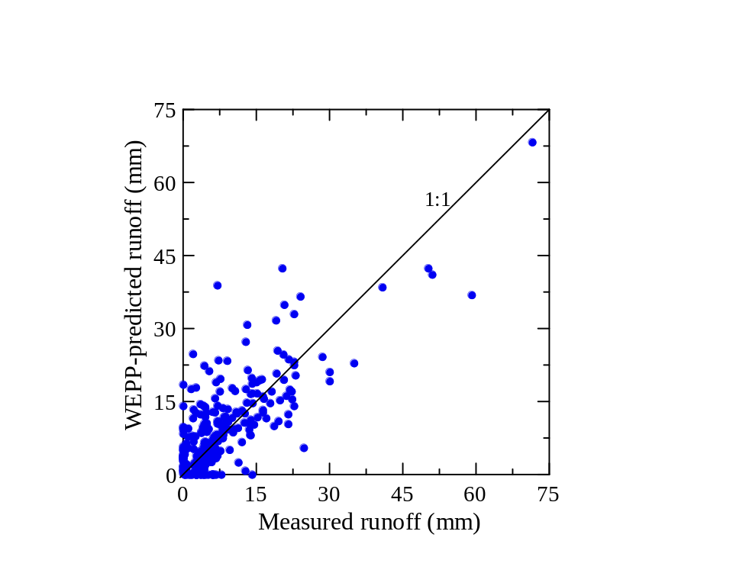
Figure 1. WEPP-predicted daily runoff compared with observed runoff, using climate data generated by BPCDG for a traditionally cultivated plot (TP2) in Anjeni Research Unit, Gojam, Ethiopia (r² = 0.58, ME = 0.51, and n = 256).

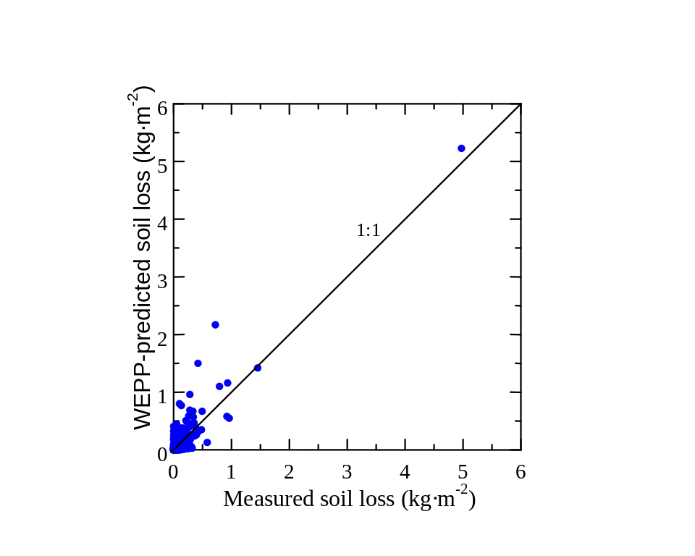

Figure 2. WEPP-predicted daily soil loss compared with measured soil loss, using climate data generated by BPCDG for a traditionally cultivated plot (TP2) in the Anjeni Research Unit, Gojam, Ethiopia (r²=0.82, ME = 0.75 and n=256).

9. Summary

The BPCDG program is a step towards enhancement of the WEPP erosion prediction system. It takes advantage of the power of WEPP that allows two kinds of climate data sets as input files. BPCDG has an advantage over other climate data generators, for instance CLIGEN, because it allows use of observed weather data sets (i.e., storms, daily minimum and maximum temperature, wind velocity and strength, radiation and dew point temperatures) as inputs to the WEPP model. In addition, the user is not confronted with huge statistical data analysis procedures such as those required by the CLIGEN. This is of particular importance to countries that have no specially formatted weather statistical data sets such as those in the US. BPCDG requires simple inputs that are available in many countries’ standard climate databases. For some specific data requirements, especially wind velocity and direction, where measured daily data sets are not usually available, an option is provided to use qualitatively observed data, which we think is very important under such circumstances. The WEPP model performed very well using the data sets generated by BPCDG for a test location in Ethiopia, indicating the future potential of the program.

Though BPCDG is useful in its existing format, future improvement of the model will make it more user friendly and interactive. The latest version of the BPCDG program and documentation can be obtained from the WEPP WWW site (http://topsoil.nserl.purdue.edu/weppmain/wepp.html).

10. References

Baffaut, C., M.A. Nearing, and G. Govers. 1998. Statistical distributions of soil loss from
runoff plots and WEPP model simulation. SSSAJ 62(3):756-763.
Flanagan, D.C. and M.A. Nearing (eds.). 1995. USDA-Water Erosion Prediction Project:
Hillslope Profile and Watershed Model Documentation. NSERL Report No. 10,
USDA-ARS-National Soil Erosion Research Laboratory, West Lafayette, IN.
Flanagan, D.C. and S.J. Livingston (eds.). 1995. USDA-Water Erosion Prediction Project:
WEPP User Summary. NSERL Report No. 11, USDA-ARS National Soil Erosion Research Laboratory, West Lafayette, IN.
Hurni H. 1982. Inception report, volume 1. Soil Conservation Research Project. University of Bern, Switzerland, in association with The United Nations University, Tokyo.
Nicks, A.D., L.J. Lane, and G.A. Gander. 1995. Chapter 2. Weather Generator. In:
(Flanagan, D.C., and M.A. Nearing, (eds.)) Hillslope Profile and Watershed Model Documentation. NSERL Report No. 10, USDA-ARS National Soil Erosion Research Laboratory, West Lafayette, IN.
Gete, Z. 1999 (forthcoming). Application and adaptation of WEPP to the traditional farming
systems of the Ethiopian highlands (With special emphasis on the methodological improvement of the climate data generator). Centre for Development and Environment, University of Bern, Switzerland.
Risse L.M., M.A. Nearing, and M.R. Savabi. 1994. Determining the Green-Ampt effective
hydraulic conductivity from rainfall-runoff data for the WEPP model. Transactions of the ASAE 37(2): 411-418.
Risse L.M., B.Y. Liu, and M.A. Nearing. 1995. Using curve numbers to determine baseline
values of Green-Ampt effective hydraulic conductivities. Water Resources Bulletin, Vol. 31(1): 147-158.

Center for Development and Environment, Institute of Geography, University of Bern, Bern, Switzerland.
Department of Civil Engineering, University of Darmstadt, Darmstadt, Germany.
National Soil Erosion Research Laboratory, USDA-Agricultural Research Service, West Lafayette, Indiana, USA.

