User Manual
ICMS Stock Transfer
CR 16002 - ICMS Tax Credit on Inter-Branch Stock Transfers
Transaction Y0033FI_ICM_STOCK_TR
Reviewed by:
Function | Cost center | Name | Signature | Date
Technical Product Owner |  | Alexandre Marcondes Silva
Developer |  | Moisés Amorim

Table of Contents
1. Solution Fundamentals
2. Key Concepts: Nota Fiscal, Item and Cycle
3. Status: full table and possible flow
4. Simplest path: 010 → 020 → 040
5. Other possible scenarios
5.1 Rejecting a candidate (010 → 015)
5.2 Deleting a candidate (010 → removed)
5.3 Posting failure (020 → 025)
5.4 Nota fiscal cancelled before posting (020 → 045)
5.5 Nota fiscal cancelled after posting (040 → 050)
5.6 Manual reversal (040/050 → 060 → 070)
5.7 Administration resources: posting, checking cancellations, reversing
5.8 Checking the history (View Log)
5.9 Accounting document traceability (FB03)
5.10 New cycle after Reversed / Rejected / Cancelled Before Posting
5.11 Origin/destination nota fiscal reference on the accounting document
5.12 Automatic approval (Auto Approved - 021)
6. What is still missing
7. Frequently Asked Questions

1. Solution Fundamentals
The solution identifies, calculates and posts the ICMS tax credit applicable to inter-branch stock transfers (transfer nota fiscal), replacing what is today a manual process with a flow that carries a full audit trail: who did what, when, and why.
The solution has two candidate-search models. The one enabled today is the Transfer model (origin); the eDocument model (destination) is still in the program, but switched off.
- Transfer model (enabled) - starts from the outbound nota fiscal issued by the origin branch (J_1BNFDOC), without depending on the destination branch's eDocument.
- eDocument model (switched off) - starts from the inbound eDocument (NF-e) with Status "Completed" of type Stock Transfer, received by the destination branch. The administration can switch it back on (option P_MODE1).
The trigger (Transfer model): an outbound nota fiscal becomes a candidate for an ICMS tax credit when it meets the three conditions below:
- the NF-e is authorized by SEFAZ (table J_1BNFE_ACTIVE with DOCSTA = 1 and CODE = 100 - "Autorizado o uso da NF-e");
- the nota fiscal is not cancelled;
- the origin branch and the item's CFOP are set up in a transfer corridor (fields TRANSFER_BRANCH and TRANSFER_CFOP).
A nota fiscal not yet authorized, rejected or denied does not show up in the search; it comes in on a later search, once authorized. There is no need to wait for the destination branch to receive it.
Everything is accessed through transaction Y0033FI_ICM_STOCK_TR, which offers two groups of resources:
- Business-user resources - search for new candidates, save, approve, reject, delete and request a reversal.
- Administration resources (restricted access) - post (generate the accounting document), check for cancellations, execute the reversal, and maintain the transfer corridors and the per-company parameters.
In other words: the business user decides what should become an ICMS tax credit; the administration (or the background job, in the most common flow) actually posts it to accounting and manages its accounting lifecycle (reversal, cancellation).

2. Key Concepts: Nota Fiscal, Item and Cycle
Every processed line is identified by three fields:
- DocNum + Item - the nota fiscal (in the Transfer model, the outbound nota fiscal of the origin branch) and its line item. The nota fiscal on the other end - the inbound one, at the destination branch - is shown in the "DocNum Dest." column (section 5.11).
- Cycle (SEQNR) - the attempt: every time the same nota fiscal/item is (re)processed, it gets a new cycle number.
The Cycle concept exists because DocNum + Item identify the nota fiscal/item, but not "how many times it has already gone through the process." If a cycle ends (Reversed, Rejected or Cancelled Before Posting) and the same nota fiscal shows up again in a future search, it opens a new cycle, with the whole process starting over - the history of every earlier cycle is preserved in the Log.
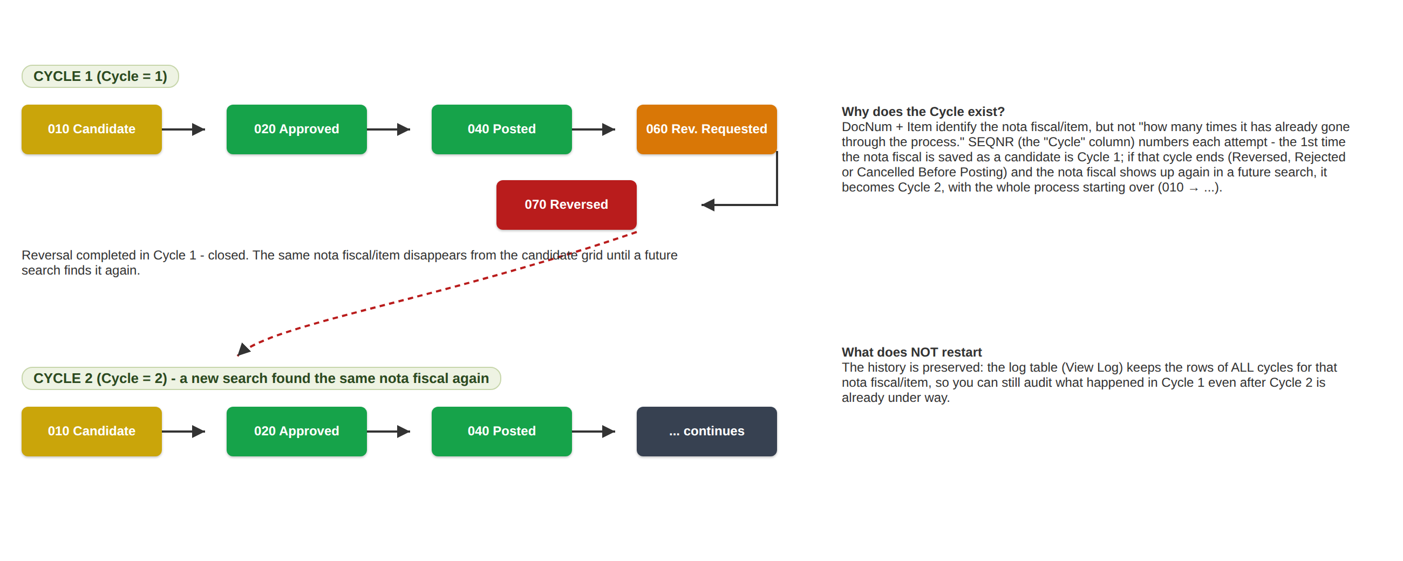
Illustrative diagram - the Cycle concept (the "Cycle" column in the grid).

3. Status: full table and possible flow
Every item has a numeric status representing where it stands in the process. Codes 900/910 only exist in memory, during the search (they are never persisted); from "010 - Candidate" onward the status is persisted.
Code | Status | Persisted? | What it means
900 | Ready to Save | No (in-memory only) | Just found by the search, calculated successfully, not yet saved.
910 | Not a Candidate | No (in-memory only) | Calculated, but with no ICMS value or a zero credit - not worth saving.
010 | Candidate | Yes | Saved by the user, waiting for a decision (approve / reject / delete).
015 | Rejected | Yes | The user decided not to proceed - terminal, but releases the nota fiscal/item for a future search.
020 | Approved | Yes | Approved by the user, waiting to be posted (job or administration).
021 | Auto Approved | Yes | Saved directly by the automatic approval (section 5.12), without going through 010/020 - waiting to be posted, same as 020.
025 | Post Failed | Yes | Posting failed, including the immediate retry with today's date - treated the same as Approved on the next run.
045 | Cancelled Before Posting | Yes | The nota fiscal was cancelled before it could be posted - terminal, releases for a future search.
030 | Posting | Yes | Being processed (a short lock, while the posting call is in progress).
040 | Posted | Yes | Successfully posted - the accounting document was created.
050 | Cancel Detected | Yes | Was Posted, but the nota fiscal was cancelled afterwards - needs a reversal.
060 | Reversal Requested | Yes | Reversal requested (manually or by a detected cancellation), waiting to be executed.
070 | Reversed | Yes | Successfully reversed - terminal, releases for a future search.
990 | Error | Depends | Can occur at any point in the flow - a technical/data failure that prevents it from proceeding.

Visual legend: every status has its own icon, shown both on the main grid and on the selection screen filters (real screens below).
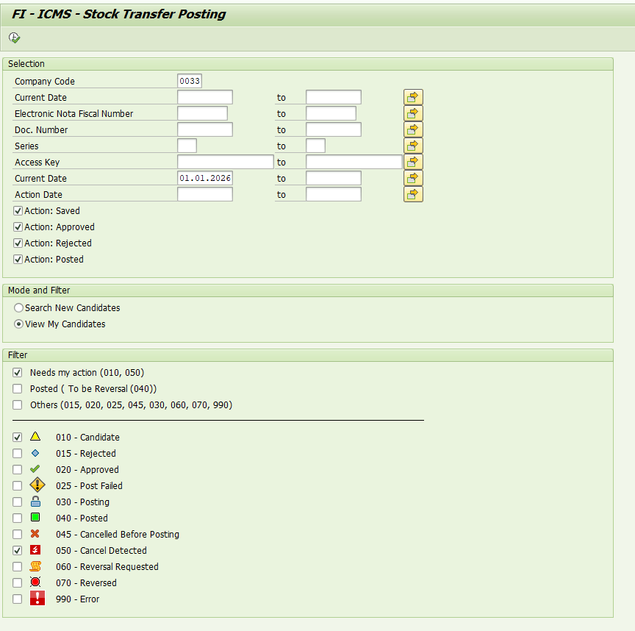
Real screen - status filters (View My Candidates), with each code's icon.
Full status-evolution diagram - each arrow is a screen action (button) or an automatic check. The three "New search" destinations represent the end of a cycle, not the end of the nota fiscal's story: it can show up again in a future search and open a new cycle.
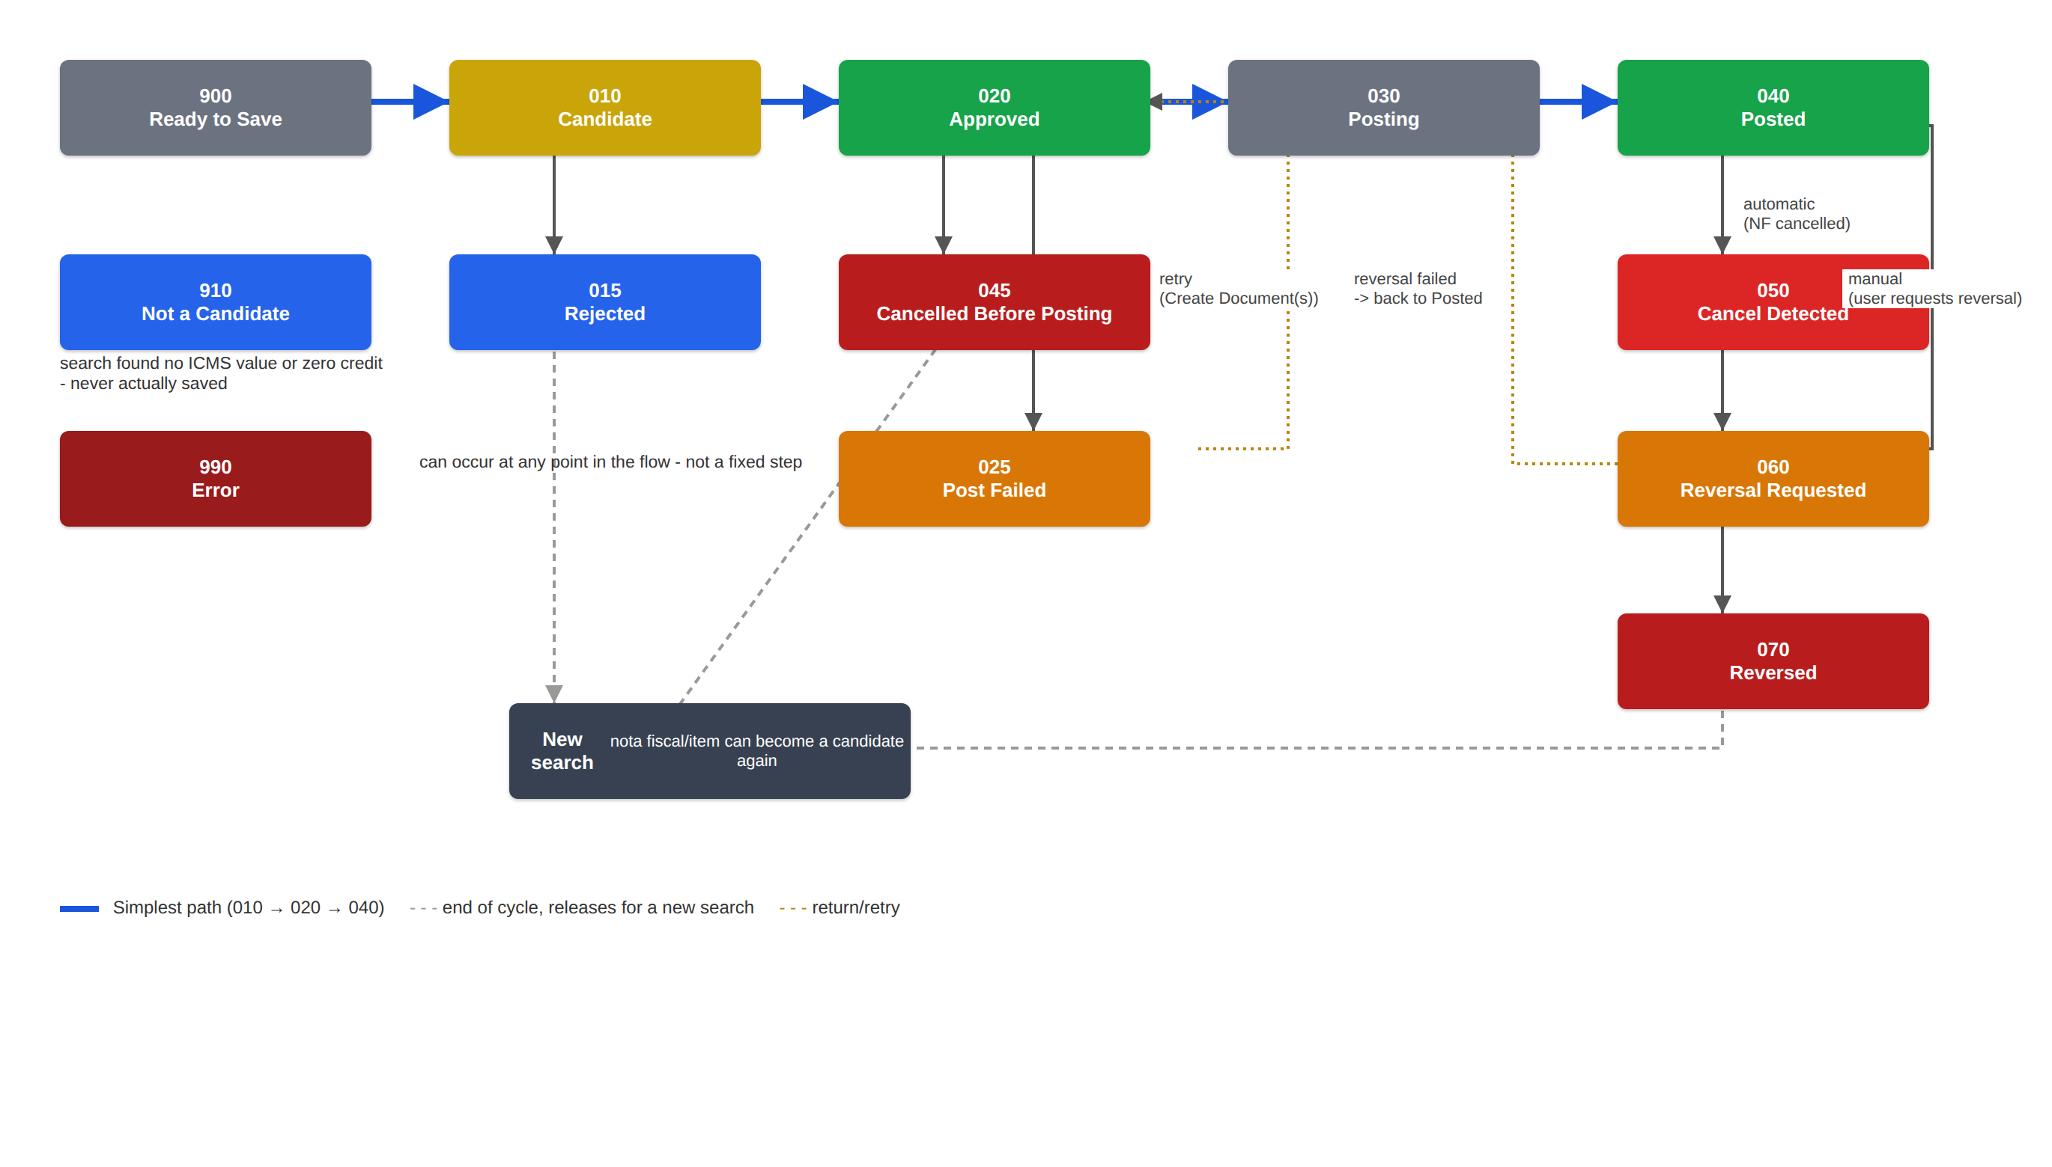
Illustrative diagram - full status flow. In blue, the simplest path.

4. Simplest path: 010 → 020 → 040
This is the most common flow: the user searches, saves and approves; the posting itself happens on its own (by the background job), with no action from the administration.
With automatic approval switched on, the path is even shorter - 900 → 021 → 040, without saving or approving item by item (section 5.12).

4.1 Search for candidates
Open transaction Y0033FI_ICM_STOCK_TR and enter the search parameters, with the "Search New Candidates" mode selected. The system looks for outbound nota fiscals whose NF-e is authorized by SEFAZ (see the trigger in section 1) - without authorization, the nota fiscal will not show up. For the date, use "NF-e Authorization Date" or the nota fiscal date; the eDocument filters (eDocument date and access key) are hidden while the eDocument model is switched off. The 900/910/990 filters control what appears in the result (usually only "900 - Ready to Save" matters).
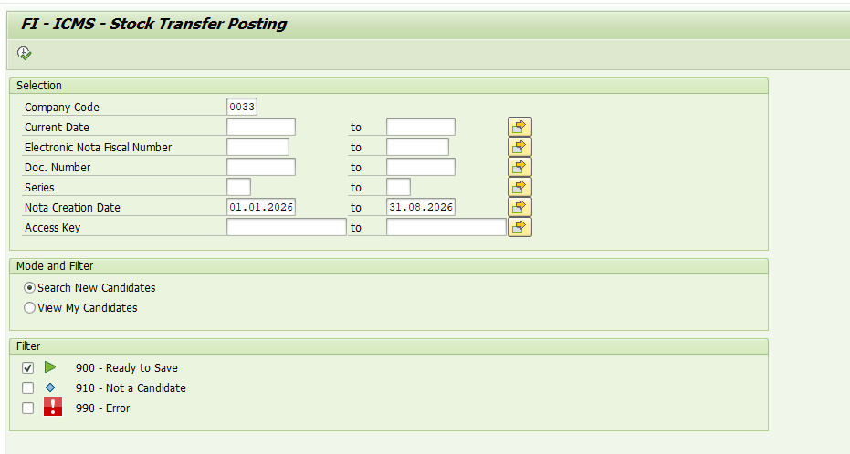
Selection screen - Search New Candidates.
The system returns the candidates found (status 900). The user reviews them, selects the ones to process and clicks "Save as Candidate".
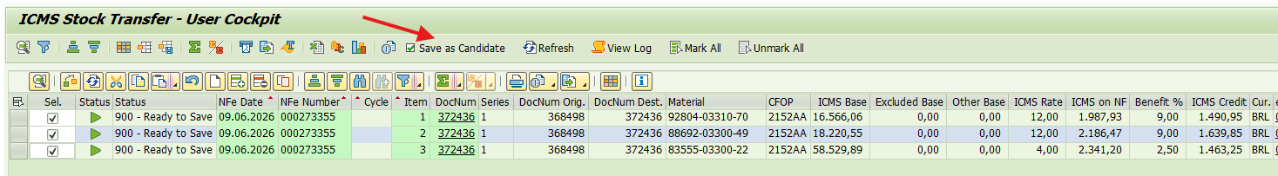
Search result - 900 (Ready to Save) items and the "Save as Candidate" button.
The system confirms how many candidates were saved (now with status 010 - Candidate).
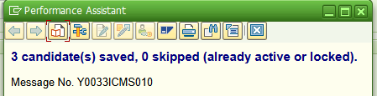
Save confirmation message.

4.2 Approving the candidate
Switch the mode to "View My Candidates". Pre-filters are available to make navigation easier, grouping statuses by action: "Needs my action" (010 and 050), "Posted / To be Reversal (040)" and "Others". Choose "Needs my action" to see the candidates awaiting approval.
View My Candidates - pre-filters and status checkboxes.
With the candidates (010) selected, use the action buttons: Approve, Request Reversal or Reject.
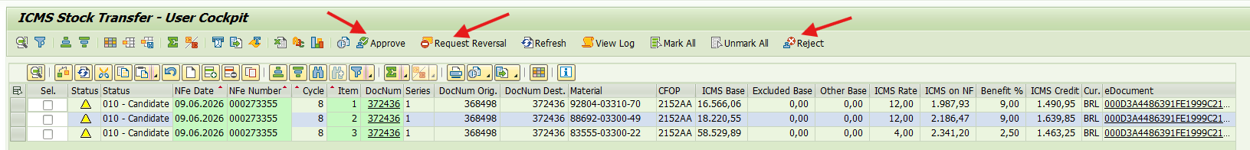
Available action buttons - Approve, Request Reversal, Reject.
Clicking Approve changes the status from 010 to 020 and the system confirms the action.
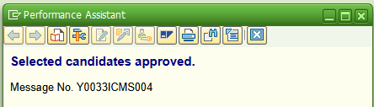
Confirmation: candidates approved.

4.3 Watching the automatic posting
From here on, the job that handles this topic runs periodically and, on finding 020 - Approved (and 021 - Auto Approved) items, posts them automatically - nobody needs to click anything for this to happen. This is precisely the job that makes the "Create Document(s)" button's work (section 5.7) run by itself, behind the scenes. Search again, now including the 040 - Posted status, to check the result.
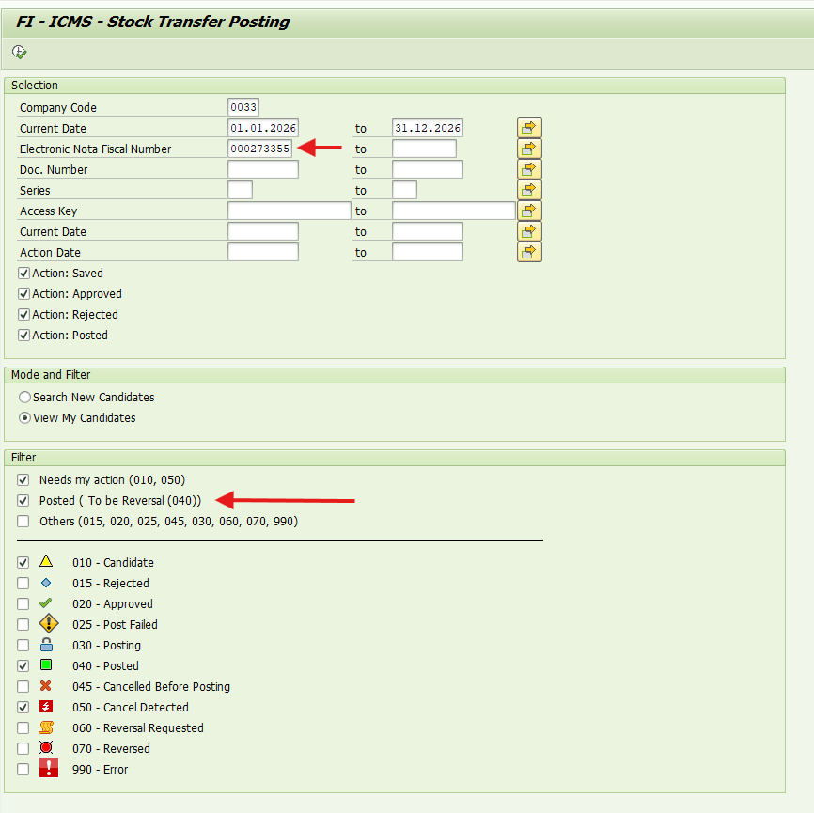
New search, now including the 040 - Posted status.
The status changed to 040 - Posted and the accounting document (Acc. Document) was created.
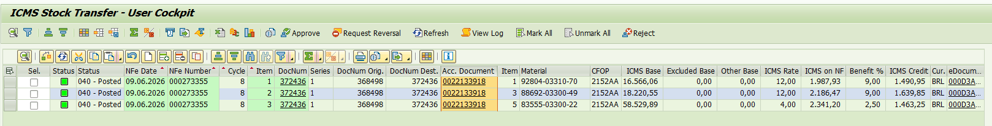
Result: 040 - Posted status, with the accounting document number.

5. Other possible scenarios

5.1 Rejecting a candidate (010 → 015)
On an item still at 010 - Candidate, instead of Approve, click Reject (same button group as section 4.2). The item moves to 015 - Rejected: it stays visible for reference, but the cycle is closed - the same nota fiscal/item may show up again in a future search.
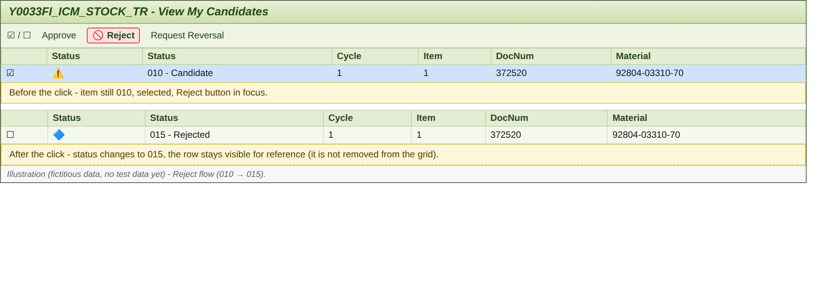
Illustration (no test data yet) - Reject flow.

5.2 Deleting a candidate (010 → removed)
Yes, this function exists: on an item still at 010 - Candidate, the Delete button removes the record entirely from the database (unlike Reject, which keeps the row visible with status 015). The only validation before deleting is the status itself - the system only deletes if the selected record is still exactly 010 - Candidate in the database; if someone else has already approved, rejected or deleted that same item between the search and the click, the deletion simply does not happen (no alarming error message, it just does not count as deleted). There is also a technical lock preventing two people from touching the same item at the same time.
On the concern about losing the trace: the record does disappear from the item table (and from the grid), but the delete action itself is permanently recorded in the Log (CANDIDATE_DELETED), next to the original CANDIDATE_SAVED entry - so the deletion is not really "invisible", it just is no longer visible through the current grid. That said, Reject preserves more day-to-day context (the row stays there, with a status, without needing to check the Log to know what happened) - so in practice it tends to be the safer everyday option; Delete is more suited to correcting a just-created search mistake or duplicate.
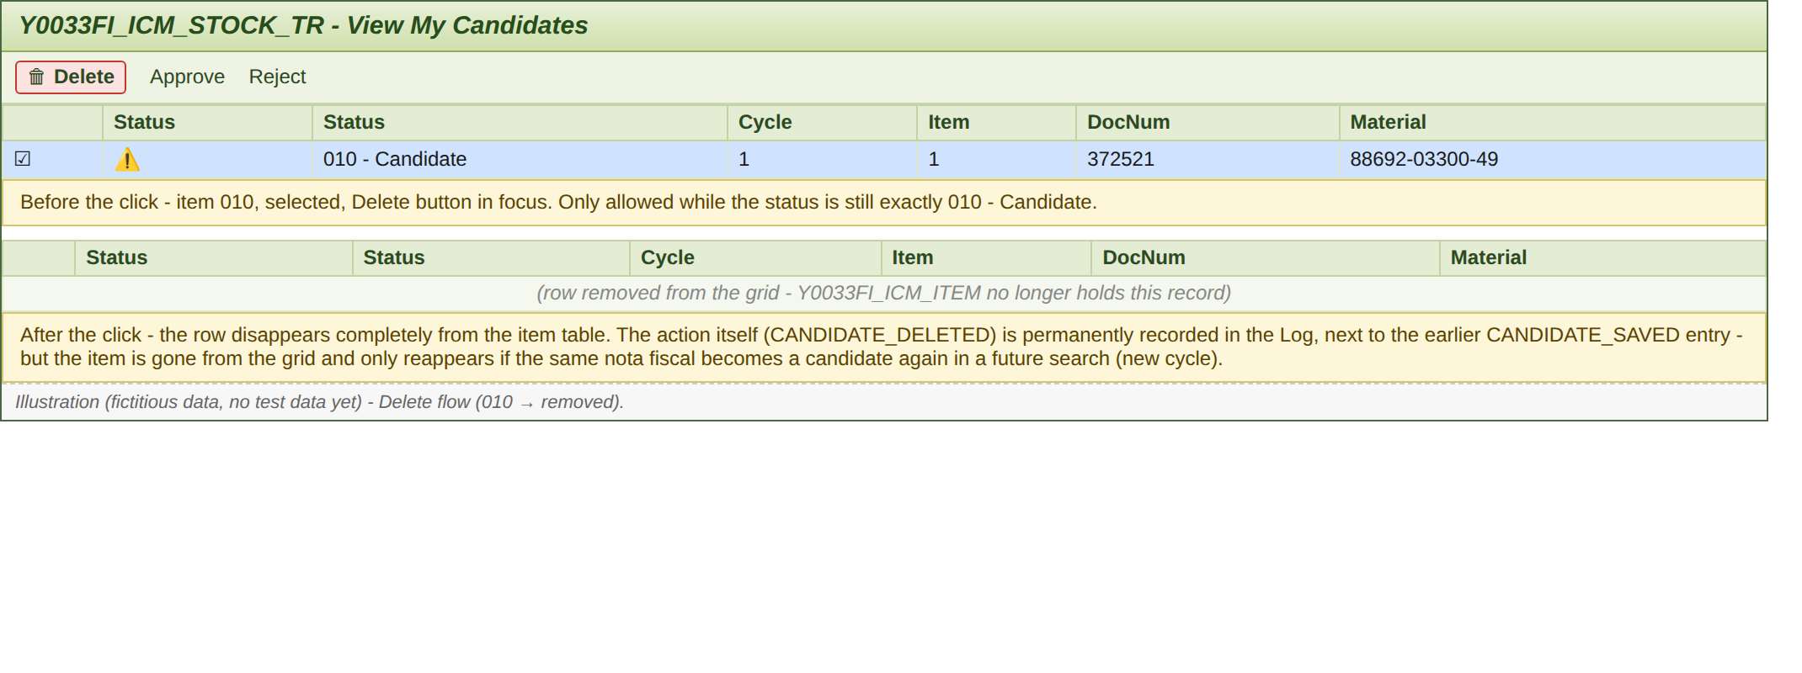
Illustration (no test data yet) - Delete flow.

5.3 Posting failure (020 → 025)
If posting fails, for any reason, the item moves to 025 - Post Failed and the program immediately retries in the same run, with today's date:
- If the retry succeeds (typical case: closed period) - the item moves to 040 - Posted, and the View Log shows both attempts.
- If it fails again - the item stays at 025 - Post Failed, with the error message visible on the grid. This status is the signal that someone needs to open an incident to investigate the cause (a blocked account, incomplete master data, etc.).
Once the cause is fixed, the next "Create Document(s)" run (or job run) picks the item up automatically again, with no extra manual "reopen" action needed.
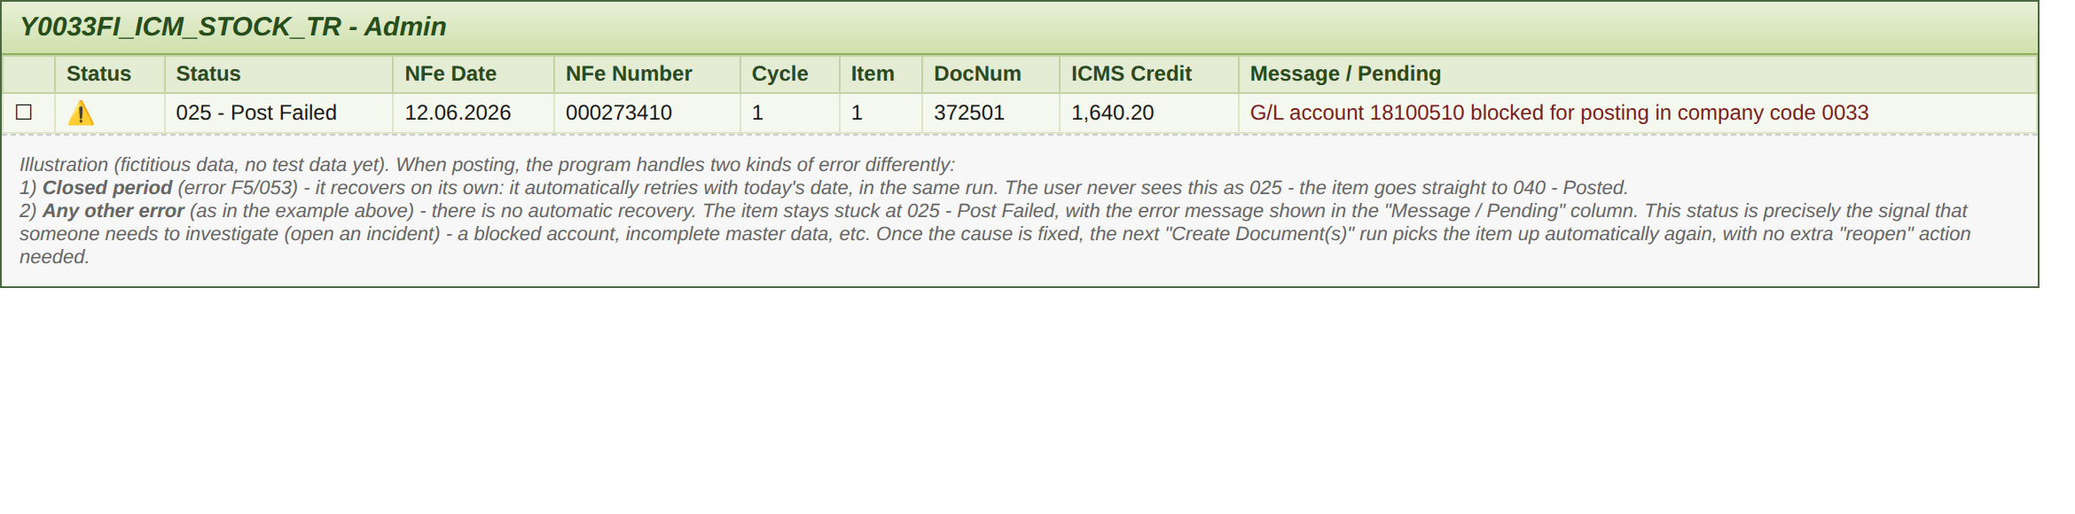
Illustration (no test data yet) - status 025 stuck, awaiting an incident.

5.4 Nota fiscal cancelled before posting (020 → 045)
If the nota fiscal is cancelled after being approved but before it can be posted, the system detects this automatically at posting time and moves the item to 045 - Cancelled Before Posting, without generating any accounting document. It is a terminal status (like Rejected) - the nota fiscal can become a candidate again in the future if it is corrected and reissued.
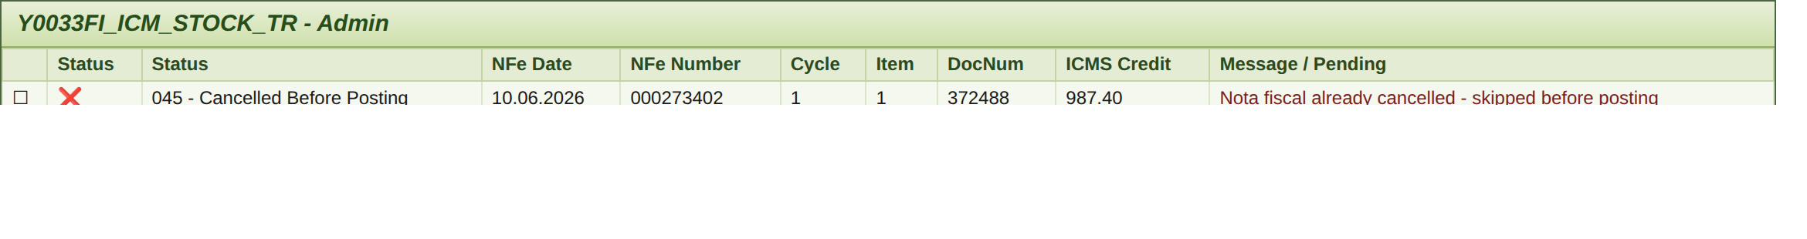
Illustration (no test data yet) - status 045.

5.5 Nota fiscal cancelled after posting (040 → 050)
On every run, the system checks whether a record with a pending action had its nota fiscal cancelled - including when the status is already 040 - Posted. In that case, the status changes to 050 - Cancel Detected, but the reversal is not posted automatically: that action depends on someone filtering by status 050, selecting the items and clicking "Request Reversal" - only then is the reversal executed (see section 5.6).
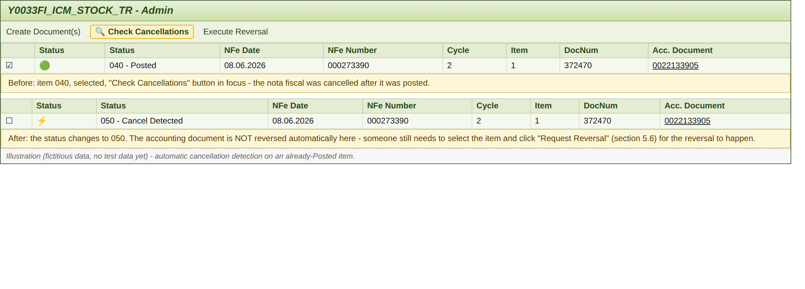
Illustration (no test data yet) - automatic cancellation detection on a Posted item.

5.6 Manual reversal (040 / 050 → 060 → 070)
Whenever a reversal is needed - whether by a manual decision on a 040 item, or after an automatic detection (050) - select the items and click "Request Reversal". After confirmation, the new status is 060 - Reversal Requested.
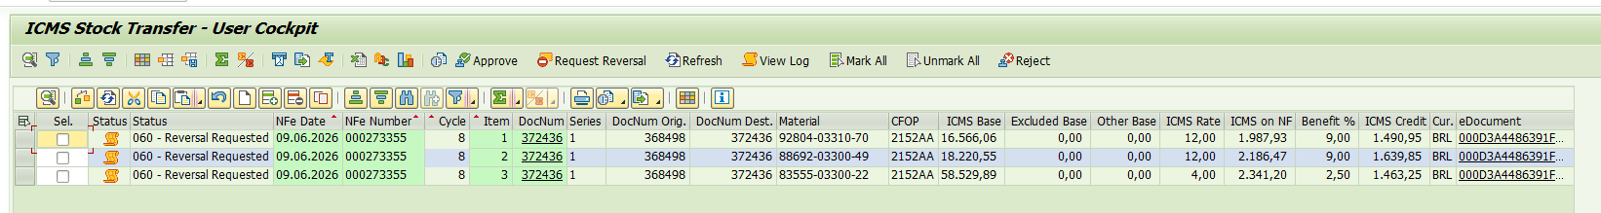
Items at 060 - Reversal Requested, awaiting execution by the job/administration.
When the job (or the administration, see section 5.7) runs, the system recognizes there is a pending action and proceeds with reversing the accounting document. After a new search selecting status 070 - Reversed, the document has been reversed and the reversal document number is shown.
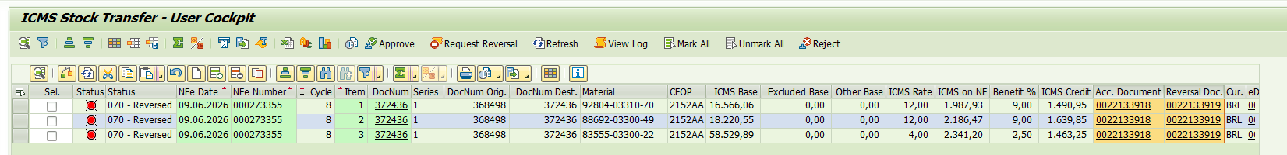
Items at 070 - Reversed, with the reversal document number (Reversal Doc.).

5.7 Administration resources: posting, checking cancellations, reversing
Everything above uses the search/approval screens; the administration resources of transaction Y0033FI_ICM_STOCK_TR are what actually post and reverse when that is not done only by the background job. They bring together the buttons: Create Document(s) (posts the selected 020/021/025 items), Check Cancellations (checks for cancelled nota fiscals), Execute Reversal (reverses the selected 060 items), plus Maintain Corridors (transfer corridor setup) and Maintain Parameters (per-company parameters).
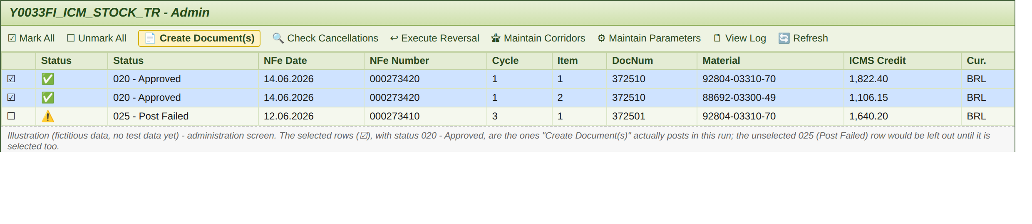
Illustration (no test data yet) - administration screen.

5.8 Checking the history (View Log)
Selecting a single row and clicking "View Log" shows the item's full history - every cycle, every action, with user, date/time and message.
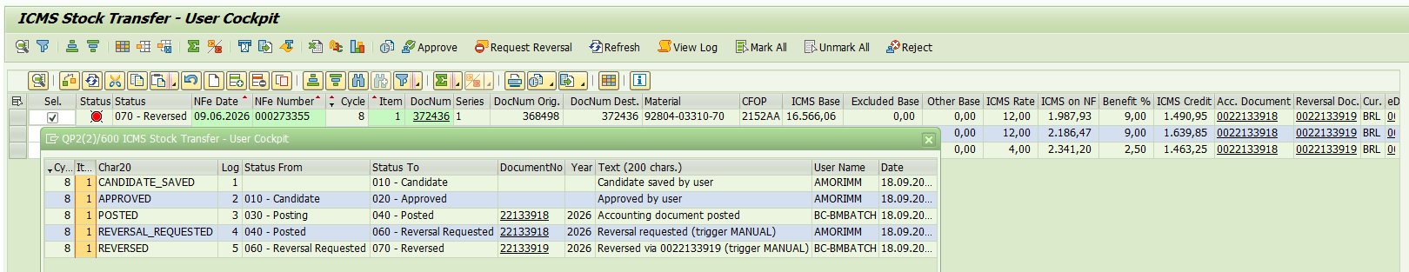
View Log popup - full history for Cycle 8, Item 1.
New: the "Acc. Document" column in the popup itself is now clickable and opens the document's FB03 directly, without having to note down the number.

5.9 Accounting document traceability (FB03)
Looking at the accounting document that was created: items are posted individually (one debit and one credit line per item), ensuring full traceability.
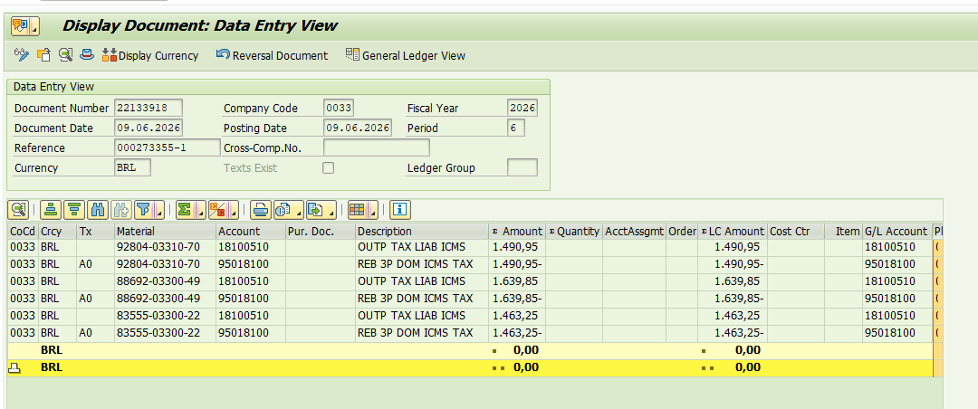
FB03 - Data Entry View: every line of the document.
Every item carries the source nota fiscal information in the Assignment and Text fields of the accounting line.
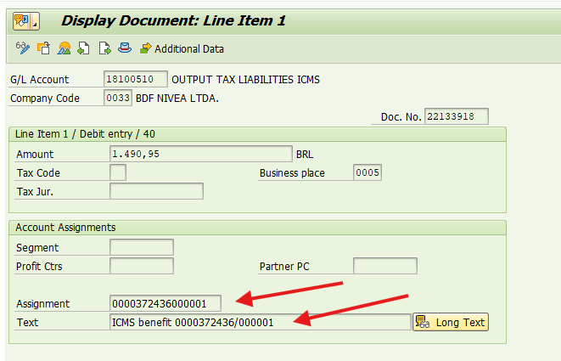
FB03 - line detail, Assignment/Text fields with the nota fiscal reference.

5.10 New cycle after Reversed / Rejected / Cancelled Before Posting
An important concept: if this document has been reversed (or rejected, or cancelled before posting), the system treats the same nota fiscal as able to become a candidate again on the next search - the process starts over from zero, and the "Cycle" column shows the new position (see the diagram in section 2).

5.11 Origin/destination nota fiscal reference on the accounting document
The "DocNum Dest." column on the grid shows the nota fiscal on the other end of the transfer - in the Transfer model, the inbound nota fiscal recorded at the destination branch. This number is saved on the item (field DOCNUM_REF).
The destination branch usually records its nota fiscal after the item has already been saved. So the system fills this field on its own as soon as the inbound nota fiscal exists - both when someone opens the view screen and on every job run (the job log shows how many were filled). Until then, the column stays blank.
On the same grid, the "NF-e Authorized on" column shows the authorization date of the outbound NF-e. On the accounting document, the reference (Assignment/Text fields) uses the item's own nota fiscal - in the Transfer model, the outbound nota fiscal of the origin.
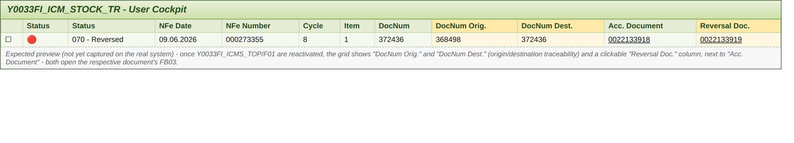
Illustration (no test data yet) - "DocNum Orig."/"DocNum Dest." and "Reversal Doc." columns (earlier version of the screen: today there is a single column, "DocNum Dest.").

5.12 Automatic approval (Auto Approved - 021)
Instead of the user saving (010) and approving (020) item by item, the administration can let the system do both steps at once: with the Auto Approved option checked, every new candidate found by the search (what would show up as 900 - Ready to Save) is saved directly as 021 - Auto Approved. From then on, 021 follows the same path as 020: it is posted by the job or by "Create Document(s)".
How to use it (online):
- In the "Admin Review" administration mode, check "Auto Approved". The search filters show up (NF-e authorization date, search models, etc.).
- Fill in at least one filter besides the company code and execute.
- Confirm the popup "Every new candidate found will be saved and approved automatically (021). Continue?". The default button is No: with No, nothing is approved and the screen opens as usual.
- With Yes, the new candidates are saved as 021 and the Admin Review list opens right after, already showing them.
In the job (background): the variant needs "Admin Review" + "Auto Approved" + a dynamic authorization date, from yesterday to today (SEFAZ authorization may arrive a few hours after issue, and anything already processed is dropped by the search, so there are no duplicates). Each run does, in this order: automatic approval → cancellation check → posting of 020/021/025 → requested reversals → filling in any missing "DocNum Dest.".
Good to know:
- The option only exists in Admin Review mode and is unchecked when the mode changes.
- Items with errors (990) or no credit (910) are not approved; items already in an active cycle are not duplicated.
- Every item approved this way has an AUTO_APPROVED line in the View Log, showing it did not go through manual approval.
- In the status filters, 021 comes together with 020 ("020/021 - Approved/Auto Approved"), with the same icon.

6. What is still missing
Since there is no test data yet, the screens for the exception scenarios (Reject, Delete, Post Failed, Cancelled Before Posting, Cancel Detected and the administration screen) were replaced with illustrations - faithful to the code's logic, but with fictitious data. Once real cases exist, it is worth swapping these illustrations for the matching real captures, just to confirm that the exact message text and layout match what the screen actually shows. None of them block using this manual as it stands.
The two items below depend on more than just "having test data":
- View Log - the clickable link on the popup's "Acc. Document" column is a new feature; once reactivated, it is worth visually confirming that the click opens the FB03 (section 5.8).
- DocNum Dest. / NF-e Authorized on / Reversal Doc. - main grid columns; a real capture is worth taking to check the layout (section 5.11).
- Selection screen captures - they predate the new fields (NF-e authorization date, Auto Approved) and the Transfer model as default; they are worth replacing with current captures (sections 4.1 and 5.12).

7. Frequently Asked Questions
Why are business-user and administration resources kept separate?
Separation of responsibility and access: only someone with administration authorization can post or reverse directly, so a business user never has, even by mistake, a way to trigger an accounting posting.
Can the same nota fiscal have more than one record?
Yes - each attempt (cycle) has its own "Cycle" (SEQNR). If a cycle ends (Rejected/Cancelled Before Posting/Reversed), the nota fiscal can open a new cycle in a future search. The history of every cycle is preserved.
Where is the history of everything that happened to an item?
In the "View Log" button (section 5.8) - every status change becomes a row, with user, date, time and a descriptive message, even after the item is deleted (Delete) or becomes a new cycle.
Do the status filters on the screen change anything about the processing?
No - the status checkboxes only affect what shows up on the grid, never the persisted data.
Which date should I filter by?
The NF-e authorization date ("NF-e Authorization Date"). It works in every mode - search and view - and is the same date shown in the "NF-e Authorized on" column. In the job, use yesterday to today.
Can automatic and manual approval be used at the same time?
Yes. Automatic approval only picks up new candidates; items already saved as 010 keep waiting for the user's decision, and 020 and 021 items are posted together.

