Data Anomalies Detection in Existing Structure Monitoring
Jiayuan Chen, Zilu Wang, and Weiyi Kong
Tongji University

ABSTRACT

This paper focused on the second problem raised by the first IPC-SHM, which asks to study the pattern of a set of existing full-scale bridge monitoring data as well as corresponding labels to tell the categories of other sets of unknown data. Our approach here is to adopt machine learning technology, or more specifically, SVM and Neural Network, as such methodologies have been proven efficacious in dealing with a wide range of engineering problems, making them deserve an attempt in structural health monitoring field. The paper will be split into several parts to expound our research, including introduction, project structure, data analysis, SVM and Neural Network Methodology, results and optimization.

INTRODUCTION

Problem Overview
Structural monitoring of an existing construction usually produces tons of data with numerous errors and missing values inside due to environmental variations. Data pre-processing thus becomes a crucial step before anything useful can be done with these data. Just look through this paragraph quoted from the introduction file of IPC-SHM.
The widespread application of sophisticated SHM systems in civil infrastructure produces a large volume of data. However, the harsh environmental conditions of civil structures cause the data measured by SHM systems to be affected by multiple anomalies. These anomalies pose a significant barrier for automatic warning for damage or accidents. The identification and removal of data anomalies due to environmental variations is thus an important preprocessing step in a successful warning system.
Out goal here is to recognize the correct sets of data and to tell as many kinds of anomalies as possible.

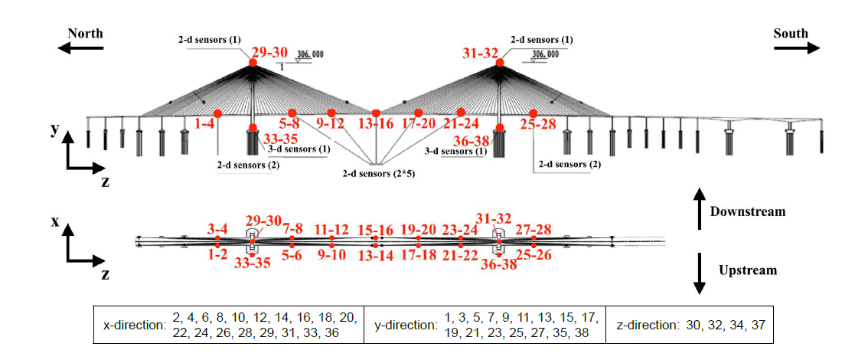
Fig1. Placement of sensors

Data Description
The monitoring data we mentioned above is actually a large set of acceleration values recorded by 38 sensors placed on a bridge. The positions of sensors are displayed as Fig.1. All sensors have an equal sampling frequency of 20Hz.
Each set of data corresponds to a single label, which indicates the status of that data(normal or anomalous). 7 labels have been declared by the problem maker, and are displayed in the introduction file. They are described as follow.

Table1. Description of each data pattern
Order | Anomaly Pattern | Description
1 | Normal | The time response is normal oscillation curve; frequency response is peak-like (may differ between bridges)
2 | Missing | Most/all of the time response is missing, which makes the time and frequency response zero
3 | Minor | Relative to normal sensor data, the amplitude is very small in the time domain
4 | Outlier | One or more outliers appear in the time response
5 | Square | The time response is like a square wave
6 | Trend | The data has an obvious trend in the time domain and has an obvious peak value in the frequency domain
7 | Drift | The vibration response is non-stationary, with random drift

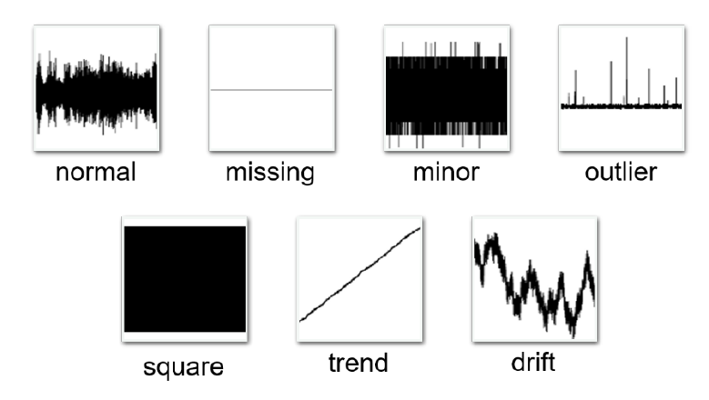
Fig. 2 The example for each data pattern (duration of each time series: 3600s)

PROJECT STRUCTURE
This project adopted Python as our machine learning platform.
###########################################################

DATA ANALYSIS

The original data we accepted has some inconsistent patterns: each hour of monitoring data from Jan.1 to Jan.31 is presented in a mat file, while all labels in 31days, 24 hours are saved in one single mat files. Such inconsistency will need to be handled in later procession.

Monitoring Data Overview
Given the sampling frequency of 20Hz, it’s easy to tell each mat file -- which represents data of all 38 sensors in one hour – has a size of 72000*38, where 38 is the number of sensors and 72000 can be calculated as 20*3600.
However, such large scale of dataset is not the single one we need to handle. There are 744 mat files with such size, which gives them a total data volume of 744*38*72000, an immense number that will take years to train also bring many problems to later adjustments.
A way to avoid such problems is to truncate the data. Several approaches can be chosen from to do data simplifying according to different handling ideas, but generally they all should meet the basic requisite that guarantee the integrity of data as a whole without losing too much details at the same time, as some details are crucial in determining some categories.

Monitoring Data Processing
First, it’s obvious that the number of every pattern is not equal. Table 2 shows the differences.

Tabel2. Numbers of each pattern
Order | Anomaly Pattern | Number
1 | Normal | 13575
2 | Missing | 2942
3 | Minor | 1775
4 | Outlier | 527
5 | Square | 2996
6 | Trend | 5778
7 | Drift | 679
 | Total | 28272

It’s easy to tell that type 1 predominate the dataset while other types have small distribution inequality respectively. Therefore, it is important to use the same amount of training samples in order not to overfits one category yet ignores another. That means one should not utilize the whole provided dataset.
Moreover, continuing to trim the dataset is still necessary as abandoning some data is not enough for reducing dataset scale.
在本项目中，我们采用过两种方法来缩小数据量。第一种是把每数据按照每1小时的72000个数据等步长分割，取每个区间中的绝对值最大值作为其代表。举例来说，如果我们取步长为8，那72000个数据会变为9000个。若再考虑到前面提到了每种种类取同样的样本的做法，假设每种种类取200组数据，那最后我们的训练集大小仅为9000*1400，相比起744*38*72000要好上不少。这种方法的优点是显而易见的——直观，计算量小，同时能继承数据原有的变化趋势。但其缺点在于会放大数据的变化量，个别离散的异常大数据可能会直接屏蔽周边稳定的数据，从而使数据整体的方差偏大。项目中，这一方法为simplifier1。
第二种方法相比起第一种方法更关注数据的宏观变化趋势，而选择降低那些不重要的离散点的权重。这种方法将数据整体的均值和方差作为简化结果的头两个数据——我们称之为总均值和总方差。并在之后同样按照步长将数据分组，每一组再产生两个数据：该组均值与总均值之差，该组所有值与该组均值之差的绝对值的最大值。可以将公式表达如下：
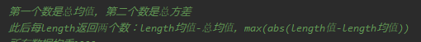
这一方法相比于前一种方法可能会在整体变化型起主要作用的异常类型（如7类）上会有更好的表现，并且其数据比较详细，损失的信息较少。其缺点在于运算量大，并且在同样的步长下数据大小为前一种方法的2倍。项目中，该种方法为simplifier2。

Labels Rearrangement
As mentioned in the introduction file, label file has a size of 744*38. Since the original label file (Label.mat) is a highly integrated Matlab struct, extracting its data with Python is rather complex compared to doing the same thing with Matlab. Being very amateur on dealing with mat files with Python, I preferred to transform the original mat into a more Python-readable one with a simple Matlab script named toLabel.m. I highly recommend you to run it first and get a new label_r.mat file as all later procedure will be reading labels exactly from this mat file.

TRAINING METHODOLOGY

我们先后采取过SVM和神经网络两种方法进行异常分类尝试，这两种方法都是行之有效的实施机器学习分类的手段。在继续我们的项目说明之前，先简单地介绍一下两种方法的原理。

SVM
支持向量机是一种二分类模型，它的基本模型是定义在特征空间上的间隔最大的线性分类器，间隔最大使它有别于感知机；SVM还包括核技巧，这使它成为实质上的非线性分类器。SVM的学习策略是间隔最大化，可形式化为一个求解凸二次规划的问题，也等价于正则化的合页损失函数的最小化问题。SVM的学习算法就是求解凸二次规划的最优化算法。
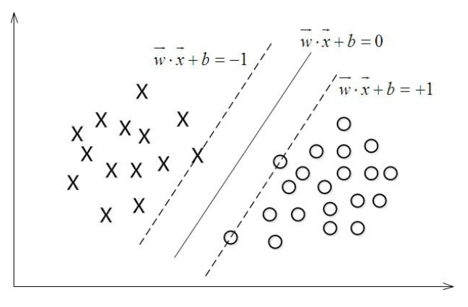
Fig3. Plane bisection problem using SVM

SVM一个最简单的例子是平面上点的二分问题。在超平面w*x+b=0确定的情况下，|w*x+b|能够表示点x到距离超平面的远近，而通过观察w*x+b的符号与类标记y的符号是否一致可判断分类是否正确，所以，可以用(y*(w*x+b))的正负性来判定或表示分类的正确性。于此，我们引入函数间隔：
此外，SVM的目的是让分割距离达到最大：
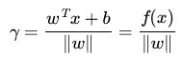
这在数学上可以证明，是等价于最大化集合间隔的。这一式子在最大化问题的求解上可以将函数间隔设为1，进而只需考虑等价于最小化。这是SVM的基本思路。
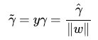
在高维问题的处理上，考虑到数据点间的纠缠，还需要利用核方法将之在高维空间上投影分割。在多分类的情况下，也需要考虑使用特殊的”one vs one” (or “one vs rest”)分类策略来进行处理。我们的SVM算法程序使用的是Github上的既有成果，因此在这里不做过多深入。
SVM作为数理算法，其运算速度快，如果能在SVM方法中得到较好的分类结果，那将会对今后的应用或是维护上带来非常大方便。

Neural Network
神经网络方法在近几年大行其道，相信几乎所有人都对其有所耳闻。神经网络的机器学习方法充分利用了现代计算机优越的计算能力，用大量的参数来对未知的函数做拟合，其原理简单，实施容易，已经成为广大工程类项目不可或缺的工具。
考虑到没有池化数据的必要（这样会损失细节），我们在项目中采用的神经网络并不需要隐层，结构非常简单，仅输入层和输出层就足够了。
神经网络虽然实施简单，但调试麻烦，费时费力，不利于今后数据集增减维护。

Training Process

Equations
Please number all equations as the sample Eq. (1).
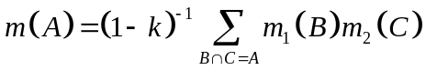 (1)

Tables
Table captions appear above the table. See Table 1 below.

Table 1. Word font size and formatting that you can use for your manuscript
Formatting style name: | Brief description:
Paper Title | 18 pt. bold
Authors | 14 pt.
Affiliations | 11 pt. italic
ABSTRACT TITLE | 11 pt. bold
Abstract body text | 11 pt.
MAIN HEADING | 11 pt. bold
Body text | 11 pt.
Figure caption | 11 pt.
Table caption | 11 pt.
Secondary Heading | 11 pt. italic bold
ACKNOWLEDGEMENTS | 11 pt. bold
REFERENCES | 11 pt. bold

Figures
Figure example is shown in Fig. 1.

Table2. Predict accuracy of each data pattern
Order | Anomaly Pattern | Accuracy | Recall | F1-score
1 | Normal
2 | Missing
3 | Minor
4 | Outlier
5 | Square
6 | Trend
7 | Drift
 | Total


Fig. 1. Welcome to IPC-SHM 2020

REFERENCES

- Bao, Y., Chen Z., Wei, S., Xu, Y., Tang, Z., & Li, H. (2019). The State of the Art of Data Science and Engineering in Structural Health Monitoring, Engineering, 5, 234-242.

