

**Amirkabir University of Technology**

**(Tehran Polytechnic)**

**Computer Engineering Department**

**Machine Learning Course**

**CE5501**

**Homework 2**

**Student**

**Reza Sajedi**

**400131072**

**r.sajedi@aut.ac.ir**

**Teacher**

**Dr. Nazerfard**

**Fall 2022**

Table of Contents

Problem 1: Why and how 1

Part a 1

Part b 1

Part c 2

Part d 2

Part e 2

Part f 3

Part g 3

Part h 3

Part i 4

Part j 4

Problem 2: Moons 5

Part a 5

Part b 5

Part c 5

Part d 5

Part e and f 5

Part g and h 6

Problem 3: Lung Cancer 6

Part a 6

Part b 6

Part c 7

Part d 11

Part e 11

Problem 4: Optical Recognition of Handwritten Digits 17

Part a 17

Part b 17

Part c and d 18

Part e 18

Part f 19

Part g 19

Part h 20

# Problem 1: Why and how

## Part a

City Blocks (a.k.a. Manhattan distance) and Euclidean distance are two kinds of Minkowski Distance with p=1 and p=2 respectively.

$${\left(\sum_{i=1}^{n}{{\left|u_{i} -{ v}_{i}\right|}^{p}}\right)}^{1/p}$$

These metrics can be used in a space where distances can be represented as a vector with a non-negative length.

Cosine similarity is measured by the cosine of the angle between two vectors and Cosine distance is calculated as follows:

$$1 - \cos{θ} =1 - \frac{\vec{u} . \vec{v}}{\left|\vec{u}\right|\left|\vec{v}\right|}$$

It is often used to measure document similarity in text analysis. When used with KNN this distance gives us a new perspective on a business problem and lets us find some hidden information in the data which we didn’t see using the above two distance matrices.

The distance values calculated using these metrics are different. For example, two arbitrary points on the line y = x have different non-zero distances using Euclidean and City Blocks, while the cosine distance is zero.

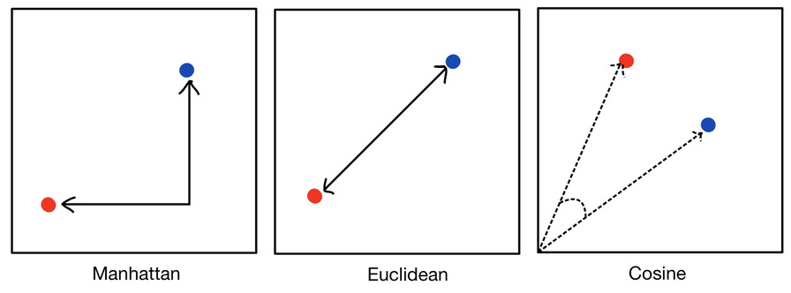

## Part b

It depends on the dataset. The best way is to examine various metrics on the desired dataset. Euclidean distance usually may have better results. (Like the results of handwritten digits recognition which is an image classification task)

## Part c

After finding the neighbors in the K-NN algorithm, we can simply take the average of target values. The ID3 algorithm can be used to construct a decision tree for regression by replacing Information Gain with Standard Deviation Reduction. The standard deviation reduction is based on the decrease in standard deviation after a dataset is split on an attribute. Constructing a decision tree is all about finding an attribute that returns the highest standard deviation reduction.

## Part d

One of the hyperparameters that control the decision tree’s complexity is maximum depth. If the depth of the tree gets so large, it tends to overfit which means may perform badly on unseen instances (test data). In such situations, we can remove some nodes to decrease the depth and get a more general model. This process is called pruning.

## Part e

$$E\left(X\right)=-\sum_{i}{p\left(x_{i}\right)}\log{p}\left(x_{i}\right)$$

$$G\left(S,F\right)=E\left(S\right)-\sum_{v∈values\left(F\right)}{\frac{\left|S_{v}\right|}{\left|S\right|}}E\left(S_{v}\right)$$

Root:

E(S) = - (1/4 * log(1/4) + 3/4 * log(3/4)) = 0.81

G(F1) = 0.81 - ( -3/4 * (3/3 * log(3/3)) -1/4 * (1/1 * log(1/1)) ) = 0.81

No need to calculate information gain for other features! Because the entropy of F1 is zero, we can not get an information gain higher than 0.81 which is the entropy of the entire set. So, F1 is the best split for the root and after that, we reach the leaves.

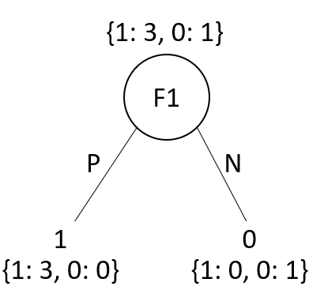

## Part f

Root:

E(S) = - (2/5 * log(2/5) + 3/5 * log(3/5)) = 0.97

G(F1) = 0.97 - ( -4/5 * (3/4 * log(3/4) + 1/4 * log(1/4)) -1/5 * (1/1 * log(1/1)) ) = 0.32

G(F2) = 0.97 - ( -1/5 * (1/1 * log(1/1)) -4/5 * (3/4 * log(3/4) + 1/4 * log(1/4)) ) = 0.32

G(F3) = 0.97 - ( -2/5 * (1/2 * log(1/2) + 1/2 * log(1/2)) -3/5 * (2/3 * log(2/3) + 1/3 * log(1/3)) ) = 0.02

G(F4) = 0.97 - ( -4/5 * (3/4 * log(3/4) + 1/4 * log(1/4)) -1/5 * (1/1 * log(1/1)) ) = 0.32

G(F5) = 0.97 - ( -4/5 * (2/4 * log(2/4) + 2/4 * log(2/4)) -1/5 * (1/1 * log(1/1)) ) = 0.17

G(F6) = 0.97 - ( -2/5 * (1/2 * log(1/2) + 1/2 * log(1/2)) -3/5 * (2/3 * log(2/3) + 1/3 * log(1/3)) ) = 0.02

Left Node of Root:

E(S) = - (1/4 * log(1/4) + 3/4 * log(3/4)) = 0.81

G(F4) = 0.81 - ( -3/4 * (3/3 * log(3/3)) -1/4 * (1/1 * log(1/1)) ) = 0.81

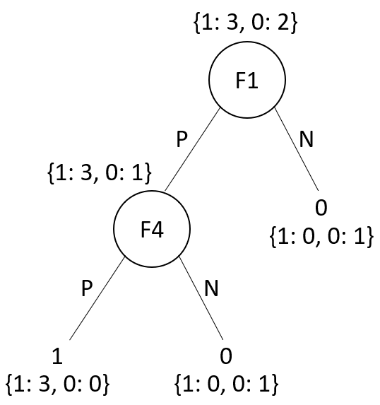

## Part g

The computational complexity of training a Decision Tree is O(m × n log(n)) because it compares all features on all samples at each node (n=number of instances, m=number of features). So, if we multiply the training set size by 10, the training time will be multiplied by K = (m × 10n × log(10n)) / (m × n × log(n)) = 10 × log(10n) / log(n). If n = 10⁶, then K ≈ 11.7, so we can expect the training time to be roughly 11.7 hours.

## Part h

The maximum possible combinations with M binary features are 2M. So, if N < 2M, the number of leaves should be equal to N. Otherwise, the maximum number of leaves is 2M.

## Part i

|  |  |  |  |  |  |  |  |  |
| --- | --- | --- | --- | --- | --- | --- | --- | --- |
| **x1** | **x2** | **label** | **d1(x, [5,0])** | **d1(x, [1,1])** | **d1(x, [-2,1])** | **d2(x, [5,0])** | **d2(x, [1,1])** | **d2(x, [-2,1])** |
| 0 | 0 | T | 5 | 1 | 2 | 5 | 2 | 3 |
| -5 | 0 | T | 10 | 6 | 3 | 10 | 7 | 4 |
| -5 | 5 | T | 10 | 6 | 4 | 15 | 10 | 7 |
| -5 | -5 | T | 10 | 6 | 6 | 15 | 12 | 9 |
| 0 | 5 | C | 5 | 4 | 4 | 10 | 5 | 6 |
| 0 | -5 | C | 5 | 6 | 6 | 10 | 7 | 8 |
| 8 | 3 | C | 3 | 7 | 10 | 6 | 9 | 12 |
| 8 | -3 | C | 3 | 7 | 10 | 6 | 11 | 14 |
| **1-NN Predicted label** | | | C | T | T | T | T | T |
| **4-NN Predicted label** | | | C | T | T | C | C | T |

**T: Triangle, C: Circle**

## Part j

These metrics are used to evaluate the performance in the multi-class classification task. Instead of having multiple per-class f1 scores, it would be better to average them to obtain a single number to describe overall performance. Micro and Macro are two methods of averaging.

Macro averaging means computing the f1-score for each label and reporting the average without considering the proportion for each label in the dataset.

Micro averaging means computing the f1-score by considering total true positives, false negatives, and false positives (no matter the prediction for each label in the dataset). In multi-class classification, micro f1, micro precision, micro recall, and accuracy share the same value.

If the dataset is imbalanced and all classes are equally important, the macro f1-score should be used. If the dataset is balanced and we want to report an easily understandable metric for overall performance regardless of the class, micro f1-score (overall Accuracy) should be used.

# Problem 2: Moons

## Part a

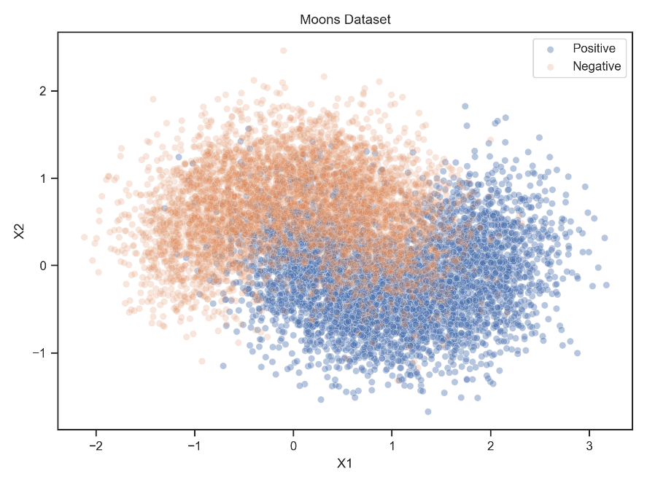

## Part b

The instruction has been followed.

## Part c

Grid search is a model selection technique. It performs an exhaustive search over specified hyperparameter values for an estimator and finds the best combination of these values, leading to the model with the highest performance. We considered a range between 1 to 20 for the maximum depth of the tree and the maximum number of leaf nodes. The optimal hyperparameter values are as follows:

{'max_depth': 7, 'max_leaf_nodes': 18}

Accuracy: 0.8669

## Part d

Accuracy: 0.8565

Confusion Matrix:

[[854 162]

[125 859]]

## Part e and f

Average Accuracy: 0.794 ± 0.0258

Max Accuracy: 0.8505

Min Accuracy: 0.689

## Part g and h

This kind of ensemble approach which we can call Random Forest has performed a little bit better.

Accuracy: 0.8615

The improvement compared to part d: 0.005

# Problem 3: Lung Cancer

## Part a

Results for iteration 1 with train size 25%:

Accuracy: 0.8578

Confusion Matrix:

[[ 12 19]

[ 14 187]]

Depth: 5

Number of nodes: 15

Number of leaves: 8

## Part b

The results are different because we are choosing a small proportion of the dataset for training and the training instances are chosen randomly.

Results for iteration 1 with train size 25%:

Accuracy: 0.875

Confusion Matrix:

[[ 0 29]

[ 0 203]]

Depth: 4

Number of nodes: 9

Number of leaves: 5

Results for iteration 2 with train size 25%:

Accuracy: 0.8793

Confusion Matrix:

[[ 0 28]

[ 0 204]]

Depth: 4

Number of nodes: 9

Number of leaves: 5

Results for iteration 3 with train size 25%:

Accuracy: 0.8707

Confusion Matrix:

[[ 0 29]

[ 1 202]]

Depth: 2

Number of nodes: 5

Number of leaves: 3

Results for iteration 4 with train size 25%:

Accuracy: 0.8793

Confusion Matrix:

[[ 0 28]

[ 0 204]]

Depth: 0

Number of nodes: 1

Number of leaves: 1

Results for iteration 5 with train size 25%:

Accuracy: 0.8534

Confusion Matrix:

[[ 13 15]

[ 19 185]]

Depth: 4

Number of nodes: 11

Number of leaves: 6

Results for iteration 6 with train size 25%:

Accuracy: 0.7716

Confusion Matrix:

[[ 18 13]

[ 40 161]]

Depth: 4

Number of nodes: 9

Number of leaves: 5

Results for iteration 7 with train size 25%:

Accuracy: 0.8664

Confusion Matrix:

[[ 3 27]

[ 4 198]]

Depth: 6

Number of nodes: 19

Number of leaves: 10

**Average accuracy of 7 iterations with train size 25%:** 0.8565 ± 0.0357

## Part c

The results show that when the training data increases the performance improves and also makes the tree bigger.

Results for iteration 1 with train size 45%:

Accuracy: 0.8706

Confusion Matrix:

[[ 1 20]

[ 2 147]]

Depth: 5

Number of nodes: 13

Number of leaves: 7

Results for iteration 2 with train size 45%:

Accuracy: 0.8647

Confusion Matrix:

[[ 9 13]

[ 10 138]]

Depth: 5

Number of nodes: 17

Number of leaves: 9

Results for iteration 3 with train size 45%:

Accuracy: 0.8588

Confusion Matrix:

[[ 4 18]

[ 6 142]]

Depth: 5

Number of nodes: 11

Number of leaves: 6

Results for iteration 4 with train size 45%:

Accuracy: 0.8588

Confusion Matrix:

[[ 0 22]

[ 2 146]]

Depth: 5

Number of nodes: 17

Number of leaves: 9

Results for iteration 5 with train size 45%:

Accuracy: 0.8294

Confusion Matrix:

[[ 14 7]

[ 22 127]]

Depth: 5

Number of nodes: 21

Number of leaves: 11

Results for iteration 6 with train size 45%:

Accuracy: 0.8824

Confusion Matrix:

[[ 12 7]

[ 13 138]]

Depth: 6

Number of nodes: 23

Number of leaves: 12

Results for iteration 7 with train size 45%:

Accuracy: 0.8176

Confusion Matrix:

[[ 1 26]

[ 5 138]]

Depth: 5

Number of nodes: 13

Number of leaves: 7

**Average accuracy of 7 iterations with train size 45%:** 0.8546 ± 0.0213

Results for iteration 1 with train size 65%:

Accuracy: 0.8899

Confusion Matrix:

[[ 0 12]

[ 0 97]]

Depth: 5

Number of nodes: 13

Number of leaves: 7

Results for iteration 2 with train size 65%:

Accuracy: 0.7982

Confusion Matrix:

[[12 3]

[19 75]]

Depth: 5

Number of nodes: 23

Number of leaves: 12

Results for iteration 3 with train size 65%:

Accuracy: 0.8807

Confusion Matrix:

[[ 0 12]

[ 1 96]]

Depth: 6

Number of nodes: 17

Number of leaves: 9

Results for iteration 4 with train size 65%:

Accuracy: 0.8807

Confusion Matrix:

[[ 5 8]

[ 5 91]]

Depth: 6

Number of nodes: 19

Number of leaves: 10

Results for iteration 5 with train size 65%:

Accuracy: 0.844

Confusion Matrix:

[[ 0 16]

[ 1 92]]

Depth: 7

Number of nodes: 27

Number of leaves: 14

Results for iteration 6 with train size 65%:

Accuracy: 0.8807

Confusion Matrix:

[[ 0 12]

[ 1 96]]

Depth: 3

Number of nodes: 9

Number of leaves: 5

Results for iteration 7 with train size 65%:

Accuracy: 0.8899

Confusion Matrix:

[[ 0 12]

[ 0 97]]

Depth: 5

Number of nodes: 15

Number of leaves: 8

**Average accuracy of 7 iterations with train size 65%:** 0.8663 ± 0.0313

Results for iteration 1 with train size 85%:

Accuracy: 1.0

Confusion Matrix:

[[47]]

Depth: 8

Number of nodes: 19

Number of leaves: 10

Results for iteration 2 with train size 85%:

Accuracy: 0.8936

Confusion Matrix:

[[ 3 4]

[ 1 39]]

Depth: 6

Number of nodes: 31

Number of leaves: 16

Results for iteration 3 with train size 85%:

Accuracy: 0.9149

Confusion Matrix:

[[ 4 1]

[ 3 39]]

Depth: 6

Number of nodes: 27

Number of leaves: 14

Results for iteration 4 with train size 85%:

Accuracy: 0.8936

Confusion Matrix:

[[ 3 3]

[ 2 39]]

Depth: 6

Number of nodes: 31

Number of leaves: 16

Results for iteration 5 with train size 85%:

Accuracy: 0.8723

Confusion Matrix:

[[ 0 6]

[ 0 41]]

Depth: 4

Number of nodes: 9

Number of leaves: 5

Results for iteration 6 with train size 85%:

Accuracy: 0.7447

Confusion Matrix:

[[ 0 11]

[ 1 35]]

Depth: 8

Number of nodes: 29

Number of leaves: 15

Results for iteration 7 with train size 85%:

Accuracy: 0.8936

Confusion Matrix:

[[ 1 4]

[ 1 41]]

Depth: 7

Number of nodes: 29

Number of leaves: 15

**Average accuracy of 7 iterations with train size 85%:** 0.8875 ± 0.0698

## Part d

Maximum depth is a hyperparameter that controls the complexity of the tree. When its value increases, the accuracy increases for the training data most of the time. After some values, it doesn’t have any impact on the accuracy because all of the leaves are pure. Increasing the maximum depth doesn’t always improve the accuracy of the test data. We should find its optimal value through the chart.

Optimal max depth for Train set: 5

Optimal max depth for Test set: 4

Maximum accuracy for Train set: 0.9004

Maximum accuracy for Test set: 0.8718

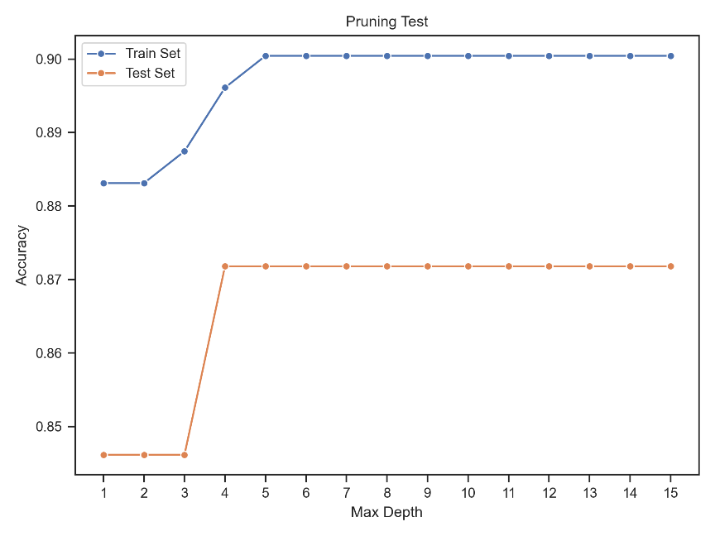

## Part e

The results of our algorithm are very similar to sklearn’s implementation results. In sklearn the best split for numeric data (Age feature) is found using a good algorithm, but we handled that by simply categorizing them with length 10.

**Part e.a**

Results for iteration 1 with train size 25%:

Accuracy: 0.8578

Confusion Matrix:

[[ 20 8]

[ 25 179]]

Depth: 5

Number of nodes: 21

Number of leaves: 11

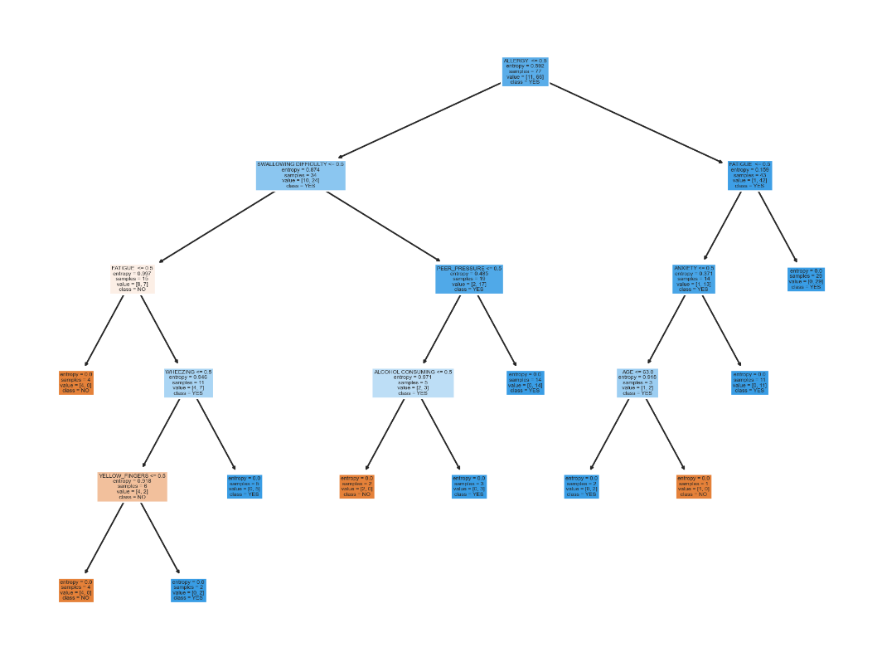

**Part e.b**

Results for iteration 1 with train size 25%:

Accuracy: 0.875

Confusion Matrix:

[[ 16 15]

[ 14 187]]

Depth: 5

Number of nodes: 23

Number of leaves: 12

Results for iteration 2 with train size 25%:

Accuracy: 0.8922

Confusion Matrix:

[[ 16 12]

[ 13 191]]

Depth: 6

Number of nodes: 23

Number of leaves: 12

Results for iteration 3 with train size 25%:

Accuracy: 0.8319

Confusion Matrix:

[[ 15 16]

[ 23 178]]

Depth: 6

Number of nodes: 27

Number of leaves: 14

Results for iteration 4 with train size 25%:

Accuracy: 0.8621

Confusion Matrix:

[[ 15 12]

[ 20 185]]

Depth: 5

Number of nodes: 17

Number of leaves: 9

Results for iteration 5 with train size 25%:

Accuracy: 0.8879

Confusion Matrix:

[[ 13 19]

[ 7 193]]

Depth: 5

Number of nodes: 15

Number of leaves: 8

Results for iteration 6 with train size 25%:

Accuracy: 0.8707

Confusion Matrix:

[[ 18 9]

[ 21 184]]

Depth: 8

Number of nodes: 33

Number of leaves: 17

Results for iteration 7 with train size 25%:

Accuracy: 0.8405

Confusion Matrix:

[[ 17 17]

[ 20 178]]

Depth: 5

Number of nodes: 25

Number of leaves: 13

**Average accuracy of 7 iterations with train size 25%:** 0.8658 ± 0.021

**Part e.c**

Results for iteration 1 with train size 45%:

Accuracy: 0.7765

Confusion Matrix:

[[ 6 17]

[ 21 126]]

Depth: 8

Number of nodes: 35

Number of leaves: 18

Results for iteration 2 with train size 45%:

Accuracy: 0.8647

Confusion Matrix:

[[ 8 15]

[ 8 139]]

Depth: 10

Number of nodes: 43

Number of leaves: 22

Results for iteration 3 with train size 45%:

Accuracy: 0.8647

Confusion Matrix:

[[ 9 12]

[ 11 138]]

Depth: 11

Number of nodes: 39

Number of leaves: 20

Results for iteration 4 with train size 45%:

Accuracy: 0.8882

Confusion Matrix:

[[ 13 8]

[ 11 138]]

Depth: 8

Number of nodes: 39

Number of leaves: 20

Results for iteration 5 with train size 45%:

Accuracy: 0.8529

Confusion Matrix:

[[ 7 15]

[ 10 138]]

Depth: 7

Number of nodes: 31

Number of leaves: 16

Results for iteration 6 with train size 45%:

Accuracy: 0.9

Confusion Matrix:

[[ 9 10]

[ 7 144]]

Depth: 9

Number of nodes: 43

Number of leaves: 22

Results for iteration 7 with train size 45%:

Accuracy: 0.8647

Confusion Matrix:

[[ 11 14]

[ 9 136]]

Depth: 9

Number of nodes: 27

Number of leaves: 14

**Average accuracy of 7 iterations with train size 45%:** 0.8588 ± 0.0368

Results for iteration 1 with train size 65%:

Accuracy: 0.8532

Confusion Matrix:

[[11 5]

[11 82]]

Depth: 7

Number of nodes: 49

Number of leaves: 25

Results for iteration 2 with train size 65%:

Accuracy: 0.7798

Confusion Matrix:

[[ 8 14]

[10 77]]

Depth: 8

Number of nodes: 45

Number of leaves: 23

Results for iteration 3 with train size 65%:

Accuracy: 0.8257

Confusion Matrix:

[[ 5 9]

[10 85]]

Depth: 7

Number of nodes: 43

Number of leaves: 22

Results for iteration 4 with train size 65%:

Accuracy: 0.8349

Confusion Matrix:

[[ 9 10]

[ 8 82]]

Depth: 10

Number of nodes: 55

Number of leaves: 28

Results for iteration 5 with train size 65%:

Accuracy: 0.8624

Confusion Matrix:

[[ 8 4]

[11 86]]

Depth: 11

Number of nodes: 55

Number of leaves: 28

Results for iteration 6 with train size 65%:

Accuracy: 0.8624

Confusion Matrix:

[[ 2 4]

[11 92]]

Depth: 10

Number of nodes: 61

Number of leaves: 31

Results for iteration 7 with train size 65%:

Accuracy: 0.844

Confusion Matrix:

[[ 8 10]

[ 7 84]]

Depth: 7

Number of nodes: 53

Number of leaves: 27

**Average accuracy of 7 iterations with train size 65%:** 0.8375 ± 0.0267

Results for iteration 1 with train size 85%:

Accuracy: 0.9149

Confusion Matrix:

[[ 4 3]

[ 1 39]]

Depth: 9

Number of nodes: 65

Number of leaves: 33

Results for iteration 2 with train size 85%:

Accuracy: 0.8511

Confusion Matrix:

[[ 4 2]

[ 5 36]]

Depth: 13

Number of nodes: 73

Number of leaves: 37

Results for iteration 3 with train size 85%:

Accuracy: 0.9149

Confusion Matrix:

[[ 4 1]

[ 3 39]]

Depth: 8

Number of nodes: 51

Number of leaves: 26

Results for iteration 4 with train size 85%:

Accuracy: 0.9149

Confusion Matrix:

[[ 4 3]

[ 1 39]]

Depth: 10

Number of nodes: 69

Number of leaves: 35

Results for iteration 5 with train size 85%:

Accuracy: 0.9149

Confusion Matrix:

[[ 5 1]

[ 3 38]]

Depth: 9

Number of nodes: 75

Number of leaves: 38

Results for iteration 6 with train size 85%:

Accuracy: 0.8936

Confusion Matrix:

[[ 5 3]

[ 2 37]]

Depth: 9

Number of nodes: 61

Number of leaves: 31

Results for iteration 7 with train size 85%:

Accuracy: 0.9149

Confusion Matrix:

[[ 5 2]

[ 2 38]]

Depth: 10

Number of nodes: 73

Number of leaves: 37

**Average accuracy of 7 iterations with train size 85%:** 0.9027 ± 0.0223

**Part e.d**

Optimal max depth for Train set: 8

Optimal max depth for Test set: 3

Maximum accuracy for Train set: 1.0

Maximum accuracy for Test set: 0.8718

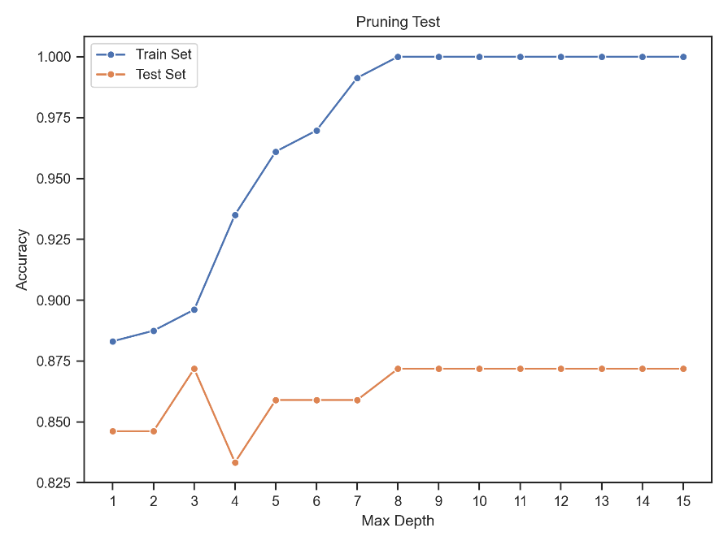

# Problem 4: Optical Recognition of Handwritten Digits

## Part a

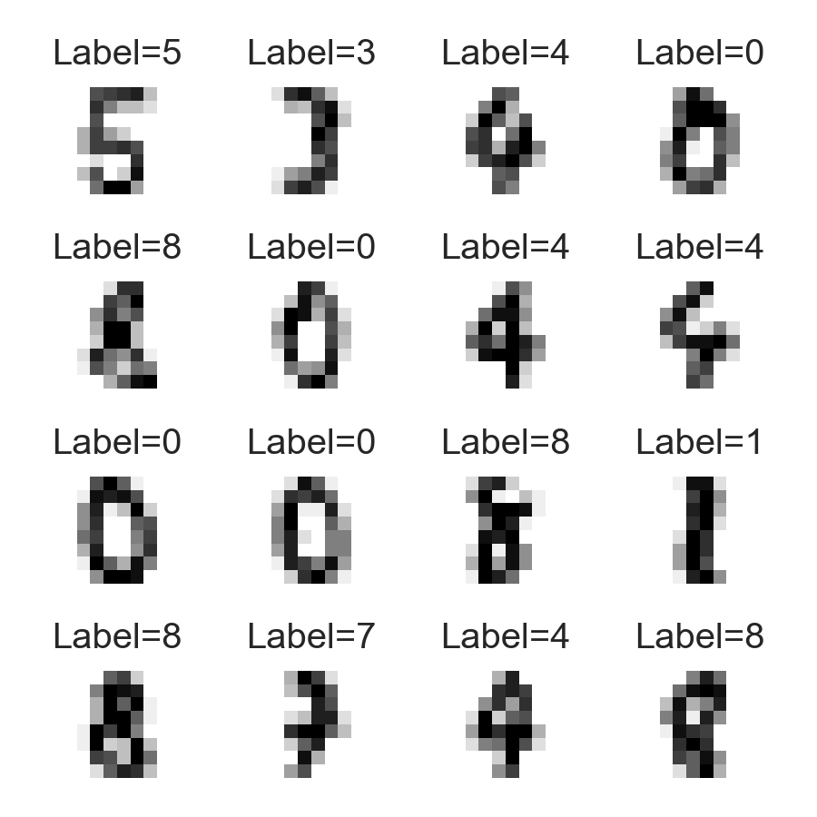

## Part b

The implementation code has been attached.

## Part c and d

According to the chart, the overall error rate of Euclidean distance is lower than the cosine distance in this application. The best values for k are as follows:

* Best k for Euclidean distance: 4
* Best k for Cosine distance: 9

Values higher than these lead to an overall error rate increment.

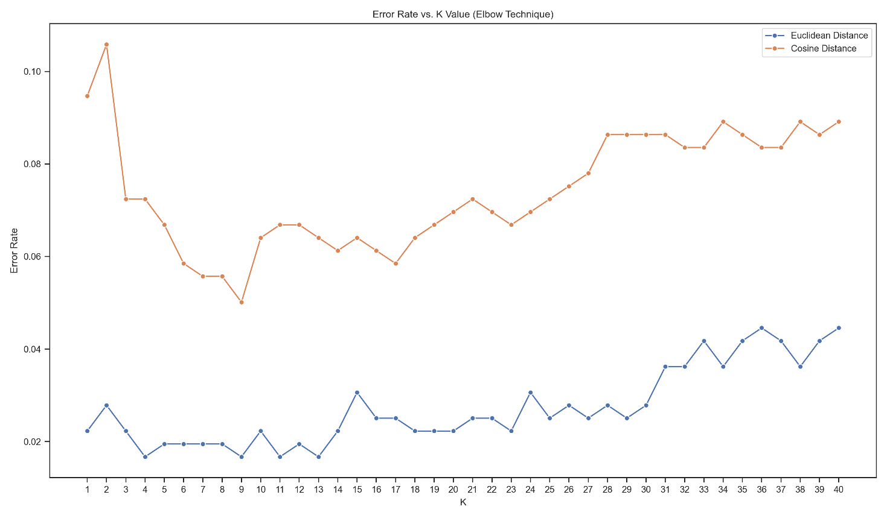

## Part e

The randomly selected sample is 9. All 4 neighbors found using Euclidean distance have the correct label. Using the cosine distance, 4 of 9 found neighbors are indicating the wrong labels. Although the predicted label using these two metrics for this sample is correct, Euclidean distance is preferred. Because it selects the lower number of neighbors with higher similarities and the model is simpler.

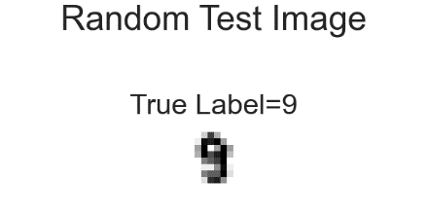

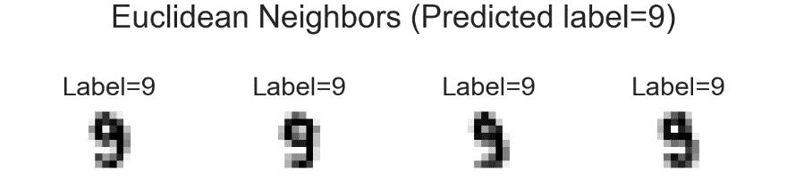

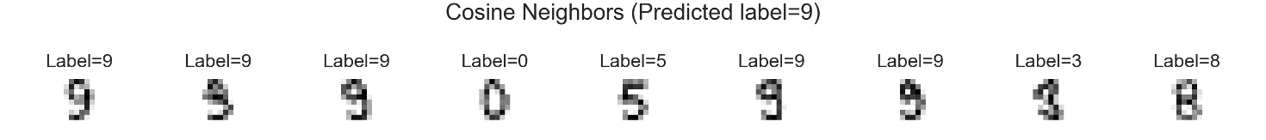

## Part f

Confusion Matrix for Euclidean Distance:

[[35 0 0 0 0 0 0 0 0 0]

[ 0 37 0 0 0 0 0 0 0 0]

[ 0 0 43 0 0 0 0 0 0 0]

[ 0 0 0 37 0 0 0 0 0 0]

[ 0 0 0 0 35 0 0 0 0 0]

[ 0 0 0 0 0 29 0 0 0 1]

[ 0 0 0 0 0 0 43 0 0 0]

[ 0 0 0 0 0 0 0 31 0 0]

[ 0 2 0 0 0 0 0 0 30 0]

[ 0 0 0 0 0 1 0 0 2 33]]

Confusion Matrix for Cosine Distance:

[[35 0 0 0 0 0 0 0 0 0]

[ 0 36 0 0 0 0 0 0 1 0]

[ 0 0 43 0 0 0 0 0 0 0]

[ 1 0 0 36 0 0 0 0 0 0]

[ 0 0 0 0 34 0 0 1 0 0]

[ 0 0 0 0 0 29 0 0 0 1]

[ 1 0 0 0 0 0 42 0 0 0]

[ 0 0 0 0 0 0 0 31 0 0]

[ 1 1 0 5 0 0 0 0 24 1]

[ 1 0 0 0 0 2 0 1 1 31]]

## Part g

Euclidean Distance Performance for target 8:

TP: 30

TN: 329

FP: 2

FN: 2

F1-score: 0.9375

Precision: 0.9375

TPR (Recall, Sensitivity): 0.9375

TNR (Specificity): 0.994

Euclidean Distance Performance for target 3:

TP: 37

TN: 322

FP: 0

FN: 0

F1-score: 1.0

Precision: 1.0

TPR (Recall, Sensitivity): 1.0

TNR (Specificity): 1.0

## Part h

Cosine Distance Performance for target 6:

TP: 42

TN: 317

FP: 0

FN: 1

F1-score: 0.9882

Precision: 1.0

TPR (Recall, Sensitivity): 0.9767

TNR (Specificity): 1.0

Cosine Distance Performance for target 4:

TP: 34

TN: 325

FP: 0

FN: 1

F1-score: 0.9855

Precision: 1.0

TPR (Recall, Sensitivity): 0.9714

TNR (Specificity): 1.0