PROJECT DESCRIPTION

DECK GENERALS

2017

DECK GENERALS 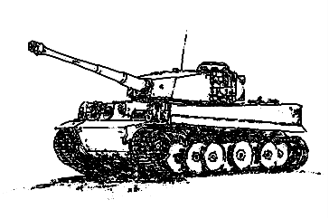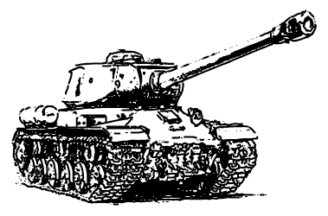

CONTENTS

1 Genre 2

2 Platform 2

3 Gameplay 2

3.1 ABOUT 2

3.2 Cards 2

3.2.1 City card 2

3.2.2 Armor card 3

3.2.3 infantry card 3

3.2.4 Resource card 4

4 Application architecture 4

4.1 Business logic 5

4.2 MVC architecture 6

5 Technologies used 7

6 IN Future 7

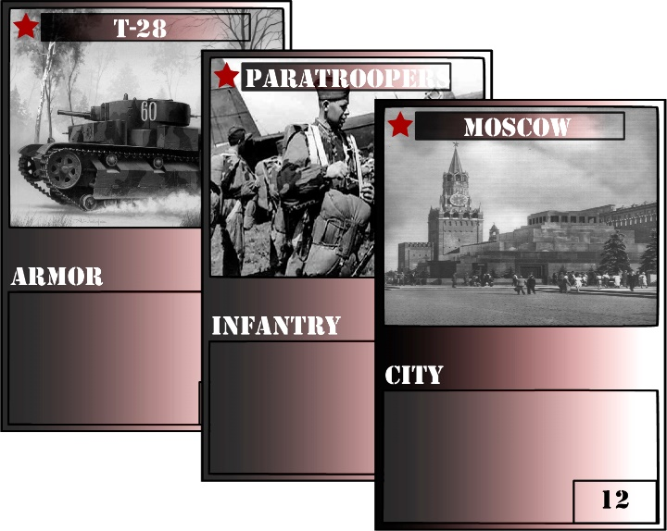

# 1 Genre

* Turn based strategy
* Collectible card game

# 2 Platform

* PC

# 3 Gameplay

## 3.1 ABOUT

* The game is a turn-based card game between a player and AI, using constructed decks cards along with a selected city with a unique power and strength. Players use resource points to summon infantry or armor minions to occupy the field, with the goal to reduce the opponent's city strength to zero. The game starts with 0 resources and 5 cards in hand for each player. Each turn each player gain 1 resource and take 1 card from his deck. At the end of each player’s turn minions, which occupied the field will deal damage to the opponent player. There are two slots on the field: armor slot and infantry slot. At one time only one minion can occupy one slot.
* Winning matches gives a player points, which he can spend in a shop to buy cards in order to improve and customize their decks.
* Players start the free-to-play game with a limited collection of basic cards but can gain rarer and more powerful cards through purchasing packs of cards in the shop.
* Deck Generals take place during World War II, so all cards, themes, arts are about it. Now there’s one nation in game – USSR.

## 3.2 Cards

The game has 4 types of cards: armor, infantry, city, resource.

Depending on card rarity, you can put only restricted number of copies of card in your deck:

* + Common card (White color) - 4 copies
  + Rare card (Green color) – 3 copies
  + Unique card (Cyan color) -2 copies
  + Legendary card (Orange color) – 1 copy

### 3.2.1 City card

For each deck there can be only one city card. City card has strength and may have special ability. Each damage dealt to player, will be dealt to his city card. City card is played automatically when the game is started.

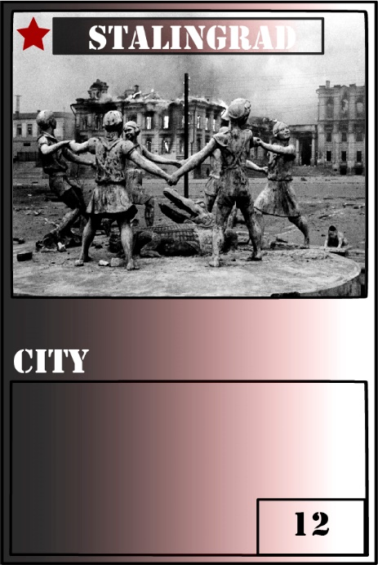 Card name

Nation accessory

Card type

Card strength

City card strength is actually the player’s strength. Once it becomes 0 or less – that player loses. So the main object in game is to keep field slots empty from opposite player’s minions.

### 3.2.2 Armor card

Armor cards can be played in armor slot of the field. Unlike city card, which is played automatically, armor cards are played manually and besides strength has also attack. Also you may need specific number of resources to play armor card. At the end of each player’s turn, if armor card is in the armor slot of the field – it deals damage equal to its attack to opponent player’s city. If armor card attacks the field armor slot, which is taken by opponent player’s minion – it deals damage equal to its attack to opponent’s minion. If attack of attacking card is bigger than strength of defending card – attacking card defeats defending and takes the slot. If attack of attacking card is equal to strength of defending – they both are defeated, but the field slot is set to empty value.

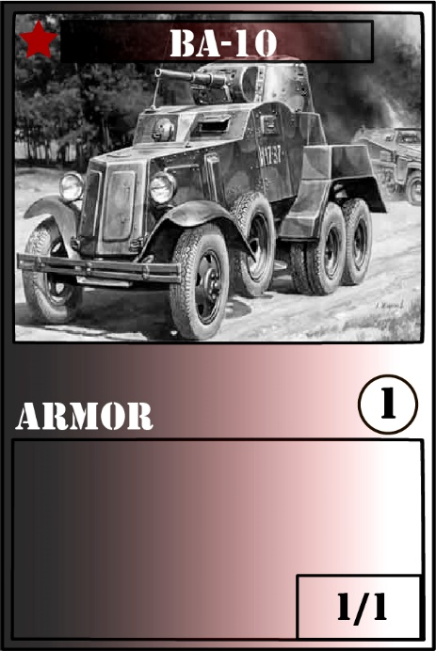

Number of resources needed to play card

Card strength

Card attack

### 3.2.3 infantry card

Infantry card is similar to armor card, with the only difference that it can take the infantry slot of the field.

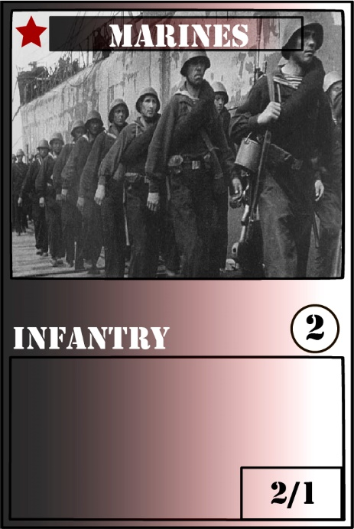

### 3.2.4 Resource card

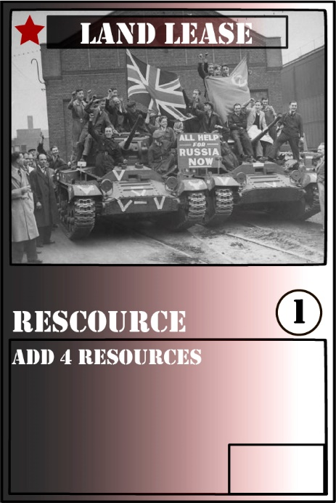Resource card adds resources to player’s bank.

# 4 Application architecture

## 4.1 Business logic

## 4.2 MVC architecture

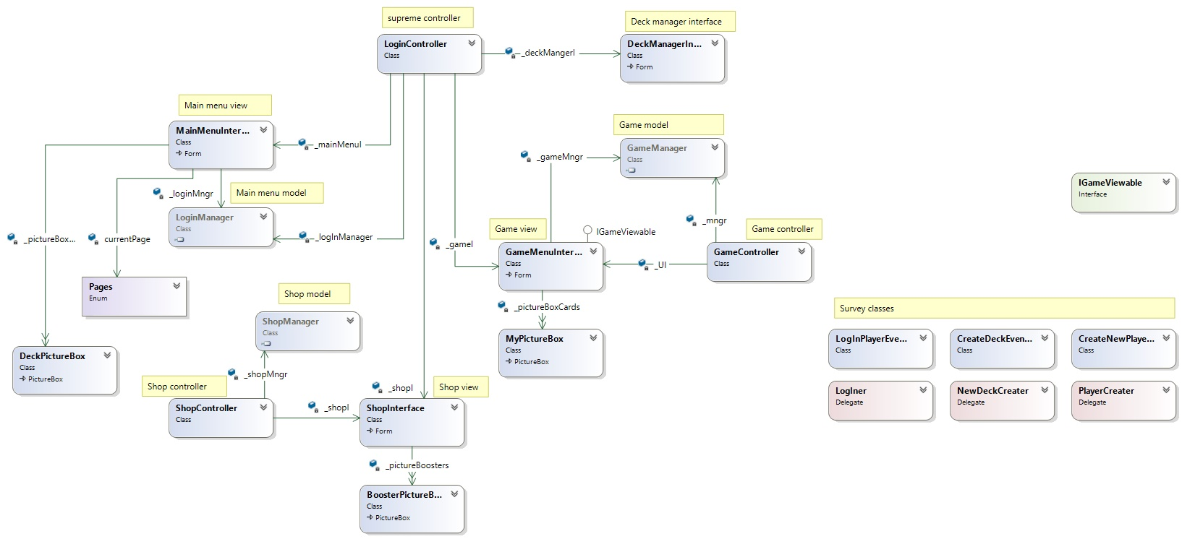

# 5 Technologies used

Languages:

* C#
* SQL

Modelling / Design tools:

* MS Visual Studio 2015
* SQL Server Management Studio
* Adobe Illustrator
* Sybase Power designer

Databases:

* MS SQL Server 2012

Technologies:

* ADO.NET
* Entity framework
* WinForms
* LINQ

Version Control System:

* GIT

# 6 IN Future

Near future:

* Cloud server database relocation
* User-friendly interface
* Design improvement
* More cards
* Better AI logic
* Different boosters
* New nation
* Improved point calculation system

Far future:

* Player vs player game
* New interface, based on WPF
* 4 game nations
* Different play modes