**MAKEREREUNIVERSITY**

**SCHOOL OF COMPUTING AND INFORMATICS TECHNOLOGY**

**P. O. Box 7062, Kampala-Uganda, Tel: +256 414 533332, Fax: +256 414 534125**

**E-mail: ar@acadreg.mak.ac.ug, Website: www.mak.ac.ug**

**NETWORK APPLICATIONS DEVELOPMENT**

**Code : BSE 2205**

**Lecturer : ALEX MWOTIL**

| **NAME** | **REG NO.** | **SIGN** |
| --- | --- | --- |
| MUSUMBA GERALD MICHAEL | 18/U/23407/EVE |  |
| TENDO JECONIAH CALEB | 18/U/23441/EVE |  |
| LAKER SHARON | 18/U/23399/EVE |  |
| TUMUKUNDE BENON | 18/U/23454/EVE |  |

**CONTENT:**

1. Background
2. Problem statement
3. Programmatic approach
4. Structure.

**BAG INVENTORY SYSTEM**

**BACKGROUND OF THE PROBLEM**

Business is one of the major daily sources of income round the country benefiting both the owners and the customers in such a way that the owners earn from it and customers need is to get reliable quality goods such that their money is valued. Tracking the business on the side of the business owner turns out to be a cumbersome in tracking the records of sales and stock manually.

Bag’s shop owners have difficulties in managing there incoming and outgoing stock

**PROBLEM STATEMENT**

1. Sometimes certain types of bags get out of stock, and the shop owners aren’t aware in time which leads to loss of potential customers.
2. At times they tend to tend to stock the same type of bags which are still so many remaining.
3. They also tend to lose a lot of money and customers since they don’t keep very good records of their inventory. Customers will always be disappointed to find their products of interest missing at the specific shops and get into unnecessary expenses of transport and time, besides, the client’s trust in the business / shop will be depreciated killing the business too.
4. It is harder for the business owner to know if he made a profit or loss since there is poor record keeping.
5. Managers might overstock products which are less on demand as compared to consumer wants thus not meaning the required goods on demand and making losses thus mismanagement.
6. Records can get stolen or lost in case of fires, this leads to poor decision making because of inadequate information.
7. It is hard to add, query and search or a given record, this is because the records are kept in hard copies in books.
8. There are a lot of error due to manual entry of record.
9. High costs on manual accounting.
10. Keeping records in books and ledgers is not good as company grows in size.

**PROGRAMMATIC APPROACH**

1. The application enables the business owners to create accounts for their business, login and then manage their businesses’ from the platform taking knowledge of the stock, modifying the items and also putting their specifications with prices for the consumers.
2. The business owners will be given notifications when the bag count of a particular brand reaches bellow a specified threshold so that they can restock in time.
3. Items present are displayed with their details about them, current status for the business sales and items remaining in stock.
4. Once an item is ordered and taken off by the consumer, the stock on the side of the business should be modified and the sales updated.
5. The business owners will be given notifications when the bag count of a particular brand reaches bellow a specified threshold so that they can restock in time.
6. Statistics showing which category of bags are demanded in each month basing on transactions and shall be shown to the managers in form of chart/graph.
7. Statistic of profits vs expenses shall be shown to the user so that he can know if he has made a profit or loss.
8. Forms and tables will be put in place for a simple and fast data entry process and a search field will there to lookup records.
9. Reduction of manual errors due to automation of the processes.
10. Saves staff costs on manual accounting through automated accounting process
11. It will enable scalabilty as the organization grows.
12. Data backup will be carried out occasionally and a copy of the information will be kept in the cloud in case of fires or stolen devices.

**STRUCTURE**

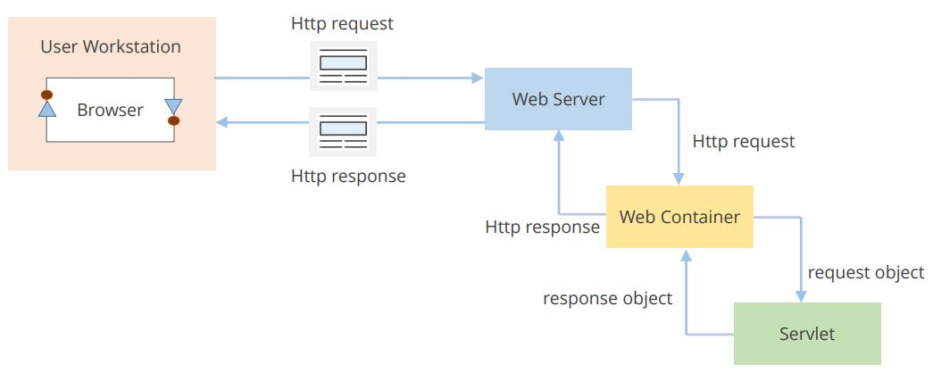Users access the system from there web browsers. They send requests to the web tomcat server which in turn returns the requested object.

The web container is part of the web or application server that support HTTP protocol and manages the execution of the servlets and JSP.

The servlets are used to handle the request obtained from the web server, process the request, produce the response, then send response back to the web server.

**Some of the servlet to be used:**

CreateAccountServlet : this will enable the users to create an account on the system.

LoginSevlet: this will enable users to login into the system.

InStockServlet: this will allow the users to add new stock onto the system.

SalesServlet: this will enable the users to register day to day sales.

StatisticsServlet: this will fetch data from the database and display charts of most in demand goods.