Constant Change Design Document

By: Gerald Anthony, Jr.

# Project Outline

The “Constant Change” project was created using the multiple P5 libraries and a simple Arduino set. The main design aspect of the project was having a theme of constant change.

# Project Description

In order to create the theme of “Constant Change”, I created three different states for the piece. On state create a series of circles that constantly change in size, color, and place on the screen. Each circle bounces around the screen at varying speeds. Another state in the piece is when a group of rectangles spawn and flip constantly at different speeds. The rectangles color is based on a random color which is generated during the circle state. The final state is a state where there are no objects. Each of these states uses a different sequence with different instruments. When an Arduino button is used to activate a state change, a led is activated on the Arduino board.

# Project Showreel

Video of Project - <https://youtu.be/msMSIwK6bI4>

Start Screen -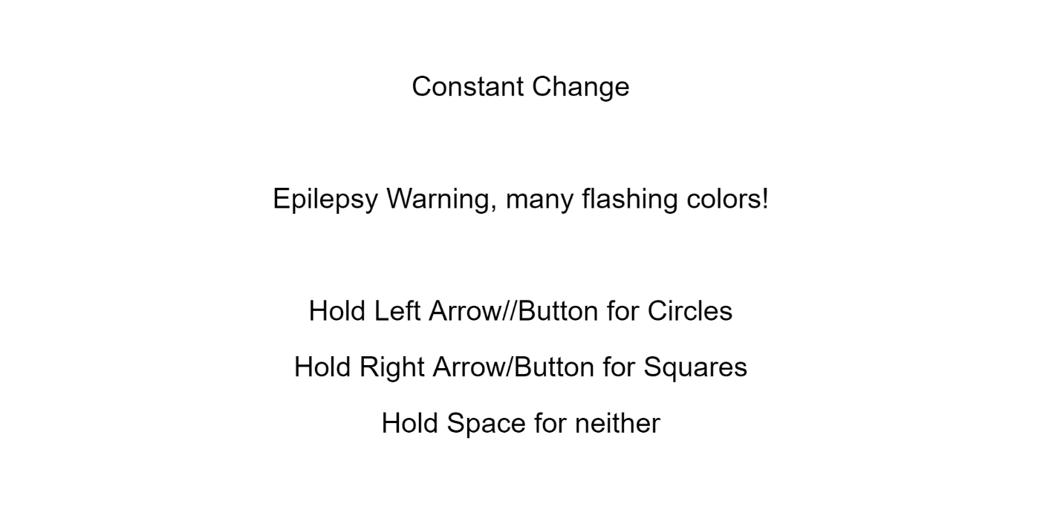

Circle State - 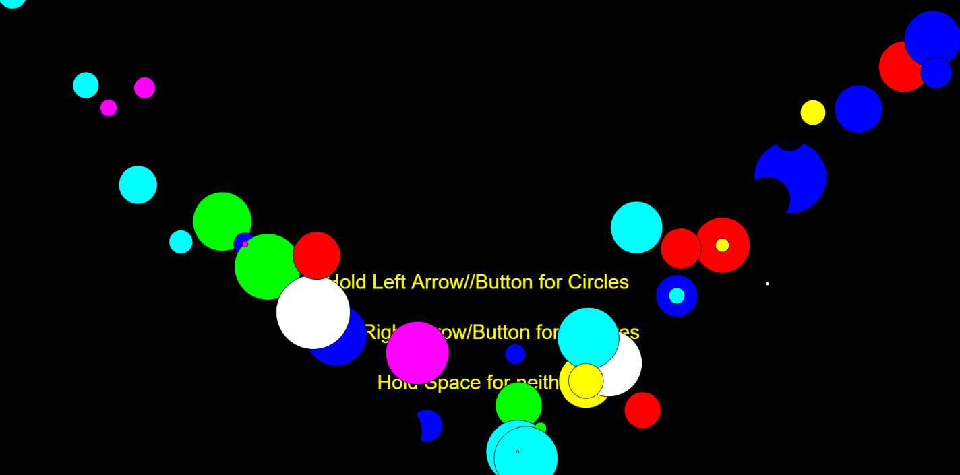

Rectangle State - 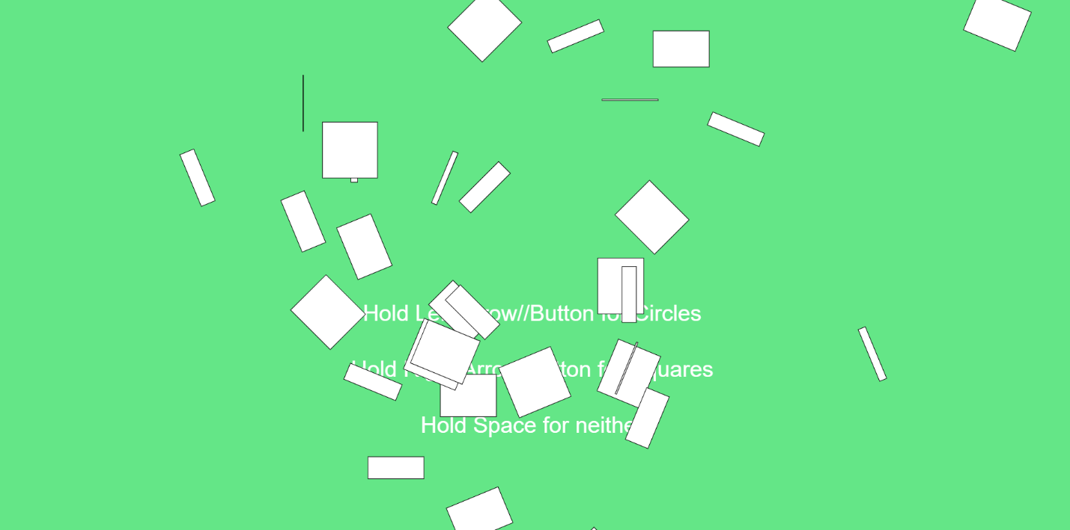

No Object State - 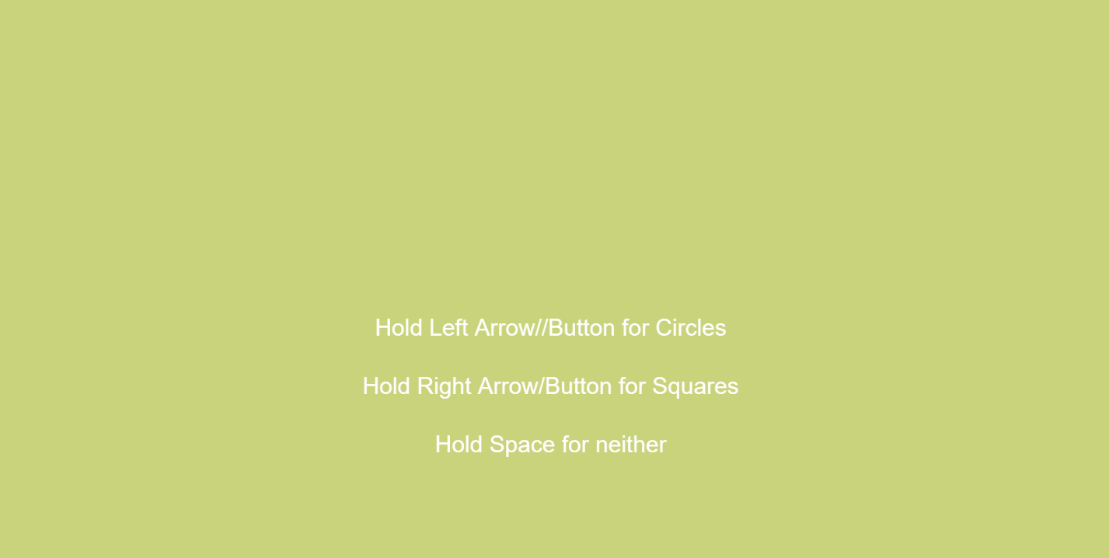

# Project Diagrams

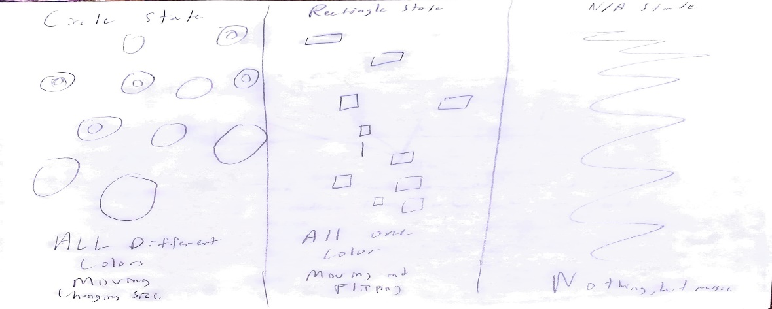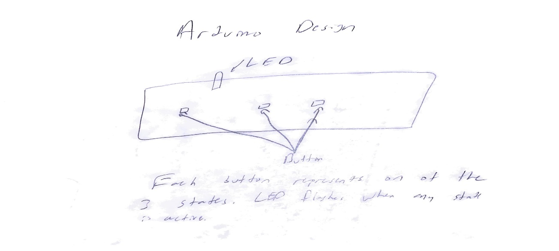

# Future Development

Things I would like to add to this project in the future are different states that utilizes different shapes and transformations along with new unique songs for each state. I would also like too add a state that uses random animated characters.