Price comparison website report

Name: Geraldas Kastauna
SID: M00651656
EMAIL: GK468@live.mdx.ac.uk

Description:
A website that helps its users find and choose the best available laptop price, searching through 5 different online laptop stores. Website design allows quick and easy price comparison between all shops, so customers are able to choose the most suitable option for themselves with a quick redirect to particular store website that they chose.

Website should use the database that was built using scraping application written by the student using Java with frameworks.

Threads:
I scraped the data from 5 different websites:
1. https://www.box.co.uk
2. https://www.ebuyer.com
3. https://www.very.co.uk
4. https://www.laptopsdirect.co.uk
5. https://www.laptopoutlet.co.uk/

Each scraper has its own class (thread) in my java application. The class file name represents the website so its easy to recognise what website the thread is designed to scrape.

Maven:

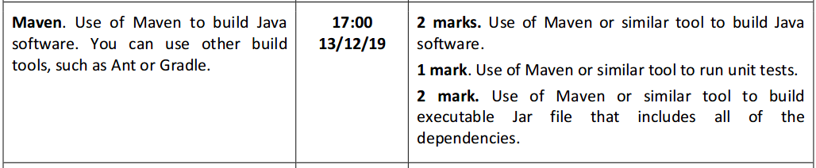
All dependencies required for the scraping application to run can be download with maven by running mvn package. This will also run Java Unit tests and builds an executable Jar file that includes all of the dependencies. See picture below:
Running mvn package
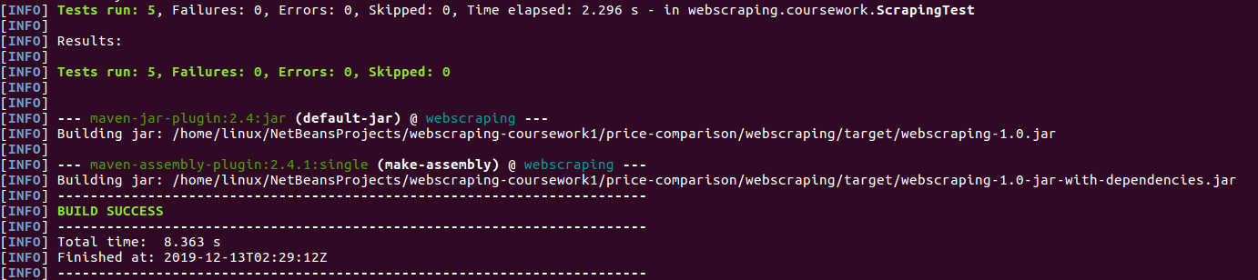

Spring:
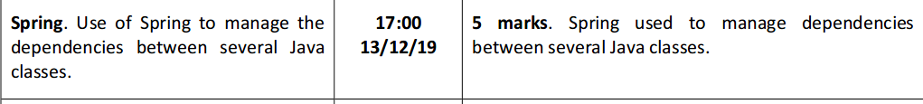
In the Java application AppConfig.java class file I am using Spring “beans” for managing dependencies between several Java classes. Few examples:
https://www.box.co.uk scraper Spring “bean”:

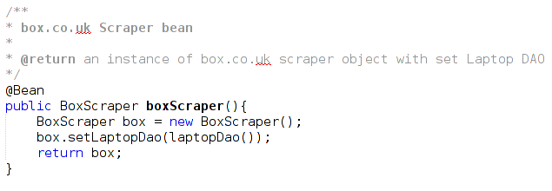

ScraperManager Spring “bean” that holds sends full list of scrapers into ScraperManager class:
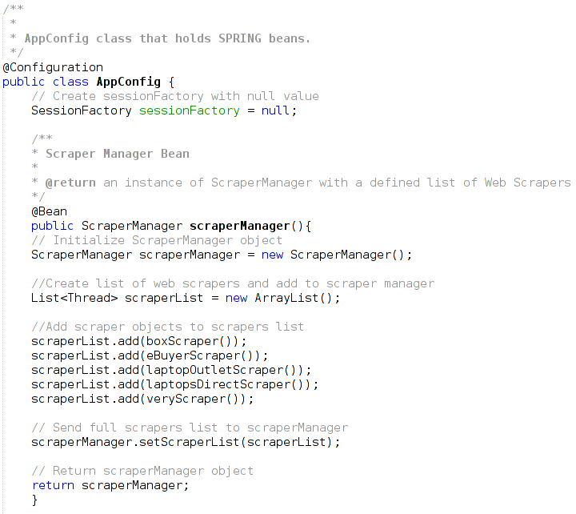

Hibernate:
I used Java Hibernate to store data into MySQL localhost database using Hibernate annotations and foreign key mapping. Hibernate.cfg.xml file with <mapping> set for each class is required if using Hibernate annotations.

Hibernate.cfg.xml:

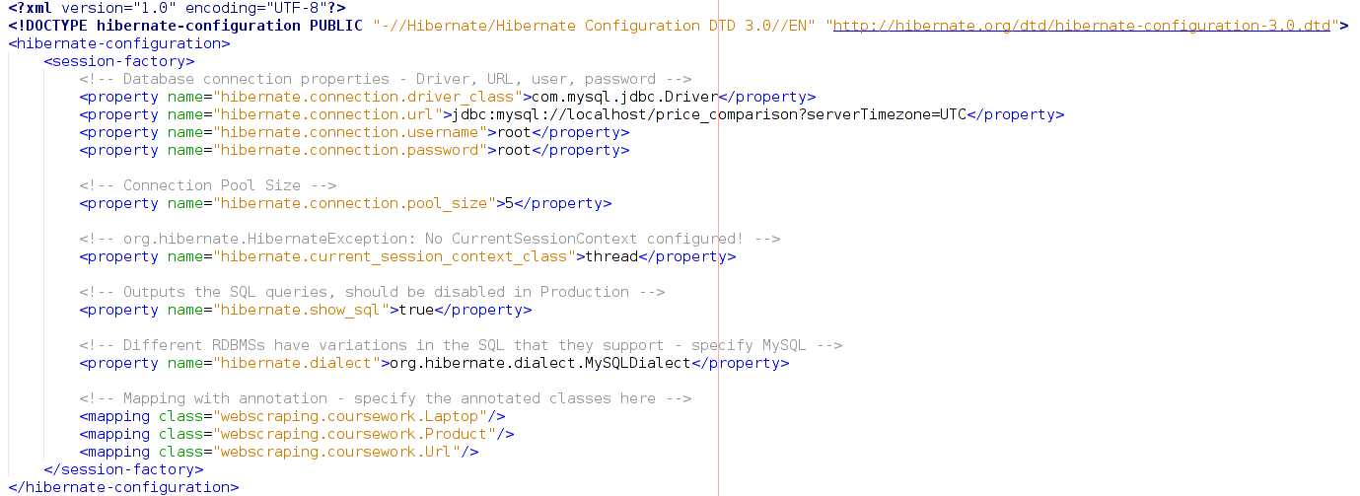
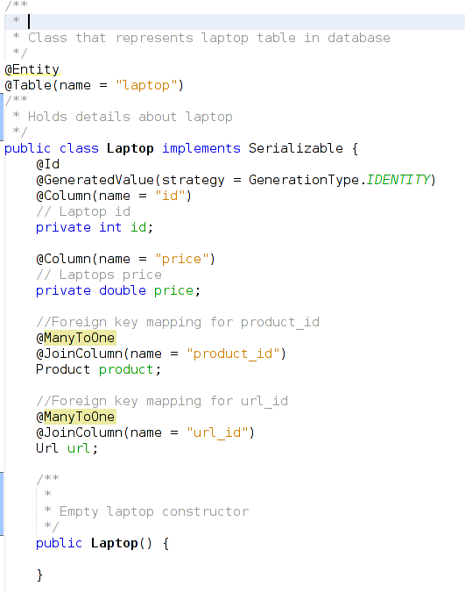

To store the data from the scraper into the MySQL database we need:
1. Create each class object that represents our database.
2. Get new session from session factory.
3. Set elements in the objects.
4. Begin session transaction.
5. Save objects.
6. Commit the transacton.
7, Close the session.

Example:

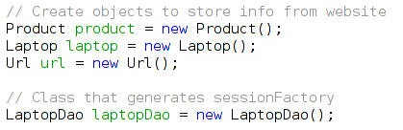
1

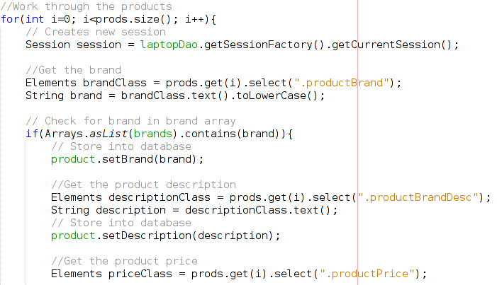

2
3
3

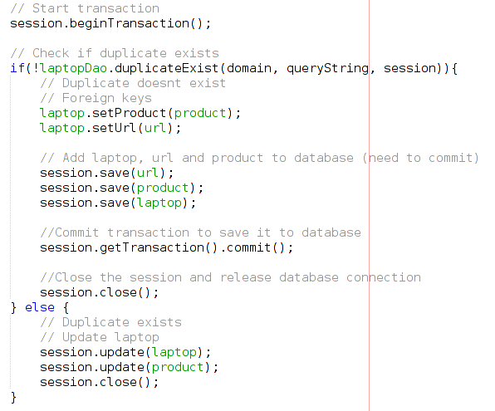
4

3
3

5

6
5
7
7

Session factory (laptop data access object) class:

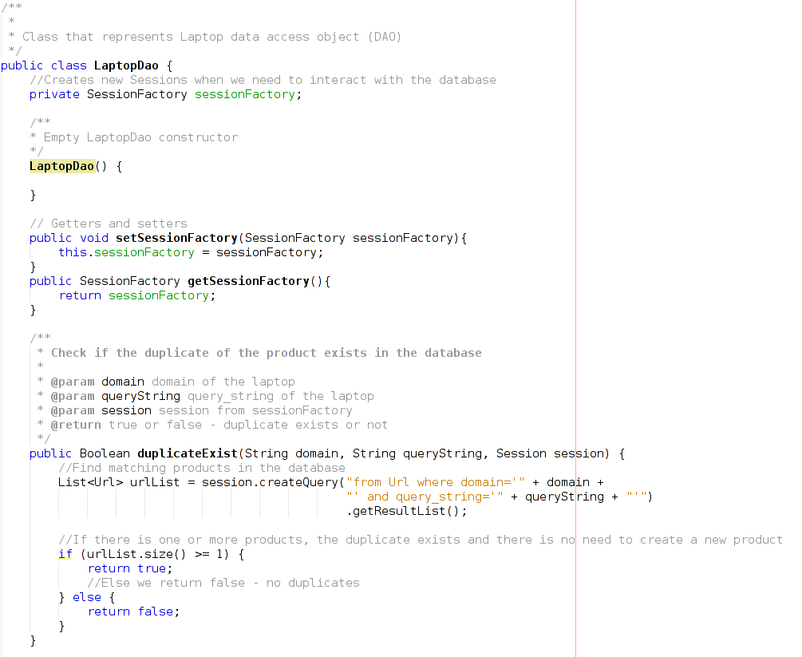

Webscraping:
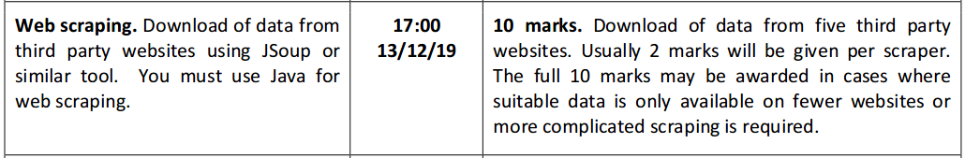
As mentioned before I had 5 scrapers for 5 different websites. Amount of data in the database:

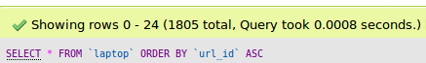

Data:
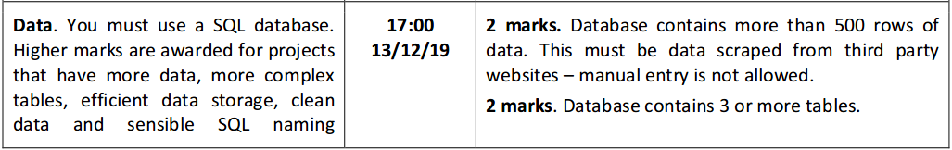
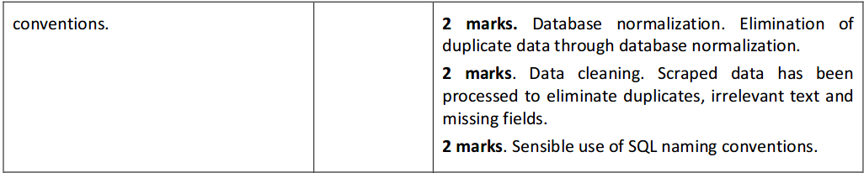
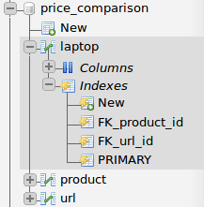
As shwon above amount of data in the database is 1805 total. My database contains 3 tables:

Data cleaning:

Used a method that checks for the same domain and query string combination:
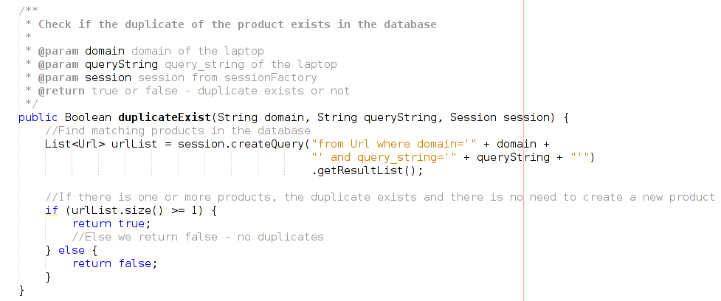

Testing:
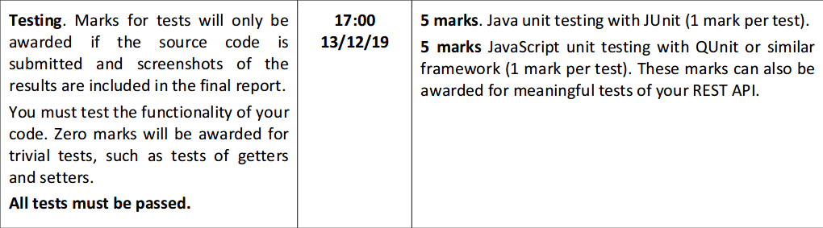
Only Java unit tests were implemented:
Each test name is displayed at the top

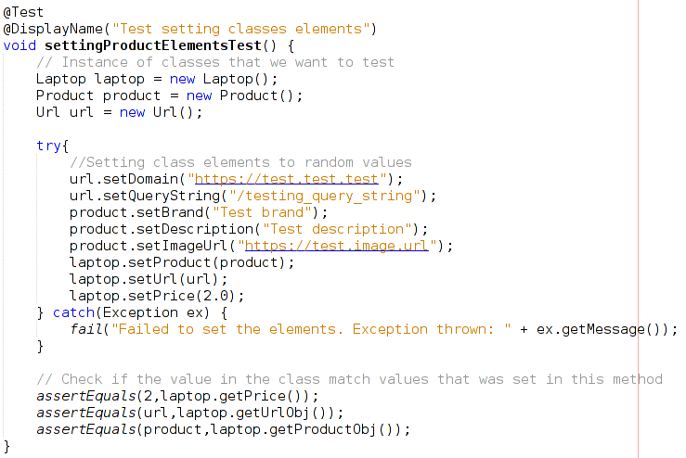
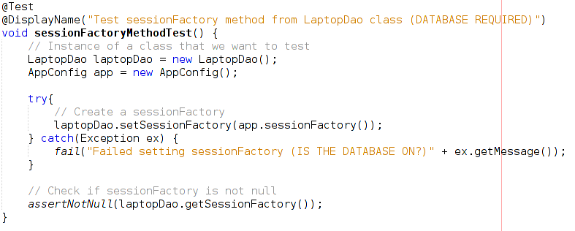

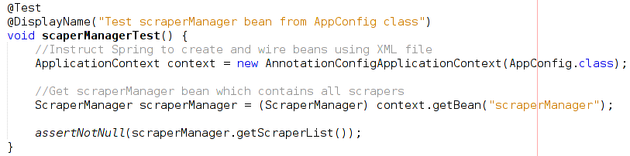

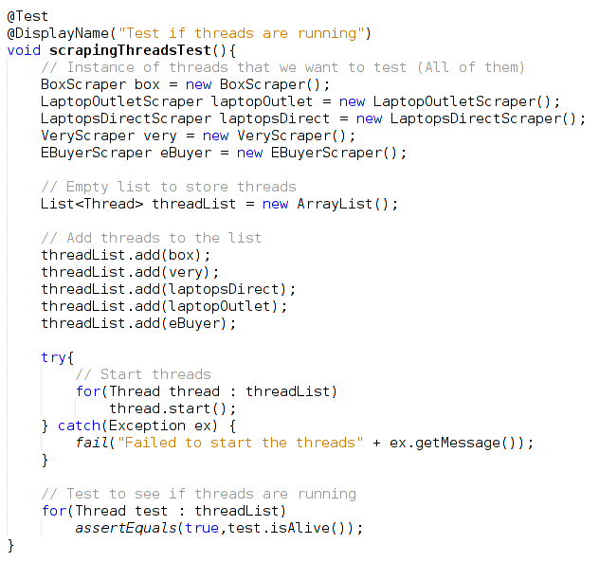

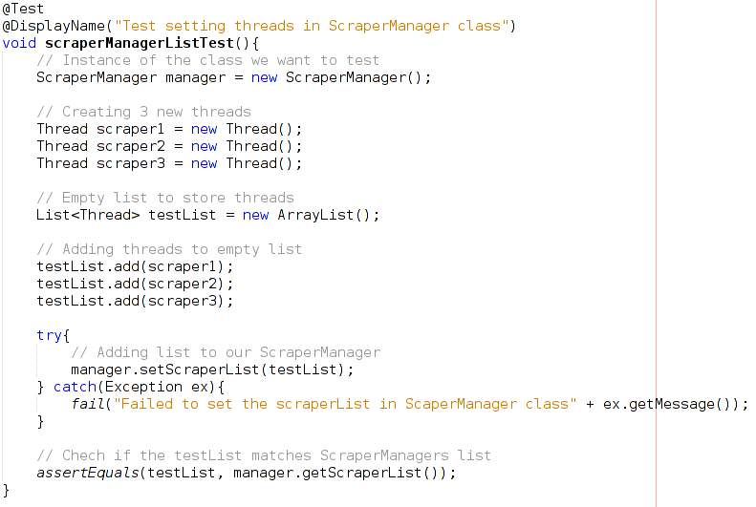

REST API:
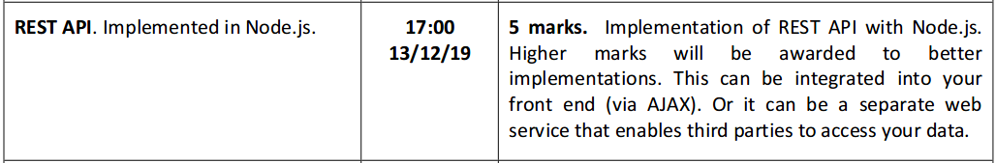
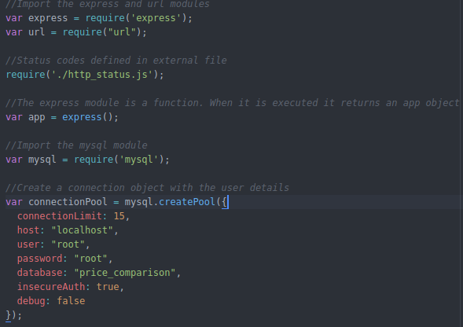
REST API was implemented using Node.js. server.js file in SERVER folder for backend:
var express = require(‘express’);
var url = require(“url”);

Run npm install to install all dependencies from package.json
For back we need to run nodemon server.js command in terminal inside SERVER folder
For client (frontend) connection we need to run npm run serve command in CLIENT folder:
Backend uses port:3000
Frontend uses port:8080

http_status.js:
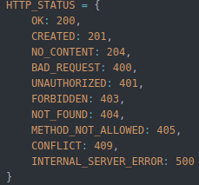

app.js:
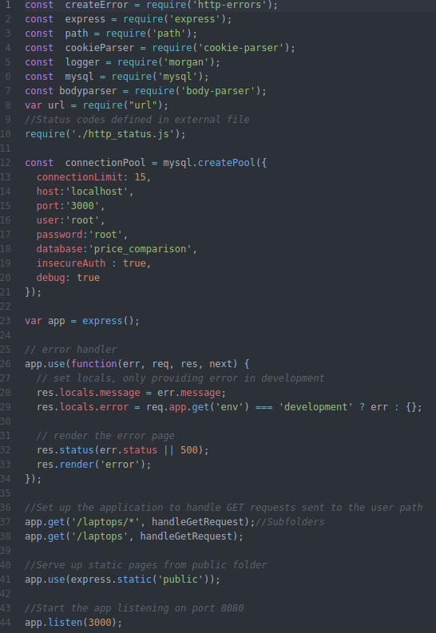

Database on port:3000:
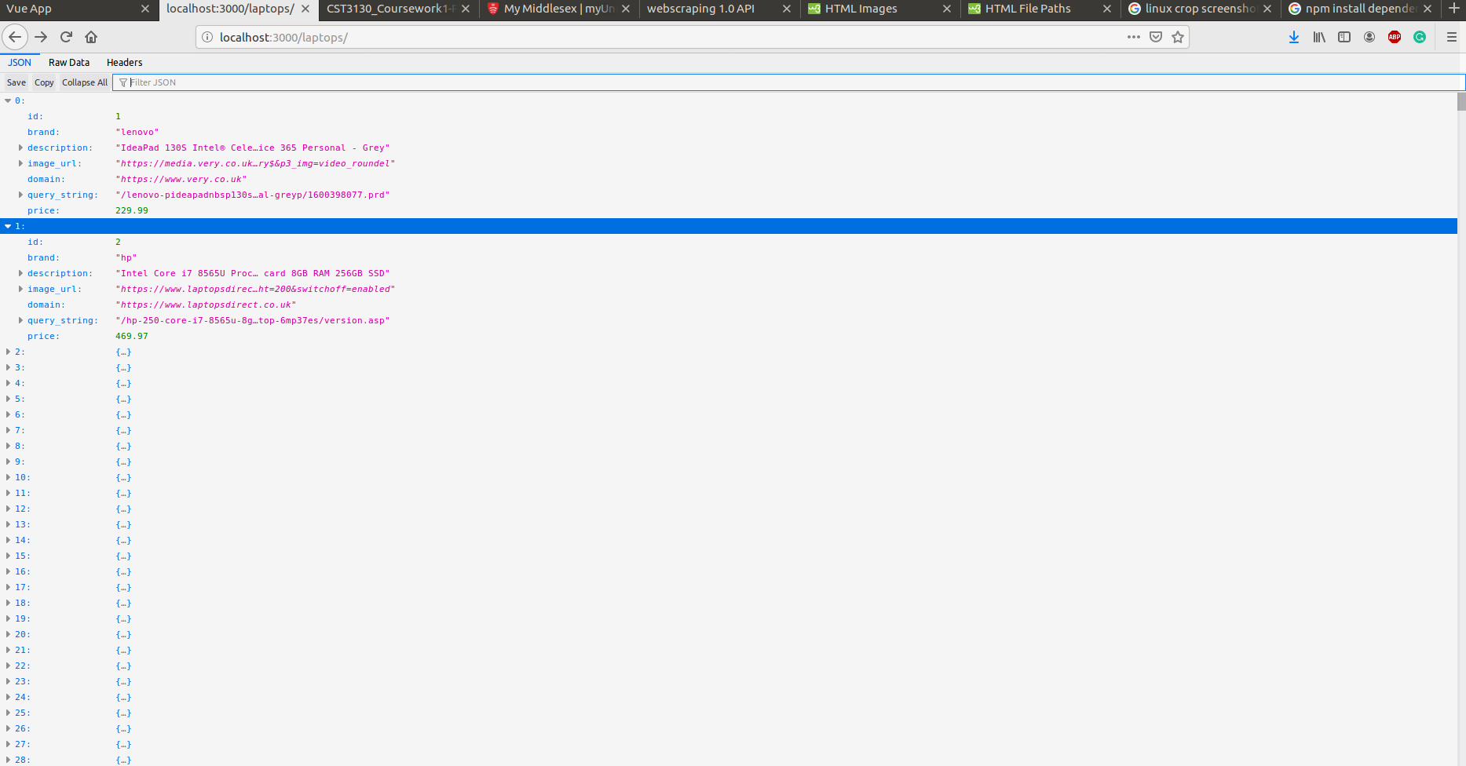

Website:
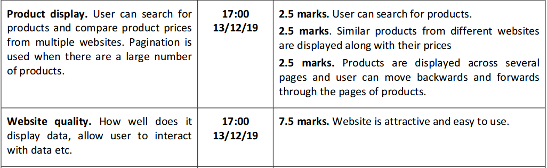
SEARCH WAS NOT IMPLEMENTED
SIMILAR PRODUCTS WAS NOT IMPLEMENTED

Product display;
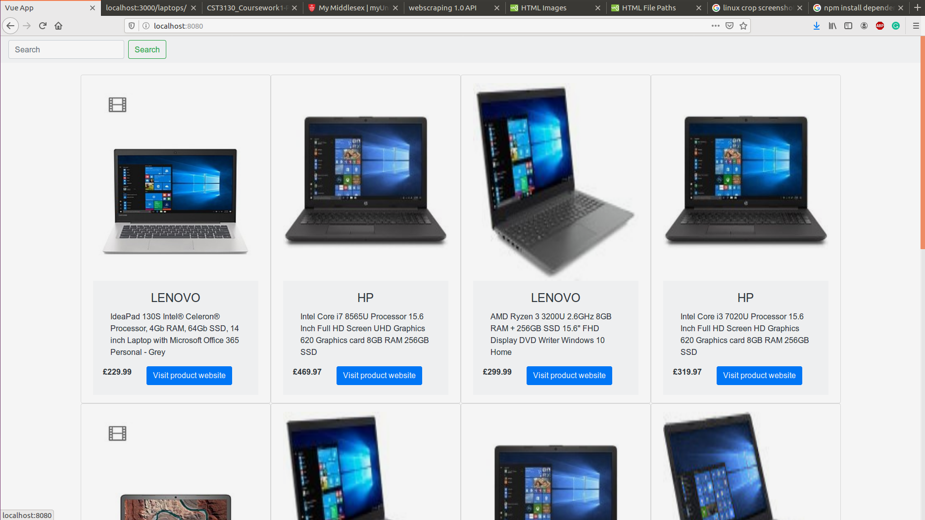

Product display code is located in App.vue

Pagination:

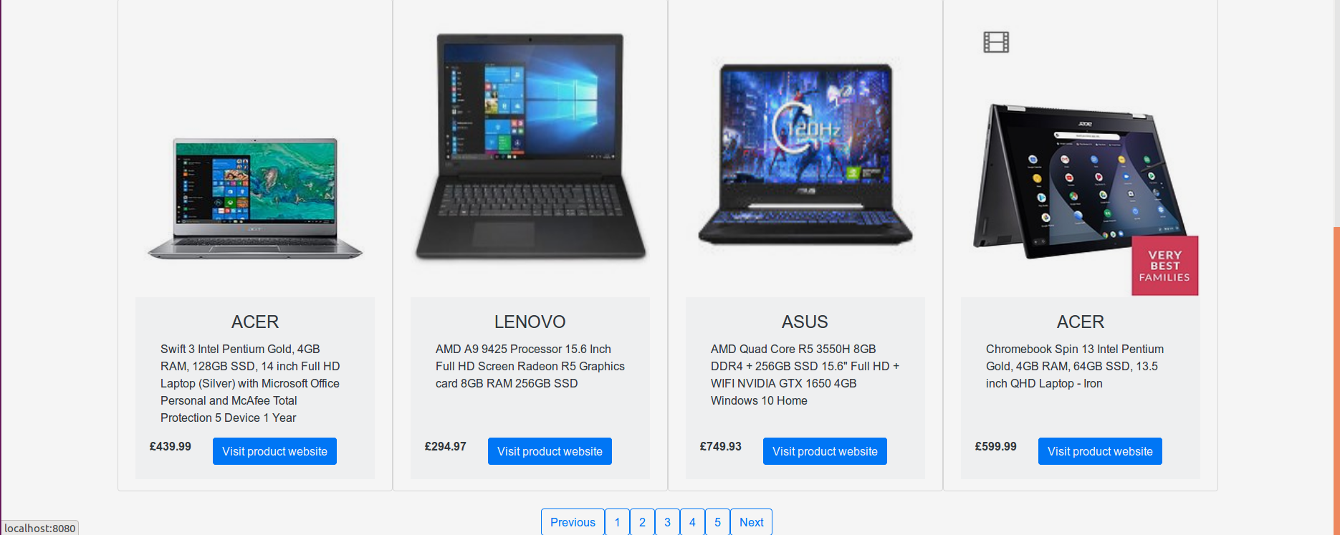
Pagination code is located in App.vue

JAVA API documentation is located in ‘JavaApiDoc’ folder. Start from index.html.

Database diagram:

