- .A local business in Pampanga
SINGKU CAFÉ
- The business official website
https://l.facebook.com/l.php?u=https%3A%2F%2Fwww.instagram.com%2Fsingku.cafe&h=AUAPO8wb7A_ual0t67AmCqi4YQMAjTBbr8x882IEs6Ovcy5gb6iHSuqQuQ0dgS5yD_ZJx0uuzdbiJh8-5Bf1Kq1dkGKFlMUmuwrfQvfyC_hDillEkHoEZdNj-puvrFhuVJ9Air5NsiLnhfIDDaI-wA
- Their facebook page
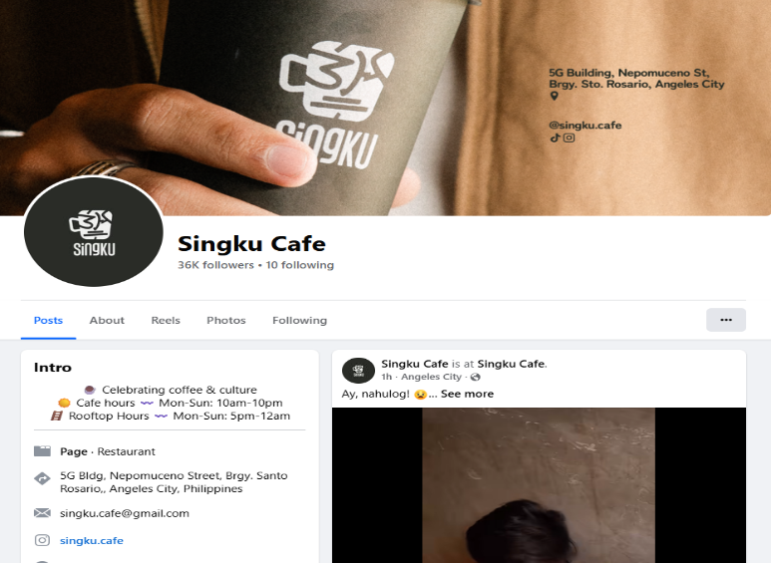
- Their contact number
0994 417 2569
- Their products or services
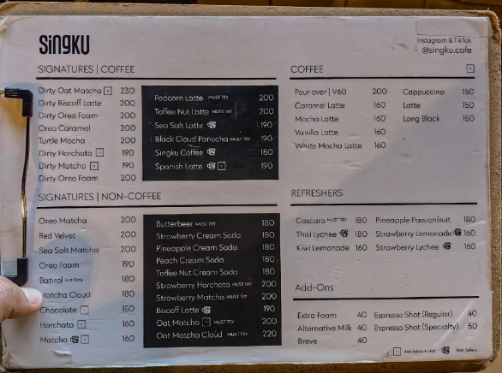
- Their business address
5G Bldg, Nepomuceno Street, Santo Rosario St, Angeles, 2009 Pampanga
- Their google rating
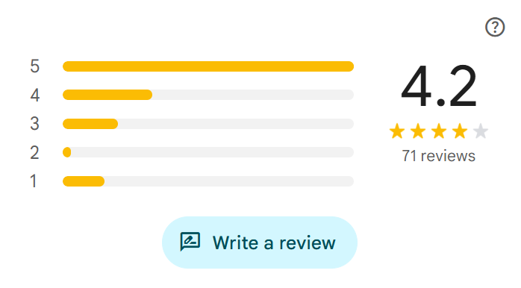

- One interesting about the business



QUESTIONS:
- WHAT IS THE CURRENT INFLATION RATE IN THE PHILIPINES?
The Philippines' headline inflation rate eased to 6.8% in May 2026, down from 7.2% in April. This brings the national average inflation rate for the first five months of 2026 to 4.5%. [1, 2]
- WHAT IS T HE SECRETARY OF THE DEPARTMENT OF TRADE AND INDUSTRY?
The current Secretary of the Department of Trade and Industry (DTI) in the Philippines is Maria Cristina "Cris" Aldeguer-Roque. Appointed by President Ferdinand R. Marcos Jr., she heads the department, advises on economic and trade policies, and serves as a member of the Cabinet. [1, 2, 3, 4]
3. FIND ONE ONLINE BUSINESS THAT STARTED DURING THE PANDEMIC?
Sari-sari store.


4. WHAT IS THE MEANING OF MARKET RESEARCH?
Market research is the systematic process of gathering, analyzing, and interpreting information about a target market, consumers, and competitors. It helps businesses understand who their buyers are, what they need, and why they make purchasing decisions, enabling companies to launch products and tailor marketing strategies with confidence. [1, 2, 3]
5. FIND THE OFFICIAL WEBSITE OF THE BUREAU OF INTERNA; REVENUE (BIR)
https://www.bir.gov.ph/home.

QUESTIONS:
WHY IS THE INTERNET RESEARCH IMPORTANT IN BUSINESS?
(CHATGPT)
Internet research is important in business because it provides accurate and up-to-date information that helps companies make informed decisions. It allows businesses to understand customer needs, analyze competitors, identify market trends, improve marketing strategies, reduce risks, and discover new opportunities for growth. By using reliable online information, businesses can stay competitive and adapt to changes in the market.
WHY IS THE INTERNET RESEARCH IMPORTANT IN BUSINESS?
(GEMINI)
Internet research is important in business because it provides immediate, cost-effective access to global data on competitor strategies, customer preferences, and emerging market trends, allowing companies to make smarter, data-driven decisions that minimize risk and maximize growth.

COMPARISON BETWEEN CHATGPT AND GEMINI IN WHY IS THE INTERNET RESEARCH IMPORTANT IN BUSINESS?
Comparison between ChatGPT and Gemini
Both ChatGPT and Gemini explain the importance of internet research in business, but they differ in their writing style and focus. ChatGPT provides a more detailed and easy-to-understand explanation by listing several benefits, such as understanding customer needs, analyzing competitors, identifying market trends, improving marketing strategies, reducing risks, and discovering growth opportunities. Its response is well suited for students and educational purposes because it uses simple language and offers a comprehensive explanation.
In contrast, Gemini presents the same idea in a shorter and more professional manner. It emphasizes immediate and cost-effective access to global data, customer preferences, competitor strategies, and market trends, while highlighting the importance of making data-driven decisions that minimize risk and maximize growth. Although Gemini's response is more concise and impactful, it includes more business-oriented terminology and fewer supporting details.
Overall, ChatGPT is better for readers who need a clear and detailed explanation, while Gemini is more appropriate for professional or business contexts where a brief

ANSWER THE QUESTIONS:
- WHICH ANSWER WAS EASIER TO UNDERSTAND?
For me is chat CHATGPT because it give me a lot of answer and define me every bullet so that I can understand easier.
- WHICH SOURCE GAVE MORE DETAILED INFORMATION?
For me CHATGPT because give me all her thougth about my question so I can understand and easier to think more knowledge.

