Report

-The program is written using some functions of C++ as well.
- The link given was used as a basis for the rest of the work done. The code was taken as is, and my current solution was built on it.
- The final solution is designed to display packets with substantial amount of information. The packets displayed in details are ‘UDP’, ‘TCP’, ‘ICMP’, and ‘ARP’. The rest of the packets are also displayed, but without all the little details. Hardware information such as mac addresses (as advised by the professor), timestamps (in the ISO format), length, and type are displayed for all. In cases other than the ones mentioned, the payload is printed directly.
- This program is written to only recognize Ethernet packets.
-The user is free to “sniff” on a live interface or a file. The two cases are mutually exclusive and in the event that a user enters both options, precedence is give to the option that appears first. The second option is discarded.
-The file is a PCAP file. The one used in the previous homework was used for testing purposes here as well.
-The program was tested on two different Ubuntu (14.04 and 16.04) machines and was found to be working correctly. The 16.04 was running on Virtual Box running on Windows 10.
-The output is in the format specified by the professor. Only the ARP packets are displayed a little differently than the others.

-Coming to the program itself, new structs were defined for the UDP, ARP and ICMP headers.
-There is a function for string comparison, but the operations were later moved to a different part of the code. It does no serve any purpose here.
-The majority of the work was done in the got_packet() function.
- First, I checked for an ARP packet. If an ARP packet was found, no more checking was required, and further packets were examined.
-Next was the broad category of IP files. Cases were checked for UDP, TCP, ICMP and others. In case of the first three, more information was printed, for the others, the entire payload was printed as it is.
- In the middle of this, the case of string matching was also implemented. If the user had specified a string to be searched for, then the printing of packets would only commence if the string was found in the payload. (The payload string was evaluated by only accepting printable characters. The non-printable characters were replaced by “ . ”).

-The main function, takes output in a different number of ways. The only thing to be observed here is that if there are any BPF filters, all of them must appear together towards the end of the command. The “-i”, “-r”, “-s” are interchangeable in their positioning.
- Most invalid inputs are taken care of. The execution is stopped when there is such a scenario.
-The execution continues indefinitely, until we reach the end of the file or the user stops the execution of the live capture.

Some example outputs are displayed below:

1. sudo ./tcpdump -r sample.pcap {only first few can be displayed}

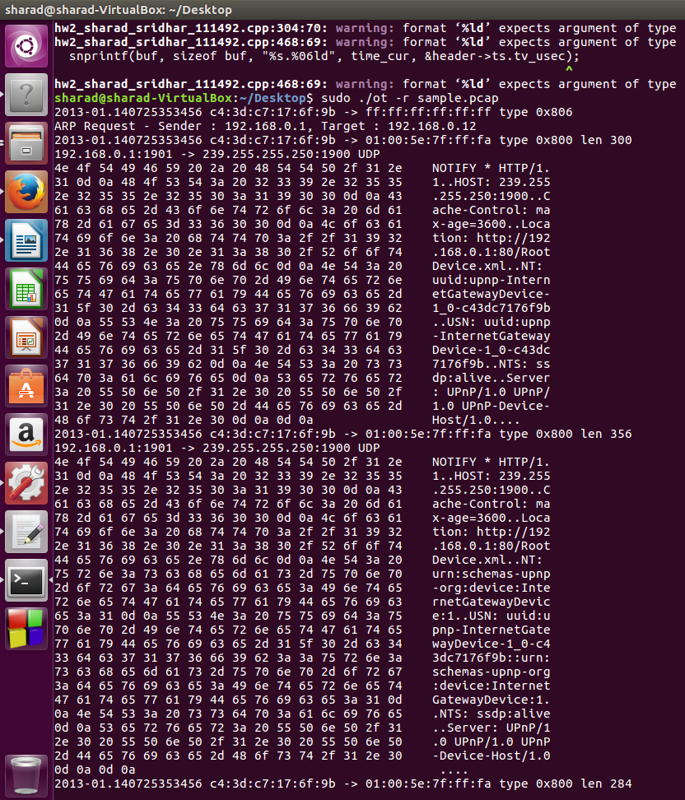

2. Live capture: sudo ./mydump -s reddit ip {string to be searched is reddit, and an IP filter is applied}

