Good morning everyone, welcome to the session. In this demo, I am going to walk you through Spark architecture and Azure Databricks. We will look at cluster creation, notebooks, SQL commands, and also go deeper into Delta Lake and Medallion Architecture. Along the way, I will explain the key architectural concepts that senior data engineers and architects should know.
Let us first set the foundation with some key definitions.
What is Apache Spark
Apache Spark is a open-source, in-memory, distributed computing framework designed for big data processing in parallel. It supports languages such as Pythan, Scala, Java, SQL and R.
Apache Spark is a unified analytical engine as provides one single engine that can handle various types of big data workloads such as batch processing, streaming, machine learning, sql analytics and graph processing.
SQL Engine:
When a user runs multiple cells in an Azure Databricks notebook with a series of transformations, Spark does not execute them immediately. This is because Spark follows lazy evaluation. Each transformation such as select, filter, or join is simply recorded as part of a logical plan inside the driver, but the actual computation is deferred. Only when an action such as .show(), .count(), or .write is called does Spark trigger the execution. Lazy evaluation allows Spark to look at the entire lineage of transformations before execution and apply global optimizations.
At this point, the SQL Engine begins its full lifecycle. The first step is to create an unresolved logical plan, which is a direct representation of the user’s code without knowing whether column names or table names actually exist. This plan is then transformed into a resolved logical plan, where Spark consults the catalog and metadata to verify references and resolve them to actual schema definitions. Once resolved, the plan goes through a series of optimizations.
The Catalyst Optimizer is the heart of Spark’s SQL Engine. Its job is to improve the query before execution. Catalyst performs three major functions. First, it applies Rule-Based Optimizations (RBO). These are standard rewrite rules like constant folding, predicate pushdown, null propagation, and projection pruning that simplify the plan and reduce unnecessary operations. Next, if table and column statistics are available, Catalyst performs Cost-Based Optimizations (CBO). Here, different strategies are evaluated based on estimated cost, and the most efficient execution plan is selected. For example, if one side of a join is very small, the optimizer may choose a broadcast join instead of a shuffle join. After these optimizations, the result is an optimized logical plan. This plan is then converted into a physical plan, which represents the actual execution strategy. Finally, the physical plan is transformed into an RDD lineage graph, which expresses the computation at Spark’s core RDD level. At this point, Tungsten comes into play with execution-level optimizations such as whole-stage code generation, vectorized processing, and memory management to make the execution as efficient as possible.
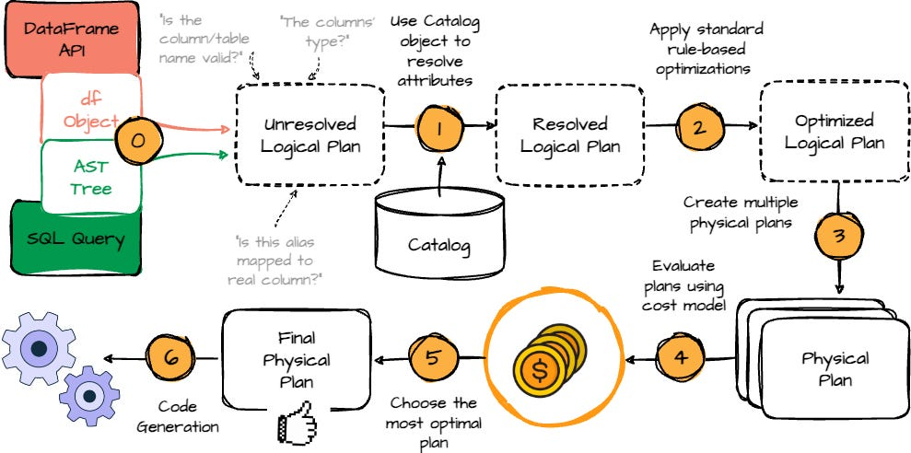
Will transformations create multiple copies of RDDs in memory:
In PySpark, each DataFrame transformation does not create a full in-memory copy. Transformations are lazy; Spark builds a lineage graph of RDDs, where each RDD stores the transformation function and references to parent RDDs, not the data itself. Actual computation occurs only when an action (e.g., show(), count()) is invoked. For memory efficiency, Spark executes tasks partition by partition and store intermediate results in memory or spilling to disk if needed. It Cache/persist an RDD stores its computed data once for reuse.
Scheduler:
With the plan ready, the Scheduler takes over. The RDD lineage is submitted to the SparkContext, which is the entry point and the master coordinator of the Spark application. SparkContext passes the lineage to the DAGScheduler, which breaks the computation into stages at shuffle boundaries and builds a Directed Acyclic Graph of stages. Each stage is expressed as a set of tasks and submitted to the TaskScheduler. The TaskScheduler is responsible for assigning tasks to resources, but it does not manage resources directly. Instead, it works with the SchedulerBackend, which communicates with the Cluster Manager.
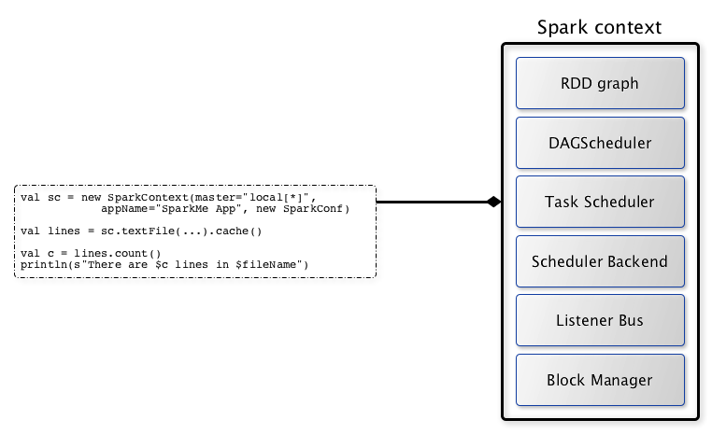

Cluster Manager:
The Cluster Manager is responsible for allocating resources such as executors, CPU cores, and memory. When multiple applications demand more resources than the cluster has, the cluster manager performs resource negotiation. In Databricks, autoscaling may add nodes to increase capacity. In other environments like YARN or Kubernetes, scheduling policies such as FIFO or Fair Scheduling are applied. This ensures resources are shared fairly or based on priority. The driver, through the SchedulerBackend, negotiates with the cluster manager to acquire executors. Once granted, tasks are shipped to executors.
Executors:
Executors are the worker processes running on the cluster nodes. They are responsible for fetching data from storage such as ADLS, Delta, or Parquet, executing the transformations defined in the physical plan, and either returning results to the driver or writing output back to storage. As tasks complete, results and status updates flow back from executors to the SchedulerBackend, then to the TaskScheduler, then to the DAGScheduler, and finally to the SparkContext, which delivers the outcome to the notebook cell.
In Spark, executors communicate with both the driver and the cluster managers.
Executor → Driver
Executors send detailed task-level information back to the driver, including:
- Task status (running, completed, failed)
- Task metrics (time taken, bytes read/written, CPU/memory usage)
- Shuffle and stage metrics (records read/written, spill size, shuffle fetch time)
- Accumulator updates (counters or sums for job-level metrics)
- Logs or exceptions in case of task failures
This allows the driver (via DAGScheduler and TaskScheduler) to monitor progress, handle retries, update stages, and eventually return results to the user.
Executor → Cluster Manager
Executors report heartbeat and resource health information to the cluster manager, including:
- Executor liveness (alive or dead)
- Resource usage (CPU, memory, disk)
- Node health and availability
The cluster manager uses this information to:
- Detect failed executors and restart them if needed
- Track cluster resource availability for scheduling new executors
- Make decisions for dynamic allocation when scaling the cluster up or down

Failure handling:
Failure handling is an important part of the lifecycle. If a task fails because of a transient error or data issue, the TaskScheduler retries it on another executor, and Spark recomputes the lost partition from lineage. If an executor itself fails due to node crash or out-of-memory errors, the cluster manager informs the driver, and Spark reschedules the unfinished tasks on other executors. Dynamic allocation may also provision new executors to replace failed ones. However, if the driver fails, the entire Spark application stops because the driver holds the SparkContext, the DAG, and all coordination logic. In client environments like Databricks notebooks, the job must be manually restarted. In cluster-managed deployments such as YARN or Kubernetes, the driver may be restarted automatically, but still the application must reinitialize.
What is speculative execution
Speculative execution in Spark re-launches slow or “straggler” tasks on other executors. The earliest finishing attempt’s result is used, improving performance in skewed or unreliable cluster conditions.
Speculative execution is disabled by default in Azure Databricks because it introduces overhead (Extra Resource Consumption, Unnecessary Task Duplication, Cluster cost) that can negatively affect small or interactive workloads, which are common in notebooks.
FIFO vs Fair scheduler:
Databricks defaults to FIFO for simplicity, uses fair scheduling for multi-tenant workloads.
The Fair Scheduler is designed to share cluster resources fairly among multiple jobs or pools so that no single job monopolizes the cluster. Spark divides available executor slots into pools, and each pool gets a minimum guaranteed share of resources. Within a pool, tasks from different jobs are scheduled in a round-robin or weighted fashion to ensure fairness.
Transformations and Actions:
In Spark, operations on data are classified into transformations and actions, which define how Spark executes computations.
Transformations are lazy operations that create a new DataFrame or RDD from an existing one without executing any computation immediately. They build a logical plan that Spark records for later execution.
Examples include map, filter, select, withColumn, groupBy, and join. Because transformations are lazy, multiple transformations can be pipelined together, and Spark only computes them when an action is triggered.
- Narrow transformations process data within a single partition without requiring data to be shuffled or redistributed across partitions. Ex: SELECT, WITHCOLUMN, FILTER, UNION, DISTINCT, ORDER BY,
- Wide transformations require data to be shuffled or redistributed across partitions.
Exa: Sort() or OrderBy() both are same. GroupBy(), Join(), Repartition(), distinct(), dropduplicates(),
Note: Wide transformations leads to shuffles (and stages in job).
Actions are operations that trigger execution of the transformations. They produce a result to the driver or write data to external storage. When an action is called, Spark optimizes the entire lineage of transformations using the Catalyst optimizer, generates the physical plan, and schedules tasks on executors. Examples of actions include collect, count, show, take, write, and saveAsTable.
Common Actions:
- count(): Gets the total number of rows in a DataFrame or RDD.
- collect(): Retrieves all rows of a DataFrame or RDD as a list.
- show(): Displays a preview of the first few rows of a DataFrame.
- save(): Writes the DataFrame to external storage (e.g., a file).
- take(n): Returns the first n rows of a DataFrame or RDD.
- first(): Returns the first row of a DataFrame or RDD.

In Apache Spark, a shuffle is a process that redistributes data across a cluster. It's a critical but costly operation because it involves moving data over the network and writing to disk. Shuffling is a consequence of certain transformations that require data to be grouped or aggregated.
In Apache Spark, there are four core abstractions for working with distributed data:
- RDD (Resilient Distributed Dataset)
The RDD is the fundamental building block of Spark Core. It is an immutable, distributed collection of objects partitioned across the cluster. Each RDD keeps track of its lineage, which is a record of the sequence of transformations that created it. This lineage allows Spark to recompute lost partitions in case of failures, making RDDs fault-tolerant.
- DataFrame
A DataFrame is a higher-level abstraction built on top of RDDs, designed for working with structured and semi-structured data. It organizes data into named columns with types, similar to a table in a relational database. DataFrames provide SQL-like operations, such as select, groupBy, and join, and are optimized internally using the Catalyst query optimizer.
- Spark SQL
Spark SQL is the module that allows querying structured data using standard SQL syntax. Behind the scenes, Spark SQL queries are converted into DataFrame operations, which are then optimized using the Catalyst engine.
- Dataset
Datasets are a typed extension of DataFrames available in Scala and Java. They combine the benefits of RDDs (type-safety and functional operations) with DataFrames (Catalyst optimization). In PySpark, Datasets are not available.

What is Azure Databricks
Azure Databricks is a managed Apache Spark platform on Azure. It is a first-party service, meaning it is natively integrated into Azure. It provides a collaborative environment for data engineers, data scientists, and business analysts to work together on various big data use cases.
Azure Databricks has a control plane, which is managed by Databricks, and a data plane, which runs inside your Azure subscription. The control plane takes care of notebooks, jobs, cluster configuration, and authentication. The data plane is where your Spark clusters actually run, and this is inside a managed resource group that Azure creates automatically. Whenever you create a workspace, Azure also provisions a managed resource group — in this group, the VMs, disks, and networking objects for your clusters are created. This ensures isolation and security, but at the same time, Databricks manages the lifecycle of those resources.
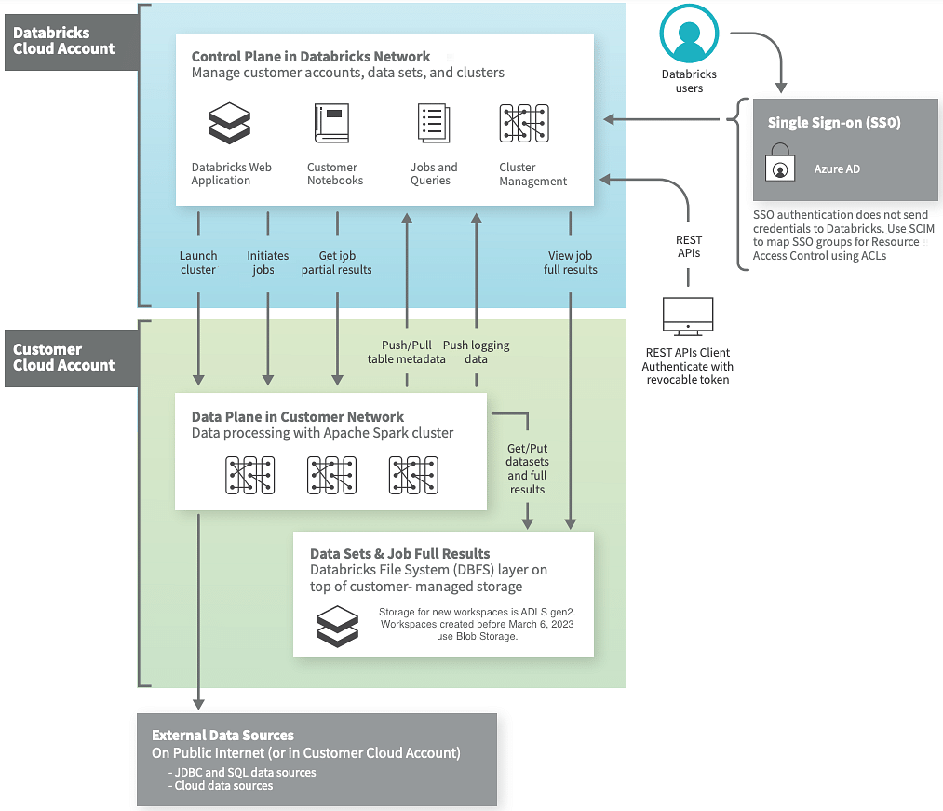
A Cluster in Databricks is a set of virtual machines running Spark. It has a driver node and worker nodes. The driver hosts the SparkContext, coordinates jobs, and manages metadata. Worker nodes run executors that handle the actual computation. When you create a cluster in Databricks, it provisions these VMs in your subscription’s managed resource group. You can configure things like the runtime version, VM size, autoscaling, spot instances, and termination policies.
What is Data lake:
A Data Lake in Azure is a centralized storage repository that allows you to store structured, semi-structured, and unstructured data at any scale. It is built on Azure Data Lake Storage (ADLS) Gen2, which provides high-performance, secure, and cost-effective storage with hierarchical namespace, access control, and integration with Azure analytics services like Databricks, Synapse, and Azure Data Factory.
Data lakes support batch and streaming ingestion, enable big data analytics, and serve as the foundation for building modern data pipelines and architectures like Medallion Architecture.
What is Delta lake
Delta Lake is a storage framework built on top of a data lake (such as adls) that provides ACID transactions, schema enforcement, time travel, and reliability for big data pipelines. It stores data in Parquet files and maintains a _delta_log transaction log that records every operation, such as inserts, updates, deletes, or schema changes. When Spark reads a Delta table, it automatically reads the latest consistent snapshot using this log. This ensures that even if multiple jobs are writing at the same time, your data remains correct and consistent.
Delta Lake also supports schema enforcement and schema evolution, meaning any write operation is validated against the defined table schema, and changes can be safely applied without corrupting the table. Time travel allows querying a table as it existed at a previous version, which is critical for audits, debugging, and incremental processing.
[Delta Lake is an open-source storage framework that enables building a format agnostic Lakehouse architecture with compute engines including Spark, PrestoDB, Flink, Trino, Hive, Snowflake, Google BigQuery, Athena, Redshift, Databricks, Azure Fabric and APIs for Scala, Java, Rust, and Python. With Delta Universal Format aka UniForm, you can read now Delta tables with Iceberg and Hudi clients.]
Medallion architecture:
Medallion architecture is a data design pattern used to logically organize data in a data lakehouse. The goal of this architecture, which was coined by Databricks, is to incrementally improve the quality and structure of data as it flows through distinct layers. This multi-layered approach helps to build a single source of truth for an organization's data.
The architecture is typically composed of three distinct layers, or "zones," which are named after the quality of the data they contain
- Bronze Layer (Raw Data): This is the entry point for all data. It acts as a landing zone where data is ingested in its original, raw format without any transformations or quality checks. This layer serves as a historical archive, providing a complete record of all incoming data and allowing for future auditing and reprocessing. Data in this layer is often immutable and append-only.
- Silver Layer: Data from the bronze layer is cleansed, filtered, and enriched in this layer. The primary goal is to refine the data into a more structured and usable format. Tasks performed here include deduplication, handling missing values, standardizing data formats, and joining data from multiple sources to create a unified view. This layer is often used for self-service analytics and machine learning.
- Gold Layer (Analytics-Ready Data): This is the final layer where data is fully refined and aggregated for high-value business analytics and reporting. The data in this layer is highly structured, denormalized, and optimized for fast queries by business analysts, data scientists, and business intelligence (BI) tools. Common transformations include generating key performance indicators (KPIs) and creating aggregated summaries for dashboards.
Databricks Lakehouse (built on top of Delta lake with additional capabilities):
Lakehouse is a unified data platform combining the reliability of data warehouses with the scalability of data lakes. Delta Lake is the storage layer of Lakehouse providing ACID transactions, schema enforcement, and time travel.
Databricks Lakehouse is not a replacement of Delta Lake; it builds on top of Delta Lake and adds capabilities that Delta Lake alone does not provide. Delta Lake is primarily a storage and reliability layer (ACID transactions, schema enforcement, time travel), while the Lakehouse concept is a full architectural pattern with the below features
- Lakehouse is integrated with unity catalog. This provides fine-grained table/column-level security, auditing
- Optimize query performance via Z-Ordering, data skipping, file compaction, caching layers for faster queries
- ML Integration - Lakehouse tables are queryable by ML frameworks, BI tools, and external engines without extra pipelines.
- Supports Delta Live Tables, structured streaming pipelines, monitoring, and quality constraints
Databricks LakeFlow and its components:
LakeFlow is a framework for managing and automating end-to-end data pipelines in Databricks. Its components:
- Connect (ingest data from various sources),
- Declarative Pipelines (transform data using simple, reusable definitions), and
- Jobs (orchestrate execution, scheduling, and monitoring).
Databricks Lakebase:
LakeBase is a Postgres-based database designed for AI and ML workloads, providing structured storage for features, model inputs, and results. It supports transactional consistency, fast queries, and integration with AI pipelines.
Databricks AgentBricks:
Agent Bricks is a no-code Databricks platform for building domain-specific AI agents using enterprise data. It automates agent creation, evaluation, and optimization, supports multiple agent types (knowledge assistants, custom LLMs, extractors), integrates with Unity Catalog, manages cost-quality tradeoffs, enables batch/streaming workflows, and allows continuous improvement via expert feedback.

Alright, with that foundation, let us move to the demo.
First, open your browser and type portal.azure.com. Log in with your credentials. Once you are inside, you will see the Azure portal dashboard. At the top, there is a search bar. Just search for “Databricks.” From the results, select Azure Databricks.
This will open the Databricks service page. You will notice your workspaces listed here. Click on your workspace. When you do this, Azure will open the Databricks workspace in a new browser tab. Just wait for a second while it loads.
On the left-hand side, you will notice options like Workspace, Data, Clusters, Jobs, and Repos. Workspace is where your notebooks are stored. Clusters is for managing compute resources. Data is for connecting to storage. Jobs is for orchestration.
Now let us create a cluster. Click on Clusters, then click Create Cluster. On this page, you need to provide details. First, give a name to the cluster. Let us call it demo_cluster. Then select the Databricks runtime version. For this demo, let us use the latest runtime that includes Apache Spark 3.5, Delta Lake, and Photon. Photon is an execution engine optimized for SQL queries — it provides much faster performance.
Next, select the node type. For the demo, we will select a small node. In production, you would choose memory-optimized or compute-optimized VMs depending on the workload. Then set the number of worker nodes, say 2. You can also enable autoscaling, which will allow the cluster to grow or shrink depending on workload. Finally, click Create.
Now, the cluster creation will take a couple of minutes. While it is creating, let me explain what is happening. Azure is provisioning VMs in the managed resource group, along with related objects like NICs and disks. Databricks then installs the Spark runtime on those VMs, sets up the driver, attaches executors, and configures networking and security. So essentially, the infrastructure is being built in the background, but from our side, it’s just one click.
Alright, the cluster is now up. Let us create a notebook. On the left, click Workspace, then click Create, and choose Notebook. Provide a name, let’s call it demo_notebook. For language, choose SQL. Then attach it to the cluster we created. Click Create.
Now let us run some SQL commands. In the first cell, enter the below command:
SHOW DATABASES;
Click Run. This will list all the databases available. You will see the default ones, like default and hive_metastore.
Next, let us create a database. In a new cell, enter:
CREATE DATABASE demo_db;
Run this. Now the database is created.
Next, set the context to this database by running:
USE demo_db;
This will make sure all tables we create are stored inside demo_db.
Now let us create a table. Enter the following:
CREATE TABLE employees(id INT, name STRING, salary DOUBLE);
Run this, and the table will be created successfully.
Next, let us insert data. Enter the below command:
INSERT INTO employees VALUES (1, 'Ram', 50000);
Run this, and you will see the command completes without error.
Now let us view the data. In a new cell, enter:
SELECT * FROM employees;
Run this. The output will display the row we inserted.
If we want to see the schema of this table, enter:
DESCRIBE TABLE employees;
Run this. The output will show the columns id, name, and salary, along with their types.
Creating Medallion architecture using Delta lake:
Now, let us talk about Delta Lake. Instead of creating normal tables, let us create a Delta table. In a new cell, enter:
CREATE TABLE employees_delta (id INT, name STRING, salary DOUBLE) USING DELTA;
Run this command. This is now backed by Delta.
Let us insert some data. Enter:
INSERT INTO employees_delta VALUES (2, 'Sita', 60000);
Run this.
Now select from the table:
SELECT * FROM employees_delta;
Run this. You will see the record we just inserted.
Behind the scenes, Delta is storing this data in Parquet files and maintaining a transaction log in the _delta_log folder. This ensures ACID properties, meaning even if multiple writes happen at the same time, the table remains consistent.
Now let us quickly see how Medallion architecture is implemented. First, Bronze. Imagine we are ingesting raw JSON files. We can create a Bronze table using Delta:
CREATE TABLE bronze_employees
USING DELTA
LOCATION '/mnt/bronze/employees';
This stores raw ingested data.
Next is Silver. We clean and standardize the data. For example:
CREATE TABLE silver_employees
USING DELTA
AS SELECT id, name, salary
FROM bronze_employees
WHERE salary IS NOT NULL;
Here, we are filtering out rows with null salary.
Finally, Gold. We prepare business-friendly aggregates:
CREATE TABLE gold_salary_summary
USING DELTA
AS SELECT AVG(salary) as avg_salary
FROM silver_employees;
This creates a table ready for reporting.
So, step by step, Bronze holds raw data, Silver cleans it, and Gold makes it ready for dashboards. This separation is key for governance and scalability.
To summarize: today we saw what Spark is, what Azure Databricks is, what a cluster is and how it works, what Delta Lake provides, and how Medallion Architecture structures data pipelines. We also created a cluster, created notebooks, ran SQL queries, and saw how to implement Delta Lake and Medallion layers.
Thank you for following along.

