Executive Findings
This report to the Reserve Bank of Australia outlines findings from three use cases developed by Australia Payments Plus for Phase Two of Project Acacia. These use cases explore elements of a proposed national payments scheme featuring bi-directional value transfer between conventional deposits and programmable ledgers; a public-ledger token interchange synchronised to private-ledger currency balances; and a coordination service supporting transactions in tokenised money and assets with near-real-time settlement. These services would support the broader industry’s participation in tokenised financial markets, enabling a variety of uses cases pursued by other Project Acacia participants, and any other use case that implicitly depends on this type of enabling architecture.
Two of these use cases were completed with Australia Payments Plus as Lead Entity, and one with Imperium Markets as Lead Entity and Australia Payments Plus as collaborating entity. Findings from these experiments support the technical and commercial viability of a neutral, domestically-owned and operated settlement utility & governance framework based on the general design principles collectively illustrated by these use cases. The proposed digital infrastructure and rulebook would allow Australia’s systemically important institutions to manage their adoption of programmable money and assets – including their issuance and exchange on open and interoperable digital ledgers – in a coordinated manner that mitigates potential risks identified during Phase One.
Project Acacia and the Digital Finance CRC program were created in preparation for a major transition now underway in the technological foundation of global capital markets. The accelerating change and international policy response carries significant implications for Australia’s economic competitiveness, financial stability, and monetary sovereignty. If developed expeditiously, the proposed future payments scheme would advance these core national interests and establish Australia as a leader in digital financial innovation. However, the collective action problem that challenges investment in common infrastructure – demonstrated in the case of fast retail payments – recommends an active role for regulators in shaping a strategic consensus among industry leaders.

Project Acacia Scope & Approach

Scope and Objectives
Project Acacia is part of a ten-year national research, education and commercialisation program that aims to prepare Australia for the universal digitisation of financial assets. This program distinguishes a “first wave” of industry digitisation – one that transformed interactions such as the trading, registry, and surveillance of financial instruments – from a “second wave” that is now digitising the financial instruments themselves – transforming them into programmable tokens on digital ledgers, and thereby enabling direct and permissionless exchange with instant settlement. Programmability allows tokenised money and assets to execute complex and composable financial functions, unconstrained by conventional infrastructures, and facilitating fully-automated, cross-border marketplaces and liquidity networks with continuous 24/7/365 availability.
Over recent years, policy institutions worldwide have extensively researched the tokenisation of money; both private money – commercial bank deposits and e-money – and public money – central bank reserves or cash. Project Acacia is one of numerous national and multinational programs currently investigating the implications of central bank digital currency (CBDC) issuance – its legal, financial and technical aspects – merits, alternatives, and design variants – and other subjects relating to tokens and the institutional adoption of Distributed Ledger Technologies (DLT). The scope and objectives of Project Acacia were informed by an initial RBA-DFCRC experiment conducted with industry participation in 2023. This experiment involved the first (temporary) live issuance of a pilot CBDC, and was followed in 2024 by the release of Central Bank Digital Currency and the Future of Digital Money in Australia, a joint RBA-Treasury report exploring various CBDC design options and their potential benefits and risks.
The report concluded that no compelling policy case existed for the introduction of a retail CBDC over the foreseeable future, by virtue of the quality of existing domestic retail payments infrastructure. The scope of Project Acacia was therefore limited to wholesale uses – where it was assessed that tokenised money and assets could bring functional improvements to the operation of markets and introduce efficiency gains with little risk of disruption. The Project scope includes the exploration of different forms of tokenised wholesale money (including wCBDC, stablecoin, and deposit tokens), a variety of asset classes (including fixed income, trade receivables and carbon credits) and multiple digital ledger platforms (including Hedera, Redbelly, and Ethereum).
The principal objectives of Project Acacia are to systematise the design space for digital innovation in wholesale markets payments and settlement; and to generate evidence of the benefits, risks, and feasibility of alternative design options and associated applications. This evidence is to be collected from a range of commercially-relevant use cases designed by industry participants, and pursued (where possible) through live, real-money pilot experiments. The collected evidence is to inform evaluations of different settlement models, instruments, infrastructures, platforms, and policies as these relate to the design, issuance, management, regulation, and governance of tokenised assets and money – including wCBDCs, deposit tokens, and wholesale stablecoins – in addition to modifications of existing systems that support wholesale payments and settlement.
Approach and Principles
Phase One of Project Acacia proceeded as a desktop exercise following the initial live pilot CBDC experiment. The RBA-DFCRC engaged with stakeholders to define a policy design space relevant for tokenised wholesale asset markets. This Phase concluded with the 2024 Project Acacia Consultation Paper which introduces five baseline settlement models for Delivery vs Payment (DvP) transactions involving exchange of tokenised financial assets (discussed below). Phase Two of Project Acacia ran throughout 2025 involving live pilots and proof-of-concept experiments developed with industry under a temporary ASIC regulatory relief instrument.
The main principles guiding Project Acacia are captured in the set of considerations listed in the Consultation Paper for evaluating Models of tokenised wholesale markets settlement and their implications:
- Promoting financial stability
- Maintaining the ‘singleness of money’
- Maintaining a two-tier monetary system
- Supporting market efficiency and complex use cases
- Minimising complexity, cost and risk
- Management by commercial banks of their liquidity
- Optimising technical performance and robustness

Other relevant principles will be inherited from the CPMI-IOSCI Principles for Financial Market Infrastructures and the Application of the Principles for Financial Market Infrastructures to stablecoin arrangements. These principles will inform the discussion of findings from the AP+ Project Acacia experiments set out in the remainder of this document.
Settlement Models A - E Overview
The five Models of DvP Settlement outlined in the Consultation Paper distinguish on-ledger atomic settlement from conventional settlement using ESA balances transferred via the Reserve Bank Information and Transfer System (RITS); Australia’s Real Time Gross Settlement (RTGS) payments engine. The Models also make a distinction between the use of privately-issued and publicly-issued money tokens as the on-ledger settlement asset.

Model A: settlement coordination between tokenised asset market and RITS

Model B: atomic on-ledger settlement in asset markets using tokenised public money (CBDC)

Model C: atomic on-ledger settlement in asset markets using tokenised private money (deposit tokens); settlement coordination between private money tokens and RITS

Model D: atomic settlement in asset markets using tokenised private money (deposit tokens); token interchange of private monies without a common settlement asset

Model E: atomic settlement in asset markets using tokenised private money (deposit tokens); token interchange of private monies with common “public money” asset

Model A resembles conventional DvP, with the asset transfer on one layer (the asset layer) and payment happening in the banking layer, relying on a settlement coordination mechanism such as a “feeder system”. The asset moves from seller to buyer on the asset layer, with the Settlement Coordinator initiates a corresponding payment within the banking layer. The buyer pays with – and the seller receives – a deposit (commercial bank money) but the interbank payment is intermediated with central bank money, like all conventional interbank payments made from deposit accounts, as illustrated in the diagram.
Model A: conventional interbank payment for settlement
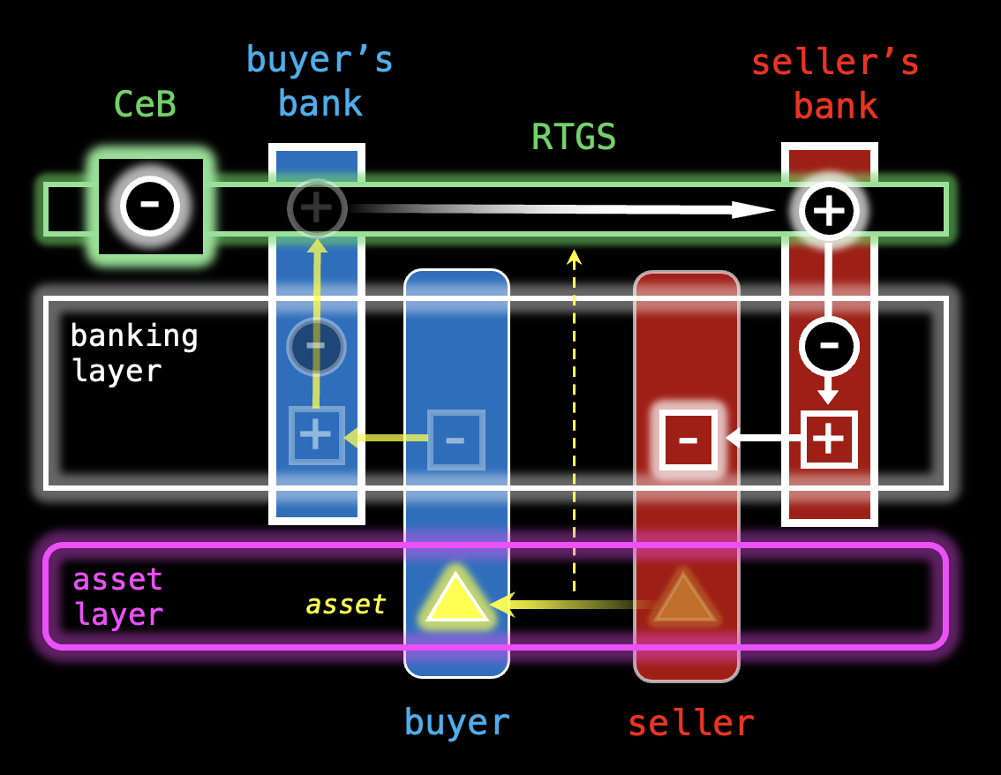
The buyer’s deposit (a liability of Buyer’s Bank) is extinguished, as reserves – central bank money – are sent from Buyer’s Bank to Seller’s Bank via RTGS, where a deposit is created for the seller. The Seller’s Bank does not hold the reserves for the seller, but uses them to acquire other assets, while the seller holds the deposit (the Seller’s Bank liability) as commercial bank money. In Australian wholesale markets, central bank money is used to settle exchange even where buyer and seller have accounts at the same commercial bank. Model A is essentially the existing system of DvP settlement for conventional infrastructures, without on-ledger atomic swaps of money and assets which is a key advantage of programmable ledgers when both are maintained on a common ledger.
In Model B, the central bank issues its liabilities on a common ledger with the assets. Buyer and seller are able to hold the central bank money directly and swap it atomically in asset exchange. No banks need to be involved in the exchange – except where the buyer needs to acquire central bank money using a bank deposit before the swap, or the seller wishes to deposit the central bank money with a bank after the swap (those steps are excluded from the diagram). This would represent an expansion of access to central bank money from its current role in the intermediation of payments made from deposits to a new role as the money-form from which payments are made and in which payments can be received.
Model B: direct access to central bank money by non-banks
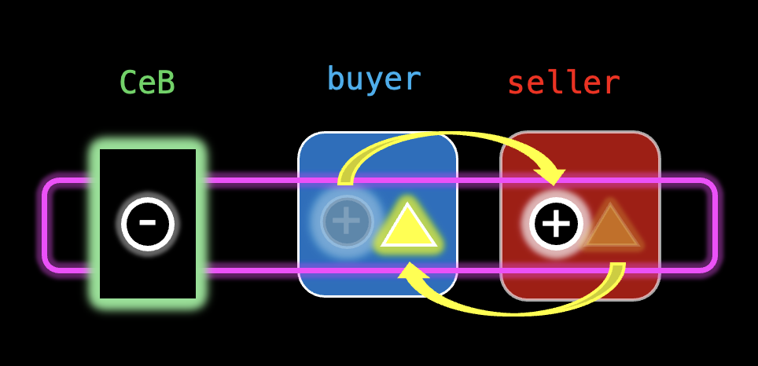
In Model C, no central bank money is tokenised on the asset layer. Instead, deposit tokens are used to swap atomically with tokenised assets for settlement. RTGS is used to settle interchange between different deposit tokens. If the asset exchange is settled with a money token that the seller does not wish to hold, the token must be converted by the seller after the trade; or alternatively, by the buyer before the trade. In either case, the buyer’s deposit token is “burned” with the issuer of the buyer’s token sending an RTGS payment in central bank money to the issuer of the token that the seller wishes to receive; as with a regular deposit, this token issuer does not hold the central bank money in reserve but uses it to acquire other assets while minting a deposit token for the seller.

Model C: money token interchange after (left) or before (right) asset swap
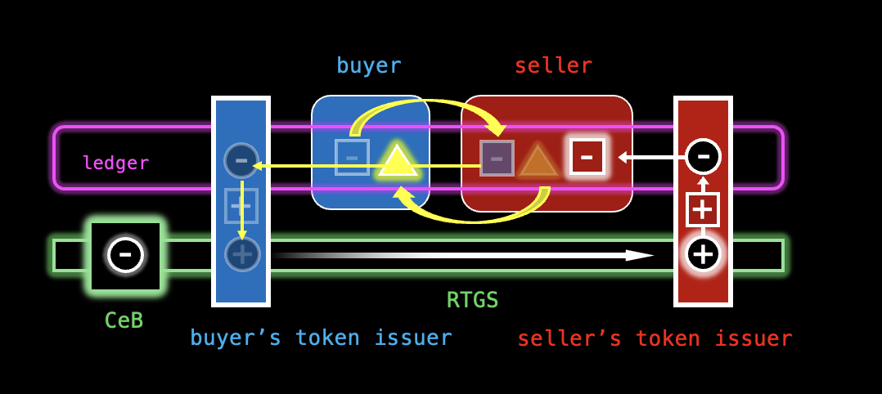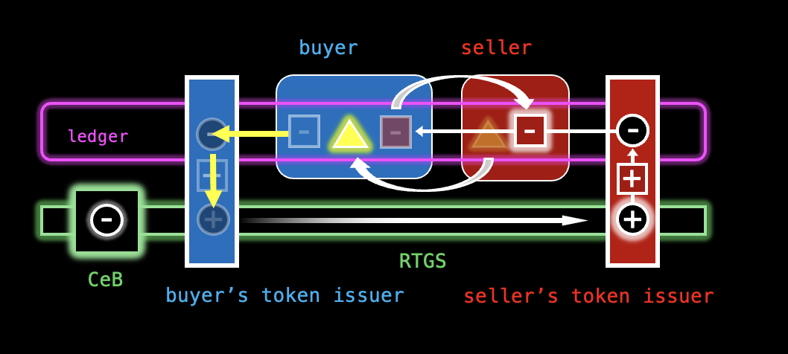
In Model D, deposit tokens are used to swap atomically with tokenised assets for settlement. Rather than using RTGS for the interchange of deposit tokens, these tokens are also interchanged atomically on ledger via decentralised exchange, facilitated by automated markets that hold liquidity for both types of token. Parity between the tokens will rely on activity by liquidity providers and arbitrageurs on both the AMM’s ledger and the banking layer, where parity in the corresponding (non-tokenised) deposits would continue to be maintained through the use of central bank money in RTGS (not shown in the diagram).
Model D: market exchange in money tokens
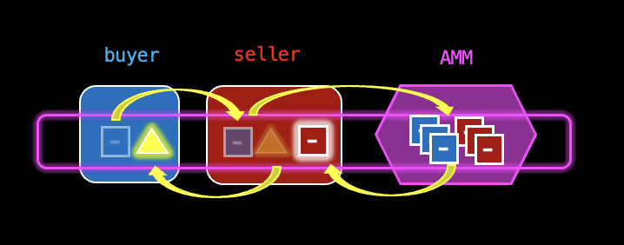
In Model E, deposit tokens are used to swap atomically with tokenised assets, and a common interchange asset is used to swap between deposit tokens. In one variant, this interchange asset is a CBDC, issued to the ledger by the central bank (but not for any other use except interchange between deposit tokens, making it effectively a tokenised ESA balance). Where the seller does not wish to receive the buyer’s deposit token, this is swapped for CBDC and then for the seller’s preferred token. This will remove the value of the buyer’s token from that token’s supplied liquidity and move it (as CBDC) to the supplied liquidity for the seller’s token. To maintain parity of value, the issuer of the buyer’s token will (in the course of managing appropriate liquidity buffers) need to replace this CBDC liquidity.
A variant of Model E removes the central bank from the asset ledger and allows the use of a RBDC for the interchange asset. The RBDC is used on the Token Interchange and is fully collateralised by central bank money held in reserve off the ledger. On the part of the RBDC issuer this requires the ability to maintain a Treasury of segregated reserves for token issuers providing liquidity to the interchange; the RBDC’s RTGS account will be an “Omnibus” of these reserves. In this “Omnibus Treasury” design used to collateralise a reserve token for multilateral interchange of money tokens, this most closely resembles the AP+ proposal. Although our interchange token was not an RBDC (legally an asset issued in its own right), the technology for one would be effectively the same.

Model E: tokenised central bank money as interchange asset for money tokens
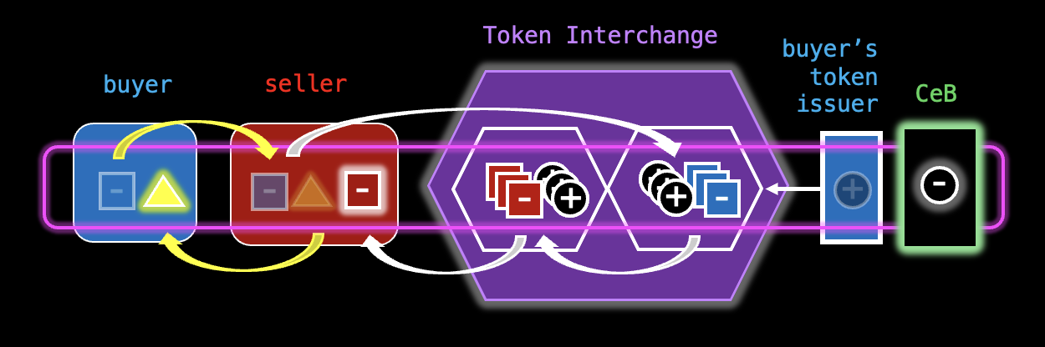
Model E: reserves-backed digital currency as interchange asset for money tokens
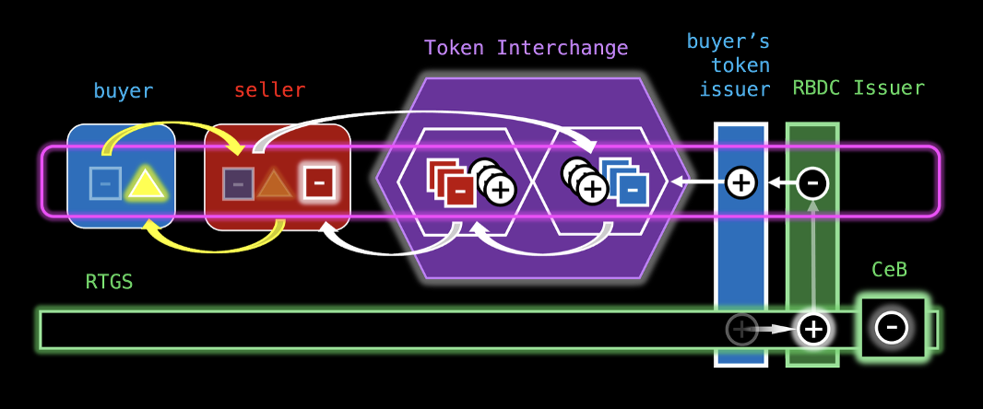

AP+ Design Principles
Australia Payments Plus (AP+) is the national payments and banking industry body that operates Australia's domestic retail Payment Schemes.^{[1]} For the second phase of Project Acacia, AP+ developed three use cases designed to outline the key elements of a Future Payments Scheme – an industry-operated utility that would integrate tokenised money and asset markets with existing national payments and settlement infrastructures under a multilateral governance framework.
Each of the use cases focuses on a core scheme component:
- NPP Token Service: a facility supporting direct, real-time 24/7 value transfers between conventional Australian dollar deposit accounts and digital tokens issued to (and redeemed from) open, public, programmable ledgers via the New Payments Platform (Account-to-Coin / Coin-to-Account)

- Token Interchange Service: a facility supporting multilateral conversion between privately-issued money (par value) tokens – including stablecoins and deposit tokens – deployed to a public ledger and using a common interchange token that represents (and is synchronised to) public money reserves managed by issuers on a separate private ledger

- Settlement Coordinator Service: a service supporting on-chain marketplaces for tokenised financial instruments, including near-real-time (T+0) DvP settlement, identity and compliance, asset tokenisation and stablecoin issuance, and scheme administration.

Under the proposal, on-ledger interchange of privately-issued Australian money tokens is to be intermediated through a common multilateral interchange asset. This asset is collateralised with off-ledger public-money balances, giving it the form of reserve token that is parallel in function to ESA balances.^{[2]} The requirement to intermediate exchange of privately-issued money tokens through some (albeit indirect) form of central bank liability creates an extension of RITS, the conventional payments infrastructure that enforces fungibility of deposits by requiring interbank payments (made from deposit accounts i.e. private money) to be settled exclusively using ESA balances (public money).
By similarly enforcing fungibility of par-value money tokens through a reserves-collateralised interchange token, the proposed scheme would permit competition between issuers of tokenised private money, while preserving the existing institutional roles of public and private money and the singleness of the national currency – key principles of Project Acacia.
The scheme design can accommodate the substitution of public-ledger CBDC for the common interchange token, however the proposed model of synchronised settlement is intended to demonstrate to policymakers that an industry- (scheme-) managed alternative performs the same function while relieving the central bank of the responsibility, costs, and risks of issuing and managing its tokenised liabilities as a new digital form of currency. While the pilots synchronise the interchange token to off-ledger CBDC balances, a similar (but simpler) design would synchronise the interchange token directly to ESA balances. This idea will be developed in further detail below.

^{[1]} The New Payments Platform (NPP), eftpos, and BPAY.
^{[2]} ESA balances – i.e. central bank reserves – settle interbank payments in RITS. The overnight cost of obtaining these reserves anchors the financing costs across the economy and is managed by the Reserve Bank as the national monetary policy instrument.

AP+ Use Cases

Overview
Use Case 1 (AP+1) – the NPP Token Service – was run as a desktop study led by AP+ in collaboration with Cuscal (Authorised Deposit-taking Institution and settlement service provider) and SWIFT, the NPP infrastructure vendor and financial messaging consortium.
Use Case 2 (AP+2) – the Token Interchange Service – was a live pilot delivered with AUDD Digital, Forte AUD, and Macropod (formerly Catena) acting as token issuers, and Cuscal acting both as issuer and as settlement agent for other issuers. The pilot demonstrated:
- deployment of a smart-contract-operated token-interchange facility on the permissioned public ledger Hedera, supporting multilateral conversion between Australian-dollar money tokens

- issuance, circulation and redemption of pilot wholesale CBDC on a separate permissioned private network (an instance of HashSphere)

- operation of a synchroniser allowing the public-network token-interchange settlement asset to mirror wholesale CBDC balances on the private-network

- deployment of a cross-ledger bridge between the permissioned public Hedera network and the permissionless public Ethereum network.

Use Case 3 (AP+3) – the Settlement Coordinator Service – defines scheme administration and supporting services for NPP token integration, money-token interchange, and tokenised asset market settlement (DvP/PvP). These services include digital identity, risk and compliance, Know Your Customer (KYC) / Know Your Business (KYB), Proof of Reserves, and key management / custodial services. The proof of concept focuses on the central element of the Settlement Coordinator Service; a mechanism enabling near-real-time DvP settlement of tokenised asset exchange, technically able to offer legal finality comparable to that of institutional securities settlement facilities.
The AP+3 proof of concept originally positioned AP+ as Lead Entity, demonstrating the use of the Settlement Coordinator to support collaborating entity Imperium Markets in the operation of a tokenised “Real World Asset” (RWA) market. Participation in AP+3 led Imperium Markets – itself a Project Acacia Lead Entity – to adopt Hedera as a ledger platform for its own use cases exploring tokenised term deposits, Negotiable Certificates of Deposit, and annuities.
The RBA subsequently merged AP+3 with these Imperium Markets use cases and named Imperium Markets as Lead Entity, with the live-money pilot falling under this combination use case. As the technical solution originated with AP+3 and the Lead Entity reassignment occurred late in the Project, this pilot retains the original focus on generic RWA tokenisation and settlement coordination, rather than on the tokenisation of specific money-market instruments. With the core features of the Settlement Coordinator architecture demonstrated, the design and implementation of dynamic and differentiated smart contract systems embedding distinctive logics for various financial instruments should be the focus of the next stage of research and development.

Findings Overview
Development for the three AP+ use cases was predominantly undertaken during the second half of 2025. The set of participating entities was finalised in September, with pilots conducted in December.
This section will provide answers to the questions set out in the RBA-DFCRC Research Information Guidelines for Lead Entities, with reference to all three use cases and to the broader proposal for an Australian industry-operated Future Payments Scheme.

1. Overall Findings
What is the most significant learning or insight gained from the experimentation about each of the following:

1.1. The opportunities & challenges of asset tokenisation in wholesale markets

Opportunities

The experiments confirmed that a domestic Scheme can extend settlement finality to tokenised wholesale markets without necessarily waiting for the introduction of a wholesale CBDC. The industry can replicate the risk-free profile of central bank money for 24/7 wholesale settlement by synchronising private ledger balances to Exchange Settlement Accounts (ESAs). Integration of the Fast Settlement Service (FSS) with programmable platforms can overcome the constraints of traditional RTGS operating hours and Australia’s wholesale market infrastructures. The proposed architecture supports the singleness of money – ensuring that privately issued AUD tokens remain fungible across diverse platforms – and advances interoperability, a basis for an emerging digital finance “network of networks”. The Scheme also offers an opportunity to advance domestic federated digital identity, allowing for the automation of compliance workflows (KYB/AML) while preserving data privacy, avoiding the risks of centralised identity silos.
Challenges
The most significant hurdle is the “collective action problem”, where the strategic urgency of national digital transformation conflicts with the commercial mandates of individual incumbents, creating a barrier to collaborative investment. Achieving legal settlement finality on a public ledger will require formal regulatory designation. Operationally, the move to a multi-ledger environment introduces challenges regarding liquidity fragmentation, requiring prudent Scheme design to meet the needs of wholesale markets for predictable liquidity arrangements. There are challenges in designing systems that maintain transparency of market activity while protecting the confidentiality of market participants. More broadly, the technological ecosystem is still maturing, with operation frictions in the systems available to connect platforms, entities, instruments, and controls.
1.2. The settlement model(s) explored and the benefits, limitations and trade-offs associated with them

The pilots are oriented around a structure often described as a “Synthetic CBDC” (or “Narrow Bank” model). Originally conceptualised in IMF working papers, this is a digital liability 100% backed by central bank reserves. In the Project Acacia Consultation Paper, Model E puts forward the utility of a RBDC serving as a public-money-backed multilateral interchange asset (via an industry “Omnibus Account”) for private money tokens able to serve as settlement assets in various digital marketplaces across platforms. Broadly, the Scheme concept resembles the BIS Unified Ledger in its vision for common programmable infrastructure where tokenised “central bank money”, “commercial bank money”, and financial assets coexist and can swap atomically across a variety of interlinked platforms.
The proposed Scheme delivers the functional benefits of a Unified Ledger through secure interoperability and settlement coordination standards. The model encourages competition between private issuers, curbing the strong network effects that might otherwise lead to a single privately-issued token monopolising the AUD market, while enforcing AUD fungibility through a common reserve-based anchor. Significantly, this architecture relieves the central bank of the substantial operational burden, costs, and risks that are associated with issuing a CBDC, allowing it to delegate the technology layer and customer management to the private sector while retaining ultimate control over its operation.
A key precedent is Fnality (UK), which utilises an “Omnibus Account” at the central bank to back a tokenised settlement asset, creating a "Single Pool of Liquidity" that operates 24/7. Similarly, regulatory interventions in China in 2019 mandated that non-bank payment providers (such as Alipay) hold 100% of customer funds in centralised reserve accounts. By forcing full collateralisation, regulators effectively converted private digital balances into synthetic central bank liabilities.
In the AP+ experiments, the interchange reserve token ("WhiteCoin") functioned economically as this type of synthetic asset. However, the pilot highlighted a subtle distinction: the interchange token is not issued as a distinct reserve-backed asset – it operates as a "settlement message" instructing the Scheme to move value within the underlying Treasury reserve. In the pilots this reserve was experimental CBDC on a private-ledger connected by a synchronisation operator to the Interchange platform – in a future state this operator could synchronise with RTGS, with conventional ES balances as the underlying Scheme Treasury reserve (“Omnibus Account”).

1.3. The capabilities or attributes that central bank and/or privately issued money would need to have to realise the potential of tokenisation in wholesale markets

The experimentation indicates that a Central Bank Digital Currency (CBDC) is not strictly required to unlock the potential of wholesale tokenisation. The primary requirement is a settlement asset that offers 24/7 availability and legal finality. If a private Scheme can operate a “synthetic” or “synchronised” model where the settlement asset is fully collateralised by central bank money and designated under the Payment Systems and Netting Act 1998, it can deliver the same risk-free settlement outcomes as a public-ledger CBDC. The necessity of a true CBDC therefore depends less on technical capability and more on the regulator's verdict regarding PFMI Principle 9 (Money Settlements) – specifically, whether the regulator accepts the settlement arrangement as sufficient to mitigate systemic risk, or if a direct central bank liability is mandatory.

The following table summarises various money and money-like instruments in terms of their capabilities or attributes. Programmable platforms introduce the possibility of a new form of money; a par-value, secured yield-bearing token; the tokenised Money Market Fund or yield-bearing regulated stablecoin. This is an instrument similar to a wholesale CBDC but privately-issued and secured with programmable collateral (tokenised Real World Assets) rather than by “fiat”.

 | Secured | Token | Yield-Bearing | Par Value
Gold | ✔
Bitcoin |  | ✔
Bonds / Equities |  |  | ✔
Tax Credit / Gift Card |  |  |  | ✔
(Fiat) Cash / (Fiat) rCBDC |  | ✔ |  | ✔
Tokenised Commodity / Bullion | ✔ | ✔
Bank Deposit / (Fiat) Reserves |  |  | ✔ | ✔
E-money / Future Payment | ✔ |  |  | ✔
Asset-Backed Security | ✔ |  | ✔
Ethereum (Staked) |  | ✔ | ✔
Tokenised Security | ✔ | ✔ | ✔
Regulated Stablecoin | ✔ | ✔ |  | ✔
Algorithmic Stablecoin / (Fiat) wCBDC |  | ✔ | ✔ | ✔
Money Market Fund / Reverse Repo | ✔ |  | ✔ | ✔
Tokenised Money Market Fund | ✔ | ✔ | ✔ | ✔

2. Business motivation and economic impact

2.1. Business problem assessment

2.1.1. What did you learn through your experimentation about the business problem(s) that you set out to explore in your use case?

The experimentation reinforced that the core business problem is
- a missing trustworthy interface between Australia’s existing banking/payments rails and programmable token platforms, and
- the absence of any domestically credible wholesale-market infrastructure operator that is both incentivised and positioned to build it.

Market Readiness. Collaborating market participants institutions indicated they are ready to move quickly to commercialisation, provided regulatory settings (including APRA/ASIC licensing and operational expectations) are clear enough to underwrite investment. Existing AUD stablecoin issuers are already planning tokenised money/asset propositions and see clear value in a common, Scheme-governed interchange rather than fragmented bilateral integrations. The pilots provided enough practical evidence to support an end-to-end build estimate that appears materially below historic industry technology spends – notably relative to the scale of sunk expenditure on the failed CHESS replacement – with Cuscal in particular viewing tokenisation-linked settlement services as a natural adjacently-scaled extension of its existing role. There is little expectation that Australia’s incumbent FMI monopoly will prioritise an enabling layer that directly lowers barriers to entry for competitors (the CHESS replacement history reinforcing this point).

Timeline Discrepancies for Use Cases. The timeline for the NPP/SWIFT path is feasible but slow. Using NPP/FSS as the primary on/off ramp is an ideal Scheme final state, but because of governance, membership and change processes (e.g., transaction limits and Scheme rules designed for retail), the likely timeline is closer to 3 years. In contrast, Use Cases 2 and 3 can proceed sooner using non‑NPP ramps.

Interchange Reserve Token Concept. We found some scepticism around the “mirror/digital twin” reserve token (referred to as “WhiteCoin” throughout the experiments due to its origin in examples involving hypothetical “BlueCoin” and “RedCoin” deposit tokens). Scepticism typically reduced once the concept was explained and compared with recognised “Synthetic CBDC” proposals to which it serves an economically similar purpose. However, we note the relative absence of concern given to the fact that RWA tokens are also “mirrors” of off-ledger instruments and issuer ledgers, which raises the question of whether token “mirroring” is only controversial in the context of central-bank settlement finality.

2.1.2. Did your experimentation confirm or change your view about whether and how the business problem(s) can be solved?

The experimentation confirmed the problem is solvable technically and commercially: a settlement/interchange layer can be built that supports atomic settlement on-ledger while remaining anchored to wholesale-grade settlement assets and controls. The experimentation raised questions about how best to execute. Attempting to incubate a wholesale, agile innovation within a structure designed for retail scheme operations stability risks a significantly slower rollout during a fast-moving industry transition. The development of the NPP itself predated the AP+ merger and the organization has not previously created a new Scheme. There is institutional trepidation regarding broader Delivery-versus-Payment (DvP) settlement, with a preference to restrict scope to Payment-versus-Payment (PvP). This is despite the fundamental reality that any tokenised payment infrastructure capable of atomic PvP naturally supports DvP via the same primitives.

2.1.3. Did your experimentation reveal any business problems not initially considered?

Several issues emerged that were not in the initial framing:

Legacy fiat movement as an operational constraint. We observed unpredictable delays in interbank transfers of fiat from pilot participants to Cuscal. That friction reinforced the value proposition of the “banking-to-token” interface (the specific goal of Use Case 1) and highlighted the practical reliance on settlement agents for participants that don't have direct access to the relevant rails.

Intraday settlement expectations. The market operator’s desire for intraday settlement highlighted a key constraint: settlement requiring conversion of CBDC to ESA balances cannot be made truly on-demand in real time unless the RBA is running continuous issuance/redemption operations. Again, this highlights the importance of a “banking-to-token” interface and the utility of an interface that does not involve an intermediate issuance/redemption layer dependent on the central bank.

Wholesale Identity needs are KYB-oriented and depend on an external identity utility. Use Case 3 intended to demonstrate on-chain identity using an ERC-3643 solution ideally leveraging the AP+ ConnectID scheme for digital identity. In practice, ConnectID's access/security requirements created a barrier even for an R&D setting, and its KYC identity capability was closer to retail demands than institutional wholesale. This highlighted the dependency on a KYB business identity provider as an enabler for wholesale adoption.

Custody/wallet infrastructure. There appears to be a “missing middle” in the market between lightweight open-source wallets that are suitable for small-scale pilots and the expensive, feature-rich enterprise custody SaaS used in Project Acacia. Selecting fit-for-purpose custodial wallet tooling is a non-trivial business decision for scaling beyond experimentation.

Additional questions surfaced following the Use Case 3 Lead Entity reassignment. The shift in emphasis highlighted unresolved commercial and operational questions that were not originally in scope, including:
- how to tokenise specific money market instruments (e.g. Negotiable Certificate of Deposit) so that their lifecycle logic (issuance, coupons, redemption) is executed reliably via smart contracts
- how the use of public rather than private ledgers fundamentally changes the privacy and self-custody equation for market operators. The experiment highlighted a key distinction between architectures like Corda – which permits both privacy and self-custody by participants – and the HashSphere, where self-custody implies a participant’s full visibility over the network.
- what level of on-ledger transparency market participants will tolerate (even with pseudonymity), and what privacy-preserving techniques are needed
- what the "market operator" role becomes for secondary trading where token exchange can occur directly between participants on-ledger (or for primary trading where the ledger platform enables decentralised RFQ).

2.2. Costs and benefits analysis

2.2.1. What evidence did your experimentation provide about the costs and benefits involved in solving the business problem(s) that you set out to explore?

The pilots reinforced that the primary economic benefit accrues to the broader market, not only to the Scheme operator. The experimentation provided enough implementation detail to support a credible estimate that an end-to-end Scheme could be built for far below the widely referenced sunk cost of the abandoned CHESS infrastructure.

Initial cost drivers would be primarily engineering – interchange, synchroniser, integration of coordination services – legal/rulebook and governance design, and security/audit. Ongoing costs would include infrastructure and Scheme operations (cloud, monitoring, administration, incident response, reporting), with platform transaction costs (on Hedera) being small and predictable.

A key pilot learning is that an intermediate private ledger with its own enterprise custody layer is costly relative to the incremental benefits, particularly if a simpler design could synchronise directly to ESAs rather than via a private-ledger CBDC.

2.2.2. How did your experimentation demonstrate one or more of: risk reduction, capital efficiency, increased liquidity (e.g. in trading the asset), operational efficiency (e.g. automation), new markets, products or services

The strongest demonstrated benefit was settlement risk reduction via near-real-time atomic exchange with money market trades were settled in minutes. The infrastructure supports T+0 settlement patterns suitable for wholesale instruments, with applicability beyond the specific pilot assets (i.e., as enabling architecture). A reduction from T+1/T+2 cycles reduces counterparty exposure windows and reconciliation burden (although participants in some markets may retain a preference for longer settlement cycles on account of the netting benefits).

We demonstrated that token-native infrastructures could support weekend/after-hours liquidity and settlement, creating 247/365 market operation potential not constrained by RTGS opening hours. Smart-contract driven escrow/DvP patterns and token lifecycle automation can reduce manual processes – e.g. coupon and redemption workflows. Interchange and coordination services can support dedicated liquidity providers and more continuous intraday liquidity management, with near-instant PvP/DvP enabled by assets directly addressable by settlement systems.

2.2.3. What is your estimate of the costs and benefits (this might be at firm-level or industry-wide)?

A firm-level estimate is less meaningful for enabling infrastructure where the appropriate view is at the industry or national level – similarly as communications or transportation infrastructure.

Benefits: we rely on DFCRC estimates that the potential industry benefits will be in the multiple billions over time, driven by features including reduced settlement risk and failures, lower operating costs through automation, improved liquidity and market access (including fractionalisation), and improved support for emerging asset classes (e.g. environmental markets).

Costs: based on pilot experience, a reasonable, conservative estimate is in the order of roughly $60m with modest ongoing operating costs for a largely automated system. Use Case 1 (NPP integration) would be the less certain element with NPP governance and membership constraints dominating the timeline and costs.

Critically, analysis should consider the costs of inaction: fragmented liquidity on non-interoperable ledgers, continued reliance on ageing wholesale infrastructure, and potential capture of core “scheme” functions by non-domestic facilities, with implications for resilience and sovereignty.

2.2.4. What new costs (e.g. increased liquidity requirements from pre-funding) or risks (e.g. operational risks, outsourcing management, conflicts of interest) might arise?

The Scheme introduces a treasury requirement to pre-fund the interchange reserve token to maintain par convertibility and confidence that the reserve token is demonstrably collateralised at all times. This creates an opportunity cost of capital for participants. Additional liquidity requirements are introduced where the Scheme supports bridging to multiple ledgers. The effective cost of the design will depend on whether the pre-funded balances (or tokenised claims over them) are treated as Level 1 HQLA under the APRA definition that includes cash and central bank reserves.

The size of the pre-funding buffer is a non-trivial question for Scheme design. In the pilots, liquidity is pre-sized because flows are known in advance. In production, if every privately-issued AUD token had to be matched 1:1 with reserve token at all times, private issuance of AUD tokens would be economically pointless. A practical Scheme would involve something resembling FMI-style liquidity risk management, with rules for Scheme treasury resources, stress sizing based on observed flows, “cover” standards, default waterfalls, and explicit policies for how liquidity is provided in normal vs stressed conditions.

There is a close operational precedent for this type of prefunding requirement in Australia already. The RBA’s Open Repo arrangements were explicitly designed to support after-hours settlement liquidity for FSS/NPP payments outside normal interbank cash-market hours. The Open Repo buffer must accommodate any gross outflow of reserves during the after-hours period. Its size is dynamically determined based on participant forecasting under RBA mandates for operational resilience with zero failure tolerance. Conceptually, the interchange reserve token extends a similar “pre-positioned liquidity for 24/7 settlement” idea into tokenised markets.

While these pre-positioned liquidity buffer requirements are here noted here as a “cost”, it represents a saving relative to the alternative of bilateral liquidity pairings maintaining the equivalent level of convertibility between AUD tokens. Without a common interchange asset, interchange between n token issuers requires each party to hold reserves in every counterparty's token, scaling quadratically with the number of participants. A multilateral hub-and-spoke model reduces this to a single reserve position per issuer with the efficiency gains become apparent once three or more tokens participate in the Scheme.

Operational risks arise from the synchroniser and its controls, the underlying ledger[s] and smart contracts, and key management/custody providers. These include vendor concentration, “fourth party” operational, cybersecurity, compliance, and reputational risks. The Scheme rulebook would ensure that any entity playing multiple roles (e.g. Scheme operator, settlement agent, liquidity provider, custody vendor, token issuer, bridge operator), would be subject to explicit conflict management and transparency requirements.

2.3. Suitability of settlement and interchange assets

2.3.1. Did your experimentation confirm or change your view about the suitability of the settlement asset (and, if relevant, interchange asset) that was used?

Suitability for wholesale settlement is a regulatory decision that must be anticipated in relation to the PFMIs and specifically Principle 9 (Money settlements):

An FMI should conduct its money settlements in central bank money where practical and available. If central bank money is not used, an FMI should minimise and strictly control the credit and liquidity risk arising from the use of commercial bank money.

Under Principle 9 Key Consideration 2: If central bank money is not used, an FMI should conduct its money settlements using a settlement asset with little or no credit or liquidity risk.

The CPMI-IOSCO stablecoin guidance specifically addresses the question in relation to stablecoins:

[Where] a stablecoin is used as the settlement asset, participants will be subject to the credit and liquidity risks of the stablecoin itself, the issuer of the stablecoin and/or the settlement institution. This may result in a greater amount of risk than “little to no” credit and liquidity risk and may not enable the FMI and its participants to readily transfer their assets into other liquid assets, such as claims on a central bank.

Relevant factors cited include “the clarity and enforceability of the legal claims, titles, interests and other rights and protections accorded to holders of the stablecoin” and “the clarity, robustness and timeliness of the process for converting the stablecoin into other liquid assets such as claims on a central bank in both normal and stressed circumstances”.

The Project Acacia Consultation Paper explains how limitations on the acceptance of certain privately-issued monies – which in the Paper are not generic “stablecoins” but specifically bank-issued deposit tokens – creates the need for “interchange” to convert the buyer’s money into something the seller can accept. Our experimentation confirmed a case for separating the DvP settlement asset (what the seller wants to receive) from an interchange asset (used to make multiple private monies fungible) as a viable model for adoption of tokenised money and assets, with singleness of money across competing private tokens preserved through a public-money-anchored interchange utility.

Use Case 2 (Token Interchange) was designed to strengthen the case for an interchange asset of the kind described by the variant of Model E, specifically the variant in which the common interchange asset is not a CBDC but a Reserves Backed Digital Currency (RBDC) – a privately-issued token fully backed by funds in a pooled (“omnibus”) account at the central bank, structured to protect holder entitlements but not itself central bank money.

The Interchange reserve token (“WhiteCoin”), as implemented, functions economically like that concept: a reserves-anchored interchange asset that enforces par convertibility across privately-issued AUD tokens. The Scheme design could accommodate the substitution of the reserve Interchange token for a RBDC (or a CBDC in the event that one is legislated). The experiments indicated that industry and regulatory acceptance depends on legal and operational specifics in relation to defined rights of Scheme members and legal finality.

Two critical differences exist between this pilot’s settlement model and the Project Acacia RBDC Model E; the fact that the Interchange reserve token (“WhiteCoin”) is not technically an RBDC; and the fact that the AUD tokens being interchanged are not deposit tokens.

1) The Interchange “Asset” as Payment Authorisation Message

The pilot Interchange reserve token is different from an actual RBDC or “Synthetic CBDC”, as it is not a redeemable claim carrying value in its own right, and can never be held independently of the provision of interchange liquidity intermediating the exchange of other tokens. The distinction is explicitly anticipated by the CPMI-IOSCO Stablecoin Guidance on Principle 9:

The [Stablecoin Arrangement] should clearly define and document the nature of the stablecoin and its legal relationship to the underlying arrangements... This includes clarifying... whether the transfer of the stablecoin constitutes the transfer of the settlement asset or essentially a message to the settlement institution to transfer the settlement asset.

Rather than an asset issued by the Interchange operator, this apparent “mirror” or “digital twin” is more properly considered a “message”; an authorisation mechanism for the off-ledger execution (“pull payment”) of transactions via the synchroniser. Were this synchronisation made directly to FSS, the arrangement would more closely resemble Model C, where the “interchange asset” between privately-issued money tokens is conventional ESA balances. Were this form of authorisation mechanism be used to directly intermediate swaps between asset tokens and money tokens (in addition to money token interchange), the reserve token would resemble a programmatic reservation feeder system to RITS; more similar to Model A.

There is a parallel in how this "messaging" logic applies to cross-chain interoperability, specifically when facilitating interchange between Hedera-native tokens and external assets (e.g., ERC-20s). In a standard bridging model, an external asset is "wrapped" to create a new, distinct financial instrument on the destination chain. However, if the interchange mechanism treats tokens as messaging instructions rather than assets, the bridge can utilize a similar "ghost" proxy for interchange over incompatible tokens. In this scenario, an incoming ERC-20 token is not wrapped for the purpose of long-term holding or circulation on Hedera. Instead, it is represented technically as a transient HTS token solely to interact with the interchange mechanism.

2) The Significance of Deposit Tokens vs “Stablecoins”

While the “WhiteCoin” reserve token is not a RBDC, the DvP settlement asset that used in Use Case 3 – the CCLD stablecoin issued by Cuscal – was essentially an RBDC; fully collateralised by equivalent CBDC on the private ledger for the duration of its circulation (meaning also its full-collateralisation with by ES balances – held in segregated reserve for the duration of the CBDC token’s circulation). CCLD was conceived and created for the purposes of the pilot experiment. None of the preexisting AUD stablecoins are similarly 100% backed by central bank money (as this would make them unprofitable to issue). Given PFMI recommendations it is unlikely that AUDM, AUDF, or AUDD would be accepted as a settlement asset by a marketplace operators or participants – especially where a genuine RBDC exists as an alternative.

Notwithstanding CCLD’s 100% central bank money backing, the Use Case 3 experiment demonstrated recipients’ preference to withdraw this value of CCLD from the ledger and into conventional accounts as quickly as possible, with expectations for end-of-day RTGS settlement. There was a strong preference for intraday settlement, however the intermediate private-ledger CBDC layer and the RBA’s schedule for redemption (burning) made this infeasible. Without this CBDC layer (i.e. synchronising directly to RITS) intraday settlement would likely have been achievable for participants with FSS access.

In any case, this demonstrated that atomic technical settlement cannot equate to “ultimate” settlement where the asset seller receives a settlement asset that they do not wish to hold. For the seller to accept a buyer’s stablecoin, the seller either must accept that stablecoin’s credit and liquidity characteristics or redeem/swap it for something preferable in a subsequent step.

For systemically important wholesale DvP, the PFMI demands an interchange architecture enabling immediate conversion via public money. Existing FMIs hold ESA accounts and settle DvP intermediate trade with central bank money even where buyer and seller deposit accounts are at the same commercial bank. Note that even though the exchange is intermediated by the CCP’s central bank money, the seller (unless themselves an ESA-holder) will ultimately receive a commercial bank deposit in payment, rather than anything with the liquidity and credit profile of an RBDC or any other non-deposit form of stablecoin.

The direct equivalence of deposit tokens to bank deposits is an apparent reason for these – rather than “stablecoins” generally – to be discussed as the relevant form of (wholesale) private money in the Project Acacia context. A deposit (token) is qualitatively different from a (regulated) stablecoin in that it is an unsecured liability against general bank assets, whereas the backing assets of a stablecoin are (supposedly) segregated and identifiable. For this reason, the general discussion of “money tokens” in the context of tokenised “private money” should be limited to deposit tokens if the general characteristics of this “private money” are assumed to those of commercial bank money.

It may be that in a future state, where deposit tokens are seamlessly convertible and legally equivalent to bank deposits, sellers’ current preference to immediately move value “out” of the ledger environment would diminish. Where the token serves as a direct, legally enforceable representation of an off-platform deposit claim, the distinction between on-chain holding and off-chain settlement should be much reduced, with participants able to hold deposit tokens with the same confidence as conventional commercial bank money.

2.3.2. How, if at all, did the settlement or interchange asset contribute to solving the business problem(s) that you explored and the benefits obtained?

The interchange asset was central to solving the central problem: the absence of a public-money-anchored interchange that enforces fungibility of privately-issued AUD tokens. Project Acacia explicitly notes that using central bank money for the interchange payment between issuing banks can support at-par convertibility of their respective private tokens.

The interchange asset enables multilateral conversion at par between competing AUD stablecoins/deposit-like tokens without forcing bilateral arrangements between every issuer pair. It offers credible path to preserve singleness of money in token markets (avoiding “discount/premium” dynamics and reliance on arbitrage where interchange is purely market-based), and a way to support DvP/PvP use cases that avoids turning every trade into a decision for the seller on whether to accept the buyer’s chosen AUD token.

Fnality in the United Kingdom is a useful point of comparison. Fnality’s £FnPS represents central bank funds on a DLT system connected by RTGS to an omnibus account at the Bank of England, and has received regulatory Settlement Finality designation. This is a relevant precedent for how a token representing central bank funds can be treated in an FMI-grade settlement context.

2.3.3. Did you encounter any technical or operational limitations with the settlement or interchange asset

The path from a participant’s deposit to the settlement agent to the CBDC collateralisation introduced operational steps and latency, particularly because CBDC mint/burn automation was constrained. This created a real friction point for “near-real-time” conversion between the on-ledger settlement asset and ESA-equivalent value. (Note that technically, the pilot CBDC was a representation of escrowed ESA balances and not a direct liability of the central bank, making “WhiteCoin” effectively a mirror token of a mirror token.)

Additionally, we encountered friction where specific pilot assets (like AUDF and AUDM) were not native to the Hedera chain, requiring “wrapping” to interact with the Interchange. Cross-chain bridging, although an essential feature, increases the set of dependencies that must be controlled under a technical and operational risk framework.

2.3.4. What evidence did your experimentation provide about the scalability of the settlement model?

Interoperability between ledgers is the key scalability factor. Scaling an interchange beyond a single ledger introduces bridging and standardisation requirements, and liquidity requirements that may become a binding constraint. Participants are sensitive to the amount of liquidity that must sit in the interchange structure and across bridges.

At pilot scale, the “Omnibus Treasury” problem can be overlooked, but in production this would become a central design task based on the PFMI expectations around liquidity and credit risk and the clear requirements for finality and money settlement safety (especially if the arrangement becomes systemically important). These requirements make the multilateral interchange architecture similar to a Central Counterparty (CCP).

Liquidity requirements exhibiting similar scaling properties to margining under central clearing; an open, multi-issuer tokenised ecosystem is more economical compared to bilateral arrangements. In bilateral OTC derivatives markets, margin requirements scaled quadratically with the number of counterparty relationships. Mandatory central clearing imposed a hub-and-spoke structure with each participant posting margin only against the CCP. The same logic applies here: bilateral liquidity between four token issuers arrangements requires six separate buffers – for ten issuers, forty-five – but the interchange reserve token reduces this to n positions regardless of participant count.

2.4. Future Adoption

2.4.1. What key enablers or blockers of broader adoption did your experimentation highlight or reveal?

The “synthetic CBDC” model is the definitive enabler by providing a wCBDC-like safe settlement asset without requiring the years-long legislative process of issuing a "real" CBDC. Willing settlement agents and early issuers – partners like Cuscal – will significantly reduce time-to-market by absorbing operational complexity.

Blockers include:

Licensing/designation and trust. A Scheme operator providing custody-like functions and settlement coordination will need FMI-grade governance and is likely to require formal designation to support settlement finality expectations. The RBA must evaluate whether it can "trust" the Scheme under the Payment Systems and Netting Act 1998.

NPP governance constraints. Although the RBA has previously raised the prospect of utilising the FSS for wholesale use, doing so via the NPP would require changes to retail-oriented aspects including amount limits. NPP governance timelines are a blocker to the speed of integrating the Use Case 1 element of the Scheme. Existing members may be disincentivised to develop an “open” scheme beneficial to wider industry if they believe that a “closed shop” alternative can be pursued to the narrower benefit of the financial sector.

2.4.2. If you utilised or simulated existing settlement infrastructure (e.g. NPP or RITS) as part of your use case, what did your experimentation reveal about changes or enhancements to that infrastructure (or supporting account structures or access policies) that may be required to better support tokenised asset markets?

The pilots demonstrated that synchronisation is easiest when account systems expose clean, automatable interfaces. If FSS/RTGS interfaces can better support “synchroniser-style” operations, integration complexity drops substantially – especially relative to approaches that depend on CBDC minting and burning operations undertaken by the RBA. For NPP/FSS to become a primary on/off ramp for tokenised wholesale use cases, retail-oriented constraints – including transaction value limits and participation (or sponsorship) models – would need to be revised to accommodate large-value DvP/PvP-like flows (this may involve creation of a separate entity to access FSS under alternative arrangements). Adoption of richer ISO 20022 message sets relevant to securities/settlement workflows (such as used in Europe’s TARGET2) would help align tokenised settlement with established FMI operating models.

3. Technology and design
3.1. Design choices

3.1.1. What major design choices were you faced with in the project, and how did you resolve them?

1) Structuring the “Future Payments Scheme” as three distinct use cases.

We deliberately separated the work into (i) an on/off-ramp, (ii) a token interchange, and (iii) a settlement coordinator to make Phase Two experimentation modular and to isolate the technical and commercial learnings. However, the pilots also revealed that stakeholders can misread the modular delivery plan as implying independent business cases. In practice, the combined proposition is materially stronger than the sum of its parts – particularly because the Token Interchange (Use Case 2) is most valuable when paired with actual market settlement workflows (Use Case 3), rather than operated as a standalone conversion utility.

2) Choice of DLT platform (Hedera)

Hedera was selected partly due to strategic alignment: AP+ inherited membership of the Hedera Governing Council involvement via eftpos. This relationship materially advanced delivery, including substantial direct funding and technical support. Beyond that practical consideration, Hedera is well-suited to wholesale/enterprise requirements due to its deterministic finality, high performance, and predictable fees, recommending it as a suitable foundation for a Scheme settlement utility.

3) Public Ledger CBDC, Private Ledger CBDC or No CBDC

Because Project Acacia is a CBDC research program, the design had to accommodate multiple policy outcomes. The AP+ architecture was deliberately “CBDC-agnostic” insofar as it can operate with (a) a public-ledger CBDC, (b) a private-ledger CBDC, or (c) no CBDC (i.e. synchronisation directly to ESA/RTGS balances). For Phase Two, we included a private-ledger CBDC environment to generate evidence about CBDC issuance and wallet operations while meeting RBA control requirements (mint/burn/freeze/seize). At the same time, the pilots were designed to demonstrate that the circulation of CBDC in public markets is not a prerequisite for near-real-time DvP/PvP functionality with programmable money and assets.

4) Whether to include Cross-Chain Bridge

Use Case 2 could have been delivered “Hedera-only”, but we chose to include bridging to demonstrate that interoperability is an essential design requirement for any national Scheme utility. We selected the message-based bridging approach LayerZero because it offered the robust Hedera-to-EVM compatibility required to connect Scheme’s utility layer on Hedera and the broader cross-chain market. Ethereum was selected as the external test network due to its dominance, its deep liquidity, and its origination of the EVM standard, serving as a proxy for the wider ecosystem of EVM-compatible environments.

5) Custody Wallet Platform

For the private CBDC environment, the RBA required Fireblocks. For public-network participation (Use Cases 2 and 3), we introduced Utila to reduce cost, and increase speed of solution delivery, while still meeting institutional custody expectations. This also allowed the pilots to evaluate competing custody vendors.

6) RWA Token Standard

Use Case 3 originally intended to demonstrate identity-enabled permissioning via ERC-3643 and potentially the capability to programmatically integrate compliance with AUSTRAC. In practice, identity/compliance requirements in wholesale markets are oriented toward KYB rather than retail-style KYC and ConnectID was not practically accessible for exploration in any case. Combined with time constraints (including the Lead Entity reassignment and a late shift toward Imperium Markets’ RFQ use case context), we used a simpler ERC20 placeholder asset token to focus the proof-of-concept on DvP coordination and settlement mechanics, rather than identity-based permissioning and financial instrument lifecycle logic (although the Settlement Coordinator service was successfully integrated with the Imperium Markets RFQ platform).

3.1.2. To what extent were your design choices driven by the scale and nature of the pilot project?

The pilot focus was to prove technical feasibility end-to-end and surface the key design dependencies. Pilot constraints motivated some pragmatic simplifications relative to end-state design, including the use of “out of the box” tooling where available (e.g. Hedera’s Stablecoin Studio), representation of RWAs with a generic token rather than instrument-specific smart contracts, limiting the cross-chain scope to a single external chain demonstrated with virtual participants, and deferring comprehensive Scheme rulebook design (e.g. detailed admission criteria, liquidity resources, treasury governance, default waterfall, monitoring, enforcement).

3.1.3. Were your design choices validated by your experimentation?

Yes – the successful execution of cross-chain DvP atomic settlement validated the core architectural decisions. It also demonstrated the value emerging from the combination of interchange and tokenised asset markets. The experiments clarified where design choices remain to be validated in production, particularly around identity, automated conversion to and from fiat, and tooling for less conventional token standards. Cross-chain interoperability proved essential and demonstrated the practical constraints of “native-only” settlement assets. Running both a private CBDC environment and a public-ledger environment helped separate relevant learnings and showed where the private layer added limited value versus cost and operational overhead.

3.1.4. How, if at all, would you change your design choices if you were to start over?

If starting over, we would keep the overall public network architecture. Earlier in the Project we might determine whether the objective is to explore “CBDC operations” versus a simpler ESA-RTGS synchronisation model, to evaluate whether an expensive private-ledger middle-layer between RTGS and the public ledger will be required for the end-state. We may have prioritised a wholesale-oriented KYB identity approach and validated bridge and token-standard compatibility earlier, while finalising requirements for the asset-market use case (i.e. instrument types) to avoid late-stage shifts in scope.

3.1.5. What were the most resource-intensive or problematic aspects of your design to implement as part of the project, and why?

The Use Case 3 Lead Entity reassignment (Imperium Markets) created coordination challenges in the later stages of the Project, with changing requirements that had not been formally specified, and integration work that had to be done on a short timeline with geographically-dispersed teams.

Some challenges were posed by Hedera “out-of-the-box” services that were not as production-ready for mainnet as had been expected. HashSphere remains a relatively new product requiring ongoing support by the Hashgraph team. Interoperability work on bridging and token standards alignment required more specialised attention relative to other components.

Custody requirements for the private ledger (Fireblocks) added unplanned cost and procurement/integration effort versus the originally anticipated open-source wallet approach. It also introduced vendor dependency risk and occasional delays. However, this forced a realistic assessment of enterprise custody constraints and motivated the parallel evaluation of Utila for the public-ledger components, which produced useful learnings.

3.2. Network selection

3.2.1. What were your key motivations for your choice of blockchain network?

We used two networks for distinct purposes: Hedera mainnet as the public, scheme-facing environment (Token Interchange and Settlement Coordinator), and HashSphere as a private Hedera-based environment for the pilot CBDC (to satisfy RBA operational control constraints). One key motivation was AP+’s existing presence on the Hedera Governing Council, which granted access to significant development support. However, the platform selection was also supported by several important features orienting the network toward enterprise requirements.

- Deterministic finality and fork-resilience (legal and operational certainty)

CPMI-IOSCO’s PFMI guidance for stablecoin arrangements explicitly highlights that under the probabilistic settlement mechanisms of conventional blockchains: “even if the relevant legal framework and the [Stablecoin Arrangement]’s rules and procedures have defined the point at which final settlement occurs, the possibility remains that the validation of a transaction on the ledger (technical settlement) can never be achieved with absolute certainty or forks emerge that could lead to a revocation of transactions validated on competing (and later discarded) forked ledger(s).”

Wholesale settlement utilities demand confidence that “technical settlement” aligns with legal finality and that history won’t be rewritten by chain reorganisations or “forks”. Hedera’s hashgraph consensus approach is advantageous here because it is designed for deterministic confirmation rather than the probabilistic finality typical of blockchains (including Ethereum).

- Security (aBFT consensus)

Hashgraph implements asynchronous Byzantine Fault Tolerance (aBFT), meaning the network can reach consensus without relying on timing assumptions about message delivery even if up to one-third of nodes are compromised. This is especially significant for a settlement model incorporating a cross-chain synchroniser; if the synchroniser fails mid-operation and must be restarted, recovery depends on the ability to query the underlying ledger and determine the pre-failure state with certainty.

Probabilistic-finality chains create ambiguity and a nonzero possibility that a transaction apparently confirmed could be reversed by a subsequent chain reorganisation, potentially after the other leg of an “atomic” operation has already completed. The aBFT consensus mechanism eliminates this ambiguity, allowing the synchroniser to resume from a known, immutable state without risk that the ledger history it relied upon could be rewritten. This property is essential for building robust failure-recovery into cross-chain settlement infrastructure.

- Market integrity through fair ordering

Transaction ordering is critical for settlement infrastructure. On conventional blockchain platforms, block producers (miners or validators) can manipulate the order of pending transaction order for profit, a practice known as Maximal Extractable Value (MEV). This can involve front-running – where a block producer inserts their own buy ahead of a pending large buy order, raising the price for the original buyer. With a sandwich attack the block producer also places a sell immediate after the buy, extracting value from the price gain. MEV also includes arbitrage racing, with bots competing to capture price discrepancies, inflating network transaction fees.

MEV extracts millions of dollars from Ethereum daily and creates a degree of uncertainty about execution prices that would be unacceptable for a wholesale settlement infrastructure. Hedera's hashgraph consensus eliminates the conditions for MEV as there are no “blocks” and therefore no opportunity to observe transactions pending inclusion at the discretion of block producers able to reorder, insert, or omit transactions for profit.

- Governance distribution

Hedera's Governing Council comprises 39 term-limited members (including AP+) explicitly selected for geographic and sectoral diversity. Each operates a consensus node, with geographic concentration controls intended to reduce operator concentration risk.

- Performance characteristics

Hedera achieves deterministic consensus finality in a matter of seconds, with throughput capacity suited for wholesale settlement volumes. Transaction fees (paid using the HBAR cryptocurrency but denominated in USD) are predictable at less than 0.01 USD equivalent per Hedera-native transaction; this supports cost modelling for Scheme economics in a manner that would be impossible with Ethereum. In addition to fee volatility, Ethereum is unsuitable as settlement venue involving synchronisation to RTGS due to its probabilistic-finality characteristics.

This pilot did not run a full comparative evaluation of other deterministic-finality DLTs (e.g. Redbelly; also a public permissioned network oriented toward institutional use and used in Project Acacia).

3.2.2. How did the public or private, permissioned or permissionless nature of the network factor into your decision?

R3 Corda is a platform originally intended for Project Acacia use cases proposed by Imperium Markets before switching to Hedera as a result of their participation in AP+ Use Case 3. Corda is a permissioned private platform oriented around the privacy and self-custody of participants. By contrast, the Future Payment Scheme vision is for “open infrastructure” supporting broader participation, interoperability, and transparent rules and operation – and avoiding closed, single-vendor dependencies.

Despite this commitment, a permissionless Layer One blockchain (e.g. Ethereum) would be less likely to suit the needs of wholesale participants and regulators for guarantees around governance, operational cost, compliance, and predictability of execution. As a permissioned public network, Hedera offers a middle ground that is practical for enterprise use cases that do not have strict privacy requirements of the sort met by Corda. Although the use of the Hedera mainnet ledger – reading from, writing to, and operating mirror nodes of – is permissionless, the ability to operate mainnet consensus nodes is permissioned by the Hedera Council.

HashSphere is a permissioned private instance of Hedera hashgraph which was included in the design to allow for controlled CBDC experimentation. Although private from the outside world, it does not reproduce the privacy and self-custody aspects of Corda; by contrast, it gives network visibility to all participants with self-custody, limiting its advantages with respect to market participants’ likely motivations for adopting a private ledger.

3.2.3. What legal, regulatory, governance or other challenges (if any) did you experience or do you anticipate with future use of the selected network?

As with any platform, future use of the selected network will depend on FMI and settlement finality designation. Even with deterministic technical finality, legal settlement finality depends on the regulatory framework and Scheme design. Regulators must evaluate requirements for network oversight, resilience, and risk assessments for any FMI-like use at scale. Cross-chain bridges to other networks are a particular locus of operational and security risk requiring critical governance, controls, and allocation of liability.

3.2.4. If relevant, what additional research benefits could your use case have generated if it was executed on a public permissionless network?

Additional research could compare networks in terms of fee volatility and congestion, and the enforcement of identity and compliance controls. The Ethereum blockchain would offer a venue to study composability with existing DeFi liquidity and marketplaces, as well as MEV transaction-ordering risk.

3.2.5. What barriers (if any) may prevent you from using a public permissionless network for your use case?

An ‘open’ platform should be interoperable and connected to public permissionless networks – especially Ethereum as the original and largest public smart-contract network and the origin of the EVM standard for interoperability. However, as permissionless public blockchain with MEV rents, probabilistic finality, unpredictable operating costs, and decentralised ‘tumblers’ (Tornado Cash) introducing potential compliance risk, Ethereum is unlikely to be adopted as a ‘consortium platform’ for major institutions where the alternative exists of a credible and interoperable permissioned public platform.

3.3. Automation and programmability

3.3.1. What did you learn through your experimentation about automation (e.g. smart contracts, automated, conditional payments) beyond straight through processing?

We confirmed that smart contracts can deliver real automation for payments, PvP and DvP settlement in a wholesale context. A smart-contract-operated interchange can execute multilateral conversions between money tokens with deterministic rather than manual/operational processes. Escrow-style smart contracts can enforce “both legs or neither” for DvP, reducing operational steps and settlement risks.

The pilot demonstrated the application of programmable “guardrails” around flows (e.g., eligibility gating at the application layer, transfer restrictions by token design, and operational controls via custody policies). It explored the programmability challenges of standardisation. These can create interoperability frictions but are addressable with Scheme standards that certify compatibility.

3.3.2. Was the level of automation or programmability achieved in your use case affected by the chosen settlement asset or settlement model?

Yes. Where settlement depended on the private-ledger CBDC lifecycle, end-to-end automation was constrained by the RBA mint/burn schedule and related processes that could not be fully automated in the pilot. This created frictions at the fiat-to-CBDC “ramp”. Hedera-native settlement/interchange simplified automation for Hedera-native tokens (fast, predictable execution) but introduced integration work for non-native tokens. Stablecoins deployed as EVM contracts required additional adaptation.

Programmability can be applied to settlement assets where they are directly available on the execution platform or can be synchronised at low latency. When the DvP payment leg is settled with a private stablecoin, automation can execute the swap, but the end-state may still require an additional conversion/redemption step – after the atomic DvP swap – for central-bank-money-equivalent finality.

3.3.3. How did you ensure compliance and auditability given the automation and programmability in your use case?

Auditability is inherent to all on-ledger actions (swaps, transfers, smart contract deployment) which produce transparent immutable event histories suitable for independent reconstruction and review. Institutional custody platforms were used for compliance and auditability, and to enforce signing policies giving authorisation to automated execution. Full on-chain digital identity was not feasible within pilot timelines, but a permissioning system was implemented that demonstrated the broader capability.

In particular, for the synchronisation component, the public notary capability of Hedera (Hedera Consensus Service, HCS) was utilised to audit, and anchor, key events and status’ on chain – providing an immutable audit trail on top of the existing ledger’s capabilities.

3.4. Interoperability and integration with external systems

3.4.1. What interoperability challenges (e.g. between tokenised asset systems and settlement systems) did you face in the project and how did you overcome them?

Keeping the market and interchange activity on a public ledger while confining CBDC operations to a private environment required a synchronisation operator. We addressed this with a synchroniser + mirrored token approach to reflect value movements across environments without moving the CBDC itself onto the public ledger. Differences in token standards informed findings on Scheme-level interoperability and bridge implementation.

3.4.2. What principles guided you to the outcomes achieved, and what did you learn?

The guiding principles included:

- A preference for open, widely adopted interfaces with EVM compatibility; interoperability as a priority requirement under an assumption the market will remain multi-ledger
- Keeping policy-sensitive assets under appropriate control; confining CBDC issuance to a private environment satisfying central bank requirements while enabling public-ledger market activity
- Minimise fragmentation; use common utilities (Token Interchange and Settlement Coordinator coordinator) and Scheme standards to avoid siloed liquidity.
- Avoiding synthetic representation of value, where possible (e.g. Bridging), to minimise the risk of value redemption.

In following these principles, a solution was architected that demonstrated viability in a live-money pilot, informing further design considerations for a production system.

3.4.3 If your use case involved using data oracles, interoperability bridges or any other similar smart contract arrangements that were dependent on external systems, what technical, operational, regulatory or other risks did you identify with those arrangements and how did you mitigate those risks?

AP+-2 utilises the LayerZero protocol to deliver cross-DLT smart contract-based messaging which underpins our bridge design. A key consideration that surfaced during the selection of this provider was the ability to configure / limit nodes that processed messages (also known as Decentralized Verifier Networks (DVNs)) to desirable / reputable entities. Platform selection was also made on the premise that self-hosted DVNs could also be provisioned by Future Scheme participants and our message processing limited to these entities. This would then ensure we are not distributing messages across any sanctioned jurisdictions.

3.5. Technical performance and integrity

3.5.1. What latency and throughput results did you observe in your experimentation and how did they compare to your expectations?

Given our selection of Hedera as the DLT, our benchmark for latency & throughput was already enterprise-grade. However, there were two areas where processing latency impacted our design & choices:
- Inter-DLT Bridging: As discussed above, AP+ selected LayerZero as our inter-DLT messaging protocol. LayerZero operates “workers” to facilitate the validation, commitment, and execution of messages across DLTs. We observed up to a minute lag in protocol instructions being indexed, before an additional minute of processing to facilitate our bridging instructions.

- Custodial Transaction Processing: Both Utila & Fireblocks Custodial Platforms have deliberately protracted approaches to EVM transaction processing to ensure finality is confirmed before reporting back to transaction signers. Notably, we foresee this as a hangover from earlier generation DLTs where a risk of forking, or front-running, could impact transaction finality – an issue, not present on later generation DLTs, such as Hedera. During our use case demonstrations, we observed a minimum of 4 minutes, for Utila to process transactions (from creating, to signing, mining, publishing and completion).
Both of these processing delays illustrate the nuance of working with distributed systems, and the need to provide resilience around asynchronous processes. Undoubtedly higher throughput, and time-sensitive processes would require accommodations to be made, or alternative approaches chosen, with the current processing delays we have observed.
3.5.2. What measures or strategies did you implement to give you confidence in your selected network's ability to maintain transactional integrity?

Confidence in the Hedera mainnet derives from the platform's operational track record – continuously live since 2019 – and its deterministic finality properties eliminating fork risk. AP+'s position on the Hedera Governing Council provided direct visibility into network governance, platform development, and node operations. HashSphere – the private Hedera-based environment used for CBDC operations – is a more recent product. The pilot served partly as collaborative R&D with The Hashgraph Group, with dedicated technical support arrangements in place. Two unplanned downtime incidents during development tested recovery procedures over the pilot period.

3.5.3. What measures did you implement to mitigate the risks associated with failed or delayed (slower) transactions or an increased cost of transactions during periods of increased network congestion?

Given our selection and use of Custodial Key Providers (i.e. Utila) as a primary source of secure, policy-based transaction signing, the risk of transaction failure was managed (by systems) in two ways during the pilot:

- Transactions were submitted with a “High” priority by default - given the low, fixed cost of Hedera’s network fees, and the desire for transaction success by our use-case participants, the rel ative cost increase was minimal and, during our build, demonstrated a higher success rate for transaction processing.

- Transaction progress was monitored and escalated if required - transactions submitted to the Custodial Provider were tracked, and if delays were observed during processing, the transaction was automatically “accelerated” (i.e. provided with a higher network-fee limit) to ensure timely incorporation into the ledger.

Cost-efficiency considerations were intentionally descoped during the pilot. Given the exploratory nature of Project Acacia, transaction success and functional validation took precedence. Any comprehensive optimisation of transaction costs - spanning fee-management at signing time and gas-efficiency in smart-contract design - is understood as a production-readiness activity, should such a phase be pursued.

3.6. Central bank digital currency design and deployment

3.6.1. If you used CBDC in your experimentation, what functionality of the CBDC smart contract enhanced your use case?

The pilot wCBDC provided a public-money-anchored settlement instrument with central bank control functions (mint/burn/freeze/seize) that satisfied RBA operational requirements. It offered a credible reserves-linked anchor for collateralising private money tokens, consistent with the RBDC interchange Model E explored in Project Acacia. The CBDC environment demonstrated an ability to support proof-of-reserves for off-ledger tokens backed by CBDC balances including RBDC.

3.6.2. What challenges did you face using the RBA's pilot CBDC smart contract?

Custody tooling requirements for the private environment added unplanned integration cost. Mint/burn operations could not be fully automated within the pilot’s constraints, making fiat-to-CBDC conversion slow and partially manual, limiting intraday usability. Confining CBDC to a private ledger required a synchroniser mechanism to reflect CBDC-backed value on the public network, serving to highlight the possibility of synchronising to RTGS directly.

3.6.3. How could a CBDC smart contract be improved to support safe and efficient settlement?

Improvements to its support in the pilot settlement model would include:

- Integration with an on-chain data feed for proofs of reserve (against ES account balances for example).
- Audited claim / redemption interfaces for CBDC.
- Automated transaction signing for authorised claims / redemptions of CBDC (e.g. for 24/7/365 access to mint/burn).

3.6.4. Did using CBDC bring you the target benefits that you expected, were there any unexpected benefits and/or costs, and could the target benefits have been achieved with an alternative settlement asset?

CBDC delivered its expected benefit as a policy-relevant public-money anchor, enabling demonstration of settlement flows consistent with PFMI Principle 9 (Money settlements) preferences. The cost of this was the RBA’s issuance/redemption operations preventing true on-demand convertibility and becoming the binding constraint on end-to-end settlement speed. Target benefits could largely be achieved with alternatives. Synchronising an interchange reserve token directly to RITS rather than via an intermediate CBDC layer would remove the mint/burn bottleneck while preserving public-money anchoring. The pilot reinforced that CBDC circulation is not a prerequisite for tokenised wholesale settlement if an ESA-anchored design can deliver equivalent safety properties with less overhead.

4. Legal, regulatory and risk management
4.1. Legal rights and liabilities

4.1.1. How did you ensure legal certainty and enforceability of token ownership and transfer?

End user agreements for the experimental pilots did not address the full legal certainty and enforceability of token ownership and transfer that would exist under a working scheme. The future payment scheme’s governing framework would rigorously codify legal rights in accordance with PFMI Principles 1 (Legal basis) and 9 (Money settlements), as well as all relevant legislative and regulatory requirements once these are finalised by Parliament and regulators. The Scheme rulebook would ensure clarity and enforceability of the legal claims, titles, interests and other rights accorded to holders of the Interchange reserve token; the privately-issued money tokens interchanged using the reserve token; and tokenised Real World Assets (which also reference off-ledger records of title).

4.1.2. How did you ensure that settlements were final and irrevocable?

Deterministic technical finality was achieved through on-ledger atomic settlement using Hedera's hashgraph consensus, as described above. However, technical finality alone does not constitute legal settlement finality; to provide statutory protection against the insolvency “zero hour rule”, the Reserve Bank would need to designate the Interchange as an approved RTGS system (or netting arrangement) under the Payment Systems and Netting Act 1998. A designated Scheme would satisfy PFMI Principles 8 (Settlement finality), 9 (Money settlements), and 12 (Exchange-of-value settlement systems), ensuring a legal basis that supports finality of transfer – preferably in near-real-time.

The atomic nature of the technical settlement ensures that the Payment (P) cannot occur without the Delivery (D), with a binary smart contract, execution is binary - either both transfers succeed or both revert. Note that for the “Delivery” (asset) leg of the DvP transaction, the token is likely to be a digital twin representing an off-chain asset (as was the case in the Use Case 3 live pilot). Finality relies on the Scheme rules and agreements establishing that the ledger update constitutes a binding instruction to transfer legal title. The Scheme’s legal framework must ensure that the legal finality on the Asset side is as simultaneous as on the Payment side, ensuring the legal transfer of title aligns perfectly with the technical token exchange.

4.1.3. What (if any) legal issues created uncertainty for the structuring or execution of your experimentation, and how did you resolve these uncertainties?

The pilot operated under the regulatory relief provided by the ASIC Project Acacia Participation Exemption Instrument. This allowed the pilot infrastructure to be tested without licensing, however there is some uncertainty about how post-pilot operations would fit into the future law. During the pilot’s development, Treasury released an exposure draft of the Digital Asset and Tokenised Custody Platforms Bill. This draft legislation introduces two new categories of financial products – the Digital Asset Platform (DAP, which holds tokens deposited by clients) and Tokenised Custody Platform (TCP, which creates new tokens that represent other assets) – but states that facilities meeting both DAP/TCP definitions and financial market or Clearing and Settlement facility definitions are classified as the latter (CS facility) rather than financial products.

We anticipate that key components of the pilot – the Token Interchange and Settlement Coordinator services – would be deemed Clearing and Settlement facilities rather than simply DAPs, as they are designed to enable multi-party token exchange and settlement, which resembles the functions of a CS facility. The NPP Token Service links tokenised value with the existing New Payments Platform) and could be designed with or without the properties of a DAP. The draft framework gives the Minister powers to declare that a particular digital asset platform is to be treated as a financial market or CS facility (or conversely, not treated as one) for specified tokens or products. This provides a mechanism to ensure novel platforms like ours can be appropriately classified or exempted.

4.2. Regulatory uncertainty when piloting your use case?

4.2.1. What regulatory challenges did you encounter when piloting your use case?

The temporary ASIC relief instrument waived what would otherwise have been financial services licensing and clearing and settlement facility licensing requirements. Separately, strict regulation surrounding digital identity precluded experimentation with ConnectID as a mechanism for on-chain compliance verification. This limitation prevented testing of more sophisticated programmable compliance models that would link token transfers to verified digital identities.

4.2.2. What (if any) regulatory barriers would prevent you from undertaking your use case outside of Project Acacia (i.e. absent the project-level relief provided by ASIC)?

Absent the ASIC relief instrument, the use case would require: an Australian Financial Services Licence for participants dealing in or providing custodial services for financial products; and potentially a Clearing and Settlement Facility Licence for the Scheme operator. We assume that pending legislation (including the proposed regulatory framework for payment stablecoins and digital asset platforms) and finalisation of APRA/ASIC rules will establish pathways for these use cases to proceed where participants have obtained the necessary licensing and authorisations.

4.3. Operational risk management

4.3.1. What risk management processes and controls were implemented in support of your use case to address operational resilience and information security risks?

The experiments were undertaken under the standard risk management frameworks of use case participants. AP+ maintains controls appropriate to its role in the Australian payment scheme operator. As an ADI and settlement services provider, Cuscal operates under APRA's prudential standards including Information Security and Operational Risk Management. As a licensed financial market operator, Imperium Markets maintains controls consistent with its ASIC licence conditions. These existing frameworks provided robust baseline controls for operational resilience and information security during the pilot. A production Scheme would formalise processes and controls designed to adhere to PFMI Principle 16 (Custody and investment risks) and Principle 17 (Operational risk), including defined recovery time objectives, business continuity arrangements, and incident response procedures.

4.3.2. How did you manage the risks of smart contract failure or system downtime?

Smart contracts were developed following secure coding practices with unit and integration testing prior to deployment. Hedera’s hashgraph consensus reduces the operational risks associated with probabilistic consensus mechanisms. The pilot operated with defined transaction value limits and a controlled participant set, constraining the impact of any contract or system failure and with technical support on standby. During development the private HashSphere environment experienced unplanned downtime on two occasions requiring external support, with improved recovery time on the second occasion demonstrating improved recovery readiness. A production Scheme would formalise controls consistent with PFMI Principle 17 (Operational Risk), including independent smart contract audits, penetration testing, and security assessments aligned with APRA requirements.

4.4. AML/CTF compliance

4.4.1. Did you identify any challenges regarding compliance with AML/CTF or sanctions laws within a tokenised ecosystem?

The challenges regarding AML/CTF and sanctions compliance within tokenised ecosystems are well understood and fall under the regulatory mandate of AUSTRAC. The pilot operated with a closed participant set of known, regulated entities, which simplified AML/CTF considerations. In a production environment with broader participation, the Scheme would need to address due diligence for token holders, transaction monitoring for suspicious patterns, and sanctions screening. These requirements would be incorporated into Scheme rules and participant obligations.

4.4.2. Were you able to leverage any of the benefits of tokenisation, such as programmability (i.e. to embed compliance processes), to address these challenges?

Hedera Token Service provides account-level authorisation through KYC flags, which gate transfers of Hedera-native tokens to accounts marked as authorised by the token’s compliance key holder. This mechanism was used in the pilot to restrict participation to authorised entities, enforcing compliance at the protocol level. We had intended to experiment with ERC-3643 combined with on-chain identity verification via ConnectID, which would have enabled more sophisticated programmable compliance linking token transfers to verified digital identities although regulatory obstacles precluded this. The potential remains for future implementations to embed AML/CTF checks directly into token transfer logic.

4.5. Liquidity risk management

4.5.1. What liquidity risks (e.g. from pre-funding of the cash settlement leg, or splitting available settlement funds across different settlement venues) did you identify in your experimentation?

Bi-directional conversion between deposits and tokens requires token issuers to manage liquidity for on/off-ramp flows. Collateralisation of the Interchange reserve token demands that scheme participants pre-fund positions, creating opportunity cost of capital. Supporting multiple ledgers or bridges introduces the risk of fragmenting available settlement liquidity across disconnected pools, potentially increasing aggregate liquidity requirements compared to a single consolidated venue. This is addressed in the response to question 2.2.4.

4.5.2. What risk management processes and controls were implemented, or could be implemented, to address those risks?

Within the pilot, liquidity was managed through predetermined allocations appropriate to the controlled transaction volumes. Defining comprehensive liquidity risk management controls was not within scope of the proof of concept. A production Scheme would address these risks through: Scheme rules specifying minimum liquidity contributions and buffer requirements; stress testing methodologies calibrated to observed and projected flows; treasury resources available to the Scheme operator for liquidity provision in stressed conditions; and clear default management procedures including loss allocation waterfalls. These would form a critical element of Scheme design, consistent with PFMI Principle 7 (Liquidity risk).

4.5.3. Did your experimentation reveal any tools or mechanisms that could help with the management of liquidity?

Liquidity management was not the primary focus of the experimentation. However, several relevant observations emerged. The on-ledger atomic DvP mechanism demonstrated that settlement can occur without the intraday credit extensions characteristic of correspondent banking, compressing settlement windows but potentially concentrating liquidity demands. Where not obscured by custodial wallets services, the public nature of the ledger did provide participants (both customers and the marketplace provider, Imperium Markets) with real-time visibility of token positions and pending obligations, assisting in effective intraday liquidity management and forecasting.

The Interchange design, by maintaining convertibility with central bank money via synchronised settlement, is able to preserve participants’ ability to mobilise existing HQLA and access central bank liquidity facilities, avoiding the fragmentation risk that would arise from fully siloed DLT liquidity pools. Although the pilot did not implement any such mechanisms, smart contract logic is also capable of supporting liquidity-saving mechanisms similar to those used in RTGS systems involving bilateral or multilateral offsetting queues, netting windows and conditional payment execution.

4.6. Auditability

4.6.1. What did you learn through your experimentation about the effect of programmability on the auditability and verifiability of compliance with regulatory requirements?

The public ledger’s transparent and immutable transaction record creates a verifiable audit trail for every token movement, issuance, and redemption, serving as a single source of truth that auditors and regulators can independently verify without reliance on participant-maintained records or cross-system reconciliation. However, where institutional custody solutions (such as Fireblocks or Utila) are used, auditors must still reconcile between on-chain addresses and off-chain ownership data maintained by the custody provider.

Hedera’s KYC authorisation flags enable compliance rules to be enforced at the token level. Standards like ERC-3643 extend this by linking transfers to verified on-chain identities and allowing jurisdiction-specific compliance modules to be embedded in token contracts. Programmability enables improved audit efficiency through continuous compliance monitoring rather than periodic retrospective audits. Smart contracts can emit events that supervisors could subscribe to, providing ongoing visibility into scheme operations.

4.6.2. Are there specific technological or procedural gaps that need to be addressed to improve regulatory auditability?

The experiments revealed that Australia’s digital identity framework must evolve to support tokenised financial infrastructure. Clarity on the legal status of on-chain records in regulatory and judicial terms would improve confidence for participants and auditors. Audit standards for reconciling between on-ledger and off-ledger records require development. No established standard exists for regulatory access to ledger-based systems nor for smart contract assurance. A Future Payments Scheme would assist in establishing unified standards and governance frameworks to address these challenges systematically.

5. Public interest

5.1. Controlling risk in the financial system

5.1.1. In what way(s) would the design of your use case (e.g. your selection of settlement asset or blockchain network) assist in controlling systemic risk (i.e. the risk that a problem in one institution may trigger instability across the financial system)?

The design addresses systemic risks to the Australian financial system that could emerge if tokenisation develops in an uncoordinated manner without a common interchange layer. Tokenised markets have the potential to create fragmented liquidity pools where assets and money tokens exist on incompatible ledgers, impeding efficient price discovery and increasing vulnerability to localised liquidity shocks. Stablecoin issuers operating without adequate reserves or enforceable redemption mechanisms pose risks analogous to bank runs, but with faster transmission speeds enabled by 24/7 token transferability. The absence of a credible digital infrastructure provider may result in a reliance on “shadow FMIs” that lack adequate governance and regulatory oversight. The proposed scheme mitigates these risks, along with others that may arise as a consequence of retail adoption.

5.1.2. In what way(s) did your experimentation demonstrate the potential of tokenisation to alter the nature or visibility of counterparty risk, and/or the way in which counterparty risk is monitored and mitigated?

The pilots demonstrated token platforms’ ability to deliver atomic PvP/DvP, mitigating the principle risk arising from delayed settlement cycles. The pilots also demonstrated ways in which risk can be better monitored – through real-time on-ledger data – and managed with automatically-enforced controls; programmable platforms enable conditional execution according to defined eligibility rules. The experiments also demonstrated the central importance of operational and technological dependencies, and the public interest in their governance and assurances.

5.1.3. In what way(s) did your experimentation demonstrate increased or decreased system resilience compared with existing financial infrastructure?
The experiment demonstrated token-based settlement capabilities as the basis of a Scheme that would be designed around enforcement of resiliency standards as a national interest.

This will depend on managing the risks and dependencies introduced by the technology, in particular:
- bridge and interoperability risk once multiple ledgers are in scope
- vendor concentration (custody, key management, infrastructure operators)
- governance risk (how changes to the Scheme and its supporting infrastructures are made safely, and who can make them)

5.1.4. What redundancy or resilience features did your experimentation reveal as important to your use case design?

Key features revealed as important include:
- Resilience of the synchroniser mechanism and bridges
- Multiple custody/key-management options and compatibility between them
- Resilience of transaction signing, and appropriate acceleration to balance DLT EVM load / congestion.
- Multiple settlement agents (avoiding single-point dependency at the “ramp”)
- Treasury/liquidity risk framework: buffer size and stress policies/waterfall

5.2. Promoting efficiency of the payments system

5.2.1. In what way(s) would the design of your use case (e.g. your selection of settlement asset or blockchain network) assist in promoting efficiency in the payments system? For example, if you experimented with pilot CBDC, what efficiencies (if any) did access to central bank money in that form by a broader set of market participants than existing ESA holders demonstrate, and why?

The pilots suggest the efficiency gains come from Scheme design rather than a particular CBDC implementation. In the case of these experiments, participant CBDC wallets were managed by Cuscal as settlement agent. Broadening self-custody of CBDC to non-ESA holders would have added administrative complexity but made little difference to the efficiencies demonstrated, which arose from multilateral interchange and its reduced integration costs relative to bilateral links. Atomic settlement reduces multi-day exposure windows and reconciliation. 24/7 settlement removes business-hour constraints. Programmable workflows can automate escrow, conditional payment, and lifecycle events.

The private-ledger CBDC layer primarily served research/control objectives, with the pilots strengthening the case that direct ESA/RTGS synchronisation or an RBDC could deliver similar economic outcomes with less complexity and cost.

The efficiency benefits are far broader than the financial sector and extending into capital markets access for corporates in various sectors. As benefits may not be monetisable by incumbent financial institutions, a national mutli-sector utility Scheme is recommended, aligned to broader national goals. The wider economy – e.g., mining, energy, agriculture, trade – benefits from secure 24/7 settlement and programmable wholesale markets; improved settlement for commodity trade flows and new digital marketplaces for sectors like carbon and real estate. The financial sector may be disincentived to construct an “open” infrastructure with the potential to reduce incumbency advantages. The national interest in this case then recommends a multi-sector Scheme approach.

5.2.2. How did your use case design promote at par convertibility of different forms of public and private money denominated in Australian dollars?

Enforcing at-par convertibility was the purpose of Use Case 2; all private AUD token conversions intermediated through a common interchange asset anchored to public money (CBDC in the pilot, potentially ESA post-pilot). Scheme rules would standardise redemption and convertibility obligations for participating issuers.

5.3. Promoting competition

5.3.1. In what way(s) did your use case provide research evidence about how asset tokenisation and/or new forms of public or private money may promote competition in the development of new markets and settlement infrastructure services? For example, did your use case demonstrate if barriers to new entry or service development can be lowered or bypassed, and if so how?

The experiments demonstrated that a scheme-governed, interoperable settlement layer can significantly enhance market contestability by unbundling marketplace functions from settlement utility. Common settlement and compliance primitives would allow specialised digital marketplaces to compete without building proprietary end-to-end technology stacks, while an interchange model enables multiple private AUD issuers to compete on service quality without fragmenting liquidity. The projected infrastructure build cost creates a materially lower barrier to entry than historical FMI programs, offering broader economic benefits across sectors.

5.3.2. Were there barriers that prevented you from structuring your use case in a way that may have provided more information on this question, and if so what were those barriers?
The main barrier to structuring the use case for broader insight into competition insight was the exclusion of retail scenarios from the Project Acacia scope. This limitation obscured that the adoption of tokenised assets and programmable money by retail users is imminent – and a critical market and industry dynamic – regardless of whether a retail CBDC is legislated or even considered. The adoption of tokenised assets is likely to blur the distinction between retail and wholesale markets across instruments for savings, investment, and cross-currency PvP.

By excluding this sector, the Project could not analyse the implications of “dollarisation” – the phenomenon of retail users defaulting to global USD stablecoins in the absence of credible domestic retail AUD tokens – nor could it demonstrate how existing operators like AP+ may be able to leverage their identity and KYC infrastructure to meet this challenge and its commercial opportunities. Consequently, while this report details a wholesale implementation, the proposed Interchange Scheme is not limited to it; the architecture is equally viable for retail and offers a necessary infrastructure to preserve monetary sovereignty and foster digital innovation across the whole economy.

Digital Finance CRC 2022 Prospectus

