Trustworthy Digital Society Hub

*April 2025*

**An Index for Trustworthy Government in the Digital Age**

**Introduction**

Societies depend on trustworthy government services, including essential utilities, education, healthcare, transportation and civil administration. Over the past three decades, digital technology has transformed the delivery of government services in three main stages:

1. Web Presence (1990s-2000s): governments begin creating websites and portals, allowing individuals to access information online
2. Web Engagement (2000s-2010s): social-media and interactive web platforms emerge, enabling two-way communication between government and public. Government service transactions move online, but systems are usually siloed between departments
3. Digital-Native Government (2010s-Present): governments adopt holistic digital strategies, pursuing integration across departments, high-performance cloud infrastructure, mobile-first service delivery, and universal identification systems. Moves toward this stage received an impetus from the covid pandemic.

The Trustworthy Digital Government project aims to develop a global trust index for government services transitioning to G3 and beyond. The proposed indexing system will integrate expert evaluations across key dimensions of digital trust with user-experience data from government platforms.

The project will deliver an operational framework for benchmarking the trustworthiness of digital government services. It will devise systems for aggregating complex, dynamic data to evaluate and monitor government service delivery. It will produce indicators for digital-age institutional capacity and service quality, intended to guide transformation initiatives, inform sovereign assessments, and promote productivity-enhancing public investments in digital technology.

This paper will describe the motivations for this program, reviewing digital government maturity and trust metrics, the scope of digital government services, and the challenge of measuring government service productivity. It will consider the requirements of a system for dynamically measuring trust in government services, and some of the key elements that this program could integrate.

**Digital Government Maturity and Trust Metrics**

A range of metrics have been developed to capture elements of government effectiveness and institutional quality (see Appendix A). Some of these metrics are referenced by credit ratings agencies in sovereign risk assessments.[1] Metrics for *digital government maturity*, evaluating the level of effectiveness in the adoption of digital technology by governments, are published by organisations including the United Nations, the World Bank, and the Organization of Economic Co-operation and Development (OECD).[2] These metrics allow for international comparisons (Figures 1 and 2, Appendix B) but overlook significant variation at the subnational level.[3] Digital government maturity metrics focus on infrastructure, technical capabilities, and service availability, but do not specifically consider *outcomes* in government service-delivery, nor *user trust* in service-providers.

***Figure 1. Figure 2.***

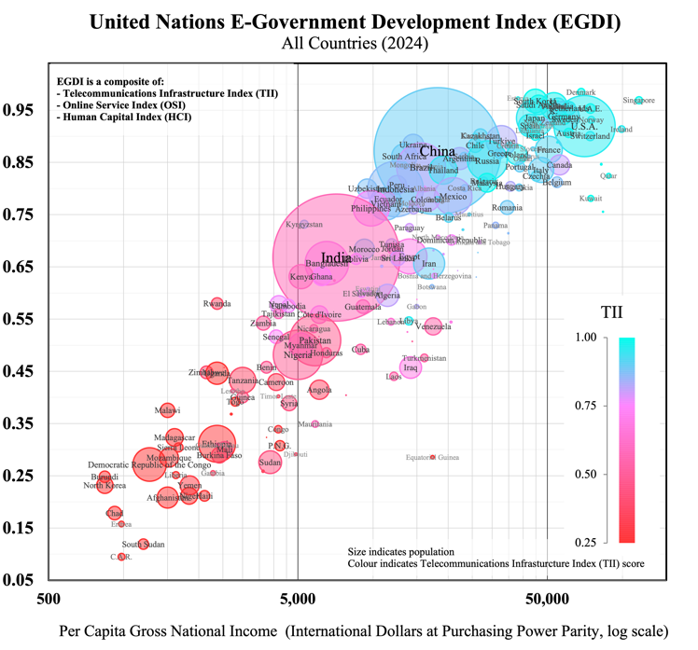 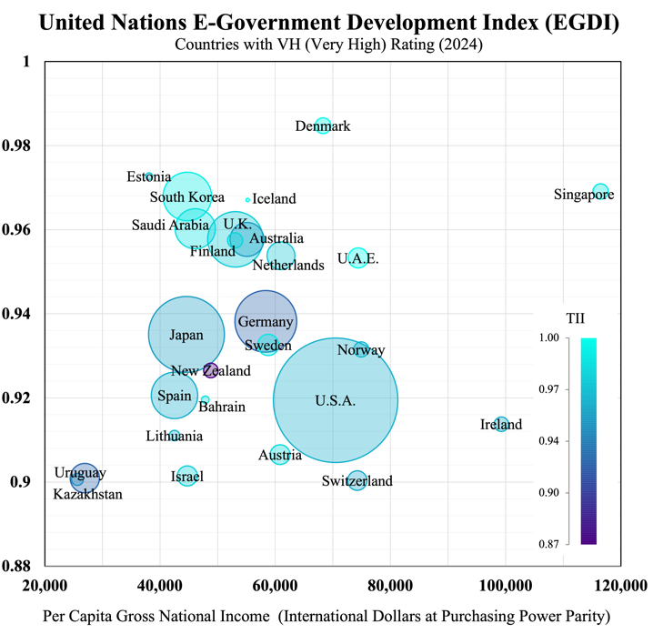

A *trust metric* quantifies the degree of trust held by stakeholders in institutions. Trust measurement frameworks derive standardized scores from structured assessments, summarizing information over multiple trust dimensions such as *competence* and *ethics* (Edelman Trust Barometer) or *effectiveness*, *ease* and *emotion* (Forrester Customer Experience CX). Trust metrics have been used to rate public trust in consumer brands, international corporations, digital platforms and public institutions (Table 1). These metrics have traditionally relied on surveys – e.g. customer experience or public opinion – which limit data to the responses of individuals to pre-defined questions.[4] Recent advances in machine learning enable trust-related sentiment to be tracked dynamically and automatically from unstructured digital communications, such as news articles, social media posts, and online forums. Boston Consulting Group’s 2022 Trust Index processed real-time natural-language input from leading wire-services, newspapers, journals, and Twitter, to derive dynamic trust indicators for over one thousand companies. Numerous open-source and paid machine-learning tools are now available for identifying topical themes and monitoring sentiment in various forms of live communications.[5]

***Table 1.*** *Prominent Trust Metrics*

|  |  |  |  |
| --- | --- | --- | --- |
| Metric | Data | Trust Dimensions | Application |
| **Edelman Trust Barometer** (2001 – Present) | Public Surveys | *Competence; Ethics* | Businesses, governments, NGOs and media organizations in 28 countries |
| **Global RepTrack**  (2004 – Present) | Public Surveys and Communications | *Products and Services; Innovation; Workplace; Governance; Citizenship; Leadership; Performance* | Top 100 reputable companies ranked from surveys across 14 countries |
| **Forrester Customer Experience (CX) Index**  (2007 – Present) | Customer Surveys | *Effectiveness; Ease; Emotion* | Approximately 500 brands across 14 sectors in 11 markets |
| **OECD Trust Survey**  (2021, 2023) | Public Surveys | *Competencies (reliability; responsiveness);*  *Values (openness; integrity; fairness)* | Public institutions in 38 OECD countries (about 2000 respondents per country) |
| **Boston Consulting Group Trust Index** (2022) | Stakeholder Communications | *Competence; Fairness; Transparency; Resilience* | Over 1000 companies internationally |

**Digital Trust**

Along with new ways to measure trust, digitisation introduces new dimensions to institutional trust-relationships. A World Economic Forum initiative defines *digital trust* as *individuals’ expectation that digital technologies and services – and the organizations providing them – will protect all stakeholders’ interests and uphold societal expectations and values.*[6] These “societal expectations and values” include upholding digital systems’ security and reliability, accountability and oversight, and inclusive, ethical, and responsible use (WEF, 2022). Some elements of digital trustworthiness that are common across organisations can be measured using prospective, objective capability indicators. The WEF initiative identifies eight elements as dimensions of a proposed structured framework for objectively evaluating technical capabilities and governance processes: *cybersecurity*, *safety*, *transparency*, *interoperability*, *auditability*, *redressability*, *fairness*, and *privacy* (Table 2). Other elements of trustworthiness may be captured by retrospective, subjective perception metrics, which capture the experience of users interacting with digital systems. Collection of this type of metric relies on the quality of these systems’ feedback mechanisms, and they may include user ratings for satisfaction and confidence, or user comprehension of system features and data flows.

Perception indicators can be complemented by behavioural metrics that reveal how users engage with digital services, including adoption rates, engagement patterns, support requests, retention over time, and willingness to promote the service to others. While prospective metrics on trustworthiness may be suited to expert evaluation of an organisation’s capabilities, it is these retrospective perception and behavioural measures that capture the actual progress of an organisation toward trusted relationships with users.

***Table 2.*** *Digital Trust Dimensions and Objective Capability Indicators (World Economic Forum framework)*

|  |  |  |
| --- | --- | --- |
| Dimension | Organisational Objectives | Capability Indicators |
| **Cybersecurity** | Incident prevention and response | *Protocols for securing infrastructure, devices, networks, data, and applications*  *Defined plans for breach detection, containment, and post-attack recovery* |
| **Safety** | Harm prevention measures | *Risk assessments and safeguards to minimize physical, emotional, or societal harm.*  *Preparedness for incidents, including corrective actions and support for affected stakeholders.* |
| **Transparency** | Appropriate and informative disclosure | *Policies determining what, when, and how information is shared (beyond regulatory mandates)*  *Audience-tailored explanations of data flows and system operations (e.g., FAQs, plain-language policies)* |
| **Interoperability** | Technical capabilities and community engagement | *Systems enabling seamless data exchange and portability (e.g., APIs, open-source tools)*  *Participation in industry standards and collaborative ecosystems (e.g., open-source contributions)* |
| **Auditability** | Effective processes and remediation | *Structured evaluations of high-risk areas (e.g., scoping, roles, timelines)*  *Accountability frameworks to address findings and drive improvements* |
| **Redressability** | User-friendly support and feedback incorporation | *Multi-channel grievance resolution (e.g., self-service portals, escalation paths)*  *Mechanisms to integrate user concerns into product/service design (e.g., recurring issue analysis)* |
| **Fairness** | Process and outcome fairness | *Inclusive design reviews to prevent bias (e.g., accessibility assessments)*  *Bias testing and documentation of fairness decisions (e.g., algorithmic audits)* |
| **Privacy** | User and organizational functionality | *Tools for data control (e.g., consent management, access requests)*  *Privacy-by-design practices and impact assessments (e.g., GDPR alignment)* |

Digitisation of government services introduces novel capabilities for gauging user experience and tracking service quality. Data from digital government platforms, including structured or unstructured user feedback, can be used in the construction public service performance indicators. The digital trust measurement framework can be adapted to the modern public sector by combining these indicators with objective capability evaluations of responsible technology use and organisational governance. An indexing system for government services based on this framework can enable performance benchmarking and the identification of trust-gaps. It can help establishes digital trustworthiness as a concrete policy objective, and orient digital transformation initiatives around competence and responsiveness in government service delivery.

**The Scope of Digital Government Services**

Government-provided services account for a significant share of total services consumed by individuals in developed economies, making their quality an important element of living standards globally (Figure 3).[7] However, comparative evaluations of service quality are complicated by the variety of determining factors – for example, user-experience, time, satisfaction, accessibility, and outcomes – and by the absence of standardised units or methods for their measurement. Measuring the *general* quality of service provision by government is further complicated by the vast heterogeneity of services that governments provide, and complex divisions of responsibility between various government bodies at different levels (central, regional and local).

Government services include activities relating to core state functions, such as law enforcement, tax collection, currency issuance, pension payments, licensing and regulations, and foreign affairs. Governments also typically provide education services – public schools, kindergartens, universities, and vocational training centres – as well as healthcare and social work services – public hospitals, disease-control programs, insurance systems, and care-services for children, the elderly, and persons with disabilities. Governments may provide these types of services directly, or support private provision through accreditation, funding, and regulatory mechanisms. Although modes of provision vary between and within countries, these types of services are significant categories of general government expenditure in all developed economies (Figure 4) and have been priority areas for public digitisation initiatives internationally.[8]

Government services extend to transportation and utilities: public transit systems, road networks, ports and airports, postal services, telecommunications, water supply, sewerage, waste management, power generation, and the transmission and distribution of gas and electricity. Due to scale and network economies, services in these sectors tend to be provided either by public entities or by private entities operating under substantial public regulation and oversight. Governments also commonly provide (or support the provision of) cultural and recreational services, such as museums, libraries, heritage sites, public broadcasting, and sports facilities, among many other areas of service-provision potentially suitable for inclusion in a service trust index (see Appendix C).

***Figure 3. Figure 4.***

The collective value of ‘non-market’ services provided directly by government, or in service sectors where statutory regimes are prevalent, represents a major component of aggregate production across developed economies (Figure 5).[9] Digitisation offers the potential to significantly improve performance and productivity growth in these key sectors, by enabling the large-scale collection and analysis of data that directly reflects the perceptions, and behaviour of service users. Trustworthy digital governments will aim to leverage this data responsibly to transform the design and delivery of public services, with a focus on user experience.

***Figure 5.***

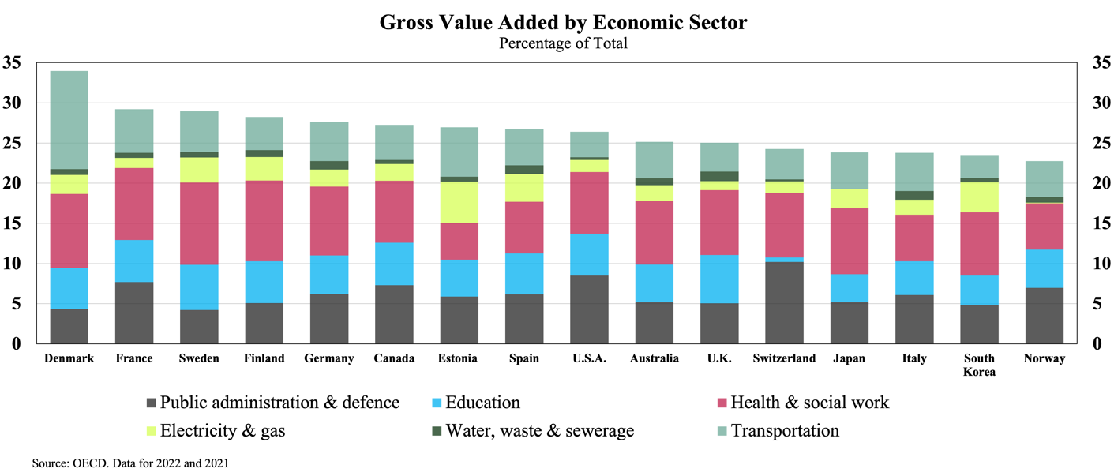

**Productivity, Service Quality, and User Feedback**

Productivity growth is a goal for governments worldwide, but measuring productivity in the public sector is a known methodological challenge (see Atkinson, 2005). Productivity estimates normally involve comparisons between the market-values of inputs and outputs, which is problematic for public services that produce outputs without market-based valuations.[10] National accounting conventions, which are used for calculating economic indicators like Gross Domestic Product, traditionally assume that the value of *non-market outputs* is equivalent to the value of their inputs (i.e. their costs of production, including labour costs), regardless of the value that the public might place on them. This convention overlooks the public sector’s potential for productivity improvements, since changes to the volume of non-market output for a fixed set of inputs will not be measured as a change in productivity.[11] To address this problem, a number of countries have experimented with ‘output-based’ measurements for the volume of public sector outputs, which depend on *quantity indicators* that ‘count’ public service outputs in the same manner as physical units (Schreyer, 2010). Examples include:

* **Education:** number of students enrolled, number of hours of teaching received by students (‘pupil hours’); number of degrees or credits obtained
* **Healthcare:** number of patients treated, number of diagnostic procedures or surgeries performed, number of hospital or care-facility occupant-days[12]
* **Public Safety and Justice:** number of crimes resolved, number of emergency call responses, number of inspections conducted, number of court hearings held.

These volume measurements do not account for output quality, and so can be misleading indicators of productivity if used by themselves.[13] To reflect service productivity in terms of outcomes rather than just outputs, statistical agencies that construct public service productivity indices typically adjust output volumes using *quality indicators*. Due to the diversity and complexity of relevant outcomes – which are often influenced by factors outside the control of the service-provider – there is no single standard approach to making these adjustments, but quality indicators employed in different countries include:

* **Education:** standardised test-score performance, teacher qualifications, prevalence of bullying, graduation rates, graduate employability and incomes
* **Healthcare:** hospital readmission rates, surgical complication rates, survival rates, waiting times for surgeries, procedures avoided due to early prevention, prevalence of health conditions in the community
* **Public Safety and Justice:** seriousness of crimes prevented, rates of recidivism, court processing timelines, number of cases dismissed, number of verdicts appealed or overturned on appeal.

These indicators are all ‘objective’, quantitative values which are independent of any observer’s identity.[14] Some quality indicators may rely on user-reporting, for example Patient-Reported Outcome Measures (PROMS), which are responses by patients to standardised questionnaires on health outcomes post-treatment, used to evaluate clinical effectiveness and widely used in healthcare service-volume quality-adjustments.

Another class of quality indicator is the ‘subjective’ kind: feedback given directly by users of the service. For example, Patient-Reported Experience Measures (PREMs) use standardised questionnaires to record patients’ feelings and opinions on various aspects of the care services they have received (e.g. waiting times, facilities, patient-clinician interaction). Subjective, experienced-based (i.e. user-satisfaction) measures such as these are not widely used in official productivity statistics, but several national statistical agencies use extensive experience-based data to construct parallel quality indicators for public service performance benchmarking, complementing objective measures of performance (Productivity Commission 2022, EIPA 2024).

Subjective experience metrics can be collected at the point of service (online, by phone or at in-person at service-centers), when users are prompted after an interaction to rate their experience. This may involve a scale (e.g. *very satisfied* to *very dissatisfied*) or as simple two or three-option sentiment indicator (i.e. *Thumbs-Up Thumbs-Down*, or *Happy, Neutral, Sad*).[15] Such simple forms of feedback require minimal time or effort by the respondent, which encourages high response rates. They can provide governments with real-time data that serves as a parsimonious high-level, user-focused performance indicator, suitable for aggregation across different service functions.

More detailed feedback requests – such as multi-question customer-experience surveys – can deliver actionable insights for performance improvements, but when collected at the point of service they may be subject to lower response rates and attribution problems. Detailed user-experience surveys, often targeting service-users some time after the event, usually aim to collect user-profile information to investigate possible differences in experience between groups, and to query various dimensions of user-experience, for example *ease*, *satisfaction* and *trust*.[16] These surveys ideally draw upon large, representative samples, but insights may still be revealed even where data is drawn from smaller and less representative samples, if considered together with objective performance indicators. Performance-monitoring systems for public services should include both objective measures for processes and outcomes, as well as standardised measures of subjective user experience.

In addition to surveys that specifically target known individual users of public services, many countries undertake ‘central surveys’, or ‘citizen surveys’, which periodically gather feedback on perceptions of public service quality from the general population. These surveys may query demographically-representative samples on overall trust and satisfaction (e.g. *Overall, how satisfied are you with health care services?*), with the results used to compare performance of different services at the central or federal level. Some of these surveys employ a *panel* of respondents (retaining the same respondents for multiple survey periods), allowing for more robust comparisons across time, while countries with more advanced systems (South Korea and Estonia) permit unstructured, real-time feedback. Table 3 gives examples of some of the comprehensive citizen surveys undertaken internationally.

***Table 3.*** *Citizen Feedback Systems*

|  |  |  |  |
| --- | --- | --- | --- |
| Country | System | Description | Surveyed Aspects |
| **Canada** | Citizens First | *Periodic national citizen satisfaction survey using standardized questions and metrics. Conducted every 3–4 years by the Institute for Citizen-Centred Service.* | *Overall satisfaction, priorities, expectations, service timeliness, staff courtesy, ease of access, digital service quality.* |
| **Denmark** | Den Nationale Borgerundersøgelse (National Citizen Survey) | *Annual national-level citizen survey managed by Local Government Denmark (KL), assessing user satisfaction with municipal service experiences.* | *Satisfaction with local services such as education, childcare, employment services, waste management, and healthcare.* |
| **Estonia** | Eesti.ee Feedback System | *Continuous integrated online satisfaction surveys embedded within Estonia’s national digital e-government portal, triggered after online service interactions.* | *User satisfaction with digital public services, ease of use, clarity, transaction efficiency, responsiveness of government digital platforms.* |
| **France** | Baromètre Paul Delouvrier (Barometer of Public Service Quality) | *Annual national satisfaction survey gathering detailed citizen perceptions of service quality.* | *Satisfaction with public services including healthcare, education, policing/security, taxation, transportation, justice, and user experience of online government services.* |
| **Germany** | Lebenslagenbefragung  (Life Events Survey) | *Biennial national citizen satisfaction survey conducted by Germany’s Federal Statistical Office, examining user experiences with public services during key administrative life events.* | *Administrative efficiency, clarity of procedures, satisfaction with specific government interactions (e.g., taxes, identity documents, healthcare, marriage processes).* |
| **Japan** | Survey on Satisfaction and Quality of Life | *Annual national citizen satisfaction survey conducted by Japan’s Cabinet Office, measuring quality of life and satisfaction with public services.* | *Citizen satisfaction in public safety, healthcare quality, education services, disaster response, local administrative performance, and digital government services.* |
| **Netherlands** | Burgerpeiling  (Municipal Citizen Survey) | *Standardized survey framework developed by the Association of Dutch Municipalities (VNG), utilized by municipalities to assess citizen satisfaction and experiences with local services.* | *Quality of life, community involvement, satisfaction with municipal services (e.g., public spaces, safety, social services), and the relationship between citizens and local government.* |
| **New Zealand** | Kiwis Count | *Quarterly national citizen satisfaction survey managed by the Public Service Commission, continuously monitoring public experiences with government services.* | *Satisfaction with quality and accessibility of public services, trust in government institutions, ease and effectiveness of digital versus non-digital channels, responsiveness and fairness of service delivery.* |
| **Saudi Arabia** | Watani App | *Real-time national citizen feedback smartphone application managed by the National Center for Performance Measurement, rating public service interactions.* | *Real-time citizen satisfaction with public services, facility quality, service speed, staff courtesy, transparency, overall efficiency, direct feedback loop for service improvements.* |
| **Singapore** | REACH (Government Feedback Unit) | *Government-managed, multi-channel national engagement platform allowing citizen feedback via surveys, forums, dialogues, social media, and mobile apps.* | *Public opinions on policy decisions, satisfaction with government services, healthcare access, public housing, education reforms, responsiveness of policy implementation, and citizen involvement.* |
| **South Korea** | Minwon24 / Government24 | *Integrated national digital portal offering comprehensive online citizen feedback and public service transactions, managed by Ministry of Interior and Safety.* | *Citizen satisfaction, complaint management, real-time service resolution, convenience and usability of digital public services, responsiveness, comprehensive service availability.* |
| **Sweden** | Medborgarpanelen (Citizen Panel) | *Large-scale online citizen panel operated by University of Gothenburg’s SOM Institute, periodically gathering broad public feedback and satisfaction levels.* | *Satisfaction with public services (healthcare, elderly care, education), trust in public institutions, service quality perceptions, policy impact evaluations.* |

Results from these types of surveys are they are not suited for international comparisons, due to the wide variety of structures used, as well as the tendency of satisfaction to be reported *relative to expectations* (which may vary widely between populations) rather than relative to any consistent standard. However, the OECD has recently (in 2021 and 2023) undertaken an international comparative *Survey on the Drivers of Trust in Public Institutions*, part of the Organisation’s Reinforcing Democracy Initiative, and supporting its *Government at a Glance* database. The survey questions respondents (roughly 2000 in each of 30 countries) on attitudes toward national, regional, and local government; satisfaction with healthcare and education systems, law and order institutions, administrative services; and trust in the use of personal data by public agencies. While finding wide variation between countries and demographics, the Survey results indicated that a key driver of trust in service providers is their *perceived responsiveness*: both to evidence and to public feedback.

**Appendix A**

|  |  |  |  |  |  |
| --- | --- | --- | --- | --- | --- |
| ***Table A1.*** *Government Effectiveness Metrics* | | | | | |
|  | Index | Publisher | Latest | Governments | Dimensions |
| ***Digital Government Maturity*** | | | | | |
|  | E-Government Development Index (EGDI) | United Nations | 2024 | 193 | *Composite of Online Service Index (OSI), Telecommunications Infrastructure Index (TII) and Human Capital Index (HCI)* |
|  | Online Service Index (OSI) | United Nations | 2024 | 193 | *Online services and content provision, institutional framework, e-Participation Index (EPI)* |
|  | E-Participation Index (EPI) | United Nations | 2024 | 193 | *Digital engagement and transparency: e-information, e-consultation, e-decision-making* |
|  | Human Capital Index (HCI) | United Nations | 2024 | 193 | *Education enrolment, adult literacy, years of schooling, e-government literacy* |
|  | Telecommunication Infrastructure Index (TII) | United Nations | 2024 | 193 | *Internet users, mobile subscriptions, broadband access, affordability* |
|  | GovTech Maturity Index (GTMI) | World Bank | 2023 | 198 | *Core systems, public services, citizen engagement, institutional and strategic enablers* |
|  | OECD Digital Government Index (DGI) | OECD | 2022 | 33 | *Digital by design, data-driven public sector, government as platform, open by default, user-driven, proactiveness* |
|  | Waseda-IAC Digital Government Rankings | Waseda University | 2024 | 66 | *Ten dimensions including infrastructure, e-services, national portal, cybersecurity, open data, online services, management optimisation* |
|  | Digital Economy and Society Index (DESI) | European Commission | 2023 | 27 | *Connectivity, human capital, use of internet, digital public services* |
|  | eGovernment Benchmark Report | European Commission | 2023 | 35 | *User-centricity, transparency, cross-border services* |
| ***Technology and Data*** | | | | | |
|  | Global Cybersecurity Index | ITUa | 2023 | 194 | *Legal, technical, and organizational cybersecurity capacity* |
|  | Global Data Barometer | D4D.net and ILDAb | 2021 | 109 | *Governance, capability, availability, use and impact of data for public good* |
|  | Open Data Inventory | Open Data Watch | 2023 | 192 | *Coverage, openness, accessibility of official statistics* |
|  | OUR Data Index | OECD | 2023 | 50 | *Open data availability, government support for reuse* |
|  | IMD World Digital Competitiveness Ranking | IMDc | 2023 | 64 | *Knowledge, technology, future readiness* |
|  | Network Readiness Index | Portulans Institute | 2023 | 134 | *Technology, people, governance, impact* |

*Continued next page*

|  |  |  |  |  |  |
| --- | --- | --- | --- | --- | --- |
| *Government Effectiveness Metrics, continued* | | | | | |
|  | Index | Publisher | Latest | Governments | Dimensions |
| ***Governance and Public Integrity*** | | | | | |
|  | Worldwide Governance Indicators (WGI) | World Bank | 2022 | 215 | *Voice/accountability, political stability, control of corruption, rule of law, regulatory quality* |
|  | Global Public Procurement Dataset | World Bank | 2023 | 82 | *Procurement transparency, contract awards, bid competitiveness* |
|  | Corruption Perceptions Index (CPI) | Transparency International | 2023 | 180 | *Perceived public sector corruption* |
|  | Rule of Law Index | World Justice Project | 2023 | 142 | *Constraints on government, civil justice, regulatory enforcement* |
|  | PARIS21 Statistical Capacity Monitor | OECD | 2023 | 150 | *Data ecosystems, coordination, dissemination* |
|  | Government at a Glance | OECD | 2023 | 38 | *Public service delivery, budget practices, public employment, digital government* |
|  | OECD Trust in Government Index | OECD | 2023 | 22 | *Reliability, responsiveness, integrity, openness, fairness* |
|  | Public Integrity Indicators | OECD | 2023 | 50 | *Anti-corruption frameworks, lobbying transparency* |
|  | Open Budget Survey | International Budget Partnership | 2023 | 125 | *Budget transparency, oversight, public participation* |
|  | International Civil Service Effectiveness (InCiSE) Index | Blavatnik School of Government, Oxford | 2019 | 38 | *Civil service capabilities, attributes, functions* |
| ***Economic Competitiveness and Business Environment*** | | | | | |
|  | Business Ready | World Bank | 2023 | 190 | *Business regulations, digital services, transparency* |
|  | Logistics Performance Index | World Bank | 2023 | 139 | *Customs efficiency, infrastructure quality, logistics competence* |
|  | Global Competitiveness Index (GCI) | World Economic Forum | 2020 | 141 | *Institutions, infrastructure, macroeconomics and markets, health, education, technology, innovation* |
|  | Global Innovation Index | World Intellectual Property Organization | 2023 | 132 | *Innovation inputs (education, infrastructure) and outputs (patents, tech)* |
|  | Survey of Adult Skills (PIAAC) | OECD | 2023 | 39 | *Literacy, numeracy, problem-solving skills* |
|  | Global Talent Competitiveness Index | INSEAD | 2023 | 134 | *Ability to attract, develop, and retain talent* |
|  | Economic Freedom Index | Heritage Foundation | 2023 | 184 | *Rule of law, government size, regulatory efficiency, open markets* |
|  | Economic Complexity Index | Harvard Growth Lab | 2023 | 133 | *Knowledge intensity, diversification* |
|  | *a. International Telecommunications Union b. Data for Development Network and Latin American Open Data Initiative.*  *c.International Institute for Management Development*  *The WGI scores on six aggregate dimensions rather than a single index* | | | | |

**Appendix B**

***Table B1.*** *Comparative government digital maturity rankings, top sixty countries by United Nations E-Government Development Index*

|  |  |  |  |  |  |  |  |  |  |
| --- | --- | --- | --- | --- | --- | --- | --- | --- | --- |
|  | EGDIa | OSIb | EPIc | TIId | HCIe | GTMIf | DGIg | Wasadah | NRIi |
| Denmark 🇩🇰 | 1 | 2 | 3 | 4 | 7 | 17 | 2 | 3 | 10 |
| Estonia 🇪🇪 | 2 | 3 | 7 | 20 | 8 | 5 | 6 | 7 | 18 |
| Singapore 🇸🇬 | 3 | 6 | 10 | 9 | 11 | 34 |  | 1 | 2 |
| South Korea 🇰🇷 | 4 | 1 | 4 | 6 | 17 | 1 | 1 | 5 | 5 |
| Iceland 🇮🇸 | 5 | 20 | 8 | 3 | 2 | 19 | 13 | 15 | 25 |
| Saudi Arabia 🇸🇦 | 6 | 4 | 9 | 14 | 19 | 3 |  | 8 | 35 |
| U.K. 🇬🇧 | 7 | 7 | 6 | 18 | 9 | 30 | 3 | 2 | 8 |
| Australia 🇦🇺 | 8 | 14 | 23 | 33 | 1 | 44 | 5 | 22 | 15 |
| Finland 🇫🇮 | 9 | 19 | 19 | 16 | 3 | 45 | 12 | 17 | 3 |
| Netherlands 🇳🇱 | 10 | 15 | 12 | 21 | 4 | 63 | 24 | 6 | 6 |
| U.A.E. 🇦🇪 | 11 | 16 | 41 | 1 | 10 | 4 |  | 21 | 28 |
| Germany 🇩🇪 | 12 | 12 | 5 | 40 | 5 | 56 |  | 9 | 9 |
| Japan 🇯🇵 | 13 | 9 | 2 | 34 | 18 | 58 | 33 | 11 | 12 |
| Sweden 🇸🇪 | 14 | 27 | 36 | 12 | 13 | 67 | 28 | 14 | 4 |
| Norway 🇳🇴 | 15 | 18 | 22 | 24 | 16 | 49 | 4 | 16 | 14 |
| New Zealand 🇳🇿 | 16 | 8 | 13 | 69 | 6 | 41 | 29 | 10 | 22 |
| Spain 🇪🇸 | 17 | 22 | 33 | 29 | 23 | 13 | 17 | 27 | 24 |
| Bahrain 🇧🇭 | 18 | 23 | 18 | 10 | 32 | 37 |  | 48 | 51 |
| U.S.A. 🇺🇸 | 19 | 17 | 11 | 27 | 25 | 60 |  | 4 | 1 |
| Ireland 🇮🇪 | 20 | 29 | 15 | 30 | 20 | 109 | 8 | 13 | 19 |
| Lithuania 🇱🇹 | 21 | 26 | 29 | 26 | 24 | 8 | 16 | 40 | 31 |
| Austria 🇦🇹 | 22 | 39 | 39 | 15 | 22 | 12 | 25 | 28 | 20 |
| Israel 🇮🇱 | 23 | 35 | 53 | 17 | 28 | 79 | 31 | 32 | 13 |
| Kazakhstan 🇰🇿 | 24 | 10 | 27 | 41 | 42 | 39 |  | 29 | 61 |
| Uruguay 🇺🇾 | 25 | 28 | 26 | 37 | 27 | 24 |  | 49 | 53 |
| Switzerland 🇨🇭 | 26 | 38 | 32 | 31 | 21 | 64 |  | 19 | 7 |
| Türkiye 🇹🇷 | 27 | 13 | 25 | 82 | 15 | 18 | 20 |  | 58 |
| Malta 🇲🇹 | 28 | 30 | 46 | 19 | 48 | 66 |  |  | 33 |
| Latvia 🇱🇻 | 29 | 47 | 37 | 23 | 26 | 27 | 18 |  | 37 |
| Ukraine 🇺🇦 | 30 | 5 | 1 | 78 | 47 | 57 |  |  | 43 |
| Chile 🇨🇱 | 31 | 33 | 30 | 36 | 41 | 65 | 35 | 41 | 54 |
| Croatia 🇭🇷 | 32 | 31 | 17 | 47 | 36 | 61 | 36 |  | 59 |
| Slovenia 🇸🇮 | 33 | 32 | 40 | 52 | 37 | 35 | 30 |  | 34 |
| France 🇫🇷 | 34 | 37 | 34 | 44 | 34 | 6 | 9 | 23 | 16 |
| China 🇨🇳 | 35 | 11 | 14 | 55 | 57 | 86 |  | 43 | 17 |
| Greece 🇬🇷 | 36 | 45 | 60 | 73 | 14 | 28 |  |  | 56 |
| Poland 🇵🇱 | 37 | 50 | 43 | 28 | 45 | 83 | 22 | 37 | 32 |
| Cyprus 🇨🇾 | 38 | 42 | 55 | 60 | 31 | 77 |  |  | 39 |
| Serbia 🇷🇸 | 39 | 36 | 20 | 45 | 50 | 11 |  |  | 47 |
| South Africa 🇿🇦 | 40 | 24 | 31 | 59 | 53 | 103 |  | 38 | 72 |
| Oman 🇴🇲 | 41 | 48 | 64 | 22 | 55 | 31 |  | 33 | 50 |
| Argentina 🇦🇷 | 42 | 52 | 69 | 79 | 12 | 62 | 34 | 56 | 69 |
| Russia 🇷🇺 | 43 | 56 | 67 | 32 | 44 | 10 |  | 36 | 41 |
| Liechtenstein 🇱🇮 | 44 | 66 | 62 | 7 | 46 | 155 |  |  |  |
| Luxembourg 🇱🇺 | 45 | 64 | 68 | 8 | 56 | 42 | 23 |  | 23 |
| Mongolia 🇲🇳 | 46 | 41 | 38 | 39 | 63 | 9 |  |  | 88 |
| Canada 🇨🇦 | 47 | 34 | 16 | 90 | 29 | 55 | 10 | 12 | 11 |
| Armenia 🇦🇲 | 48 | 53 | 28 | 66 | 35 | 76 |  |  | 66 |
| Portugal 🇵🇹 | 49 | 54 | 66 | 58 | 43 | 33 | 11 | 42 | 30 |
| Brazil 🇧🇷 | 50 | 21 | 24 | 91 | 51 | 2 | 15 | 46 | 44 |
| Italy 🇮🇹 | 51 | 61 | 61 | 54 | 40 | 48 | 21 | 25 | 26 |
| Thailand 🇹🇭 | 52 | 62 | 44 | 38 | 52 | 14 |  | 18 | 40 |
| Qatar 🇶🇦 | 53 | 58 | 93 | 5 | 90 | 16 |  |  | 38 |
| Czechia 🇨🇿 | 54 | 77 | 75 | 46 | 38 | 53 | 19 | 39 | 27 |
| Bulgaria 🇧🇬 | 55 | 57 | 59 | 49 | 68 | 82 |  |  | 55 |
| Belgium 🇧🇪 | 56 | 71 | 86 | 71 | 39 | 46 | 26 | 30 | 21 |
| Malaysia 🇲🇾 | 57 | 69 | 54 | 13 | 83 | 51 |  | 31 | 36 |
| Peru 🇵🇪 | 58 | 40 | 42 | 80 | 72 | 15 | 14 | 58 | 83 |
| Hungary 🇭🇺 | 59 | 73 | 81 | 84 | 30 | 50 | 32 |  | 42 |
| Slovakia 🇸🇰 | 60 | 74 | 57 | 57 | 54 | 88 |  |  | 46 |
| *a. UN E-Government Development Index b. UN Online Services Index c. UN E-Participation Index d. UN Telecommunications Infrastructure Index*  *e. UN Human Catpial Index (EGDI componenet) f. World Bank GovTech Maturity Index g. OECD Digital Government Index*  *h. Wasada-AIG Digital Government Rankings i. World Economic Forum / Portulans Institue Network Readiness Index* | | | | | | | | | |

***Table B2.*** *Correlation between government digital maturity rankings*

|  |  |  |  |  |  |  |  |  |
| --- | --- | --- | --- | --- | --- | --- | --- | --- |
|  | EGDI | OSI | EPI | TII | HCI | GTMI | DGI | Wasada |
| OSI | 0.853 |  |  |  |  |  |  |  |
| EPI | 0.745 | 0.874 |  |  |  |  |  |  |
| TII | 0.549 | 0.208 | 0.160 |  |  |  |  |  |
| HCI | 0.792 | 0.575 | 0.524 | 0.173 |  |  |  |  |
| GTMI | 0.212 | 0.255 | 0.128 | 0.095 | 0.123 |  |  |  |
| DGI | 0.360 | 0.405 | 0.420 | 0.276 | 0.236 | 0.420 |  |  |
| Wasada | 0.659 | 0.524 | 0.597 | 0.464 | 0.623 | 0.061 | 0.392 |  |
| NRI | 0.553 | 0.332 | 0.315 | 0.452 | 0.527 | -0.028 | 0.397 | 0.771 |

***Figure B1. Figure B2.***

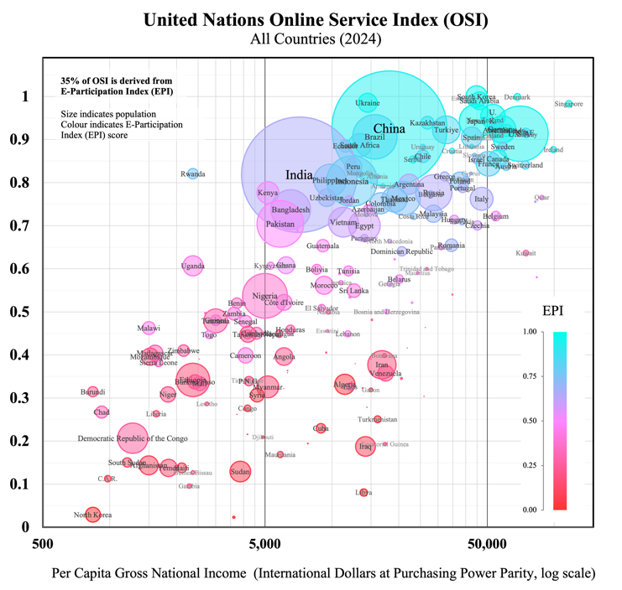 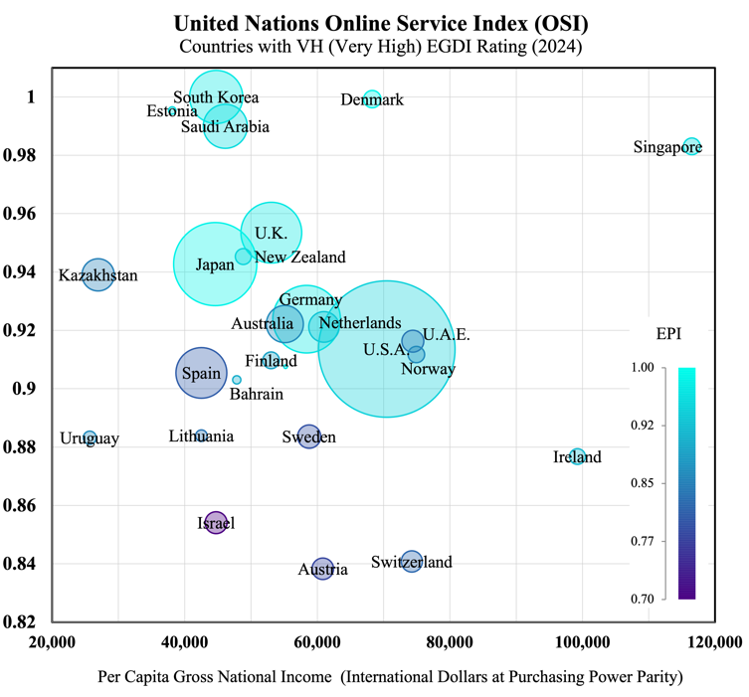

***Figure B1. Figure B2.***

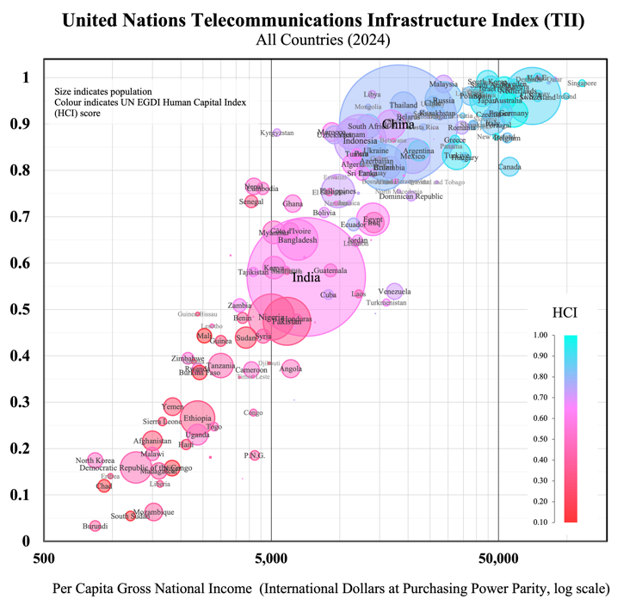 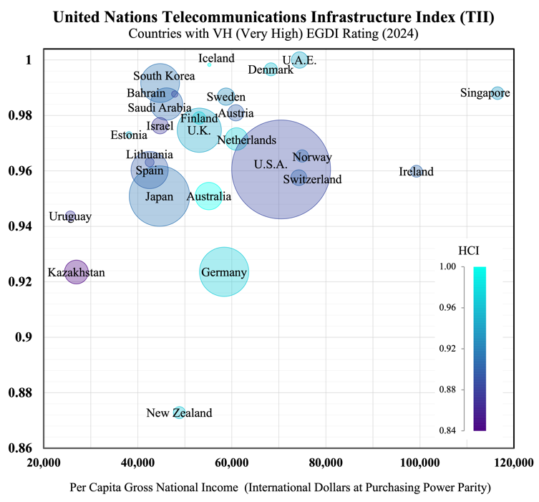

**Appendix C**

*Indicative public services activities and their categorisation (United Nations International Standard Industrial Classification framework)*

|  |  |
| --- | --- |
| Economic Sector (ISIC) | Service Activities |
| **Public Administration and Defence; Compulsory Social Security** | *Tax and customs administration; Civil registry services; Electoral administration and census; Regulation of social services; Administration of commerce, trade, and labour regulations, intellectual property, licensing, subsidies, and grants; Diplomatic missions and consular services; Visa and immigration policies; Refugee and asylum policies; Defence and border control activities; Administration of police forces and public security operations; Traffic regulation and control; Civil and criminal law courts; Prisons, correctional, rehabilitation, probation and parole services; Emergency disaster response; Compulsory social security activities* |
| **Education** | *Public pre-primary and primary education; Secondary education (general and technical); Higher education (universities and colleges); Technical and vocational training; Special education services; Adult education programs; School inspection and supervision; Curriculum development; Educational testing and assessment; Student financial aid administration* |
| **Human Health and Social Work** | *Hospital services; Medical and dental practice activities; Mental health facilities; Residential care facilities; Ambulance services; Public health campaigns; Medical research; Quarantine services; Health inspection; Vaccination programs; Child protection services; Elder care services; Services for persons with disabilities; Social counselling services; Community welfare services; Homeless shelters; Food banks and nutrition programs; Substance abuse treatment; Occupational health services; Maternal and child health services; Disease surveillance and monitoring; Health emergency preparedness* |
| **Electricity, Gas, Steam and Air Conditioning Supply** | *Electric power generation, transmission, distribution; Gas manufacture and distribution; Energy conservation programs; Rural electrification programs; Management of strategic energy reserves; Energy policy implementation; Renewable energy development; Nuclear energy regulation; Energy efficiency programs; Public lighting; District heating systems* |
| **Water Supply; Sewerage, Waste Management** | *Water collection, treatment, and supply; Sewerage system operation; Wastewater treatment; Hazardous and non-hazardous waste management; Materials recovery facilities; Remediation activities; Sanitation services; Environmental cleanup; Public toilets operation; Street cleaning services; Drinking water quality monitoring; Flood control infrastructure; Irrigation system administration; Water conservation programs* |
| **Transportation and Storage** | *Railway transport; Bus and school-bus services; Metro and light rail operation; Port authority operations; Airport operations; Air traffic control; Government space agencies; Highway and bridge maintenance; Tunnel operation; Parking facilities; Transportation safety administration; Maritime safety and navigation; Postal services; Public transit planning; Transportation infrastructure development* |
| **Information and Communication** | *Government broadcasting (radio and television), telecommunications, information services, data processing, web portals, publications, press offices; Government IT infrastructure management and cybersecurity operations; Public internet access points; Public information campaigns; Public statistical services* |
| **Financial and Insurance Activities** | *Central banking: issuing and managing national currency, monitoring and controlling money supply, supervising banking operations, managing international and gold reserves, setting interest rates, regulating financial markets, operating payment systems; Public banks* |
| **Real Estate Activities** | *Government land development; Affordable housing development; Public housing management; Land registry services; Land use planning; Urban renewal programs* |
| **Professional, Scientific and Technical Activities** | *Government research, testing and standards laboratories, scientific institutions, geological surveys, meteorological services, legal services, engineering services, veterinary services, advertising and public relations* |
| **Arts, Entertainment and Recreation** | *Public museums and historical sites, botanical and zoological gardens, nature reserves, libraries and archives, theatres and performing arts facilities, recreational facilities and parks, swimming pools, sports facilities; Cultural development programs; Community recreation programs; Youth centers; National lotteries; Public media production* |

**References**

Atkinson, T. (2005). Atkinson Review: Final report Measurement of Government Output and Productivity for the National Accounts. Retrieved from <https://webarchive.nationalarchives.gov.uk/ukgwa/20160105160709/http:/www.ons.gov.uk/ons/guide-method/method-quality/specific/public-sector-methodology/articles/atkinson-review-final-report.pdf>

Australian Institute of Health and Welfare. (2021). Patient reported measures. Retrieved from <https://www.aihw.gov.au/getmedia/31d2844d-323e-400a-875e-e9183fafdfad/aihw-aus-221-chapter-7-17.pdf.aspx>

Bertelsmann Stiftung. (2024). Bertelsmann Sustainable Governance Indicators. Retrieved from <https://www.sgi-network.org/2024/>

Bertelsmann Stiftung. (2024). Bertelsmann Transformation Index. Retrieved from <https://bti-project.org/en/?andcb=00000>

Blavatnik School of Government. (2024). Understand the methodology behind the Blavatnik Index of Public Administration. Retrieved from <https://index.bsg.ox.ac.uk/methodology/>

Boston Consulting Group. (2022). Trust index: Analyzing companies' trustworthiness. Retrieved from <https://www.bcg.com/publications/2022/trust-index-analyzing-companies-trustworthiness>

CAFRAL. (2020). Sovereign credit ratings: An assessment of methodologies and rating biases. Retrieved from <https://www.cafral.org.in/sfControl/content/Speech/1230202044754PMCRA_WP_25Dec2020.pdf>

Digital Dubai. (2025). Global trends in government innovation: Happiness Meter. Retrieved from <https://www.digitaldubai.ae/apps-services/details/happiness-meter>

Digital Transformation Agency. (n.d.). Measure performance. Retrieved from <https://www.dta.gov.au/11-measure-performance>

Edelman. (2021). Edelman Trust in Technology. Retrieved from <https://www.edelman.com/trust/2021-trust-barometer/trust-technology>

Edelman. (2025). Edelman Trust Barometer Global Report. Retrieved from <https://www.edelman.com/sites/g/files/aatuss191/files/2025-01/2025%20Edelman%20Trust%20Barometer%20Global%20Report_01.23.25.pdf>

European Commission. (2024). Digital Decade 2024 E-Government Benchmark. Retrieved from <https://digital-strategy.ec.europa.eu/en/library/digital-decade-2024-egovernment-benchmark>

European Commission. (2024). Digital Economy and Society Index (DESI). Retrieved from <https://digital-strategy.ec.europa.eu/en/policies/desi>

European Commission. (2024). eGovernment Benchmark. Retrieved from <https://digital-strategy.ec.europa.eu/en/library/digital-decade-2024-egovernment-benchmark>

European Institute of Public Administration. (2025). EIPA Benchmarking Study. Retrieved from <https://www.eipa.eu/wp-content/uploads/2025/04/2024-1621_Eipa_Benchmarking-Study_2024_v12.pdf>

Eurostat. (n.d.). Glossary: Actual individual consumption (AIC). Retrieved from <https://ec.europa.eu/eurostat/statistics-explained/index.php?title=Glossary:Actual_individual_consumption_(AIC)>

Fitch Ratings. (2024). Fitch sovereign rating criteria. Retrieved from <https://www.fitchratings.com/research/sovereigns/sovereign-rating-criteria-24-10-2024>

Forrester. (n.d.). Forrester CX Index methodology. Retrieved from <https://www.forrester.com/policies/cx-index/>

Glaeser, E., Laibson, D., Scheinkman, J., & Soutter, C. (2000). Measuring trust. Quarterly Journal of Economics, 115(3), 811-846.

Global Data Barometer. (2022). The Global Data Barometer Report: First edition. Retrieved from <https://globaldatabarometer.org/the-global-data-barometer-report-first-edition/>

ICAO. (2022). Guide Handling ICAO VDS-NC Health Proofs and EU-DCC. Retrieved from <https://www.icao.int/Security/FAL/TRIP/Documents/Guide%20Handling%20ICAO%20VDS-NC%20Health%20Proofs%20and%20EU-DCC%20V1.0.pdf>

IMD World Competitiveness Center. (2023). World Digital Competitiveness Ranking. Retrieved from <https://www.imd.org/centers/wcc/world-competitiveness-center/rankings/world-digital-competitiveness-ranking/>

INSEAD. (2023). Global Talent Competitiveness Index. Retrieved from <https://www.insead.edu/global-talent-competitiveness-index>

International Budget Partnership. (2023). Open Budget Survey. Retrieved from <https://internationalbudget.org/open-budget-survey/>

International Telecommunication Union. (2023). Global Cybersecurity Index. Retrieved from <https://www.itu.int/en/ITU-D/Cybersecurity/Pages/global-cybersecurity-index.aspx>

Moody's. (2022). Moody's rating methodology: Sovereigns. Retrieved from <https://ratings.moodys.com/api/rmc-documents/395819>

National Statistician. (2012). National Statistician's Independent Review of the Measurement of Public Services Productivity. Retrieved from <https://uksa.statisticsauthority.gov.uk/publication/national-statisticians-independent-review-of-the-measurement-of-public-services-productivity/>

OECD. (2010). Towards Measuring the Volume Output of Education and Health Services: A Handbook. Retrieved from <https://www.oecd.org/content/dam/oecd/en/publications/reports/2010/04/towards-measuring-the-volume-output-of-education-and-health-services_g17a1e7e/5kmd34g1zk9x-en.pdf>

OECD. (2023). Government at a Glance 2023. Retrieved from <https://www.oecd.org/en/publications/government-at-a-glance-2023_3d5c5d31-en.html>

OECD. (2023). OECD Digital Government Index (DGI). Retrieved from <https://www.oecd.org/en/publications/2023-oecd-digital-government-index_1a89ed5e-en.html>

OECD. (2024). Global Trends in Government Innovation. Retrieved from <https://www.oecd.org/en/publications/global-trends-in-government-innovation-2024_c1bc19c3-en.html>

OECD. (2024). OECD Survey on Drivers of Trust in Public Institutions. Retrieved from <https://www.oecd.org/en/publications/oecd-survey-on-drivers-of-trust-in-public-institutions-2024-results_9a20554b-en.html>

OECD. (n.d.). Budgeting Database. Retrieved from <https://www.oecd.org/en/topics/policy-issues/public-finance-and-budgets.html>

OECD. (2024). Exploring New Frontiers of Citizen Participation in the Policy Cycle Discussion Paper. Retrieved from <https://www.oecd.org/content/dam/oecd/en/about/programmes/reinforcing-democracy-initiative/Exploring-New-Frontiers-of-Citizen-Participation-Discussion-Paper.pdf>

OECD. (2022). Open government data. Retrieved from <https://web-archive.oecd.org/temp/2022-05-20/253891-open-government-data.htm>

OECD. (2025). Public Integrity Indicators. Retrieved from <https://oecd-public-integrity-indicators.org/>

OECD. (2024). Recommendation of the Council on Human-Centred Public Administrative Services. Retrieved from <https://legalinstruments.oecd.org/en/instruments/OECD-LEGAL-0503>

OECD. (2022). Serving Citizens. Retrieved from <https://www.oecd.org/en/publications/serving-citizens_65223af7-en.html>

OECD. (2024). Survey of Adult Skills. Retrieved from <https://www.oecd.org/en/about/programmes/piaac.html>

Open Data Watch. (2023). Open Data Inventory. Retrieved from <https://odin.opendatawatch.com/>

PARIS21. (2021). Praia handbook of governance statistics. Retrieved from <https://paris21.org/sites/default/files/2021-12/PRAIA%20Handbook%20final%20WEB-REVISED2021.pdf>

PARIS21. (2025). Paris 21 Statistical Capacity Monitor. Retrieved from <https://statisticalcapacitymonitor.org/>

Portulans Institute. (2023). Network Readiness Index. Retrieved from <https://networkreadinessindex.org/>

Productivity Commission. (2022). Report on Government Services. Retrieved from <https://www.pc.gov.au/ongoing/report-on-government-services/2022/data-downloads>

Qualtrics. (2025). Qualtrics XM. Retrieved from <https://www.qualtrics.com/en-au/customer-experience/>

Standard and Poor's. (2013). Country risk and sovereign risk. Retrieved from <https://www.spglobal.com/marketintelligence/en/documents/country-risk-and-sovereign-risk-1-.pdf>

The Heritage Foundation. (2024). Index of Economic Freedom. Retrieved from <https://www.heritage.org/index/>

The Observatory of Economic Complexity. (2024). Economic Complexity Index. Retrieved from <https://oec.world/en/rankings/eci/hs6/hs96?tab=ranking>

Transparency International. (2024). Corruption Perceptions Index. Retrieved from <https://www.transparency.org/en/cpi/2024>

United Nations Department of Economic and Social Affairs. (2023). National Accounts Statistics: Main Aggregates and Detailed Tables, 2023. Retrieved from <https://unstats.un.org/unsd/nationalaccount/sdpubs/MADT-2023.pdf>

United Nations. (2024). UN E-Government Survey 2024. Retrieved from <https://publicadministration.un.org/egovkb/en-us/Reports/UN-E-Government-Survey-2024>

United Nations. (2025). Cross classification of Gross value added by industries and institutional sectors. Retrieved from <http://data.un.org/Data.aspx?d=SNA&f=group_code%3a502>

United Nations. (2024). E-Participation Index. Retrieved from <https://publicadministration.un.org/egovkb/en-us/About/Overview/E-Participation-Index>

United Nations. (2008). ISIC: International Standard Industrial Classification. Retrieved from <https://unstats.un.org/unsd/publication/seriesm/seriesm_4rev4e.pdf>

United Nations. (2025). SNA 2025. Retrieved from <https://unstats.un.org/unsd/nationalaccount/snaupdate/2025/2025_SNA_Combined.pdf>

University of Gothenburg. (2023). The Swedish Citizen Panel. Retrieved from <https://www.gu.se/en/som-institute/the-swedish-citizen-panel/about-the-swedish-citizen-panel>

Waseda University. (2024). 2024 Digital Government Ranking Report. Retrieved from <https://idg-waseda.jp/pdf/2024_Digital_Government_Ranking_Report.pdf>

World Bank. (2024). Business Ready. Retrieved from <https://www.worldbank.org/en/businessready>

World Bank. (2025). GovTech. Retrieved from <https://www.worldbank.org/en/programs/govtech>

World Bank. (2022). International Comparisons Project. Retrieved from <https://databank.worldbank.org/source/icp-2021#>

World Bank. (2023). Logistics Performance Index. Retrieved from <https://lpi.worldbank.org/>

World Bank. (2021). Public-Sector Productivity (Part 1). Retrieved from <https://documents1.worldbank.org/curated/en/913321612847439794/pdf/Public-Sector-Productivity-Part-One-Why-Is-It-Important-and-How-Can-We-Measure-It.pdf>

World Bank. (2024). Worldwide governance indicators. Retrieved from <https://www.worldbank.org/en/publication/worldwide-governance-indicators>

World Economic Forum. (2020). The Global Competitiveness Report 2020. Retrieved from <https://www.weforum.org/publications/the-global-competitiveness-report-2020/>

World Economic Forum. (2022). Earning digital trust: Decision-making for trustworthy technologies. Retrieved from <https://www3.weforum.org/docs/WEF_Earning_Digital_Trust_2022.pdf>

World Economic Forum. (2023). Measuring digital trust: Supporting decision-making for trustworthy technologies. Retrieved from <https://www3.weforum.org/docs/WEF_Measuring_Digital_Trust_2023.pdf>

World Intellectual Property Organization. (2024). Global Innovation Index. Retrieved from <https://www.wipo.int/en/web/global-innovation-index>

World Justice Project. (2023). Rule of Law Index. Retrieved from <https://worldjusticeproject.org/rule-of-law-index/>

1. These have included the World Bank’s Worldwide Governance Indicators, the World Economic Forum’s Global Competitiveness Index, and Transparency International’s Corruption Perceptions Index. See Moody’s (2022), Fitch (2024).
2. The United Nations E-Government Development Index (EGDI) is the most prominent global digital government maturity index, published annually since 2001. It combines an Online Service Index, a Telecommunications Infrastructure Index, and a Human Capital Index. Twenty-six nations achieved the highest rating (Very High, “VH”) in the 2024 EGDI, corresponding to an index value above 0.9.
3. Pilot indexing projects for subnational government digital maturity have recently been undertaken by the United Nations (Local Online Service Index, 2024) and the World Bank (Subnational Government GovTech Maturity Index, 2022), but coverage has been limited. These subnational indices are not used in the computation of the corresponding national-level indices.
4. Questions on survey-participants’ opinions and attitudes are usually answered on a Likert scale – a multi-point scale with options typically ranging from “strongly agree” to “strongly disagree”. Statistical techniques infer population opinion from the responses of demographically balanced samples, but results can be subject to response bias (due to unreliable answers), as well as participation bias (where respondents and non-respondents are not similarly representative of the population).
5. These include Qualtrics XM – a management platform employing artificial intelligence for real-time multi-channel data (customer, employee, or product) analytics for businesses – and Signal AI, a reputation and risk intelligence platform allowing organisations to track sentiment and identify emerging topics from news, social media, and official communications.
6. This initiative, involving government representatives, technology companies and consumer advocates, was motivated by surveys showing internationally declining trust in technology over the preceding years (Edelman, 2021).
7. Actual Individual Consumption (AIC) is the formal statistical measure encompassing the value of consumer goods and services provided to households by the government (and by non-profit institutions) for individual (i.e. excludable) consumption, e.g. education and healthcare services, in addition to those goods and services purchased directly by households, i.e. Personal Consumption Expenditure (PCE). In addition to services provided directly to individuals, governments also provide a range of collective (or ‘non-excludable’) services, such as street lighting, flood-control systems, or national defence, which do not have individual users distinguishable from the general community, posing additional challenges for quality measurement.
8. These initiatives include government-managed platforms for storing and sharing academic credentials or personal medical records. Standardised digital records acquired a crucial role during the covid pandemic, with the International Civil Aviation Organization (ICAO) setting the standard for Visible Digital Seal (individual QR code) technology used in proofs of vaccination for cross-border travel.
9. The OECD publishes cross-country estimates of Gross Value Added for the International Standard Industrial Classification (ISIC) sectors indicated in Figure 5 but does not separate government and non-government production within these sectors. Non-market services belonging to these sectors fall within the scope of the proposed trust index. Non-market services belonging to other sectors – such as Telecommunications and Information, or Construction (both of which include public infrastructure), Real Estate Activities (which includes public housing) or Arts, Entertainment, and Recreation (which includes cultural programs) – may also fall within its scope (see Appendix C). Government-owned firms may operate in other economic sectors where private production and market transactions dominate (e.g. agriculture or manufacturing), but the activities of such firms would not fall within the scope considered for this indexing proposal.
10. Productivity is usually measured in growth-rates rather than levels, with productivity-growth estimated as the residual after accounting for changes to the value of outputs produced and changes to the value of inputs used in production. For market goods and services, these values are inferred using price information, but many public sector outputs are either provided free at the point of use or at subsidised prices. These include both individual and collective (i.e. non-excludable) goods and services.
11. It will instead be measured as a revaluation of the outputs produced relative to their inputs. This convention has the effect of reducing the reliability of standard measures of economic growth and living standards.
12. Due to the heterogeneity of medical conditions and treatments, output volumes for healthcare services are typically categorized according to sets of relatively cost-homogenous diagnosis related groups (DRGs).
13. Schools may teach more students, but to a lower standard. Increased hospital activity may reflect a failure of preventative care. A higher number of crimes resolved may simply be the corollary to rising crime rates.
14. The indicators themselves may be objective, but with myriad potentially relevant indicators, the particular combination and weighting of inputs used for quality adjustment will be debatable. Quality adjustment metrics may involve independent expert assessments or audit results and might also be made to account for variations in service accessibility or the equity of service provision across different population groups.
15. TUTD (Thumbs-Up Thumbs-Down) is a widget developed by the New South Wales Government to capture user sentiment for digital products or services. The Dubai government introduced three-option Happiness Meter for service interactions (both private and government) that is used to compute a Happiness Index, “the world’s first, city-wide, live sentiment capture engine”. Another method for recording user feedback is Net Promoter Score (NPS), asking users to rate their likelihood of “recommending” a product or service, but this is less suited to government services which are often used out of necessity.
16. These are the three dimensions used in the annual NSW Government Customer Experience Survey. Other surveys may be more granular, a Norwegian service user survey gathers feedback on eight experience-dimensions: *quality*, *accessibility*, *benefits*, *information &communication*, *consumer orientation*, *competence*, *trust*, and *overall satisfaction.*