Trustworthy Digital Society Hub

April 2025

**An Index for Trustworthy Government in the Digital Age**

**Introduction**

Societies depend on trustworthy government services, including essential utilities, education, healthcare, transportation and civil administration. Over the past three decades, digital technology has transformed the delivery of government services in three main stages:

1. Web Presence (1990s-2000s): governments begin creating websites and portals, allowing individuals to access information online
2. Web Engagement (2000s-2010s): social-media and interactive web platforms emerge, enabling two-way communication between government and public. Government service transactions move online, but systems are usually siloed between departments
3. Digital-Native Government (2010s-Present): governments adopt holistic digital strategies, pursuing integration across departments, high-performance cloud infrastructure, mobile-first service delivery, and universal identification systems. Moves toward this stage received an impetus from the covid pandemic.

The Trustworthy Digital Government project aims to develop a global trust index for government services transitioning to G3 and beyond. The proposed indexing system will integrate expert evaluations across key dimensions of digital trust with user-experience data from government platforms.

The project will deliver an operational framework for benchmarking the trustworthiness of digital government services. It will devise systems for aggregating complex, dynamic data to evaluate and monitor government service delivery. It will produce indicators for digital-age institutional capacity and service quality, intended to guide transformation initiatives, inform sovereign assessments, and promote productivity-enhancing public investments in digital technology.

This paper will describe the motivations for this program, reviewing digital government maturity and trust metrics, the scope of digital government services, and the challenge of measuring government service productivity. It will consider the requirements of a system for dynamically measuring trust in government services, and some of the key elements that this program could integrate.

**Digital Government Maturity and Trust Metrics**

A range of metrics have been developed to capture elements of government effectiveness and institutional quality (see Appendix A). Some of these metrics are referenced by credit ratings agencies in sovereign risk assessments.[1] Metrics for *digital government maturity*, evaluating the level of effectiveness in the adoption of digital technology by governments, are published by organisations including the United Nations, the World Bank, and the Organization of Economic Co-operation and Development (OECD).[2] These metrics allow for international comparisons (Figures 1 and 2, Appendix B) but overlook significant variation at the subnational level.[3] Digital government maturity metrics focus on infrastructure, technical capabilities, and service availability, but do not specifically consider *outcomes* in government service-delivery, nor *user trust* in service-providers.

***Figure 1. Figure 2.***

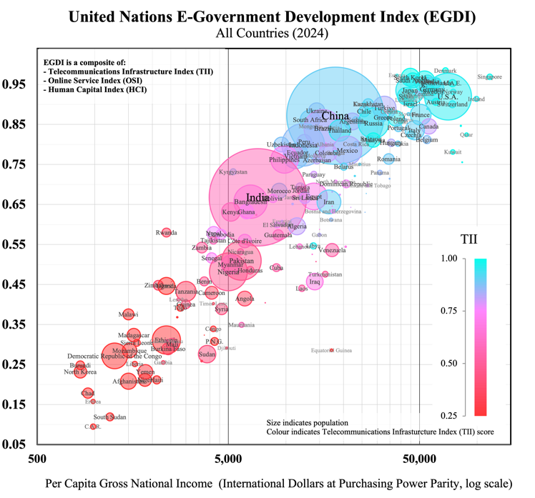 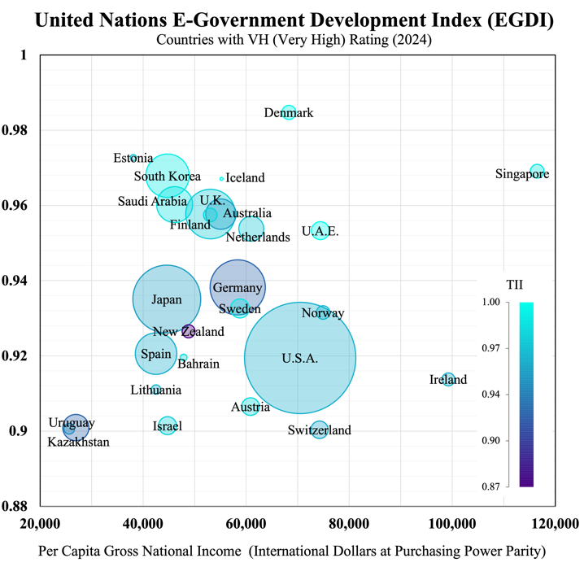

A *trust metric* quantifies the degree of trust held by stakeholders in institutions. Trust measurement frameworks derive standardized scores from structured assessments, summarizing information over multiple trust dimensions such as *competence* and *ethics* (Edelman Trust Barometer) or *effectiveness*, *ease* and *emotion* (Forrester Customer Experience CX).

Trust metrics have been used to rate public trust in consumer brands, international corporations, digital platforms and public institutions (Table 1). These metrics have traditionally relied on surveys – e.g. customer experience or public opinion – which limit data to the responses of individuals to pre-defined questions.[4] Advances in machine learning now enable trust-related sentiment to be tracked dynamically and automatically from unstructured digital communications, such as news articles, social media posts, and online forums. Boston Consulting Group’s 2022 Trust Index processed real-time natural-language input from leading wire-services, newspapers, journals, and Twitter, deriving dynamic trust indicators for over one thousand companies. Numerous open-source and paid machine-learning tools are now available for identifying topical themes and monitoring sentiment in various forms of live communications.[5]

***Table 1.*** *Prominent Trust Metrics*

|  |  |  |  |
| --- | --- | --- | --- |
| Metric | Data | Trust Dimensions | Application |
| **Edelman Trust Barometer** (2001 – Present) | Public Surveys | *Competence; Ethics* | Businesses, governments, NGOs and media organizations in 28 countries |
| **Global RepTrack**  (2004 – Present) | Public Surveys and Communications | *Products and Services; Innovation; Workplace; Governance; Citizenship; Leadership; Performance* | Top 100 reputable companies ranked from surveys across 14 countries |
| **Forrester Customer Experience (CX) Index**  (2007 – Present) | Customer Surveys | *Effectiveness; Ease; Emotion* | Approximately 500 brands across 14 sectors in 11 markets |
| **OECD Trust Survey**  (2021, 2023) | Public Surveys | *Competencies (reliability; responsiveness);*  *Values (openness; integrity; fairness)* | Public institutions in 38 OECD countries (about 2000 respondents per country) |
| **Boston Consulting Group Trust Index** (2022) | Stakeholder Communications | *Competence; Fairness; Transparency; Resilience* | Over 1000 companies internationally |

**Digital Trust**

Along with new ways to measure trust, digitisation introduces new dimensions to institutional trust-relationships. A World Economic Forum initiative defines *digital trust* as *individuals’ expectation that digital technologies and services – and the organizations providing them – will protect all stakeholders’ interests and uphold societal expectations and values.*[6] These “societal expectations and values” include upholding digital systems’ security and reliability, accountability and oversight, and inclusive, ethical, and responsible use (WEF  2022). Some elements of digital trustworthiness that are common across organisations can be measured using prospective, objective capability indicators. The WEF initiative identifies eight elements as dimensions of a proposed structured framework for objectively evaluating technical capabilities and governance processes: *cybersecurity*, *safety*, *transparency*, *interoperability*, *auditability*, *redressability*, *fairness*, and *privacy* (Table 2). Other elements of trustworthiness may be tracked using retrospective, subjective perception metrics that capture the experience of users interacting with digital systems. Collection of this type of metric relies on the quality of digital systems’ feedback mechanisms. They may include user ratings for satisfaction and confidence, or user comprehension of system features and data flows.

***Table 2.*** *Digital Trust Dimensions and Objective Capability Indicators (World Economic Forum framework)*

|  |  |  |
| --- | --- | --- |
| Dimension | Organisational Objectives | Capability Indicators |
| **Cybersecurity** | Incident prevention and response | *Protocols for securing infrastructure, devices, networks, data, and applications*  *Defined plans for breach detection, containment, and post-attack recovery* |
| **Safety** | Harm prevention measures | *Risk assessments and safeguards to minimize physical, emotional, or societal harm.*  *Preparedness for incidents, including corrective actions and support for affected stakeholders.* |
| **Transparency** | Appropriate and informative disclosure | *Policies determining what, when, and how information is shared (beyond regulatory mandates)*  *Audience-tailored explanations of data flows and system operations (e.g., FAQs, plain-language policies)* |
| **Interoperability** | Technical capabilities and community engagement | *Systems enabling seamless data exchange and portability (e.g., APIs, open-source tools)*  *Participation in industry standards and collaborative ecosystems (e.g., open-source contributions)* |
| **Auditability** | Effective processes and remediation | *Structured evaluations of high-risk areas (e.g., scoping, roles, timelines)*  *Accountability frameworks to address findings and drive improvements* |
| **Redressability** | User-friendly support and feedback incorporation | *Multi-channel grievance resolution (e.g., self-service portals, escalation paths)*  *Mechanisms to integrate user concerns into product/service design (e.g., recurring issue analysis)* |
| **Fairness** | Process and outcome fairness | *Inclusive design reviews to prevent bias (e.g., accessibility assessments)*  *Bias testing and documentation of fairness decisions (e.g., algorithmic audits)* |
| **Privacy** | User and organizational functionality | *Tools for data control (e.g., consent management, access requests)*  *Privacy-by-design practices and impact assessments (e.g., GDPR alignment)* |

Perception indicators can be complemented by behavioural metrics that reveal how users engage with digital services, including adoption rates, engagement patterns, support requests, retention over time, and willingness to promote the service to others. While prospective metrics on trustworthiness may be suited to expert evaluation of an organisation’s capabilities, it is these retrospective perception and behavioural measures that capture the actual progress of an organisation toward trusted relationships with users.

Digitisation of government services introduces novel capabilities for gauging user experience and tracking service quality. Data from digital government platforms, including structured or unstructured user feedback, can be used in the construction public service performance indicators. The digital trust measurement framework can be adapted to the modern public sector by combining these indicators with objective capability evaluations of responsible technology use and organisational governance. Through enabling performance benchmarking and the identification of trust-gaps, an indexing system for government services based on this framework can help establish digital trustworthiness as a concrete policy objective.

**The Scope of Digital Government Services**

The public sector produces a significant share of total services consumed by individuals in developed economies, making public service quality an important element of living standards globally (Figure 3).[7] Comparative evaluations of the quality of individual public services are complicated by the variety of determining factors – for example, user-experience, time, satisfaction, accessibility, and outcomes – and by the absence of standardised units or methods for their measurement. Measuring the *general* quality of service provision by government is further complicated by the vast heterogeneity of services that governments provide, and complex divisions of responsibility between various government bodies at different levels (central, regional, and local).

Government services include activities relating to core state functions, such as law enforcement, tax collection, currency issuance, pension payments, licensing and regulations, and foreign affairs. Governments also typically provide education services – public schools and universities – as well as healthcare and social work services – public hospitals, disease-control programs, insurance systems, and care-services for children, the elderly, and persons with disabilities. Modes of provision vary between and within countries, with governments both providing these services directly and supporting private provision through accreditation, funding, and regulatory mechanisms. Health and education services account for significant components of general government expenditure in all developed economies (Figure 4) and have been priority areas for public digitisation initiatives internationally.[8]

***Figure 3. Figure 4.***

Government services extend to transportation and utilities: public transit systems, road networks, ports and airports, postal services, telecommunications, water supply, sewerage, waste management, power generation, and the transmission and distribution of gas and electricity. Due to scale and network economies, services in these sectors tend to be provided either by public entities or by private entities operating under substantial public regulation and oversight. Governments also provide (or support the provision of) many other areas of service-provision potentially suitable for inclusion in a service trust index (see Appendix C). The collective value of ‘non-market’ services provided directly by government, or in service sectors where statutory regimes are prevalent, represents a major component of economic activity (around one-quarter by gross value-added) across developed countries (Figure 5).[9] Digitisation offers the potential to significantly improve service quality by enabling the large-scale collection and analysis of data that directly reflects the perceptions and behaviour of service users. A key objective of trustworthy digital government is to leverage this data responsibly to transform the design and delivery of public services, boosting productivity growth across key economic sectors.

***Figure 5.***

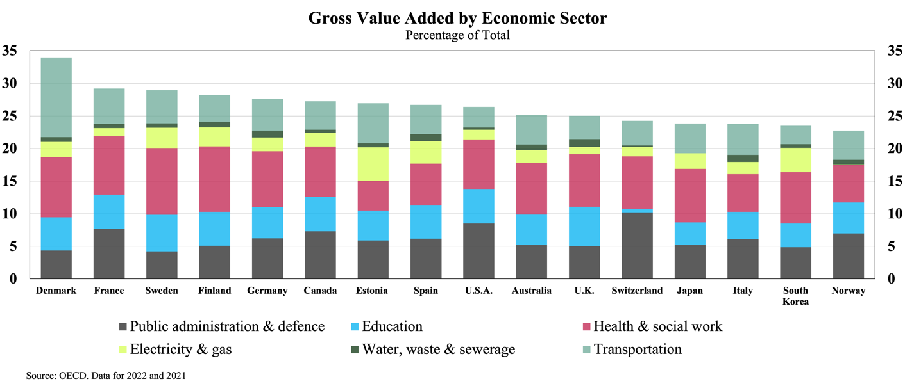

**Productivity, Service Quality, and Public Feedback**

Measuring productivity in the public sector is a known methodological challenge (see Atkinson, 2005). Productivity estimates normally involve comparing market-values of inputs and outputs, which is problematic for public services that produce outputs without market-based valuations.[10] National accounting conventions, which are used for calculating economic indicators like Gross Domestic Product, traditionally assume that the value of *non-market outputs* is equivalent to the value of their inputs (i.e. their costs of production, including labour costs), regardless of the value that the public might place on them. This convention overlooks the public sector’s potential for productivity improvements, as changes to the *volume* of non-market output for a fixed set of inputs are not registered as a change in productivity.[11]

To address this problem, a number of countries have experimented with ‘output-based’ measurements for public sector output volume, which adopt *quantity indicators* that ‘count’ public service outputs in the same manner as physical units (Schreyer, 2010), for example:

* *Education:* number of students enrolled, number of hours of teaching received by students (‘pupil hours’); number of degrees or credits obtained
* *Healthcare:* number of patients treated, number of diagnostic procedures or surgeries performed, number of hospital or care-facility occupant-days[12]
* *Public Safety and Justice:* number of crimes resolved, number of emergency call responses, number of inspections conducted, number of court hearings held.

These volume measurements do not account for output quality, so can be misleading indicators of productivity if used by themselves.[13] To reflect service productivity in terms of outcomes rather than just outputs, statistical agencies that construct public service productivity indices typically adjust output volumes using *quality indicators*. Due to the diversity and complexity of relevant outcomes – which are often influenced by factors outside the control of the service-provider – there is no single standard approach to making these adjustments. Quality indicators used by statistical agencies include:

* *Education:* standardised test-score performance, teacher qualifications, prevalence of bullying, graduation rates, graduate employability and incomes
* *Healthcare:* hospital readmission rates, surgical complication rates, survival rates, waiting times for surgeries, procedures avoided due to early prevention, prevalence of health conditions in the community
* *Public Safety and Justice:* seriousness of crimes prevented, rates of recidivism, court processing timelines, number of cases dismissed, number of verdicts appealed or overturned on appeal.

These indicators are all quantitative values which can be measured independently, or ‘objective’ indicators.[14] Some quality indicators may rely on user-reporting, for example Patient-Reported Outcome Measures (PROMS), which are responses by patients to standardised questionnaires on health outcomes post-treatment, used to evaluate clinical effectiveness and widely used in healthcare service-volume quality-adjustments.

Another class of quality indicator is the ‘subjective’ kind: feedback given directly by users of the service. Patient-Reported Experience Measures (PREMs) use standardised questionnaires to record patients’ feelings and opinions on various aspects of the care services they have received (e.g. waiting times, facilities, patient-clinician interaction). Subjective, experienced-based (i.e. user-satisfaction) measures are not widely used in official productivity statistics, but several national statistical agencies use extensive experience-based data to construct parallel quality indicators for public service performance benchmarking, complementing objective performance metrics (Productivity Commission 2022, EIPA 2024).

Subjective experience metrics can be collected at the point of service (online, by phone or at in-person at service-centres), when users are prompted after an interaction to rate their experience. This may involve a scale (e.g. *very satisfied* to *very dissatisfied*) or a simple two-option (*Thumbs-Up, Thumbs-Down*) or three-option (*Happy, Neutral, Sad*) sentiment indicator.[15] Simple forms of post-transaction feedback require little time or effort, encouraging high response rates. They can provide governments with real-time data that serves as a parsimonious high-level, user-focused performance indicator, suitable for aggregation across different service functions.

More detailed experience surveys can deliver actionable insights for performance improvements, but when collected at the point of service they may be subject to lower response rates and attribution problems.[16] Detailed post-transaction user-experience surveys usually aim to collect user-profile information (to construct representative samples and investigate differences in experience between groups) and query multiple dimensions of user-experience – for example, *ease*, *satisfaction,* and *trust.*[17] In addition to surveys that specifically gather post-transaction feedback, many countries undertake ‘central’ or ‘citizen’ surveys that periodically gather feedback on perceptions of government service quality from the general population, often with a focus on *life events*.[18] Some of these surveys employ a panel of respondents (retaining the same respondents for multiple survey periods), allowing for more robust comparisons over time. Data on subjective user experience are used in performance measurement systems as a complement to objective process and outcome metrics, to which they are generally correlated (Baredes 2022).

Several countries have developed integrated national platforms for government services with feedback mechanisms that permit free text (or speech) along with post-transaction user-experience ratings. These systems process complex natural language data to track service quality and identify issues at a granular level. Advanced public service digitisation opens channels for continuous unstructured feedback and detailed real-time population data, in contrast to the structured sample data provided by periodic central surveys. Table 3 gives examples of both continuous feedback systems and periodic central surveys that are used internationally.

***Table 3.*** *Central Surveys and Feedback Systems*

| Country | System | Description | Surveyed Aspects |
| --- | --- | --- | --- |
| **Australia** | **Survey of Trust in Australian Public Services** | *Rolling national survey of adults across Australia, from 2019* | *Satisfaction with service delivery; life‑event service experiences across agencies* |
| **Canada** | **Citizens First** | *Periodic national satisfaction survey of Canadian citizens conducted every 3-4 years by independent Institute for Citizen-Centred Service, since* ***1998*** | *Overall satisfaction; Service priorities; Expectations; Timeliness; Staff courtesy; Ease of access; Digital service quality* |
| **Denmark** | **Den Nationale Borgerundersøgelse** | *Annual national citizen survey; Municipal service users; annual since* ***2009*** | *Satisfaction with local services: education, childcare, employment services, waste management, healthcare* |
| **Estonia** | **Eesti.ee** | *Continuous online feedback embedded in unified e‑government portal* | *Digital service satisfaction; Ease of use; Clarity; Transaction efficiency; Platform responsiveness* |
| **France** | **Baromètre Paul Delouvrier** | *Annual public service quality survey conducted by independent Non-Government Organisation annually since* ***2004*** | *Satisfaction with healthcare, education, policing/security, taxation, transportation, justice, online services* |
| **Germany** | **Lebenslagenbefragung** | *Biennial life‑event satisfaction survey of citizens and companies, since* ***2015*** | *Administrative efficiency; Procedure clarity; Satisfaction with taxes, IDs, healthcare, marriage processes* |
| **Japan** | **Survey on Satisfaction & Quality of Life** | *Annual quality‑of‑life citizen survey since* ***2011*** | *Public safety; Healthcare quality; Education; Disaster response; Local administration; Digital services* |
| **Netherlands** | **Burgerpeiling** | *Framework for municipal surveys, usually conducted biennially* | *Quality of life; Community involvement; Satisfaction with public spaces, safety, social services; Citizen–government relations* |
| **New Zealand** | **Kiwis Count** | *Quarterly trust and satisfaction survey of New Zealand residents since* ***2007*** | *Service quality; Trust in public institutions; Digital vs non‑digital channel effectiveness; Responsiveness; Fairness* |
| **Norway** | **Innbyggerundersøkelsen** | *Biennial citizen satisfaction survey since* ***2010*** | *Satisfaction with healthcare, education, welfare, police, local govt; Trust in institution* |
| **Saudi Arabia** | **Watani App** | *Real‑time continuous mobile feedback app launched in* ***2019*** | *Facility quality; Service speed; Staff courtesy; Transparency; Overall efficiency* |
| **Singapore** | **REACH (Reaching Everyone for Active Citizenry @ Home)** | *Multi‑channel government engagement and feedback since* ***2006*** | *Policy feedback; Satisfaction with healthcare, housing, education reforms; Responsiveness; Citizen involvement* |
| **South Korea** | **Minwon24 / Government 24** | *Continuous digital portal since* ***2002*** | *Complaint management; Satisfaction; Usability and convenience of digital services; Service availability* |
| **Sweden** | **Medborgarpanelen** | *Online citizen panel, 3–4 waves per year, since* ***2010*** | *Satisfaction with healthcare, elderly care, education; Trust in institutions; Service quality perceptions; Policy impact* |
| **Switzerland** | **National eGovernment Study** | *Triennial digital public service survey since* ***2016*** | *Usage patterns; Trust in e‑services; Adoption barriers; Demand for online offerings; Digital interaction preferences* |
| **United Arab Emirates** | **Government Services Observatory** | *Real-time customer satisfaction data across government services* |  |

Results from service feedback systems and central surveys are not well-suited for making cross-country comparisons, due to the variety of structures used, and the tendency of service quality to be perceived relative to expectations – which may vary widely between populations – rather than consistent standards. To compare perceptions of government and government services across countries, the OECD recently (in 2021 and 2023) undertook an international *Survey on the Drivers of Trust in Public Institutions*, part of the Organisation’s Reinforcing Democracy Initiative.[19] The survey questions respondents on attitudes toward national (Figure 6), regional, and local government and law and order institutions; as well as satisfaction with healthcare and education systems and administrative services, and trust in the use of personal data by public agencies (Figure 7).

***Figure 6. Figure 7.***

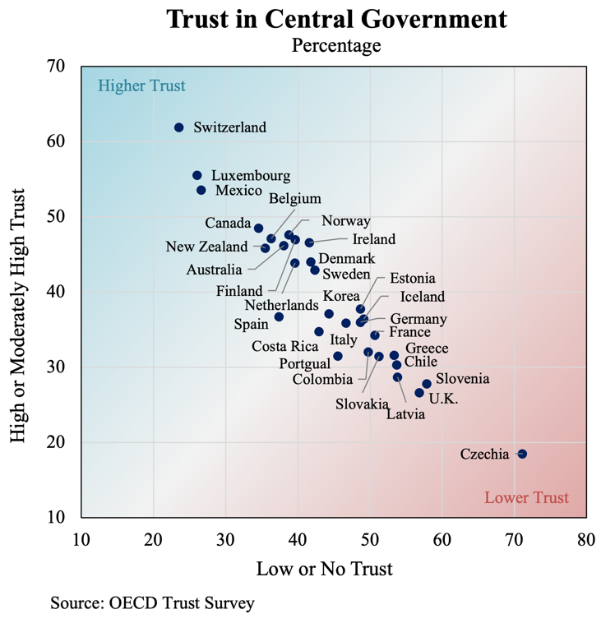 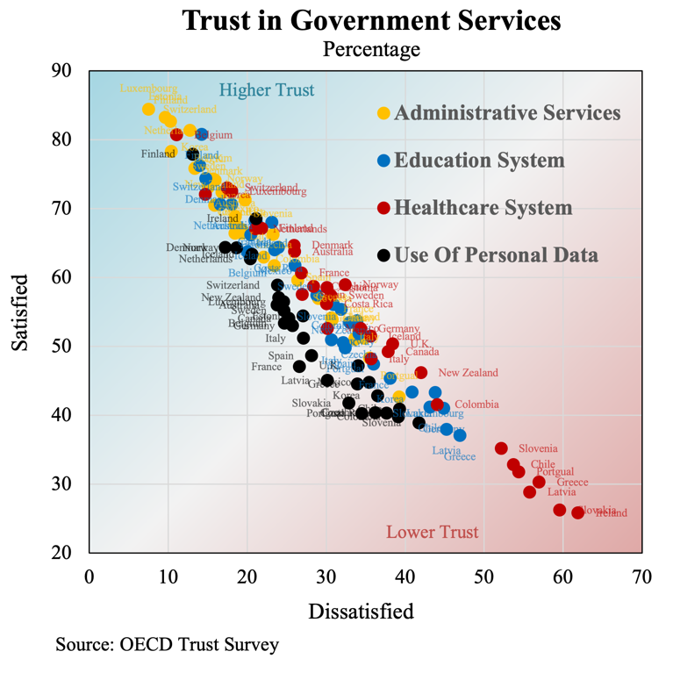

While finding wide variation between countries and demographics, the OECD Trust Survey found that a consistently strong driver of trust in service providers is their *perceived responsiveness*, both to evidence and to public feedback.[20] The importance of the *responsiveness* dimension to public evaluations of government trustworthiness underscores the value of the new channels for policy input opened by digital transformation.

**Indexing Trust in Digital Government Services**

The transition from G2 to G3 describes a shift from fragmented, siloed data environments to cross-departmental digital systems based on sophisticated national infrastructures. A leading example is Estonia’s X-Road data exchange platform, which enables secure information sharing between hundreds of public and private sector organisations across thousands of digital services.[21] Another example is South Korea’s *Government 24*, which integrates thousands of services at all levels of government under one 24/7 online portal, with case-tracking and mechanisms for user feedback, linked to the government’s real-time performance management and evaluation system. A similar digital ‘front-door’ for unified digital services is Singapore’s government app LifeSG., which organises services around life events and offers personalised recommendations based on user profiles and behavioural data.

Although few countries have reached a similar stage of G3, digital transformation initiatives worldwide are increasingly shifting responsibility for government-wide service-delivery monitoring and improvement to central digital government units, recognising the strategic role of integrated data resources. The United States Digital Service (USDS) plays a central role in improving federal online services and operates from the Executive Office of the President. A 2021 Executive Order directs high-impact agencies to prioritise ‘customer experience’ and service design centred on life events.[22] In 2025 the U.K. launched a new digital centre of government (Government Digital Service) with a comprehensive strategy for “wholesale reshaping” of the public sector. In Australia, the Digital Transformation Agency (DTA) has been made responsible for driving cross-departmental data-driven service improvement with a life-event approach and a strong focus on digital trust.[23] These initiatives reflect the increasing importance of digital performance to the credibility of public institutions, a development that may become increasingly relevant for sovereign assessments.

Integration of digital systems demands institutional commitment and coordination at different levels of government, requiring substantial investments in technology and infrastructure alongside the development of legislative and regulatory frameworks and governance schemes to ensure digital trustworthiness. The benefits include more efficient and accessible services, reductions in ‘time taxes’ imposed on the public by fragmented administrative processes, and the expansion of digital resources supporting responsive data-driven decision-making by governments, improving resource allocation and guiding policy adjustments. Interoperable information systems support reporting tools including public dashboards and enable the development of real-time performance indicators that combine objective and subjective metrics collected from various agency systems to account for multiple dimensions of government service provision.

An index is a synthetic statistic that condenses information from many indicators (usually as a *weighted average*), which can be monitored over time or compared across divisions.[24] A general government trust index would be a composite of numerous subindices for particular service areas or functions (such as education or healthcare), which will themselves be composites of indices for numerous aspects of service quality and trustworthiness. The indexing system will involve selected ‘baskets’ of indicators forming the component elements of each subindex. These components – objective or subjective metrics that capture aspects of interest – must be standardised to common scales and frequencies, then aggregated using weights that reflect each indicators’ relative importance. The selection of appropriate indicators and weighting formulae for indexing specific government functions will be an ongoing process involving consultation with experts and stakeholders, the objective being meaningful comparisons to support sovereign assessments. The index will aim to reflect the element of trust that capital markets can have in national, regional, and municipal governments’ creditworthiness according to the institutional virtues revealed in those governments’ provision of services.

With digital capabilities increasingly critical for institutional legitimacy, a trust index for any area of government service-provision should place appropriate weight on objective capability indicators for digital trust dimensions such as those identified in the WEF’s trust-measurement framework (Table 2). Independently evaluated capability indicators for these dimensions could be combined as index components with indicators for other relevant dimensions of public governance.[25] The remaining index components would include a combination of objective (process and outcome) and subjective indicators reflecting standards of service provision, potentially constructed according to a framework identifying key aspects such as:

* **Access** –*the opportunity to obtain an appropriate service in case of need*:affordability (including indirect costs); geographic proximity to point of service (or digital channel coverage); accessibility of information (including for marginalised or ‘low-tech’ groups)
* **Responsiveness** – *how well (and how quickly) services take into account the needs, preferences, perspective and dignity of individuals who use them*:courtesy and treatment; match to special needs (e.g. adaptability of service delivery for people with disabilities); timeliness
* **Quality** – *the degree to which services increase the likelihood of desired outcomes and are consistent with current professional knowledge:* effective delivery and outcomes; consistency (including in outcomes across all population segments); security and safety (including exposure to physical or digital risks in the service-delivery process).[26]

Weights chosen for different component indicators of a subindex may reflect relative importance as determined through consultation with stakeholders, using heuristics such as service-user numbers and budget item allocations, or with evidence of statistical significance for overall trust levels. Trust indices for particular government service areas (e.g. health, education, transport) can be aggregated into an overall general measure using weighting schemes that reflect their importance at different levels of government; for example, a subindex for trust in transportation services would weigh more heavily in an overall trust index for municipal government than for national government due to the municipal level’s direct role in providing these services, although a trust index for central government would still include some weighting on the quality of municipal service provision to reflect its general responsibility over national service standards. High levels of public trust in transportation services registered by this index would be an indicator of the institutional competence of municipal authorities; a potential factor for consideration in credit assessments.

Inputs into the design of aggregate index weighting schemes could include the relative sizes of budgetary allocations; these are shown in Figure 8 for Australia’s national, state, and local governments. However, budget allocations do not reflect the relative importance of particular areas service-provision areas either in terms of economic activity or individual consumption.[27] An alternative approach would be to organise index construction around key life events, in line with the user-centric approach that typically guides modern digital initiatives for service improvement.[28] Weighting schemes for indexing systems that effectively capturing the complex and evolving interplay of factors determining overall government trustworthiness will need to be continuously refined and standardised as part of an ongoing program of policy research.

***Figure 8.***

**Government Budget Allocations – Australia**

Source: Australian Bureau of Statistics. Data for 2023.

Total local government expenditures are about 5% of commonwealth expenditures.

Total state government expenditure are about 41% of commonwealth expenditures.

**From G3 to G4**

Digitally mature governments are beginning to explore the application of emerging technologies that represent a distinct stage in the evolution of digital government beyond G3. This is most clearly defined by the generative artificial intelligence capabilities of modern Large Language Models (LLMs) but includes modern machine-learning and big-data analytics in general, along with other ‘4IR’ digital technologies; robotics, the Internet of Things (IoT), distributed ledgers and 3D printing.[29] The most fundamental change is the delivery of services using digital systems that can learn, reason, and make decisions. G4 services are predictive, proactive, and personalised. G4 represents ‘intelligent government’ that uses AI to anticipate user and community needs before they arise and customises delivery and engagement for individual circumstances and preferences.

LLMs were developed following the invention of Generative Pretrained Transformer neural networks in the late 2010s and came to public attention with the launch of OpenAI’s ChatGPT web platform in 2022. The unprecedented human-like language abilities of GPT3.5 and GPT4 models, trained over long periods on enormous volumes of digital text data, represented a breakthrough in the sophistication of artificial intelligence, leading to rapid adoption and soon followed by the emergence of commercial competitors and (later) open-source alternatives. Over a short period, the technology underpinning LLMs was adapted for multimodal models using image, voice, and video as well as text, along with ‘reasoning models’ designed to handle complex tasks using chains of step-by-step problem solving. Like other organisations, government agencies and public-service-providers around the world have used LLMs to drive efficiencies in their internal operations, but a few countries with advanced digital strategies have moved to leverage the potential of LLM technology for integrated public service delivery. An exemplary case is Estonia’s Bürokratt, a single, whole-of-government virtual assistant based on an interoperable network of chatbots that allows voice-based interaction.

A particularly transformative element of LLM technology is its potential to eliminate the traditional trade-off between ‘breadth’ and ‘depth’ in citizen engagement. Due to the labour involved in ‘manually’ interpreting and analysing unstructured information, governments seeking public feedback have previously faced a choice between simple structured forms of feedback from many users, or nuanced insights from small samples (e.g. focus groups). AI-powered systems have the potential to transcend this limitation, enabling mass participation in consultative processes by enabling large volumes of unstructured (and multimodal) natural language data – provided by large numbers of individuals – to be processed, summarised, and analysed for sentiment and insights.

Governments are often unable to utilise commercial AI platforms (such as ChatGPT), due to terms of service that conflict with privacy and security requirements. The data and computational requirements of LLMs are significant and involve specialised hardware, with leading commercial models based primarily in the United States and (more recently) China. Recognising the strategic importance of LLM technology, some countries have moved to develop a sovereign AI capability, building high-performance models that do not require sharing data with an foreign platform. For example, Singapore’s state-backed LLM Sea-Lion, built with a focus on Southeast Asian languages capabilities, is now basis for the country’s SENSE LLM chatbot supporting public sector workers with data and policy analysis. AI sovereignty refers to a government's ability to integrate LLM capabilities while maintaining full control over data, applications, and digital infrastructure.

With G4 still in the early stages, the transformative impact of AI-driven “intelligent government” will be gradually realised over the coming decade, along with public sector applications of other 4IR technologies. Few countries currently possess the advanced data infrastructures and robust digital governance structures required to explore the potential of AI-driven “intelligent government”. However, for many countries, significant technical and institutional obstacles remain before even the G3 stage can be reached. A key challenge is encouraging the broad adoption of secure, interoperable national digital ID systems, which are essential for reliable user-authentication, data integrity and personalised service delivery. Digital ID is critical element of the two-way trust relationship between the public and the government necessary for realising the social benefits of digital technology.

**Appendix A**

|  |  |  |  |  |  |
| --- | --- | --- | --- | --- | --- |
| ***Table A1.*** *Government Effectiveness Metrics* | | | | | |
|  | Index | Publisher | Latest | Governments | Dimensions |
| ***Digital Government Maturity*** | | | | | |
|  | E-Government Development Index (EGDI) | United Nations | 2024 | 193 | *Composite of Online Service Index (OSI), Telecommunications Infrastructure Index (TII) and Human Capital Index (HCI)* |
|  | Online Service Index (OSI) | United Nations | 2024 | 193 | *Online services and content provision, institutional framework, e-Participation Index (EPI)* |
|  | E-Participation Index (EPI) | United Nations | 2024 | 193 | *Digital engagement and transparency: e-information, e-consultation, e-decision-making* |
|  | Human Capital Index (HCI) | United Nations | 2024 | 193 | *Education enrolment, adult literacy, years of schooling, e-government literacy* |
|  | Telecommunication Infrastructure Index (TII) | United Nations | 2024 | 193 | *Internet users, mobile subscriptions, broadband access, affordability* |
|  | GovTech Maturity Index (GTMI) | World Bank | 2023 | 198 | *Core systems, public services, citizen engagement, institutional and strategic enablers* |
|  | OECD Digital Government Index (DGI) | OECD | 2022 | 33 | *Digital by design, data-driven public sector, government as platform, open by default, user-driven, proactiveness* |
|  | Waseda-IAC Digital Government Rankings | Waseda University | 2024 | 66 | *Ten dimensions including infrastructure, e-services, national portal, cybersecurity, open data, online services, management optimisation* |
|  | Digital Economy and Society Index (DESI) | European Commission | 2023 | 27 | *Connectivity, human capital, use of internet, digital public services* |
|  | eGovernment Benchmark Report | European Commission | 2023 | 35 | *User-centricity, transparency, cross-border services* |
| ***Technology and Data*** | | | | | |
|  | Global Cybersecurity Index | ITUa | 2023 | 194 | *Legal, technical, and organizational cybersecurity capacity* |
|  | Global Data Barometer | D4D.net and ILDAb | 2021 | 109 | *Governance, capability, availability, use and impact of data for public good* |
|  | Open Data Inventory | Open Data Watch | 2023 | 192 | *Coverage, openness, accessibility of official statistics* |
|  | OUR Data Index | OECD | 2023 | 50 | *Open data availability, government support for reuse* |
|  | IMD World Digital Competitiveness Ranking | IMDc | 2023 | 64 | *Knowledge, technology, future readiness* |
|  | Network Readiness Index | Portulans Institute | 2023 | 134 | *Technology, people, governance, impact* |

*Continued next page*

|  |  |  |  |  |  |
| --- | --- | --- | --- | --- | --- |
| *Government Effectiveness Metrics, continued* | | | | | |
|  | Index | Publisher | Latest | Governments | Dimensions |
| ***Governance and Public Integrity*** | | | | | |
|  | Worldwide Governance Indicators (WGI) | World Bank | 2022 | 215 | *Voice/accountability, political stability, control of corruption, rule of law, regulatory quality* |
|  | Global Public Procurement Dataset | World Bank | 2023 | 82 | *Procurement transparency, contract awards, bid competitiveness* |
|  | Corruption Perceptions Index (CPI) | Transparency International | 2023 | 180 | *Perceived public sector corruption* |
|  | Rule of Law Index | World Justice Project | 2023 | 142 | *Constraints on government, civil justice, regulatory enforcement* |
|  | PARIS21 Statistical Capacity Monitor | OECD | 2023 | 150 | *Data ecosystems, coordination, dissemination* |
|  | Government at a Glance | OECD | 2023 | 38 | *Public service delivery, budget practices, public employment, digital government* |
|  | OECD Trust in Government Index | OECD | 2023 | 22 | *Reliability, responsiveness, integrity, openness, fairness* |
|  | Public Integrity Indicators | OECD | 2023 | 50 | *Anti-corruption frameworks, lobbying transparency* |
|  | Open Budget Survey | International Budget Partnership | 2023 | 125 | *Budget transparency, oversight, public participation* |
|  | International Civil Service Effectiveness (InCiSE) Index | Blavatnik School of Government, Oxford | 2019 | 38 | *Civil service capabilities, attributes, functions* |
| ***Economic Competitiveness and Business Environment*** | | | | | |
|  | Business Ready | World Bank | 2023 | 190 | *Business regulations, digital services, transparency* |
|  | Logistics Performance Index | World Bank | 2023 | 139 | *Customs efficiency, infrastructure quality, logistics competence* |
|  | Global Competitiveness Index (GCI) | World Economic Forum | 2020 | 141 | *Institutions, infrastructure, macroeconomics and markets, health, education, technology, innovation* |
|  | Global Innovation Index | World Intellectual Property Organization | 2023 | 132 | *Innovation inputs (education, infrastructure) and outputs (patents, tech)* |
|  | Survey of Adult Skills (PIAAC) | OECD | 2023 | 39 | *Literacy, numeracy, problem-solving skills* |
|  | Global Talent Competitiveness Index | INSEAD | 2023 | 134 | *Ability to attract, develop, and retain talent* |
|  | Economic Freedom Index | Heritage Foundation | 2023 | 184 | *Rule of law, government size, regulatory efficiency, open markets* |
|  | Economic Complexity Index | Harvard Growth Lab | 2023 | 133 | *Knowledge intensity, diversification* |
|  | *a. International Telecommunications Union b. Data for Development Network and Latin American Open Data Initiative.*  *c.International Institute for Management Development*  *The WGI scores on six aggregate dimensions rather than a single index* | | | | |

**Appendix B**

***Table B1.*** *Comparative government digital maturity rankings, top sixty countries by United Nations E-Government Development Index*

|  |  |  |  |  |  |  |  |  |  |
| --- | --- | --- | --- | --- | --- | --- | --- | --- | --- |
|  | EGDIa | OSIb | EPIc | TIId | HCIe | GTMIf | DGIg | Wasadah | NRIi |
| Denmark 🇩🇰 | 1 | 2 | 3 | 4 | 7 | 17 | 2 | 3 | 10 |
| Estonia 🇪🇪 | 2 | 3 | 7 | 20 | 8 | 5 | 6 | 7 | 18 |
| Singapore 🇸🇬 | 3 | 6 | 10 | 9 | 11 | 34 |  | 1 | 2 |
| South Korea 🇰🇷 | 4 | 1 | 4 | 6 | 17 | 1 | 1 | 5 | 5 |
| Iceland 🇮🇸 | 5 | 20 | 8 | 3 | 2 | 19 | 13 | 15 | 25 |
| Saudi Arabia 🇸🇦 | 6 | 4 | 9 | 14 | 19 | 3 |  | 8 | 35 |
| U.K. 🇬🇧 | 7 | 7 | 6 | 18 | 9 | 30 | 3 | 2 | 8 |
| Australia 🇦🇺 | 8 | 14 | 23 | 33 | 1 | 44 | 5 | 22 | 15 |
| Finland 🇫🇮 | 9 | 19 | 19 | 16 | 3 | 45 | 12 | 17 | 3 |
| Netherlands 🇳🇱 | 10 | 15 | 12 | 21 | 4 | 63 | 24 | 6 | 6 |
| U.A.E. 🇦🇪 | 11 | 16 | 41 | 1 | 10 | 4 |  | 21 | 28 |
| Germany 🇩🇪 | 12 | 12 | 5 | 40 | 5 | 56 |  | 9 | 9 |
| Japan 🇯🇵 | 13 | 9 | 2 | 34 | 18 | 58 | 33 | 11 | 12 |
| Sweden 🇸🇪 | 14 | 27 | 36 | 12 | 13 | 67 | 28 | 14 | 4 |
| Norway 🇳🇴 | 15 | 18 | 22 | 24 | 16 | 49 | 4 | 16 | 14 |
| New Zealand 🇳🇿 | 16 | 8 | 13 | 69 | 6 | 41 | 29 | 10 | 22 |
| Spain 🇪🇸 | 17 | 22 | 33 | 29 | 23 | 13 | 17 | 27 | 24 |
| Bahrain 🇧🇭 | 18 | 23 | 18 | 10 | 32 | 37 |  | 48 | 51 |
| U.S.A. 🇺🇸 | 19 | 17 | 11 | 27 | 25 | 60 |  | 4 | 1 |
| Ireland 🇮🇪 | 20 | 29 | 15 | 30 | 20 | 109 | 8 | 13 | 19 |
| Lithuania 🇱🇹 | 21 | 26 | 29 | 26 | 24 | 8 | 16 | 40 | 31 |
| Austria 🇦🇹 | 22 | 39 | 39 | 15 | 22 | 12 | 25 | 28 | 20 |
| Israel 🇮🇱 | 23 | 35 | 53 | 17 | 28 | 79 | 31 | 32 | 13 |
| Kazakhstan 🇰🇿 | 24 | 10 | 27 | 41 | 42 | 39 |  | 29 | 61 |
| Uruguay 🇺🇾 | 25 | 28 | 26 | 37 | 27 | 24 |  | 49 | 53 |
| Switzerland 🇨🇭 | 26 | 38 | 32 | 31 | 21 | 64 |  | 19 | 7 |
| Türkiye 🇹🇷 | 27 | 13 | 25 | 82 | 15 | 18 | 20 |  | 58 |
| Malta 🇲🇹 | 28 | 30 | 46 | 19 | 48 | 66 |  |  | 33 |
| Latvia 🇱🇻 | 29 | 47 | 37 | 23 | 26 | 27 | 18 |  | 37 |
| Ukraine 🇺🇦 | 30 | 5 | 1 | 78 | 47 | 57 |  |  | 43 |
| Chile 🇨🇱 | 31 | 33 | 30 | 36 | 41 | 65 | 35 | 41 | 54 |
| Croatia 🇭🇷 | 32 | 31 | 17 | 47 | 36 | 61 | 36 |  | 59 |
| Slovenia 🇸🇮 | 33 | 32 | 40 | 52 | 37 | 35 | 30 |  | 34 |
| France 🇫🇷 | 34 | 37 | 34 | 44 | 34 | 6 | 9 | 23 | 16 |
| China 🇨🇳 | 35 | 11 | 14 | 55 | 57 | 86 |  | 43 | 17 |
| Greece 🇬🇷 | 36 | 45 | 60 | 73 | 14 | 28 |  |  | 56 |
| Poland 🇵🇱 | 37 | 50 | 43 | 28 | 45 | 83 | 22 | 37 | 32 |
| Cyprus 🇨🇾 | 38 | 42 | 55 | 60 | 31 | 77 |  |  | 39 |
| Serbia 🇷🇸 | 39 | 36 | 20 | 45 | 50 | 11 |  |  | 47 |
| South Africa 🇿🇦 | 40 | 24 | 31 | 59 | 53 | 103 |  | 38 | 72 |
| Oman 🇴🇲 | 41 | 48 | 64 | 22 | 55 | 31 |  | 33 | 50 |
| Argentina 🇦🇷 | 42 | 52 | 69 | 79 | 12 | 62 | 34 | 56 | 69 |
| Russia 🇷🇺 | 43 | 56 | 67 | 32 | 44 | 10 |  | 36 | 41 |
| Liechtenstein 🇱🇮 | 44 | 66 | 62 | 7 | 46 | 155 |  |  |  |
| Luxembourg 🇱🇺 | 45 | 64 | 68 | 8 | 56 | 42 | 23 |  | 23 |
| Mongolia 🇲🇳 | 46 | 41 | 38 | 39 | 63 | 9 |  |  | 88 |
| Canada 🇨🇦 | 47 | 34 | 16 | 90 | 29 | 55 | 10 | 12 | 11 |
| Armenia 🇦🇲 | 48 | 53 | 28 | 66 | 35 | 76 |  |  | 66 |
| Portugal 🇵🇹 | 49 | 54 | 66 | 58 | 43 | 33 | 11 | 42 | 30 |
| Brazil 🇧🇷 | 50 | 21 | 24 | 91 | 51 | 2 | 15 | 46 | 44 |
| Italy 🇮🇹 | 51 | 61 | 61 | 54 | 40 | 48 | 21 | 25 | 26 |
| Thailand 🇹🇭 | 52 | 62 | 44 | 38 | 52 | 14 |  | 18 | 40 |
| Qatar 🇶🇦 | 53 | 58 | 93 | 5 | 90 | 16 |  |  | 38 |
| Czechia 🇨🇿 | 54 | 77 | 75 | 46 | 38 | 53 | 19 | 39 | 27 |
| Bulgaria 🇧🇬 | 55 | 57 | 59 | 49 | 68 | 82 |  |  | 55 |
| Belgium 🇧🇪 | 56 | 71 | 86 | 71 | 39 | 46 | 26 | 30 | 21 |
| Malaysia 🇲🇾 | 57 | 69 | 54 | 13 | 83 | 51 |  | 31 | 36 |
| Peru 🇵🇪 | 58 | 40 | 42 | 80 | 72 | 15 | 14 | 58 | 83 |
| Hungary 🇭🇺 | 59 | 73 | 81 | 84 | 30 | 50 | 32 |  | 42 |
| Slovakia 🇸🇰 | 60 | 74 | 57 | 57 | 54 | 88 |  |  | 46 |
| *a. UN E-Government Development Index b. UN Online Services Index c. UN E-Participation Index d. UN Telecommunications Infrastructure Index*  *e. UN Human Catpial Index (EGDI componenet) f. World Bank GovTech Maturity Index g. OECD Digital Government Index*  *h. Wasada-AIG Digital Government Rankings i. World Economic Forum / Portulans Institue Network Readiness Index* | | | | | | | | | |

***Table B2.*** *Correlation between government digital maturity rankings*

|  |  |  |  |  |  |  |  |  |
| --- | --- | --- | --- | --- | --- | --- | --- | --- |
|  | EGDI | OSI | EPI | TII | HCI | GTMI | DGI | Wasada |
| OSI | 0.853 |  |  |  |  |  |  |  |
| EPI | 0.745 | 0.874 |  |  |  |  |  |  |
| TII | 0.549 | 0.208 | 0.160 |  |  |  |  |  |
| HCI | 0.792 | 0.575 | 0.524 | 0.173 |  |  |  |  |
| GTMI | 0.212 | 0.255 | 0.128 | 0.095 | 0.123 |  |  |  |
| DGI | 0.360 | 0.405 | 0.420 | 0.276 | 0.236 | 0.420 |  |  |
| Wasada | 0.659 | 0.524 | 0.597 | 0.464 | 0.623 | 0.061 | 0.392 |  |
| NRI | 0.553 | 0.332 | 0.315 | 0.452 | 0.527 | -0.028 | 0.397 | 0.771 |

***Figure B1. Figure B2.***

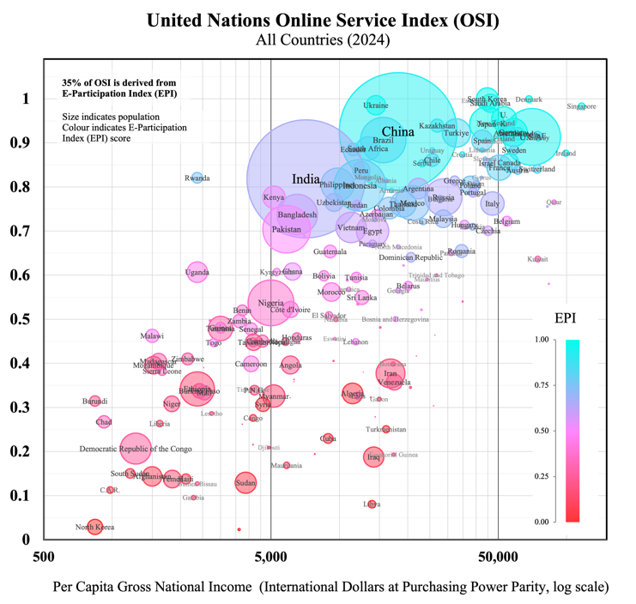 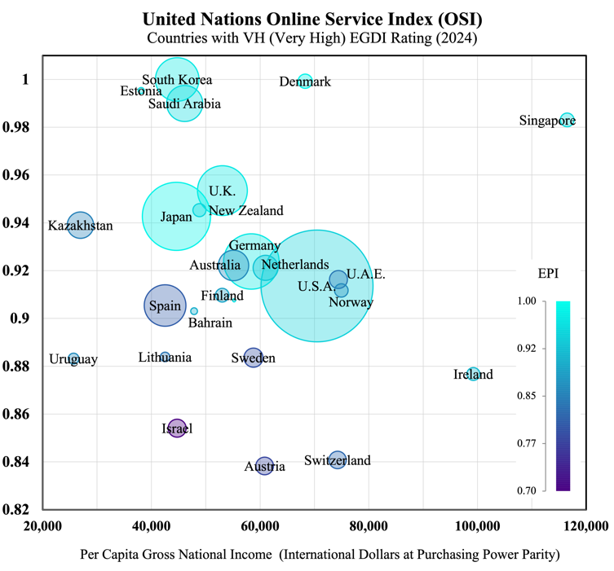

***Figure B3. Figure B4.***

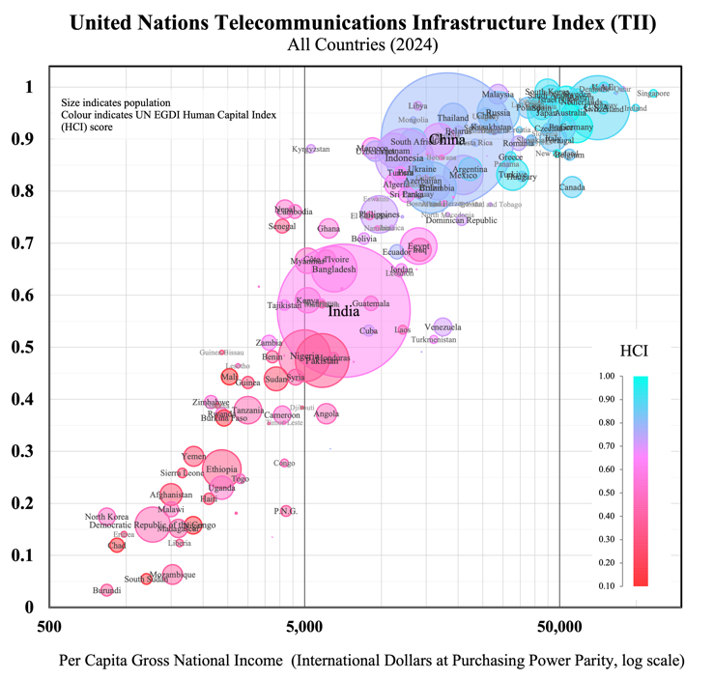 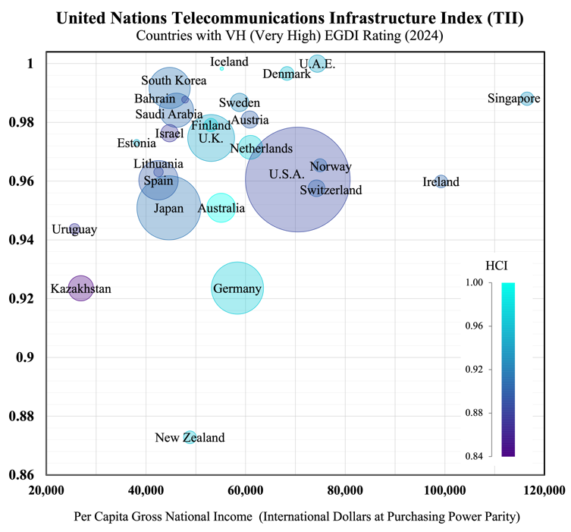

**Appendix C**

***Table C1.****Indicative public services activities and their categorisation (UN International Standard Industrial Classification framework)*

|  |  |
| --- | --- |
| Economic Sector (ISIC) | Service Activities |
| **Public Administration and Defence; Compulsory Social Security** | *Tax and customs administration; Civil registry services; Electoral administration and census; Regulation of social services; Administration of commerce, trade, and labour regulations, intellectual property, licensing, subsidies, and grants; Diplomatic missions and consular services; Visa and immigration policies; Refugee and asylum policies; Defence and border control activities; Administration of police forces and public security operations; Traffic regulation and control; Civil and criminal law courts; Prisons, correctional, rehabilitation, probation and parole services; Emergency disaster response; Compulsory social security activities* |
| **Education** | *Public pre-primary and primary education; Secondary education (general and technical); Higher education (universities and colleges); Technical and vocational training; Special education services; Adult education programs; School inspection and supervision; Curriculum development; Educational testing and assessment; Student financial aid administration* |
| **Human Health and Social Work** | *Hospital services; Medical and dental practice activities; Mental health facilities; Residential care facilities; Ambulance services; Public health campaigns; Medical research; Quarantine services; Health inspection; Vaccination programs; Child protection services; Elder care services; Services for persons with disabilities; Social counselling services; Community welfare services; Homeless shelters; Food banks and nutrition programs; Substance abuse treatment; Occupational health services; Maternal and child health services; Disease surveillance and monitoring; Health emergency preparedness* |
| **Electricity, Gas, Steam and Air Conditioning Supply** | *Electric power generation, transmission, distribution; Gas manufacture and distribution; Energy conservation programs; Rural electrification programs; Management of strategic energy reserves; Energy policy implementation; Renewable energy development; Nuclear energy regulation; Energy efficiency programs; Public lighting; District heating systems* |
| **Water Supply; Sewerage, Waste Management** | *Water collection, treatment, and supply; Sewerage system operation; Wastewater treatment; Hazardous and non-hazardous waste management; Materials recovery facilities; Remediation activities; Sanitation services; Environmental cleanup; Public toilets operation; Street cleaning services; Drinking water quality monitoring; Flood control infrastructure; Irrigation system administration; Water conservation programs* |
| **Transportation and Storage** | *Railway transport; Bus and school-bus services; Metro and light rail operation; Port authority operations; Airport operations; Air traffic control; Government space agencies; Highway and bridge maintenance; Tunnel operation; Parking facilities; Transportation safety administration; Maritime safety and navigation; Postal services; Public transit planning; Transportation infrastructure development* |
| **Information and Communication** | *Government broadcasting (radio and television), telecommunications, information services, data processing, web portals, publications, press offices; Government IT infrastructure management and cybersecurity operations; Public internet access points; Public information campaigns; Public statistical services* |
| **Financial and Insurance Activities** | *Central banking: issuing and managing national currency, monitoring and controlling money supply, supervising banking operations, managing international and gold reserves, setting interest rates, regulating financial markets, operating payment systems; Public banks* |
| **Real Estate Activities** | *Government land development; Affordable housing development; Public housing management; Land registry services; Land use planning; Urban renewal programs* |
| **Professional, Scientific and Technical Activities** | *Government research, testing and standards laboratories, scientific institutions, geological surveys, meteorological services, legal services, engineering services, veterinary services, advertising and public relations* |
| **Arts, Entertainment and Recreation** | *Public museums and historical sites, botanical and zoological gardens, nature reserves, libraries and archives, theatres and performing arts facilities, recreational facilities and parks, swimming pools, sports facilities; Cultural development programs; Community recreation programs; Youth centers; National lotteries; Public media production* |

***Table C2.*** *Government expenditure categories according to Classification of the Functions of Government (COFOG) framework*

|  |  |
| --- | --- |
| First-level | Second-level |
| **General public services** | *Executive and legislative organs, financial and fiscal affairs, external affairs; Foreign economic aid; General services; Basic research; R&D general public services; Public debt transactions; Transfers of a general character between different levels of government* |
| **Defence** | *Military defence; Civil defence; Foreign military aid; R&D defence* |
| **Public Order and Safety** | *Police services; Fire-protection services; Law courts; Prisons; R&D public order and safety* |
| **Economic Affairs** | *General economic, commercial, and labour affairs; Agriculture, forestry, fishing and hunting; Fuel and energy; Mining, manufacturing and construction; Transport; Communication; Other industries; R&D economic affairs* |
| **Environmental Protection** | *Waste management; Waste water management; Pollution abatement; Protection of biodiversity and landscape; R&D environmental protection*  *.* |
| **Housing and Community Amenities** | *Housing development; Community development; Water supply; Street lighting; R&D housing and community amenities* |
| **Health** | *Medical products, appliances and equipment; Outpatient services; Hospital services; Public health services; R&D health* |
| **Recreation, Culture and Religion** | *Recreational and sporting services; Cultural services; Broadcasting and publishing services; Religious and other community services; R&D recreation, culture and religion* |
| **Education** | *Pre-primary and primary education; Secondary education; Post-secondary non-tertiary education; Tertiary education; Education not definable by level; Subsidiary services to education; R&D education* |
| **Social Protection** | *Sickness and disability; Old age; Survivors; Family and children; Unemployment; Housing; Social exclusion n.e.c.;R&D social protection* |

**References**

Atkinson, T. (2005). Atkinson Review: Final report Measurement of Government Output and Productivity for the National Accounts. Retrieved from <https://webarchive.nationalarchives.gov.uk/ukgwa/20160105160709/http:/www.ons.gov.uk/ons/guide-method/method-quality/specific/public-sector-methodology/articles/atkinson-review-final-report.pdf>

Australian Institute of Health and Welfare. (2021). Patient reported measures. Retrieved from <https://www.aihw.gov.au/getmedia/31d2844d-323e-400a-875e-e9183fafdfad/aihw-aus-221-chapter-7-17.pdf.aspx>

Bertelsmann Stiftung. (2024). Bertelsmann Sustainable Governance Indicators. Retrieved from <https://www.sgi-network.org/2024/>

Bertelsmann Stiftung. (2024). Bertelsmann Transformation Index. Retrieved from <https://bti-project.org/en/?andcb=00000>

Blavatnik School of Government. (2024). Understand the methodology behind the Blavatnik Index of Public Administration. Retrieved from <https://index.bsg.ox.ac.uk/methodology/>

Boston Consulting Group. (2022). Trust index: Analyzing companies' trustworthiness. Retrieved from <https://www.bcg.com/publications/2022/trust-index-analyzing-companies-trustworthiness>

CAFRAL. (2020). Sovereign credit ratings: An assessment of methodologies and rating biases. Retrieved from <https://www.cafral.org.in/sfControl/content/Speech/1230202044754PMCRA_WP_25Dec2020.pdf>

Digital Dubai. (2025). Global trends in government innovation: Happiness Meter. Retrieved from <https://www.digitaldubai.ae/apps-services/details/happiness-meter>

Digital Transformation Agency. (n.d.). Measure performance. Retrieved from <https://www.dta.gov.au/11-measure-performance>

Edelman. (2021). Edelman Trust in Technology. Retrieved from <https://www.edelman.com/trust/2021-trust-barometer/trust-technology>

Edelman. (2025). Edelman Trust Barometer Global Report. Retrieved from <https://www.edelman.com/sites/g/files/aatuss191/files/2025-01/2025%20Edelman%20Trust%20Barometer%20Global%20Report_01.23.25.pdf>

European Commission. (2024). Digital Decade 2024 E-Government Benchmark. Retrieved from <https://digital-strategy.ec.europa.eu/en/library/digital-decade-2024-egovernment-benchmark>

European Commission. (2024). Digital Economy and Society Index (DESI). Retrieved from <https://digital-strategy.ec.europa.eu/en/policies/desi>

European Commission. (2024). eGovernment Benchmark. Retrieved from <https://digital-strategy.ec.europa.eu/en/library/digital-decade-2024-egovernment-benchmark>

European Institute of Public Administration. (2025). EIPA Benchmarking Study. Retrieved from <https://www.eipa.eu/wp-content/uploads/2025/04/2024-1621_Eipa_Benchmarking-Study_2024_v12.pdf>

Eurostat. (n.d.). Glossary: Actual individual consumption (AIC). Retrieved from <https://ec.europa.eu/eurostat/statistics-explained/index.php?title=Glossary:Actual_individual_consumption_(AIC)>

Fitch Ratings. (2024). Fitch sovereign rating criteria. Retrieved from <https://www.fitchratings.com/research/sovereigns/sovereign-rating-criteria-24-10-2024>

Forrester. (n.d.). Forrester CX Index methodology. Retrieved from <https://www.forrester.com/policies/cx-index/>

Glaeser, E., Laibson, D., Scheinkman, J., & Soutter, C. (2000). Measuring trust. Quarterly Journal of Economics, 115(3), 811-846.

Global Data Barometer. (2022). The Global Data Barometer Report: First edition. Retrieved from <https://globaldatabarometer.org/the-global-data-barometer-report-first-edition/>

ICAO. (2022). Guide Handling ICAO VDS-NC Health Proofs and EU-DCC. Retrieved from <https://www.icao.int/Security/FAL/TRIP/Documents/Guide%20Handling%20ICAO%20VDS-NC%20Health%20Proofs%20and%20EU-DCC%20V1.0.pdf>

IMD World Competitiveness Center. (2023). World Digital Competitiveness Ranking. Retrieved from <https://www.imd.org/centers/wcc/world-competitiveness-center/rankings/world-digital-competitiveness-ranking/>

INSEAD. (2023). Global Talent Competitiveness Index. Retrieved from <https://www.insead.edu/global-talent-competitiveness-index>

Institute for Citizen-Centred Service. (2023). Citizens First 2023. Retrieved from <https://iccs-isac.org/our-work/research-and-publications/citizens-first>

International Budget Partnership. (2023). Open Budget Survey. Retrieved from <https://internationalbudget.org/open-budget-survey/>

International Telecommunication Union. (2023). Global Cybersecurity Index. Retrieved from <https://www.itu.int/en/ITU-D/Cybersecurity/Pages/global-cybersecurity-index.aspx>

Moody's. (2022). Moody's rating methodology: Sovereigns. Retrieved from <https://ratings.moodys.com/api/rmc-documents/395819>

National Statistician. (2012). National Statistician's Independent Review of the Measurement of Public Services Productivity. Retrieved from <https://uksa.statisticsauthority.gov.uk/publication/national-statisticians-independent-review-of-the-measurement-of-public-services-productivity/>

OECD. (2010). Towards Measuring the Volume Output of Education and Health Services: A Handbook. Retrieved from <https://www.oecd.org/content/dam/oecd/en/publications/reports/2010/04/towards-measuring-the-volume-output-of-education-and-health-services_g17a1e7e/5kmd34g1zk9x-en.pdf>

OECD. (2023). Government at a Glance 2023. Retrieved from <https://www.oecd.org/en/publications/government-at-a-glance-2023_3d5c5d31-en.html>

OECD. (2023). OECD Digital Government Index (DGI). Retrieved from <https://www.oecd.org/en/publications/2023-oecd-digital-government-index_1a89ed5e-en.html>

OECD. (2024). Global Trends in Government Innovation. Retrieved from <https://www.oecd.org/en/publications/global-trends-in-government-innovation-2024_c1bc19c3-en.html>

OECD. (2024). OECD Survey on Drivers of Trust in Public Institutions. Retrieved from <https://www.oecd.org/en/publications/oecd-survey-on-drivers-of-trust-in-public-institutions-2024-results_9a20554b-en.html>

OECD. (n.d.). Budgeting Database. Retrieved from <https://www.oecd.org/en/topics/policy-issues/public-finance-and-budgets.html>

OECD. (2024). Exploring New Frontiers of Citizen Participation in the Policy Cycle Discussion Paper. Retrieved from <https://www.oecd.org/content/dam/oecd/en/about/programmes/reinforcing-democracy-initiative/Exploring-New-Frontiers-of-Citizen-Participation-Discussion-Paper.pdf>

OECD. (2022). Open government data. Retrieved from <https://web-archive.oecd.org/temp/2022-05-20/253891-open-government-data.htm>

OECD. (2025). Public Integrity Indicators. Retrieved from <https://oecd-public-integrity-indicators.org/>

OECD. (2024). Recommendation of the Council on Human-Centred Public Administrative Services. Retrieved from <https://legalinstruments.oecd.org/en/instruments/OECD-LEGAL-0503>

OECD. (2022). Serving Citizens. Retrieved from <https://www.oecd.org/en/publications/serving-citizens_65223af7-en.html>

OECD. (2024). Survey of Adult Skills. Retrieved from <https://www.oecd.org/en/about/programmes/piaac.html>

Open Data Watch. (2023). Open Data Inventory. Retrieved from <https://odin.opendatawatch.com/>

PARIS21. (2021). Praia handbook of governance statistics. Retrieved from <https://paris21.org/sites/default/files/2021-12/PRAIA%20Handbook%20final%20WEB-REVISED2021.pdf>

PARIS21. (2025). Paris 21 Statistical Capacity Monitor. Retrieved from <https://statisticalcapacitymonitor.org/>

Portulans Institute. (2023). Network Readiness Index. Retrieved from <https://networkreadinessindex.org/>

Productivity Commission. (2022). Report on Government Services. Retrieved from <https://www.pc.gov.au/ongoing/report-on-government-services/2022/data-downloads>

Qualtrics. (2025). Qualtrics XM. Retrieved from <https://www.qualtrics.com/en-au/customer-experience/>

Standard and Poor's. (2013). Country risk and sovereign risk. Retrieved from <https://www.spglobal.com/marketintelligence/en/documents/country-risk-and-sovereign-risk-1-.pdf>

The Heritage Foundation. (2024). Index of Economic Freedom. Retrieved from <https://www.heritage.org/index/>

The Observatory of Economic Complexity. (2024). Economic Complexity Index. Retrieved from <https://oec.world/en/rankings/eci/hs6/hs96?tab=ranking>

Transparency International. (2024). Corruption Perceptions Index. Retrieved from <https://www.transparency.org/en/cpi/2024>

United Nations Department of Economic and Social Affairs. (2023). National Accounts Statistics: Main Aggregates and Detailed Tables, 2023. Retrieved from <https://unstats.un.org/unsd/nationalaccount/sdpubs/MADT-2023.pdf>

United Nations. (2024). UN E-Government Survey 2024. Retrieved from <https://publicadministration.un.org/egovkb/en-us/Reports/UN-E-Government-Survey-2024>

United Nations. (2025). Cross classification of Gross value added by industries and institutional sectors. Retrieved from <http://data.un.org/Data.aspx?d=SNA&f=group_code%3a502>

United Nations. (2024). E-Participation Index. Retrieved from <https://publicadministration.un.org/egovkb/en-us/About/Overview/E-Participation-Index>

United Nations. (2008). ISIC: International Standard Industrial Classification. Retrieved from <https://unstats.un.org/unsd/publication/seriesm/seriesm_4rev4e.pdf>

United Nations. (2025). SNA 2025. Retrieved from <https://unstats.un.org/unsd/nationalaccount/snaupdate/2025/2025_SNA_Combined.pdf>

University of Gothenburg. (2023). The Swedish Citizen Panel. Retrieved from <https://www.gu.se/en/som-institute/the-swedish-citizen-panel/about-the-swedish-citizen-panel>

Waseda University. (2024). 2024 Digital Government Ranking Report. Retrieved from <https://idg-waseda.jp/pdf/2024_Digital_Government_Ranking_Report.pdf>

World Bank. (2024). Business Ready. Retrieved from <https://www.worldbank.org/en/businessready>

World Bank. (2025). GovTech. Retrieved from <https://www.worldbank.org/en/programs/govtech>

World Bank. (2022). International Comparisons Project. Retrieved from [https://databank.worldbank.org/source/icp-2021#](https://databank.worldbank.org/source/icp-2021)

World Bank. (2023). Logistics Performance Index. Retrieved from <https://lpi.worldbank.org/>

World Bank. (2021). Public-Sector Productivity (Part 1). Retrieved from <https://documents1.worldbank.org/curated/en/913321612847439794/pdf/Public-Sector-Productivity-Part-One-Why-Is-It-Important-and-How-Can-We-Measure-It.pdf>

World Bank. (2024). Worldwide governance indicators. Retrieved from <https://www.worldbank.org/en/publication/worldwide-governance-indicators>

World Economic Forum. (2020). The Global Competitiveness Report 2020. Retrieved from <https://www.weforum.org/publications/the-global-competitiveness-report-2020/>

World Economic Forum. (2022). Earning digital trust: Decision-making for trustworthy technologies. Retrieved from <https://www3.weforum.org/docs/WEF_Earning_Digital_Trust_2022.pdf>

World Economic Forum. (2023). Measuring digital trust: Supporting decision-making for trustworthy technologies. Retrieved from <https://www3.weforum.org/docs/WEF_Measuring_Digital_Trust_2023.pdf>

World Intellectual Property Organization. (2024). Global Innovation Index. Retrieved from <https://www.wipo.int/en/web/global-innovation-index>

World Justice Project. (2023). Rule of Law Index. Retrieved from <https://worldjusticeproject.org/rule-of-law-index/>

1. These have included the World Bank’s Worldwide Governance Indicators, the World Economic Forum’s Global Competitiveness Index, and Transparency International’s Corruption Perceptions Index. See Moody’s (2022), Fitch (2024).
2. The United Nations E-Government Development Index (EGDI) is the most prominent global digital government maturity index, published annually since 2001. It combines an Online Service Index, a Telecommunications Infrastructure Index, and a Human Capital Index. Twenty-six nations achieved the highest rating (Very High, “VH”) in the 2024 EGDI, corresponding to an index value above 0.9.
3. Pilot indexing projects for subnational government digital maturity have recently been undertaken by the United Nations (Local Online Service Index, 2024) and the World Bank (Subnational Government GovTech Maturity Index, 2022), but coverage has been limited. These subnational indices are not used in the computation of the corresponding national-level indices.
4. Questions on survey-participants’ opinions and attitudes are usually answered on a Likert scale – a multi-point scale with options typically ranging from “strongly agree” to “strongly disagree”. Statistical techniques infer population opinion from the responses of demographically balanced samples, but results can be subject to response bias (due to unreliable answers), as well as participation bias (where respondents and non-respondents are not similarly representative of the population).
5. These include Qualtrics XM, a management platform employing artificial intelligence for real-time multi-channel data (customer, employee, or product) analytics for businesses. Another example is Signal AI, a reputation and risk intelligence platform allowing organisations to track sentiment and identify emerging topics from news, social media, and official communications.
6. This initiative, involving government representatives, technology companies and consumer advocates, was motivated by surveys showing internationally declining trust in technology over the preceding years (Edelman, 2021).
7. Actual Individual Consumption (AIC) is the formal statistical measure encompassing the value of consumer goods and services provided to households by the government (and by non-profit institutions) for individual consumption, e.g. education and healthcare services, in addition to those goods and services purchased directly by households, i.e. Personal Consumption Expenditure (PCE). In addition to services provided directly to individuals, governments also provide a range of collective (or ‘non-excludable’) services, such as street lighting, flood-control systems, or national defence, which do not have individual users distinguishable from the general community, posing additional challenges for quality measurement.
8. These initiatives include government-managed platforms for storing and sharing academic credentials and personal medical records. Standardised digital records acquired a crucial role during the covid pandemic, with the International Civil Aviation Organization (ICAO) setting the standard for Visible Digital Seal (individual QR code) technology used in proofs of vaccination for cross-border travel.
9. The OECD publishes cross-country estimates of gross value added for the International Standard Industrial Classification (ISIC) sectors indicated in Figure 5 but does not separate government and non-government production within these sectors. Non-market services belonging to these sectors fall within the scope of the proposed trust index. Non-market services belonging to other sectors – such as Telecommunications and Information, or Construction (both of which include public infrastructure), Real Estate Activities (which includes public housing) or Arts, Entertainment, and Recreation (which includes cultural programs) – may also fall within its scope (see Appendix C). Government-owned firms may operate in other economic sectors where private production and market transactions dominate (e.g. agriculture or manufacturing), but the activities of such firms would not fall within the scope considered for this indexing proposal.
10. Productivity is usually measured in growth-rates rather than levels, with productivity-growth estimated as the residual after accounting for changes to the value of outputs produced and changes to the value of inputs used in production. For market goods and services, these values are inferred using price information, but many public sector outputs are either provided free at the point of use or at subsidised prices. These include both individual and collective (i.e. non-excludable) goods and services.
11. A change to the amount of output is measured as a revaluation of output relative to the inputs, rather than a productivity change. This convention has the effect of reducing the reliability of standard measures of economic growth and living standards.
12. Due to the heterogeneity of medical conditions and treatments, output volumes for healthcare services are typically categorised according to sets of relatively cost-homogenous diagnosis related groups (DRGs).
13. For example, schools may teach more students, but to a lower standard. Increased hospital activity may reflect a failure of preventative care. A higher number of ‘crimes resolved’ may simply be the corollary to a higher crime rate.
14. The merit of a particular weighting of myriad potentially relevant ‘objective’ inputs used for quality adjustment will be subjective. Quality-adjustment metrics may involve independent expert assessments or audit results, and might also be made to account for variations in service accessibility or the equity of service provision across different population groups.
15. TUTD (Thumbs-Up Thumbs-Down) is a widget developed by the New South Wales Government to capture user sentiment for digital products or services. A thumbs-up thumbs-down system is also used by Estonia’s comprehensive ‘one‑stop’ government portal *eesti.ee*. The Dubai government introduced a three-option Happiness Meter for service interactions (both private and government) that is used to compute a Happiness Index; “the world’s first, city-wide, live sentiment capture engine”.
16. Survey responses often omit information relevant to attribution, due either to the design of the survey or the imperfect recall of the respondents.
17. *Ease*, *satisfaction*, and *trust* are the dimensions used in the annual NSW Government Customer Experience Survey. Federal U.S. government agencies recently adopted a standardised post-transaction survey framework (A-11) with seven dimensions: *trust*, *effectiveness*, *ease*, *efficiency*, *transparency*, *humanity/equity,* and *employee interaction* (General Service Administration, 2024). A Norwegian health service-user survey gathers feedback on eight dimensions: *quality*, *accessibility*, *benefits*, *information & communication*, *consumer orientation*, *competence*, *trust*, and *overall satisfaction.*
18. For example, childbirth, beginning schooling, illness and injury, finding a home, or retirement. A *life events* focus centers the user experience and highlights areas where different departmental responsibilities and different levels of government interact.
19. The Initiative aims to identify drivers of trust in government and set standards for human-centred public services and information integrity. For earlier data on public trust, the OECD shares survey results (from 2008), taken from the Gallup World Poll’s question on “confidence” in “national level government”. The OECD also cites Eurobarometer, the European Union public opinion service that conducts regular official surveys on issues of relevance to the Union, including trust in institutions.
20. The OECD identifies *responsiveness* and *reliability* as two dimensions of government *competencies*, joining three dimensions of government *values* – *openness*, *integrity,* and *fairness* – as the key drivers of trust in public institutions.
21. X-Road is a decentralised database, allowing organisations to retain full control over their own data while enabling others to request and receive verified information in real time. X-Road is an inspiration for the Gaia-X initiative to develop an interoperable data infrastructure for the European Union.
22. Executive Order 14058, *Transforming Federal Customer Experience and Service Delivery to Rebuild Trust in Government*. This follows the 2018 *Integrated Digital Experience Act* which requires federal agencies to report annually on digital improvement efforts. The USDS was supported by 18F, a digital services agency of the General Services Administration eliminated in 2025. A 2025 Executive Order renamed the USDS the United States DOGE (Department of Government Efficiency) Service.
23. Australia’s digital strategy includes the *Online Safety Act 2021*; the Hosting Certification Framework to manage government use of cloud infrastructures (e.g. Amazon Web Services); the *Data Availability and Transparency Act 2022* which establishes an Australian Government Data Catalogue and a Scheme for safely sharing data across government bodies; the 2023 *Review of the Privacy Act* and *2023-2030 Australian Cyber Security Strategy* to address data privacy and security risks; the 2024 *Digital ID Act* promoting a common digital ID system for all levels of government; and the Digital Experience (DX) Policy – which sets standards for human-centered service design.
24. Indices combine multiple measures and are unitless, making absolute scores less meaningful than relative ones.
25. Dimensions of digital trust (e.g. cybersecurity) may carry risks significant enough to recommend a *weakest-link* index using the minimum value of any specified critical subcomponent. Examples of general governance dimensions include those United Nations Handbook on Governance Statistics (2020) identifies eight governance dimensions: *non‑discrimination & equality*, *participation in public affairs*, *openness*, *access to and quality of justice*, *responsiveness*, *absence of corruption*, *trust*, and *safety & security.*
26. These are the elements of the OECD’s Serving Citizens framework (2022), which also sets out five criteria for the selection of sector-specific measures: *adequacy* (of the indicator in representing the concept being measured), *policy relevance, data availability and coverage, comparability*, and *data interpretability*.
27. Figure 8 uses the international standard Classification of Functions of Government (COFOG) framework (see Appendix C). Large budget items include collective services like defence and public debt management, the value of expenditures on economic support to private industry, and the total value of ‘social protection’ payments which include pensions and unemployment payments (not only expenditure on the administration of these programs).
28. As an example of a life-event approach to service-improvement, federal and regional Australian governments are currently undertaking a pilot ‘Birth of a Child – Life Event Redesign’ initiative, involving the cross-jurisdictional integration of services used by new parents.
29. 4IR stands for the ‘Fourth Industrial Revolution’ and is a term used (by the WEF among others) to describe the current wave of innovative technologies as a successor to the First (18th Century steam-powered mechanical production), Second (19th Century electricity and mass production) and Third (20th Century electronics and information technology) Industrial Revolutions. IoT describes the network of connected electronic devices with embedded sensors (e.g. ‘smart home’ consumer devices or devices for industrial manufacturing, healthcare, or agriculture) that collect and transmit data without human intervention. Distributed ledger technology (blockchain) records transactions across multiple computers in a way that ensures data is transparent, immutable, and secure without requiring a central authority. Extended Reality (XR) and quantum computing are described as 4IR digital technologies, while biotechnological innovations like gene editing are also considered part of 4IR.