**An Index for Trustworthy Government in the Digital Age**

**Introduction**

Societies depend on trustworthy government services, including essential utilities, education, healthcare, transportation and civil administration. Over the past three decades, digital technology has transformed the delivery of government services in three main stages:

1. Web Presence (1990s-2000s): governments begin creating websites and portals, allowing individuals to access information online
2. Web Engagement (2000s-2010s): social-media and interactive web platforms emerge, enabling two-way communication between government and public. Government service transactions move online, but systems are usually siloed between departments
3. Digital-Native Government (2010s-Present): governments adopt holistic digital strategies, pursuing integration across departments, high-performance cloud infrastructure, mobile-first service delivery, and universal identification systems. Moves toward this stage received an impetus from the covid pandemic.

The Trustworthy Digital Government project aims to develop a global trust index for government services transitioning to G3 and beyond. The proposed indexing system will integrate expert evaluations across key dimensions of digital trust with user-experience data from government platforms.

The project will deliver an operational framework for benchmarking the trustworthiness of digital government services. It will devise systems for aggregating complex, dynamic data to evaluate and monitor government service delivery. It will produce indicators for digital-age institutional capacity and service quality, intended to guide transformation initiatives, inform sovereign assessments, and promote productivity-enhancing public investments in digital technology.

This paper will describe the motivations for this program, reviewing digital government maturity and trust metrics, the scope of digital government services, and the challenge of measuring government service productivity. It will consider the requirements of a system for dynamically measuring trust in government services, and some of the key elements that this program could integrate.

**Digital Government Maturity and Trust Metrics**

A range of metrics have been developed to capture elements of government effectiveness and institutional quality (see Appendix A). Some of these metrics are referenced by credit ratings agencies in sovereign risk assessments.[1] Metrics for *digital government maturity*, evaluating the level of effectiveness in the adoption of digital technology by governments, are published by organisations including the United Nations, the World Bank, and the Organization of Economic Co-operation and Development (OECD).[2] These metrics allow for international comparisons (Figures 1 and 2, Appendix B) but overlook significant variation at the subnational level.[3] Digital government maturity metrics focus on infrastructure, technical capabilities, and service availability, but do not specifically consider *outcomes* in government service-delivery, nor *user trust* in service-providers.

***Figure 1. Figure 2.***

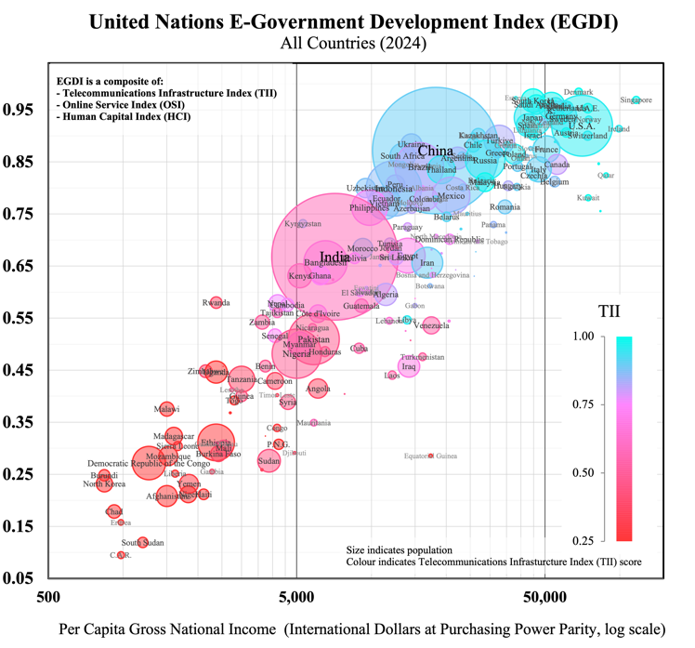 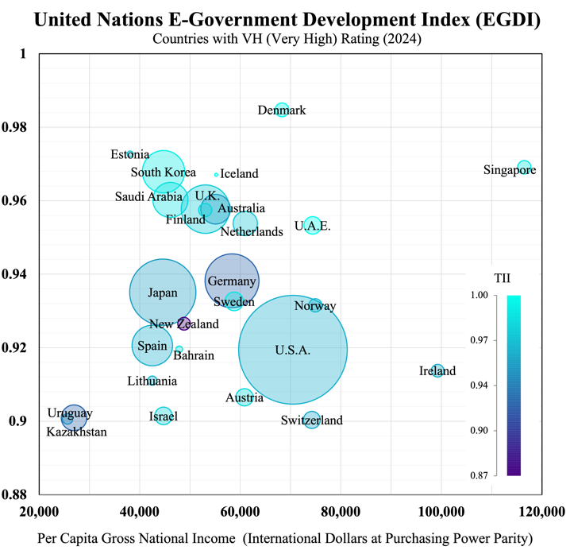

A *trust metric* quantifies the degree of trust held by stakeholders in institutions. Trust measurement frameworks derive standardized scores from structured assessments, summarizing information over multiple trust dimensions such as *competence* and *ethics* (Edelman Trust Barometer) or *effectiveness*, *ease* and *emotion* (Forrester Customer Experience CX).

Trust metrics have been used to rate public trust in consumer brands, international corporations, digital platforms and public institutions (Table 1). These metrics have traditionally relied on surveys – e.g. customer experience or public opinion – which limit data to the responses of individuals to pre-defined questions.[4] Advances in machine learning now enable trust-related sentiment to be tracked dynamically and automatically from unstructured digital communications, such as news articles, social media posts, and online forums. Boston Consulting Group’s 2022 Trust Index processed real-time natural-language input from leading wire-services, newspapers, journals, and Twitter, deriving dynamic trust indicators for over one thousand companies. Numerous open-source and paid machine-learning tools are now available for identifying topical themes and monitoring sentiment in various forms of live communications.[5]

***Table 1.*** *Prominent Trust Metrics*

|  |  |  |  |
| --- | --- | --- | --- |
| Metric | Data | Trust Dimensions | Application |
| **Edelman Trust Barometer** (2001 – Present) | Public Surveys | *Competence; Ethics* | Businesses, governments, NGOs and media organizations in 28 countries |
| **Global RepTrack**  (2004 – Present) | Public Surveys and Communications | *Products and Services; Innovation; Workplace; Governance; Citizenship; Leadership; Performance* | Top 100 reputable companies ranked from surveys across 14 countries |
| **Forrester Customer Experience (CX) Index**  (2007 – Present) | Customer Surveys | *Effectiveness; Ease; Emotion* | Approximately 500 brands across 14 sectors in 11 markets |
| **OECD Trust Survey**  (2021, 2023) | Public Surveys | *Competencies (reliability; responsiveness);*  *Values (openness; integrity; fairness)* | Public institutions in 38 OECD countries (about 2000 respondents per country) |
| **Boston Consulting Group Trust Index** (2022) | Stakeholder Communications | *Competence; Fairness; Transparency; Resilience* | Over 1000 companies internationally |

**Digital Trust**

Along with new ways to measure trust, digitisation introduces new dimensions to institutional trust-relationships. A World Economic Forum initiative defines *digital trust* as *individuals’ expectation that digital technologies and services – and the organizations providing them – will protect all stakeholders’ interests and uphold societal expectations and values.*[6] These “societal expectations and values” include upholding digital systems’ security and reliability, accountability and oversight, and inclusive, ethical, and responsible use (WEF, 2022). Some elements of digital trustworthiness that are common across organisations can be measured using prospective, objective capability indicators. The WEF initiative identifies eight elements as dimensions of a proposed structured framework for objectively evaluating technical capabilities and governance processes: *cybersecurity*, *safety*, *transparency*, *interoperability*, *auditability*, *redressability*, *fairness*, and *privacy* (Table 2). Other elements of trustworthiness may be captured by retrospective, subjective perception metrics, which capture the experience of users interacting with digital systems. Collection of this type of metric relies on the quality of these systems’ feedback mechanisms, and they may include user ratings for satisfaction and confidence, or user comprehension of system features and data flows.

***Table 2.*** *Digital Trust Dimensions and Objective Capability Indicators (World Economic Forum framework)*

|  |  |  |
| --- | --- | --- |
| Dimension | Organisational Objectives | Capability Indicators |
| **Cybersecurity** | Incident prevention and response | *Protocols for securing infrastructure, devices, networks, data, and applications*  *Defined plans for breach detection, containment, and post-attack recovery* |
| **Safety** | Harm prevention measures | *Risk assessments and safeguards to minimize physical, emotional, or societal harm.*  *Preparedness for incidents, including corrective actions and support for affected stakeholders.* |
| **Transparency** | Appropriate and informative disclosure | *Policies determining what, when, and how information is shared (beyond regulatory mandates)*  *Audience-tailored explanations of data flows and system operations (e.g., FAQs, plain-language policies)* |
| **Interoperability** | Technical capabilities and community engagement | *Systems enabling seamless data exchange and portability (e.g., APIs, open-source tools)*  *Participation in industry standards and collaborative ecosystems (e.g., open-source contributions)* |
| **Auditability** | Effective processes and remediation | *Structured evaluations of high-risk areas (e.g., scoping, roles, timelines)*  *Accountability frameworks to address findings and drive improvements* |
| **Redressability** | User-friendly support and feedback incorporation | *Multi-channel grievance resolution (e.g., self-service portals, escalation paths)*  *Mechanisms to integrate user concerns into product/service design (e.g., recurring issue analysis)* |
| **Fairness** | Process and outcome fairness | *Inclusive design reviews to prevent bias (e.g., accessibility assessments)*  *Bias testing and documentation of fairness decisions (e.g., algorithmic audits)* |
| **Privacy** | User and organizational functionality | *Tools for data control (e.g., consent management, access requests)*  *Privacy-by-design practices and impact assessments (e.g., GDPR alignment)* |

Perception indicators can be complemented by behavioural metrics that reveal how users engage with digital services, including adoption rates, engagement patterns, support requests, retention over time, and willingness to promote the service to others. While prospective metrics on trustworthiness may be suited to expert evaluation of an organisation’s capabilities, it is these retrospective perception and behavioural measures that capture the actual progress of an organisation toward trusted relationships with users.

Digitisation of government services introduces novel capabilities for gauging user experience and tracking service quality. Data from digital government platforms, including structured or unstructured user feedback, can be used in the construction public service performance indicators. The digital trust measurement framework can be adapted to the modern public sector by combining these indicators with objective capability evaluations of responsible technology use and organisational governance. Through enabling performance benchmarking and the identification of trust-gaps, an indexing system for government services based on this framework can help establish digital trustworthiness as a concrete policy objective.

**The Scope of Digital Government Services**

Government-provided services account for a significant share of total services consumed by individuals in developed economies, making their quality an important element of living standards globally (Figure 3).[7] However, comparative evaluations of service quality are complicated by the variety of determining factors – for example, user-experience, time, satisfaction, accessibility, and outcomes – and by the absence of standardised units or methods for their measurement. Measuring the *general* quality of service provision by government is further complicated by the vast heterogeneity of services that governments provide, and complex divisions of responsibility between various government bodies at different levels (central, regional and local).

Government services include activities relating to core state functions, such as law enforcement, tax collection, currency issuance, pension payments, licensing and regulations, and foreign affairs. Governments also typically provide education services – public schools, kindergartens, universities, and vocational training centres – as well as healthcare and social work services – public hospitals, disease-control programs, insurance systems, and care-services for children, the elderly, and persons with disabilities. Modes of provision vary between and within countries, with governments both providing these services directly and supporting private provision through accreditation, funding, and regulatory mechanisms. Health and education services account for significant components of general government expenditure in all developed economies (Figure 4) and have been priority areas for public digitisation initiatives internationally.[8]

***Figure 3. Figure 4.***

Government services extend to transportation and utilities: public transit systems, road networks, ports and airports, postal services, telecommunications, water supply, sewerage, waste management, power generation, and the transmission and distribution of gas and electricity. Due to scale and network economies, services in these sectors tend to be provided either by public entities or by private entities operating under substantial public regulation and oversight. Governments also commonly provide (or support the provision of) cultural and recreational services, such as museums, libraries, heritage sites, public broadcasting, and sports facilities, among many other areas of service-provision potentially suitable for inclusion in a service trust index (see Appendix C). The collective value of ‘non-market’ services provided directly by government, or in service sectors where statutory regimes are prevalent, represents a major component of aggregate production across developed economies (Figure 5).[9] Digitisation offers the potential to significantly improve performance and productivity growth in these key sectors by enabling the large-scale collection and analysis of data that directly reflects the perceptions and behaviour of service users. The objective of trustworthy digital government will be to leverage this data responsibly to transform the design and delivery of public services.

***Figure 5.***

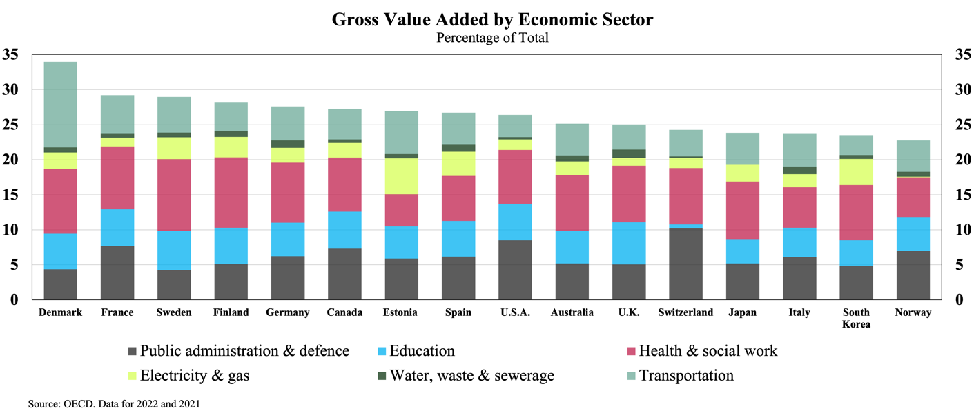

**Productivity, Service Quality, and User Feedback**

Productivity growth is a goal for governments worldwide, but measuring productivity in the public sector is a known methodological challenge (see Atkinson, 2005). Productivity estimates normally involve comparisons between the market-values of inputs and outputs, which is problematic for public services that produce outputs without market-based valuations.[10] National accounting conventions, which are used for calculating economic indicators like Gross Domestic Product, traditionally assume that the value of *non-market outputs* is equivalent to the value of their inputs (i.e. their costs of production, including labour costs), regardless of the value that the public might place on them. This convention overlooks the public sector’s potential for productivity improvements, since changes to the volume of non-market output for a fixed set of inputs will not be measured as a change in productivity.[11] To address this problem, a number of countries have experimented with ‘output-based’ measurements for the volume of public sector outputs, which depend on *quantity indicators* that ‘count’ public service outputs in the same manner as physical units (Schreyer, 2010). Examples include:

* **Education:** number of students enrolled, number of hours of teaching received by students (‘pupil hours’); number of degrees or credits obtained
* **Healthcare:** number of patients treated, number of diagnostic procedures or surgeries performed, number of hospital or care-facility occupant-days[12]
* **Public Safety and Justice:** number of crimes resolved, number of emergency call responses, number of inspections conducted, number of court hearings held.

These volume measurements do not account for output quality, and so can be misleading indicators of productivity if used by themselves.[13] To reflect service productivity in terms of outcomes rather than just outputs, statistical agencies that construct public service productivity indices typically adjust output volumes using *quality indicators*. Due to the diversity and complexity of relevant outcomes – which are often influenced by factors outside the control of the service-provider – there is no single standard approach to making these adjustments, but quality indicators employed in different countries include:

* **Education:** standardised test-score performance, teacher qualifications, prevalence of bullying, graduation rates, graduate employability and incomes
* **Healthcare:** hospital readmission rates, surgical complication rates, survival rates, waiting times for surgeries, procedures avoided due to early prevention, prevalence of health conditions in the community
* **Public Safety and Justice:** seriousness of crimes prevented, rates of recidivism, court processing timelines, number of cases dismissed, number of verdicts appealed or overturned on appeal.

These indicators are all ‘objective’, quantitative values which are independent of any observer’s identity.[14] Some quality indicators may rely on user-reporting, for example Patient-Reported Outcome Measures (PROMS), which are responses by patients to standardised questionnaires on health outcomes post-treatment, used to evaluate clinical effectiveness and widely used in healthcare service-volume quality-adjustments.

Another class of quality indicator is the ‘subjective’ kind: feedback given directly by users of the service. Patient-Reported Experience Measures (PREMs) use standardised questionnaires to record patients’ feelings and opinions on various aspects of the care services they have received (e.g. waiting times, facilities, patient-clinician interaction). Subjective, experienced-based (i.e. user-satisfaction) measures such as these are not widely used in official productivity statistics, but several national statistical agencies use extensive experience-based data to construct parallel quality indicators for public service performance benchmarking, complementing objective measures of performance (Productivity Commission 2022, EIPA 2024).

Subjective experience metrics can be collected at the point of service (online, by phone or at in-person at service-centres), when users are prompted after an interaction to rate their experience. This may involve a scale (e.g. *very satisfied* to *very dissatisfied*) or a simple two-option (*Thumbs-Up Thumbs-Down*) or three-option (*Happy, Neutral, Sad*) sentiment indicator.[15] Simple forms of post-transaction feedback require little time or effort, encouraging high response rates. They can provide governments with real-time data that serves as a parsimonious high-level, user-focused performance indicator, suitable for aggregation across different service functions.

More detailed experience surveys can deliver actionable insights for performance improvements, but when collected at the point of service they may be subject to lower response rates and attribution problems. Detailed post-transaction user-experience surveys usually aim to collect user-profile information to investigate differences in experience between groups, and to construct representative samples. They query multiple dimensions of user-experience – for example, *ease*, *satisfaction,* and *trust.*[16] In addition to surveys that specifically gather post-transaction feedback, many countries undertake ‘central’ or ‘citizen’ surveys that periodically gather feedback on perceptions of government service quality from the general population. Some of these surveys employ a panel of respondents (retaining the same respondents for multiple survey periods), allowing for more robust comparisons across time. Data on subjective user experience are used in performance measurement as a complement to objective metrics for processes and outcomes, to which they are generally correlated (Baredes 2022).

Several countries have now launched integrated national service platforms with systems that permit text (or speech) feedback along with user post-transaction ratings. These systems process complex natural language data on a real-time basis, allowing agencies across government to track service quality and identify issues at a granular level. Advanced digitisation delivers detailed population information and opens channels for continuous unstructured feedback, in contrast to the periodic and structured results of central surveys. Table 3 gives examples of some of the continuous feedback systems and periodic central surveys (some administered by independent organisations) used internationally.

***Table 3.*** *Citizen Feedback Systems*

| Country | System | Description | Surveyed Aspects |
| --- | --- | --- | --- |
| **Canada** | **Citizens First** | Periodic national satisfaction survey of Canadian citizens; every 3-4 years since **1998** [ICCS-ISAC](https://iccs-isac.org/our-work/research-and-publications/citizens-first?utm_source=chatgpt.com) | Overall satisfaction; Service priorities; Expectations; Timeliness; Staff courtesy; Ease of access; Digital service quality |
| **Denmark** | **Den Nationale Borgerundersøgelse** | Annual national citizen survey; Municipal service users; annual; **2009** [Slots- og Kulturstyrelsen](https://slks.dk/fileadmin/user_upload/SLKS/Omraader/Kulturinstitutioner/Museer/Statistik_om_museer/Den_nationale_brugerundersoegelse/Den_nationale_brugerundersoegelse_2023.pdf?utm_source=chatgpt.com) | Satisfaction with local services: education, childcare, employment services, waste management, healthcare |
| **Estonia** | **Eesti.ee** | Continuous online feedback embedded in e‑gov portal; Portal users; continuous post‑interaction; **1996** [Statistikaamet](https://www.stat.ee/en/statistics-estonia/about-us/user-surveys?utm_source=chatgpt.com) | Digital service satisfaction; Ease of use; Clarity; Transaction efficiency; Platform responsiveness |
| **France** | **Baromètre Paul Delouvrier** | Annual public service quality survey; French citizens; annual; **2004** [delouvrier.org](https://www.delouvrier.org/travaux/barometres?utm_source=chatgpt.com) | Satisfaction with healthcare, education, policing/security, taxation, transportation, justice, online services |
| **Germany** | **Lebenslagenbefragung** | Biennial life‑event satisfaction survey; Citizens & companies; every 2 years; **2015** [Statistisches Bundesamt](https://www.destatis.de/DE/Themen/Staat/Buerokratiekosten/Lebenslagen/einfuehrung.html?utm_source=chatgpt.com) | Administrative efficiency; Procedure clarity; Satisfaction with taxes, IDs, healthcare, marriage processes |
| **Japan** | **Survey on Satisfaction & Quality of Life** | Annual quality‑of‑life survey; Citizens 15+; annual; **2011** [内閣府ホームページ](https://www.esri.cao.go.jp/jp/esri/prj/current_research/shakai_shihyo/survey/survey.html?utm_source=chatgpt.com) | Public safety; Healthcare quality; Education; Disaster response; Local administration; Digital services |
| **Netherlands** | **Burgerpeiling** | Municipal framework survey; Residents; set by municipality (often biennial); **2014** [VNG](https://vng.nl/nieuws/modelvragenlijst-burgerpeiling-toegankelijker-voor-inwoners?utm_source=chatgpt.com) | Quality of life; Community involvement; Satisfaction with public spaces, safety, social services; Citizen–government relations |
| **New Zealand** | **Kiwis Count** | Quarterly trust & satisfaction survey; NZ residents; quarterly; **2007** [publicservice.govt.nz](https://www.publicservice.govt.nz/research-and-data/kiwis-count-survey-2019?utm_source=chatgpt.com) | Service quality; Trust in public institutions; Digital vs non‑digital channel effectiveness; Responsiveness; Fairness |
| **Norway** | **Innbyggerundersøkelsen** | Biennial citizen satisfaction survey; Residents; every 2 years; **2010** [dfo.no](https://dfo.no/sites/default/files/Fagomr%C3%A5der/Rapporter/2021/Innbyggerundersokelsen/Om-innbyggerundersokelsen-2021.pdf?utm_source=chatgpt.com) | Satisfaction with healthcare, education, welfare, police, local govt; Trust in institution |
| **Saudi Arabia** | **Watani App** | Real‑time mobile feedback app; Citizens, residents & visitors; continuous; **2019** [Wikipedia](https://en.wikipedia.org/wiki/E-Government_in_Saudi_Arabia?utm_source=chatgpt.com) | Facility quality; Service speed; Staff courtesy; Transparency; Overall efficiency |
| **Singapore** | **REACH** | Multi‑channel gov’t engagement & feedback; Citizens; ongoing; **2006** [Wikipedia](https://en.wikipedia.org/wiki/REACH_%28Singapore%29?utm_source=chatgpt.com) | Policy feedback; Satisfaction with healthcare, housing, education reforms; Responsiveness; Citizen involvement |
| **South Korea** | **Minwon24** | Continuous digital portal; Citizens; 24/7; **2002** | Complaint management; Satisfaction; Usability & convenience of digital services; Service availability |
| **Sweden** | **Medborgarpanelen** | Online citizen panel (3–4 waves/yr); Residents; 3–4 waves per year; **2010** [Göteborgs universitet](https://www.gu.se/en/som-institute/the-swedish-citizen-panel/about-the-swedish-citizen-panel?utm_source=chatgpt.com) | Satisfaction with healthcare, elderly care, education; Trust in institutions; Service quality perceptions; Policy impact |
| **Switzerland** | **National eGovernment Study** | Triennial digital public service survey; Citizens, businesses, authorities; every 3 years; **2016** [Staatssekretariat für Wirtschaft SECO](https://www.seco.admin.ch/dam/seco/en/dokumente/Publikationen_Dienstleistungen/Publikationen_Formulare/Standortfoerderung/Studien_Berichte/nationale_e_government_studie_2022.pdf.download.pdf/National_eGovernment_Study_2022_short_report.pdf?utm_source=chatgpt.com) | Usage patterns; Trust in e‑services; Adoption barriers; Demand for online offerings; Digital interaction preferences |

Results from service feedback systems and central surveys are not well-suited for making international comparisons. This is due to the variety of structures used and the tendency of reported perceptions of service quality to be relative to expectations (which may vary widely between populations) rather than to a consistent standard. The OECD recently (in 2021 and 2023) undertook an international comparative *Survey on the Drivers of Trust in Public Institutions*, part of the Organisation’s Reinforcing Democracy Initiative.[17] The survey questions respondents on attitudes toward national (Figure 6), regional, and local government and law and order institutions; as well as satisfaction with healthcare and education systems and administrative services, and trust in the use of personal data by public agencies (Figure 7). While finding wide variation between countries and demographics, the Survey results indicate that a key driver of trust in service providers is their *perceived responsiveness*: both to evidence and to public feedback. The importance of responsiveness as a factor in public trust

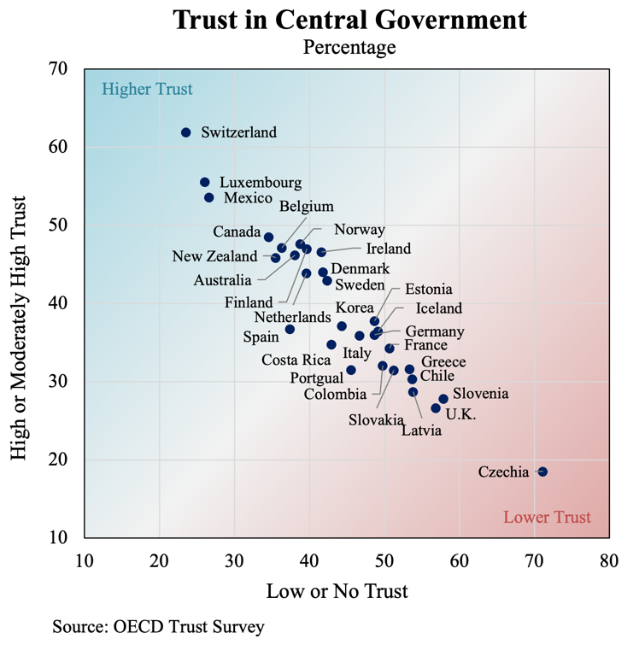 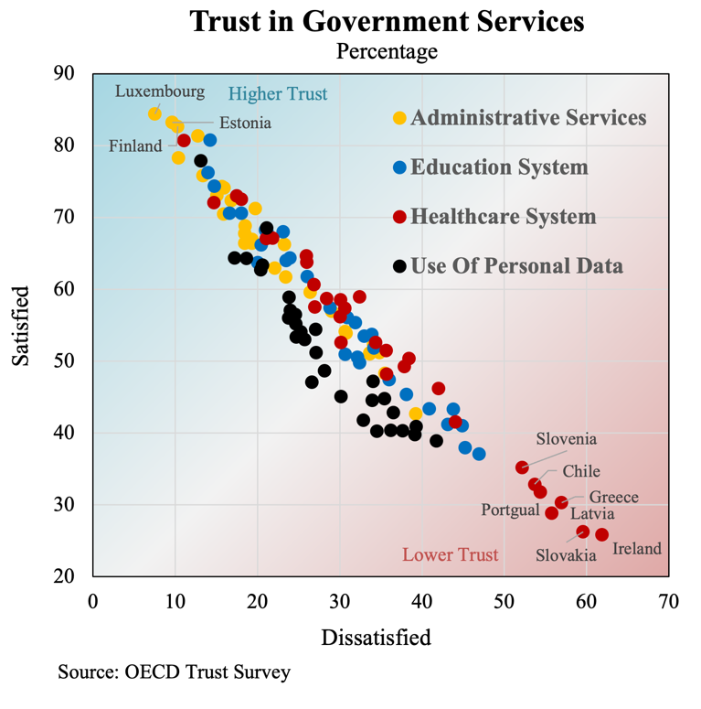

**Indexing Trust in Government Services**

One of the key

1. These have included the World Bank’s Worldwide Governance Indicators, the World Economic Forum’s Global Competitiveness Index, and Transparency International’s Corruption Perceptions Index. See Moody’s (2022), Fitch (2024).
2. The United Nations E-Government Development Index (EGDI) is the most prominent global digital government maturity index, published annually since 2001. It combines an Online Service Index, a Telecommunications Infrastructure Index, and a Human Capital Index. Twenty-six nations achieved the highest rating (Very High, “VH”) in the 2024 EGDI, corresponding to an index value above 0.9.
3. Pilot indexing projects for subnational government digital maturity have recently been undertaken by the United Nations (Local Online Service Index, 2024) and the World Bank (Subnational Government GovTech Maturity Index, 2022), but coverage has been limited. These subnational indices are not used in the computation of the corresponding national-level indices.
4. Questions on survey-participants’ opinions and attitudes are usually answered on a Likert scale – a multi-point scale with options typically ranging from “strongly agree” to “strongly disagree”. Statistical techniques infer population opinion from the responses of demographically balanced samples, but results can be subject to response bias (due to unreliable answers), as well as participation bias (where respondents and non-respondents are not similarly representative of the population).
5. These include Qualtrics XM, a management platform employing artificial intelligence for real-time multi-channel data (customer, employee, or product) analytics for businesses. Another example is Signal AI, a reputation and risk intelligence platform allowing organisations to track sentiment and identify emerging topics from news, social media, and official communications.
6. This initiative, involving government representatives, technology companies and consumer advocates, was motivated by surveys showing internationally declining trust in technology over the preceding years (Edelman, 2021).
7. Actual Individual Consumption (AIC) is the formal statistical measure encompassing the value of consumer goods and services provided to households by the government (and by non-profit institutions) for individual (i.e. excludable) consumption, e.g. education and healthcare services, in addition to those goods and services purchased directly by households, i.e. Personal Consumption Expenditure (PCE). In addition to services provided directly to individuals, governments also provide a range of collective (or ‘non-excludable’) services, such as street lighting, flood-control systems, or national defence, which do not have individual users distinguishable from the general community, posing additional challenges for quality measurement.
8. These initiatives include government-managed platforms for storing and sharing academic credentials or personal medical records. Standardised digital records acquired a crucial role during the covid pandemic, with the International Civil Aviation Organization (ICAO) setting the standard for Visible Digital Seal (individual QR code) technology used in proofs of vaccination for cross-border travel.
9. The OECD publishes cross-country estimates of Gross Value Added for the International Standard Industrial Classification (ISIC) sectors indicated in Figure 5 but does not separate government and non-government production within these sectors. Non-market services belonging to these sectors fall within the scope of the proposed trust index. Non-market services belonging to other sectors – such as Telecommunications and Information, or Construction (both of which include public infrastructure), Real Estate Activities (which includes public housing) or Arts, Entertainment, and Recreation (which includes cultural programs) – may also fall within its scope (see Appendix C). Government-owned firms may operate in other economic sectors where private production and market transactions dominate (e.g. agriculture or manufacturing), but the activities of such firms would not fall within the scope considered for this indexing proposal.
10. Productivity is usually measured in growth-rates rather than levels, with productivity-growth estimated as the residual after accounting for changes to the value of outputs produced and changes to the value of inputs used in production. For market goods and services, these values are inferred using price information, but many public sector outputs are either provided free at the point of use or at subsidised prices. These include both individual and collective (i.e. non-excludable) goods and services.
11. It will instead be measured as a revaluation of the outputs produced relative to their inputs. This convention has the effect of reducing the reliability of standard measures of economic growth and living standards.
12. Due to the heterogeneity of medical conditions and treatments, output volumes for healthcare services are typically categorised according to sets of relatively cost-homogenous diagnosis related groups (DRGs).
13. Schools may teach more students, but to a lower standard. Increased hospital activity may reflect a failure of preventative care. A higher number of crimes resolved may simply be the corollary to rising crime rates.
14. The indicators themselves may be objective, but with myriad potentially relevant indicators, the particular combination and weighting of inputs used for quality adjustment will be debatable. Quality adjustment metrics may involve independent expert assessments or audit results and might also be made to account for variations in service accessibility or the equity of service provision across different population groups.
15. TUTD (Thumbs-Up Thumbs-Down) is a widget developed by the New South Wales Government to capture user sentiment for digital products or services. A thumbs-up thumbs-down system is used by Estonia’s comprehensive ‘one‑stop’ state portal *eesti.ee*. The Dubai government introduced a three-option Happiness Meter for service interactions (both private and government) that is used to compute a Happiness Index; “the world’s first, city-wide, live sentiment capture engine”.
16. *Ease*, *satisfaction*, and *trust* are used in the annual NSW Government Customer Experience Survey. Federal U.S. government agencies recently introduced a standardised post-transaction survey framework (A-11) with seven dimensions: *trust*, *effectiveness*, *ease*, *efficiency*, *transparency*, *humanity/equity,* and *employee interaction* (General Service Administration, 2024). A Norwegian health service-user survey gathers feedback on eight dimensions: *quality*, *accessibility*, *benefits*, *information & communication*, *consumer orientation*, *competence*, *trust*, and *overall satisfaction.*
17. For earlier data on public trust, the OECD shares survey results (from 2008) onward, taken from the Gallup World Poll’s question on “confidence” in “national level government”. Within the European Union, the Eurobarometer public opinion service conducts regular official surveys on issues of relevance to the Union, including trust in institutions.