FMA
MDE - Advanced Engineering Topics, ITESO
Gomez Enriquez, Gerardo
gerardo.gomez@iteso.mx
Guadalajara, Mexico

Architecture and considerations

Fused Multiply-Add (FMA)
This architecture reuses the Booth Radix-4 Wallace multiplier hardware to compute an add operation on top of the multiplication result with minimal area and typically no timing cost.
Specifically, it takes advantage of the Wallace tree by including the third source (add operation) in the sum of the multiplier partial products. The cost is only an additional “partial product” or operand for the Wallace tree. The CSA levels grow logarithmically, so the impact is null.
Width (A×B) | Partial Products (extra PP for unsigned) | Wallace Tree Operands (PP + comp2_corr + FMA srcc) | Wallace CSA Levels | CLA LCU Levels
64×64 | 33 | 35 | 8 | 4
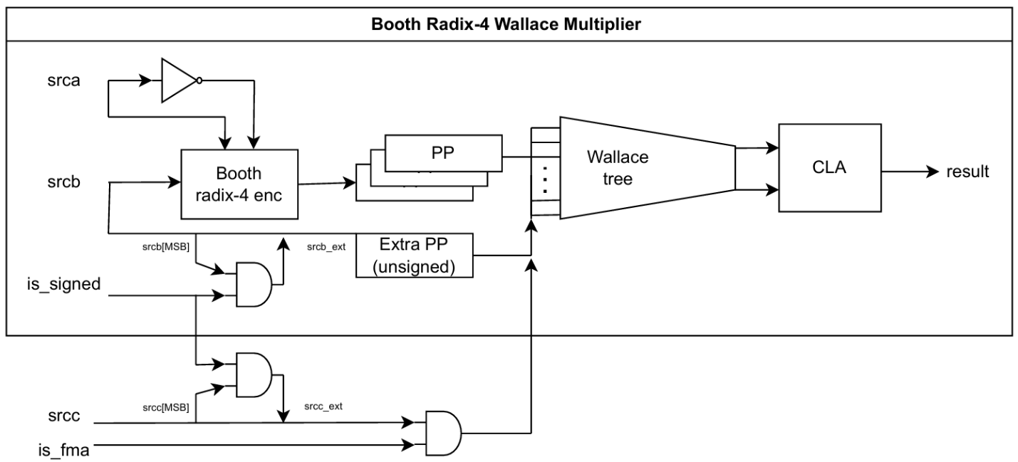

“FMA” forcing multiplication and addition independently
For comparison, this alternative architecture implements first the multiplication operation and then the addition as independent operation, so they are not really “fused”. The cost in area is an additional adder in series with the multiplier, which increases the logic depth drastically making timing worse.
Width (A×B) | Partial Products (extra PP for unsigned) | Wallace Tree Operands (PP + comp2_corr) | Wallace CSA Levels | CLA LCU Levels (per instance)
64×64 | 33 | 34 | 8 | 4
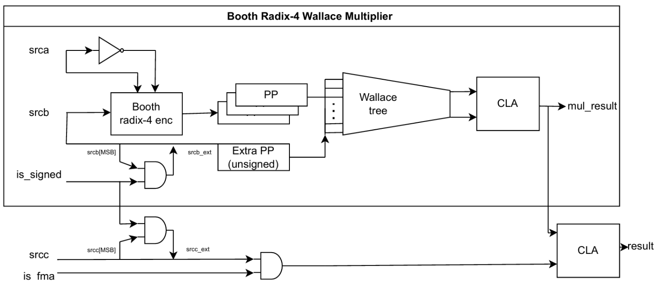

FMA using behavioral model
The final implementation for comparison is using the behavioral model “(a * b) + c” for FMA and letting the FPGA synthesis tool decide the architecture / hardware.

Area / resource usage analysis

LUT / DSP usage
Resource usage breakdown | fma | fma_split | fma_behav
Total LUTs | 10,056 | 10,262 | 679
arith mode | 0 | 0 | 605
— 2 data inputs | — | — | 84
— 3 data inputs | — | — | 521
normal mode | 10,056 | 10,262 | 74
— 0 data inputs | — | — | 4
— 1 data input | — | — | 2
— 2 data inputs | 630 | 826 | 67
— 3 data inputs | 1,776 | 1,687 | 1
— 4 data inputs | 7,650 | 7,749 | —
DSP (Embedded Multiplier 9-bit elements) | 0 | 0 | 32

- fma and fma_split (separate multiply then add) both build the entire datapath from soft logic — ~10k 3 and 4 input LUTs in normal mode, zero DSP blocks nor arith (carry-chain) cells at all. Folding the addend into the Wallace tree (fma) is slightly leaner (10,056 vs 10,262 LUTs) since fma_split pays for a second full-width CLA.
- fma_behav is dominated by arith-mode cells (605 of 679) — Quartus maps the inferred adder and DSP-support logic onto the carry chain, with mostly 3-input arith cells. The multiply itself is absorbed into the 32 DSP elements (16 mac_mult + 16 mac_out in the netlist), leaving only a small soft-logic shell.
- The mode split makes the trade-off concrete: the structural designs pay in a large fleet of normal-mode LUTs, while the behavioral design leans on hard multipliers plus a compact arith-mode carry chain.

Timing / latency analysis

Fmax & MAX LUT depth
Implementation | Fmax | Max LUT depth
fma | 60.15 MHz | 24
fma_split | 46.76 MHz | 32
fma_behav | 62.66 MHz | 14.7

- fma_behav is both the fastest (62.66 MHz) and shortest (14.70 depth) — the DSP blocks absorb the multiply, so the critical path is essentially the addend adder plus DSP latency rather than a deep soft-logic tree.
- fma (addend folded into the Wallace tree) nearly matches the behavioral Fmax (60.15 MHz) despite using ~15× more LUTs and a much deeper netlist (24.0). Folding srcc as an extra Wallace operand adds it "for free" in terms of depth — it's reduced in parallel with the partial products.
- fma_split is clearly the worst on both metrics (46.76 MHz, depth 32.0). Doing the multiply and the add as two separate serial stages stacks a second full-width CLA after the multiplier, lengthening the critical path by ~8 levels and dropping Fmax ~22% versus fma.

Critical paths

FMA – Critical path
From: srcb_q[1] → To: result_q[127]
Node description | Signal | Count
Booth PP-select MUX | fma|Mux*~N|combout | 2
Wallace-tree CSA full-adder | fma|wallace_tree|gen_lvl[*].gen_csa[*].csa|...|fa|sum/cout | 6
CLA carry look-ahead unit (LCU) | fma|cla|gen_lvl[*].gen_lcu[*].lcu4|gg/c | 10
CLA final full-adder sum | fma|cla|gen_fa[127].fa_gp|sum~N | 2
 | Total | 20

FMA split – Critical path
From: srcb_q[3] → To: result_q[127]
Node description | Signal | Count
Booth PP-select MUX | ...|multiplier|Mux*~N|combout | 2
Multiplier Wallace-tree CSA full-adder | ...|multiplier|wallace_tree|...|fa|sum/cout | 7
Multiplier CLA LCU | ...|multiplier|cla|...|lcu4|gg/c/pg | 8
Multiplier CLA final full-adder sum | ...|multiplier|cla|gen_fa[95].fa_gp|sum | 1
Second adder full-adder propagate | ...|adder|gen_fa[95].fa_gp|p~2 | 1
Second adder CLA LCU | ...|adder|...|lcu4|gg/c | 8
Second adder final full-adder sum | ...|adder|gen_fa[127].fa_gp|sum | 1
 | Total | 28

FMA behavioral – Critical path
From: srca_q[63] → To: result_q[127]
Node description | Signal | Count
Operand sign-extend LUT | ...|srca_ext[64]|combout | 1
DSP embedded multiplier (mac_mult + mac_out) | ...|Mult0|auto_generated|mac_mult25 / mac_out26 | 2
DSP-output reconstruction adder (arith carry chain) | ...|Mult0|auto_generated|add53_result[*]~N|cout/cin | 60 (arith mode)
 | Total (after arith / normal mode weights) | 8

Other timing parameters
All architectures share similar parameter values:
- Latency: 1 cycle (single cycle)
- Throughput: 1 operation per cycle
- Slack: Significantly negative for both architectures. Frequency was set to 1 GHz for analysis purposes and getting the maximum possible frequency, which was 159.62 MHz for the Booth radix-4 with Wallace tree when widths are 8.

Conclusion
The comparison between the real fused multiply-add operations and the split / independent multiply and addition operations demonstrate that splitting the addition from the multiplication has no engineering advantage, since both area and logic depth area increased with the additional adder in series.
On the other hand, implementing the FMA describing the hardware in detail vs the behavioral model and letting synthesis decide the FMA architecture / hardware used has a core trade-off when implementing in FPGA: soft logic vs hard silicon.
Data shows that the behavioral model winds on every area / timing metric because it uses dedicated hardware from the multipliers embedded in the DSPs and the adder chain structure in the FPGA architecture. But if those DSPs are limited in the FPGA architecture or if those dedicated multipliers are needed elsewhere, this option evaporates.

