Dividers
MDE - Advanced Engineering Topics, ITESO
Gomez Enriquez, Gerardo
gerardo.gomez@iteso.mx
Guadalajara, Mexico

Architecture and considerations
This is a pipelined 64-bit divider based on the restoring division algorithm. To optimize the pipeline for frequency, each pipe stage handles an addition/subtraction operation plus miscellaneous logic such as multiplexors, shifters by constant amount or qualifications. These architectural choices resulted in a 66-stage pipeline described below.
Stage 0 | Stage 1 | Stage 2 to N-2 (63) | Stage N-1 (64) | Stage N (65)
Extract operands signs and qualify with is_signed | Initialize AQ |  | Detect divide-by-zero | Get quotient two's complement
Get dividend two's complement | Shift AQ | Shift AQ | Shift AQ | Get remainder two's complement
Get divider two's complement | Subtract with divider | Subtract with divider | Subtract with divider | Apply quotient sign
Select dividend absolute value | Select partial reminder (subtracted or "restored") | Select partial reminder (subtracted or "restored") | Select partial reminder (subtracted or "restored") | Apply remainder sign
Select divider with negative sign (for subtractions) | Issue quotient bit | Issue quotient bit | Issue quotient bit | Override outputs if divide-by-zero

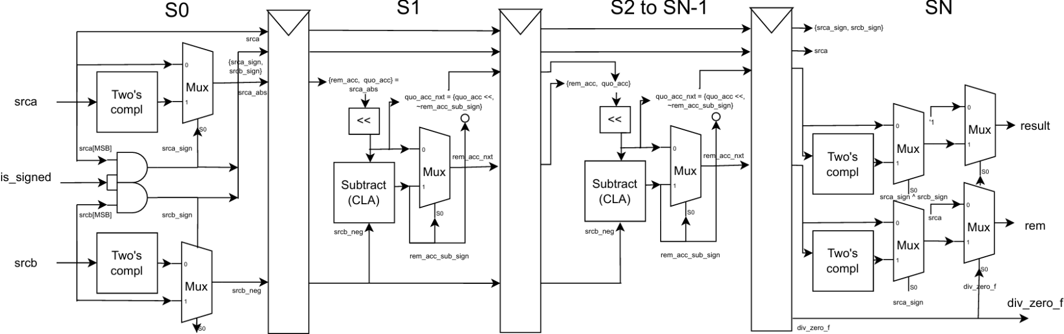

Implementation details

Summary
Metric | Value
LUTs (all normal mode) | 20,646
FFs (pipe stages) | 16,513
Fmax (Slow 1200 mV 85 °C) | 141.0 MHz
Max LUT depth | 12

Area breakdown

CLA instances
Adder role | Instance name | Count
Restoring-stage trial subtractor | gen_restoring_div[*].cla_rem_acc_sub | 64 (one per stage)
Input two's-complement | cla_srca_comp2, cla_srcb_comp2 | 2
Output two's-complement (sign correction) | cla_quo_comp2, cla_rem_comp2 | 2
 | Total | 68

LUTs per restoring stage
Stages | Subtractor LUTs
Steady-state (stages 3–64) | ~247 avg (min 238, max 256)
Stage 2 | 62
Stage 1 | 22
Sum of all 64 stage subtractors | 15,414
- Stages 1–2 are much smaller because the partial remainder is still mostly zero that early (rem_acc initialized to 0, only 1–2 dividend bits shifted in), so synthesis prunes most of the subtractor.
- The table summarizes only the subtractor. Each stage also has shift + restore-select MUX + quotient-bit logic. A fully-loaded steady-state stage is closer to ~250 (subtract) + ~50–80 (shift/restore) ≈ 300+ LUTs.

FFs per restoring stage
Register | Width (bits)
rem_acc_ss | 65 (WIDTH+1)
quo_acc_ss | 64 (WIDTH)
a_ss (dividend passthrough) | 64
b_neg_ss (subtrahend passthrough) | 64
a_sign_ss, b_sign_ss | 1 + 1
Total per restoring stage | 259
- This information is derived analytically from the pipelined registers in each stage.
- Based on this analysis, the total number of FFs only from restoring pipe stages should be 259×64=16,576 which is above the total number reported by Quartus due to registers removed during synthesis due to optimizations (i.e. registers merged with other registers).

Timing breakdown

Critical path
The critical paths are each restoring iteration in the partial reminder computation.
From rem_acc_ss[52][8] → To rem_acc_ss[53][43]
Logic description | Node | Count
CLA carry look-ahead (c~, c[*]) | gen_restoring_div[52].cla_rem_acc_sub|gen_lvl[*].gen_lcu[*].lcu4|c~*/c[*]|combout | 6
CLA group-generate (gg~) | ...|gen_lvl[1].gen_lcu[0].lcu4|gg~2/gg~3/gg~4|combout | 3
Nested carry-into-carry (c[3]~*) | ...|gen_lvl[0].gen_lcu[10].lcu4|c[3]~2/c[3]~3|combout | 2
Restore/quotient select MUX | ...|rem_acc_nxt_ss[52][43]~3307|combout | 1
 | Total | 12
This critical path starts from the partial reminder in stage 52, goes through the subtractor (CLA) until the final MUX that checks the subtraction sign to choose the subtracted remainder or the original partial remainder before the subtractor (“restored”).

Other timing parameters
- Latency: 66 cycles (Restoring divider processes 1 bit per cycle + 1 cycle to get absolute values + 1 cycle to apply sign to result).
- Throughput: 1 operation per cycle / ~64 bits per cycle due to pipeline.
- Slack: Significantly negative. Frequency was set to 1 GHz for analysis purposes and getting the maximum possible frequency, which was 141.0 MHz

Conclusion
Pipelining the restoring divider became very expensive because the area cost grows linearly with operands width. The design registers the full {rem_acc,quo_acc} datapath plus all sideband signals (a_ss, b_neg_ss, a_sign_ss, b_sign_ss) across all stages. Plus, the algorithm requires one subtractor in each restoring stage. This is a typical cost in area of a fully pipelined bit-per-cycle divider.
This implementation is not suitable for high performance 64-bit CPUs due to the high latency. The penalty for branch mispredictions would require refilling the 66-stage pipeline every time. Other division algorithms / architectures are more suitable for high-performance CPUs, which reduce area and latency drastically.
The restoring algorithm is more suitable for low-performance/ area-constrained designs when reusing the hardware using an FSM for each iteration — a trade-off between area and throughput acceptable for general-purpose dividers.

