Saturation
MDE - Advanced Engineering Topics, ITESO
Gomez Enriquez, Gerardo
gerardo.gomez@iteso.mx
Guadalajara, Mexico

Architecture and considerations
This is an adder with saturation that can saturate to a maximum and a minimum configurable / dynamic value. Both saturations can be enabled/disabled with another set of signals.
The adder used is a Carry Look-ahead Adder (CLA) and the saturation logic is in series with the result and carry-out. The saturation logic consists of signed and unsigned comparators that check the configured saturation values with the adder result (concatenated with its carry-out for complete adder precision). The final output result is muxed depending on the overflow / underflow detection and the saturation enablement.
Since the saturation values are configurable / dynamic the overflow and carry-out output signals from the adder cannot be used directly with as in other adder with saturation architectures.
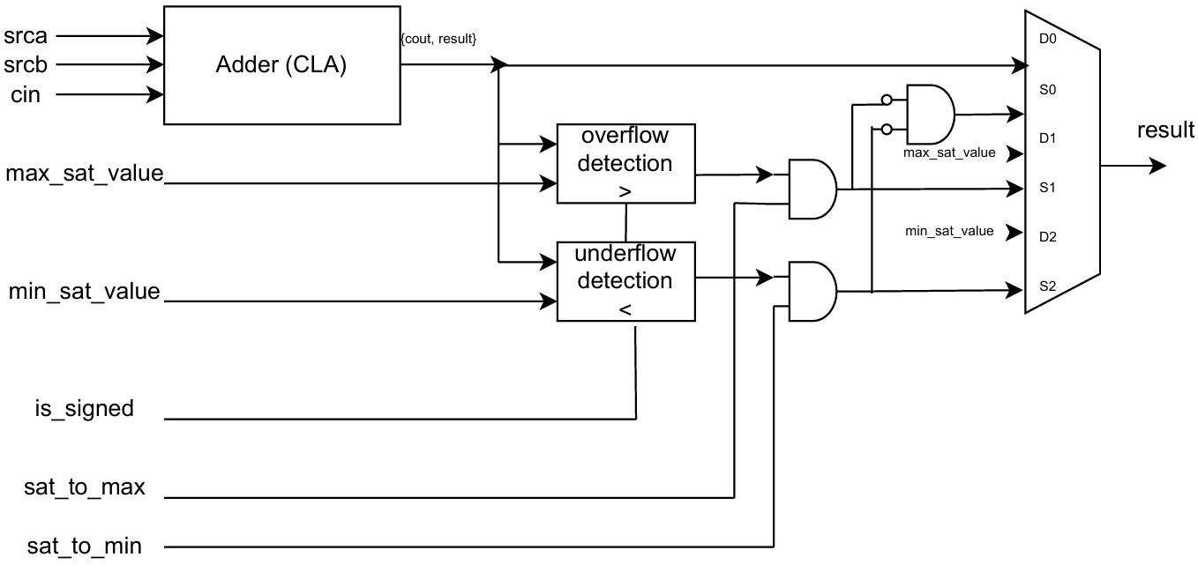

Area / resource usage analysis

LUT usage
Width | Adder LUTs | Saturation Logic LUTs | Total LUTs | Saturation Logic %
8 | 37 | 56 | 93 | 60.20%
16 | 69 | 104 | 173 | 60.10%
53 | 244 | 326 | 570 | 57.20%
128 | 599 | 776 | 1,375 | 56.40%

- The cost of the saturation logic in this architecture is higher than the adder (CLA) logic itself in all width configurations.
- The saturation logic consistently accounts for ~57–60% of the total LUTs, with the fraction slightly decreasing at wider widths. The CLA grows linearly with width, and its two comparators drive the saturation cost

Timing / latency analysis

Fmax & Max logic depth
Width | Fmax (MHz) | Max LUT Depth
8 | 174.25 | 8.5
16 | 135.34 | 11.1
53 | 101.32 | 15
128 | 71.68 | 23.1

- The saturation logic makes heavy use of arith cells. Quartus weighs arith-mode LUT cells (carry-chain adder cells) at 0.5 depth instead of 1.0, since they use dedicated carry hardware rather than the LUT fabric.
- Both Fmax and logic depth scale as expected with width. The fractional depths reflect the mixed arith + normal LUT path.

Critical paths
The critical path is the same for all widths: src*_q[*] → result_q[*]. It goes through the same logic elements, summarized below for the different width implementations.
Logic description | Node | W8 (LoL=8.5) | W16 (LoL=11.1) | W53 (LoL=15) | W128 (LoL=23.1)
CLA — LCU carry-generate/propagate | cla|gen_lvl[*].gen_lcu[*].lcu4|gg/c|combout | 3 | 5 | 8 | 11
CLA — FA propagate | cla|gen_fa[*].fa_gp|p|combout | — | 1 | — | —
CLA — FA sum | cla|gen_fa[*].fa_gp|sum|combout | 1 | 2 | 1 | 1
Comparator carry chain | LessThan*~N|cout → ~M|combout | 2 | 2 | 16 | 27+
Saturation select | sel_max/min_sat_value~0|combout | 1 | 1 | 1 | 1
Result MUX | result[*]~N|combout | 2 | 2 | 2 | 1
Notice that the logic levels are weighted by Quartus differently for arithmetic more logic such as the dedicated hardware for carry chain (LessThan*~N|cout).

Other timing parameters
- Latency: 1 cycle (single cycle)
- Throughput: 1 operation per cycle
- Slack: Significantly negative. Frequency was set to 1 GHz for analysis purposes and getting the maximum possible frequency, which was 174.25 MHz when width=8.

Conclusion
The CLA contributes a roughly logarithmic number of logic levels as width grows, consistent with its look-ahead carry structure. The saturation comparator, however, grows linearly because $signed(ext_result) > $signed(ext_max_sat_value) synthesizes as a ripple-carry chain over WIDTH+1 bits with no look-ahead.
The saturation logic (two WIDTH+1-bit comparators plus the output MUX) is structurally heavier than the CLA in terms of area. Each comparator requires roughly as many cells as a ripple-carry adder of the same width, so two comparators alone already outweigh the CLA in LUT count.
Replacing the ripple-carry comparators with CLA-style comparators — or reusing the adder's own carry and overflow flags to detect saturation — would recover both Fmax and a substantial fraction of the LUT budget.

