Floating Point
MDE - Advanced Engineering Topics, ITESO
Gomez Enriquez, Gerardo
gerardo.gomez@iteso.mx
Guadalajara, Mexico

Architecture and considerations
The architecture is a half precision (16-bits) floating point adder/subtractor (IEEE 754 binary16). It is fully combinational and supports five rounding modes. An unpack stage splits each operand into sign, exponent, and fraction, restores the implicit bit, and classifies zeros, subnormals, infinities, and NaNs.
The datapath follows the classic five stages: alignment (swap by magnitude and right-shift the smaller significand by the exponent difference), add/subtract (effective operation from the XOR of the signs), normalization (leading-zero count and exponent adjust), rounding (guard and sticky bits per the selected mode, with re-normalization if rounding carries out), and packing with exception flag generation.
Special cases bypass the datapath through a dedicated handler and a final result mux: NaNs propagate quieted with their payload preserved (SoftFloat's default behavior), ∞ − ∞ returns the canonical qNaN with the invalid flag, infinities dominate, and signed zeros follow the IEEE rules. Overflow saturates to infinity or maximum finite depending on the rounding direction; underflow is flagged only for inexact subnormal results.
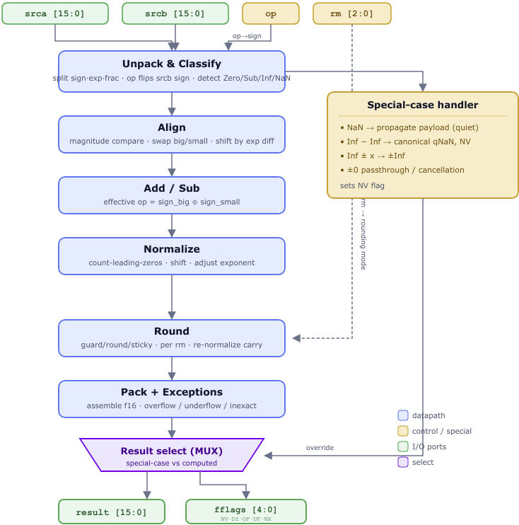

Implementation details

Summary
Metric | Value
LUTs | 1,141
— normal mode | 943
— arith mode | 198
Max LUT depth | 48.4
Fmax (Slow 1200 mV 85 °C) | 30.11 MHz

- ~1,141 LUTs, mostly normal mode (83%). Only 198 cells map to the carry chain (arith mode). The design is dominated by soft combinational logic — the alignment/normalization barrel shifters, the leading-zero counter, and the rounding/mux fabric — rather than adders, which is expected for FP where the mantissa add/subtract is a small fraction of the total.
- Deep critical path (Max LUT depth 48.40). This is the deepest single-cycle block in the project so far, and it directly explains the low Fmax. A binary16 add serializes several variable shifts back-to-back — exponent-difference align → mantissa add/sub → leading-zero normalize shift → round → re-normalize — with no pipeline registers, so the logic levels stack up.
- Fmax 30.11 MHz is the price of the fully combinational, single-cycle design. The obvious lever is pipelining: splitting the datapath into stages (e.g. align / add / normalize+round) would roughly halve the depth and multiply Fmax, at the cost of latency and control — the same trade-off seen in the multiplier and divider analyses.

Timing breakdown

Critical path
All 100 worst-slack paths are at the max depth (38 integer levels / 48.40 weighted), all terminating at result_q[10], launched from 4 different operand bits.
From Node | To Node | Occurrences (of 100) | Logic levels | Total cells
srcb_q[13] | result_q[10] | 41 | 38 | 95
srcb_q[11] | result_q[10] | 24 | 38 | 95
srca_q[11] | result_q[10] | 19 | 38 | 95
srca_q[12] | result_q[10] | 16 | 38 | 95
These paths share the identical datapath described below.
Logic description | Node | Count
Classify + effective exponent | Equal5/eb_eff/e_small | 3–4
Exponent difference | Add0 | 1
Align — right shift | ShiftRight0 | 4
Mantissa add/sub | Add1 | 11
Leading-zero count | f_clz42 | 6
Shift-amount / exponent math | Add4–Add7 | 9
Normalize — left shift | ShiftLeft1 | 3
Exponent-adjust wide add | Add8 | 31
Rounding decision | round_up | 6
Round select mux | Mux1 | 1
Round increment | Add9 | 12
Final pack add | Add10 | 3
Overflow / range compare | LessThan8 | 2
Output pack | result | 2
Total |  | ~95
- The paths collapse to a single end-to-end datapath (classify → align → mantissa add → CLZ → normalize → exponent adjust → round → pack → result_q[10])
- The "different" paths are just the same chain fed from srca/srcb bits 11–13.
- result_q[10] is the tail because bit 10 is the mantissa/exponent boundary the rounding carry and final mux resolve last.
- Carry chains dominate the depth. Add8 (31 cells) plus Add9 (12) account for ~45% of all cells on the path.

Other timing parameters
- Latency: 1 cycle (single cycle)
- Throughput: 1 operation per cycle
- Slack: Significantly negative. Frequency was set to 1 GHz for analysis purposes and getting the maximum possible frequency, which was 30.11 MHz.

Conclusion
The design is functionally bit-exact and area-reasonable, but its single-cycle nature makes it timing-limited, and it is a candidate for width-trimming plus pipelining — the same area/latency/frequency trade-off for pipelined implementations.
The design can be improved to be faster by implementing several classic FP-adder techniques trade area for shorter delay by overlapping stages that are currently serial, for instance: trimming the exponent/shift-amount widths, using a compound-adder for rounding, using a Leading-Zero Anticipator (LZA) to predict the leading-zero count directly from the operands, in parallel with the adder, among other changes.

