Adders
MDE - Advanced Engineering Topics, ITESO
Gomez Enriquez, Gerardo
gerardo.gomez@iteso.mx
Guadalajara, Mexico

Architecture and considerations

Ripple Carry Adder (RCA)
The RCA is a structurally simple architecture whose critical path scales linearly with width — every additional bit adds one full-adder stage to the carry chain because it propagates through all full-adders. Considerations:
- Advantages: Simple, minimal area
- Disadvantages: Lineal delay. Not suitable for modern CPUs with wide additions.
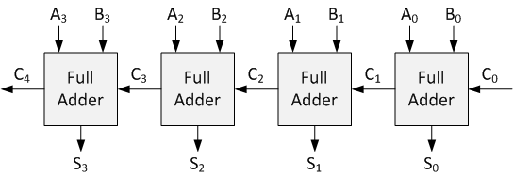

Carry Look-ahead Adder (CLA)
The CLA trades area for speed by computing carry signals in parallel. The logic depth of the carry out computation grows logarithmically since the Look-Ahead Carry Units (LCUs) are connected in a hierarchical way (tree of carries). By using 4-bit wide LCUs, the delay grows by log₄(N).
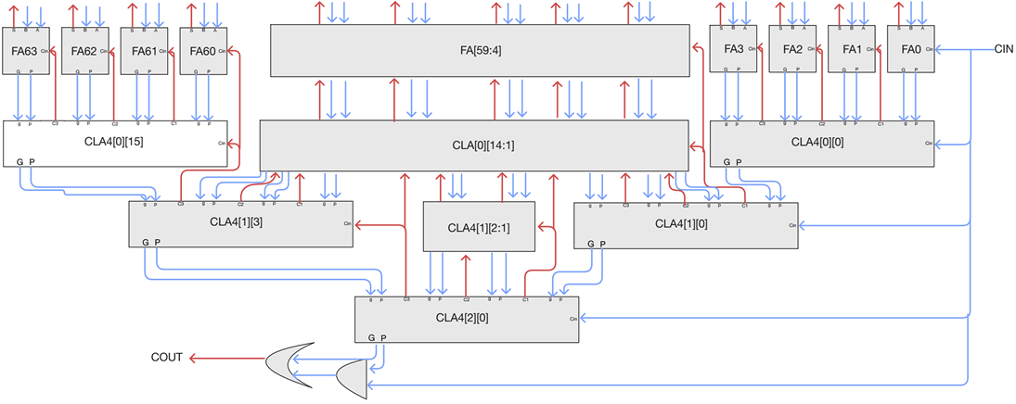

Area / resource usage analysis

LUT usage
Width | RCA LUTs | CLA LUTs | CLA overhead vs RCA
8 | 27 | 37 | +37%
32 | 96 | 164 | +71%
64 | 190 | 345 | +82%
72 | 211 | 373 | +77%

- The RCA consistently uses fewer LUTs than the CLA across all widths, which is expected — the CLA requires extra logic to compute the carry generate/propagate signals in parallel.
- The CLA overhead grows from ~37% at width 8 up to ~82% at width 64, then slightly drops to ~77% at width 72. This reflects the increased carry lookahead logic that is added at wider widths.
- Both adders scale roughly linearly with width, confirming the CLA trades area for speed.

Timing / latency analysis

Fmax
Width | RCA Fmax (MHz) | CLA Fmax (MHz) | CLA speedup vs RCA
8 | 308.55 | 282.65 | −8.4%
32 | 106.78 | 167.42 | +56.8%
64 | 55.38 | 120.90 | +118.3%
72 | 46.88 | 128.83 | +174.8%

- At width 8, the RCA is actually slightly faster than the CLA (308.55 vs 282.65 MHz). At this narrow width the extra carry-lookahead logic adds more delay than it saves.
- Starting from width 32, the CLA's parallel carry computation pays off, and the advantage grows significantly with width — reaching ~175% faster at width 72.
- The RCA degrades steeply with width because the carry must ripple through all bits. The CLA degrades much more gracefully, confirming its logarithmic critical path behavior.

Max logic depth
Width | RCA Max LUT Depth | CLA Max LUT Depth | CLA reduction vs RCA
8 | 6 | 6 | 0%
32 | 24 | 10 | −58.3%
64 | 45 | 14 | −68.9%
72 | 53 | 14 | −73.6%

- At width 8, both architectures share the same maximum logic depth (6 LUTs), consistent with the Fmax result where the RCA was marginally faster — there is no depth advantage to exploit at this width.
- From width 32 onward, the CLA's depth advantage becomes substantial and grows with width. By width 64/72 the CLA holds the depth constant at 14 LUTs while the RCA continues to grow linearly.
- The RCA depth scales linearly with width, as expected from its ripple-carry chain. The CLA depth grows much more slowly, reflecting its hierarchical carry structure — this directly explains the Fmax trends seen in the previous table.

Critical paths

RCA – Critical paths
From Node | To Node | w=8 | w=32 | w=64 | w=72
cin_q | zero_f_q | 6 | 24 | 45 | 53
cin_q | ov_f_q | 6 | 24 | 45 | 53
cin_q | cout_q | 6 | 24 | 45 | 53
cin_q | result_q[*] | 6 | — | 45 | 53
srcb_q[*] | zero_f_q | 6 | 24 | 45 | 53
srcb_q[*] | ov_f_q | 6 | 24 | 45 | 53
srcb_q[*] | cout_q | 6 | 24 | 45 | 53
srcb_q[*] | result_q[*] | 6 | — | 45 | 53
srca_q[*] | zero_f_q | 6 | 24 | 45 | 53
srca_q[*] | ov_f_q | 6 | 24 | 45 | 53
srca_q[*] | cout_q | 6 | 24 | 45 | 53
srca_q[*] | result_q[*] | 6 | — | 45 | 53

- In the RCA, all critical paths originate from low-index inputs (cin_q, srca_q[0], srcb_q[0], etc.) — bits that must propagate the carry through the entire chain to reach cout_q, ov_f_q, zero_f_q, or the MSB of result_q.

CLA – Critical paths
From Node | To Node | w=8 | w=32 | w=64 | w=72
cin_q | zero_f_q | 6 | — | — | —
srcb_q[*] | zero_f_q | 6 | 10 | 14 | 14
srcb_q[*] | ov_f_q | 6 | — | — | —
srca_q[*] | zero_f_q | 6 | 10 | 14 | —
srca_q[*] | ov_f_q | 6 | — | — | —

- CLA collapses almost entirely to zero_f_q from width 32 onward, with depth plateauing at 14 between widths 64 and 72 — the carry chain is no longer the critical path; the OR reduction for the zero flag is.

Other timing parameters
Both architectures share similar parameter values:
- Latency: 1 cycle (single cycle)
- Throughput: 1 operation per cycle
- Slack: Significantly negative for both architectures. Frequency was set to 1 GHz for analysis purposes and getting the maximum possible frequency, which was 308.55 MHz for the RCA when width=8.

Conclusion
Ripple-carry adders are preferred narrow adders (≤8 bits) or area-constrained designs where timing is not critical. At width 8, the RCA achieves higher Fmax than the CLA (308 vs 283 MHz) while using 37% fewer LUTs, making it the strictly better choice.
On the other hand, the best use case for carry look-ahead adders are wide adders (≥32 bits) in performance-critical designs.

Width | Recommended | Rationale
≤8 bits | RCA | Higher Fmax, 37% fewer LUTs — strictly better at this width
32 bits | CLA | +57% Fmax at only +71% LUT cost; carry depth already 2.4× shallower
64 bits | CLA | +118% Fmax; depth advantage grows to 3.2×
72 bits | CLA | +175% Fmax; depth has stabilized — the CLA scales to this width nearly for free when implemented in FPGA

