Tailoring the ATAM process

Phase 0 - Partnership and prepartion
Phase 0 is done by arbitrarily assigning roles to the members of our group. We decided that person having the role as architect should not have any important role on the evaluation team, like e.g. evaluation leader. Also we decided to keep the roles we have been assigned when doing H2. Then we extended the list of roles with roles from the ATAM.

Phase 1 - Evaluation
Since we are going to tailor our own ATAM process we will keep step 1. Step 1 will then be used to present our tailored version. Step 2 will be done as a short review of H2. Step 3 will be done by presenting our architecture from H1 together with our tactics from H2. We think it would have been better to be able to present architectural views that support our tactics, since we didn’t have that, this was not possible. Step 4 will be done by identifying patterns in the architecture from H1. Step 5 will be done by building a Quality Attribute Utility Tree from scenarios made in H2. Then we will decide whether it fits, or whether we should add more scenarios to it. When done we will prioritize the scenarios on the tree. Here we will not consider the prioritizations made in H2. Step 6 will be done by analysing the highest-ranked scenarios one at a time.

Phase 2 – Evaluation continued
We will skip step 7 and step 8, because this is already done in phase 1. Step 9 will be done as described in the book.

Doing the ATAM
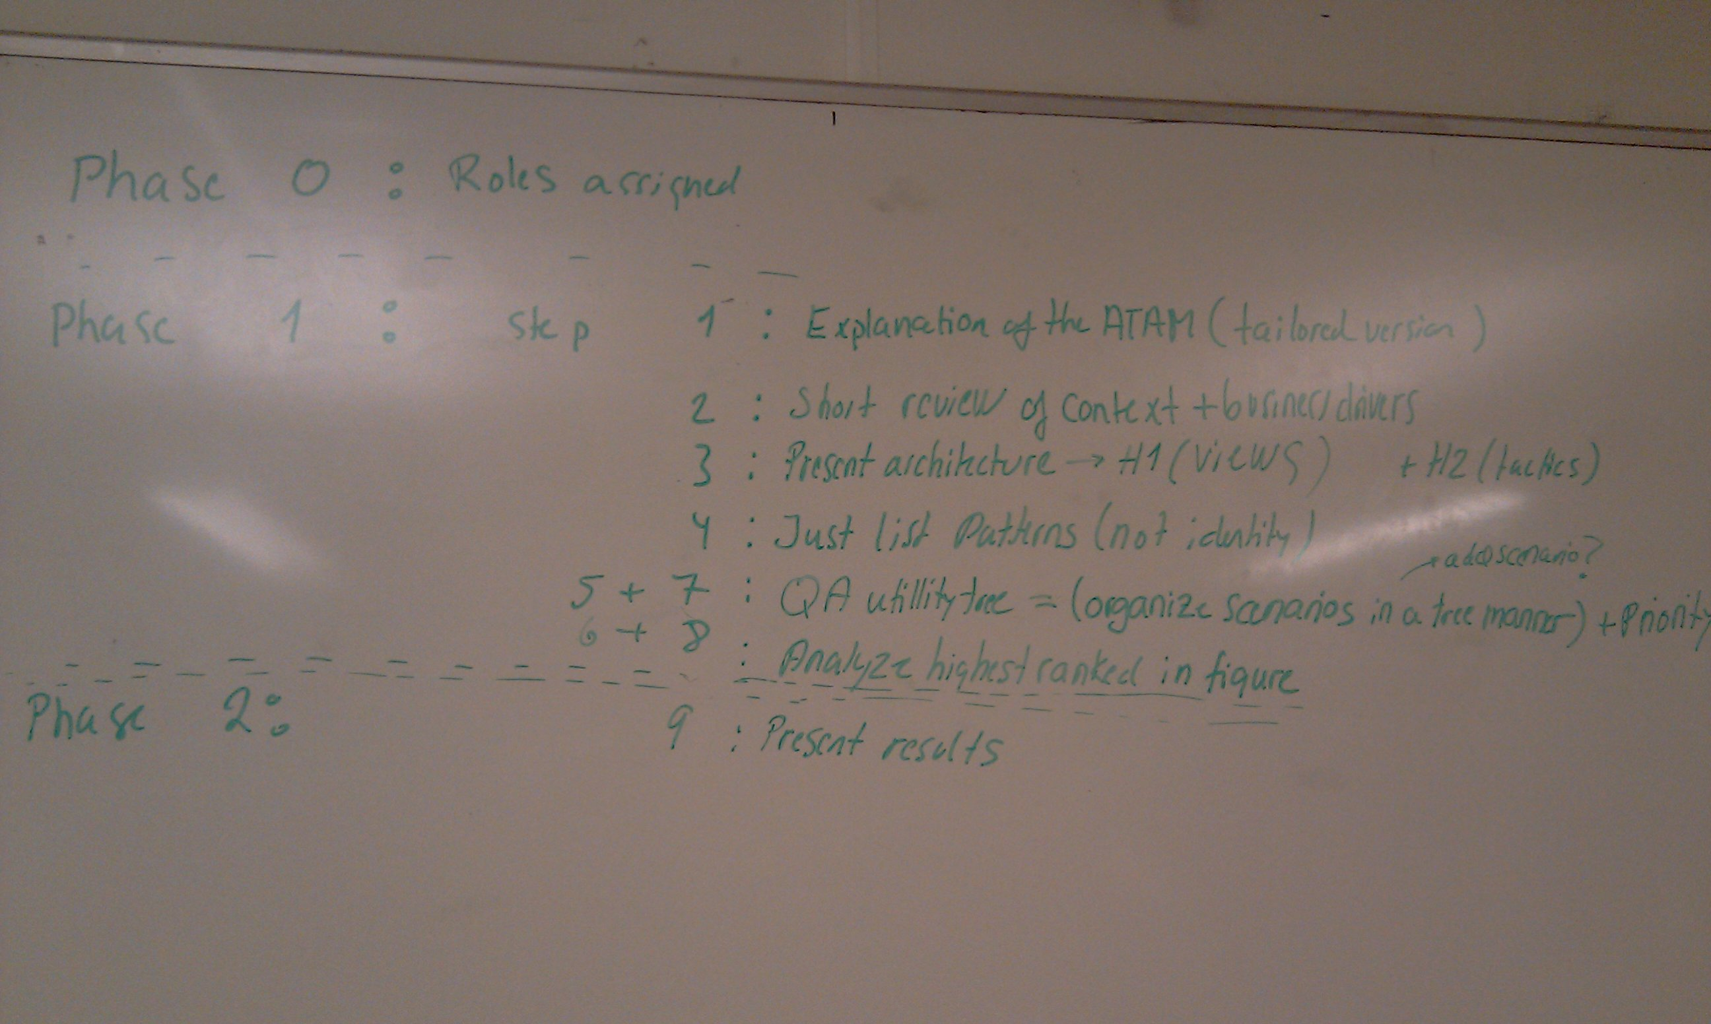
Phase 0 |  | Roles assigned
Phase 1 | Step 1 | Explanation of the ATAM (tailored version)
Phase 1 | Step 2 | Short review of context + business drivers
Phase 1 | Step 3 | Present architecture->H1 (views) + H2 (tactics)
Phase 1 | Step 4 | Just list patterns/approaches (also identifiy)
Phase 1 | Step 5 + 7 | QA Utility tree = (organize scenarios in a tree manner) + priority
Phase 1 | Step 6+8 | Analyze highest ranked scenarios
Phase 2 | Step 9 | Present results

Step 1 was done as seen in the table above. The evaluation leader wrote up the steps on the blackboard to give an overview. Step 2 was done by looking in H1 for the functionality and H2 for the architectural drivers. Step 3 was done by looking at the architectural views from H1 together with the tactics from H2. In step 4 we identified an observer pattern between the gateway and the radiator, and a publish/subscribe pattern between the gateway and the thermometers. Also we think the broker pattern is used several times in the architecture. E.g. when the gateway is pulling the thermometer for a temperature, the gateway acts as the client, the broker on the gateway side is the Invoker class, the broker on the thermometer side is the ThemometerService and the remote object is the thermometer.
The approach used to access the remote objects (thermometers, gateways, radiators) was to create a web server for each of them. This implies possible concurrency, since a web server can handle 2 or more requests at the same time by creating a thread for each request and they all access the same remote object.
Next time: Do Step 5

