Tailoring the ATAM process

Phase 0 - Partnership and prepartion
Phase 0 is done by arbitrarily assigning roles to the members of our group. We decided that person having the role as architect should not have any important role on the evaluation team, like e.g. evaluation leader. Also we decided to keep the roles we have been assigned when doing H2. Then we extended the list of roles with roles from the ATAM.

Phase 1 - Evaluation
Since we are going to tailor our own ATAM process we will keep step 1. Step 1 will then be used to present our tailored version. Step 2 will be done as a short review of H2. Step 3 will be done by presenting our architecture from H1 together with our tactics from H2. We think it would have been better to be able to present architectural views that support our tactics, since we didn’t have that, this was not possible. Step 4 will be done by identifying patterns in the architecture from H1. Step 5 will be done by building a Quality Attribute Utility Tree from scenarios made in H2. Then we will decide whether it fits, or whether we should add more scenarios to it. When done we will prioritize the scenarios on the tree. Here we will not consider the prioritizations made in H2. Step 6 will be done by analysing the highest-ranked scenarios one at a time.

Phase 2 – Evaluation continued
We will skip step 7 and step 8, because this is already done in phase 1. Step 9 will be done as described in the book.

Doing the ATAM
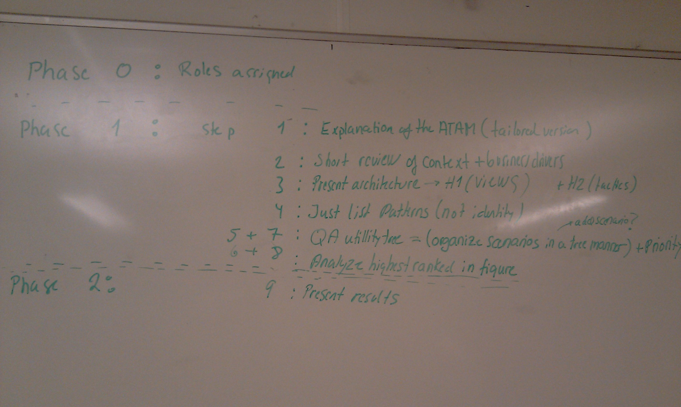
Phase 0 |  | Roles assigned
Phase 1 | Step 1 | Explanation of the ATAM (tailored version)
Phase 1 | Step 2 | Short review of context + business drivers
Phase 1 | Step 3 | Present architecture->H1 (views) + H2 (tactics)
Phase 1 | Step 4 | Just list patterns/approaches (also identifiy)
Phase 1 | Step 5 + 7 | QA Utility tree = (organize scenarios in a tree manner) + priority
Phase 1 | Step 6+8 | Analyze highest ranked scenarios
Phase 2 | Step 9 | Present results

Step 1 was done as seen in the table above. The evaluation leader wrote up the steps on the blackboard to give an overview. Step 2 was done by looking in H1 for the functionality and H2 for the architectural drivers. Step 3 was done by looking at the architectural views from H1 together with the tactics from H2. In step 4 we identified an observer pattern between the gateway and the radiator, and a publish/subscribe pattern between the gateway and the thermometers. Also we think the broker pattern is used several times in the architecture. E.g. when the gateway is pulling the thermometer for a temperature, the gateway acts as the client, the broker on the gateway side is the Invoker class, the broker on the thermometer side is the ThemometerService and the remote object is the thermometer.
The approach used to access the remote objects (thermometers, gateways, radiators) was to create a web server for each of them. This implies possible concurrency, since a web server can handle 2 or more requests at the same time by creating a thread for each request and they all access the same remote object.

Step 5 + 7 – Quality Attribute Utility Tree and brainstorm
We have done this step by building a utility tree from the scenarios we made in the QAW in H2. Afterwards we made a brainstorm which made us add some additional scenarios. Below here we have started by listing our tables with scenarios from H2, followed by our Utility Tree Table. Here we have marked the most important scenarios with orange, and the next most important with yellow.
Scenario(s): | 1 - Out of water
Relevant Quality Attributes: | Availability
Source: | System
Stimulus: | ”Not enough water”
Artifact: | System
Environment: | Normal usage
Response: | Stop – then recover when flow is normal
Response Measure: | 10 minutes after work supply
Questions:
Issues:

Scenario(s): | 2 - Breakdown of thermometers
Relevant Quality Attributes: | Availability/robustness
Source: | Internal to the system
Stimulus: | 5 thermometers break down
Artifact: | Sensors
Environment: | Normal usage
Response: | Set temp to 18 degrees
Response Measure: | The temperature will reach 18 degrees within 30 minutes
Questions:
Issues:

Scenario(s): | 3 - New wireless technology is available
Relevant Quality Attributes: | Modifiability
Source: | Developer
Stimulus: | New wireless technology is available on the market
Artifact: | The gateway code
Environment: | Design time
Response: | New module implementation without side effects
Response Measure: | It should be possible to do the implementation in 5 days
Questions:
Issues:

Scenario(s): | 4 - New radiators are available
Relevant Quality Attributes: | Modifiability
Source: | Market
Stimulus: | Provides new radiators that are more energy efficient
Artifact: | The device-subsystem of HS07
Environment: | At any given time
Response: | Implementation of the required interface is done without side effects
Response Measure: | It should be possible to do the implementation in 5 days
Questions:
Issues:

Scenario(s): | 5 – Turn on heat using smartphone
Relevant Quality Attributes: | Usability
Source: | User
Stimulus: | Wants to turn on the heat using a smartphone
Artifact: | The gateway (the system)
Environment: | Online
Response: | The user gets access to a web interface suitable for his smartphone
Response Measure: | It should fit the smartphone screen in such a way that margins are not bigger than 20%
Questions:
Issues:

Scenario(s): | 6 - Average family buys HS07
Relevant Quality Attributes: | Business
Source: | Average family
Stimulus: | Wants to buy a HS07 system
Artifact: | Retailer
Environment: | Market
Response: | The family is able to pay and get the system
Response Measure: | The family pays no more than €500
Questions:
Issues:

Scenario(s): | 7 - External quality testing
Relevant Quality Attributes: | Testability
Source: | The developer company
Stimulus: | The system has been completed and is ready to be tested by quality insurance company
Artifact: | System
Environment: | Design time
Response: | It will be possible for the company to test the system using their standards
Response Measure: | The first quality test should last at most 3 weeks. Any further modification should last no longer than one week.
Questions:
Issues:

Scenario(s): | 8 - Environment testing
Relevant Quality Attributes: | Testing
Source: | The developer
Stimulus: | Want to test device interaction under different conditions
Artifact: | System
Environment: | Design time
Response: | It will be easy to simulate the presence of any number of devices in any possible state (e.g. working or not working)
Response Measure: | The environment should be setup within one hour.
Questions:
Issues:

Scenario(s): | 9 - External attack on system
Relevant Quality Attributes: | Security, robustness
Source: | External to the system, not an owner of the home
Stimulus: | An outsider is trying to change the temperature to a high level
Artifact: | HS07 Gateway (The system)
Environment: | Under normal conditions
Response: | Temperature is not changed and the activity is logged
Response Measure: | The attack is intercepted by 99.9% probability
Questions:
Issues:

Scenario(s): | 10 - Outsider trying to get access
Relevant Quality Attributes: | Security
Source: | External to the system, not an owner of the home
Stimulus: | An outsider is trying to log in to the system
Artifact: | The system
Environment: | Under normal conditions
Response: | Access is denied, access attempt is being logged
Response Measure: | Access is denied for 99.9% of all attempts.
Questions:
Issues:

Scenario(s): | 11a - ”Temperature increase”
Relevant Quality Attributes: | Performance
Source: | Gateway
Stimulus: | Detects temperature above desirable max
Artifact: | Thermometers
Environment: | Normal usage
Response: | Turn off the radiators (could be many)
Response Measure: | All radiators should be turned off in less than 5 minutes
Questions:
Issues: | By responding quickly to temperature increases, this scenario covers the architectural driver stating that the system should be performant such that a large number of thermometers and radiators may be part of the system. It also covers part of the architectural driver saying that the system should be friendly to the environment.

Scenario(s): | 11b - ”Temperature decrease”
Relevant Quality Attributes: | Performance
Source: | Gateway
Stimulus: | Detects temperature decrease below desirable min
Artifact: | Thermometers
Environment: | Normal usage
Response: | Turn on the radiators (also here, it could be many)
Response Measure: | All radiators should be turned on in less than 2 minutes
Questions:
Issues: | This scenario should cover:”The system shall be able to heat the house when it is turned on”.

Scenario(s): | 12 - Radiator availability
Relevant Quality Attributes: | Availability
Source: | The gateway
Stimulus: | Turns on the system
Artifact: | Radiator
Environment: | Under normal operations
Response: | The radiator works with requested intensity
Response Measure: | It does so without interruptions 99% of the time.
Questions:
Issues:

Utility tree table
Quality Attribute | Attribute Refinement | Scenarios | Priority (importance, difficulty)
Availability | Robustness | 1 - Out of water | M, L
 |  | 2 - Breakdown of thermometers | M, L
 | Reliability | 12 - Radiator availability | H, L
Modifiability | Adding new technology | 3 - New wireless technology is available | L, M
 | Adding new device | 4 - New radiators are available | H, M
 | Portability | When a new gateway enters the market it should be possible to port the software to the new gateway by modifying only 1 module, and by doing it within 3 weeks. | H, H
Usability | Remote access | 5 – Turn on heat using smartphone | M, M
 | Installation | The gateway should detect the model of the new device being plugged and install the required software without user interaction. | H, H
 | Normal operations | A user should be able to make a temperature change with fewer than three commands | H, L
 | Affordance | A computer literate user should be able to use the system without reading the manual | H, L
Testability | External testing | 7 - External quality testing | H, M
 | Internal testing | 8 - Environment testing | M, M
Security | Detection | 9 - External attack on system | M, M
 | Authentication | 10 - Outsider trying to get access | M, M
Performance | Response time | 11c - Temperature change | M, L
 | Network traffic | The gateway should poll the temperature with a frequency of 2 seconds | L, L

Step 6 – Analyse architectural approaches
Scenario | New gateway enters market
Attribute(s) | Portability (modifiability)
Environment | Design time
Stimulus | New gateway enters the market
Response | It should be possible to port the software to new gateway by modifying only 1 module, and by doing it within 3 weeks.
Architectural decision | Sensitivity | Trade-off | Risk | Nonsrisk
Layering
Abstraction

