Functionality Description

For

[SP Travel]

Date: [16/08/2026]

Contents

1 Document Management 3
1.1 Contributors 3
1.2 Version Control 3
2 OVERVIEW 4
2.1 Function Description 4
2.2 Technology 4
2.3 Development Tools and Processes 5
2.4 Interfaces and services 5

Document Management

Contributors

Please provide details of all contributors to this document

Function Integrated | Name
Admin Login / JWT Authentication | Gerard
Add Travel | Gerard
Update Travel | Gerard
List Travel | Gerard

Version Control

Please document all changes made to this document since creation.

Date | Version | Author | Section | Amendment
16/08/2026 | 1.0 | Gerard | All | Initial Creation
21/08/2026 | 1.1 | Gerard | 2.1, 2.4 | Added List Travel functionality

OVERVIEW
A brief description of what the overall system is about from a business perspective.

SP Travel is a web-based travel management system that allows users to browse available travel packages and view information such as the destination, price, travel period and package description. The system also provides administrative functions that allow an authenticated administrator to add, update and manage travel packages. Travel package information is stored in a central database, allowing the website to provide up-to-date travel information to users.

Function Description
High level description of what functionality the system contains (a list of the components / functionalities that have been integrated (frontend ↔ backend)).

This should include
i) a sequence diagram of the input / output between the User, Front End (i.e. the Website) and the Backend (i.e. the Server App).
ii) screenshots of the end to end process (i.e. what would be observed by the User)

- Admin Login / JWT Authentication

The Admin Login function allows an administrator to securely log in to SP Travel using a registered email address and password. The login credentials entered on the frontend are sent to the backend for verification. The backend retrieves the administrator account from the database and verifies the entered password against the stored encrypted password.

When authentication is successful, the backend generates a JSON Web Token (JWT) and returns it to the frontend. The frontend stores the authentication information and uses the token when making protected requests such as adding or updating travel packages.

After a successful login, administrative functions such as Add Travel and Edit Travel become available. When the administrator logs out, the authentication information is removed and these protected functions are hidden again.

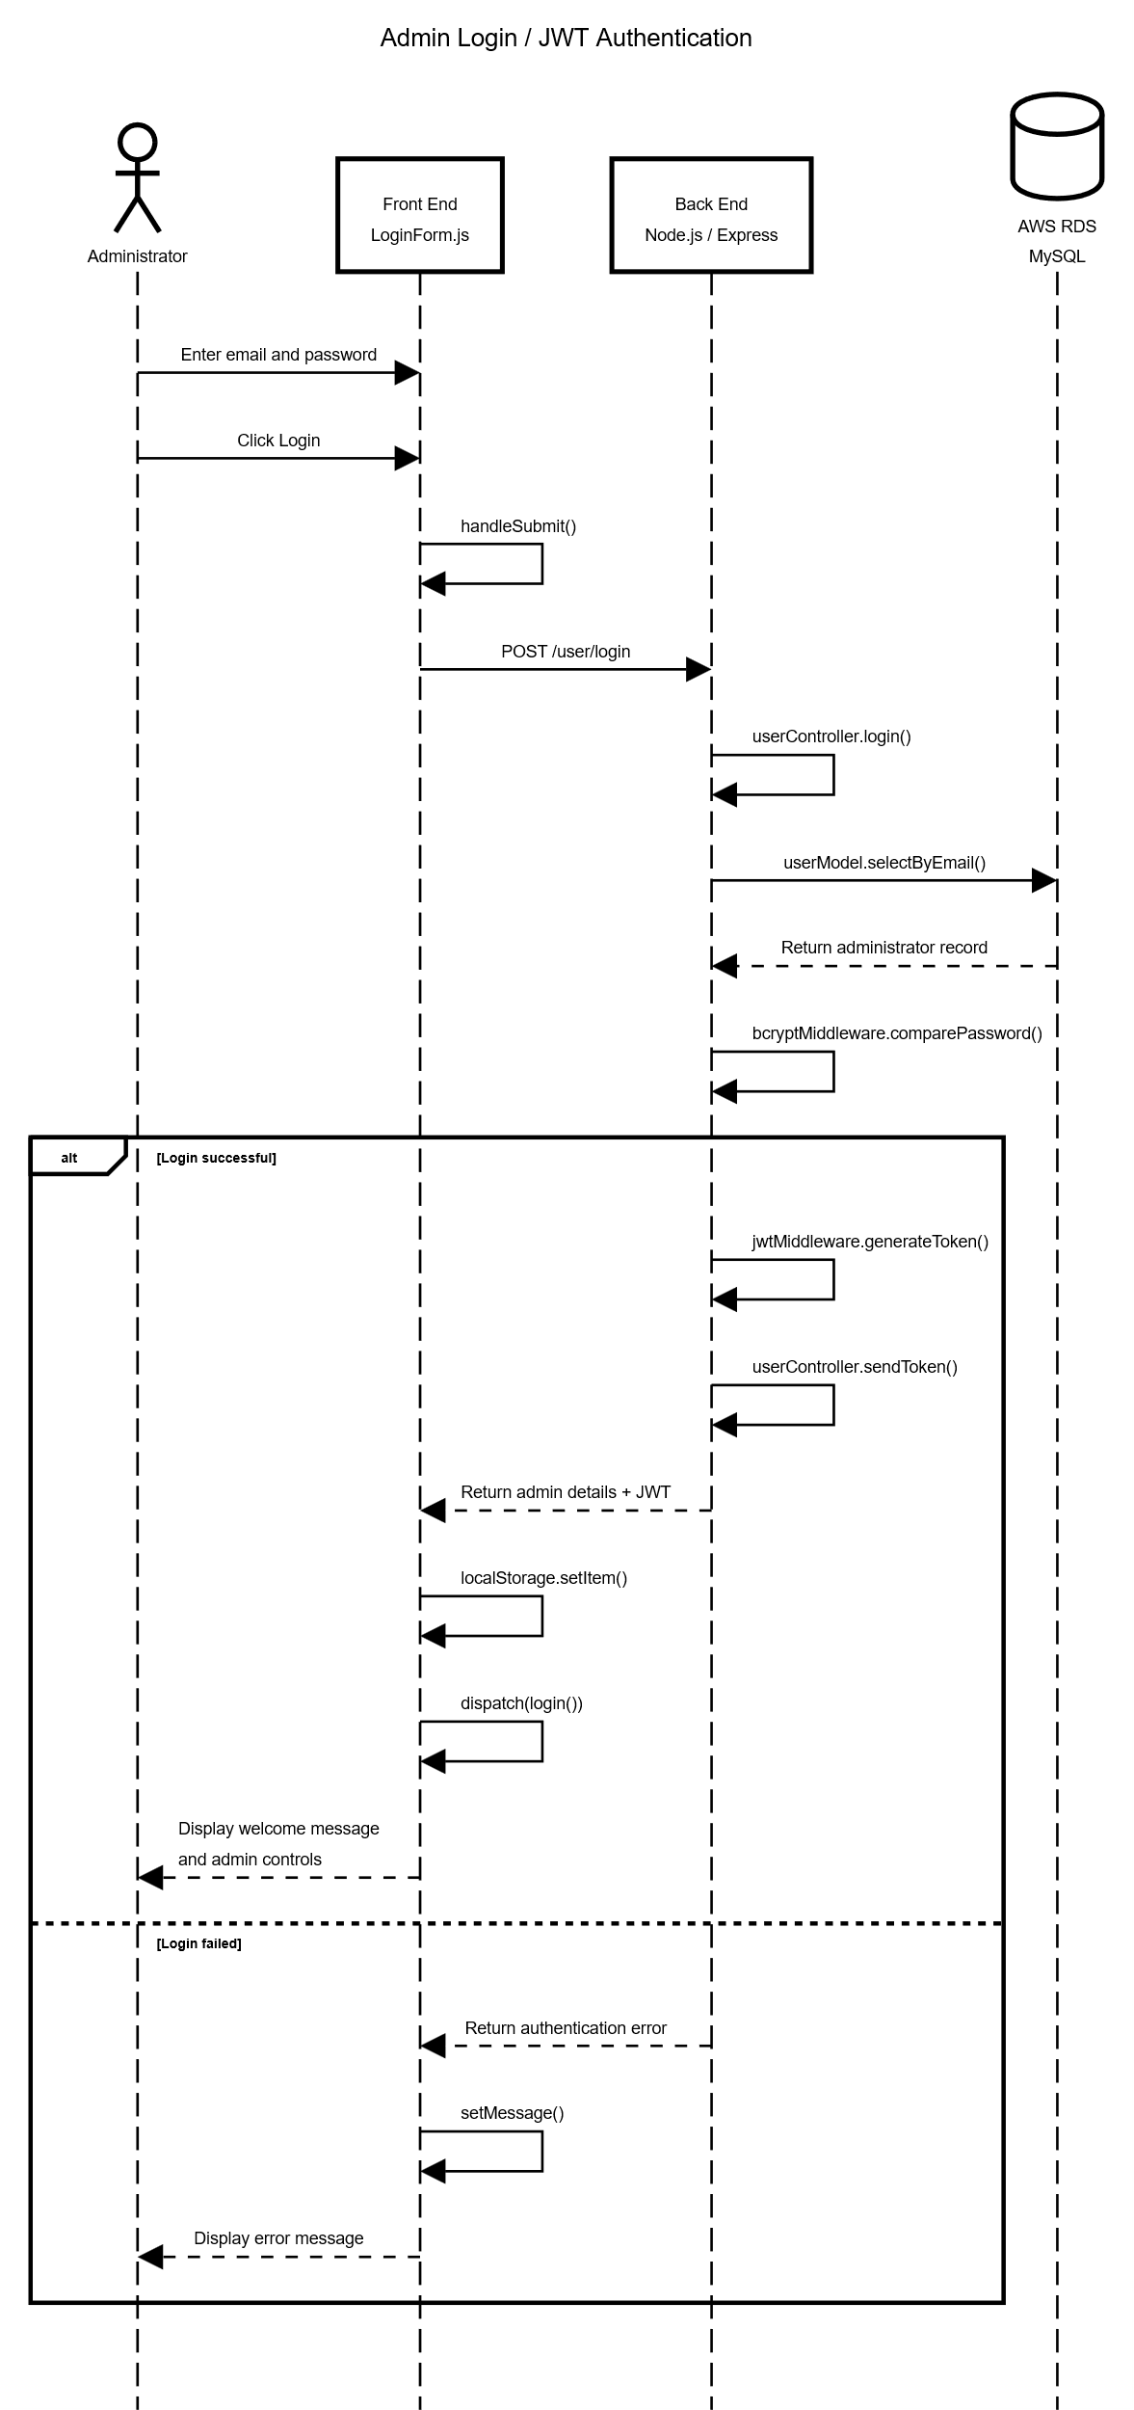

Before admin login:

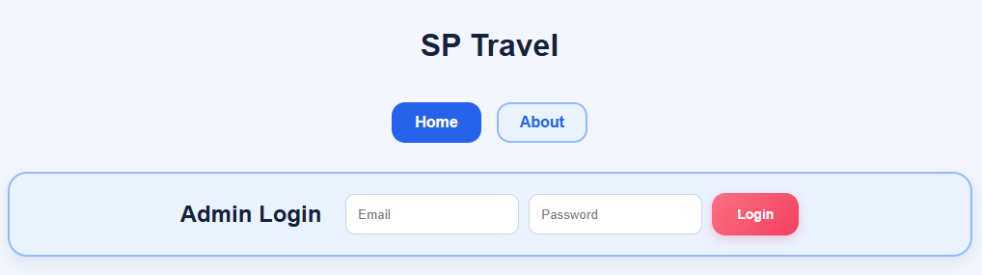

Missing email or password:

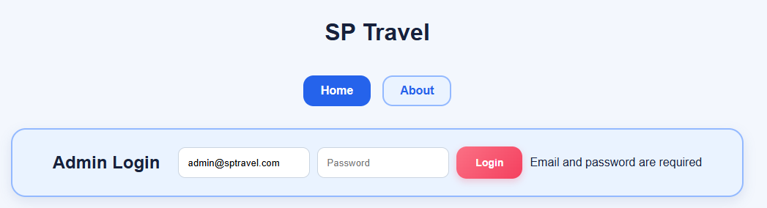

Wrong email or password:

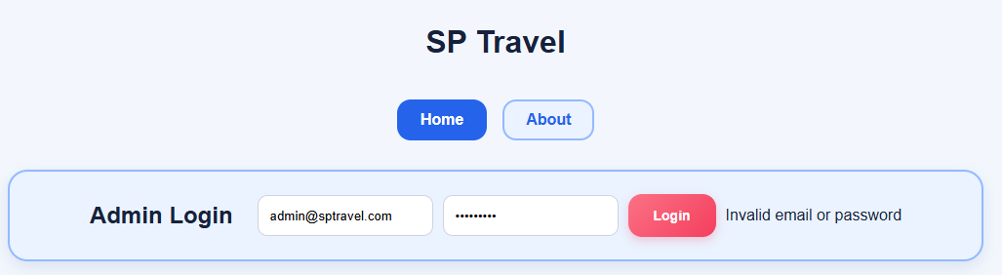

Successfully logged in:

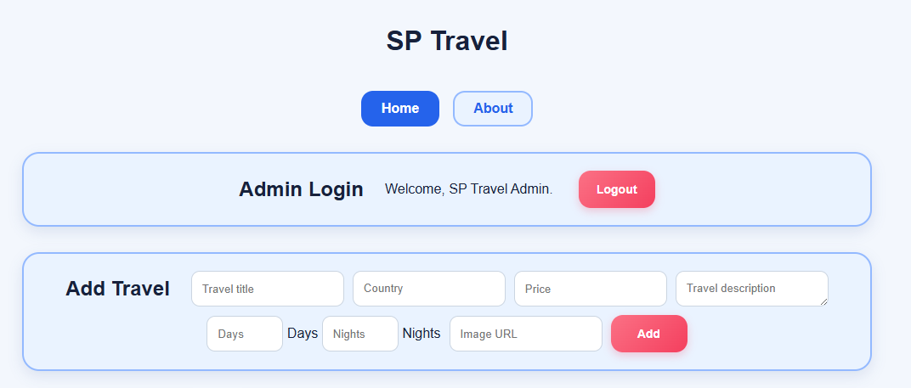

- Add Travel

The Add Travel function allows an authenticated administrator to create a new travel package in SP Travel. The administrator enters the travel title, country, price, description, travel period in days and nights, and an image URL through the Add Travel form. Input validation is performed to ensure that the required information is provided in the correct format.

When the administrator submits the form, the frontend sends the travel package information together with the administrator's JSON Web Token (JWT) to the backend. The backend verifies the JWT before processing the request and storing the new travel package in the database.

After the travel package is successfully created, the database-generated travel ID is returned to the frontend. The frontend updates its application state and immediately displays the newly created travel package without requiring the page to be refreshed.

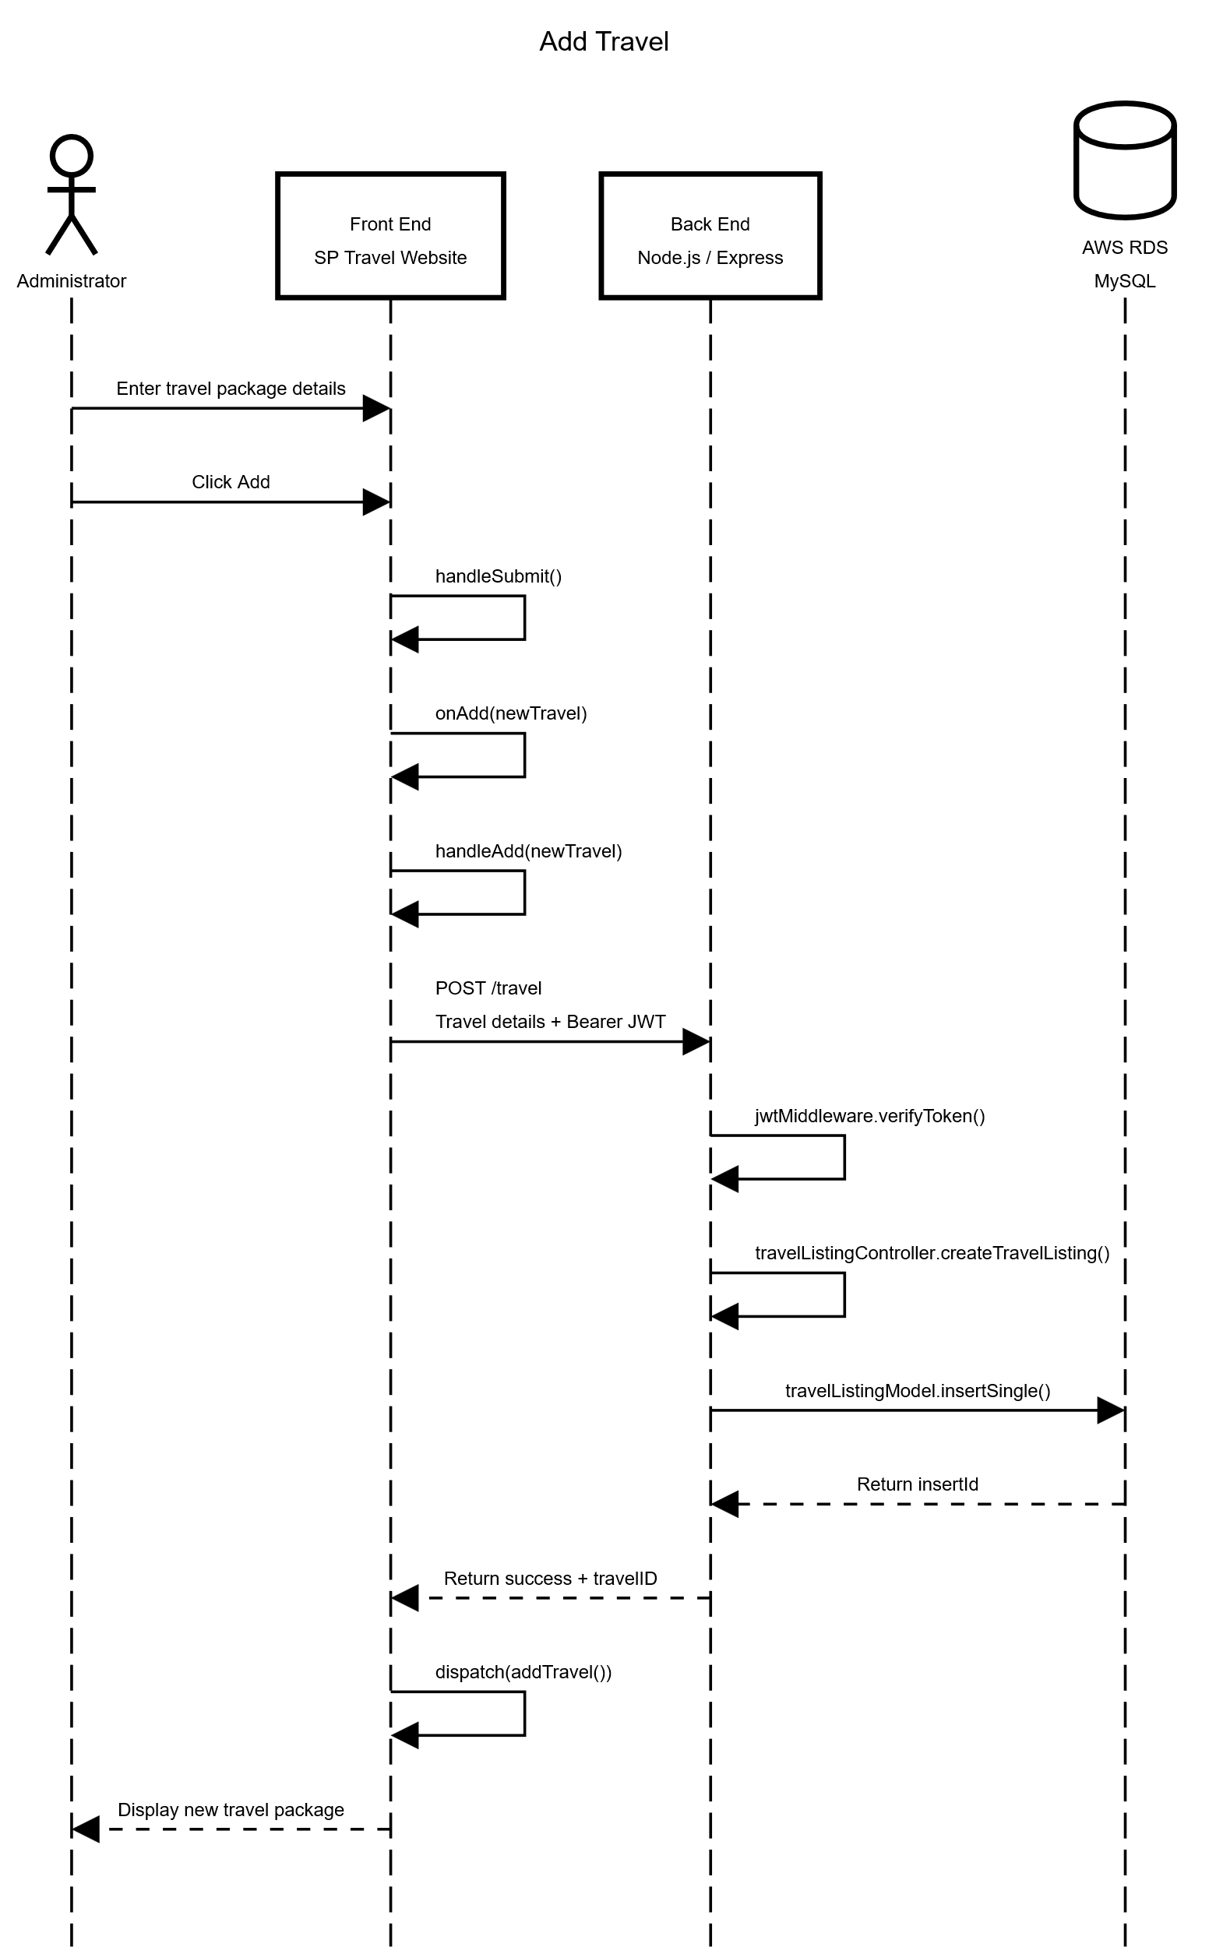
Validation on all required fields:

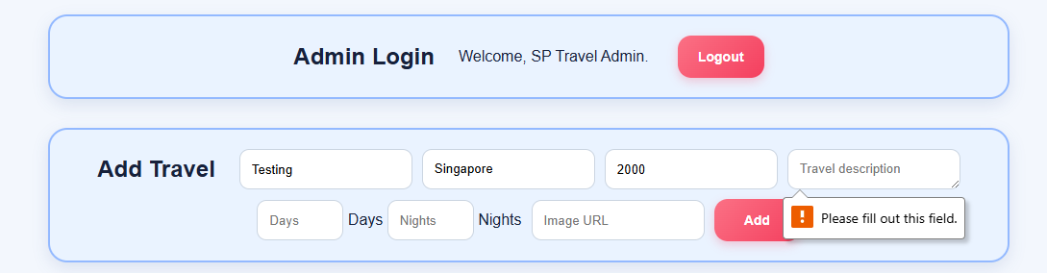

Fully filled fields:

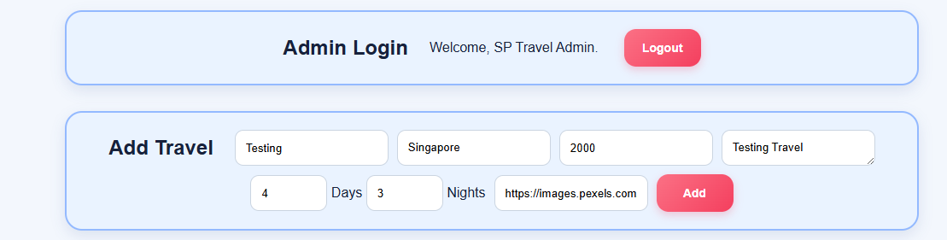

Successful addition of new travel package after clicking add:

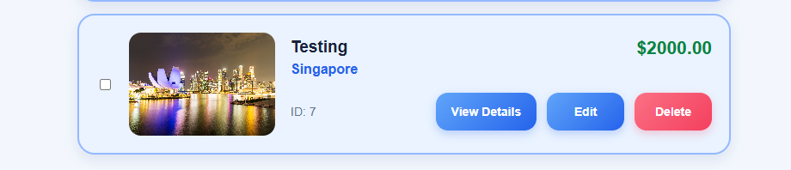

Update Travel

The Update Travel function allows an authenticated administrator to modify an existing travel package in SP Travel. The administrator selects the Edit option for a travel package, which opens an Edit Travel form containing the package's existing information. The administrator can modify the travel title, country, price, description, travel period in days and nights, and image URL, while the existing travel ID remains unchanged.

When the administrator saves the changes, the frontend sends the updated travel information together with the administrator's JSON Web Token (JWT) to the backend. The backend verifies the JWT and updates the corresponding travel package in the database using its travel ID.

After the update is successfully completed, the frontend updates its application state with the modified travel information. The Edit Travel modal closes and the updated information is immediately displayed on the travel package without requiring the page to be refreshed.

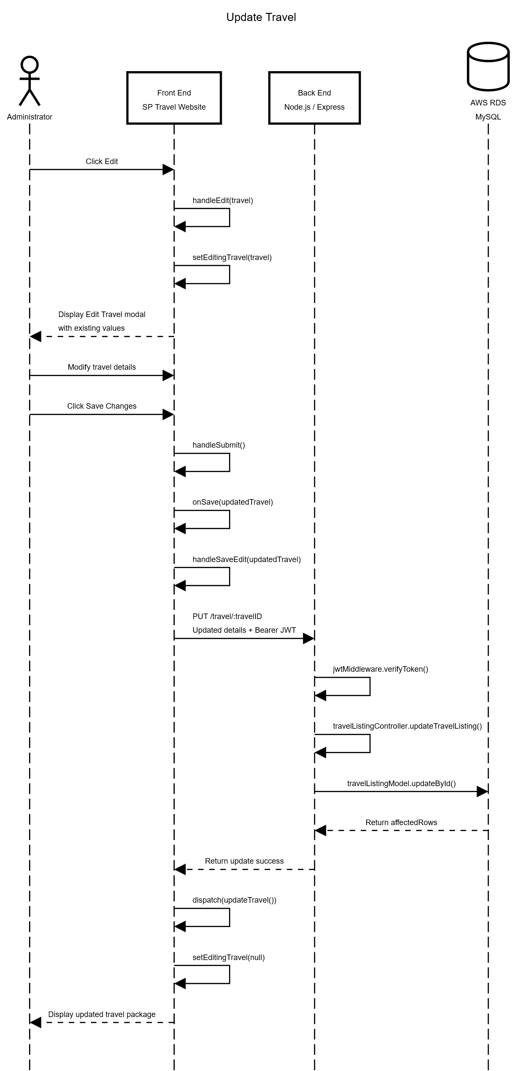
Edit Travel modal opened with existing values pre-filled:

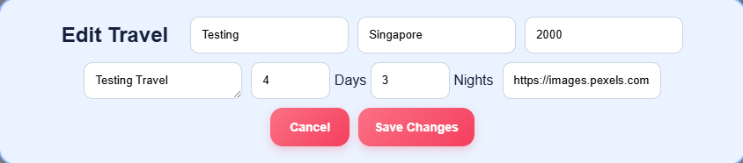

Modified travel information before saving:

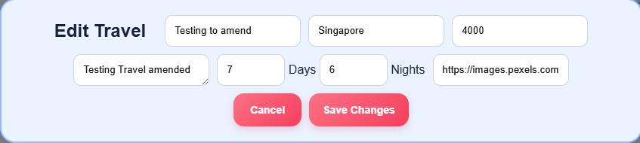

Successful update after clicking Save Changes:

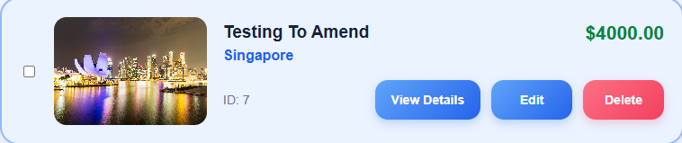

List Travel

The List Travel function allows users to view the travel packages currently stored in the SP Travel database. When the Home page loads, the frontend sends a request to the backend to retrieve all available travel packages.

The backend retrieves the travel package records from the database and returns them to the frontend. The returned data includes information such as the travel ID, title, country, price, description, travel period and image URL.

The frontend stores the returned travel packages in the Redux application state and displays them as travel package cards. This ensures that the travel listings shown on the website are loaded from the database and remain available after the page is refreshed.

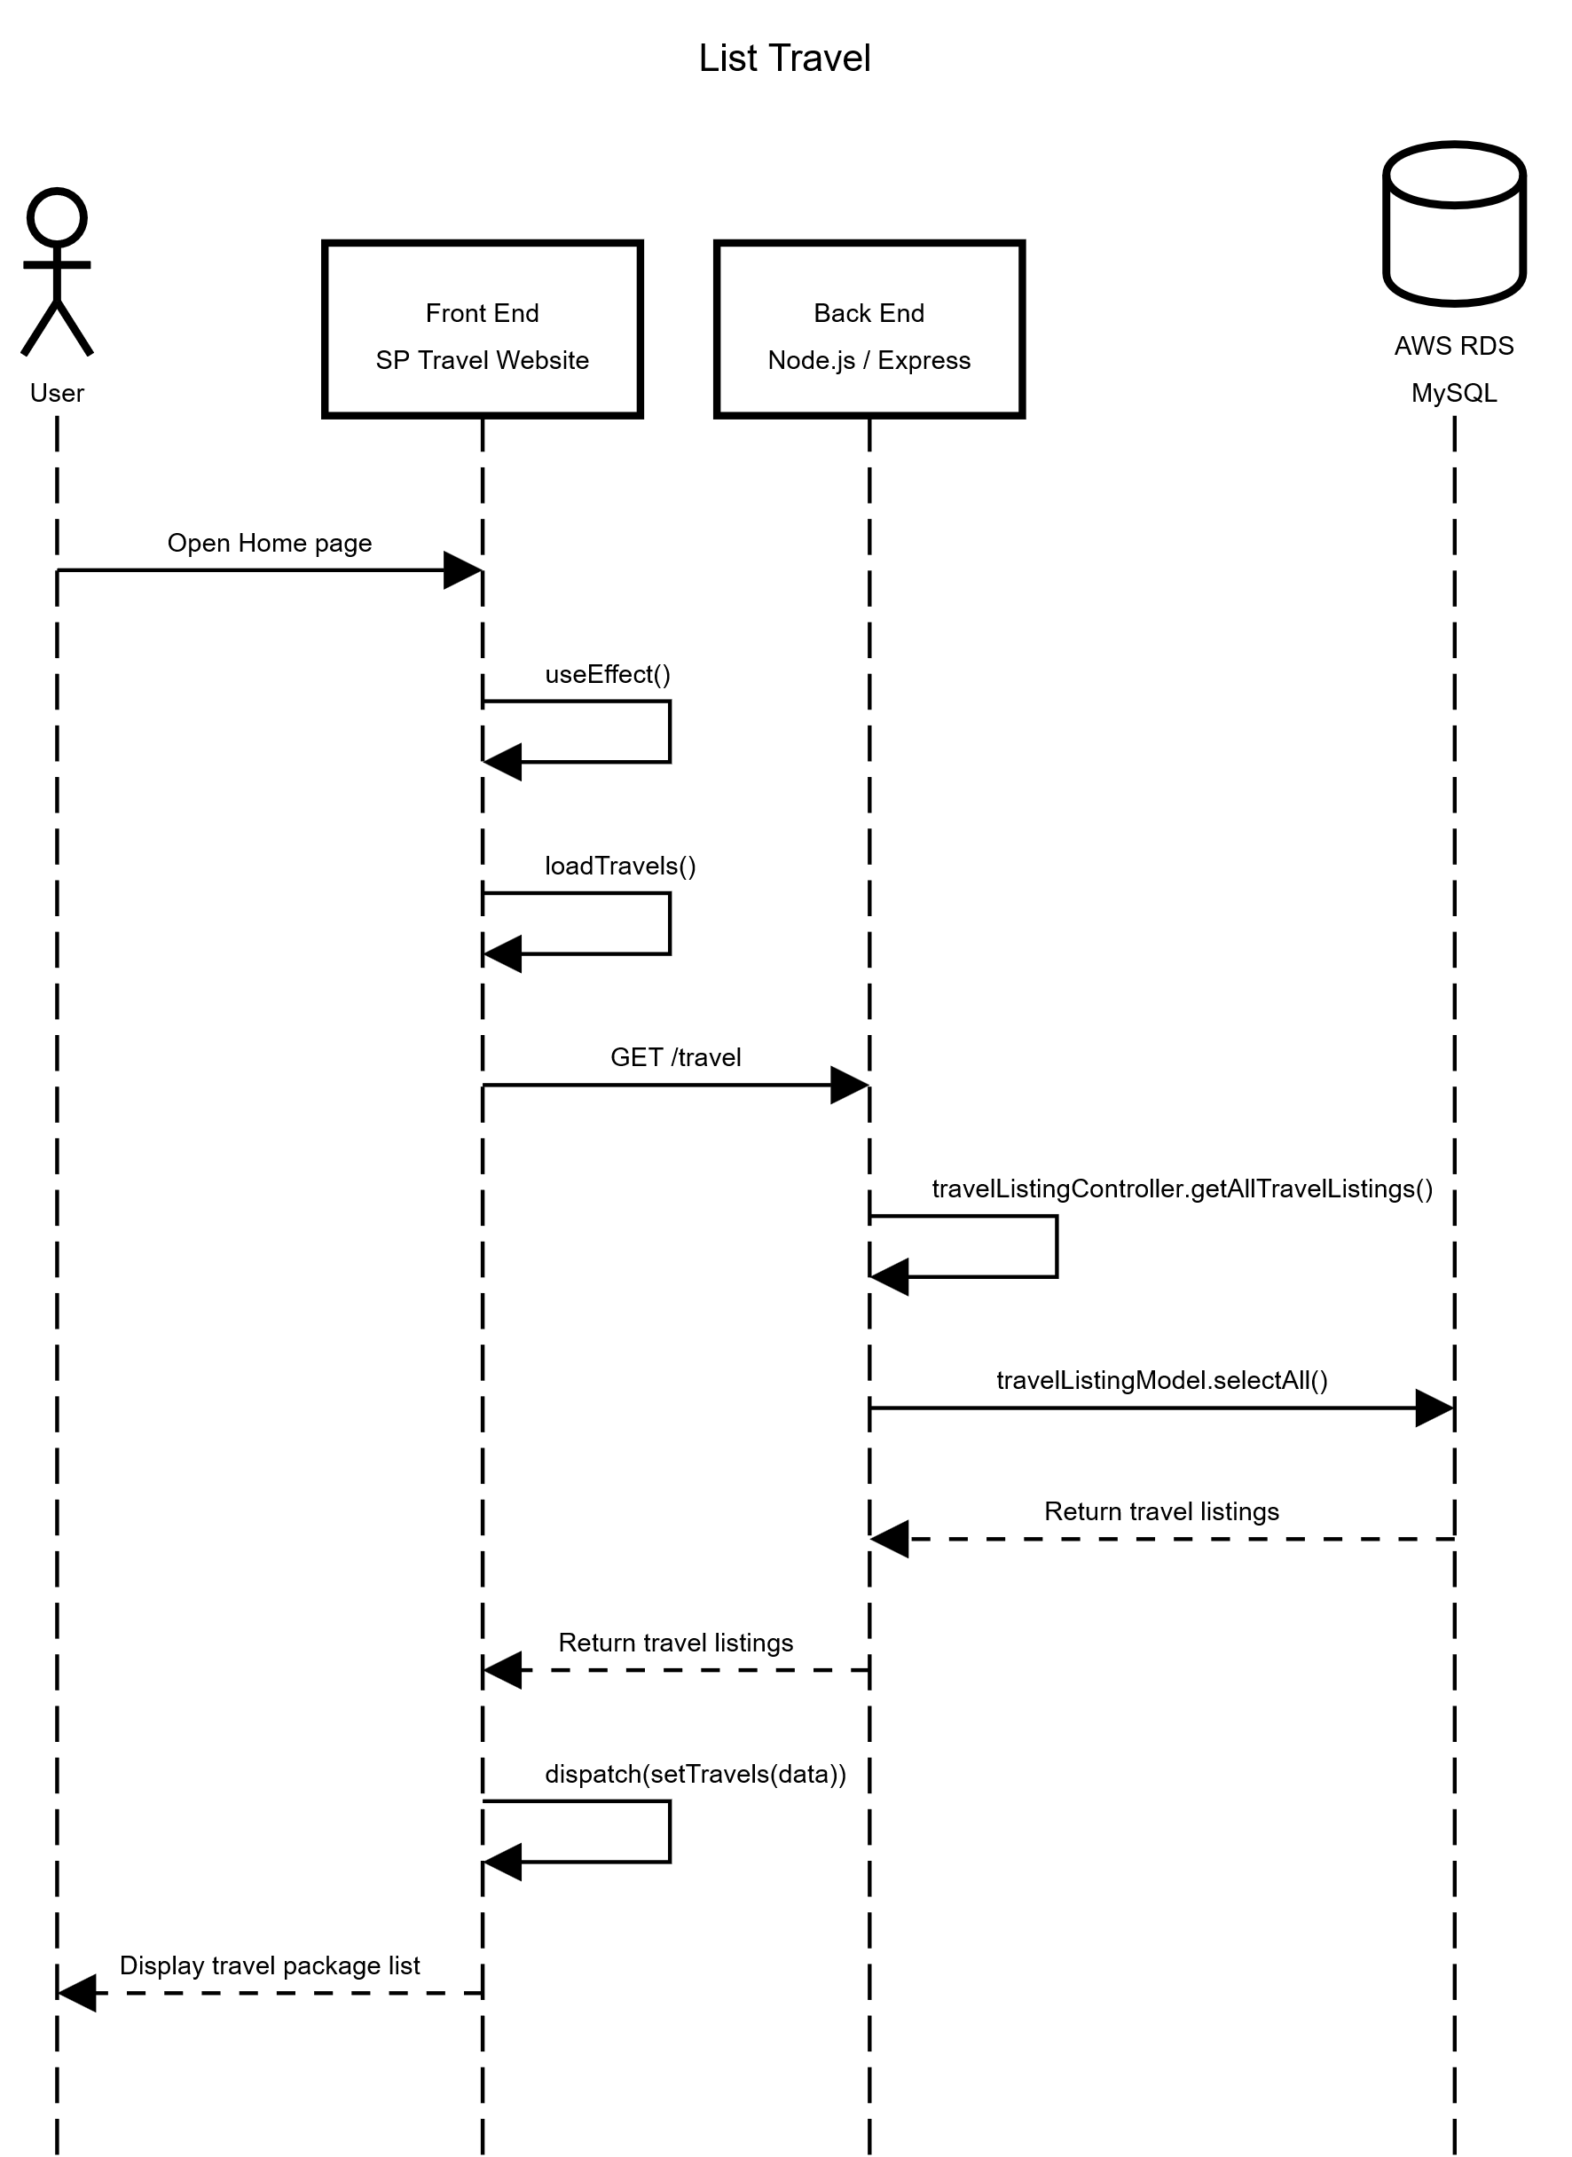

Travel listings displayed on the Homepage match the records stored in RDS:

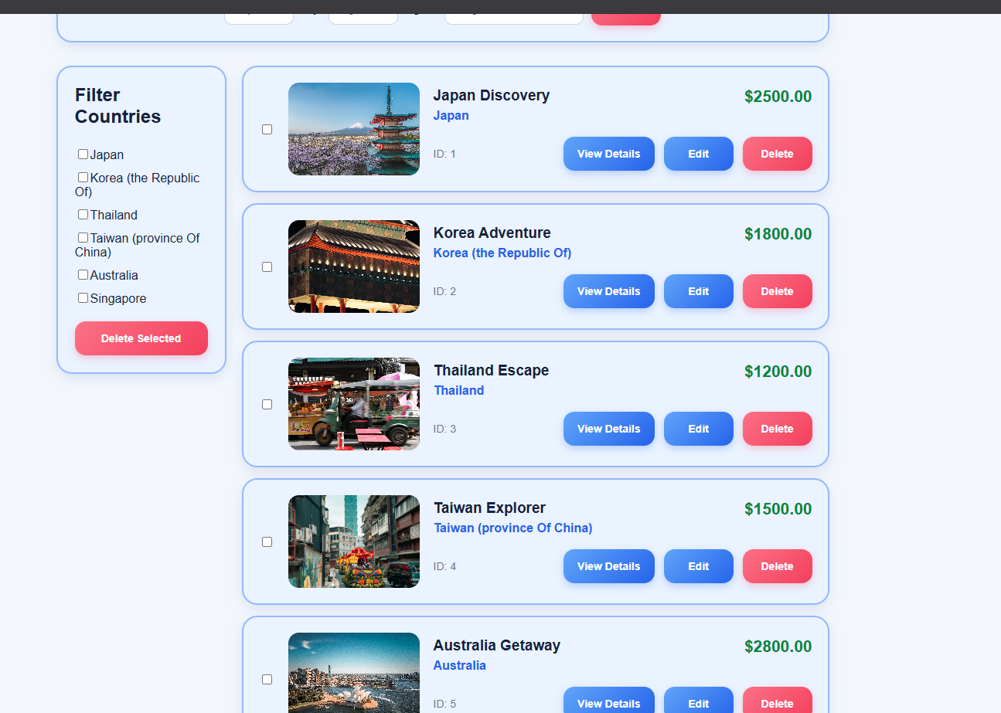

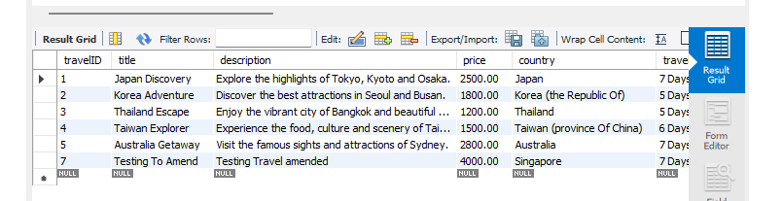

Technology
A listing and brief description of the underlying frameworks / libraries used by the application.

Technology / Library | Description
React | Frontend JavaScript library used to build the SP Travel user interface using reusable components.
Redux Toolkit / React Redux | Used to manage frontend application state, including travel package data and administrator authentication state.
React Router DOM | Used to provide navigation between pages such as the Home, About and Travel Details pages.
country-list | Provides the list of countries used by the searchable Country field in the Add Travel and Edit Travel forms.
Node.js | JavaScript runtime environment used to execute the SP Travel backend application.
Express.js | Backend web framework used to define API routes and process HTTP requests and responses.
JSON Web Token (JWT) | Implemented using the jsonwebtoken library to generate and verify authentication tokens for protected administrator functions.
bcrypt | Used to securely compare the administrator's entered password against the hashed password stored in the database.
MySQL / mysql2 | MySQL is used to store SP Travel data. The mysql2 library allows the Node.js backend to communicate with the MySQL database.
CORS | Implemented using the cors library to allow the frontend and backend running on different origins/ports to communicate.
dotenv | Used to load configuration values such as database credentials and the JWT secret from environment variables.
esbuild | Used to bundle and serve the React frontend application during development/deployment.
React Icons | Provides reusable icon components used in the SP Travel frontend user interface.

Development Tools and Processes
This section should be used to document:
- any specific development tools, compilers or suggested IDEs that are used for the application.
- Describe how software source control is performed (e.g. Git)

Tool / Process | Description
Visual Studio Code | Main development environment used to develop and edit the SP Travel frontend and backend source code.
Git | Used for source control to track code changes and manage separate development branches for different functionalities.
GitHub | Used as the remote repository for collaboration, code sharing, pull requests and merging completed functionality into the main branch.
Postman | Used to test backend REST API endpoints such as administrator login and protected travel package operations.
MySQL Workbench | Used to manage and inspect the MySQL database, including the admin, travelListing and itinerary tables.
AWS RDS | Hosts the MySQL database used by the deployed SP Travel backend.
AWS EC2 | Hosts the deployed SP Travel frontend and Node.js/Express backend application.
PM2 | Used on the EC2 server to manage the frontend and backend Node.js processes and keep them running independently of the SSH session.
npm | Used to install and manage the JavaScript packages required by the frontend and backend applications.

Source Control Process:
Git and GitHub were used throughout the development of SP Travel. Individual functionalities were developed on separate feature branches before being pushed to GitHub and merged into the main branch through pull requests. This allowed each functionality to be developed and tested separately before integration with the main application.

For example, the Add Travel and Update Travel functionalities were developed using the feature/add-travel and feature/update-travel branches respectively before being merged into the main branch.

Interfaces and services

- List all backend interfaces (incoming – data into the backend, outgoing – data out of the backend) and the path to the file (and lines of code) in which they are stored in.

Function Integrated | Details of Front End Codes | <> | Details of Back End Codes
Admin Login / JWT Authentication | LoginForm.js (lines 16–49) – handleSubmit()  authSlice.js (lines 13–23) – login(), logout() | <> | userRoutes.js (lines 8–14) – router.post()  userController.js (lines 3–44) – login()  sendToken()  userModel.js (lines 3–13) – selectByEmail()  bcryptMiddleware.js (lines 3–24) – comparePassword()  jwtMiddleware.js (lines 3–22) – generateToken()
Add Travel | AddEntityForm.js (lines 15–34) – handleSubmit()  HomePage.js (lines 49–87) – handleAdd()  travelSlice.js (lines 13–15) – addTravel() | <> | travelListingRoutes.js (lines 7–11) – router.post()  jwtMiddleware.js (lines 24–47) – verifyToken()  travelListingController.js (lines 3–45) – createTravelListing()  travelListingModel.js (lines 3–20) – insertSingle()
Update Travel | EditTravelForm.js (lines 17–29) – handleSubmit()  HomePage.js (lines 95–132) – handleEdit(), handleSaveEdit()  travelSlice.js (lines 53–61) – updateTravel() | <> | travelListingRoutes.js (lines 13–17) – router.put()  jwtMiddleware.js (lines 24–47) – verifyToken()  travelListingController.js (lines 75–124) – updateTravelListing()  travelListingModel.js (lines 44–68) – updateById()

Function Integrated | Details of Front End Codes | <> | Details of Back End Codes
List Travel | HomePage.js (lines 22–33) – useEffect(), loadTravels()  travelSlice.js (lines 63–65) – setTravels() | <> | travelListingRoutes.js (line 25) – router.get()  travelListingController.js (lines 47–55) – getAllTravelListings()  travelListingModel.js (lines 22–29) – selectAll()

