Classification of Tumour Type from Skin Images
by Using Deep Learning
Teodora Gerasimoska
Ss. Cyril and Methodius University
Faculty of Computer Science & Engineering
Skopje, Republic of Macedonia
teodora.gerasimoska@students.finki.ukim.mk

ABSTRACT
A tumour is a commonly used term for an abnormal new growth of cells. If someone has been diagnosed with a tumour, the first step the doctor will take is to find out whether it is malignant or benign, as this will affect the treatment plan. In short, the meaning of malignant is cancerous and the meaning of benign is non-cancerous.
If the cells are not cancerous, the tumour is benign. It won't invade nearby tissues or spread to other areas of the body (metastasize). Most benign tumours respond well to treatment. Malignant means that the tumour is made of cancer cells and it can invade nearby tissues. Malignant cells are often resistant to treatment, may spread to other parts of the body and they sometimes recur after they were removed.
Cancer(malignant tumour) is the second leading cause of death globally, and is responsible for an estimated 9.6 million deaths in 2018. Globally, about 1 in 6 deaths is due to cancer.
Taking the importance of timely tumour classification in account, machine learning methods are used for this approach of classifying tumorous skin images. By using features extraction and artificial neural networks, accuracy from 94% is obtained. The accuracy means that 94% of the images from tumorous part of the skin are correctly classified as benign or malignant, accordingly, and that information can be used in the following medical treatment.

CONTENT

Abstract 1
1 Introduction 3
2 Data Description 4
3 Preprocessing of the Dataset 5
4 Features Extraction 5
5 Neural Network 6
6 Possible Improvements 7
References 7

INTRODUCTION
Tumour, by definition, is an abnormal mass of tissue. Tumours can be benign or malignant(cancerous). There are hundreds of different types of tumours. Their names usually reflect the kind of tissue they arise in (breast cancer, prostate cancer…), and may also tell you something about their shape or how they grow. Diagnosis depends on the type and location of the tumour. Tumour marker tests and imaging may be used; some tumours can be seen (for example, tumours on the exterior of the skin) or felt (palpated with the hands). Treatment is also specific to the location and type of the tumour.
If a tumour is suspected to be malignant, a doctor removes all or part of it during a procedure called a biopsy. A pathologist (a doctor who identifies diseases by studying cells and tissues under a microscope) then examines the biopsied tissue to determine whether the tumour is benign or malignant.
A benign tumour is not a malignant tumour, which is cancer. It does not invade nearby tissue or spread to other parts of the body the way cancer can. In most cases, the outlook with benign tumours is very good. But benign tumours can be serious if they press on vital structures such as blood vessels or nerves. Therefore, sometimes they require treatment and other times they do not. The cause for a benign tumour to form is unknown. But its growth might be linked to: environmental toxins, such as exposure to radiation, genetics, diet, stress, local trauma or injury, inflammation or infection etc. In many cases, benign tumours need no treatment. Doctors may simply use "watchful waiting" to make sure they cause no problems. But treatment may be needed if symptoms are a problem. Surgery is a common type of treatment for benign tumours. The goal is to remove the tumour without damaging surrounding tissues. Other types of treatment may include medication or radiation.
Malignant tumours are cancerous tumours that can potentially result in death. Unlike benign tumours, malignant ones grow quickly, and can spread to new territory in a process known as metastasis. The abnormal cells that form a malignant tumour multiply at a faster rate. Anything that may cause a normal body cell to develop abnormally potentially can cause cancer. Many things can cause cell abnormalities and have been linked to cancer development. Some cancer causes remain unknown while other cancers have environmental or lifestyle triggers or may develop from more than one known cause. Some may be developmentally influenced by a person's genetic makeup. Many patients develop cancer due to a combination of these factors. A doctor who specializes in the treatment of cancer is called an oncologist. He or she may be a surgeon, a specialist in radiation therapy, or a medical oncologist. The first uses surgery to treat the cancer; the second, radiation therapy; the third, chemotherapy and related treatments. Each may consult with the others to develop a treatment plan for the particular patient.
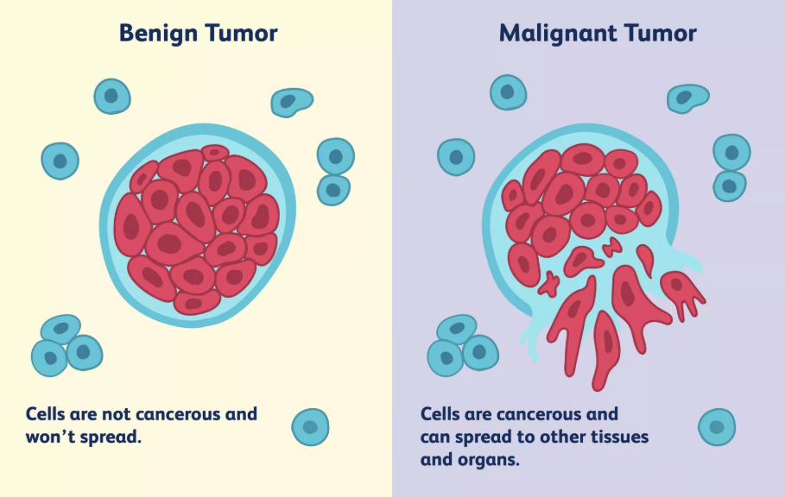
Cancer is a leading cause of death worldwide. It accounted for 8.2 million deaths (around 22% of all deaths not related to communicable diseases; most recent data from WHO). Deaths from cancer worldwide are projected to continue rising, with an estimated 13.1 million deaths in 2030 (about a 70% increase).
Taking these frightening statistics in account, one must realize of how big importance is the correct classification of tumour as cancerous or not. In this paper, tumour classification based on an artificial neural network method combined with feature selection has been proposed.
An artificial neural network is an attempt to simulate the network of neurons that make up a human brain so that the computer will be able to learn things and make decisions in a humanlike manner. Information flows through a neural network in two ways. When it's learning (being trained) or operating normally (after being trained), patterns of information are fed into the network via the input units, which trigger the layers of hidden units, and these in turn arrive at the output units.
In machine learning, feature extraction starts from an initial set of measured data and builds derived values (features) intended to be informative and non-redundant, facilitating the subsequent learning and generalization steps, and in some cases leading to better human interpretations. Feature extraction is a dimensionality reduction process, where an initial set of raw variables is reduced to more manageable groups (features) for processing, while still accurately and completely describing the original data set.
The features of the images from the dataset, which are obtained with feature extraction are used as an input, and output of the neural network is the class on which the image belongs (benign or malignant).

DATA DESCRIPTION
The International Skin Imaging Collaboration: Melanoma Project is an academia and industry partnership designed to facilitate the application of digital skin imaging to help reduce melanoma mortality. When recognized and treated in its earliest stages, melanoma is readily curable. Digital images of skin lesions can be used to educate professionals and the public in melanoma recognition as well as directly aid in the diagnosis of melanoma through teledermatology, clinical decision support, and automated diagnosis. Currently, a lack of standards for dermatologic imaging undermines the quality and usefulness of skin lesion imaging.
The incidence of cutaneous melanoma, the most lethal of all the skin cancers, has risen every year since 1979 . Although most cases occur after the age of 40, incidence is rising among younger women, thanks in part to the increased use of tanning beds and other artificial tanning devices.
When melanoma is diagnosed while still confined to the outer layers of the skin, simple excision is generally curative and the 5-year relative survival rate is approximately 98%. Unfortunately, despite the amenability of melanoma to early diagnosis through simple visual inspection, many patients continue to be diagnosed with more advanced disease. As a result, over 9,000 Americans die of melanoma each year.
The need to improve the efficiency, effectiveness, and accuracy of melanoma diagnosis is clear. The personal and financial costs of failing to diagnose melanoma early are considerable. On the other hand, inexpert screening for melanoma can lead to numerous unnecessary biopsies and excisions of benign skin lesions that resemble melanoma.
Although skin lesions are visible to the naked eye, early-stage melanomas may be difficult to distinguish from benign skin lesions with similar appearances. This has led to many missed melanomas despite an epidemic of skin biopsies.
The adoption of technological aids for melanoma detection by dermatologists in general practice and primary care physicians — who constitute the front line in melanoma detection — has been slow due to cost and inconvenience. This is changing due to the mobile revolution as smart phone based digital cameras and dermatoscopes enter the professional market.
The overarching goal of the ISIC Melanoma Project is to support efforts to reduce melanoma-related deaths and unnecessary biopsies by improving the accuracy and efficiency of melanoma early detection. To this end the ISIC is developing proposed digital imaging standards and creating a public archive of clinical and dermoscopic images of skin lesions.
The dataset contains total amount of 23906 images, which are separated in two classes for their diagnostic attributes accordingly to their metadata: benign or malignant.
For each record in the dataset there are two files. The first one is in .json format, containing id, metadata (benign_malignant, age_approx, sex, diagnosis, diagnosis_confirm_type, anatom_site_general, melanocytic) and technical information about the image. The second one is the skin image in .tiff or .jpg format, in quite good resolution.
The working dataset which is used in this project contains 496 skin images classified as benign tumour and 2123 skin images classified as malignant, from which after removing low quality photos 877 are used.

PREPROCESSING OF THE DATASET
The downloaded dataset contains all the files in a single folder without any separation by classes. With a simple Python function(datasetSeparation.py) all the files are separated according to the class(benign or malignant tumour) which is taken from the corresponding .json file and placed in the appropriate folder.

FEATURES EXTRACTION
An universal problem of intelligent (learning) agents is where to focus their attention. It is very critical to understand “What are the aspects of the problem at hand are important/necessary to solve it?” i.e. discriminate between the relevant and irrelevant parts of experience. There is no universal or exact definition of what constitutes a feature, and the exact definition often depends on the problem or the type of application. Given that, a feature is defined as an "interesting" part of an image, and features are used as a starting point for many computer vision algorithms. Since features are used as the starting point and main primitives for subsequent algorithms, the overall algorithm will often only be as good as its feature extractor.
It’s often said that “data is the fuel of machine learning.” This isn’t quite true: data is like the crude oil of machine learning which means it has to be refined into features — predictor variables — to be useful for training a model. Without relevant features, you can’t train an accurate model, no matter how complex the machine learning algorithm. The process of extracting features from a raw dataset is called feature engineering.
In machine learning, pattern recognition and in image processing, feature extraction starts from an initial set of measured data and builds derived values (features) intended to be informative and non-redundant, facilitating the subsequent learning and generalization steps, and in some cases leading to better human interpretations.
Feature extraction is for creating a new, smaller set of features that stills captures most of the useful information. On the other hand, feature selection keeps a subset of the original features while feature extraction creates new ones.
The extracted features are expected to contain the relevant information from the input data, so that the desired task can be performed by using this reduced representation instead of the complete initial data.
The major goal of image feature extraction is: given an image, or a region within an image, generate the features that will subsequently be fed to a classifier in order to classify the image in one of the possible classes.
The goal of feature extraction in images is to generate features that exhibit high information-packing properties: extract the information from the raw data that is most relevant for discrimination between the classes, extract features with low within-class variability and high between class variability, and discard redundant information.

  - Results

For each image in the dataset, by using the Python script for feature extraction, 64x64 features are extracted. The numerical values are saved in .csv files, named featuresB.csv and featuresM.csv, each for the images of the appropriate type of tumour.
Afterwards all the data is stored in features.csv where the first column represents the class (0 for Benign tumour, and 1 for Malignant tumour). The rest of the columns in each row represent the 4096 features, and each row is data for one image of the dataset.

Neural network
A neural network is a system of hardware and/or software patterned after the operation of neurons in the human brain. Neural networks -- also called artificial neural networks -- are a variety of deep learning technology, which also falls under the umbrella of artificial intelligence, or AI.
A neural network usually involves a large number of processors operating in parallel and arranged in tiers. The first tier receives the raw input information -- analogous to optic nerves in human visual processing. Each successive tier receives the output from the tier preceding it, rather than from the raw input -- in the same way neurons further from the optic nerve receive signals from those closer to it. The last tier produces the output of the system.
Each processing node has its own small sphere of knowledge, including what it has seen and any rules it was originally programmed with or developed for itself. The tiers are highly interconnected, which means each node in tier n will be connected to many nodes in tier n-1 -- its inputs -- and in tier n+1, which provides input for those nodes. There may be one or multiple nodes in the output layer, from which the answer it produces can be read.
Neural networks are notable for being adaptive, which means they modify themselves as they learn from initial training and subsequent runs provide more information about the world. The most basic learning model is centered on weighting the input streams, which is how each node weights the importance of input from each of its predecessors. Inputs that contribute to getting right answers are weighted higher.
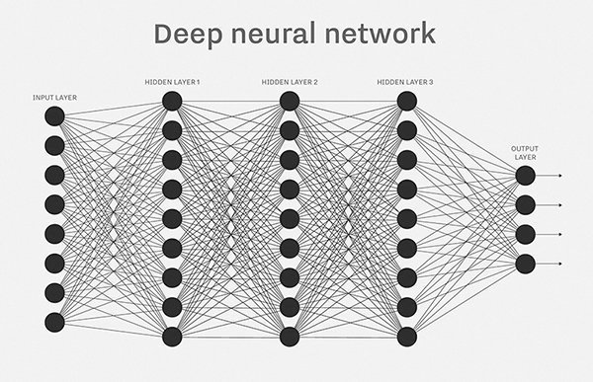

  - Results

Python’s sklearn module is used for the model for predicting the image class (Benign or Malignant). The Neural Network receives numerical values as an input. Since there are 4096 features extracted for each image of the dataset, the first input layer of the ANN has 4096 nodes. The rest of the parameters used are the default ones, meaning one input layer, one hidden layer with 100 units and one output layer in the ANN, maximum number of iterations is 200, activation function for the hidden layer is ‘relu’ - the rectified linear unit function, returns f(x) = max(0, x). The output is the instance’s class (binary: 0/1 – B/M).
The dataset is randomly separated into training and testing dataset, by using the module’s train_test_split function, which splits arrays or matrices into random train and test subsets. The size of the test dataset is 20%.
Accuracy is calculated using the module’s accuracy_score function which returns the accuracy classification score. In classification, this function computes subset accuracy: the set of labels predicted for a sample must exactly match the corresponding set of labels in y_true. In binary and multiclass classification, this function is equal to the jaccard_similarity_score function.
Since the dataset which is used for training and testing is not very large, there are multiple epochs of training and testing the ANN, and at the end the average accuracy of all the epochs is calculated. The number of epochs is a hundred, and the obtained average accuracy is 94%.

possible improvements
Beside the quite satisfying results obtained with this model, there is always place for improvements. Some of the things which it can be worked on are:
- Increasing the dataset size
- Improving the feature extraction function
- Choosing bigger N as number of features to be extracted from each image in the dataset
- More hidden layers in the Neural Network
- Fine tuning the Neural Network’s parameters

REFERENCES
- https://www.medicinenet.com/cancer/article.htm
- https://www.webmd.com/a-to-z-guides/benign-tumors-causes-treatments#1
- https://en.wikipedia.org/wiki/Feature_extraction
- https://www.verywellhealth.com/what-does-malignant-and-benign-mean-514240
- http://www.informatics.jax.org/greenbook/chapters/chapter27.shtml
- https://www.sciencedirect.com/science/article/pii/S0957417408000912
- https://elitedatascience.com/dimensionality-reduction-algorithms#feature-extraction
- https://www.investopedia.com/terms/n/neuralnetwork.asp
- https://skymind.ai/wiki/neural-network
- Pattern Recognition and Machine Learning - Christopher Bishop
- https://colab.research.google.com

