Case Study: Probabilities & Decision Trees
 Important
Please note that you can download PDF and Microsoft Word versions of this case study using the links on the right.

Case 1
In a hypothetical community, 60% of all people consume at least 6 alcoholic beverages per week and 50% are overweight. The percentage of people who are both overweight and consume this much alcohol is 40%. Construct a 2x2 table to answer (a)-(c) below. For part (d), construct a decision tree.
- What percentage of people consume at least 6 alcoholic beverages per week, are overweight, or fall into both categories?
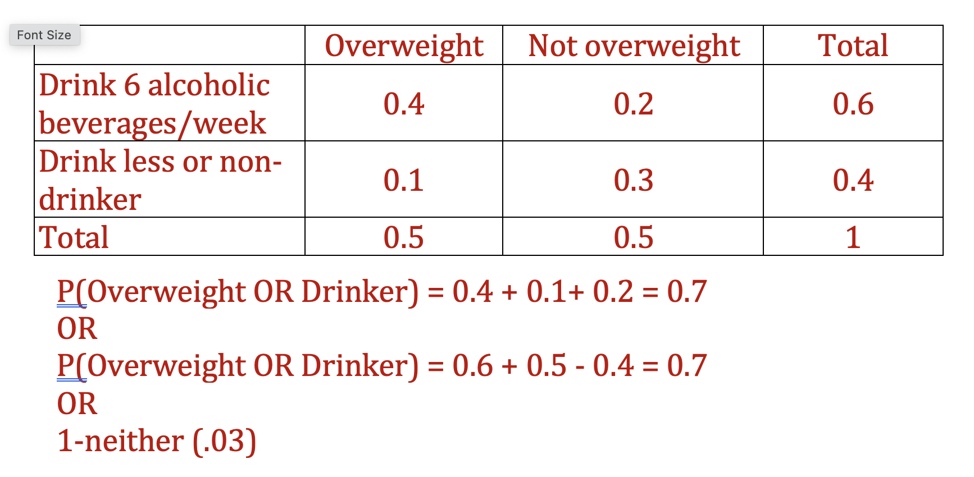
- You sample at random a person from the community and find that they consume at least 6 alcoholic beverages per week. What is the probability that they are overweight?
P(Overweight | Drinker) = 0.4 / 0.6 = 0.667
- What is the probability that someone from this community consumes at least 6 alcoholic beverages per week if they are overweight?
P(Drinker | Overweight) = 0.4 / 0.5 = 0.8
- Draw a decision tree to represent this problem
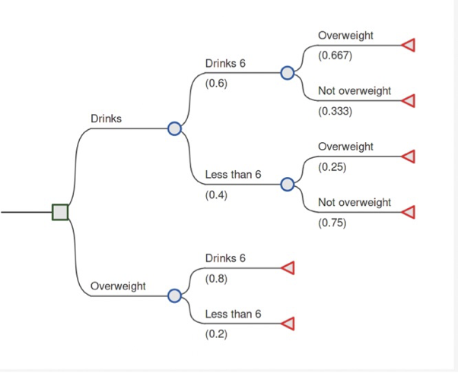

Case 2
A new screening procedure can detect 80% of women diagnosed with breast cancer but will falsely identify 2% without breast cancer. The prevalence of breast cancer in the population is 1.6 in 100
- What is the probability that a woman does not have breast cancer if the test is negative?
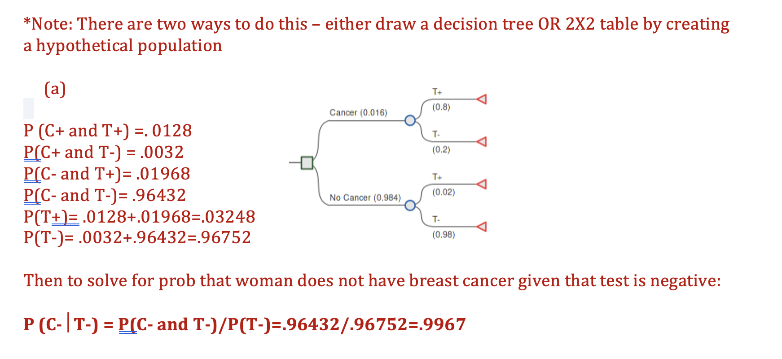
- What is the probability that a woman has breast cancer if the test is positive?
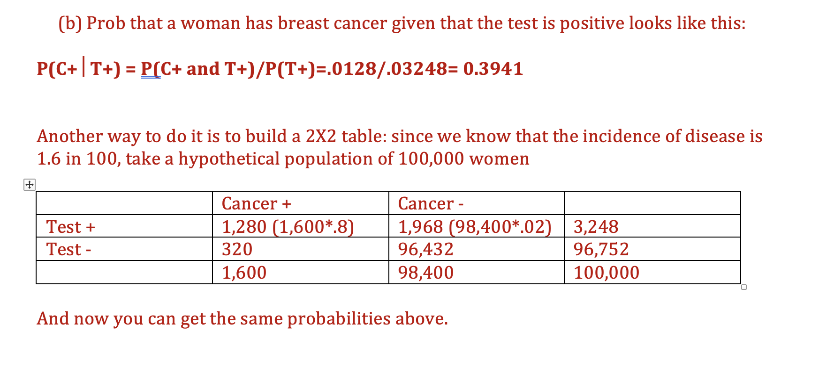

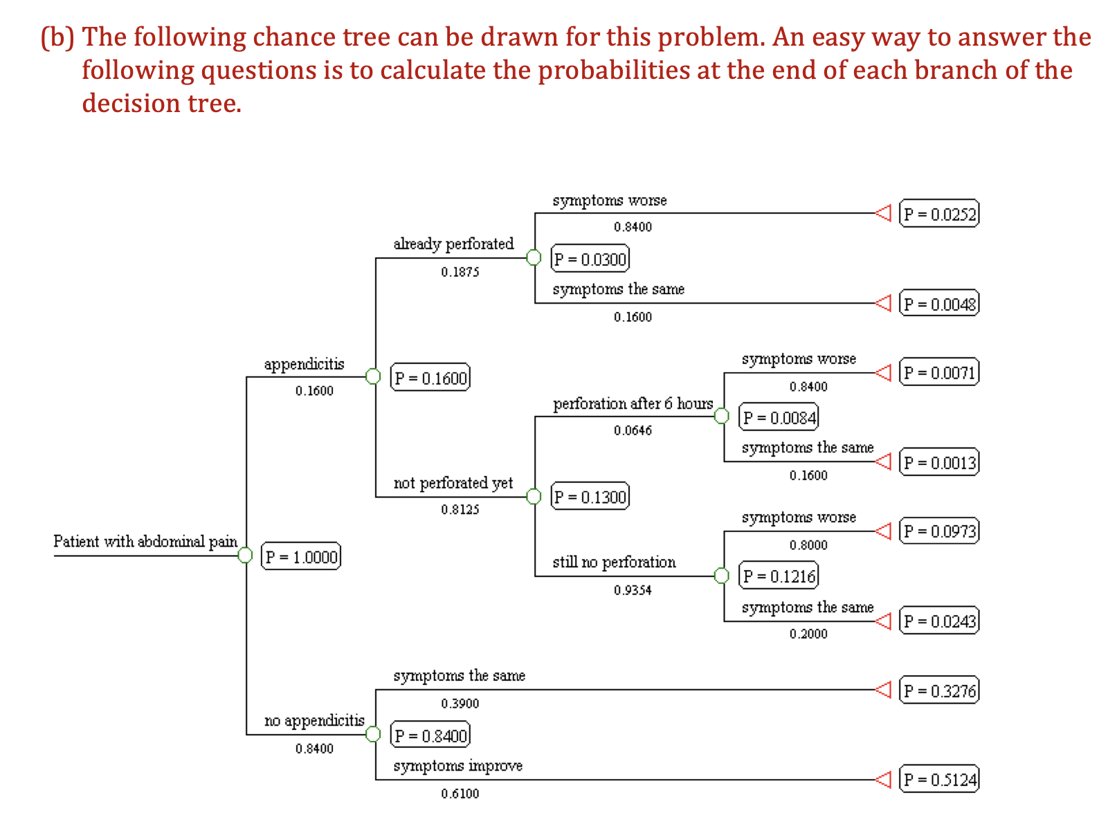
P(Perforation at the beginning of the six hours) = 0.1600 * 0.1875 = 0.0300. This is the proportion of patients with appendicitis multiplied by the conditional probability of perforation given appendicitis at the time the patient enters the hospital.
- Calculate the probability that the patient will have a perforated appendix if you wait 6 hours
P(Perforation after six hours) = 0.0300 + 0.1600 * 0.8125 * 0.0646 = 0.0384 P(Perforation after six hours) = 0.1600 * 0.2400 = 0.0384. This is the proportion of patients with appendicitis times the proportion of patients with a perforated appendix.
- Calculate the probability that the patient’s symptoms will 1) get worse, 2) stay the same, and 3) get better.
You can find these probabilities by adding up the probabilities at the ends of the branches of the decision tree. P(Symptoms worse) = 0.0252 + 0.0071 + 0.0973 = 0.1296 P(Symptoms the same) = 0.0048 + 0.0013 + 0.0243 + 0.3276 = 0.3580 P(Symptoms improve) = 0.5124
- Calculate the conditional probability that the patient has a perforated appendix if the symptoms 1) get worse; 2) stay the same or 3) get better.
By using probability definitions, we can calculate the conditional probabilities. P(E,F) = P(E | F) * P(F) P(E,F): Joint probability of E and F together P(E | F): Conditional probability of E, given F P(F): Probability of F P(E | F) = (E,F) / P(F) P(Perforation | Symptoms worse) = P(Perforation and Symptoms worse) / P(Symptoms worse) = (0.0252 + 0.0071) / 0.1296 = 0.2492 P(Perforation | Symptoms same) = P(Perforation and Symptoms same) / P(Symptoms same) = (0.0048+ 0.0013) / 0.3593 = 0.0170 P(Perforation | Symptoms improve) = P(Perforation and Symptoms improve) / P(Symptoms improve) = 0 / 0.5124 = 0
- Calculate the conditional probability that the patient has appendicitis if 1) the symptoms get worse, 2) stay the same, or 3) get better
Using the same probability notations as in question f, we can calculate the following probabilities: P(Appendicitis | Symptoms worse) = (0.0252 + 0.0071 + 0.0973) / 0.1296 = 1 P(Appendicitis | Symptoms same) = (0.0048 + 0.0013 + 0.0243) / 0.3580 = 0.0849 P(Appendicitis | Symptoms improve) = 0 / 0.5124 = 0

